**AI-Powered Learning Management System (LMS) with Video Summarization, Course Recommendation, and Enhanced Security Features**

**CN7000 MWPL Mental Wealth and Professional Life Dissertation Proposal**

**University of East London**  
 **School of Architecture, Computing and Engineering**

**Author:** Vennilavan  
 **Student ID:** S1037560  
 **Supervisor:** Preethi Kesavan

### **Introduction:**

#### **Dissertation Ideation Summary:**

The proposed dissertation aims to design and develop an AI-powered Learning Management System (LMS) that integrates video summarization, personalized course recommendation, and enhanced cybersecurity using modern web frameworks and machine learning models. The system addresses existing gaps in current LMS platforms by providing intelligent automation, adaptive learning experiences, and secure access management.

The LMS will utilize AI summarization models such as BART and T5 to condense long lecture videos into concise summaries for quick comprehension (Alesh et al., 2024; Rahman et al., 2024). A personalized recommendation engine will suggest relevant courses based on learners’ preferences and performance (Islam & Hosen, 2025; Ma et al., 2023). To ensure data integrity and user safety, the platform will implement multi-tiered security, including Role-Based Access Control (RBAC), account lockout policies, and admin-controlled recovery mechanisms (Shin et al., 2015; Olmsted, 2024).

This research contributes to the growing field of AI-driven educational technology by combining summarization, recommendation, and cybersecurity in one intelligent platform, supporting efficient, secure, and personalized digital learning.

### **Background:**

Traditional LMS platforms like Moodle and Blackboard focus on course delivery and assessment but lack intelligence-driven adaptability and security innovation (Weiling et al., 2025; Qazi et al., 2024). As education increasingly moves online, systems need to evolve toward context-aware, personalized learning (Al-Qora’n et al., 2025; Alotaibi, 2024).

Existing research has demonstrated how AI integration enhances engagement and efficiency (Ok’Onkwo, 2025; Weiling et al., 2025). However, challenges remain in unifying summarization, recommendation, and data protection. Many LMS platforms rely on static content and lack real-time intelligence, creating barriers to learner personalization (Zawacki-Richter et al., 2019).

This project aims to bridge that gap by leveraging Next.js for a high-performance user interface (Pati & Zaki, 2025; Hanafi et al., 2024), Express.js for robust backend functionality, and PostgreSQL via Supabase for scalable data management (Lorenz, 2024). Incorporating security-driven software design principles ensures system reliability and compliance with educational and legal standards (Olmsted, 2024).

### **Aim:**

To design and implement an AI-powered Learning Management System (LMS) that enhances digital education through automated video summarization, personalized course recommendations, and multi-layered cybersecurity mechanisms to ensure user trust, privacy, and institutional efficiency.

### **Objectives:**

1. To develop a full-stack LMS using Next.js, Express.js, and PostgreSQL, integrated with secure authentication and role-based access control (RBAC).
2. To integrate AI-based video summarization using transformer architectures such as BART, T5, and Hybrid Siamese Autoencoders for concise, meaningful content extraction (Xu et al., 2025).
3. To design and implement a personalized course recommendation system using user profiling, semantic analysis, and deep learning models (Islam & Hosen, 2025; Ma et al., 2023).
4. To strengthen system security through:
   1. Data encryption and audit logging;
   2. Instructor account lockout after three consecutive failed login attempts, with admin-only unlock capability to prevent brute-force access;
   3. Comprehensive RBAC enforcement to control permissions and ensure compliance with data protection laws (Shin et al., 2015; Olmsted, 2024).
5. To evaluate the system for usability, AI accuracy, and security resilience, guided by the Design Science Research Methodology (DSRM) framework (Gledson et al., 2024).

### **Literature Review:**

#### **Research Area:**

This study builds on three intersecting research domains: AI-based video summarization, personalized course recommendation, and cybersecurity in educational technology.

**AI Summarization:**  
 AI-driven summarization models such as BART, T5, and Hybrid Siamese Autoencoders have proven effective for compressing educational content (Alesh et al., 2024; Xu et al., 2025). Studies show that lecture summarization improves retention and reduces cognitive load (Rahman et al., 2024; Lee et al., 2017). Integrating summarization into LMS platforms offers learners efficient revision tools and improves accessibility (Qazi et al., 2024).

**Personalized Course Recommendation:**  
 Personalization improves learner satisfaction and academic success (Weiling et al., 2025). Systems like DORIS (Ma et al., 2023) and hybrid ML frameworks (Islam & Hosen, 2025; Premalatha et al., 2022) combine collaborative filtering, deep neural networks, and semantic analysis to recommend courses aligned with learner goals and knowledge levels (Feng & Lin, 2022; Subha et al., 2023).

**Cybersecurity and Access Control:**  
 Educational systems require robust authentication, encrypted data storage, and compliance with GDPR. The RBAC model (Shin et al., 2015) and security-driven development practices (Olmsted, 2024) ensure integrity and user protection. Adding mechanisms like login attempt tracking and administrator-based recovery prevents unauthorized access (Pati & Zaki, 2025).

These areas converge to support a smart, adaptive LMS framework that emphasizes AI-enhanced functionality within a secure and inclusive learning environment (Ok’Onkwo, 2025; Al-Qora’n et al., 2025).

#### **Venn Diagram – Computer Science Knowledge Domain**

The system’s conceptual foundation lies at the intersection of three domains:

1. Advanced Software Management–Computer Interaction
2. Artificial Intelligence (Summarization & Recommendation)
3. Cybersecurity and Access Management

Their intersection represents the innovation zone — a secure, intelligent LMS that combines learning analytics, AI automation, and ethical technology design.

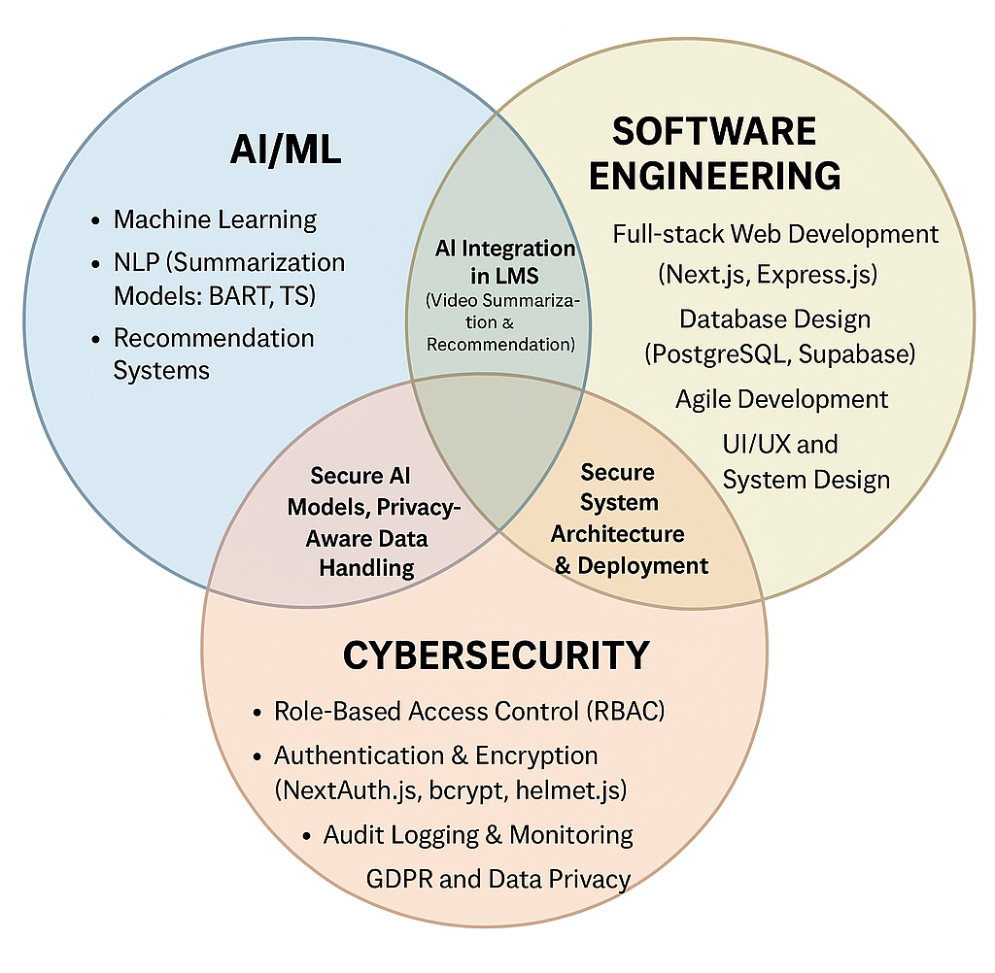

### **Methodology:**

This research applies the Design Science Research Methodology (DSRM) (Peffers et al., 2007), commonly used in educational technology development (Gledson et al., 2024).

1. Problem Identification:  
    Current LMSs lack seamless integration of AI summarization, adaptive recommendations, and advanced cybersecurity (Qazi et al., 2024).
2. Define Objectives:  
    To develop a unified AI-driven LMS that enhances learning efficiency while ensuring data privacy and institutional control.
3. Design and Development:
   1. Frontend: Next.js (Pati & Zaki, 2025; Jain & Chittezhath, 2023).
   2. Backend: Express.js with PostgreSQL via Supabase (Lorenz, 2024).
   3. AI Models: BART, T5, and Siamese Autoencoders (Xu et al., 2025; Alesh et al., 2024).
   4. Security Implementation:
      1. Password hashing using bcrypt and web protection with helmet.js.
      2. Instructor account lockout policy: If incorrect credentials are entered more than three times, the account is automatically locked and can only be unlocked by an administrator after verification.
      3. Audit logs record failed attempts and unlock actions for accountability and GDPR compliance (Shin et al., 2015; Olmsted, 2024).
      4. Regular vulnerability scans ensure resilience against brute-force attacks.
4. Demonstration:  
    The prototype will be tested with a small group of students and instructors to evaluate usability, summarization accuracy, and security functionality.
5. Evaluation:
   1. Performance: Measure response time and summarization accuracy.
   2. Usability: Conduct user surveys (System Usability Scale).
   3. Security: Validate RBAC, encryption, and account lockout effectiveness.
6. Communication:  
    Results and outcomes will be reported in the dissertation and presented at the final viva session.

### **Expected Practical Element Output:**

A fully functional AI-powered LMS prototype that demonstrates:

* Automated video summarization with transformer-based models.
* Course recommendation engine using hybrid deep learning.
* Instructor account lockout and admin-unlock features for improved security.
* Responsive web dashboard with real-time performance and analytics.

### **Required Resources:**

The successful development of the AI-powered Learning Management System (LMS) requires a combination of software, hardware, and cloud resources. The software stack will include Next.js for the frontend, Express.js for backend APIs, and PostgreSQL (via Supabase) as the relational database system for secure data management. Python and Hugging Face Transformers will be used to develop and fine-tune summarization and recommendation models. Supporting libraries such as PyTorch, scikit-learn, bcrypt, helmet.js, body-parser and Socket.IO will enhance system intelligence, data protection, and real-time interactivity.

Hardware resources include a laptop or workstation with at least 16 GB of RAM, an NVIDIA GPU (optional) for faster model inference, and stable internet access for cloud deployment and dataset downloads. Vercel will be used for frontend hosting, while Render or Supabase will support backend and database hosting, ensuring scalability and uptime. Dataset requirements include open educational video collections and academic metadata from public repositories such as Coursera, edX, and YouTube EDU. Finally, tools like Visual Studio Code, Postman, and GitHub will facilitate collaborative development, version control, and continuous integration throughout the project’s lifecycle.

### **Prerequisite Knowledge/Skills Required:**

The researcher must possess a multidisciplinary skill set that combines software engineering, machine learning, and cybersecurity expertise. Proficiency in full-stack development is essential, particularly in React/Next.js, Node.js, and PostgreSQL, to design interactive interfaces and manage server-side logic. A strong understanding of RESTful API architecture, database schema design, and state management will support seamless integration between frontend and backend components.

Knowledge of machine learning principles, including natural language processing (NLP), transformer models, and recommendation algorithms, is vital for implementing AI-based summarization and course personalization features. Experience with Python libraries such as scikit-learn, PyTorch, and Transformers will aid in training and fine-tuning models efficiently.

In cybersecurity, the student should understand encryption protocols, Role-Based Access Control (RBAC), authentication mechanisms, and GDPR compliance to secure user data and prevent unauthorized access. Familiarity with bcrypt for hashing, helmet.js for web protection, body-parser for middleware and penetration testing tools for vulnerability analysis is beneficial. Additionally, Agile development methodologies, UI/UX principles, and Git-based version control are required to ensure collaborative, iterative, and high-quality project delivery from design to deployment.

### **Data Source:**

The data will include public educational video datasets (e.g., YouTube EDU, Coursera open lectures) and academic course catalogs for model training and evaluation. Data will be anonymized and handled under GDPR-compliant storage and usage guidelines.

### **Legal, Social, Ethical and Professional Practice:**

The project adheres to GDPR and the ACM Code of Ethics. User data will remain anonymous and securely stored. AI models will be trained with balanced datasets to minimize bias (Al-Qora’n et al., 2025; Zawacki-Richter et al., 2019). Logging and access control will ensure transparency and accountability. Ethical review and consent will be sought for any user testing.

### **Planning:**

A 12-week schedule is planned:

* Weeks 1–3: Literature Review & Dataset Collection
* Weeks 4–6: System Architecture & Backend Setup
* Weeks 7–9: AI Model Integration & Frontend Development
* Weeks 10–11: Testing & Evaluation
* Week 12: Final Refinement and Report Preparation

A detailed Gantt chart will be included in Annex A.

### References:

Alesh, Y., Aoudia, M., Abdulghani, O., Al Ali, O. and Abu Talib, M. (2024, July) ‘Abstractive Summarization of Lectures and Lecture Segments Transcripts with BART’, *International Conference on Artificial Intelligence in Education Technology*, pp. 43–55. Singapore: Springer Nature Singapore.

Al-Qora’n, L.F., Nganji, J.T. and Alsuhimat, F.M. (2025) ‘Designing Inclusive and Adaptive Content in Moodle: A Framework and a Case Study from Jordanian Higher Education’, *Multimodal Technologies and Interaction*, 9(6), p.58.

Alotaibi, N.S. (2024) ‘The impact of AI and LMS integration on the future of higher education: Opportunities, challenges, and strategies for transformation’, *Sustainability*, 16(23), p.10357.

Alshaya, S.A. (2025) ‘Enhancing Educational Materials: Integrating Emojis and AI Models into Learning Management Systems’, *Computers, Materials & Continua*, 83(2).

Chang, P.C., Lin, C.H. and Chen, M.H. (2016) ‘A hybrid course recommendation system by integrating collaborative filtering and artificial immune systems’, *Algorithms*, 9(3), p.47.

Davinsi, G.R., Warnars, H.L.H.S. and Muyeba, M. (2025) ‘Revitalizing Pastoral Care: Leveraging Stupa Learning Management System in Diocese of Maumere’, *Ingenierie des Systemes d'Information*, 30(3), p.731.

Espino, J. (2025) *Modern REST API Development in Go: Design performant, secure, and observable web APIs using Go's powerful standard library.*

Feng, J. and Lin, X. (2022) ‘Research on online learners’ course recommendation system based on knowledge atlas in smart education cloud platform’, *Wireless Communications and Mobile Computing*, 2022(1), p.5043838.

Gledson, B., Rogage, K., Thompson, A. and Ponton, H. (2024) ‘Reporting on the development of a web-based prototype dashboard for construction design managers, achieved through design science research methodology (DSRM)’, *Buildings*, 14(2), p.335.

Hanafi, R., Haq, A. and Agustin, N. (2024) ‘Comparison of web page rendering methods based on Next.js framework using page loading time test’, *Teknika*, 13(1), pp.102–108.

Islam, M.S. and Hosen, A.S. (2025) ‘Personalized Course Recommendation System: A Multi-Model Machine Learning Framework for Academic Success’, *Digital*, 5(2), p.17.

Jain, S. and Chittezhath, M.D. (2023) *Modern web applications with Next.js: Learn advanced techniques to build and deploy modern, scalable and* *production-ready React applications with Next.js.* 1st edn. Delhi: Orange Education Pvt Ltd.

Konshin, K. (2018) *Next.js Quick Start Guide: Server-side rendering done right.* Packt Publishing Ltd.

Lee, G.C., Yeh, F.H., Chen, Y.J. and Chang, T.K. (2017) ‘Robust handwriting extraction and lecture video summarization’, *Multimedia Tools and Applications*, 76(5), pp.7067–7085.

Lorenz, D. (2024) *Building Production-Grade Web Applications with Supabase: A comprehensive guide to database design, security, real-time data, storage, multi-tenancy, and more.* Packt Publishing Ltd.

Ma, Y., Ouyang, R., Long, X., Gao, Z., Lai, T. and Fan, C. (2023) ‘DORIS: Personalized course recommendation system based on deep learning’, *PLoS One*, 18(6), p.e0284687.

Ok’Onkwo, C. (2025) *Smart Education Recommendation Framework with Dashboard in the Smart City: Smart Education Context.* Doctoral dissertation, University of East London.

Olmsted, A. (2024) *Security-Driven Software Development: Learn to analyze and mitigate risks in your software projects.* Packt Publishing Ltd.

Pati, S. and Zaki, Y. (2025, May) ‘Evaluating the Efficacy of Next.js: A Comparative Analysis with React.js on Performance, SEO, and Global Network Equity’, *Companion Proceedings of the ACM on Web Conference 2025*, pp.1239–1243.

Premalatha, M., Viswanathan, V. and Čepová, L. (2022) ‘Application of semantic analysis and LSTM-GRU in developing a personalized course recommendation system’, *Applied Sciences*, 12(21), p.10792.

Qazi, S., Kadri, M.B., Naveed, M., Khawaja, B.A., Khan, S.Z., Alam, M.M. and Su'ud, M.M. (2024) ‘AI-Driven Learning Management Systems: Modern Developments, Challenges and Future Trends during the Age of ChatGPT’, *Computers, Materials & Continua*, 80(2).

Rahate, V., Mehta, A.K., Deshpande, S., Jawarkar, P., Disawal, V. and Sarge, P. (2025) ‘Impact of AI-Driven Learning Management Systems on Institutional Efficiency and Student Engagement’, *Metallurgical and Materials Engineering*, 31(2), pp.98–103.

Rahman, M.R., Koka, R.S., Shah, S.K., Solorio, T. and Subhlok, J. (2024) ‘Enhancing lecture video navigation with AI generated summaries’, *Education and Information Technologies*, 29(6), pp.7361–7384.

Råmunddal, J. (2025) ‘Enhancing Math Learning in an LMS Using AI-Driven Question Recommendations’, *arXiv preprint arXiv:2504.14098.*

Shin, M.S., Ju, Y.W., Kang, H.K. and Jeong, S.P. (2015) ‘Applying RBAC security control model to manufacturing and logistics service platform’, *Studies in Informatics and Control*, 24(3), p.340.

Subha, S., Sankaralingam, B.P., Gurusamy, A., Sehar, S. and Bavirisetti, D.P. (2023) ‘Personalization-based deep hybrid E-learning model for online course recommendation system’, *PeerJ Computer Science*, 9, p.e1670.

Swanepoel, M.M. (2024) *Enhancing users’ experience of a learning management system within higher education: Chatbot design principles for service providers.* Doctoral dissertation, University of Pretoria (South Africa).

Tabassum, A., Emu, I.J. and Satter, A. (n.d.) *Software Evolution of Next.js and Angular.*

Weiling, C.T., Ling, L.S. and Yin, O.S. (2025) ‘Personalised and Collaborative Learning Experience (PCLE) Framework for AI-driven Learning Management System (LMS)’, *F1000Research*, 14, p.809.

Xu, G., Jia, G., Shi, L. and Zhang, Z. (2021) ‘Personalized course recommendation system fusing with knowledge graph and collaborative filtering’, *Computational Intelligence and Neuroscience*, 2021(1), p.9590502.

Xu, Y., Wu, Z., Li, L., Li, S., Li, W., Li, M., Rao, Y. and Deng, S. (2025) ‘Hybrid Siamese Masked Autoencoders as Unsupervised Video Summarizer’, *IEEE Transactions on Circuits and Systems for Video Technology.*

Yarandi, M. (2013) *Semantic rule-based approach for supporting personalised adaptive e-learning.* Doctoral dissertation, University of East London.

Zawacki-Richter, O., et al. (2019) ‘Systematic Review of Research on Artificial Intelligence Applications in Higher Education’, *International Journal of Educational Technology in Higher Education.*

**Annex A:**