## Automated ELK Stack Deployment

The files in this repository were used to configure the network depicted below.

https://docs.google.com/document/d/1NCK9o27eo1LiZJkbC0BiWUS5C3FmlLdRooRRtZe0ryA/edit?usp=sharing

These files have been tested and used to generate a live ELK deployment on Azure. They can be used to either recreate the entire deployment pictured above. Alternatively, select portions of the __PLAYBOOK___ file may be used to install only certain pieces of it, such as Filebeat.

Install elk.yml

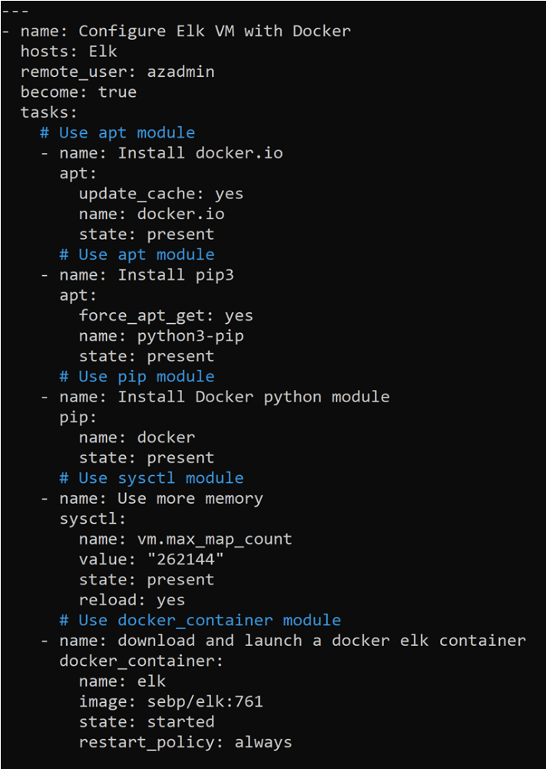

METRICBEAT.YML

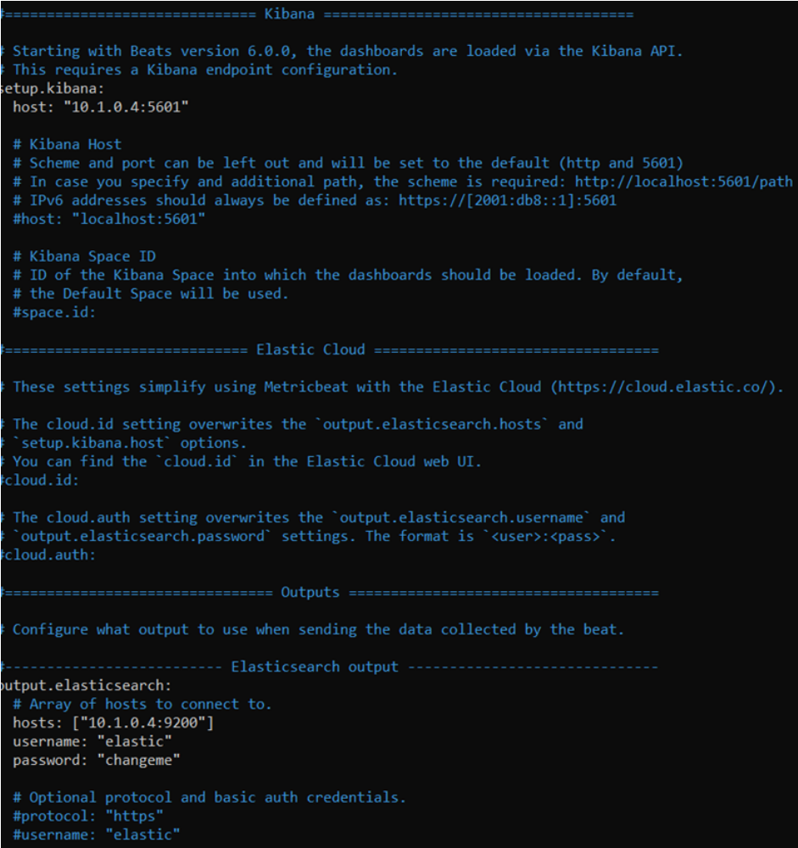

FILEBEAT-PLAY.YML

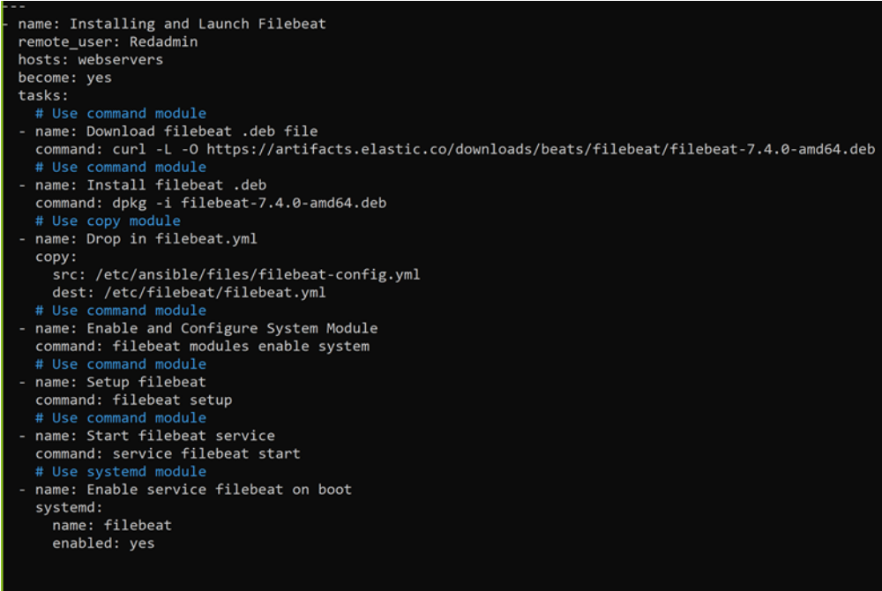

MY-PLAYBOOK-ELK-PENTEST.YML

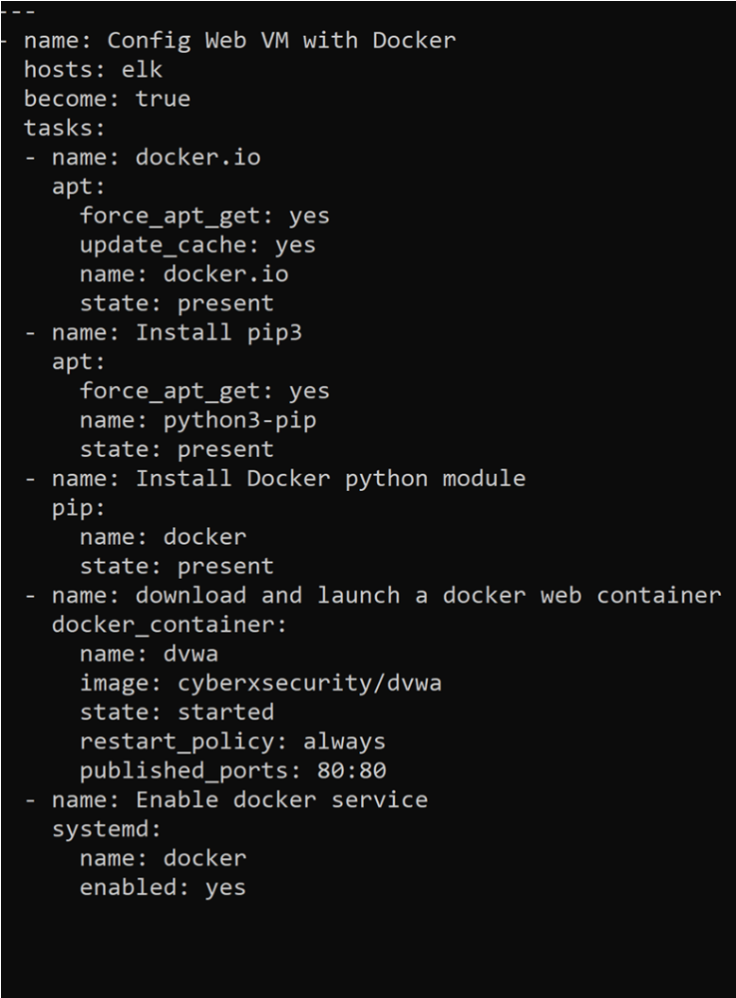

This document contains the following details:
- Description of the Topology
- Access Policies
- ELK Configuration
- Beats in Use
- Machines Being Monitored
- How to Use the Ansible Build

### Description of the Topology

The main purpose of this network is to expose a load-balanced and monitored instance of DVWA, the D*mn Vulnerable Web Application.

Load balancing ensures that the application will be highly __AVALIABILITY___, in addition to restricting __TRAFFIC___ to the network.
- _TODO: What aspect of security do load balancers protect? What is the advantage of a jump box?_

Integrating an ELK server allows users to easily monitor the vulnerable VMs for changes to the _____ and system _____.
- _TODO: What does Filebeat watch for?_ log events/files or locations that you specify, collects log events, and fowards them either to Elastic search or Logstash for indexing
- _TODO: What does Metricbeat record?_ metrics and system statistics that it collects and ships them to the output thath you specify, ie. Elastic search or Logstash

The configuration details of each machine may be found below.
_Note: Use the [Markdown Table Generator](http://www.tablesgenerator.com/markdown_tables) to add/remove values from the table_.

| Name | Function | IP Address | Operating System |
|----------|----------|------------|------------------|
| Jump Box | Gateway | 10.0.0.4 | Linux |
| Web1 |web server| 10.0.0.5 | Linux 18.04/azure| | Web2 |web server|
| ELK |elk server| 10.0.0.6 | Linux 18.04/azure|
|Load Balancer| Load balancer|static ex.IP|Linux 18.04
|Workstation|Acess control| ext. IP or PublicIP| Linux18.04|

Access Policies

The machines on the internal network are not exposed to the public Internet.

Only the _JUMPBOX PROVISIONER____ machine can accept connections from the Internet. Access to this machine is only allowed from the following IP addresses: 172.73.165.100

Machines within the network can only be accessed by __JUMP BOX PROVISIONER: 172.73.165.100___.

A summary of the access policies in place can be found in the table below.

| Name | Publicly Accessible | Allowed IP Addresses |
|----------|---------------------|----------------------|
| Jump Box | Yes | 40.83.139.135 | | Elk | NO | 10.1.0.4 |
| Elk | YES | 40.71.117.143 |
| Web 1 | No | 10.0.0.6 |
| Web 2 | NO | 10.0.0.7 |
| Load BAL.| NO |workstation publicIP on port80|
### Elk Configuration

Ansible was used to automate configuration of the ELK machine. No configuration was performed manually, which is advantageous because...
- _TODO: What is the main advantage of automating configuration with Ansible?_ ALLOWS IT ADMINISTRATORS TO AUTOMATE THE DRUDGERY FROM DAILY TASKED PERFORM.

Only the Elk Server machine can accept connections from the Internet. Access to this machine is only allowed from the following IP addresses: 172.73.165.100

Workstation Public IP through TCP 5601.
Machines within the network can only be accessed by Workstation and Jump-Box-Provisioner. Which machine did you allow to access your ELK VM? 10.1.0.4

Jump-Box-Provisioner IP : 10.0.0.4 via SSH port 22
Workstation Public IP via port TCP 5601

The playbook implements the following tasks:
- _TODO: In 3-5 bullets, explain the steps of the ELK installation play. E.g., install Docker; download image; etc._
- ...
- ...

The following screenshot displays the result of running `docker ps` after successfully configuring the ELK instance.

![TODO: Update the path with the name of your screenshot of docker ps output](Images/docker_ps_output.png)
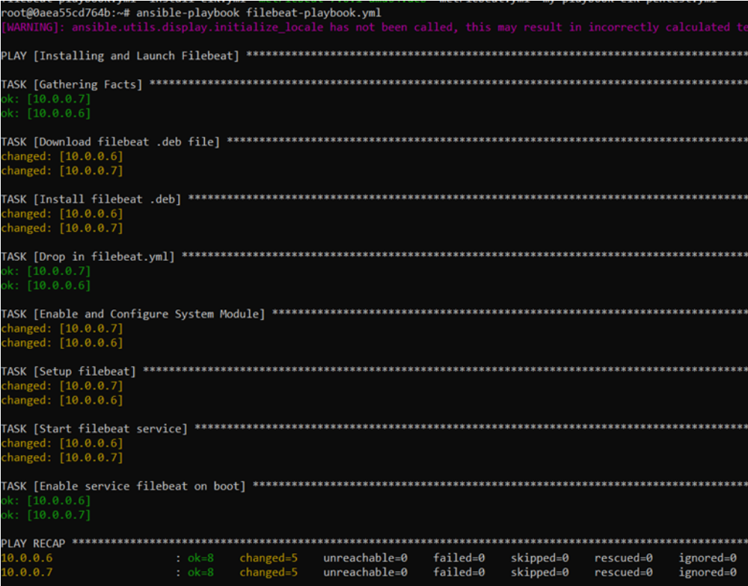

### Target Machines & Beats
This ELK server is configured to monitor the following machines:
- _TODO: List the IP addresses of the machines you are monitoring_
WEB 1- 10.0.0.6
WEB 2- 10.0.0.7

We have installed the following Beats on these machines:
- _TODO: Specify which Beats you successfully installed_
WEB 1- 10.0.0.6
WEB 2- 10.0.0.7
These Beats allow us to collect the following information from each machine:
- _TODO: In 1-2 sentences, explain what kind of data each beat collects, and provide 1 example of what you expect to see. E.g., `Winlogbeat` collects Windows logs, which we use to track user logon events, etc._

"accessing filebeat log files and user interacation "

### Using the Playbook
In order to use the playbook, you will need to have an Ansible control node already configured. Assuming you have such a control node provisioned:

SSH into the control node and follow the steps below:
- Copy the __Filebeat___ file to __Web Server___.
- Update the _HOST___ file to include...
WEB 1 - 10.0.0.6
WEB 2 - 10.0.0.7
- Run the playbook, and navigate to _http://40.114.117.19:5601/app/kibana__ to check that the installation worked as expected.

_TODO: Answer the following questions to fill in the blanks:_
- _Which file is the playbook? Where do you copy it?_
- _Which file do you update to make Ansible run the playbook on a specific machine? How do I specify which machine to install the ELK server on versus which to install Filebeat on?_
- _Which URL do you navigate to in order to check that the ELK server is running?
Download Filebeat playbook usng this command:
curl -L -O https://gist.githubusercontent.com/slape/5cc350109583af6cbe577bbcc0710c93/raw/eca603b72586fbe148c11f9c87bf96a63cb25760/Filebeat > /etc/ansible/files/filebeat-config.yml
Copy the '/etc/ansible/files/filebeat-config.yml' file to '/etc/filebeat/filebeat-playbook.yml'
Update the filebeat-playbook.yml file to include installer
curl -L -O https://artifacts.elastic.co/downloads/beats/filebeat/filebeat-7.6.1-amd64.deb
Update the filebeat-config.yml file root@c1e0a059c0b0:/etc/ansible/files# nano filebeat-config.yml
--Elk-Venomvito@10.1.0.4: curl localhost:5601/app/kibana-----

_As a **Bonus**, provide the specific commands the user will need to run to download the playbook, update the files, etc._

COMMANDS

Sudo systemctl status docker- status of the docker application
sudo apt-get update- update all packages
Sudo systemctl start docker
Sudo apt install docker.io-- install docker .io
Sudo service docker start- start the docker application
Sudo docker ps -a

Sudo docker pull cyberxsecurity/ansible- download the docker file
Sudo docker run-ti cyberxsecurity/ansible- run and create a docker image
-cyberxsecurity/ansible bash
Sudo docker container list -a
Sudo docker start silly_fermat-- start your ansible
Sudo docker attach silly_fermat-- gain root access to ansible container ssh
Sudo docker ps- Print screen
ansible -m ping all- check the connection of ansible containers
Ssh-keygen- Create as ssh key
Cat /root/.ssh/id_rsa.pub
Ls ~/.ssh/id_rsa.pub

JumpBox Provisioner
Ls /etc/ansible
Nano /etc/ansible/ansible.cfg
Nano /etc/ansible/hosts

