# 5Servlet

@WebServlet("/GetHelloForm")

**protected** **void** doPost(HttpServletRequest request, HttpServletResponse response) **throws** ServletException, IOException {

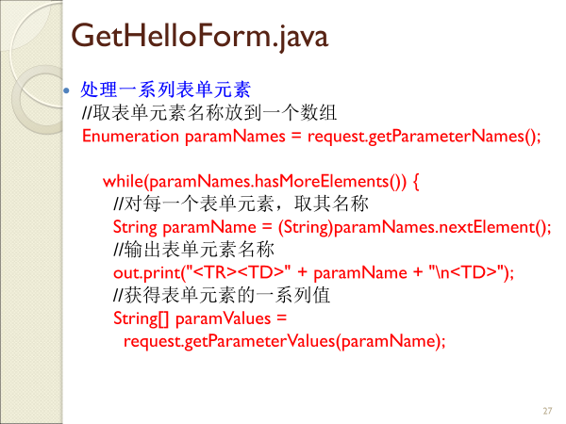

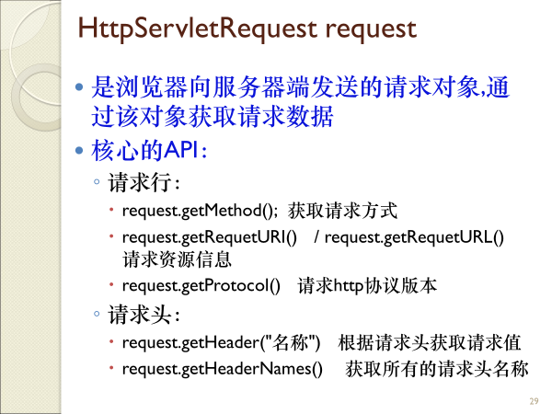

# Spring

@Service("userService")

public class UserServiceImpl implements UserService {

@Resource(name="userDao")

private UserDao userDao;

@Override

public void save() {

//调用userDao中的save方法

this.userDao.save();

System.out.println("userservice...save...");

}

}

Web.xml

<servlet>

<servlet-name>SpringMVC</servlet-name>

<servlet-class>org.springframework.web.servlet.DispatcherServlet </servlet-class>

<!-- 当applicationContext.xml放在src 下时要特别声明一下，如果不声明，则默认视图配置文件的命名方式为 SpringMVC-servlet.xml-->

<init-param>

<param-name>contextConfigLocation</param-name>

<param-value>classpath:applicationContext.xml</param-value>

</init-param>

<load-on-startup>1</load-on-startup>

</servlet>

<servlet-mapping>

<servlet-name>SpringMVC</servlet-name>

<url-pattern>*.do</url-pattern>

</servlet-mapping>

