***Lab 2***

***Assignment-1***

* Write a Java program named **Car**.
* The Car class should have the following attributes: make (String), model (String) , year (short) , and price(int).
* The car class should have a constructor that takes all the attributes.
* Add a main method to instantiate car objects.
* The program should allow the user to create and display objects of each Car class.

***Program***

**import** **java.util.Scanner**;

**public** **class** Car {

*String* make, model;

*short* year;

*int* price;

**public** Car(*String* *make*, *String* *model*, *short* *year*, *int* *price*) {

        this.make **=** make;

        this.model **=** model;

        this.year **=** year;

        this.price **=** price;

    }

**public** *void* display() {

        System.out.println("Make: " **+** make);

        System.out.println("Model: " **+** model);

        System.out.println("Year: " **+** year);

        System.out.println("Price: " **+** price);

    }

**public** **static** *void* main(*String*[] *args*) {

*Scanner* scanner **=** **new** Scanner(System.in);

        System.out.print("Enter car make: ");

*String* make **=** scanner.nextLine();

        System.out.print("Enter car model: ");

*String* model **=** scanner.nextLine();

        System.out.print("Enter car year: ");

*short* year **=** scanner.nextShort();

        System.out.print("Enter car price: ");

*int* price **=** scanner.nextInt();

*Car* car **=** **new** Car(make, model, year, price);

        car.display();

    }

}

***Output***

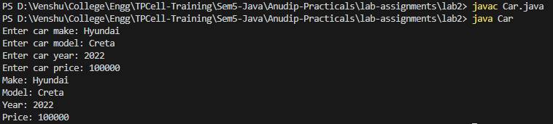

***Assignment-2***

* Write a Java program that demonstrates method overloading by creating a class called **Calculator**.
* Add three methods called add().
* The first add() method should take two int variables as arguments and return their sum as int.
* The second add() method should take three int variables as arguments and return their sum as int.
* The third add() method should take two doubles as arguments and return their sum as double.
* The program should allow the user to display the results of each method.

***Program***

**import** **java.util.Scanner**;

**public** **class** Calculator {

**public** *int* add(*int* *a*, *int* *b*) {

**return** a **+** b;

    }

**public** *int* add(*int* *a*, *int* *b*, *int* *c*) {

**return** a **+** b **+** c;

    }

**public** *double* add(*double* *a*, *double* *b*) {

**return** a **+** b;

    }

**public** **static** *void* main(*String*[] *args*) {

*Calculator* calculator **=** **new** Calculator();

*Scanner* scanner **=** **new** Scanner(System.in);

        System.out.print("Enter first integer: ");

*int* num1 **=** scanner.nextInt();

        System.out.print("Enter second integer: ");

*int* num2 **=** scanner.nextInt();

        System.out.println("Addition of " **+** num1 **+** " and " **+** num2 **+** ": " **+** calculator.add(num1, num2));

        System.out.print("Enter third integer: ");

*int* num3 **=** scanner.nextInt();

        System.out.println("Addition of " **+** num1 **+** ", " **+** num2 **+** " and " **+** num3 **+** ": " **+** calculator.add(num1, num2, num3));

        System.out.print("Enter first double: ");

*double* num4 **=** scanner.nextDouble();

        System.out.print("Enter second double: ");

*double* num5 **=** scanner.nextDouble();

        System.out.println("Addition of " **+** num4 **+** " and " **+** num5 **+** ": " **+** calculator.add(num4, num5));

    }

}

***Output***

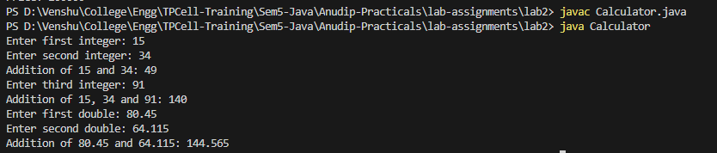

***Assignment-3***

* Create a **Java Bean Class Student**
* Add three attributes
  + private String name;
  + private int age;
  + private String department;
* Add a constructor that takes all three attributes as parameters.
* Add setter and getter methods.
* Compile the program.

***Program***

**public** **class** Student {

**private** *String* name;

**private** *int* age;

**private** *String* department;

**public** Student(*String* *name*, *int* *age*, *String* *department*) {

        this.name **=** name;

        this.age **=** age;

        this.department **=** department;

    }

**public** *String* getName() {

**return** name;

    }

**public** *int* getAge() {

**return** age;

    }

**public** *String* getDepartment() {

**return** department;

    }

**public** *void* setName(*String* *name*) {

        this.name **=** name;

    }

**public** *void* setAge(*int* *age*) {

        this.age **=** age;

    }

**public** *void* setDepartment(*String* *department*) {

        this.department **=** department;

    }

**public** **static** *void* main(*String*[] *args*) {

*Student* student **=** **new** Student("Venshu Anandani", 20, "Computer Engineering");

        System.out.println("Name: " **+** student.getName());

        System.out.println("Age: " **+** student.getAge());

        System.out.println("Department: " **+** student.getDepartment());

        student.setName("Pratik Kolhe");

        student.setAge(20);

        student.setDepartment("Computer Science (AI and DS)");

        System.out.println("Updated Name: " **+** student.getName());

        System.out.println("Updated Age: " **+** student.getAge());

        System.out.println("Updated Department: " **+** student.getDepartment());

    }

}

***Output***

