***Lab 4***

***Assignment-1***

* Write a program to find out all the armstrong numbers within a given range using a method named **printArmstrongNumber(int start, int end)** by taking input from the user.
* The program should print the Armstrong number in a given range starting from “start” and ending with “end”.
* Armstrong Number Example: 153 1 3+5 3+3 3 =153 (Number which is equal to the sum of the cubes of its digits).
* ***Note:*** Input should be taken from the keyboard. Use a loop to calculate the Armstrong number from “start” to “end”. Also use loops to calculate the cube of a number. ***Do not use the Math.pow() function.***

***Program***

**import** **java.util.Random**;

**public** **class** Rectangle {

**private** *int* length;

**private** *int* width;

**public** Rectangle(*int* *length*, *int* *width*) {

        this.length **=** length;

        this.width **=** width;

    }

**public** *int* calculateArea() {

**return** length **\*** width;

    }

**public** **static** *void* main(*String*[] *args*) {

*Random* rand **=** **new** Random();

*Rectangle* rectangle1 **=** **new** Rectangle(rand.nextInt(20) **+** 1, rand.nextInt(20) **+** 1);

*Rectangle* rectangle2 **=** **new** Rectangle(rand.nextInt(20) **+** 1, rand.nextInt(20) **+** 1);

*int* area1 **=** rectangle1.calculateArea();

*int* area2 **=** rectangle2.calculateArea();

        System.out.println("Rectangle1: length = " **+** rectangle1.length **+** ", width = " **+** rectangle1.width **+** ", area = " **+** area1);

        System.out.println("Rectangle2: length = " **+** rectangle2.length **+** ", width = " **+** rectangle2.width **+** ", area = " **+** area2);

**if** (area1 **>** area2) {

            System.out.println("Rectangle1 > Rectangle2");

        } **else** **if** (area1 **<** area2) {

            System.out.println("Rectangle1 < Rectangle2");

        } **else** {

            System.out.println("They are equal");

        }

    }

}

***Output***



***Assignment-2***

* Write a program to calculate the gross salary of a group of employees.
* Basic salary should be taken from the user.
* If the basic salary is greater than 15000, HRA=20% and DA=60% will be given, else HRA=3000 and DA 70% will be given to the employee.
* ***Note:*** Input of basic salary will be taken from the keyboard. After calculating the salary of one employee, the program will ask for the user's choice as int. If “-1” is entered, then the loop will continue and the loop will exit for other int inputs.

***Program***

**import** **java.util.Scanner**;

**public** **class** SalaryCalculator {

**public** **static** *void* main(*String*[] *args*) {

*Scanner* sc **=** **new** Scanner(System.in);

**while** (true) {

            System.out.print("Enter basic salary: ");

*double* basic **=** sc.nextDouble();

*double* hra, da, gross;

**if** (basic **>** 15000) {

                hra **=** 0.20 **\*** basic;

                da **=** 0.60 **\*** basic;

            } **else** {

                hra **=** 3000;

                da **=** 0.70 **\*** basic;

            }

            gross **=** basic **+** hra **+** da;

            System.out.println("Gross Salary: " **+** gross);

            System.out.print("Enter -1 to continue or any other number to exit: ");

*int* choice **=** sc.nextInt();

**if** (choice **!=** **-**1) {

**break**;

            }

        }

        sc.close();

    }

}

***Output***

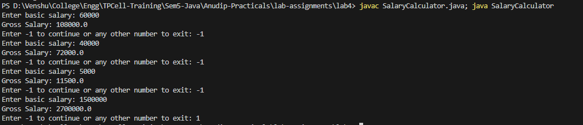

***Assignment-3***

Write a program to count and print the total number of odd and even numbers from user inputs. Program will ask for user inputs in a loop. Loop will terminate if -1 is entered as input.

***Program***

**import** **java.util.Scanner**;

**public** **class** EvenOdd {

**public** **static** *void* main(*String*[] *args*) {

*Scanner* scanner **=** **new** Scanner(System.in);

*int* evenCount **=** 0, oddCount **=** 0;

**while** (true) {

            System.out.print("Enter a number (-1 to exit): ");

*int* num **=** scanner.nextInt();

**if** (num **==** **-**1) {

**break**;

            }

**if** (num **%** 2 **==** 0) {

                evenCount**++**;

            } **else** {

                oddCount**++**;

            }

        }

        System.out.println("Total even numbers: " **+** evenCount);

        System.out.println("Total odd numbers: " **+** oddCount);

        scanner.close();

    }

}

***Output***

