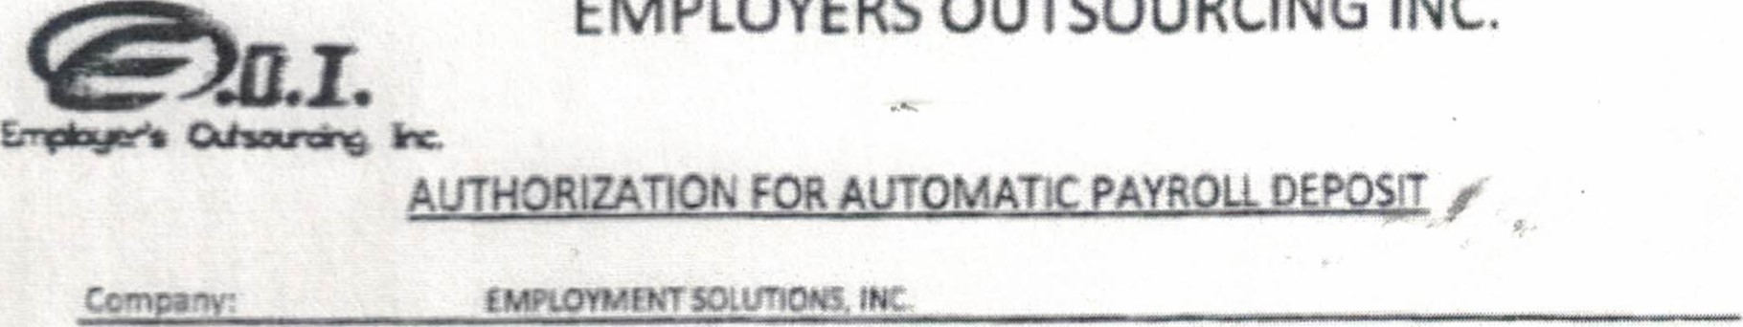

I

autheize

my

emptoyet

to

deposit

my

wages/saiary

into

the

bank

specified

i

agree

that

dreet depos!t transactions authorize compty wlth all applicable signature below indicates that am agreeing that am either the accounthoider •o' have the autfvrity to-authorize my employer to m•ke direct deposits into the named ecount. this form along with proper documentation MOSI be comp/ete in otdet process

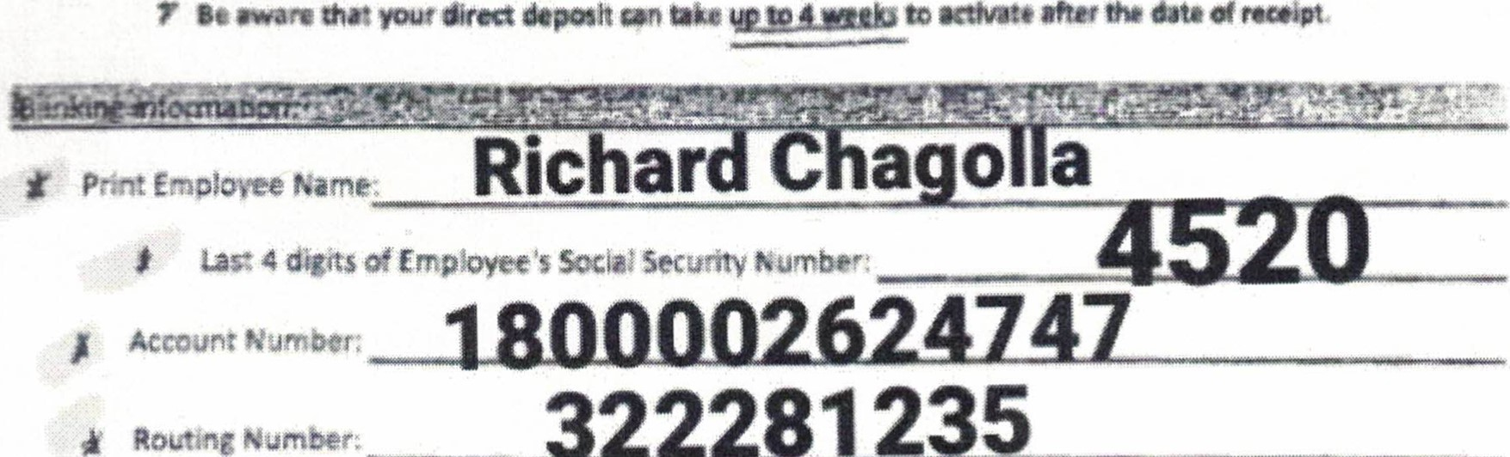

—-822281235_______

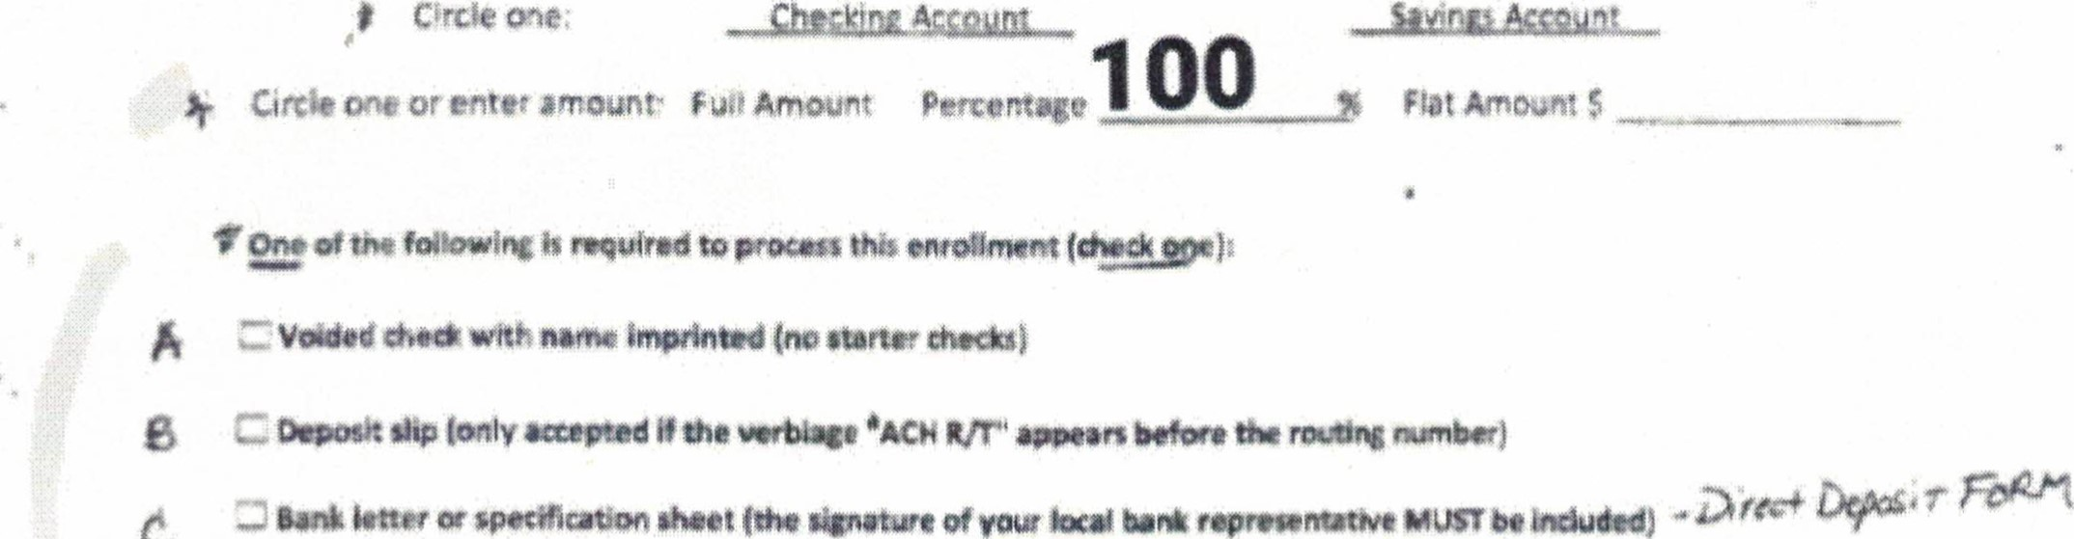Circle one or enter amount" FultAmount

One of the required to

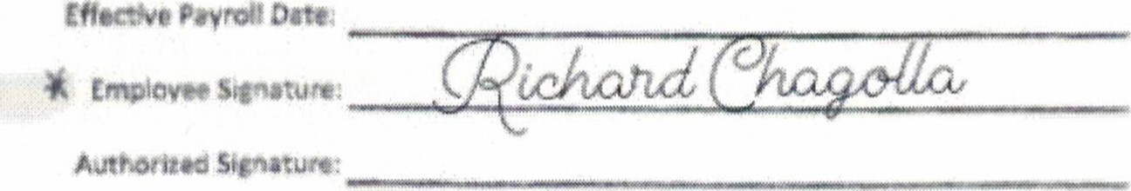



|  |  |  |
| --- | --- | --- |
|  | |  | | --- | | REQUIRED: PLEASE P'*CE CANCtUED OfECX YOUR PRINTED NAME ON tv HERE.  you NOT HAVE CHEas FOR ms ACCOUNT, PLEASt ATTACH A  COPY OF ANY ONE or THE ACCEPTABLE DOCUMENTS U$tEO ABOVE | | |

wwwNturaco,e

Alturas

CttOtt

Date:

To: Company Originating Electronic (ACH) DebiÉ/Credits

From: Altura Credit Union

Information Required to Process Electronic (ACH) Transactions

The Altura Credit Union can process debits or credits for

Member's Name: RICHARD LEON CHAGOUA

@The Routing and Transit Number to use is: 322281235

Checking C] Savings The Account Number to use is; 1800002624747

(13-digit MICR account number located on share ID)

Date: Member Signature:

|  |  |
| --- | --- |
| RICHARD LEON CHAGOUA  338 Olive Ave, Beaumont, CA 92223-2654  AltuFa | 07/22/2022 |
|  |  |

If you have any questions regqrding the process o! an Electronic payment or deposit;

•e*pleasetall Altura payroll / ACH Coordinator at (838)

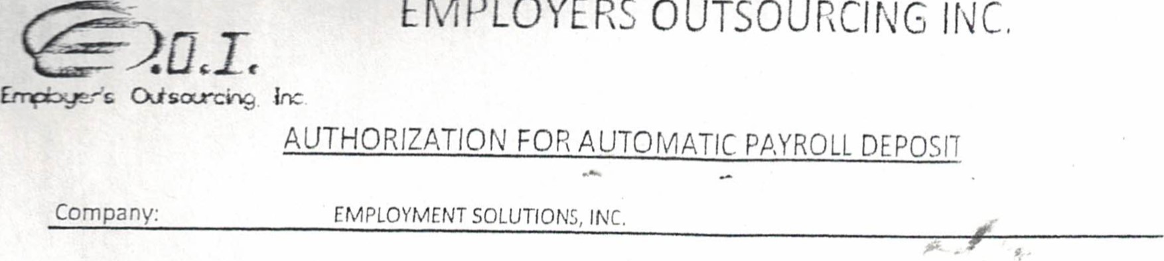

I authorize my employer to deposit my wages/salary into the bank accounts specified below. I agree that direct deposit transactions I authorize comply with all applicable law. My signature below indicates that I am agreeing that I am either the accountholder or have the authority to authorize my employer to make direct deposits into the named account. This form along with proper documentation MUST be complete in order to process.

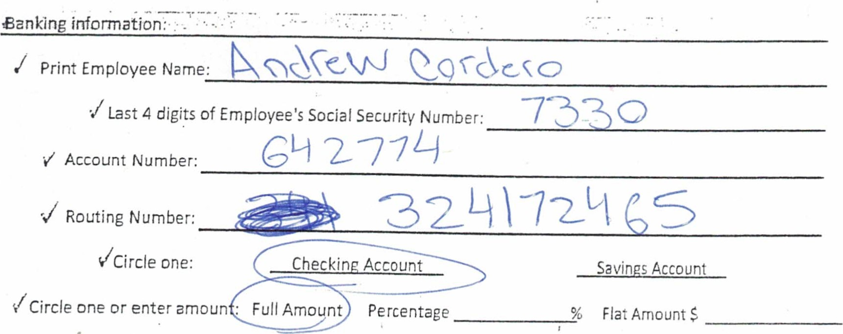

'J One of the following is required to process this enrollment (check one):

u Voided check with name imprinted (no starter checks)

Deposit slip (only accepted if the verbiage "ACH Rim'i appears before the routing number)

Bank letter or specification sheet (the signature of your local bank representative MUST be included)

Effective Payroll Date:

Employee Signature:

Authorized Signature:

Date: 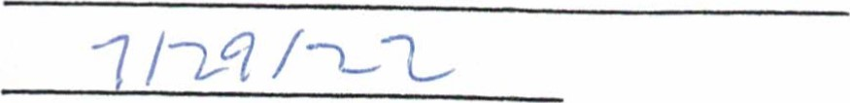

REQUIRED: PLEASE PLACE YOUR CANCELLED CHECK WITH YOUR PRINTED NAME ON IT HERE.

IF YOU DO NOT HAVE CHECKS FOR THIS ACCOUNT, PLEASE ATTACH A COPY OF ANY ONE OF THE ACCEPTABLE DOCUMENTS LISTED ABOVE.

# Jun 30, 2022

Andrew A Cordero Estrada 7550 Desert Holly St #911

Chino Hills, CA 91705

# Dear Andrew,

Thank you for using TruGrocer Federal Credit Union!

To set up Payroll Direct Deposit through ACH your employer will need the following information:

TruGrocer Federal Credit Union Routing Number: 324172465

To Deposit to Savings (Your Member Number): 8800642770

To Deposit to Checking (Your Checking Account Number): 642774

If you haven't already signed up for CU OnLine, enrollment is easy! Just visit

First time users sign up by clicking the information button for CU OnLine G). You will need your member number and your Electronic Teller PIN number. You then select a Username and Password as we confirm your identity and authenticate your account access. Your Username and Password will also give you access to your account using the TruGrocer Mobile App, which can be downloaded from Google Play or the Apple App Store. Please let us know if you have any questions,

Your Membership Services Team

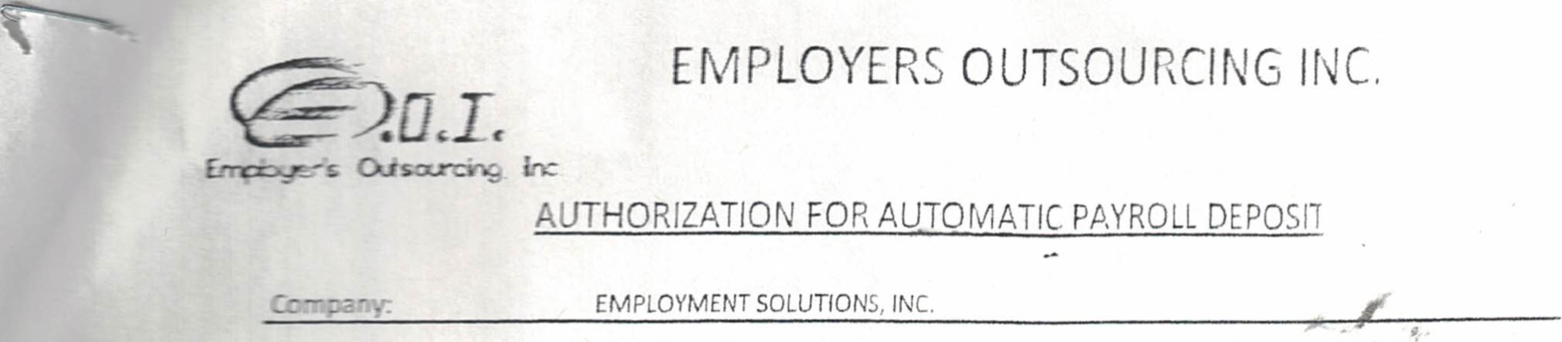

I authorize my employer to deposit my wages/salary into the bank accounts specified below. I agree that direct deposit transactions I authorize comply with all applicable law. My signature below indicates that I am agreeing that I am either the accountholder or have the authority to authori>e. my employer to make direct deposits into the named account. This form along with proper documentation MUST be complete in order to process.

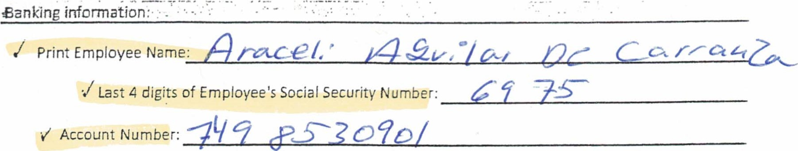

Savings Account

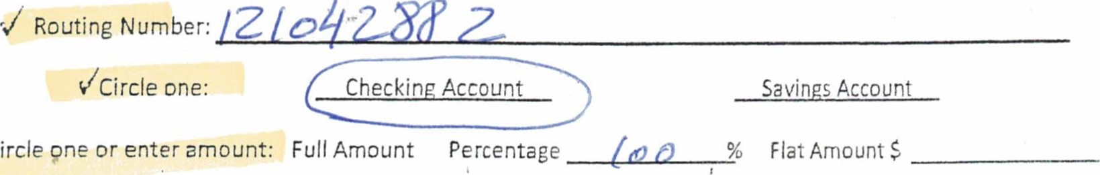

'Circle

% Flat Amount $

'J One of the following is required to process this enrollment (check one):

Voided check with name imprinted (no starter checks)

Deposit slip (only accepted if the verbiage "ACH R/T" appears before the routing number)

Bank letter or specification sheet (the signature of your local bank representative MUST be included) D i'vQECf

Effective Payroll Date: 

Employee Signature:

Authorized Signature:

Date:

|  |  |  |
| --- | --- | --- |
|  | |  | | --- | | REQUIRED: PLEASE PLACE YOUR CANCELLED CHECK WITH YOUR PRINTED NAME ON IT HERE.  IF YOU DO NOT HAVE CHECKS FOR THIS ACCOUNT, PLEASE ATTACH A COPY OF ANY ONE OF THE ACCEPTABLE DOCUMENTS LISTED ABOVE. | |

|  |
| --- |
| o希 Deposit、AutoョaticPa ョのコゴfo「mat一0コFO「m  「he「040 ョ040000三00【wa』6ョ00000』0=「0話000』00000一0一 00&20ョ・当0一( 0一~  8ゆっ0コ TOYou Co望雪 ・一0日皀00』 000060006ョ第0=』一0「』00一0 0w=00』000「0一=→00訂【一000「6000600【6を0 0  9′ 褒呂-「0コ一畠を6you「WellsFa「900000uョ・  「物4・uoY 爲一 のd【e022第【0ou「ヨ0コey0コtheday黛deposit* 一の・Neをworry3b0ミ0プの0斎9(ゴ9一0 delayed0「い6一eコ.  Aミ0 tic&0ぎ9・Wa【chyc日 g「OWwゴ0コ、ouha=00ニ004pa夛0「』00「名』0一「円帋d【0』00「080」「尸  f「 20C8コ伊  幻01.UseAccouコニコfo「ヨa0コP「ovidedBelow  Y00皀℃「0忌deyou「一n「0「ヨ2U0コabouttheaccountwheretheョ0コe、willbedeposited0「withd「  召ま9Nuョ 2与 2ョぎョブ円  をCEいIAGUILARDEC 有ZA一(一 ド21一042882 79853090日  SっドCOコ-a YourEmloye「0「Pa0「  o【 0ョで一0Y0「0「payordi「ectly6お0一コh070「「0「di「ectdep日0e2一00.W0おd一「00【deposi【 aイ0=ab p「しをなe0 呂の0一」  5「皀ti Y05で0Y0「ヨ0needyou600ョp一0【ea一0「ヨ0コdで「0丘deavoided0h00k0「COョョaコdcheck6つ「ocの out「equの、幻のp3.MOコ一6「You「Account  for00ュDeを0: 00 0=20twoョ0「==ニ0「0「 0「6 000 』00「「名00 =06000一0希お一=ぎ00一害0000P0匕尊、  0u0ぎコ WellsFa「00導0コ080コM 0=0=」b一0~、 」二 09T0,w〔〔〔s(一、80980P355当〕 |

|  |  |  |  |  |  |
| --- | --- | --- | --- | --- | --- |
| UTHO IZATICN O |  | O | ATC. PAYROLL |  |  |

Company: jNC.

t authorize my emp!oycr to deposit my wages/sa[acy Into the bank accounts cpecffjed be50w j agree that direct deposit transactions i authorize comply with all applicable law. My signaturebejcp in&acatcs that j am acteeing that am either the accountholder or have the authotity to authori:e my emptoyei to moke ditect deposits into the rsömed accountf Th15 form alorg with ptoper documentation MUST be complete in order to process.

Bankin

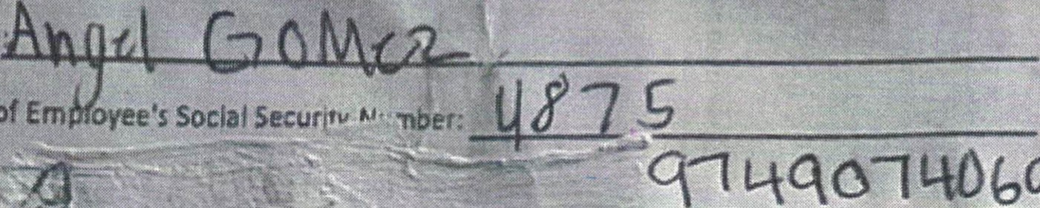

Print

Employee

Name•

'Last4

digits

of

Account

Numbet

|  |  |  |
| --- | --- | --- |
|  | PLEASE PLACENOVfi CANCtttEDtHECKWTHYOU PRINTED NAME ON IT HERE,  IF YOU DO NOT HAVE CHECKS FOR THIS ACCOUNT, PLEASE ATTACH A copy OF ANY ONE OF THE ACCEPTABLE DOCUMENTS LISTED ABOVE. |  |
|  |  |

Routing

|  |  |  |
| --- | --- | --- |
| VCircie one: | ount | s Account |
| /Circle one or enter amount; gulf Amou | Percentage | % Fl?t Amount |

Oke of the.fo!lowinc is required to process this enrollment (check one);

Z Voided deck '4th name imprinted (no starter checks)

Deposit slip (Daly accepted Éte verbiage PACKRtr appears before the routing number)

ank letter or specification sheet (the signature olyøur local bank representative MUSI be included)

Effective Payroll Date: v Employee Signature:

Authoriz ed Signa tore:

|  |  |  |
| --- | --- | --- |
|  |  | ο |

ο

OUTs0Uncll\Ic INC.

AUTOMATIC PAYROLL Company:

EMPLOYMENT SOLUTIONS INC.

authorize my employer to deposit my direct deposit transactions ! authorize comply w ary into the bank accounts specified below. agree that agreeing that j am either the accountholder ot have the pr:pet authority to authorize my employer to make direct

deposits into the named account, This form along with MUST be complete in order to

i Eanking infomation:•

Print Employee Name:

Last 4 digits of Employee's Social Security

't/ Account Number:

|  |
| --- |
| O/ |

Routing Number:

|  |
| --- |
| Che kin Account |
|  |

uCircle one:Savings Account

Flat Amount $

ICircie one or enter amount: Full Amount ercentage

One of the following is required to process this enrollment (check one):

3.V.ekféd check with name imprinted (no starter checks)

Deposit slip (only accepted if the verbiage "ACH Put". appears before the routing number)

Bank letter or specification sheet (the signature of your local bank representative MUST be included)

D iC&Cf D5PD4iT

Effective Payroll Date;

Employee Signature:

Authorized Signature:

Date:

REQUIRED: PLEASE PLACE YOUR CANCELLED CHECK WITH YOUR PRINTED NAME ON IT HERE,

YOU DO NOT HAVE CHECKS FOR THIS ACCOUNT, PLEASE ATTACH A copy OF ANY ONE OF THE ACCEPTABLE DOCUMENTS LISTED ABOVE.

|  |
| --- |
|  |
| |  |  |  | | --- | --- | --- | | DERRICK BAILEY  11975 SUGAR CREEK CT  MORENO VALLEY CA 92557  Pay to the  Order of  Farmers & Merchants Banr  CajFomWs Fullerton Office fmbscom (855) 416-5747  For | Date | 1514  90-119/1222  oepasåt• |   Date;   |  |  | | --- | --- | |  | REQUIRED: PLEASE PLACE YOUR CANCELLED CHECK WITH YOUR PRINTED NAME ON IT HERE.  IF YOU DO NOT HAVE CHECKS FOR THIS ACCOUNT, PLEASE ATTACH A  COPY OF ANY ONE OF THE ACCEPTABLE DOCUMENTS LISTED | |

OUTSOURCING INC.

# @.oeJe

CXi so-rciAf;

AUTOMATIC PAYROLL



SOiaUtlONS. Company:

authorize my employer to deposit my wages/saiaty into the bank actounts specified be!ow, I atvee that direct deposft trgns3Ctions J authori?e Comply with all applicable law, My signature below indicates that Egreesnc that I am either the accountholder or have the authority to authoroe my employee to make deposits into the named account. ThiB form along with proper documenfatio{ MtJSi be complete in ordet to

Eankin information:

ost 4 digits of Employee•s Social Security Number: count Number; 130 (0 5 3 110 0

outing Number; one or enter amoun •

V one of the following is required to process this enrollment (chæne);-

ZVeided checkwith name imprinted (no starter checks)

ZDep%it (only accepted if the verbiage "ACH appears before the number)

Z lettgæ_pgification sheet{thesignatureotyouaoel-bankqep

Date'.

Sitnature:.

Senatute•,

Pate:

## REQUIRED: PLACE YOUR CANCELLED CHECK WITHYOVR

00 HAVE CHECKS FOR ACCOUNT, PLEASE ATTACH A

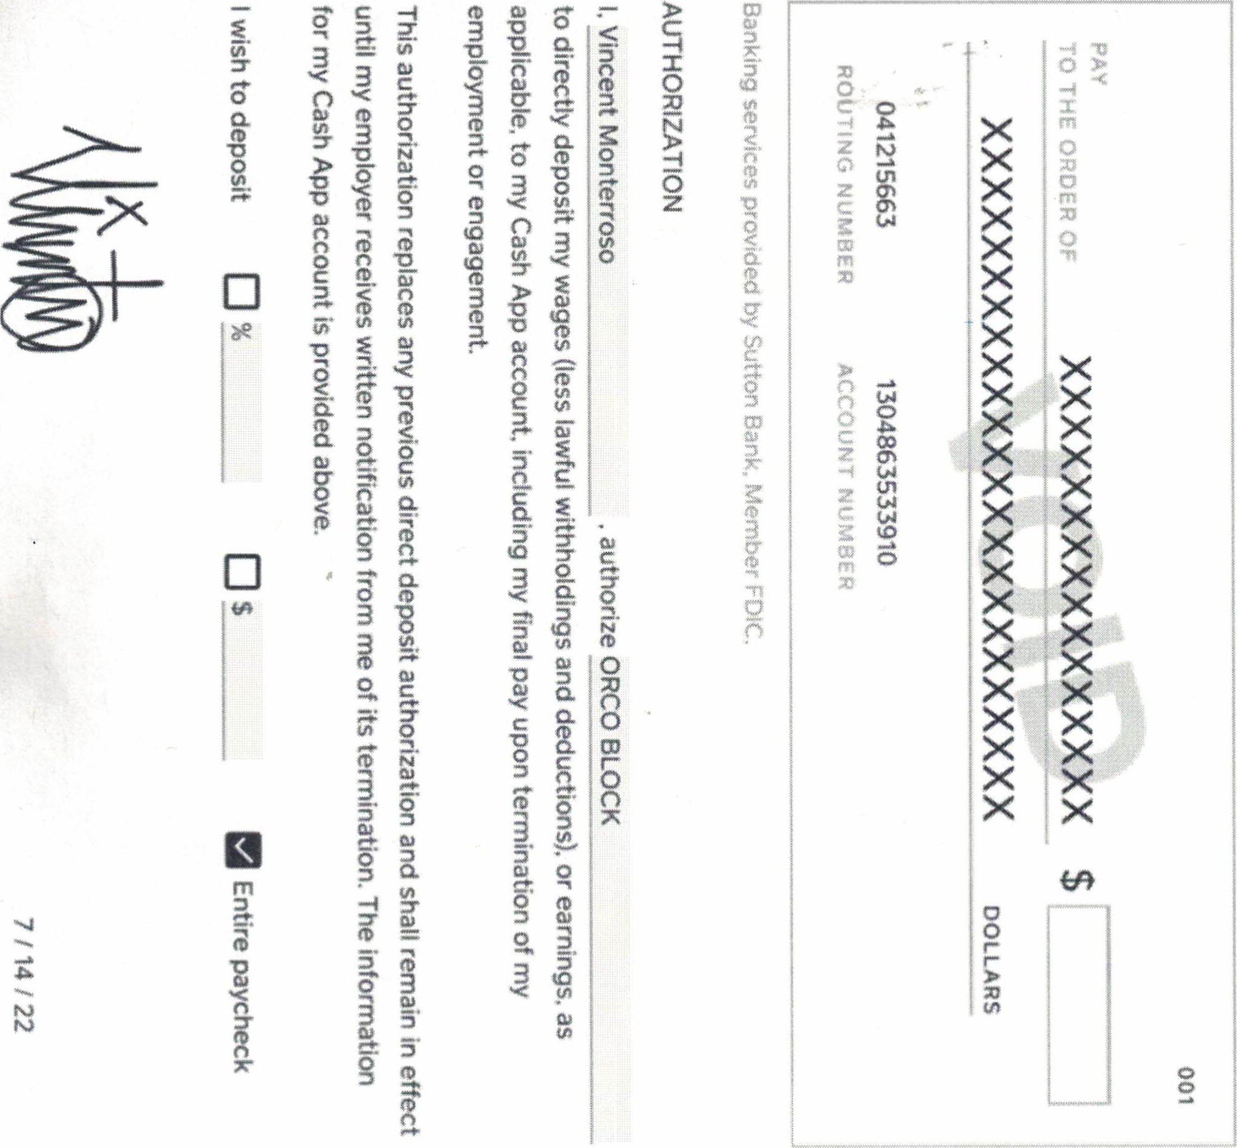

## OUTSOURCING

ErreoveHs Qiscv..rci•ve

|  |  |  |
| --- | --- | --- |
| AUTO |  | PAYROLL DEPOSIT |

Company: EMPLOYMENT SOLUTIONS,

I authorize my employer to deposit my wages/saiary into the bank accounts specified below.G agree that direct deposit transactions J authorize comply with all applicabie law. My signature below indicates that agreeing that I am either the accountholder or have the authorityto authorize my employer to make direct deposits into the named account. Thi; form along with proper documentation MUST be complete in order to process.

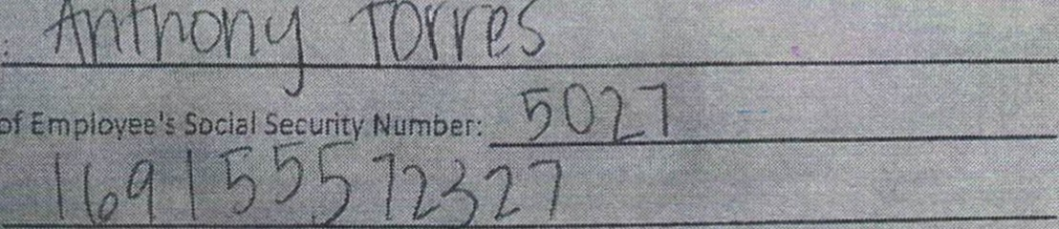

•j

Last4

digits

of

s

print

Employee

Name;

Bankin

information:•

'(Circle one orenter amount: Full Amoun Percentage % Flat Amount g

One of the following is required to process this enrollment

Voided check with name imprinted (no starter checks)

Deposit slip (only accepted tf the verbiage "ACH R/V appears before the routing number)

C) Bank letter or specffication sheet (the signature of your locat bank representative MUST be included)

D {C&Cf

Effective Date;

Employee Signatur

Authorjzed Signature.'

Date:

|  |
| --- |
| REQUIRED: PLEASE PLACE YOUR CANCELLED CHECK WITH YOUR  PRINTED NAME HERE.v  IF you DO NOT HAVE CHÉCKS FOR THIS ACCOUNT,FLEASE AITACH A copy OF ANYONE OFjHE ACCEPTABLE DOCUMENTS LISTED ABOVE, |
|  |

# chime



(844) 2446363 support@chimecorn

|  |  |  |
| --- | --- | --- |
|  | Ant,hony Torres  The Bancorp Bank |  |
| A3&ess | S Old Village PI, Sioux Falls. SD 57108 |  |
| Roueng | 031101279 |  |
| Account Nunber:  Amount | 169155572327 |  |
| Deposit my entire paycheck.. Deposit s of my | | Deposit % Of my |

## Direct Deposit Enrollment Form



paycheck paycheck.

Voided Check

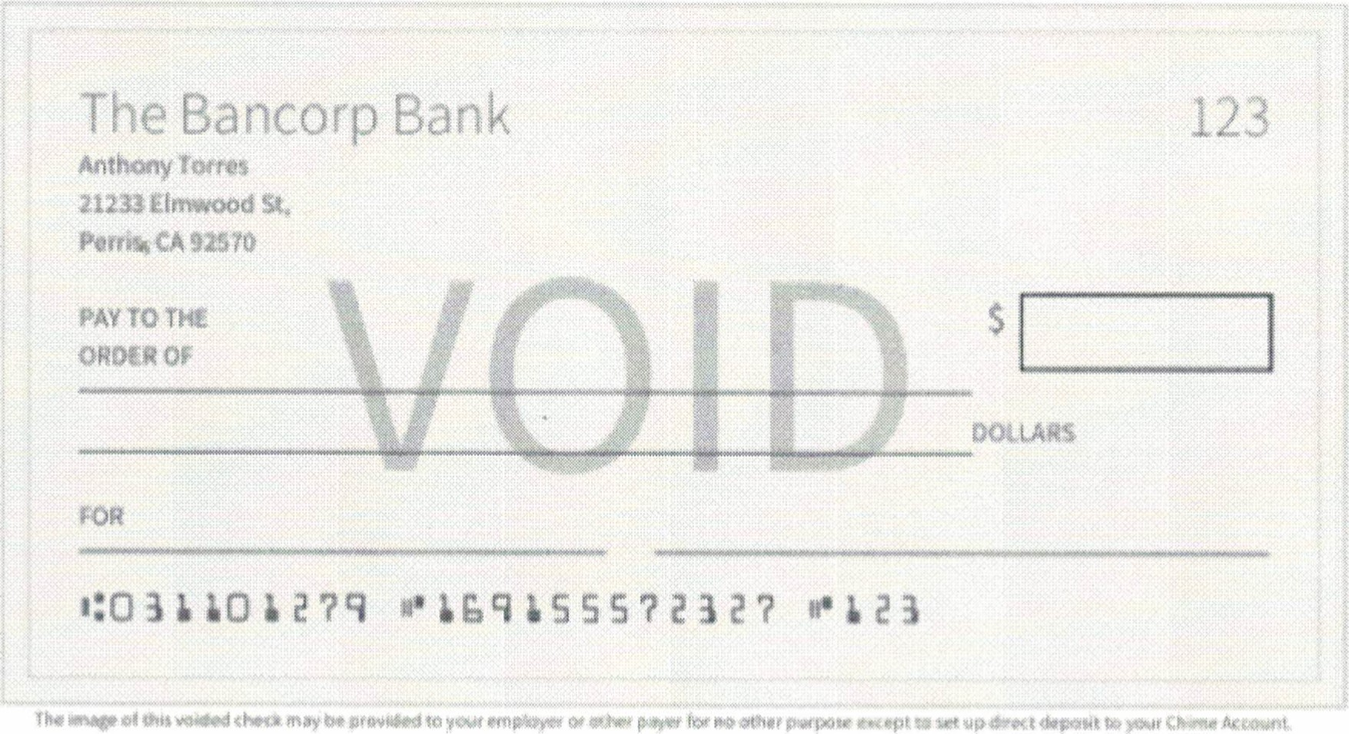

Authorization

I authorize my employer/payer to initiate credit entries. and* if necessary to initiate any debit entries to correct previous credst errors, to my Chime Checking Account This authority will remain in effect until notify my employec or other payer in Miting or as otherwise specified by my employer Of payee

 2022005

Signature Date