**MIS Report Project SOP**

**Database Installation**

**Database Restoration**

1. Restore the BACPAC File in Local Database

2. Right click on databases->select Import Data-tier Application

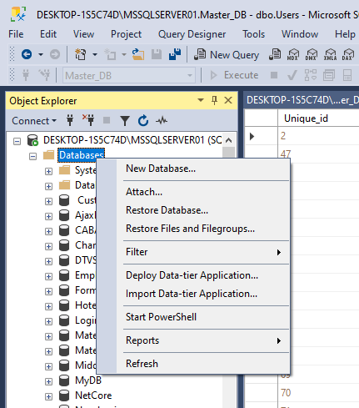

3. After Selected >>> Shown This Page

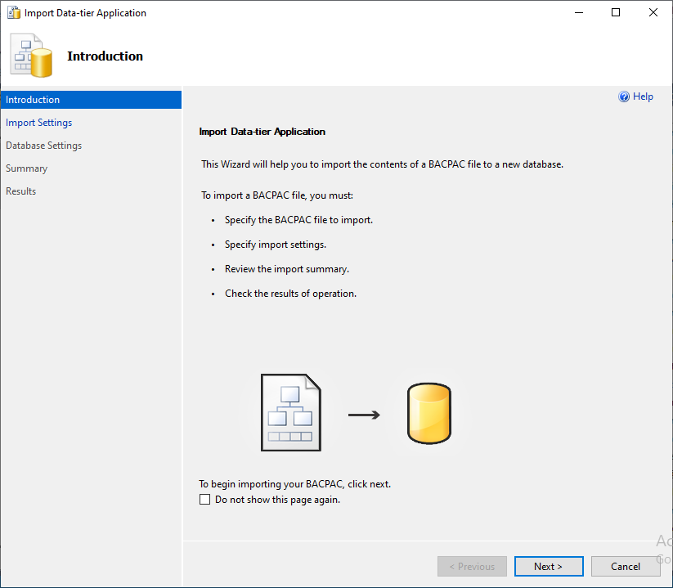

4. Click Next>>> Shown This Page

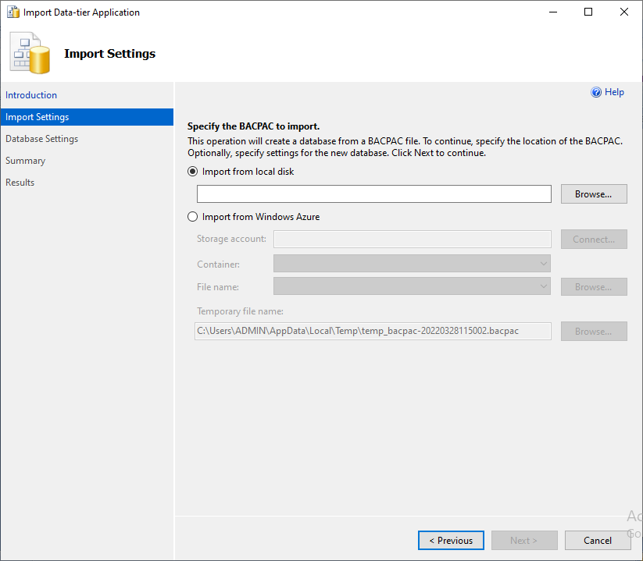

5. Click the Browser >>>find the bacpac.file location

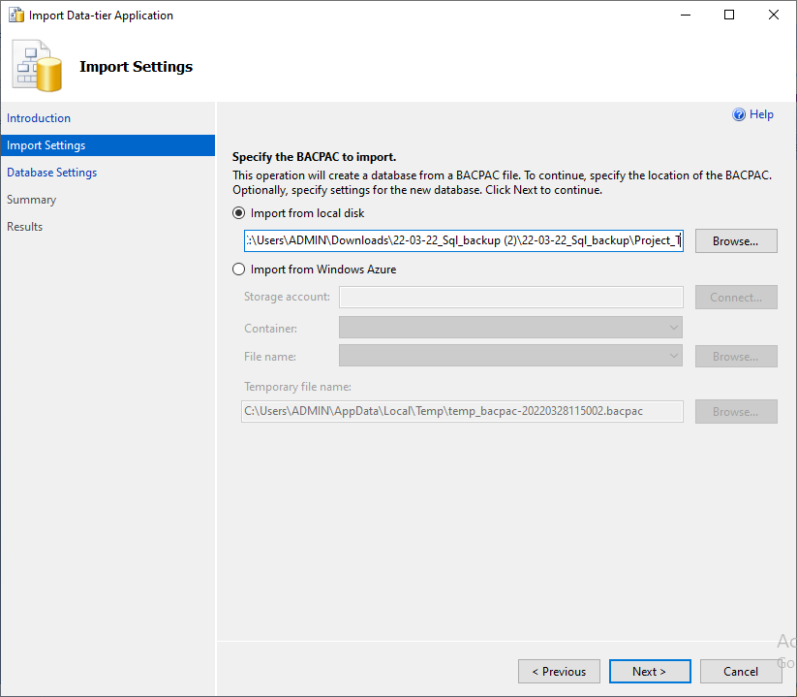

Click next >>> Database Settings page

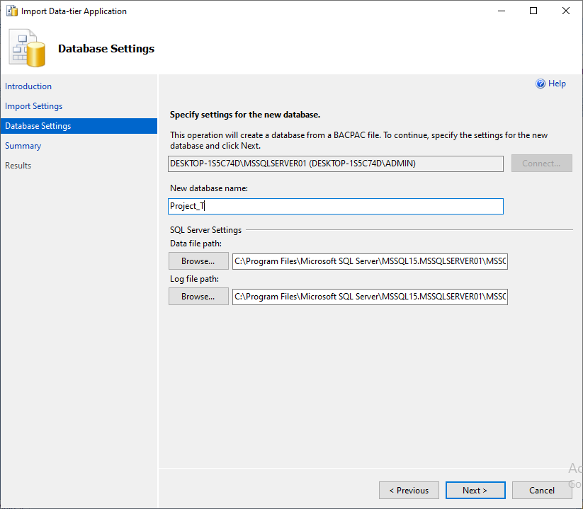

Note: If you want change the database name, enter the name in New Database Name text box

6. Finally click the finish button to restore the database in local database or cloud

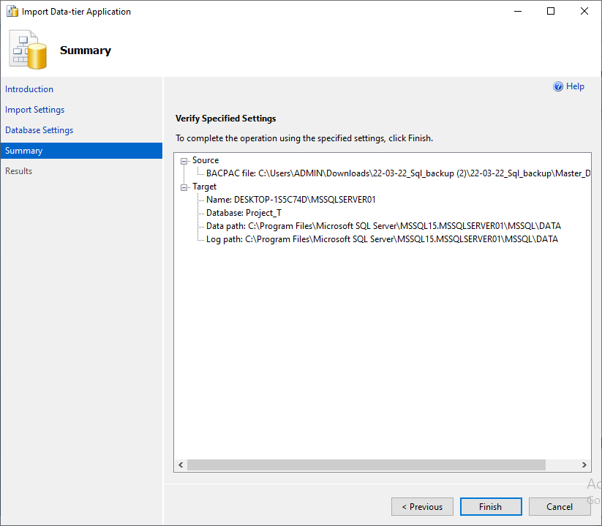

**Create New Database and Apply the Script**

1. Click Right Click in Database >>> selected the New Database

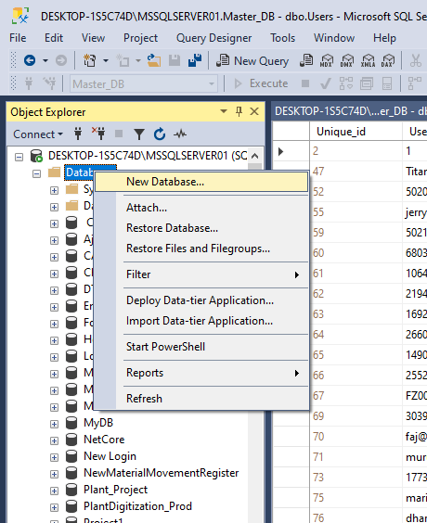

After Selected >>> Shown this Page

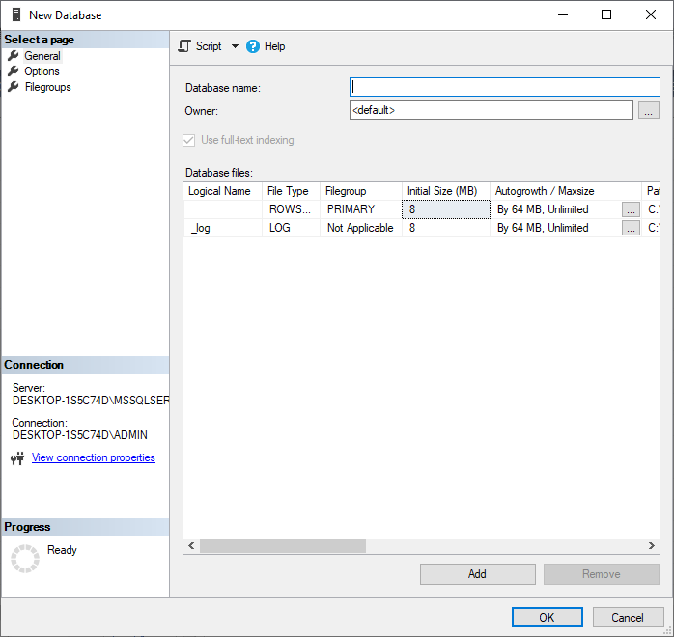

1. Enter the database name and click ok

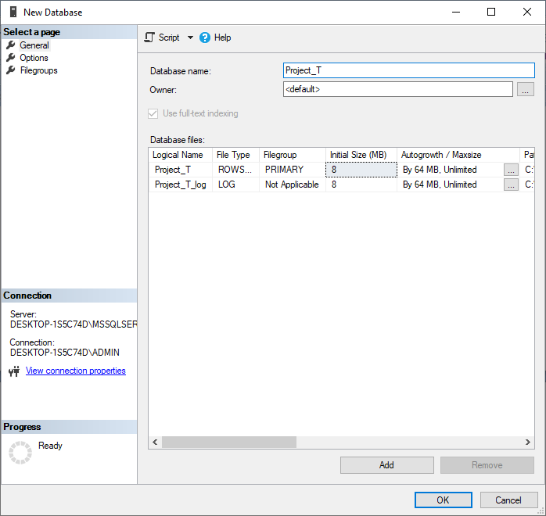

3. After creation database, Right click on database and select new query window

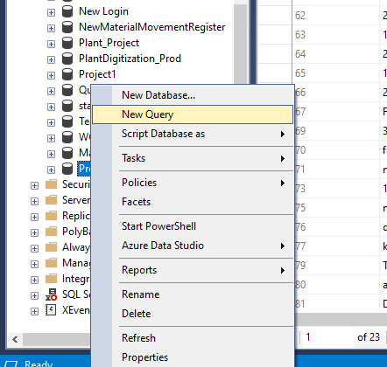

1. In case if you add script in existing database, selected Project_T>>>Programmability>>> store procedure

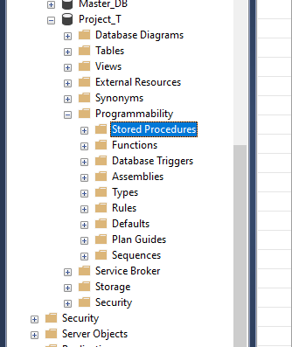

1. Then add script query what you want in the store procedure

Note: SP_NAME: sp_Project_T_MIS_Report

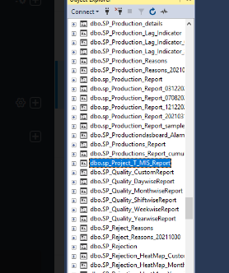

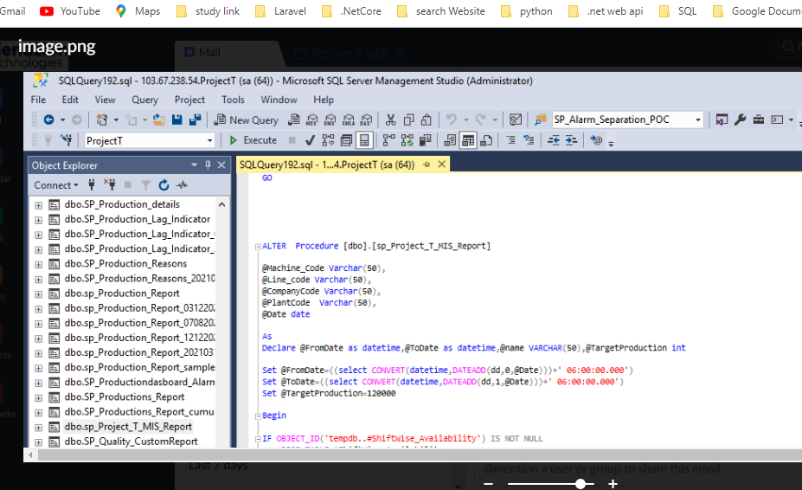

**Create the New Functionality & Update All Station**

1. if you want add new function or update function >>> select the program.cs

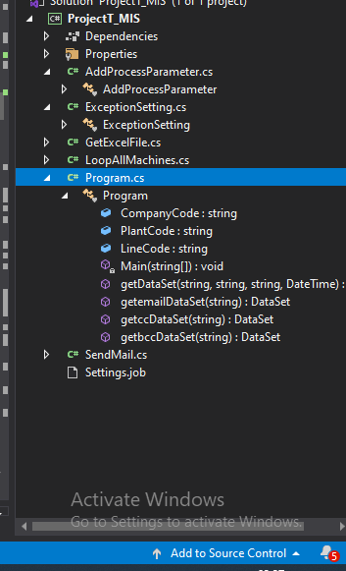

1. Then, add the table data and data script query using this file

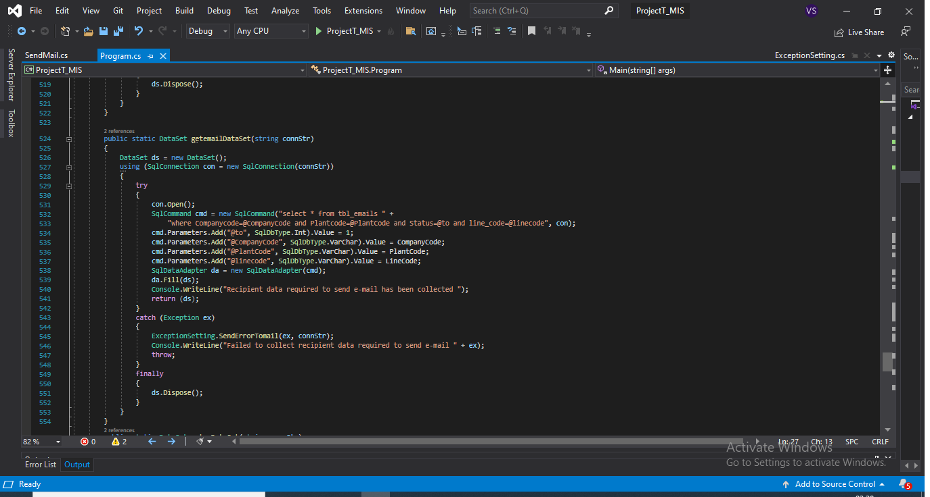

1. If you want change Process Parameter Template Sheet >>> Select the AddProcessParameter.cs file in project Application folder

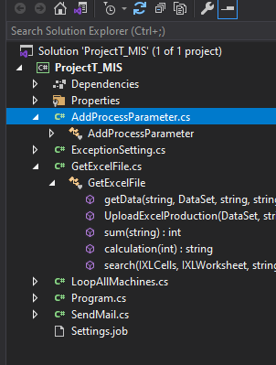

1. And apply the script logic here

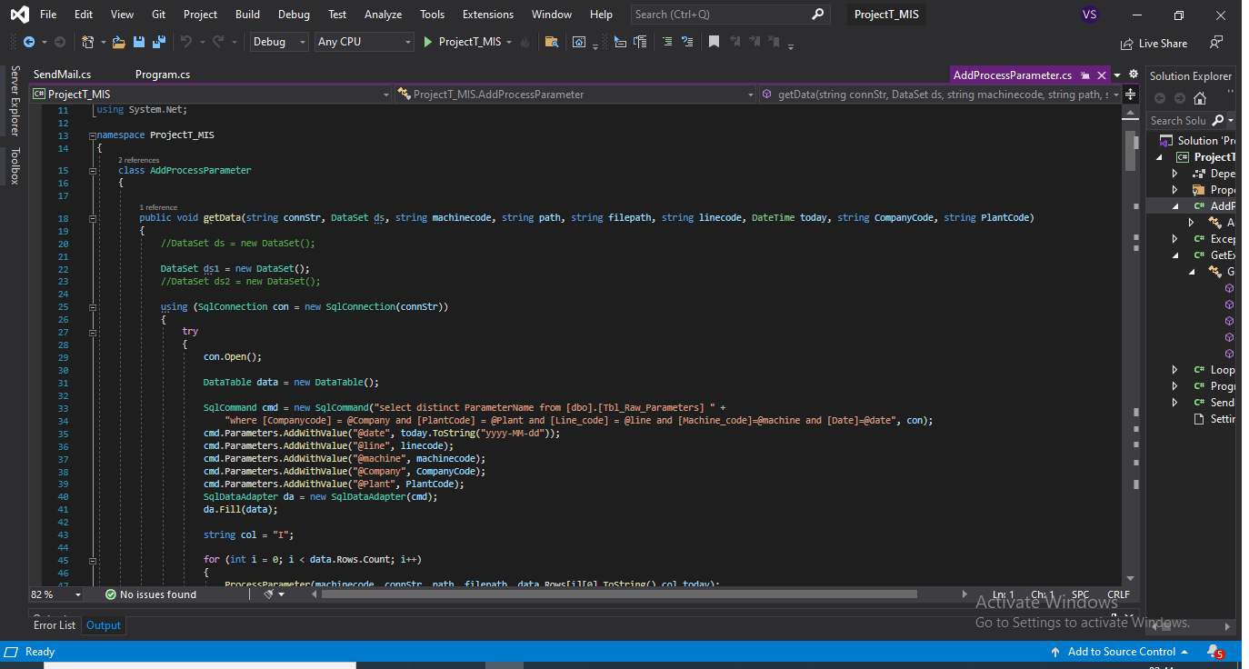

**Connect the Database configuration in Project Application**

**Database config Setup:**

1. Create the ProjectT_MIS Application
2. ProjectT_MIS>>>click the Program.cs file
3. Configure database connection string accordingly

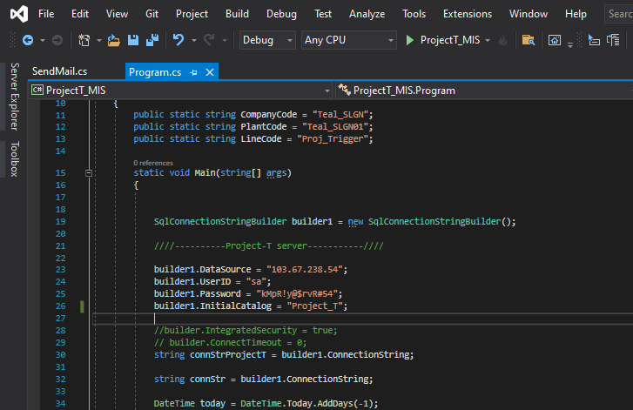

**Send Mail Setup file**

**Note:** If you what change send email configuration and setup >>> select the SendMail.cs file

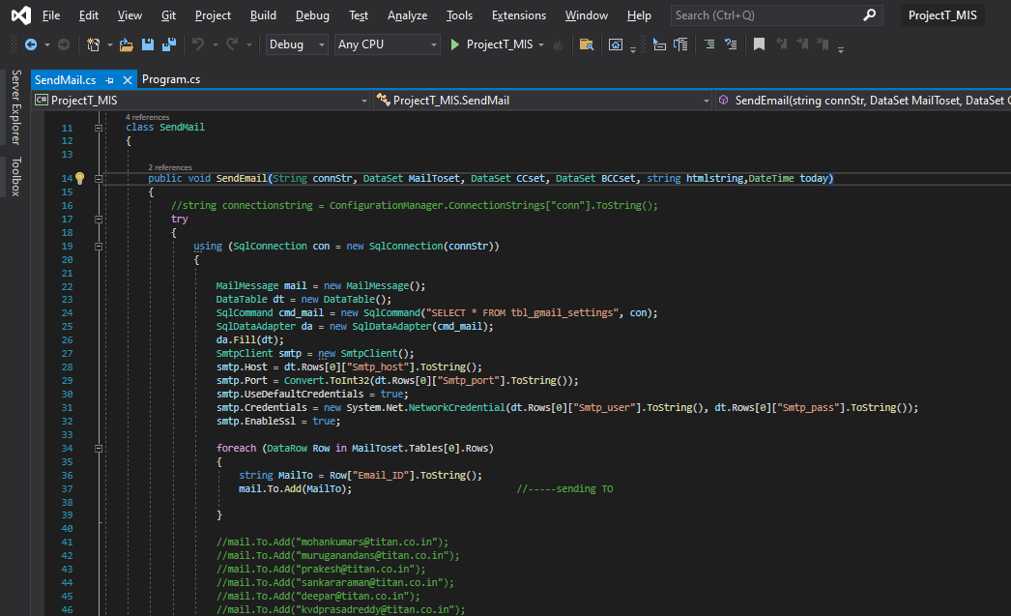

**Template file**

**Create or Update the Template**

1. if you want create or update the template file find the template file in Project_T folder and

**Path:** C:\Users\ADMIN\ProjectT_MIS\bin\Debug\netcoreapp3.1\Template

Then create or update the template file here

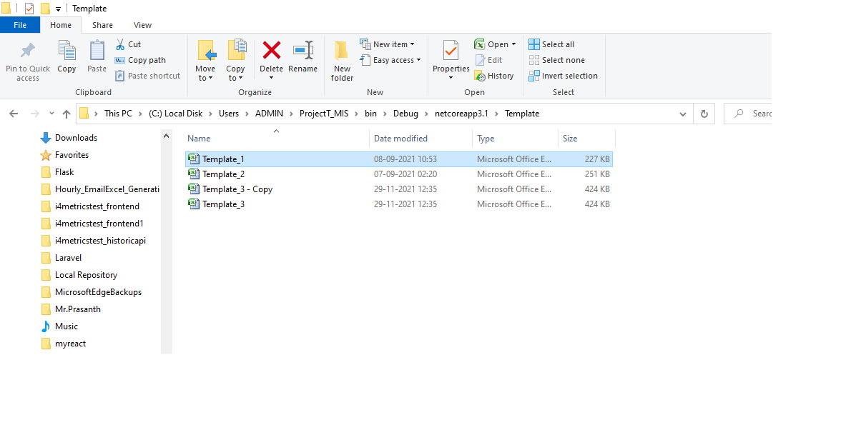

After click template >>> Shown this page

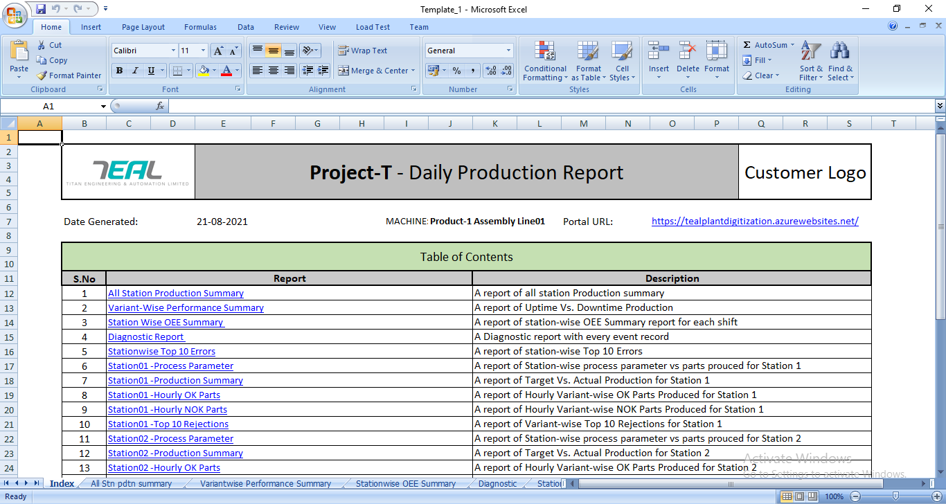

1. If you want create sheet in template file >>>click the insert worksheet or (Shift+F11) in sheet bottom side

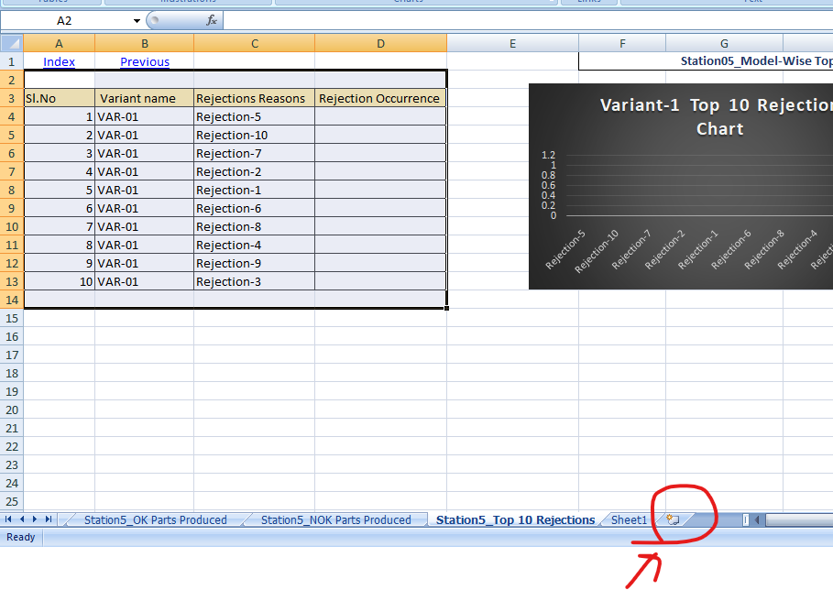

View of new sheet

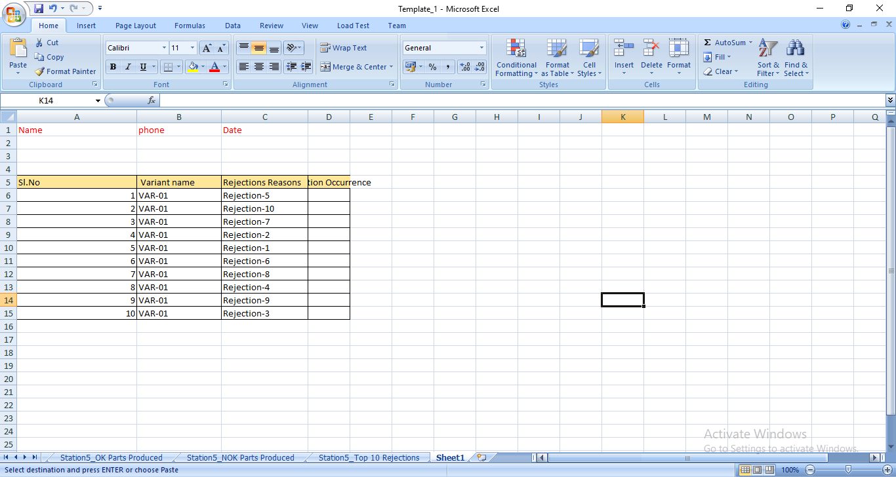

1. Then, Go to index page and create the hyper link for sheet1

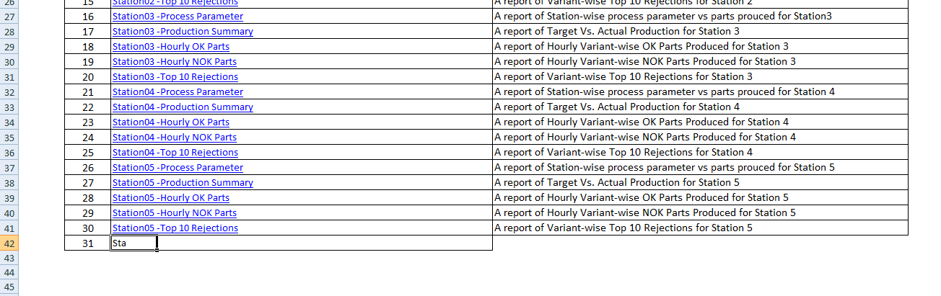

1. After Created the Report Name ,just select it

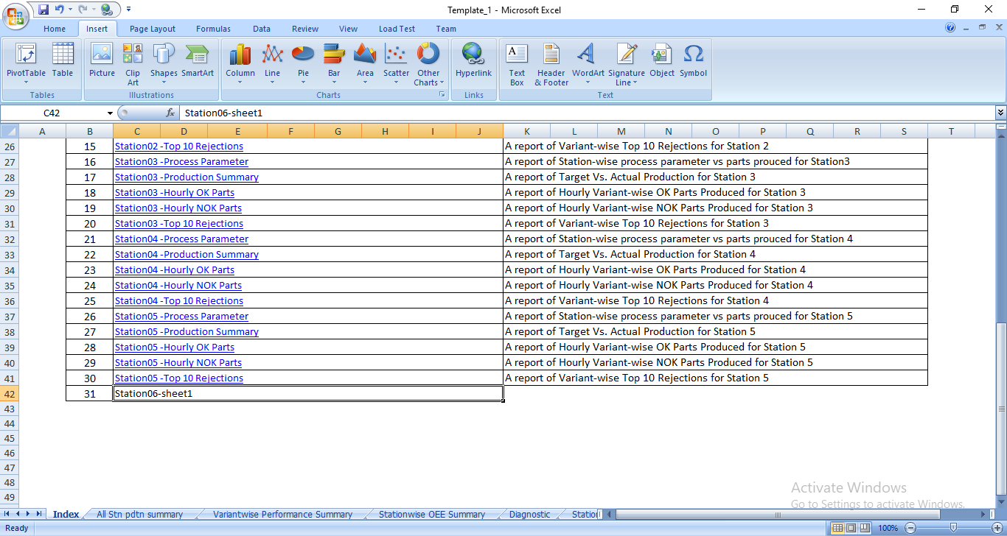

1. Then, Top side bar choose the insert option and click the hyper link

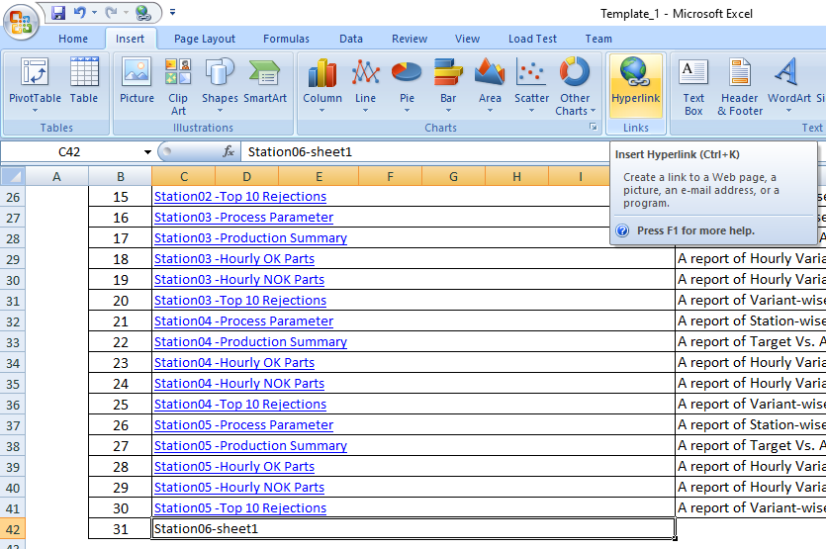

1. After clicked the hyper link >>shown this page

After that, Select the place in this Document option>>> find and select the sheet file>>click ok

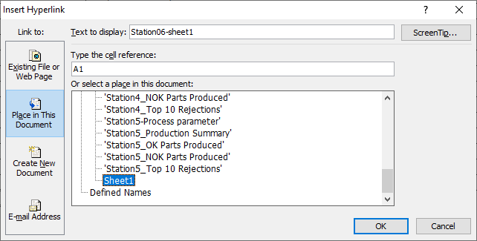

7. Finally create the hyper link file in index page

8. Then, click the link, it goes to sheet 1 page

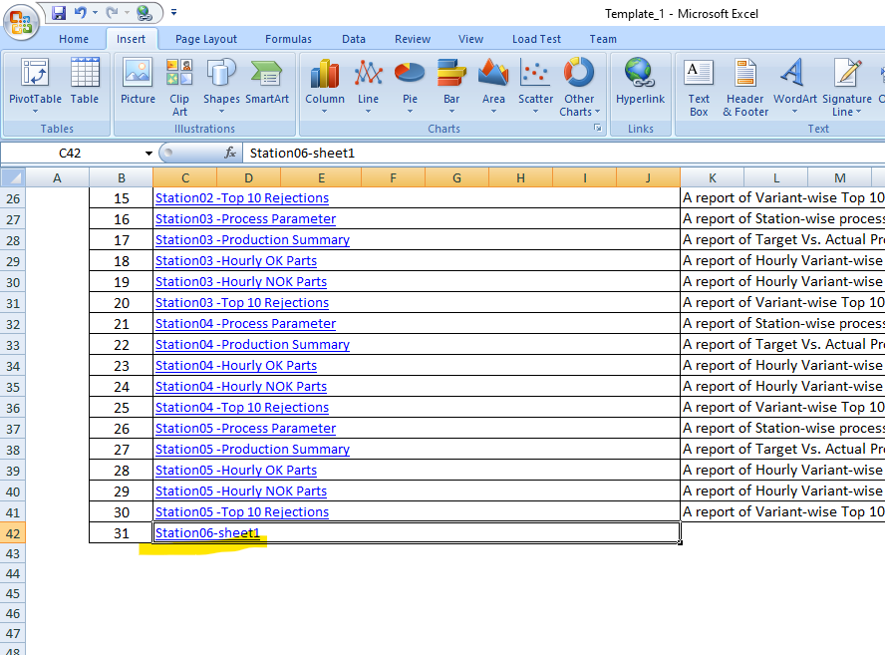

**Output sheet file**

1. If you want check the output file find the ExcelFiles Folder in project Application folder

**Path**: C:\Users\ADMIN\ProjectT_MIS\bin\Debug\netcoreapp3.1\ExcelFiles

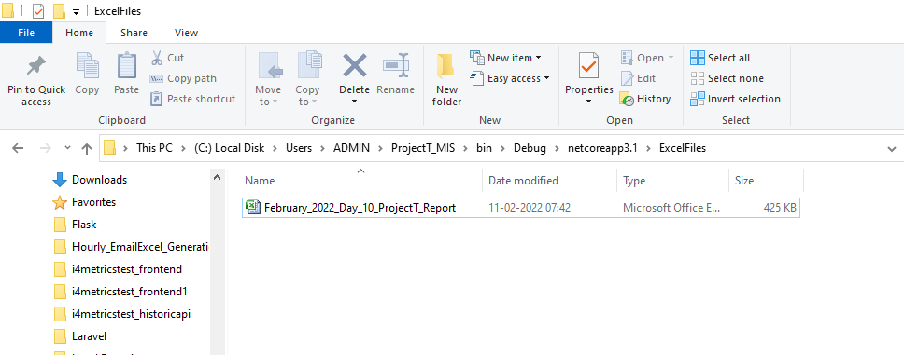

Output file View

