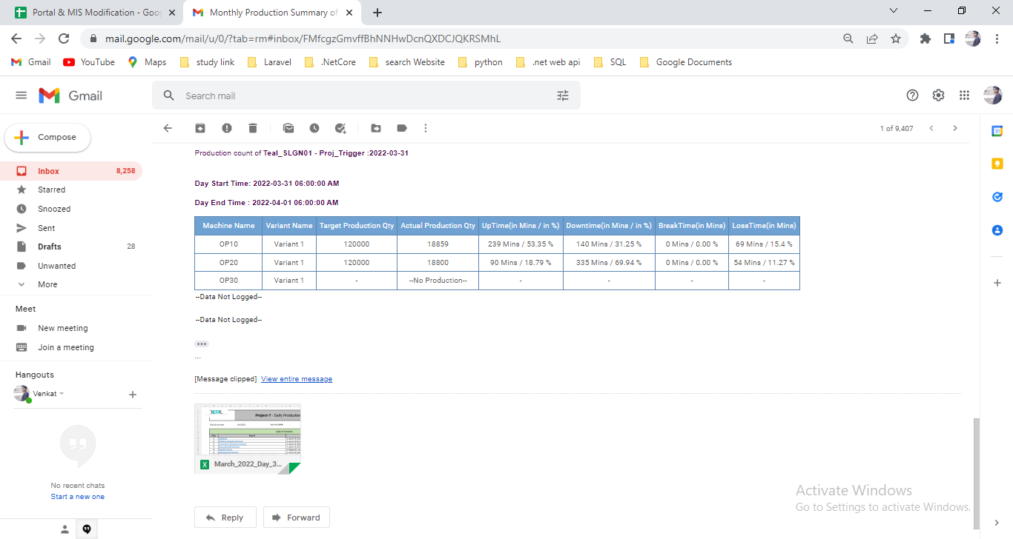

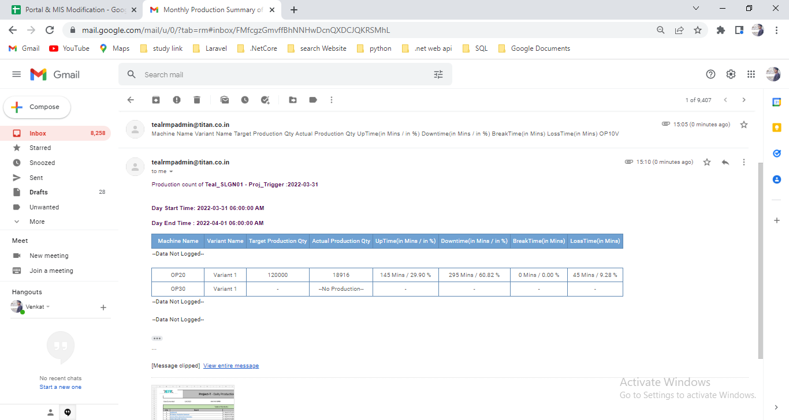

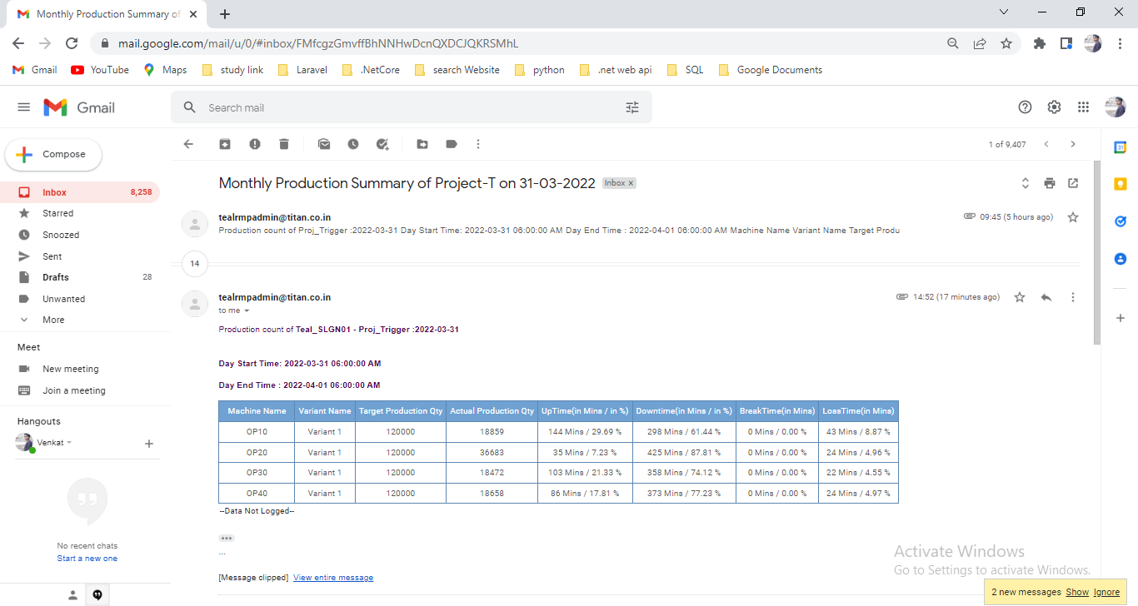

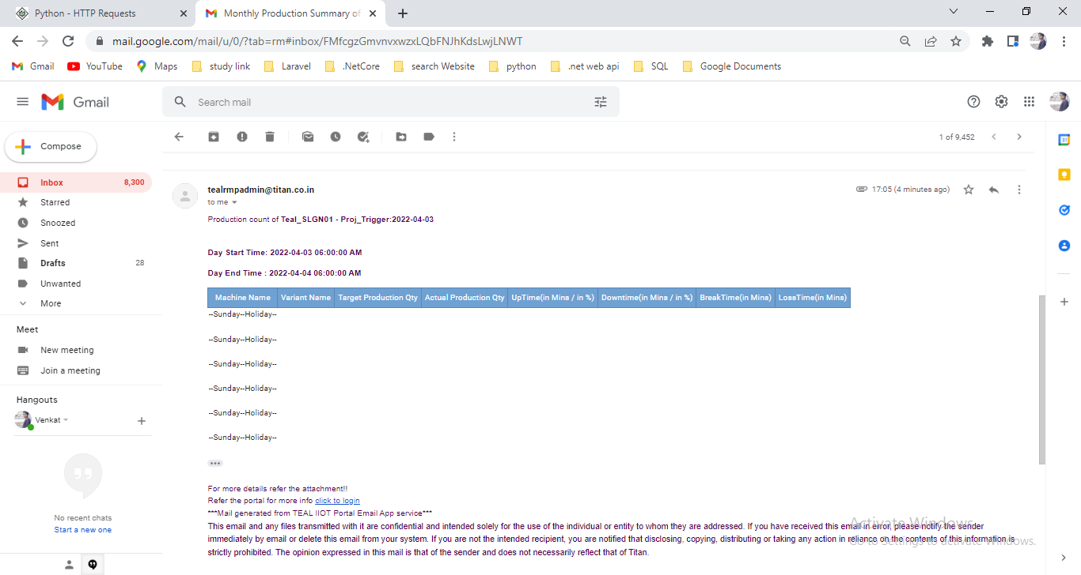

Correction in database

1. Interchanged column name loss time and break time in tbl_hourly_tracker_new
2. Added the batch code column in sp part -sp_Project_T_MIS_Report for hourly tracker

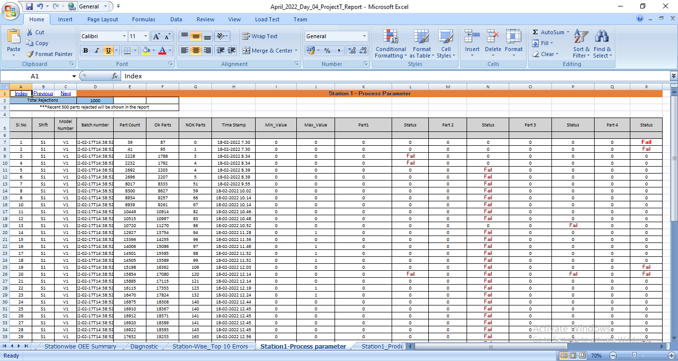

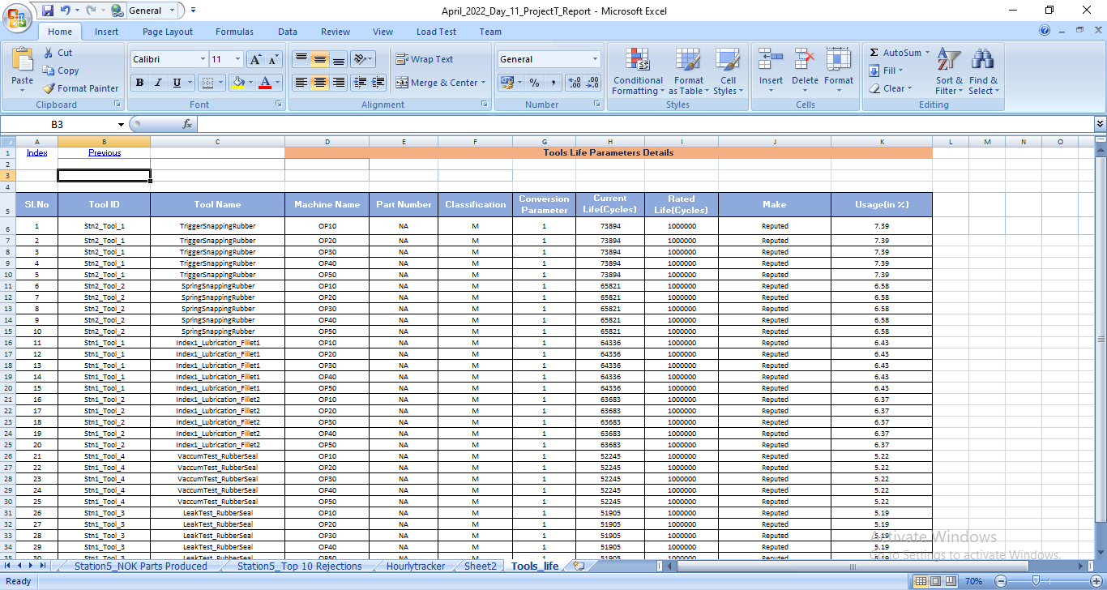

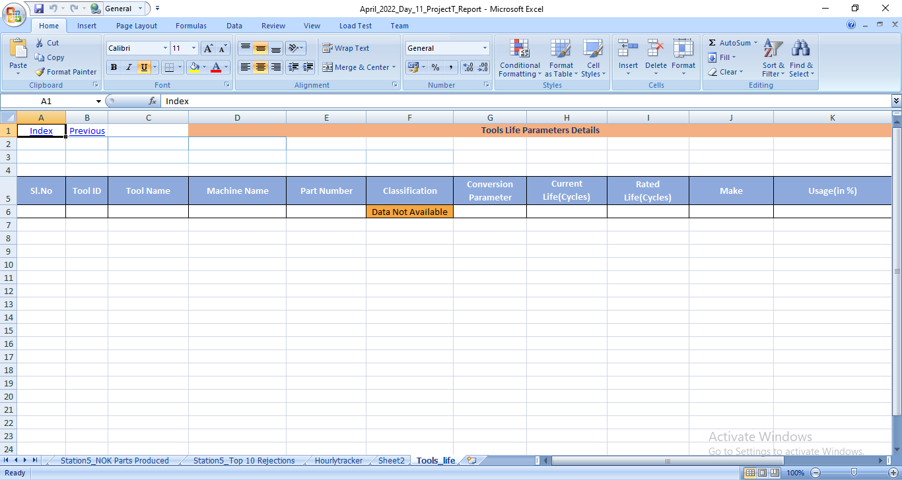

1. Shiftwise coloum to be added - station Top 10 Rejections-sheet -- pending
2. Hour to be change – 12Am-1Am -- done
3. Variantwise _performance_summary – production shown if condition based 0/value -- done

Sendmail.cs -> 36 – added the holiday select query

Sendmail.cs ->111--- added the condition for check the holiday

Program.cs -> 115 – change the message body pattern for holiday reason

