**Raw table:**

1. Provided feedback to add date selection and date validation (from and to date should not less than from date)

2. Limitation field, text can't be typed.

**Result:**

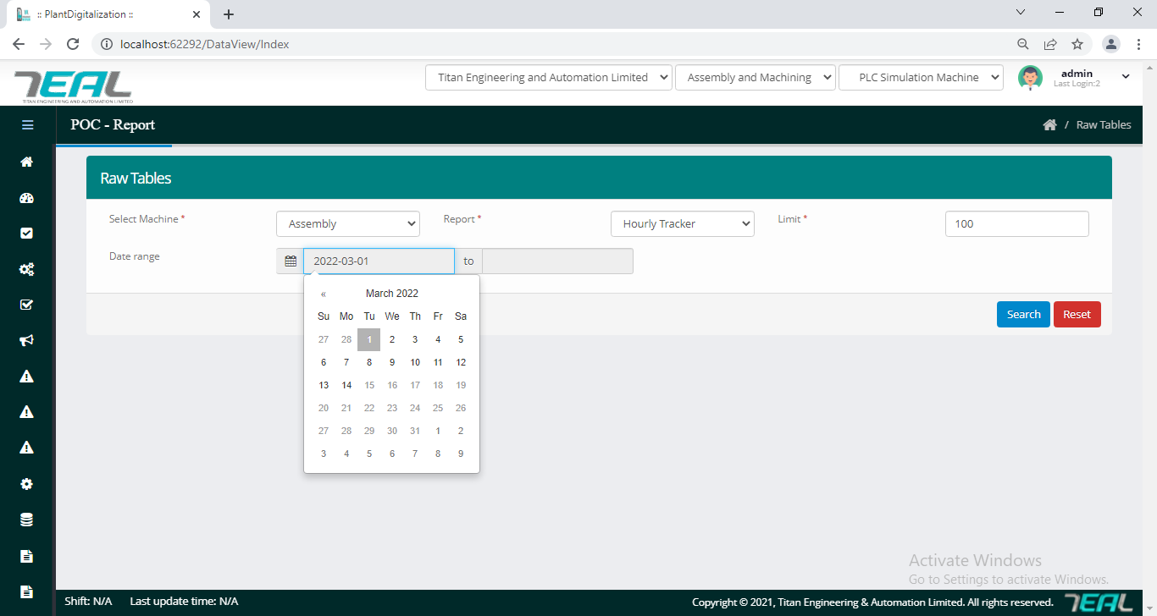

Login: when user selecting To Date is more than from (from Date)

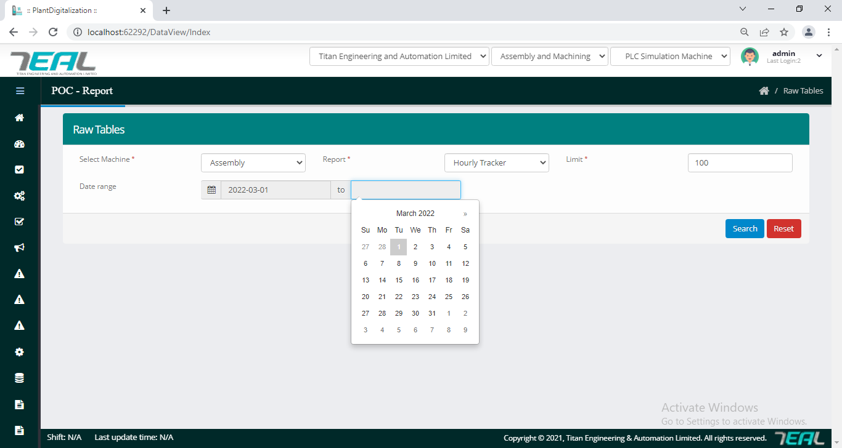

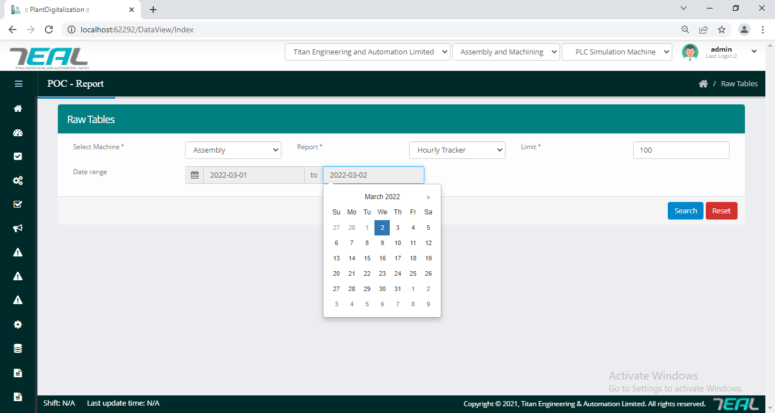

Logic: when user selecting from date is less than from (to date)

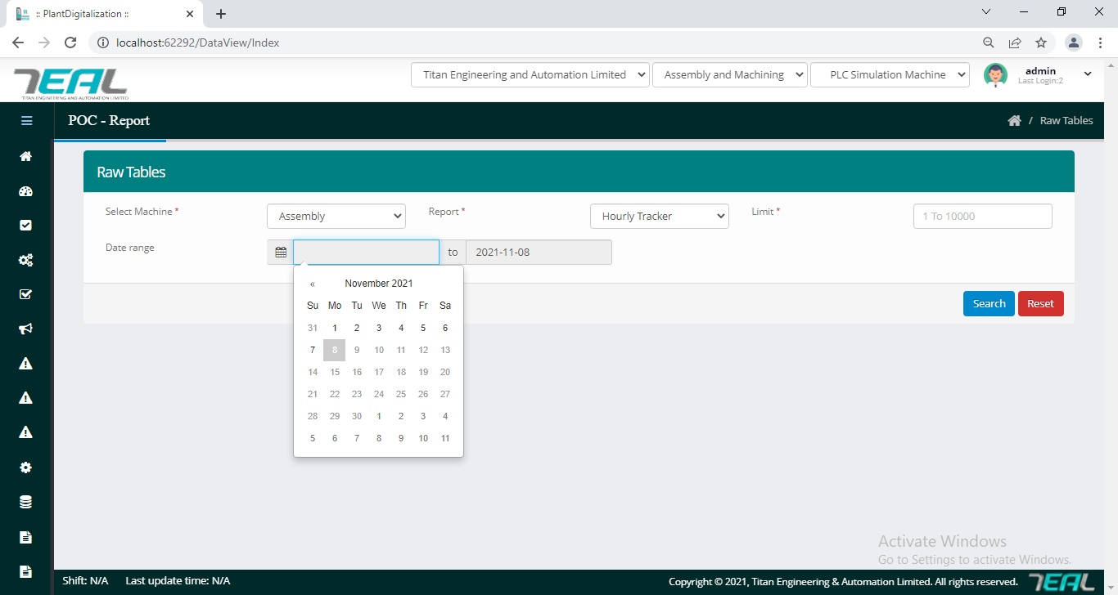

Cycle time raw table date selection:

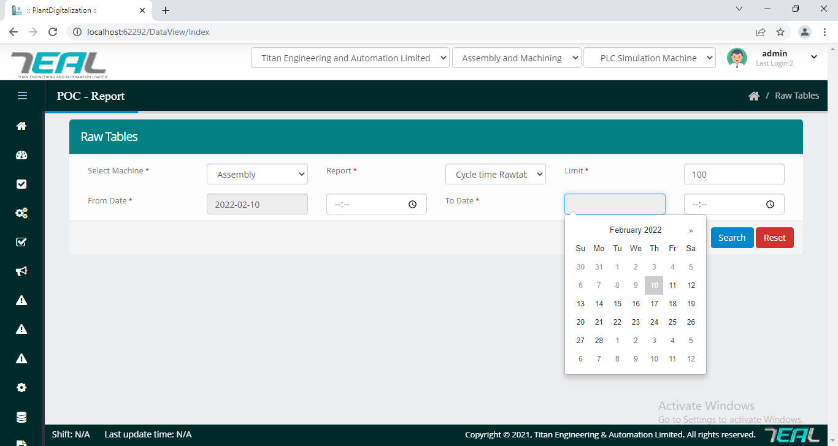

**Alarm Upload:**

1. In Alarm upload functionality, details added successfully message to details uploaded successfully to be changed

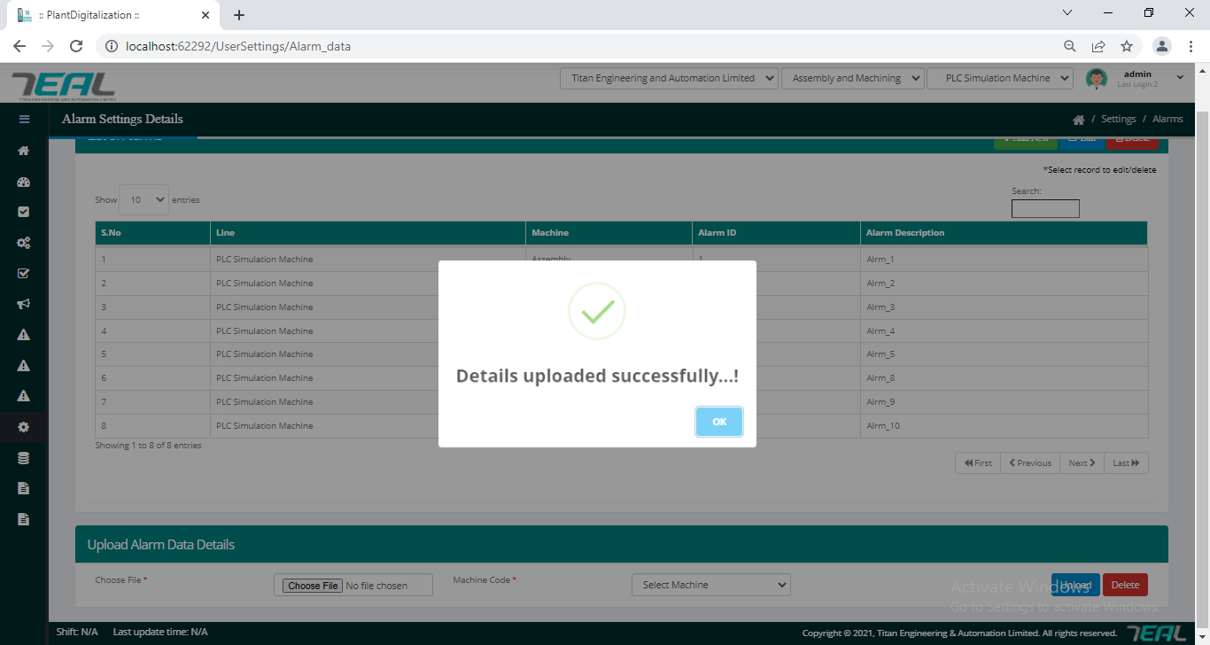

**Alarm Historic:**

1. Screenshot should be taken and added by changing the  Date  when user selecting From date  is more than To date  .Actually it can't be selected

Expected Output:

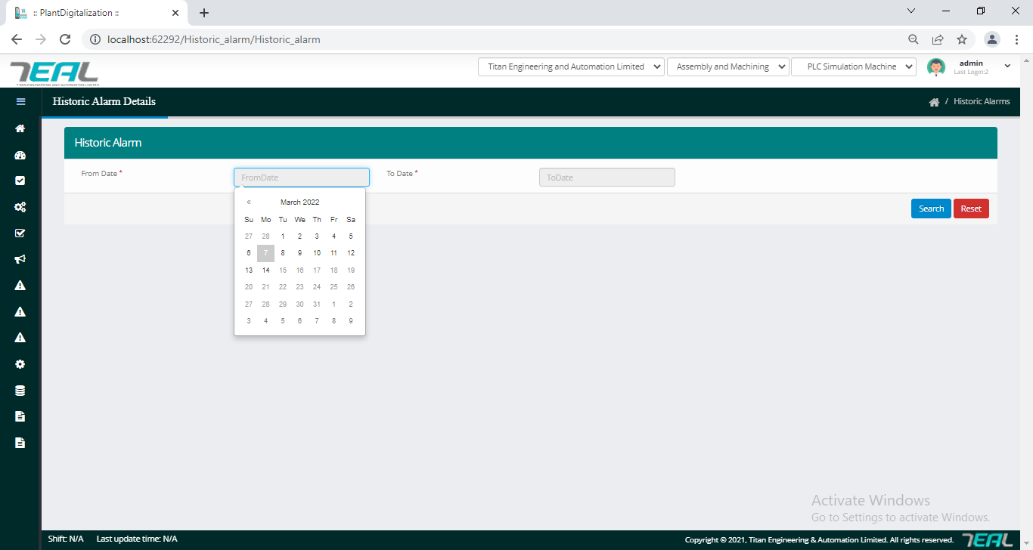

Login: when user selecting To Date is more than from (from Date)

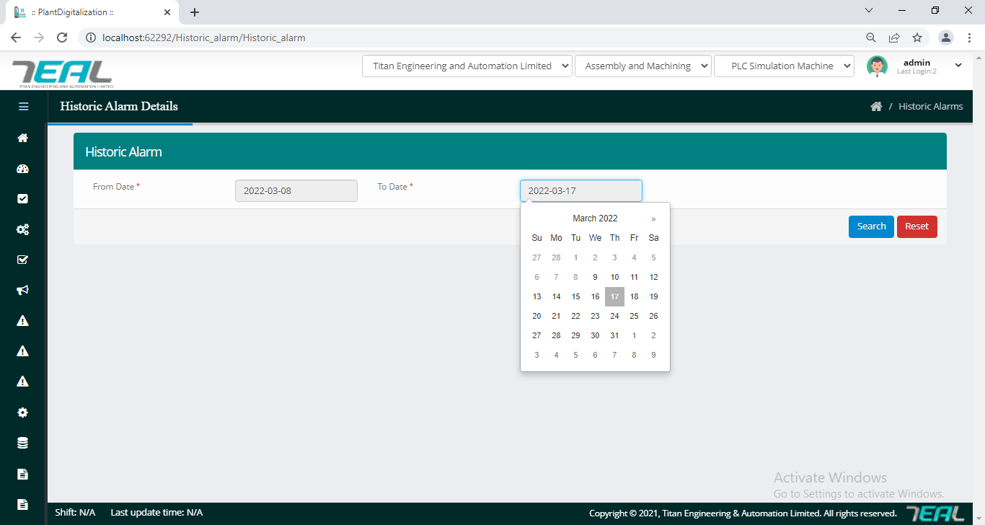

Login_2: when user selecting from date is less than from (To Date)

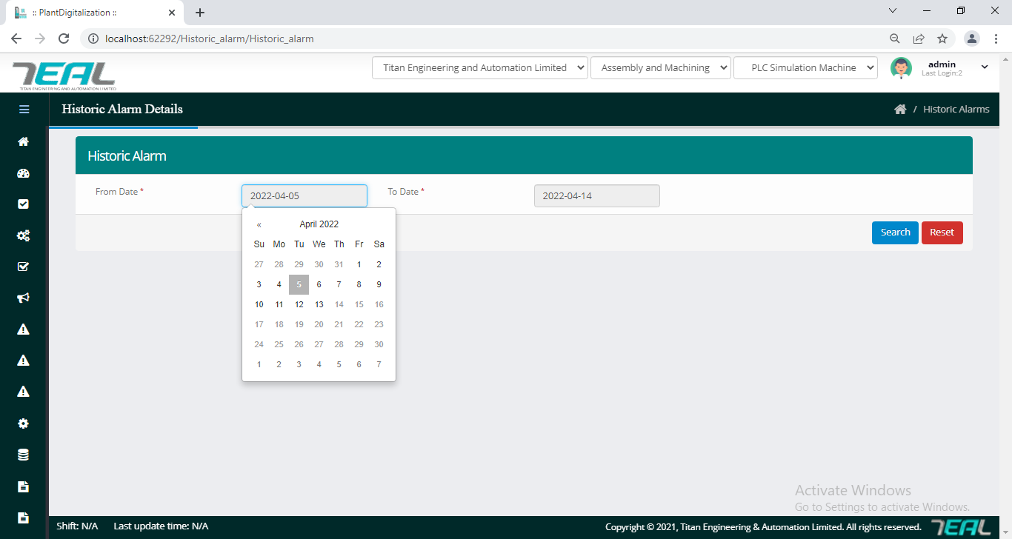

**Raw table:**

1. Additionally check for -ve values entry for value to be 1 to a maximum value decided

**Expected Output:**

