Software Architecture Documentation for

Sphinx

Team Venture

Revision 2: 10/18/13

Main Architecture (see also attached images)

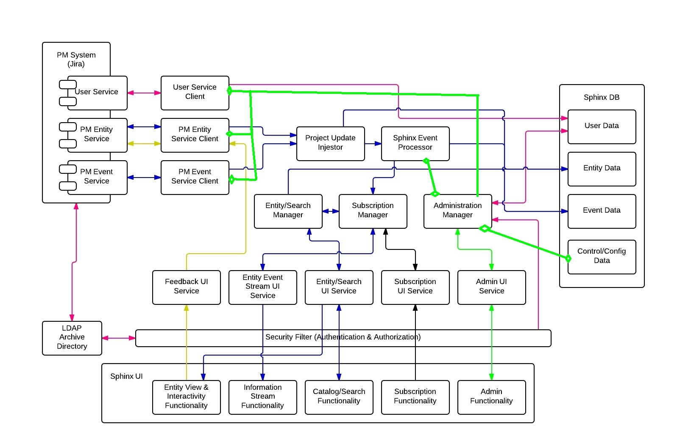

PM System

The responsibility of the PM System is to…
Component | Description
User Service | Service provides information on users
PM Entity Service | Provides information on Entities and accepts votes, watches, and comments for Entities
PM Event Service | Provides Change and Report events about Entities

Sphinx Server

The responsibility of the Sphinx Server is to…
Component | Description
User Service Client | Client to User Service
PM Entity Service Client | Client to PM Entity Service
PM Event Service Client | Client to PM Event Service
Project Update Ingester | Project Update Ingestor accepts PM Entity Data and PM Event data. It collaborates with Sphinx Event Processor to create Sphinx Events. It stores the raw data it receives to the Sphinx DB.
Sphinx Event Processor | Sphinx Event Processor receives PM Events and refines them into Sphinx Events based on configurable rules while maintaining the event’s attachment to its Entity. It stores generated Sphinx events into the Sphinx DB. It collaborates with the Subscription manager to notify it of new events.
Entity / Search Manager | Entity / Search Manager controls the retrieval and search of entities
Subscription Manager | Subscription Manager controls user subscriptions and generates related information streams to users. It collaborates with Entity / Search manager to find entities of interest to a user.
Administration Manager | Manages administrative functions of Sphinx. Collaborates with Sphinx Event Processor to set the configurable Sphinx Event Rules.
Feedback UI Service | UI Service for the UI to communicate votes, watches, and comments. Collaborates with PM Entity Service Client.
Entity Event Stream UI Service | UI Service to send the information streams to the UI
Entity / Search UI Service | UI Service to process entity and search requests from the UI
Subscription UI Service | UI Service to manage subscriptions changes from the UI
Admin UI Service | UI Service to handle administrative requests from the UI
Security Filter | Authenticates users and sets their role upon login. Authorizes activity based on role. Collaborates with external LDAP to authenticate users.

Sphinx DB

The responsibility of the Sphinx DB is to store…
Data Type | Description
User Data | User Profile Data  User Usage Data  User Subscription Data
Entity Data | Initiatives  Milestones  Risks
Event Data | Sphinx Events about Entities
Control / Configuration Data | System Control Data  Administrative Users

Sphinx UI

The responsibility of the Sphinx UI is to…
Component | Description
Entity & View Interactivity | View Entities (Milestones, Initiatives, and Risks)  Vote, Watch, and Comment on Entities  “Learn More” about entities
Information Streams | View Event Streams
Catalog / Search | Search, Filter, and Sort Entities
Subscription | Subscribe to events that satisfy stored queries or specific entities
Administration | Administrative features

Sequence Diagrams

# | Sequence Diagram | Supported Use Case / Requirement
1 | S.1 -- Saving a Query | UC-008
2 | S.2. -- Registering a Vote | UC-004
3 | S.3 – Searching for Initiatives, Milestones, and Risks | UC-002
4 | S.4 – Event Stream on Dashboard | Requirements document section 3.2 Information Feeds

S.1- Saving a Query
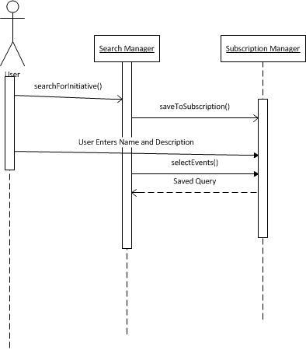

# | Action | Description of Data Flow / Potential Exceptions
1 | searchForInitiaive() | All relevant data types (such as a general search string, ids of various project managers, etc.) are sent to a Search Manager.  A list of Entities is returned and displayed on the page.
2 | saveToSubscription() | The user clicks “Save” which is propagated through the Search Manager to the Subscription Manager
3 | User Enter’s Name and Description | User enters the name and description of the query into a form.
4 | Select Events | User select event types from a multi-select list and clicks “Save”. The information is all saved.
5 | Saved Query | The object holding all of the Saved Query information is returned to the Search Manager for future use.

S.2- Registering a Vote

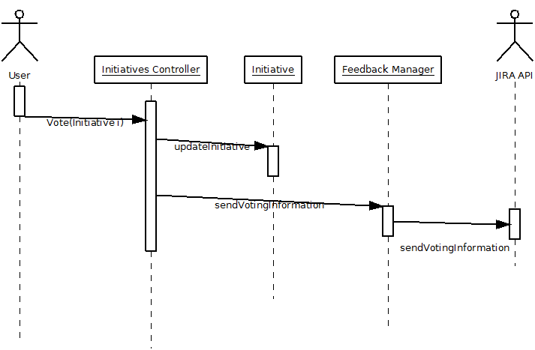

# | Action | Description of Data Flow / Potential Exceptions
1 | Vote (Initiative) | The user clicks the “Vote” button on the entity. The Initiative being voted on is sent as a parameter to the Initiatives Controller as part of the “Vote” method.
2 | updateInitiative | The Initiatives Controller updates the initiative's vote registry.
3 | sendVotingInformation | The Initiatives Controller sends information (likely the initiative id and the user's username/id) to the Feedback Manager
4 | sendVotingInformation | The Feedback Manager sends information regarding voting back to the JIRA API via JSON or some other protocol.

S.3 - Searching for Initiatives, Milestones, and Risks
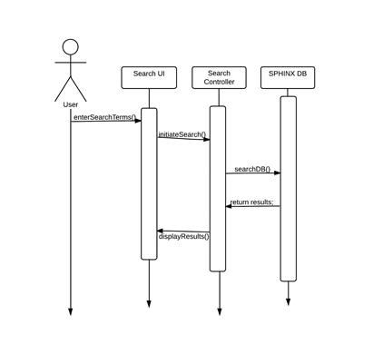
# | Action | Description of Data Flow / Potential Exceptions
1 | enterSearchTerms | User selects various facets to search by.
2 | initiateSearch | The selected search criteria are passed to a search controller
3 | searchDB | The search controller uses the passed in criteria to find all matching entities in the database.
4 | return Results | A cursor of DBObjects is returned to the search controller.
5 | displayResults | The search controller sends the list of results to the templated view where it is rendered for the user to see.

S.4 Event Stream on Dashboard
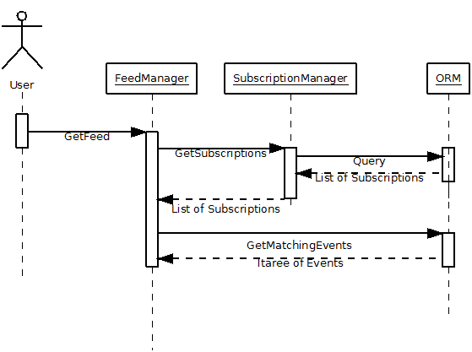
# | Action | Description of Data Flow / Potential Exceptions
1 | GetFeed | Queries the FeedManager for the user's feeds. Transmits the user's username to the FeedManager
2 | GetSubscriptions | Queries the SubscriptionManager for the user's subscriptions. Transmits the user's username to the SubscriptionManager
3 | Query | Queries the database via an ORM or other database access mechanism for all subscriptions for the user.
4 | List of Subscriptions | A list of all the user's subscriptions is returned.
5 | GetMatchingEvents | Queries the database via an ORM or other database access mechanism for all events the user is subscribed to.
6 | ItareeOfEvents | Returns an Iterator or Iteraee of events for the feed to iterate over.

Wireframes

# | Wireframe | Supported Use Case/Requirement
1 | W.1 - Dashboard | Requirements document section 3.2
2 | W.2 - Search / Catalog | UC002, UC007
3 | W.3 - Manage Subscriptions | Requirements document section 3.5
4 | W.4 - Review Saved Searches | Requirements document section 3.5, UC008
5 | W.5 - View Entity (Initiative, Milestone, Risk) | UC004, UC003
6 | W.6 - Admin Tools | Requirements document section 3.6, UC005
7 | W.7 - User Profile Page

W.1 – Dashboard

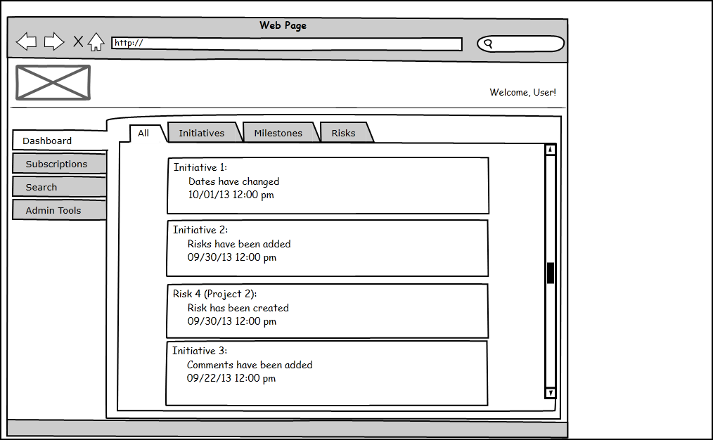

Main Elements

# | Screen Element | Description
1 | Sidebar menu | The sidebar menu will be the main method of navigation through the site. Clicking on each of the tabs in the sidebar will link to a different page.
2 | Entity Tabs | Entity Tabs exist for the purpose of filtering the feed eg. The Initiatives tab would show only initiatives.
3. | Event Details | The event detail boxes will show update events for subscribed entities. They will also have “quick links” to view more information about the element, vote, subscribe, and watch.
4 | Quick Search Box (upper right corner) | In the wireframes, unless otherwise noted, this represents the browser's search bar and not an aspect of the web page.
5 | User Profile Link | Will link to a basic profile page with options to change basic profile information.(W.7)

W.2 - Search / Catalog
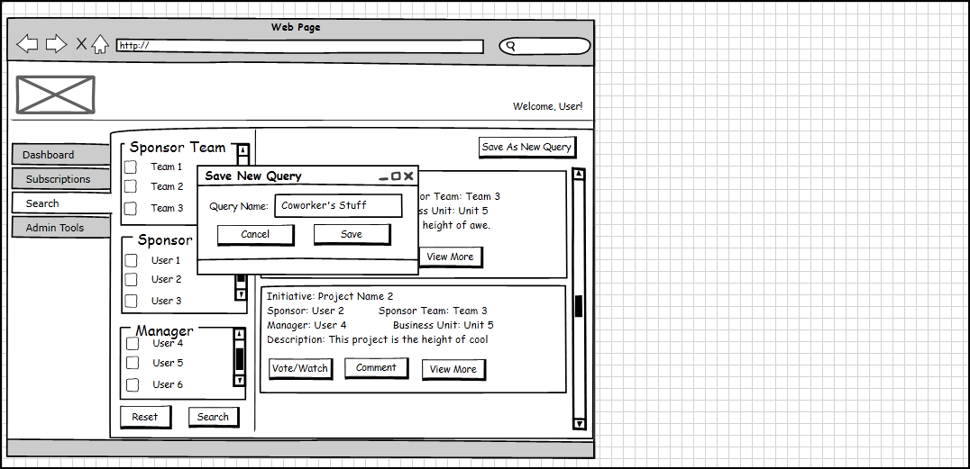

Main Elements

# | Screen Element | Description
1 | Sidebar Menu | The sidebar menu will be the main method of navigation through the site. Clicking on each of the tabs in the sidebar will link to a different page.
2 | Quick Search Box (upper right corner) | In the wireframes, unless otherwise noted, this represents the browser's search bar and not an aspect of the web page.
3. | User Profile Link | Will link to a basic profile page with options to change basic profile information.(W.7)
4 | Search Facets | The Search Facets will be selectable lists with criteria for searching over entities.
5 | Reset Button | Clears all selections in the search facets.
6 | Search Button | Searches for all entities that match the search criteria.
7 | Save as New Query Button | Pops up the “Save New Query” window so that the search criteria can be saved for the user.
8 | Save Button | Saves the search criteria as a saved query.
9 | Cancel Button | Cancels the saving of the saved query.

W.3 - Manage Subscriptions

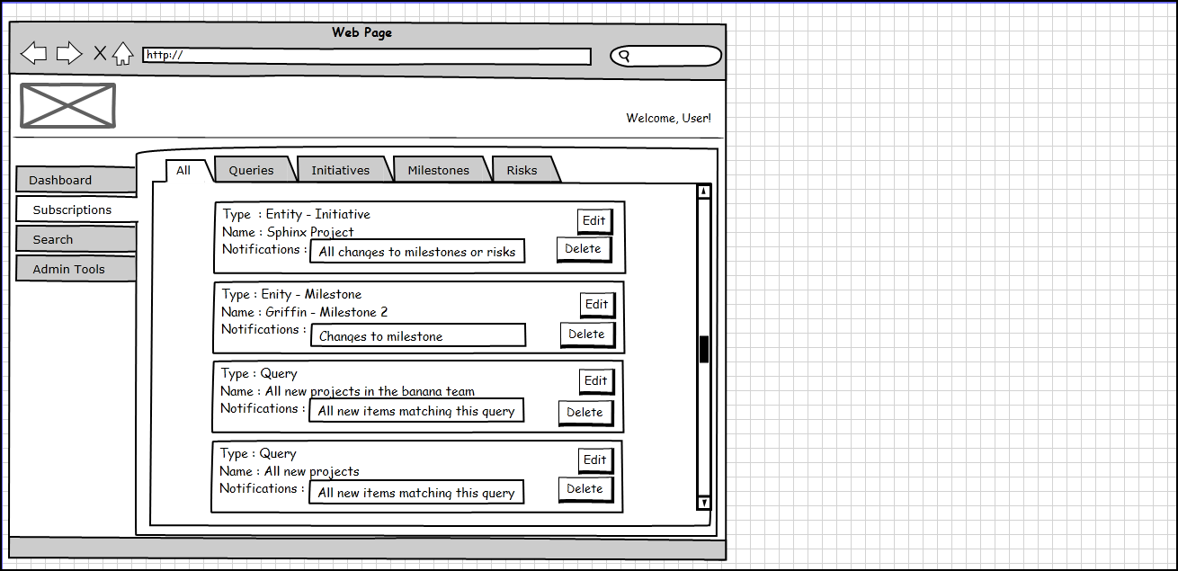

Main Elements

# | Screen Element | Description
1 | Sidebar Menu | The sidebar menu will be the main method of navigation through the site. Clicking on each of the tabs in the sidebar will link to a different page.
2 | Quick Search Box (upper right corner) | In the wireframes, unless otherwise noted, this represents the browser's search bar and not an aspect of the web page.
3. | User Profile Link | Will link to a basic profile page with options to change basic profile information.(W.7)
4 | Subscription Type Tabs | Used to easily filter the different types of subscriptions. The ALL tab combines saved queries and entity subscriptions.
5 | Edit Button | Edit the subscription for the user. Loads wireframe W.4.
6 | Delete Button | Removes the subscription from the user's subscriptions.

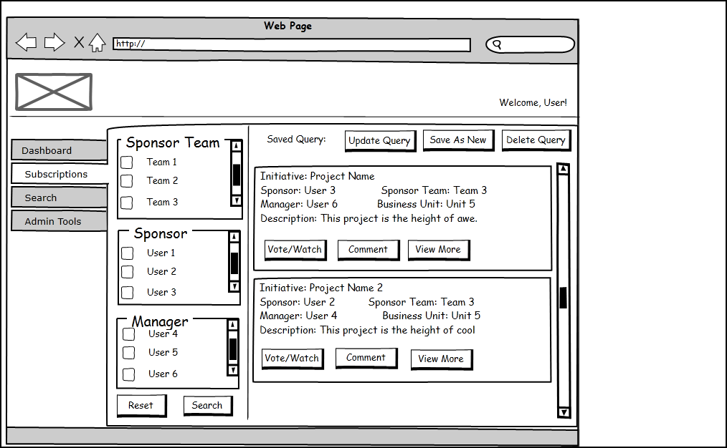
W.4 - Review Saved Searches

Main Elements

# | Screen Element | Description
1 | Sidebar menu | The sidebar menu will be the main method of navigation through the site. Clicking on each of the tabs in the sidebar will link to a different page.
2 | Search Facets | The search facets will be used to determine what is returned in the Entity Search Results.
3. | Saved Query Actions | Updating the query will change the facets used to calculate future query results. Saving the query will allow the user to save the query under a new name with new event choice. Deleting the query will remove it from the program.
4 | Entity Search Result | This shows entities that will be returned using the current search facets.
5 | Quick Search Box (upper right corner) | In the wireframes, unless otherwise noted, this represents the browser's search bar and not an aspect of the web page.
6 | User Profile Link | Will link to a basic profile page with options to change basic profile information.(W.7)

W.5 - View Entity (Initiative, Milestone, Risk)

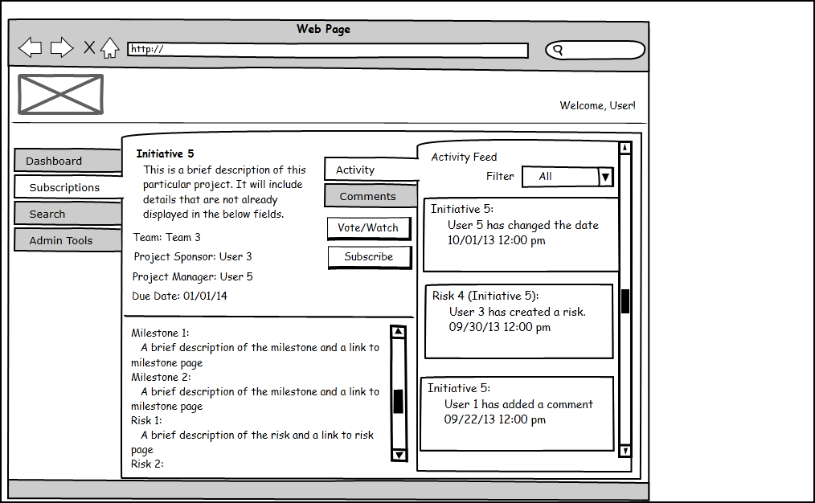

Main Elements

# | Screen Element | Description
1 | Sidebar menu | The sidebar menu will be the main method of navigation through the site. Clicking on each of the tabs in the sidebar will link to a different page.
2 | Main Entity Panel | This will display information about the main entity such as the team that is assigned to it and a description of it.
3. | Children Panel | This will contain child elements of the entity (such as risks or milestones). Each child element will contain a link to its own profile page.
4 | Activity Feed Filter | This will allow the user to filter the activity feed by the various event types defined for the instance.
5 | Event Details | This feed will show the different types of events that have occurred for the project.
6 | Quick Search Box (upper right corner) | In the wireframes, unless otherwise noted, this represents the browser's search bar and not an aspect of the web page.
7 | User Profile Link | Will link to a basic profile page with options to change basic profile information.(W.7)

W.6 - Admin Tools

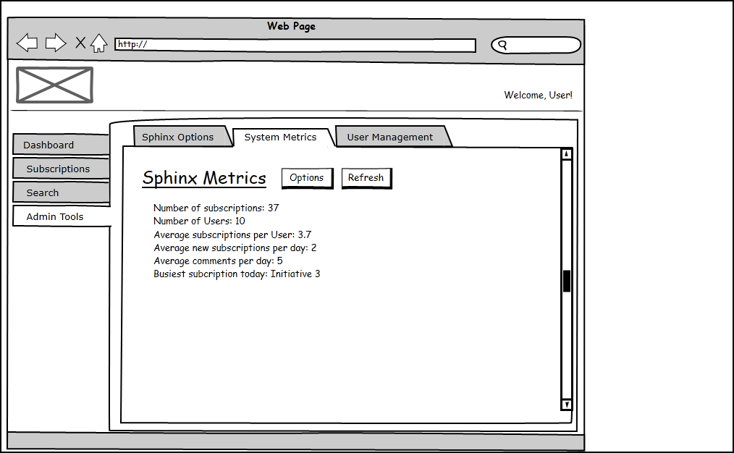

Main Elements

# | Screen Element | Description
1 | Sidebar menu | The sidebar menu will be the main method of navigation through the site. Clicking on each of the tabs in the sidebar will link to a different page.
2 | Sphinx Options Tab | Will allow administrative users to change instance-wide setting for the site ie. Event type definitions.
3. | System Metrics Tab | The metrics tab will allow administrative users to view metrics based on the usage of the system.
4 | User Management Tab | The user management tab will allow administrators to view information (and change information) about the user such as their subscriptions.
5 | Quick Search Box (upper right corner) | In the wireframes, unless otherwise noted, this represents the browser's search bar and not an aspect of the web page.
6 | User Profile Link | Will link to a basic profile page with options to change basic profile information. (W.7)

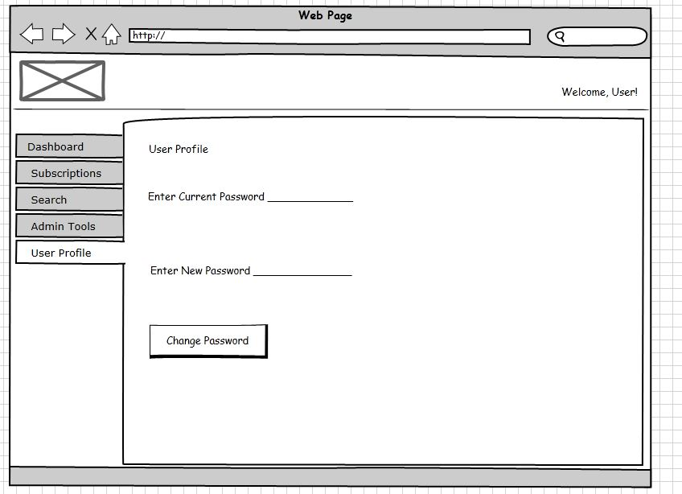
W.7 - User Profile Page

Main Elements

# | Screen Element | Description
1 | Sidebar menu | The sidebar menu will be the main method of navigation through the site. Clicking on each of the tabs in the sidebar will link to a different page.
2 | Change password button | Changes the user's password using whatever is entered into the “Enter New Password” field.
3 | Quick Search Box (upper right corner) | In the wireframes, unless otherwise noted, this represents the browser's search bar and not an aspect of the web page.

