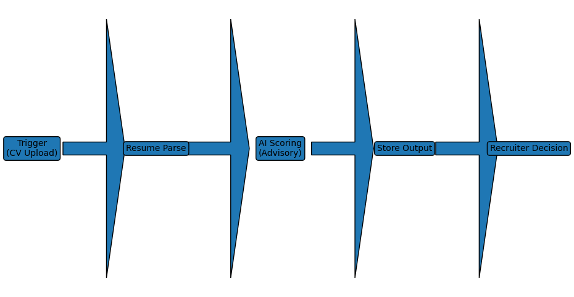
Trigger (CV Upload)
↓
Resume Parsing
↓
AI Scoring (Advisory)
↓
Store Output
↓
Recruiter Decision (Human Gate)
Where to use it
- Paste into:
  - Notion
  - Internal presentations
  - SOP docs
- Use it to explain:
  - “Where AI stops”
  - “Where humans decide”
This is exactly what stakeholders, recruiters, and future devs need.

