VHC Talent OS – n8n Workflow Diagrams (Phase 1)

1. CV Upload → AI Advisory
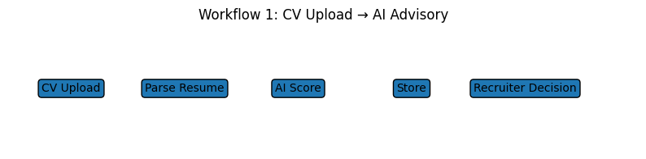

2. JD Creation → Skill Extraction
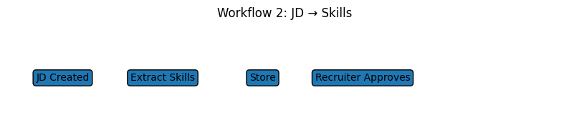

3. Interview Feedback → AI Summary
