Министерство образования и науки Республики Казахстан
Astana IT University

ОТЧЕТ
О выполнении программы производственной практики

База практики: TOO «IT Group Operating»
Студент: Алшанов Аслан Бауыржанулы
Образовательная программа: Информационные технологии (Компьютерные науки)
Группа: IT-1902

Руководители практики: Асанова Н.

«25» сентябрь 2021г.
Calendar plan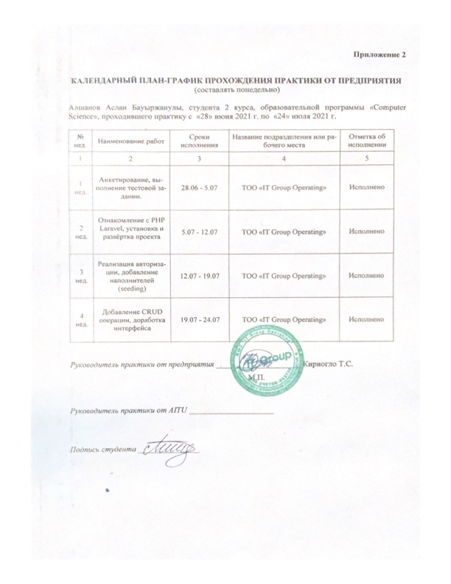

Introduction
LLP " IT Group Operating" specializes in the maintenance of Internet and Intranet sites, the promotion of sites in the Yandex and Google search engines, the creation and implementation of specialized programs based on web technologies, the development of exclusive turnkey and inexpensive sites based on ready-made solutions. The main mission is to provide the client with high-quality services at the lowest price in Kazakhstan. For 17 years of web development, the company has implemented more than 2048 projects across the country.

Content
At the enterprise "IT Group Operating", according to the results of the survey, I was sent to the role of an intern-a website developer using PHP Laravel. PHP is a flexible and lightweight web programming language with extensive features and undeniable advantages.
Today, PHP is a powerful cross-platform set of tools that is located on the server and is designed to process special code embedded in an HTML page. Thanks to this, it becomes possible to easily create dynamic sites. Files created in this way are stored and processed on the server, and when a visitor requests a document with PHP, the script is processed not by the visitor's browser, as, for example, Java Script, but by the server, and only the results of the work are transmitted to the visitor.
Laravel is a framework for web applications with an expressive and elegant syntax. It will simplify the solution of the main urgent tasks, such as authentication, routing, sessions, and caching. Laravel is an attempt to combine all the best that is available in other PHP frameworks. Laravel strives to provide an amazing developer experience while providing powerful features such as thorough dependency injection, an expressive database abstraction layer, queues and scheduled jobs, unit, and integration testing, and more. Laravel combines the best packages in the PHP ecosystem to offer the most robust and developer friendly framework available. Laravel gives you robust tools for dependency injection, unit testing, queues, real-time events, and more. Laravel is fine-tuned for building professional web applications and ready to handle enterprise workloads. Laravel is incredibly scalable. Thanks to the scaling-friendly nature of PHP and Laravel's built-in support for fast, distributed cache systems like Redis, horizontal scaling with Laravel is easy.
We used PhpStorm as our Integrated development environment. PhpStorm is a commercial cross-platform integrated development environment for PHP. It is developed by JetBrains, based on the IntelliJ IDEA platform. PHP storm has good tools like:
- The IDE provides smart code completion, syntax highlighting, extended code formatting configuration, on-the-fly error checking, code folding, supports language mixtures and more. Automated refactorings that treat your code with care, helping to make global project settings easily and safely.
- PhpStorm provides tools and code assistance features for working with databases and SQL in your projects.

- PhpStorm helps you get around your code more efficiently and save time when working with large projects. Jump to a method, function or variable definition in just one click, or search for its usages.

For practice, we chose to create a website for readers and blog writers. At the beginning, we studied what Laravel is and how to create projects on it. Then the development itself started with site layout in simple html, then we were shown how controllers work together with models, then we were shown how migrations work and how to deploy the ready project with the database and how to prepare migrate files. After that we connected the project with the database and created tables with migrate. In the second week, we connected the bootstrap and created a page for registration and login, connecting it to the database.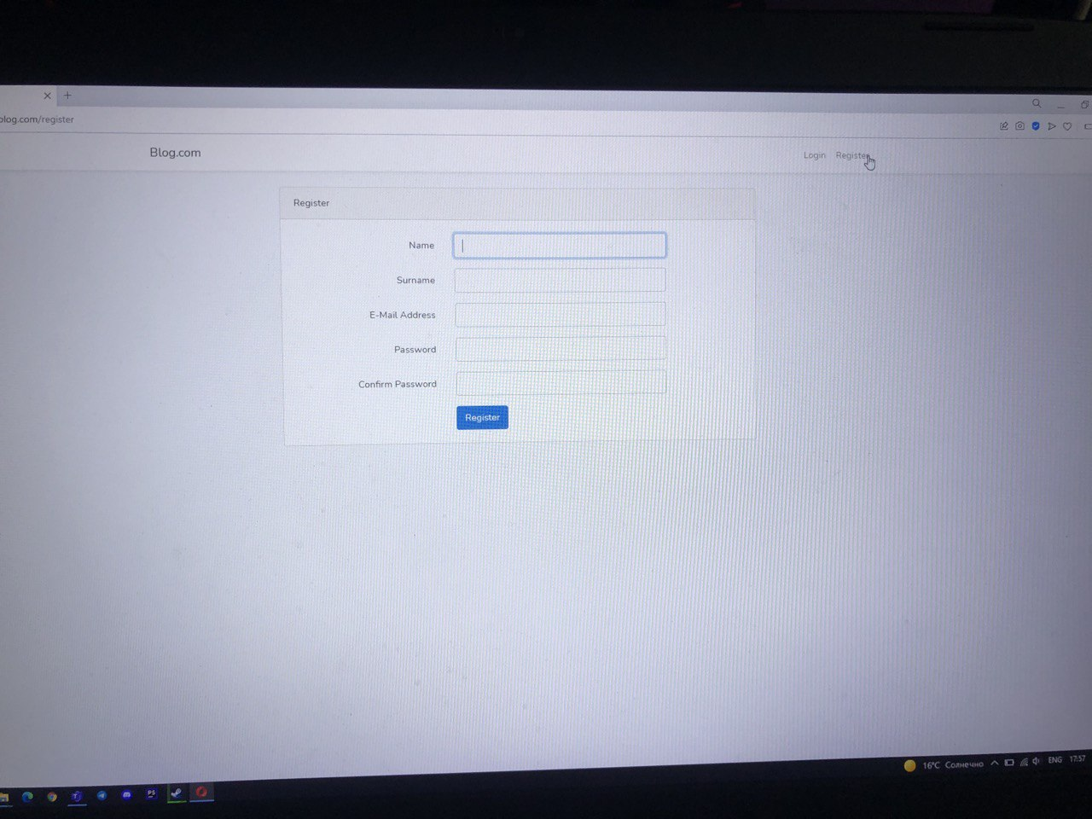

In the 3rd week, we created the main blog page with articles and connected this page with the authorization page. Then they showed how to create and update an article by adding it to the database. In the 4th week, we completed the CRUD methods and the interface
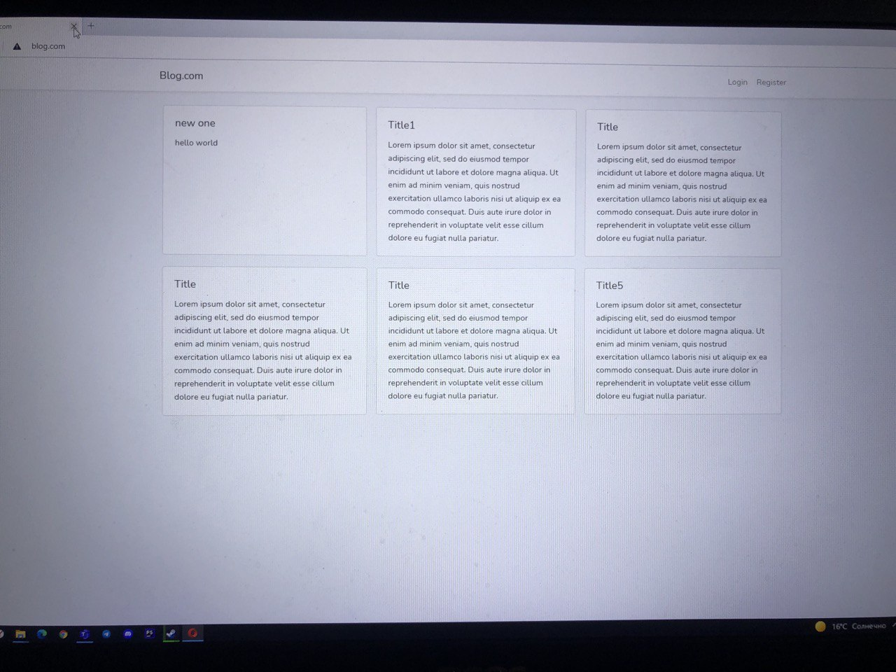

Conclusion
Industrial experience is an important part of the educational process for becoming a professional programmer. During this time, the potential programmer puts his or her knowledge, skills, and talents learned during training into practice. I was able to apply my theoretical understanding of mobile development on a real project during my internship at «IT Group Operating» LLP.

Refenrences, that I have used in work process
- https://laravel.com/docs/8.x
- https://www.php.net

