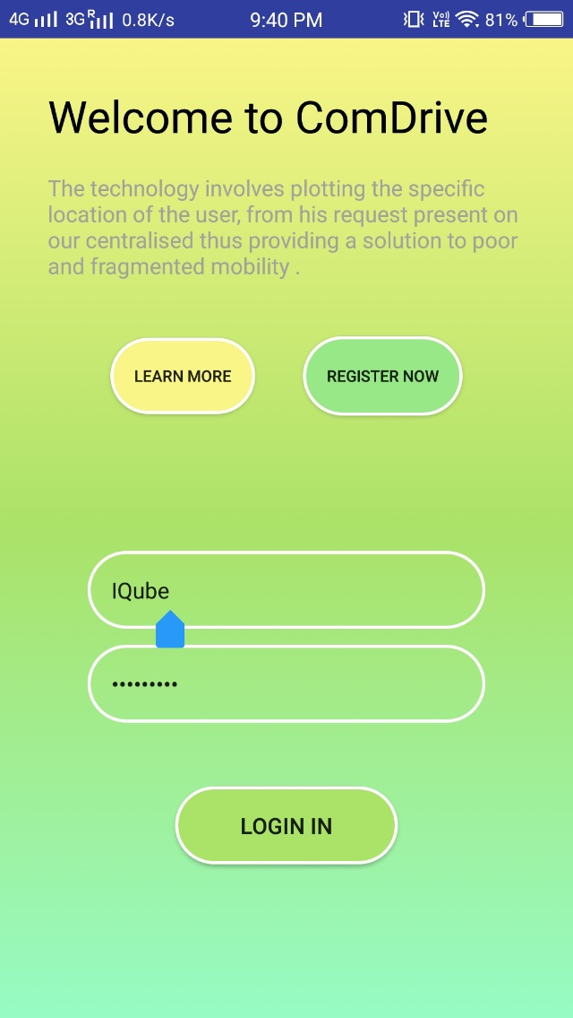

* The Client is First being directed to the login page.
* The User can either register or login into their account (If Registered).

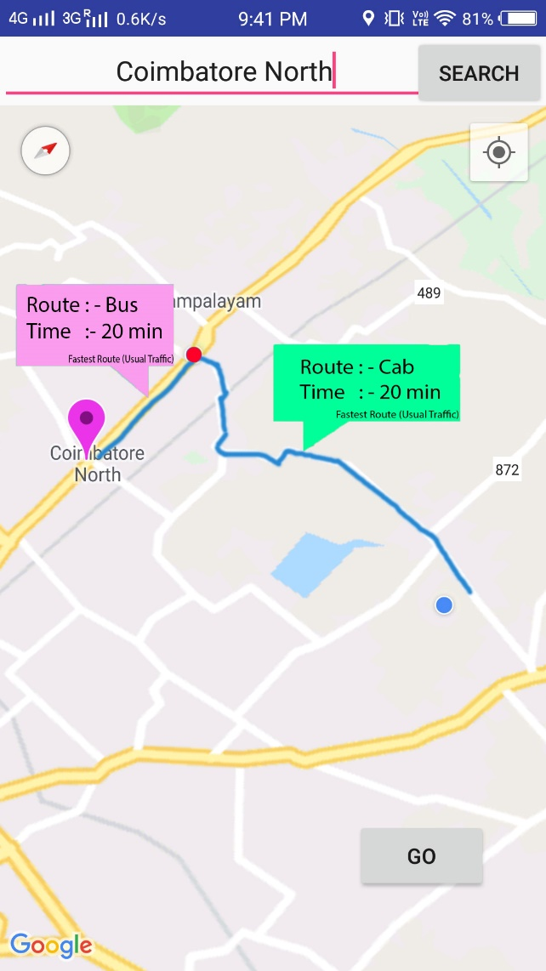

* After the user logged in, he/she is asked to enter their destination.
* After entering their destination, they are intimated as shown.
* They are shown the fastest route and the fastest medium of transportation.
* Once they give go they are directed to payment page.
* There they could pay for their whole transportation.
* The modes of transportation are shown according ETA.

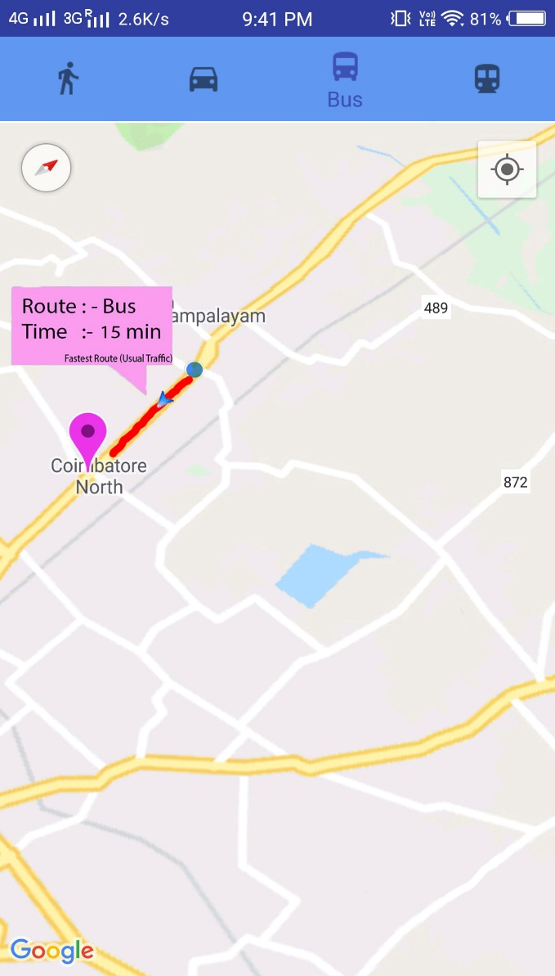

* After the user pays, they have their reserved seats(if needed).
* They can also view the real time transport data as shown.