YUVA INTERN – WEEK 1 PROJECT REPORT
Fake Job Posting Detection
Data Acquisition, Cleaning and Exploratory Data Analysis

Week 1 Deliverable
Python • Pandas • NumPy • Matplotlib • Seaborn • Google Colab

Executive Summary
This Week 1 project focuses on data acquisition, cleaning, preprocessing, and exploratory data analysis (EDA) for a Fake Job Posting Detection system. The analysis was performed in Google Colab using Python, Pandas, NumPy, Matplotlib, and Seaborn.
The working dataset contains 6,841 records and 19 columns at the reported analysis stage. The 19th column is the engineered description_length feature. The target variable is fraudulent, where 0 represents a genuine posting and 1 represents a fraudulent posting.
The final reported target distribution is 6,525 genuine postings (95.39%) and 315 fraudulent postings (4.61%). There is one missing value in the fraudulent target. Duplicate checking returned zero duplicate rows. The single unlabeled target record should be removed before supervised machine learning.
Four visualizations were prepared: missing values by column, genuine versus fraudulent postings, job-description length distribution, and employment-type distribution. The analysis shows substantial missingness in several original fields before cleaning, strong class imbalance, a right-skewed description-length distribution, and a clear dominance of full-time employment.

1. Introduction
Online recruitment platforms provide useful access to employment opportunities, but fraudulent job advertisements can mislead job seekers. Detecting potentially fraudulent postings can be treated as a binary classification problem. Before machine learning, the data must be inspected, cleaned, and explored.

1.1 Problem Statement
Prepare and explore job-posting data so that it can be used in a later stage to develop a machine-learning model that classifies postings as genuine or fraudulent.

1.2 Objectives
- Acquire and load the public dataset.
- Understand the dataset structure and target variable.
- Identify and handle missing values.
- Check duplicate rows and data types.
- Create a simple derived feature.
- Perform EDA using relevant visualizations.
- Summarize insights and limitations for future modeling.

2. Dataset Description
The project uses a publicly available fake-job-posting dataset containing textual job-advertisement information, employment metadata, binary indicators, and a fraudulent target label. Text fields include title, company profile, description, requirements, and benefits. Structured fields include location, employment type, experience, education, industry, function, telecommuting, company-logo availability, and screening-question availability.
Item | Actual project result
Rows at reported analysis stage | 6,841
Columns | 19
Target variable | fraudulent
Genuine postings | 6,525 (95.39%)
Fraudulent postings | 315 (4.61%)
Missing target values | 1
Duplicate rows | 0
Engineered feature | description_length
Environment | Google Colab

3. Data Acquisition and Initial Inspection
The CSV dataset was loaded into Google Colab with Pandas. The initial inspection used shape, head, column names, data types, and DataFrame information.
import pandas as pd
import numpy as np
import matplotlib.pyplot as plt
import seaborn as sns
df = pd.read_csv("fake_job_postings.csv")
print("Shape:", df.shape)
print(df.head())
print(df.columns.tolist())
print(df.dtypes)
df.info()
The reported output was Shape: (6841, 19).

4. Data Cleaning

4.1 Missing-Value Analysis
The missing-value chart was generated before the missing-value handling step. It shows that several original job-posting fields contained missing information. salary_range has the highest missing proportion, followed by department and other optional job-advertisement fields.
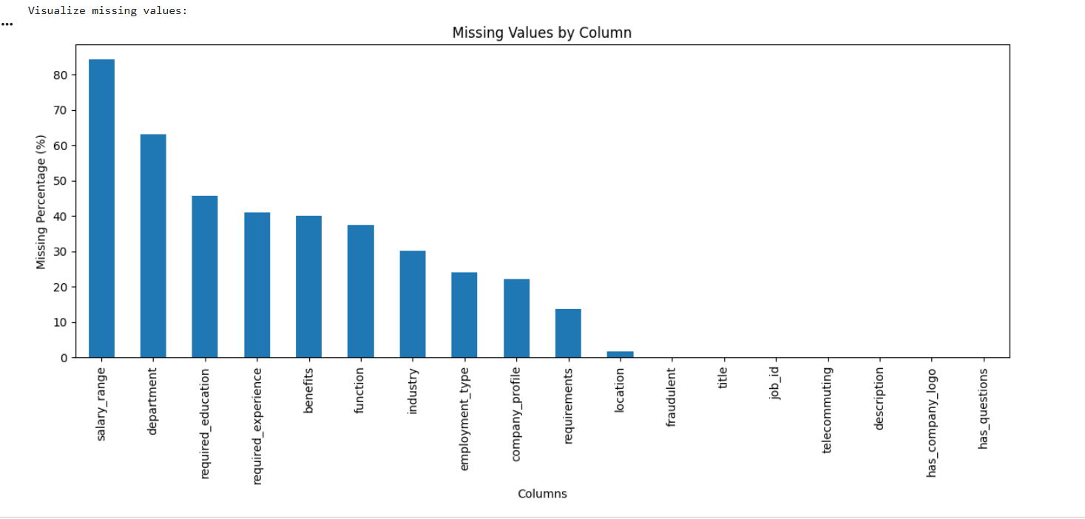
Figure 1. Missing values by column before the cleaning step.
After text/categorical missing-value handling, the reported final missing-value check showed zero missing values for all displayed fields except fraudulent, which had one missing value. Because fraudulent is the supervised-learning target, the record with an unknown target should be excluded before model training.
text_columns = [
"title","location","department","salary_range",
"company_profile","description","requirements","benefits",
"employment_type","required_experience",
"required_education","industry","function"
]
for col in text_columns:
df[col] = df[col].fillna("")
df = df.dropna(subset=["fraudulent"])

4.2 Duplicate Check
The duplicate check returned 0. Therefore, no rows were removed because of exact duplication.
duplicate_count = df.duplicated().sum()
print("Duplicate rows:", duplicate_count)
if duplicate_count > 0:
df = df.drop_duplicates()

4.3 Data-Type Validation
Binary fields were checked so that they can be treated consistently as numeric indicators.
binary_columns = [
"telecommuting","has_company_logo",
"has_questions","fraudulent"
]
for col in binary_columns:
df[col] = pd.to_numeric(df[col], errors="coerce")

5. Exploratory Data Analysis

5.1 Genuine vs Fraudulent Postings
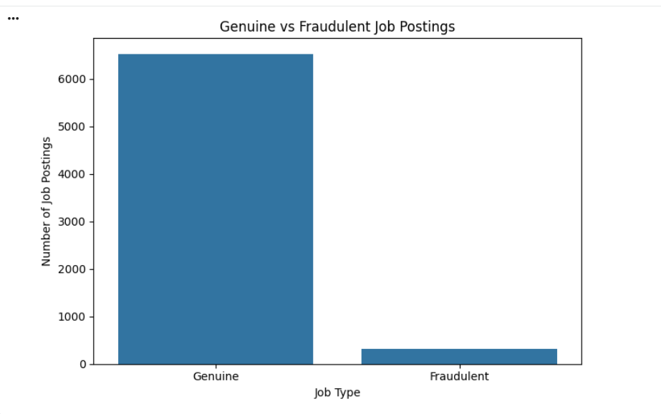
Figure 2. Genuine versus fraudulent job postings.
The target distribution is strongly imbalanced. Genuine postings account for 95.39% of labeled records, while fraudulent postings account for 4.61%. This means a future classification model should not rely on accuracy alone. Precision, recall, F1-score, confusion matrix, and ROC-AUC or PR-AUC should be considered.

5.2 Job Description Length
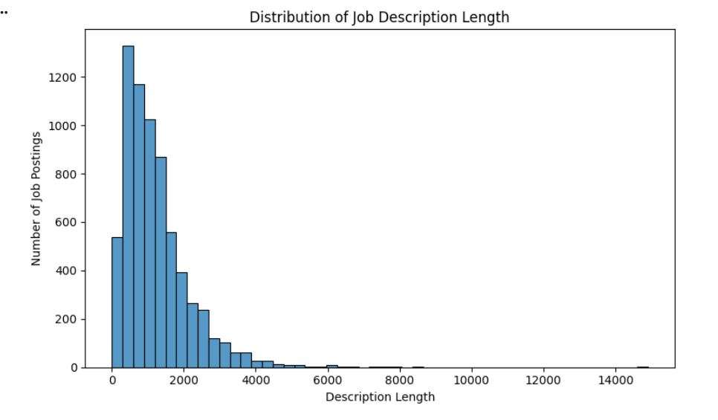
Figure 3. Distribution of job description length.
The histogram is strongly right-skewed. Most job descriptions are comparatively shorter, while a smaller number are very long. Description length can therefore be retained as a useful numerical feature, although length alone cannot establish whether a posting is fraudulent.

5.3 Employment Type
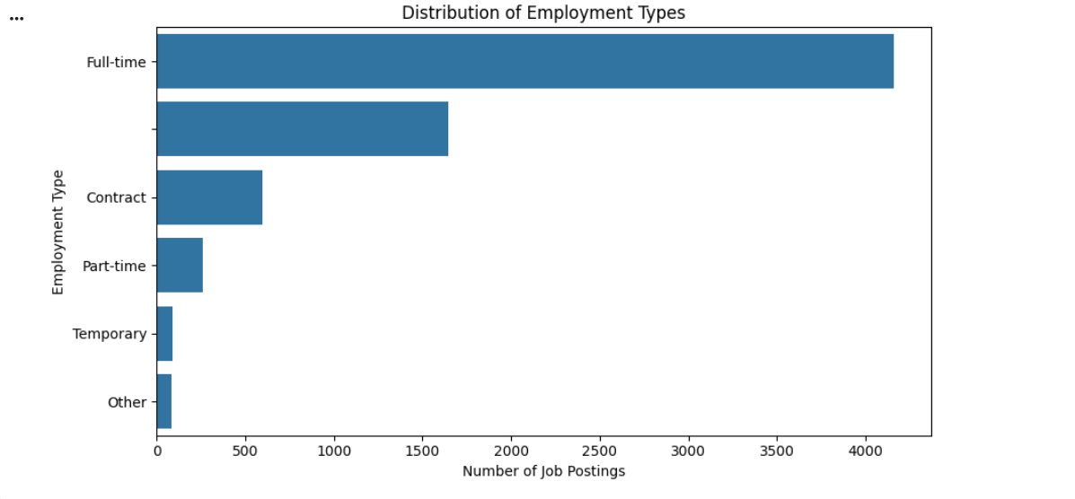
Figure 4. Distribution of employment types.
Full-time is clearly the dominant employment category. Contract and part-time postings occur less frequently, while temporary and other categories are relatively small. This distribution is useful for later categorical encoding.

6. Feature Engineering
A description_length feature was created by counting the number of characters in each job description.
df["description_length"] = (
df["description"].astype(str).str.len()
)
print(df["description_length"].describe())
Additional future features could include word counts, URL/email indicators, salary-availability flags, text TF-IDF features, and other NLP-derived signals.

7. Key Insights
- 6,841 rows and 19 columns were present at the reported analysis stage.
- After removing the one record with a missing target, 6,840 labeled records remain.
- 95.39% of labeled postings are genuine and 4.61% are fraudulent, creating strong class imbalance.
- The initial missing-value analysis shows substantial incompleteness in several optional job-posting fields, especially salary_range and department.
- Text/categorical missing values were handled without unnecessarily deleting complete job records.
- Exact duplicate checking found no duplicate rows.
- Job-description length is strongly right-skewed, with a small number of very long descriptions.
- Full-time employment is the most common employment category.
- The class imbalance will be a major consideration in the next machine-learning stage.

8. Cleaning Rationale
Issue | Action | Reason
Missing text/categorical values | Filled with empty strings | Preserves records and supports later text processing.
Missing fraudulent target | Remove 1 unlabeled record | Supervised learning requires a known target.
Duplicate rows | Checked; 0 found | Prevents repeated observations.
Binary fields | Validated as numeric | Improves consistency for analysis/modeling.
Description text | Created description_length | Converts a textual property into a numerical feature.

9. Limitations
- The current report reflects the supplied working dataset and the exact results reported from the Colab analysis.
- The fraudulent class is much smaller than the genuine class, so accuracy alone can be misleading.
- Several original fields contain missing information.
- Text fields require additional NLP preprocessing before most classical ML algorithms can use them effectively.
- EDA shows distributions and associations; it does not prove causation.
- Future modeling should use a separate test set and imbalance-aware evaluation metrics.

10. Reproducible Google Colab Code
df = pd.read_csv("fake_job_postings.csv")
print("Shape:", df.shape)
print(df.head())
print(df.info())
missing = pd.DataFrame({
"Missing Count": df.isnull().sum(),
"Missing Percentage": df.isnull().mean() * 100
})
print(missing.sort_values("Missing Percentage", ascending=False))
print("Duplicates:", df.duplicated().sum())
print(df["fraudulent"].value_counts(dropna=False))
print(df["fraudulent"].value_counts(normalize=True, dropna=True) * 100)
# Fill missing text/categorical values
for col in text_columns:
if col in df.columns:
df[col] = df[col].fillna("")
# Remove unlabeled target
df = df.dropna(subset=["fraudulent"])
# Feature engineering
df["description_length"] = df["description"].astype(str).str.len()
# Save
df.to_csv("cleaned_fake_job_postings.csv", index=False)
print("Final shape:", df.shape)

11. Recommended GitHub Structure
fake-job-detection/
├── data/
│ └── cleaned_fake_job_postings.csv
├── outputs/
│ ├── missing_values.png
│ ├── genuine_vs_fraudulent.png
│ ├── description_length.png
│ └── employment_type.png
├── notebooks/
│ └── week1_eda.ipynb
├── README.md
├── requirements.txt
└── Week1_Fake_Job_Posting_Detection_Report.docx

12. Conclusion
The Week 1 data-preparation and exploratory-analysis stage established a foundation for a Fake Job Posting Detection project. The working dataset contained 6,841 records and 19 columns, including the engineered description_length feature. The analysis identified one missing target value, zero duplicate rows, and a strong imbalance between genuine and fraudulent postings.
Missing text and categorical values were handled by replacing null entries with empty strings so that useful job records were preserved. The one record with an unknown fraudulent label should be excluded from supervised learning. The four EDA visualizations demonstrate the main data-quality and distribution patterns.
The next stage can apply NLP preprocessing, categorical encoding, train-test splitting, class-imbalance handling, and machine-learning algorithms such as Logistic Regression, Decision Tree, Random Forest, and gradient-boosting methods. Model performance should be evaluated using precision, recall, F1-score, confusion matrix, and ROC-AUC or PR-AUC.

13. YuvaIntern Submission Description (200+ Words)
This Week 1 project focuses on data acquisition, data cleaning, preprocessing, and exploratory data analysis for a Fake Job Posting Detection system. I worked with a publicly available job-posting dataset and implemented the analysis in Google Colab using Python, Pandas, NumPy, Matplotlib, and Seaborn. The working dataset contains 6,841 records and 19 columns at the reported analysis stage, including job-related text fields, employment metadata, binary indicators, the fraudulent target variable, and a newly created description_length feature.
The first step was to inspect the dataset structure using shape, head, column names, data types, and DataFrame information. I then performed missing-value analysis and created a visualization to understand missingness across columns. The initial analysis showed substantial missing information in several fields, particularly salary_range and department. Missing text and categorical values were handled by replacing null values with empty strings so that useful job records were not unnecessarily removed. A separate check identified one missing value in the fraudulent target, so that unlabeled record should be removed before supervised machine learning.
I also checked for duplicate rows and found zero duplicates. The target distribution showed 6,525 genuine postings, representing 95.39% of labeled data, and 315 fraudulent postings, representing 4.61%. This class imbalance is an important finding because future models should be evaluated using precision, recall, F1-score and other suitable metrics rather than accuracy alone.
For feature engineering, I created description_length from the job description text. Four visualizations were prepared: missing values by column, genuine versus fraudulent postings, job description length distribution, and employment type distribution. Overall, the Week 1 work provides a clean and explored foundation for the next stage, where NLP techniques and machine-learning algorithms can be applied.

14. References
- Kaggle – Real or Fake Job Posting Prediction dataset: https://www.kaggle.com/datasets/shivamb/real-or-fake-fake-jobposting-prediction
- Vidros, S., Kolias, C., Kambourakis, G., & Akoglu, L. (2017). Automatic Detection of Online Recruitment Frauds: Characteristics, Methods, and a Public Dataset. Future Internet, 9(1), 6. https://doi.org/10.3390/fi9010006

