WEEK 2 PROJECT REPORT
Advanced Data Visualization
and Data Storytelling
  - Fake Job Posting Detection
YuvaIntern – Data Science Internship
Prepared by: Venu Cheemala
Development Environment: Google Colab
Libraries: Python, Pandas, NumPy, Matplotlib, Seaborn

1. Introduction
Week 2 extends the Fake Job Posting Detection project through advanced data visualization and storytelling. The objective is to communicate meaningful patterns from the cleaned dataset using appropriate visual forms and to translate those patterns into practical insights.
2. Objectives
- Create a clear visual narrative from the cleaned job-posting dataset.
- Analyze fraud rates across important job-related categories.
- Use suitable charts to communicate findings to technical and non-technical audiences.
- Identify patterns that can be investigated further through statistical analysis and machine learning.
3. Dataset Summary
The cleaned dataset used for Week 2 contains 6,840 labeled job postings, including 6,525 genuine and 315 fraudulent postings. Fraudulent postings represent 4.61% of the labeled data.
Metric | Value
Labeled postings | 6,840
Genuine postings | 6,525
Fraudulent postings | 315
Fraud rate | 4.61%
4. Visualization Methodology
Fraud rate is calculated as the mean of the binary fraudulent variable and converted to a percentage. Fraud rate is preferred to raw posting count when comparing categories of different sizes. For industry analysis, only industries with at least 30 postings are included to reduce the effect of very small samples.
5. Visual Analysis
1. Fraud Rate by Employment Type
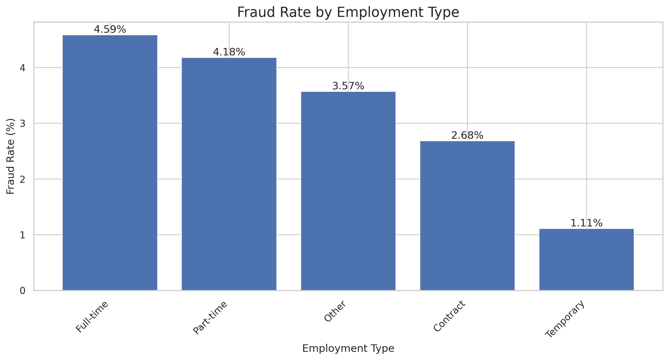
Figure 1. Fraud Rate by Employment Type
This visualization compares the percentage of fraudulent postings across employment categories. It helps identify employment types with comparatively higher observed fraud rates.
Storytelling role: Shows whether employment category may be a useful screening feature.
2. Fraud Rate by Required Experience
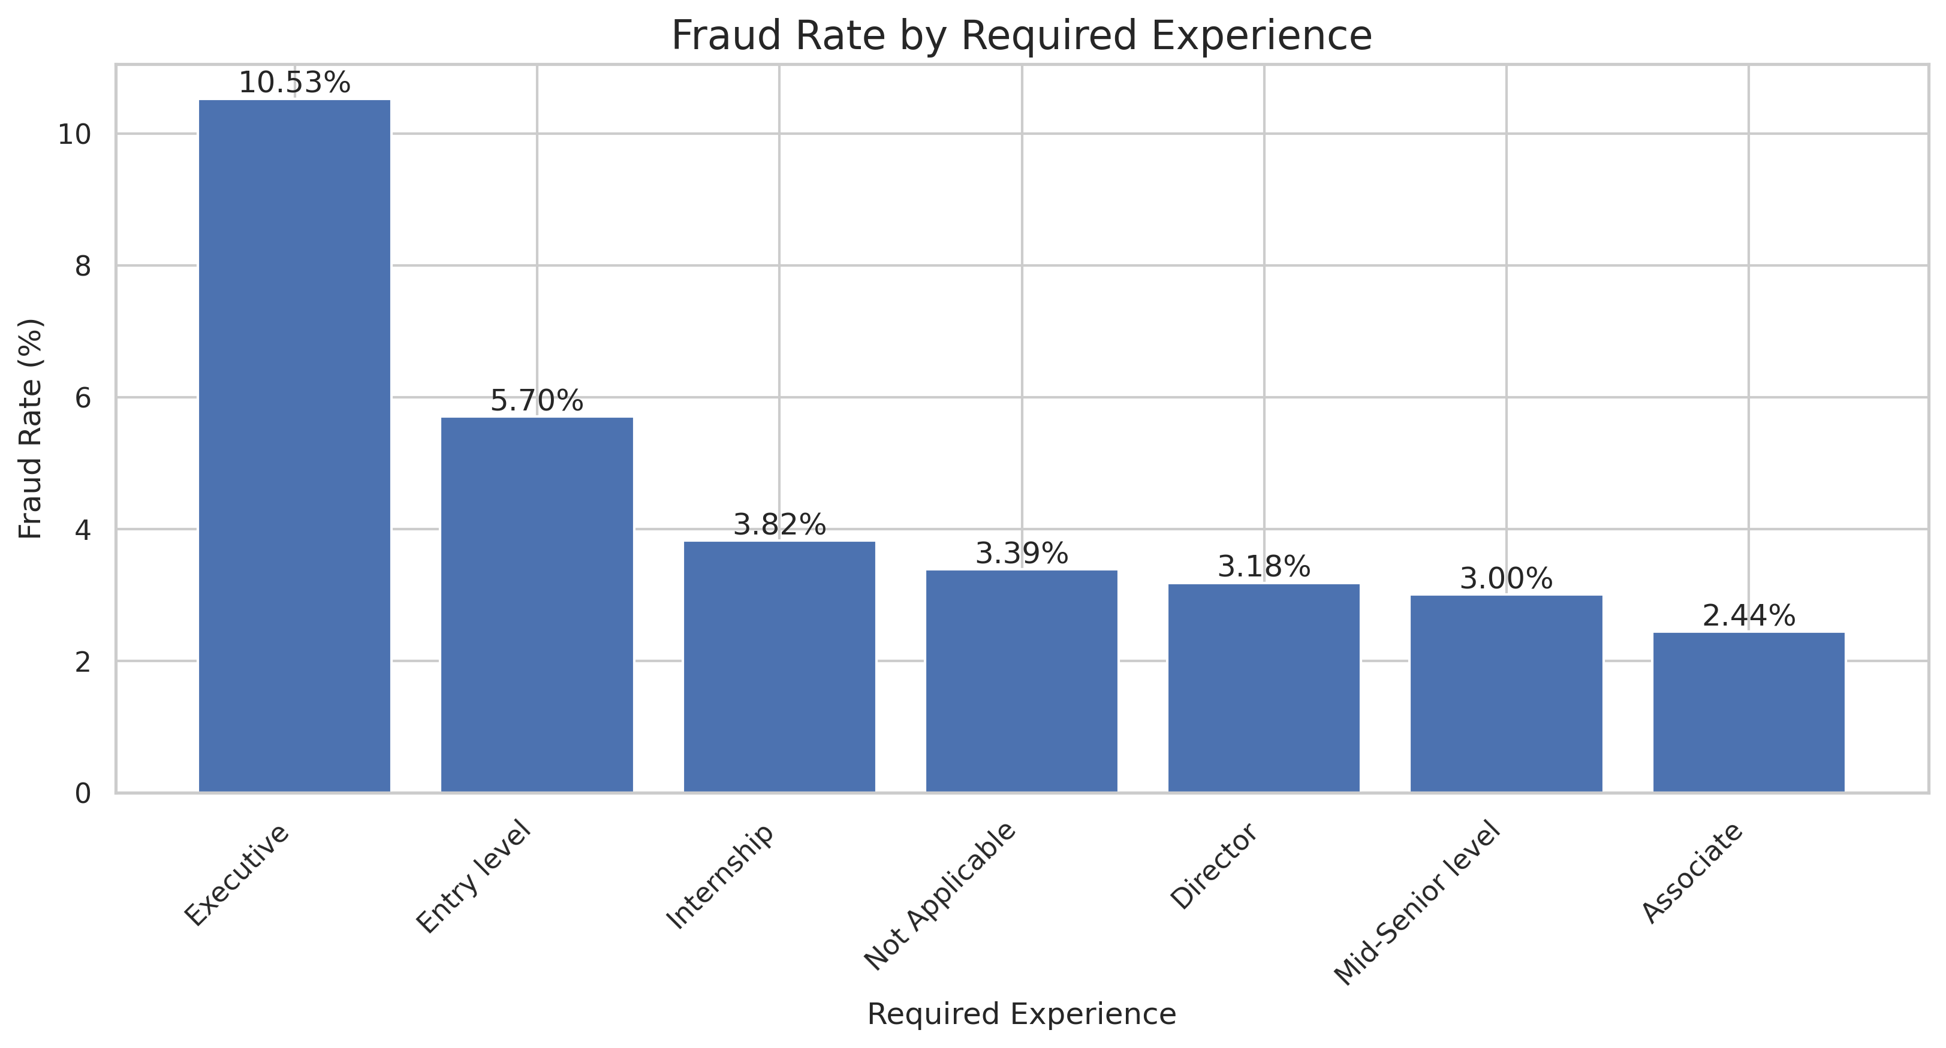
Figure 2. Fraud Rate by Required Experience
This chart compares fraud prevalence across required experience levels. Differences between categories can indicate areas that deserve deeper investigation.
Storytelling role: Connects experience requirements with the fake-job detection problem.
3. Fraud Rate by Required Education
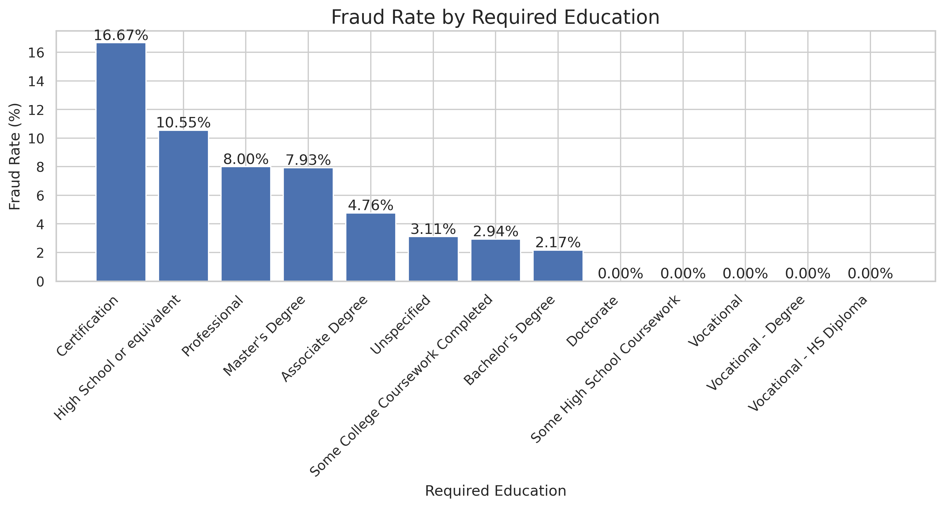
Figure 3. Fraud Rate by Required Education
This chart compares fraudulent-posting rates across education requirements. It provides another view of job requirements and their relationship with the target variable.
Storytelling role: Adds education requirements to the visual fraud-risk story.
4. Top 10 Industries by Fraud Rate
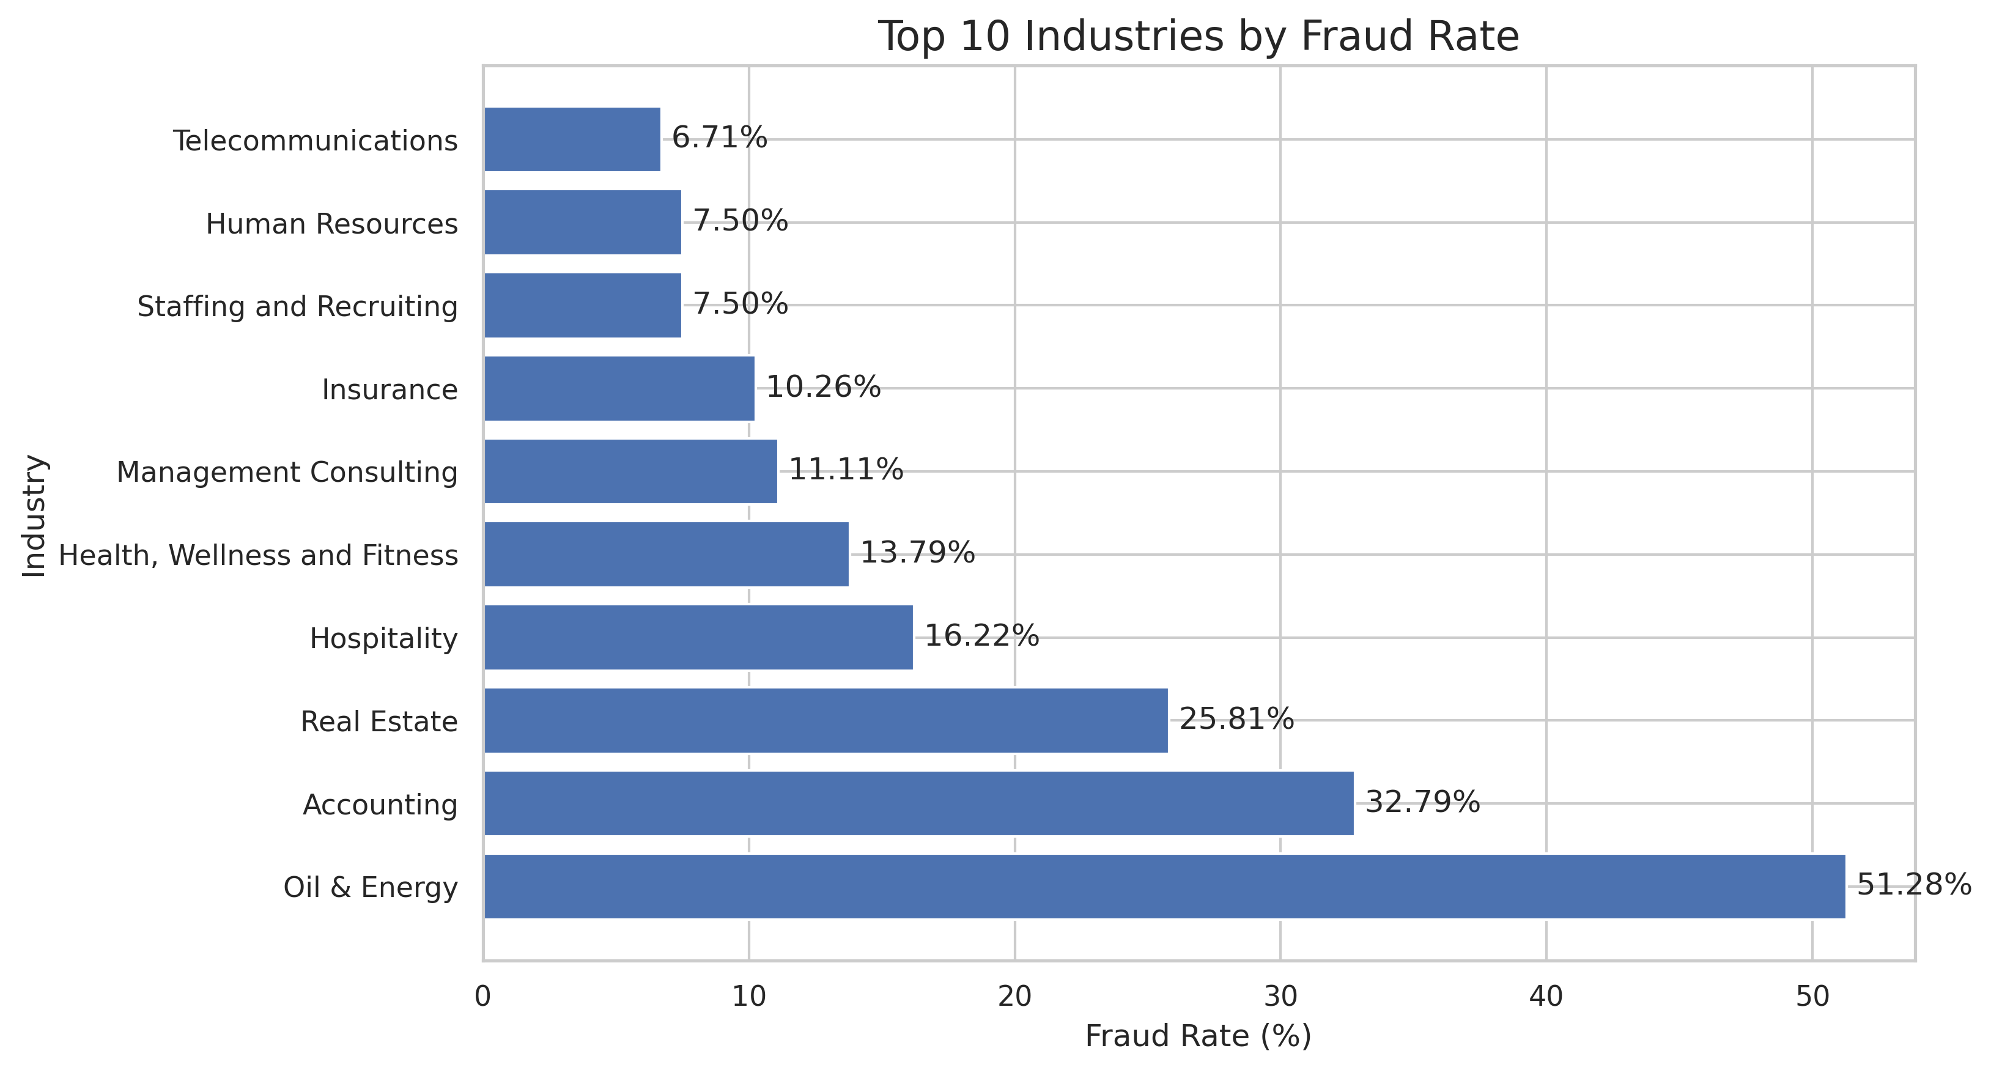
Figure 4. Top 10 Industries by Fraud Rate
The top ten industries are selected only after requiring at least 30 postings per industry. This avoids highlighting tiny groups where one or two fraudulent observations could create an extreme rate.
Storytelling role: Highlights industry segments that may warrant additional screening.
5. Fraud Rate by Company Logo Presence
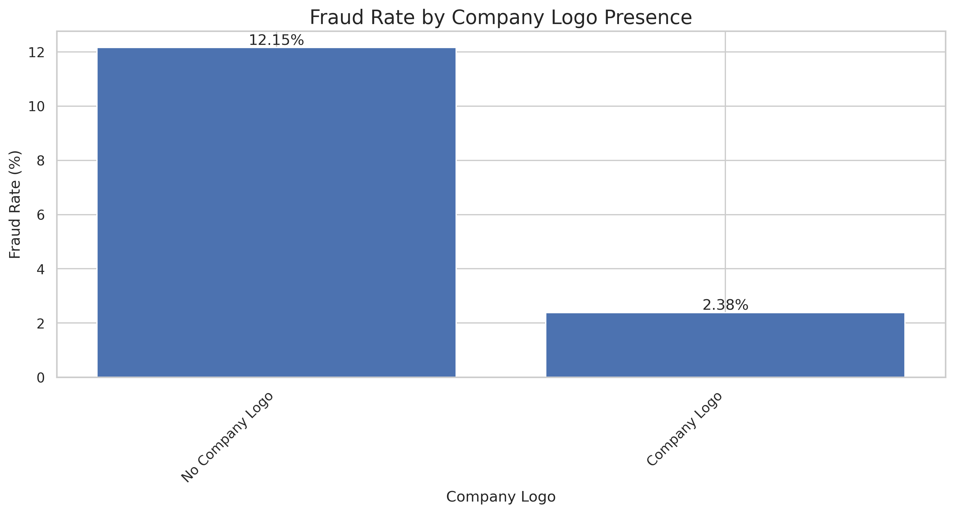
Figure 5. Fraud Rate by Company Logo Presence
This visualization compares fraud rates for postings with and without a company logo. Logo presence may be a useful signal, but it should never be treated as proof of legitimacy or fraud.
Storytelling role: Examines company branding as a potential fraud-related feature.
6. Correlation Heatmap of Numerical Features
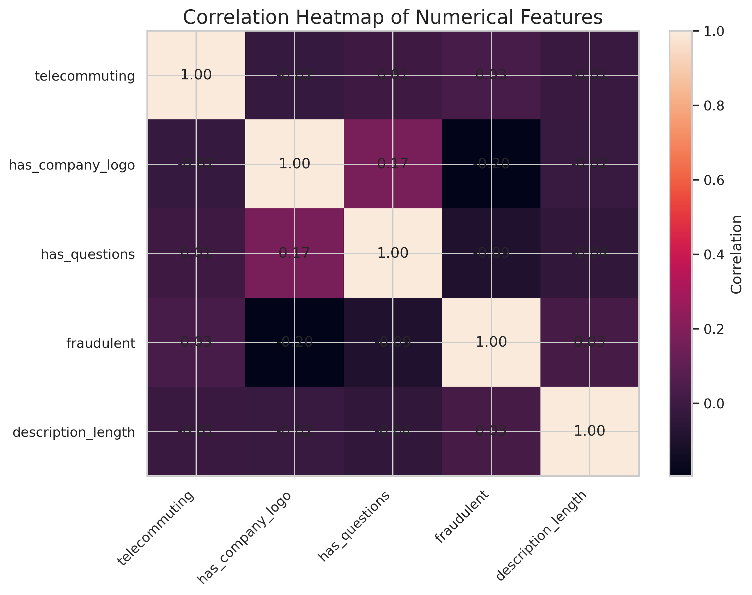
Figure 6. Correlation Heatmap of Numerical Features
The heatmap summarizes pairwise correlations among telecommuting, company-logo presence, questions, fraudulent status, and description length. Correlation represents association and does not establish causation.
Storytelling role: Provides a compact overview of relationships for future feature analysis.
6. Key Insights
- Fraudulent postings account for only 4.61% of labeled observations, indicating strong class imbalance.
- Fraud rates vary across employment, experience, education, and industry categories.
- The industry visualization uses a minimum of 30 postings to make comparisons more meaningful.
- Company-logo presence is a candidate signal, but it should be combined with other features.
- The correlation heatmap is useful for identifying associations, but correlation should not be interpreted as causation.
7. Business Implications
- Recruitment platforms can combine job attributes to support automated fraud screening.
- High-risk categories can be prioritized for verification instead of automatically rejecting postings.
- Future fraud models should evaluate precision, recall, F1-score, and confusion matrices because the target is imbalanced.
- Textual features from job descriptions and requirements can be added in future machine-learning stages.
8. Limitations and Future Work
- Visualization describes observed patterns but cannot prove causation.
- Small categories can produce unstable rates; the industry chart addresses this partly with a minimum-count rule.
- Text-based information is not fully explored in this week.
- Statistical hypothesis testing can determine whether observed differences are significant.
- Machine-learning models can evaluate whether these features improve fraudulent-job prediction.
9. Conclusion
Week 2 converts the cleaned Fake Job Posting dataset into a structured visual story. Six visualizations examine fraud rates across employment type, experience, education, industry, and company-logo presence, along with correlations among numerical features. The analysis identifies useful candidate signals and provides a strong foundation for the statistical and machine-learning stages of the project.
10. Deliverable Checklist
- Professional DOCX report
- Six visualization graphs
- Caption and explanation for every graph
- Fraud-rate-based categorical analysis
- Industry minimum-sample safeguard
- Business implications
- Limitations and future work

