YUVA INTERN – WEEK 3 PROJECT REPORT
Statistical Analysis and Hypothesis Testing
Fake Job Posting Detection
Python • Pandas • SciPy • Matplotlib • Seaborn • Google Colab

Executive Summary
This Week 3 analysis statistically evaluates whether selected job-posting characteristics are associated with fraudulent job advertisements. The Week 3 notebook uses the cleaned dataset after removal of the single missing-target record, leaving 6,840 labeled job postings. Three chi-square tests of independence were performed: company-logo presence vs fraud, screening-question availability vs fraud, and telecommuting vs fraud.
All three tests are statistically significant at α = 0.05. The strongest evidence of association is for company-logo presence, followed by screening questions and telecommuting. Statistical significance indicates evidence of association in this dataset; it does not by itself prove causation.

1. Dataset and Preparation
The Week 3 notebook reports a cleaned dataset shape of 6,840 rows and 19 columns. The analysis removes the one record with a missing fraudulent target before testing. The target variable fraudulent is binary: 0 = genuine and 1 = fraudulent.
The analysis focuses on three binary explanatory variables: has_company_logo, has_questions, and telecommuting. These variables are suitable for chi-square tests because both the explanatory variable and fraud status are categorical/binary.

2. Statistical Methodology
The chi-square test of independence evaluates whether two categorical variables are statistically independent. For each hypothesis, the null hypothesis (H₀) states that the variables are independent, while the alternative hypothesis (H₁) states that an association exists.
Decision rule: with α = 0.05, reject H₀ when p < 0.05. Otherwise, fail to reject H₀. The notebook uses scipy.stats.chi2_contingency to calculate the chi-square statistic, p-value, degrees of freedom, and expected frequencies.

3. Hypotheses

H1 – Company Logo
H₀: Company-logo presence and fraud status are independent.
H₁: Company-logo presence and fraud status are associated.

H2 – Screening Questions
H₀: Screening-question availability and fraud status are independent.
H₁: Screening-question availability and fraud status are associated.

H3 – Telecommuting
H₀: Telecommuting status and fraud status are independent.
H₁: Telecommuting status and fraud status are associated.

4. Statistical Test Results
Test | Chi-Square | p-value | df | Decision
Company Logo vs Fraud | 258.846847 | 3.061104e-58 | 1 | Reject H₀
Questions vs Fraud | 56.188986 | 6.582925e-14 | 1 | Reject H₀
Telecommuting vs Fraud | 5.504923 | 1.896302e-02 | 1 | Reject H₀

5. Hypothesis 1 – Company Logo Presence vs Fraud
The notebook reports χ² = 258.846847, p = 3.061104e-58, and df = 1. Because the p-value is far below 0.05, H₀ is rejected. There is statistically significant evidence of an association between company-logo presence and fraud status.
No Logo: 1,366 genuine, 189 fraudulent; fraud rate = 12.15% (95% Wilson CI: 10.62%–13.87%).
Logo: 5,159 genuine, 126 fraudulent; fraud rate = 2.38% (95% Wilson CI: 2.01%–2.83%).
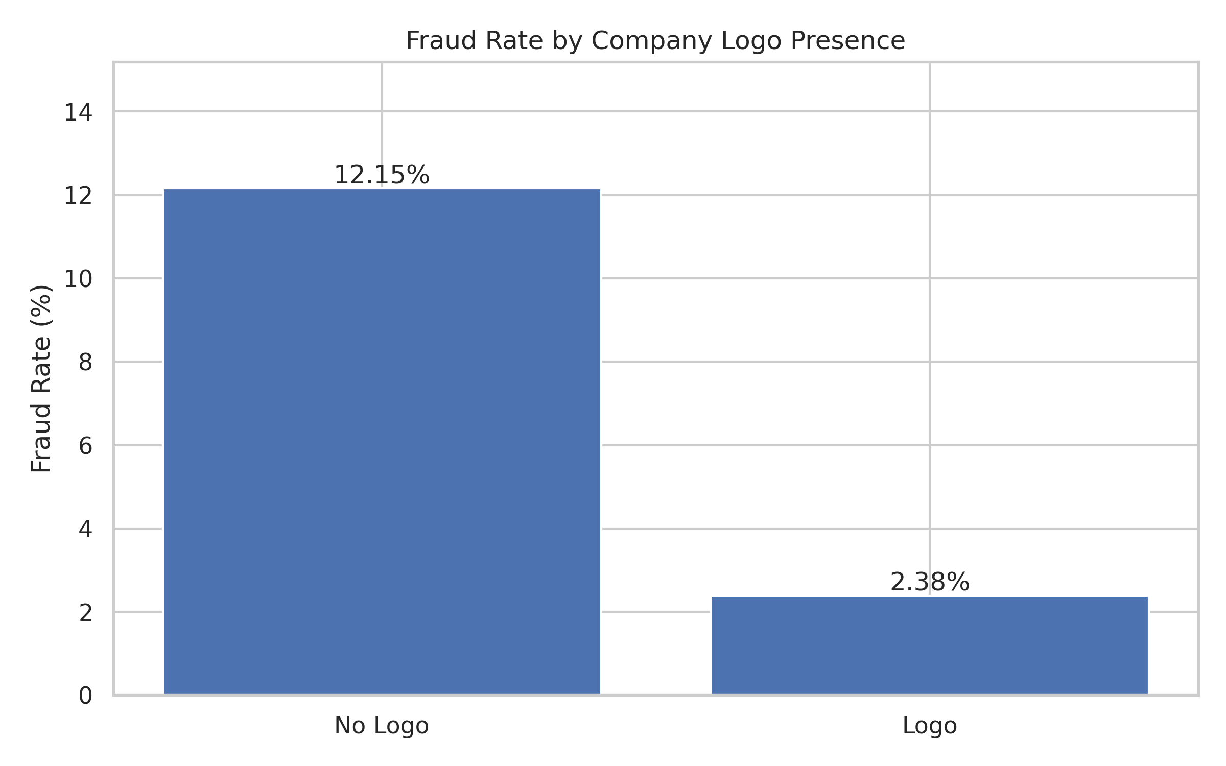
Interpretation: postings without a company logo have a substantially higher observed fraud rate than postings with a logo. This can be useful as a screening signal, but it should not be interpreted as proof that the absence of a logo causes fraud.

6. Hypothesis 2 – Screening Questions vs Fraud
The notebook reports χ² = 56.188986, p = 6.582925e-14, and df = 1. Since p < 0.05, H₀ is rejected and there is statistically significant evidence of an association.
No Questions: 2,933 genuine, 210 fraudulent; fraud rate = 6.68% (95% Wilson CI: 5.86%–7.61%).
Questions: 3,592 genuine, 105 fraudulent; fraud rate = 2.84% (95% Wilson CI: 2.35%–3.43%).
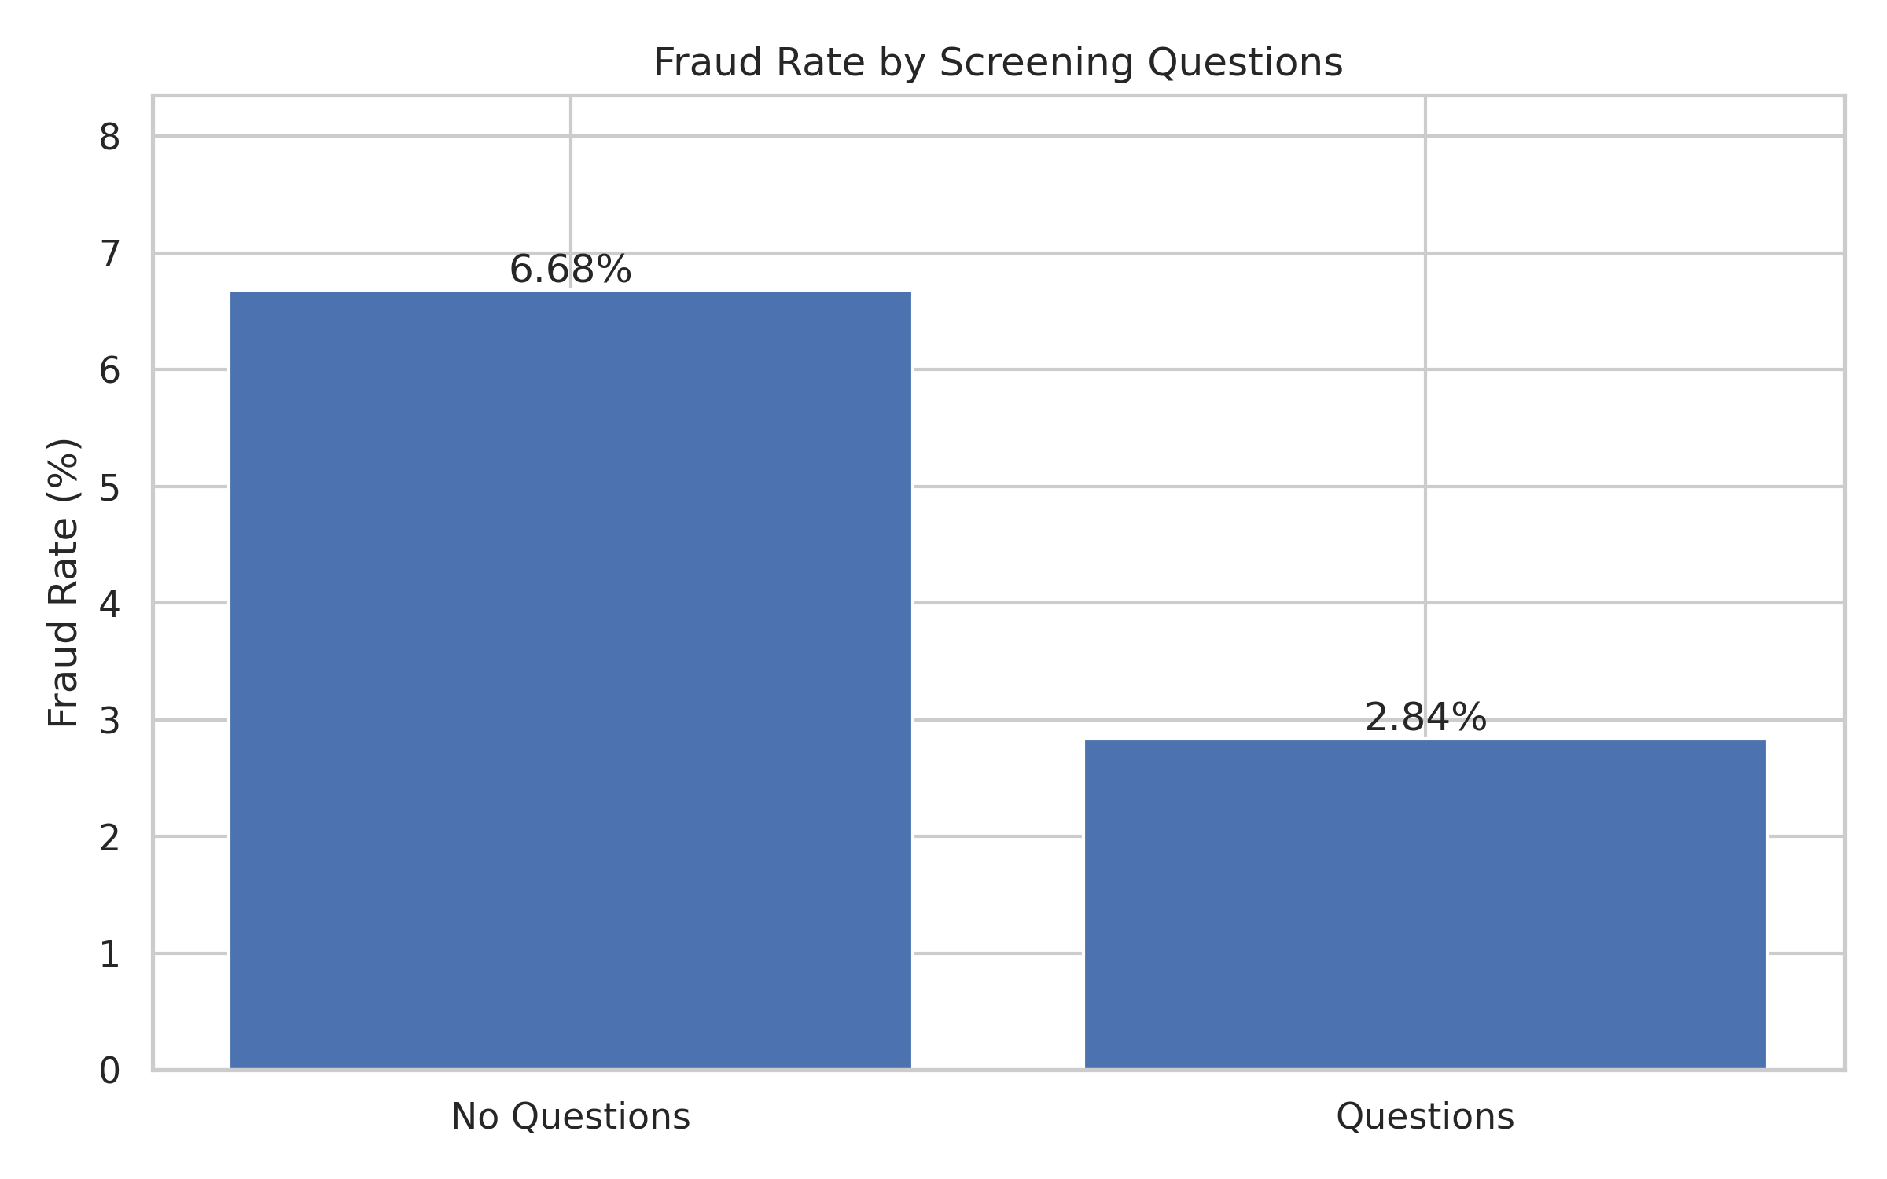
Interpretation: postings without screening questions show a higher observed fraud rate than postings with screening questions. The chi-square result indicates that this difference is unlikely to be explained by random sampling variation alone under the null hypothesis.

7. Hypothesis 3 – Telecommuting vs Fraud
The notebook reports χ² = 5.504923, p = 0.018963, and df = 1. Because p < 0.05, H₀ is rejected. Thus, the analysis provides statistically significant evidence of an association between telecommuting status and fraud status.
No Telecommuting: 6,242 genuine, 292 fraudulent; fraud rate = 4.47% (95% Wilson CI: 3.99%–5.00%).
Telecommuting: 283 genuine, 23 fraudulent; fraud rate = 7.52% (95% Wilson CI: 5.06%–11.03%).
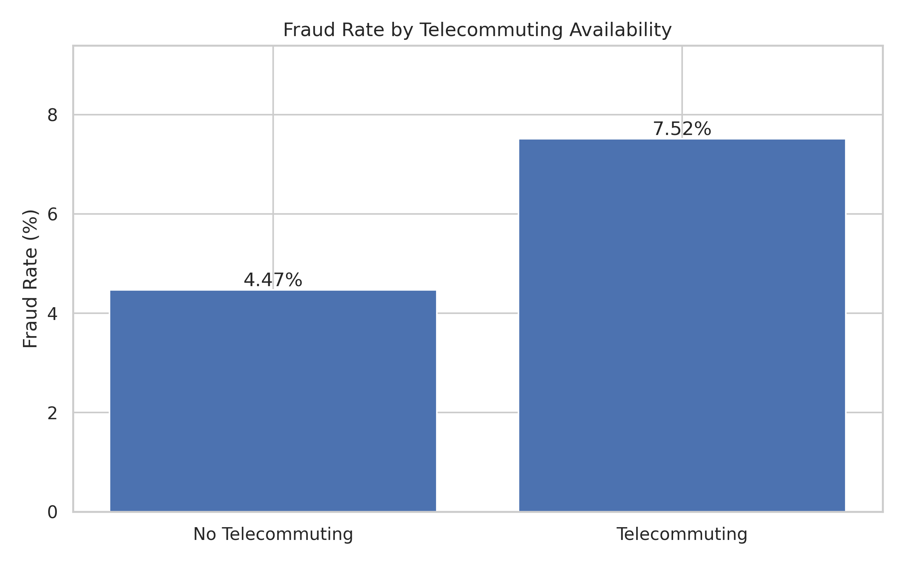
Interpretation: the telecommuting comparison shows a statistically significant relationship with fraud status. The effect is smaller than the company-logo and screening-question relationships, based on the chi-square statistics.

8. Comparative Significance Visualization
The fourth visualization compares the strength of statistical evidence across the three chi-square tests using -log10(p-value). Larger values correspond to smaller p-values. The dashed line represents α = 0.05.
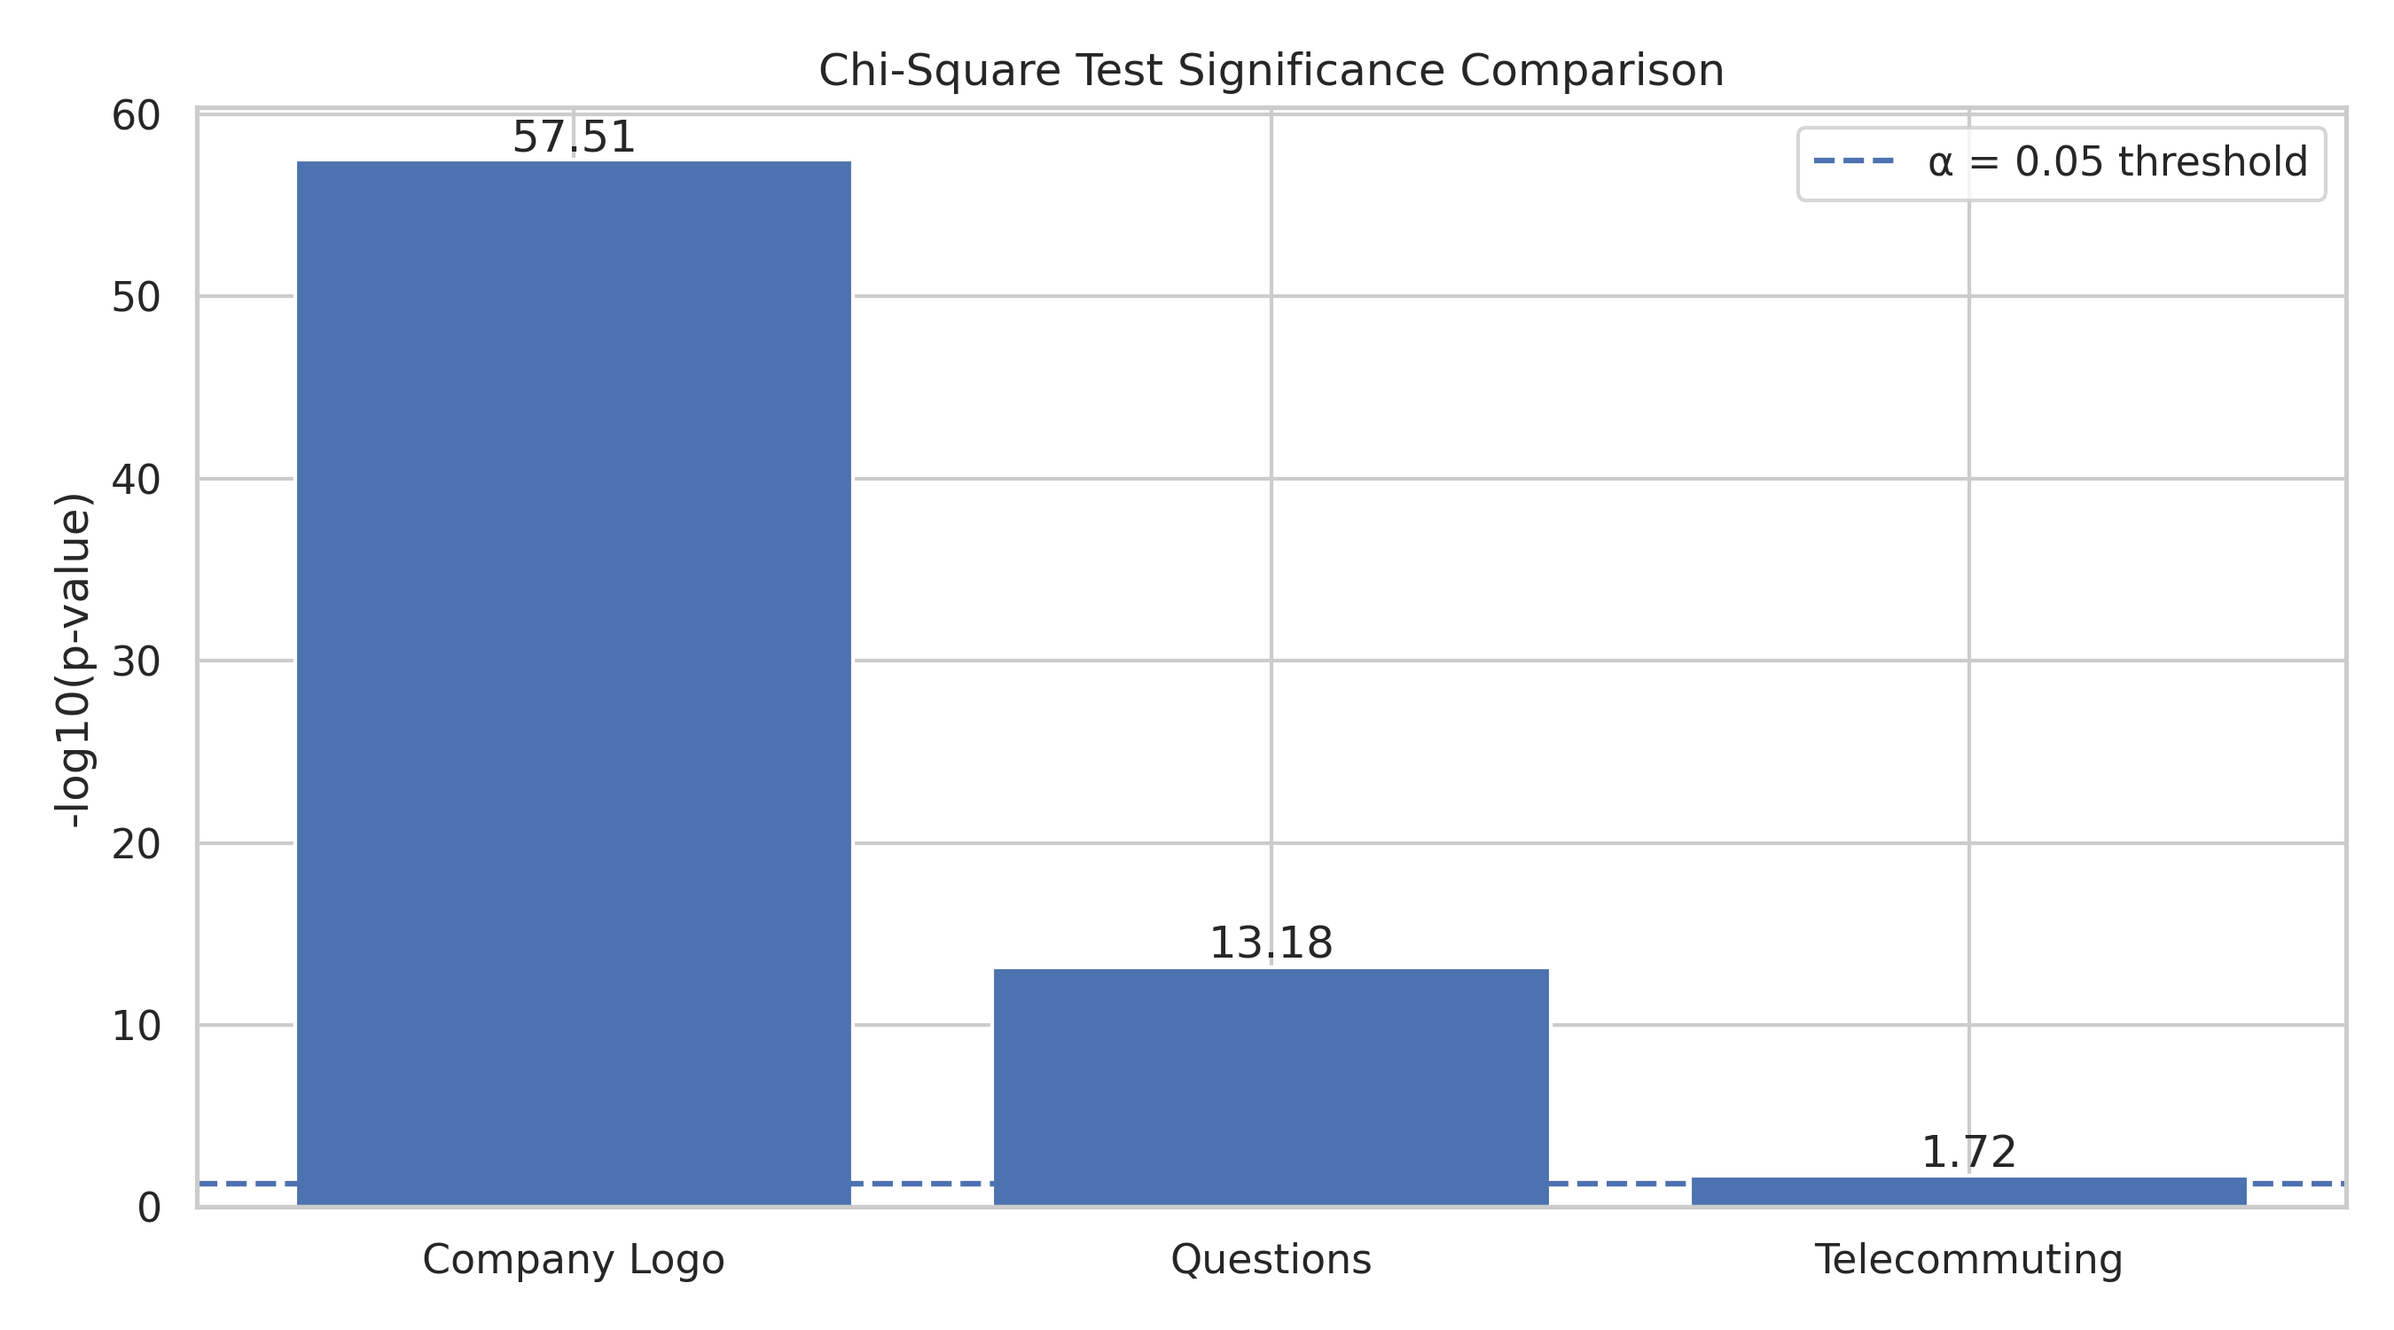
Company logo has the smallest p-value (3.061e-58) and therefore the strongest statistical evidence of association among the three tests. Screening questions also show very strong evidence (6.583e-14), while telecommuting remains significant at 0.0190.

9. Observed vs Expected Frequencies
For the company-logo test, expected frequencies represent the counts that would be expected if company-logo presence and fraud status were independent. Large differences between observed and expected frequencies contribute to the chi-square statistic.
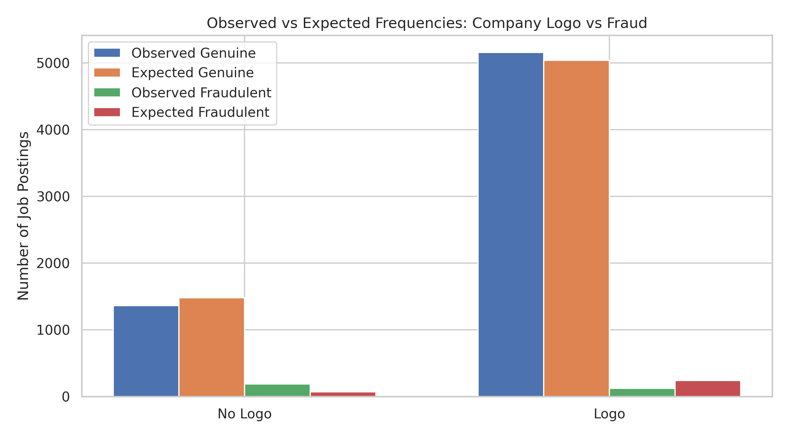
The largest discrepancy is visible for fraudulent postings: the observed number of fraudulent postings with a logo is much lower than the expected count, while the observed number without a logo is much higher than expected. These deviations are consistent with the significant chi-square result.

10. Company Logo Expected-Frequency Table
Company Logo | Fraudulent | Genuine
Logo | 243.388158 | 5041.611842
No Logo | 71.611842 | 1483.388158

11. Confidence Intervals and Practical Interpretation
For the group fraud rates reported above, 95% Wilson confidence intervals are provided as descriptive uncertainty intervals for each observed proportion. The intervals quantify uncertainty around the sample fraud rates; they do not change the chi-square hypothesis-test decision.
The results are best interpreted as screening signals. A company logo, screening questions, or telecommuting status should not be used alone to label a posting as fraudulent. Combining multiple signals with text features and a properly validated machine-learning model would be more appropriate.

12. Business and Analytical Implications
- Company-logo presence can be considered a potentially useful feature in a fraud-risk model because its association with fraud is statistically strong.
- Screening-question availability also shows a statistically significant relationship and may contribute useful predictive information.
- Telecommuting status is statistically significant but has weaker chi-square evidence than the other two variables.
- Because the fraud class is much smaller than the genuine class, future models should prioritize precision, recall, F1-score, ROC-AUC and especially PR-AUC rather than accuracy alone.
- Statistical association should be treated as evidence for feature usefulness, not evidence of causation.

13. Limitations
- The analysis uses the supplied cleaned working dataset and the variables available in the Week 3 notebook.
- Chi-square tests identify association between categorical variables; they do not establish causality.
- The strong class imbalance means the fraudulent group is relatively small compared with the genuine group.
- Multiple hypothesis tests are performed. The current notebook uses α = 0.05 for each test and does not report a multiple-testing correction.
- The notebook focuses on chi-square tests; t-tests and ANOVA are not reported as executed analyses in the supplied Week 3 notebook.

14. Conclusion
The Week 3 statistical analysis provides quantitative evidence that three job-posting characteristics are associated with fraud status in the analyzed dataset. Company-logo presence shows the strongest chi-square evidence, followed by screening questions and telecommuting. All three p-values are below the 0.05 significance level, so the corresponding null hypotheses are rejected.
The findings provide a statistically supported basis for carrying these variables forward into the machine-learning stage. However, they should be combined with other structured and text-based features and evaluated using appropriate imbalance-aware validation metrics.

15. Python Code Used for the Core Statistical Tests
import pandas as pd
from scipy.stats import chi2_contingency

df = pd.read_csv("/content/cleaned_fake_job_postings.csv")
df = df.dropna(subset=["fraudulent"])

# Company Logo vs Fraud
contingency_table = pd.crosstab(df["has_company_logo"], df["fraudulent"])
chi2, p_value, dof, expected = chi2_contingency(contingency_table)

# Screening Questions vs Fraud
questions_table = pd.crosstab(df["has_questions"], df["fraudulent"])
chi2_q, p_q, dof_q, expected_q = chi2_contingency(questions_table)

# Telecommuting vs Fraud
telecommuting_table = pd.crosstab(df["telecommuting"], df["fraudulent"])
chi2_t, p_t, dof_t, expected_t = chi2_contingency(telecommuting_table)

print("Company Logo:", chi2, p_value, dof)
print("Questions:", chi2_q, p_q, dof_q)
print("Telecommuting:", chi2_t, p_t, dof_t)

16. Source Note
Primary analytical source: the supplied Week_3_Statistical_Analysis_and_Hypothesis_Testing.ipynb. The report preserves the notebook's three chi-square tests and their reported statistics. Telecommuting group counts and the fifth visualization were derived directly from the same cleaned dataset used by the notebook, rather than invented.

