WEEK 4 TASK
Machine Learning Model Development and Evaluation
Fake Job Posting Detection using Logistic Regression

1. Executive Summary
This project develops a binary classification model to identify whether an online job posting is genuine or fraudulent. The workflow follows the complete machine-learning pipeline implemented in the notebook: dataset loading, data inspection, target cleaning, feature selection, preprocessing, train-test splitting, model training, prediction, evaluation, visualization, and error analysis.
The selected algorithm is Logistic Regression. The final test-set results show an accuracy of 74.49% and ROC-AUC of 82.06%. The model achieves high recall for fraudulent postings (69.84%), but precision is low (11.76%). This means the model detects many fraudulent postings, but it also flags a substantial number of genuine postings as fraudulent. Therefore, the model is useful as an initial fraud-screening model but requires further feature engineering and model improvement before deployment.

2. Project Objective
- Build a machine-learning classification model for fake job posting detection.
- Prepare and preprocess structured job-posting features.
- Train a Logistic Regression classifier using Scikit-learn.
- Evaluate the model using Accuracy, Precision, Recall, F1-Score, and ROC-AUC.
- Analyze the confusion matrix and identify false-positive and false-negative errors.
- Discuss limitations, possible sources of error, and practical improvement strategies.

3. Dataset Description
The notebook loads a cleaned dataset named 'cleaned_fake_job_postings.csv'. The initial dataset contains 6,841 rows and 19 columns. One row has a missing target value in the 'fraudulent' column, so that row is removed before model development. The resulting dataset contains 6,840 labeled job postings.
Item | Value | Notes
Initial records | 6,841 | 19 columns
Records after target cleaning | 6,840 | One missing target row removed
Genuine postings | 6,525 | Target = 0
Fraudulent postings | 315 | Target = 1
Training records | 5,472 | 80% split
Testing records | 1,368 | 20% split
The target distribution is strongly imbalanced: fraudulent postings are much fewer than genuine postings. This imbalance is an important consideration when interpreting accuracy and other evaluation metrics.

4. Selected Features
The notebook uses seven input features:
- telecommuting
- has_company_logo
- has_questions
- employment_type
- required_experience
- required_education
- description_length
Four features are numerical: telecommuting, has_company_logo, has_questions, and description_length. Three are categorical: employment_type, required_experience, and required_education.

5. Data Preparation and Preprocessing
The notebook uses a ColumnTransformer with separate preprocessing pipelines for numerical and categorical variables. This keeps preprocessing consistent between the training and testing data and reduces the risk of applying different transformations at different stages.
Feature Type | Preprocessing | Reason
Numerical | Median imputation + StandardScaler | Handles missing values and puts numeric variables on a comparable scale.
Categorical | Most-frequent imputation + OneHotEncoder | Handles missing categories and converts categories into model-readable variables.

6. Train-Test Split
The data is divided into 80% training data and 20% testing data using train_test_split. A random_state of 42 is used for reproducibility, and stratify=y is applied so that the class distribution is maintained across the training and testing sets.

7. Model Selection and Training
Logistic Regression was selected because it is a simple, interpretable classification algorithm and is appropriate as a baseline for a binary prediction problem. The model is configured with max_iter=1000 to allow sufficient iterations for convergence and class_weight='balanced' to address the unequal class distribution.
The preprocessing steps and Logistic Regression model are combined into one Scikit-learn Pipeline. The pipeline is trained using the training set and then used to generate both class predictions and fraud probabilities for the test set.

8. Key Python Code Snippets
X_train, X_test, y_train, y_test = train_test_split(
X, y, test_size=0.20, random_state=42, stratify=y
)
model = LogisticRegression(
max_iter=1000,
class_weight="balanced",
random_state=42
)
clf = Pipeline(
steps=[
("preprocessor", preprocessor),
("model", model)
]
)
clf.fit(X_train, y_train)
y_pred = clf.predict(X_test)
y_prob = clf.predict_proba(X_test)[:, 1]
accuracy = accuracy_score(y_test, y_pred)
precision = precision_score(y_test, y_pred, zero_division=0)
recall = recall_score(y_test, y_pred, zero_division=0)
f1 = f1_score(y_test, y_pred, zero_division=0)
roc_auc = roc_auc_score(y_test, y_prob)

9. Model Evaluation Results
The following scores are the exact evaluation results reported by the notebook:
Metric | Score | Interpretation
Accuracy | 0.7449 (74.49%) | 74.49% of all test samples were classified correctly.
Precision | 0.1176 (11.76%) | Only 11.76% of postings predicted as fraudulent were actually fraudulent.
Recall | 0.6984 (69.84%) | 69.84% of actual fraudulent postings were detected.
F1-Score | 0.2014 (20.14%) | 20.14%, reflecting the trade-off between low precision and relatively high recall.
ROC-AUC | 0.8206 (82.06%) | 82.06%, indicating good ability to rank fraudulent postings above genuine ones across thresholds.

10. Classification Report Analysis
Class | Precision | Recall | F1-Score
Genuine | 0.98 | 0.75 | 0.85
Fraudulent | 0.12 | 0.70 | 0.20
The model performs much better on the majority Genuine class than on the Fraudulent class. For fraud detection, recall is relatively strong, which is desirable when missing a fraudulent posting is costly. However, the very low fraud precision shows that many genuine postings are incorrectly flagged.

11. Visualization 1 — Confusion Matrix
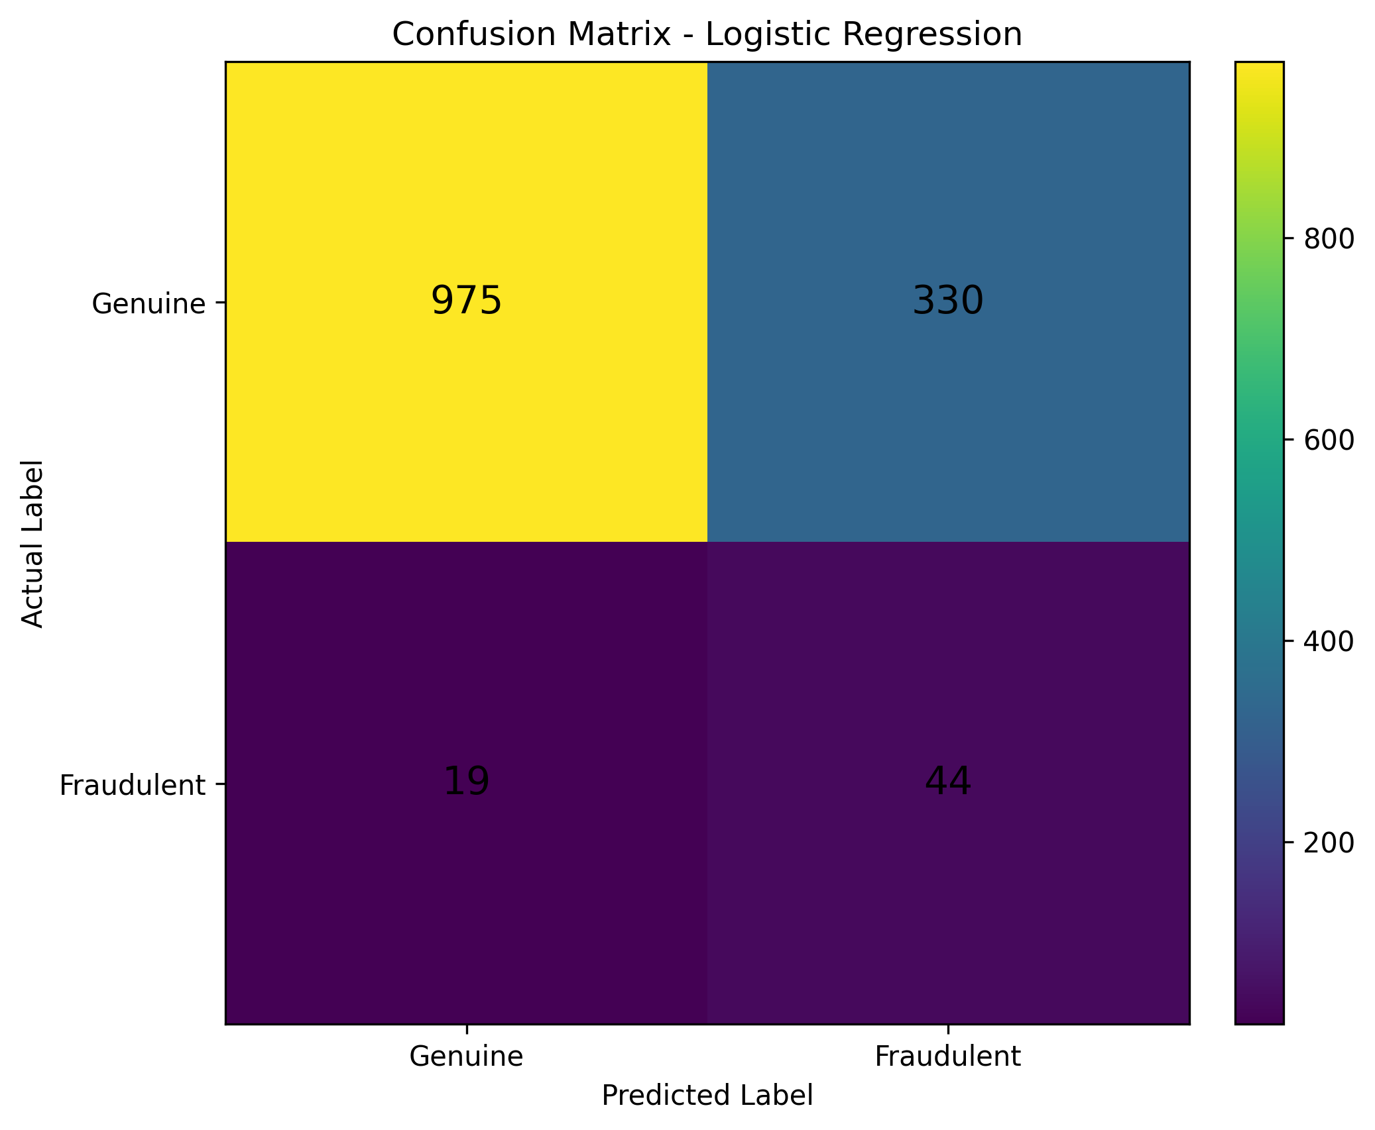
The confusion matrix contains 975 true negatives, 330 false positives, 19 false negatives, and 44 true positives. The large number of false positives is the main weakness of the current classification threshold.

12. Visualization 2 — Evaluation Metric Comparison
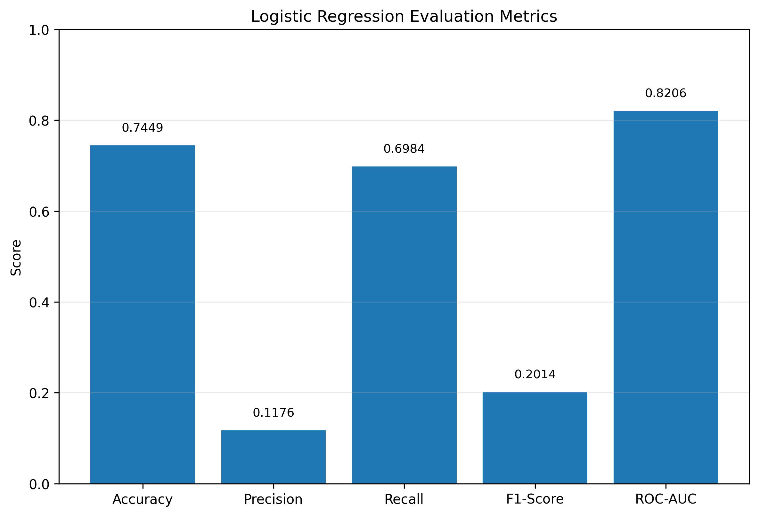
The metric comparison highlights an important difference between the model's overall ranking ability and its classification performance at the default decision threshold. ROC-AUC is 0.8206, while precision is only 0.1176. This indicates that changing the classification threshold and improving the underlying features may be valuable.

13. Error Analysis
The notebook explicitly identifies false positives and false negatives from the test set. There are 330 false positives and 19 false negatives.
Error Type | Count | Meaning
False Positive | 330 | A genuine job posting was predicted as fraudulent.
False Negative | 19 | A fraudulent job posting was predicted as genuine.
For a fraud-detection system, false negatives can be particularly important because they represent fraudulent postings that escape detection. In this model, the false-negative count is relatively small compared with false positives, consistent with the relatively high recall.

14. Critical Discussion: Sources of Error
- Class imbalance: The dataset contains 6,525 genuine postings but only 315 fraudulent postings. This makes accuracy less informative by itself and can make the minority class difficult to model.
- Limited feature set: The model uses only seven structured features. Job title, description, company profile, requirements, benefits, salary information, and other text fields are not used as predictive inputs in the current notebook.
- False-positive rate: The 330 false positives show that the selected features can cause many genuine postings to receive a fraud prediction.
- Model simplicity: Logistic Regression is a useful baseline but may not capture nonlinear relationships and interactions among features.
- Decision threshold: The default classification threshold can favor recall when class_weight='balanced' is used. This can contribute to the low precision observed in the results.
- Missing-value imputation: Replacing missing categorical values with the most frequent category and numerical values with the median is practical, but it may hide information contained in the pattern of missingness.

15. Suggestions for Model Improvement
- Add text-based features from job titles, descriptions, requirements, company profiles, and benefits using TF-IDF or suitable text embeddings.
- Compare Logistic Regression with Decision Tree, Random Forest, Gradient Boosting, or other suitable classifiers to capture nonlinear patterns.
- Tune hyperparameters using cross-validation and GridSearchCV or RandomizedSearchCV.
- Evaluate different probability thresholds using a Precision-Recall curve and choose a threshold according to the business cost of false positives versus false negatives.
- Use stratified cross-validation so minority-class performance is measured more reliably.
- Consider additional imbalance-handling approaches where appropriate, while validating that they improve test-set performance rather than only training performance.
- Add domain-specific engineered features, such as indicators derived from salary information, company profile completeness, unusual posting characteristics, and textual patterns.
- Report PR-AUC in addition to ROC-AUC because the positive class is relatively rare.

16. Overfitting and Underfitting Considerations
The notebook does not provide separate cross-validation results or training-versus-test metrics, so a definitive diagnosis of overfitting or underfitting cannot be made from the supplied results alone. However, Logistic Regression provides a relatively simple baseline. Future work should compare training and validation performance using stratified cross-validation. A large gap between training and validation scores would suggest overfitting, whereas consistently low scores on both would suggest underfitting.

17. Conclusion
The Week 4 machine-learning pipeline successfully builds and evaluates a Logistic Regression model for fake job posting detection. The model achieves 74.49% accuracy and 82.06% ROC-AUC on the test set. Its recall of 69.84% indicates that it detects a substantial proportion of fraudulent postings, but the precision of 11.76% and 330 false positives show that the current feature set and decision threshold are not sufficiently precise.
Overall, the model is a useful baseline and demonstrates the complete model-development process required for the task. The strongest next steps are richer feature engineering, especially text features, model comparison and hyperparameter tuning, cross-validation, and threshold optimization.

18. Reproducibility Notes
The report is based directly on the uploaded Week 4 notebook. The notebook uses random_state=42, an 80/20 stratified train-test split, Logistic Regression with class_weight='balanced', and the preprocessing pipeline described above. The evaluation values and error counts in this report match the notebook outputs.

