WEEK 5 — COMPREHENSIVE DATA SCIENCE PROJECT
Fake Job Posting Detection
End-to-End Data Science Workflow, Statistical Analysis, Machine Learning and Evaluation

1. Executive Summary
This Week 5 project presents a complete Data Science workflow for Fake Job Posting Detection. The notebook covers data acquisition, data cleaning, exploratory data analysis, visualization, statistical analysis and hypothesis testing, machine learning, model evaluation, business insights, strategic recommendations, and future improvements.
The final dataset contains 6,840 labeled job postings. Genuine postings account for 6,525 records (95.39%), while fraudulent postings account for 315 records (4.61%). This strong class imbalance is important when interpreting model performance.
A Logistic Regression model was trained using a preprocessing pipeline with numerical imputation and scaling, categorical imputation and one-hot encoding, and class-balanced learning. The model achieved 74.49% accuracy and 82.06% ROC-AUC. Fraudulent-job recall was 69.84%, while fraudulent-job precision was 11.76%, showing that the baseline model identifies many fraudulent postings but also generates a high number of false positives.

2. Project Objective
The objective is to develop an end-to-end system for analyzing and predicting fraudulent job postings using structured job-posting attributes. The project is designed to demonstrate the complete Data Science lifecycle rather than only model training.
- Acquire and prepare the job-posting dataset.
- Clean the data and inspect missing values and duplicates.
- Explore the distribution of genuine and fraudulent postings.
- Analyze job-posting characteristics associated with fraud.
- Perform statistical analysis and hypothesis testing.
- Build a baseline binary classification model.
- Evaluate the model using multiple classification metrics and visualizations.
- Translate analytical results into business insights and strategic recommendations.
- Identify limitations and future improvement opportunities.

3. Project Stages
- Data Acquisition
- Data Cleaning
- Exploratory Data Analysis
- Advanced Data Visualization
- Statistical Analysis
- Hypothesis Testing
- Machine Learning
- Model Evaluation
- Strategic Recommendations
- Future Improvements

4. Dataset Description
The notebook loads the cleaned dataset from cleaned_fake_job_postings.csv and removes records where the target variable fraudulent is missing. The target is converted to integer format for binary classification.
Dataset Item | Result
Final dataset shape | 6,840 rows × 19 columns
Target variable | fraudulent
Genuine postings | 6,525 (95.39%)
Fraudulent postings | 315 (4.61%)
Duplicate records | 0
Labeled target missing values | 0

5. Data Quality and Missing Values
The notebook reports no duplicate records and no missing values in the final target variable. Several descriptive fields contain missing values, including department, salary_range, company_profile, benefits, employment_type, required_experience, required_education, industry, function, and location. The final machine-learning feature set uses selected variables and handles remaining missing values through preprocessing pipelines.

6. Target Distribution
The target distribution is highly imbalanced. Fraudulent postings represent only 4.61% of the labeled dataset. Consequently, a model can obtain a seemingly reasonable accuracy while still performing poorly on the minority fraudulent class. The notebook therefore evaluates precision, recall, F1-score, ROC-AUC and the confusion matrix in addition to accuracy.

7. Exploratory Fraud Analysis — Company Logo
The notebook compares fraudulent and genuine postings by company-logo presence. The observed fraud rate is 12.15% among postings without a company logo and 2.38% among postings with a company logo.
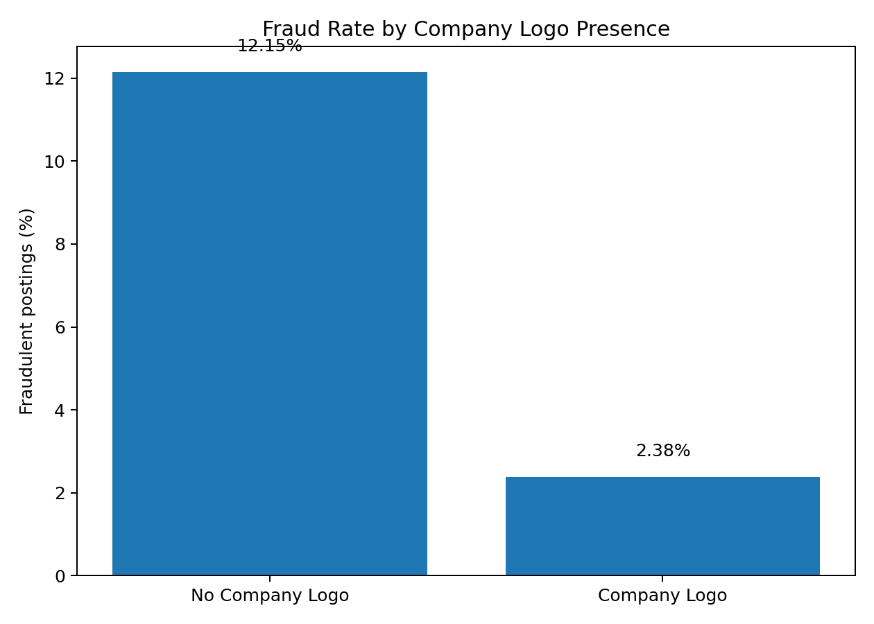
This analysis indicates that company-logo presence is associated with different fraud rates in the dataset. It should be treated as one signal among several rather than as a standalone fraud detector.

8. Statistical Analysis and Hypothesis Testing
A Chi-Square test of independence is applied to company-logo presence and fraudulent status.
Statistic | Value
Chi-Square statistic | 258.8468469536185
p-value | 3.061103938367776e-58
Degrees of freedom | 1
Significance level (α) | 0.05
Since the p-value is far below 0.05, the notebook rejects the null hypothesis and concludes that there is a statistically significant association between company-logo presence and fraudulent job status in this dataset.

9. Machine Learning Feature Selection
The final model uses seven features selected in the notebook:
- telecommuting
- has_company_logo
- has_questions
- employment_type
- required_experience
- required_education
- description_length
These features combine binary indicators, categorical job attributes, and a numerical description-length variable.

10. Data Preprocessing
The notebook implements preprocessing inside a scikit-learn Pipeline and ColumnTransformer. This keeps preprocessing connected to model training and helps prevent inconsistent transformations between training and testing data.

10.1 Numerical preprocessing
- Median imputation for missing numerical values.
- StandardScaler for feature scaling.

10.2 Categorical preprocessing
- Most-frequent imputation for missing categorical values.
- OneHotEncoder(handle_unknown='ignore') for categorical encoding.

11. Train-Test Split
The data is divided into training and testing sets using an 80/20 split with random_state=42 and stratify=y. The training set contains 5,472 records and the testing set contains 1,368 records. Stratification preserves the class distribution across the two sets.

12. Model Selection and Training
The notebook uses Logistic Regression as the final baseline classification model. The classifier is configured with class_weight='balanced' to account for the minority fraudulent class, max_iter=1000 to support convergence, and random_state=42.
The preprocessing and classifier are combined into a single pipeline. The pipeline is fitted on the training data and then used to generate both class predictions and fraud probabilities for the test set.

13. Key Python Workflow
# Features and target
X = df[features]
y = df['fraudulent'].astype(int)
# Train-test split
X_train, X_test, y_train, y_test = train_test_split(
X, y, test_size=0.20, random_state=42, stratify=y
)
# Model pipeline
model = Pipeline([
('preprocessor', preprocessor),
('classifier', LogisticRegression(
class_weight='balanced',
max_iter=1000,
random_state=42
))
])
model.fit(X_train, y_train)
# Predictions and fraud probabilities
y_pred = model.predict(X_test)
y_prob = model.predict_proba(X_test)[:, 1]

14. Final Model Evaluation
Metric | Score | Interpretation
Accuracy | 74.49% | Overall proportion of correct predictions.
Precision | 11.76% | Only a small proportion of postings predicted as fraudulent were actually fraudulent.
Recall | 69.84% | The model identifies about 70% of the fraudulent postings in the test set.
F1-Score | 20.14% | Low because fraudulent-class precision is very low.
ROC-AUC | 82.06% | Good overall ranking/discrimination capability for the baseline model.

15. Classification Report Analysis
Class | Precision | Recall | F1-Score | Support
Genuine | 0.98 | 0.75 | 0.85 | 1305
Fraudulent | 0.12 | 0.70 | 0.20 | 63
The genuine class is classified strongly, with precision 0.98 and F1-score 0.85. For the fraudulent class, recall is substantially better than precision. This is consistent with the use of class-balanced Logistic Regression: the model is encouraged to identify more minority-class cases, which increases fraud detection but also increases false positives.

16. Confusion Matrix
The test confusion matrix corresponds to 975 true negatives, 330 false positives, 19 false negatives, and 44 true positives.
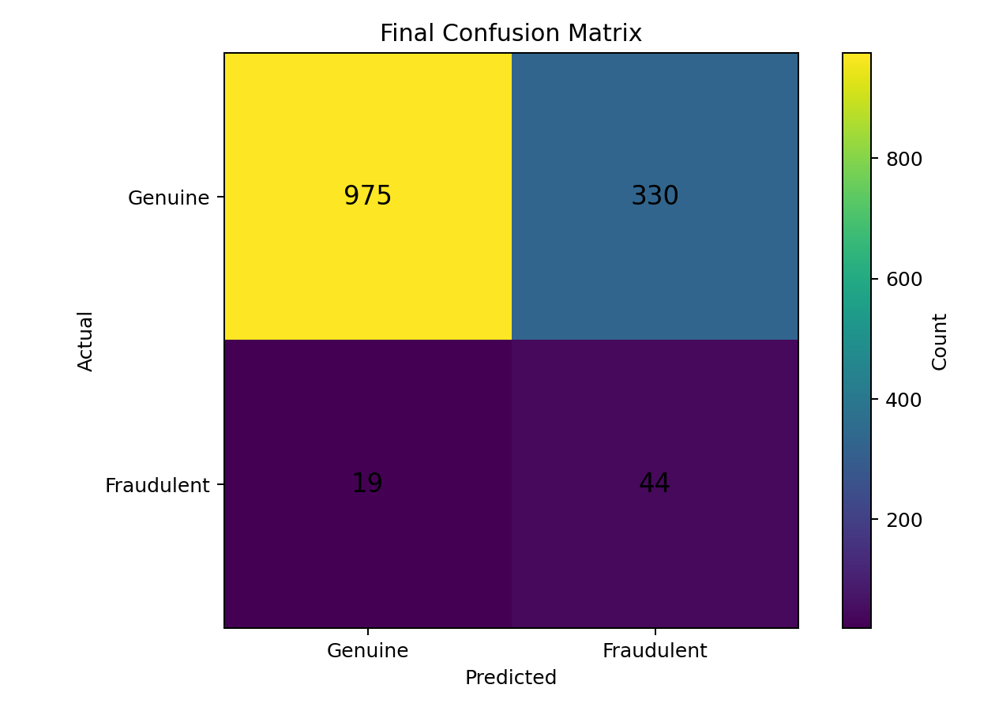
- True Negative (975): genuine postings correctly classified as genuine.
- False Positive (330): genuine postings incorrectly flagged as fraudulent.
- False Negative (19): fraudulent postings incorrectly classified as genuine.
- True Positive (44): fraudulent postings correctly identified.
False negatives are especially important from a user-protection perspective because they represent fraudulent postings that pass through the screening model as genuine. At the same time, the large number of false positives shows that the baseline model is not yet suitable for automatic removal without additional review.

17. Model Metrics Visualization
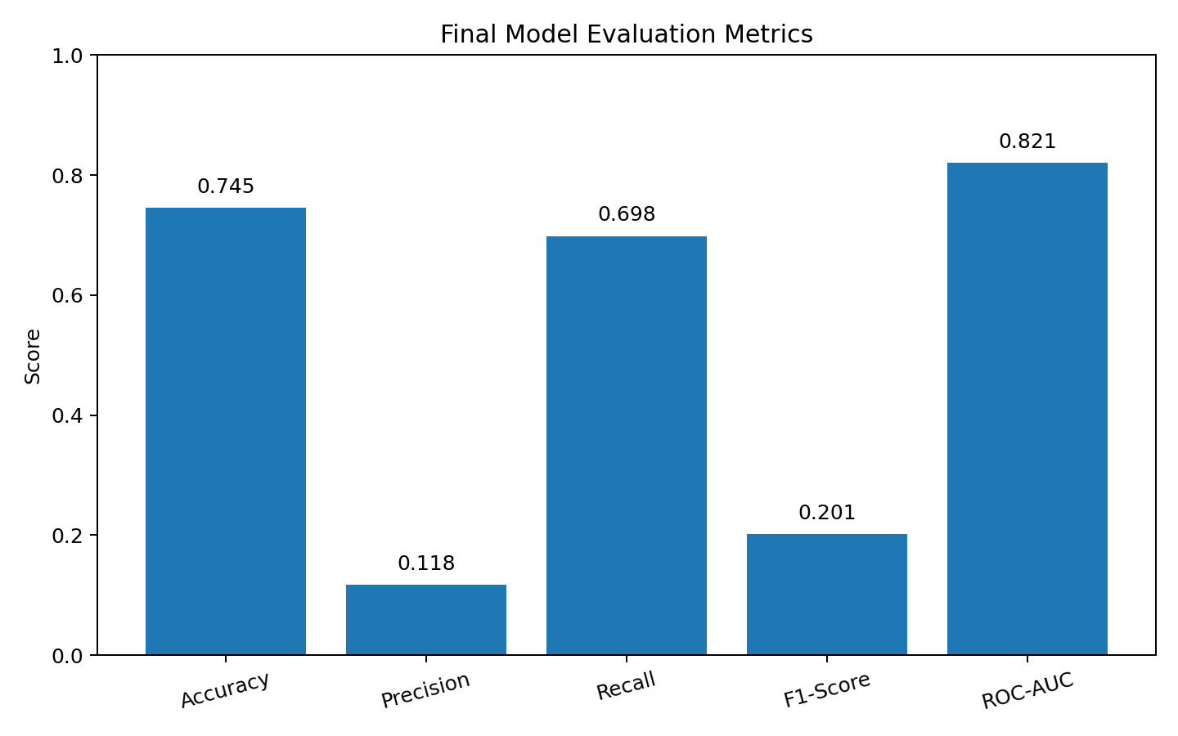
The metric comparison highlights an important pattern: ROC-AUC and recall are relatively strong, whereas precision and F1-score for the minority fraud class are much lower.

18. ROC Curve and Precision-Recall Curve
The notebook generates both a ROC Curve and a Precision-Recall Curve using the predicted fraud probabilities. The ROC curve summarizes the trade-off between true-positive rate and false-positive rate across thresholds, while the Precision-Recall curve is particularly useful for understanding minority-class performance in an imbalanced classification problem.
The reported ROC-AUC of 0.8206 indicates that the baseline model has useful discriminatory ability. However, the low fraud precision indicates that threshold selection and/or stronger features are needed before practical deployment.

19. Error Analysis
- The dominant error type is false positives: 330 genuine postings were flagged as fraudulent.
- Only 19 fraudulent postings were missed, giving a fraud recall of 69.84%.
- Low fraud precision (11.76%) means many alerts would require human review.
- Class imbalance makes accuracy alone an inadequate measure of fraud-detection quality.
- The seven structured features capture useful signals but do not fully represent the textual and contextual information contained in job postings.

20. Key Business Insights
- The dataset contains substantially more genuine postings than fraudulent postings.
- Fraudulent postings form a minority class and therefore require imbalance-aware evaluation.
- Job-posting characteristics can provide useful signals for identifying potentially fraudulent postings.
- Company-logo presence shows a statistically significant association with fraudulent status in this dataset.
- Logistic Regression provides a transparent baseline for binary fake-job classification.
- Multiple evaluation metrics are required; accuracy alone can be misleading.
- False negatives are particularly important because they correspond to fraudulent postings incorrectly treated as genuine.

21. Strategic Recommendations
- Automated Job Screening — use the model to prioritize suspicious postings for review.
- Multi-Signal Detection — combine multiple job-posting characteristics instead of relying on a single feature.
- Human Verification — route high-risk postings to human moderators before removal or approval.
- Improve Fraud Recall — continue optimizing for detection of fraudulent postings while controlling false positives.
- Use NLP — analyze job titles, descriptions, requirements, company profiles, benefits, and other text fields.
- Continuous Monitoring — retrain and monitor the model as fraud patterns change.
- User Protection — flag potentially suspicious postings and provide appropriate warnings to job seekers.

22. Limitations
- The model is a baseline Logistic Regression system rather than a production-grade fraud-detection engine.
- The structured feature set excludes most of the rich textual information available in the dataset.
- The minority fraud class is relatively small compared with the genuine class.
- The current result has a high false-positive count, limiting fully automated decision-making.
- The notebook does not establish production performance on future or independently collected job postings.

23. Future Improvements
- Apply Natural Language Processing using TF-IDF, word embeddings, or transformer-based representations.
- Experiment with tree-based and boosting algorithms such as Random Forest and gradient-boosting methods.
- Use class-imbalance techniques such as SMOTE where appropriate and compare against class-weighted models.
- Perform hyperparameter tuning and cross-validation.
- Optimize the decision threshold based on the operational cost of false positives and false negatives.
- Add explainability methods so moderators can understand why a posting was flagged.
- Deploy the model through an API or web application for practical screening.
- Continuously retrain the system with newly labeled fraud examples.

24. Conclusion
This Week 5 project demonstrates a complete end-to-end Data Science workflow for Fake Job Posting Detection. It combines data cleaning, exploratory analysis, visualization, statistical testing, machine learning, evaluation, business interpretation, and strategic recommendations.
The final dataset contains 6,840 labeled records, with fraudulent postings representing 4.61% of the data. Logistic Regression with class-balanced learning achieved 74.49% accuracy, 69.84% fraud recall, and 82.06% ROC-AUC. The strongest limitation is the low fraud precision of 11.76% and the resulting high number of false positives.
Therefore, the notebook's model should be considered a useful baseline rather than a final production solution. Future versions should incorporate NLP, stronger machine-learning algorithms, threshold optimization, imbalance-handling techniques, explainability, and continuous monitoring.

25. Reproducibility Information
- Dataset: cleaned_fake_job_postings.csv
- Target: fraudulent
- Train/test ratio: 80/20
- Random state: 42
- Split strategy: stratified
- Classifier: Logistic Regression
- Class balancing: class_weight='balanced'
- Numerical preprocessing: median imputation + StandardScaler
- Categorical preprocessing: most-frequent imputation + OneHotEncoder(handle_unknown='ignore')
- Evaluation: Accuracy, Precision, Recall, F1-Score, ROC-AUC, Classification Report, Confusion Matrix, ROC Curve, Precision-Recall Curve

