XYZ Company

~ Employee Records

Contents:

1. Introduction
2. Technical Stack
3. Build and Deployment
4. Authentication
5. Validation
6. Images(Screenshots)

Developer : M Venu Gopal

Mail ID : [venumalladi18@gmail.com](mailto:venumalladi18@gmail.com)

Github Repo : [Django-React-CRUD](https://github.com/VenuGopal1899/django-react)

**Introduction:**

Django-React-CRUD App is used to perform CRUD Operations (Create, Read, Update,Delete) on the Employee Records of XYZ Company.

**Requirements :**

* List the Employee Records of XYZ Company
* User should be Create (Add new employee), Read (Read the list of employees), Update (Update the details of existing employee) and Delete (Delete an employee from the list)
* Only Authenticated Users should be able to perform Create, Update and Delete Operations (they must be protected) whereas any user should be able to perform Read Operation and get the list of employees

**Technical Stack:**

1. To keep all the dependencies required by this Project isolated, Python Virtual Environment has been used.
2. Backend API has been built using Python and Django framework
3. Front-end has been built using ReactJS
4. CSS, Bootstrap and Reactstrap have been used to style the front-end application
5. User will be able to perform CRUD operations only after successful login
6. As of now, Signing Up a new User feature shall be added based on requirements.

**Build and Deployment:**

**Setup :**

1. Download the zip file and extract the code from the above mentioned Github Repository.
2. Make sure python3 and virtualenv are installed on your system.
3. Else to install virtualenv run the command - **pip3 install virtualenv**
4. After successful installation run - **source xyz_env/bin/activate**
5. Once the virtual environment is activated, the name (**xyz_env**) of your virtual environment will appear on the left side of your terminal. This will let you know that the virtual environment is currently active.

(As shown in Fig-1 below)

1. Now run the command : **pip3 install -r requirements.txt**
2. This will download all python packages required for the project

**Backend :**

1. Now, change directory, **cd django_react_proj**
2. To start and run the Backend server, use the command: **python manage.py runserver** (In **django_react_proj** folder)

(As shown in Fig-2 below)

1. Backend will run on, localhost:8000/
2. Open localhost:8000/api/employees in browser. This allows you to

check your current status of db.

(As shown in Fig-3 below)

**Frontend :**

1. To start running front-end make sure NodeJS is installed on your

system. Now, open Node.js command prompt.

1. Change your current directory from root (Root user) to **front-end**

**folder** and run the command : **npm install**

1. This will install all node-packages required based on package.json

file in the **front-end folder**

1. After successful installation, run command: **npm start**

This will run our front-end application on localhost:3000/

(As shown in Fig-4 below)

1. A login form will be loaded and on successful login :

Username : owl

Password : owl

On incorrect credentials, error will be shown.

You will be redirected to localhost:3000/employees-list/ which will

let you perform all required CRUD Operations on the backend.

(As shown in Fig-5a&5b&6 below)

**Authentication:**

For now, Sign Up feature hasn’t been added and form validation is done using Auth Token, but this can be further developed into database of User accounts in the backend API

**Validations:**

**Adding a new Employee to DataBase:**

* EMP ID : Employee ID will be Unique ID assigned by the company

to that particular Employee (Cannot be Empty)

* EMP Name : Name of the Employee (Cannot be Empty)
* EMAIL : Mail ID of the Employee (Cannot be Empty and should be

valid mail id (Validated based on Input type))

* Phone : Contact number of the Employee (Cannot be Empty and

Input should be a valid phone number(Validated based on RegEx - Regular Expression)))

* As shown in Fig-7a & 7b & 7c & 7d & 8 below

**Editing an existing Employee from the DataBase:**

* Initially, existing data from the database will be loaded on the form,

but can be edited as per requirements

* EMP ID : Employee ID will be Unique ID assigned by the company

to that particular Employee (Cannot be Empty)

* EMP Name : Name of the Employee (Cannot be Empty)
* EMAIL : Mail ID of the Employee (Cannot be Empty and should be

valid mail id (Validated based on Input type))

* Phone : Contact number of the Employee (Cannot be Empty and

Input should be a valid phone number(Validated based on RegEx - Regular Expression)))

* As shown in Fig-9&10 below

**Delete an Employee from the DataBase:**

* On clicking Delete button, alert will pop up asking for deletion confirmation
* On further confirmation, employee will be deleted from the database
* On selecting Cancel, no changes will be made to the database
* As shown in Fig-11&12 below

**Screenshots:**

**Fig-1 :**

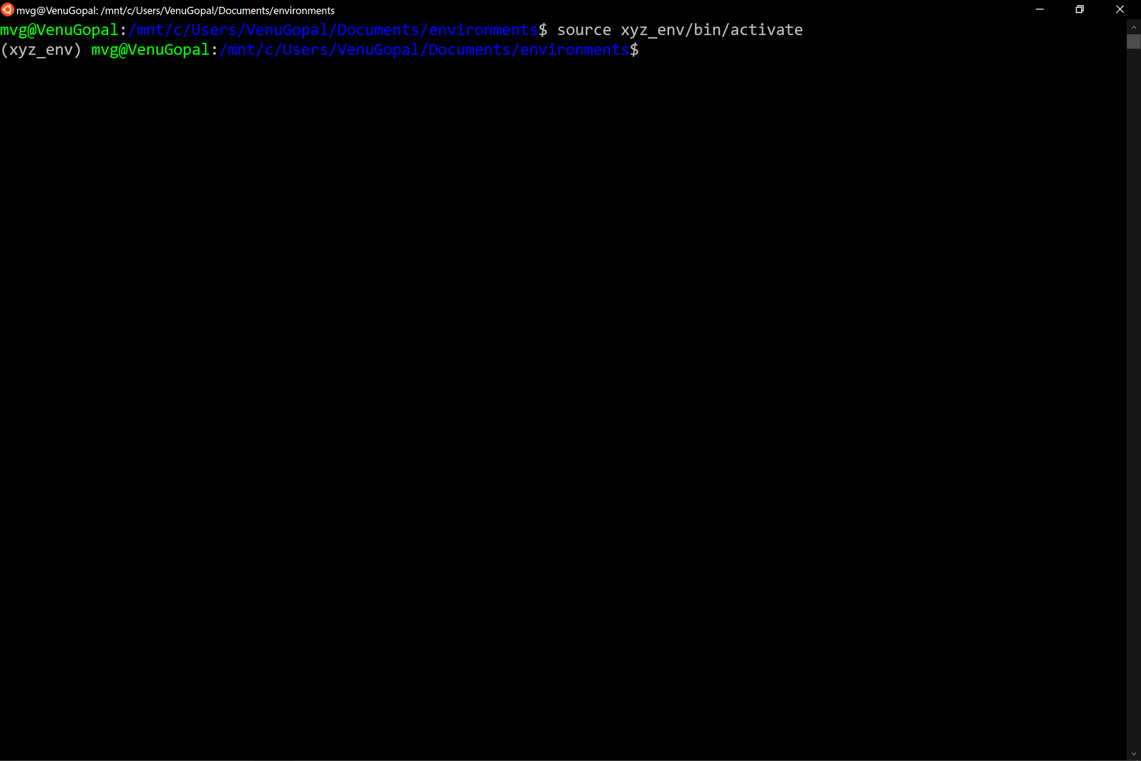

**Fig-2 :**

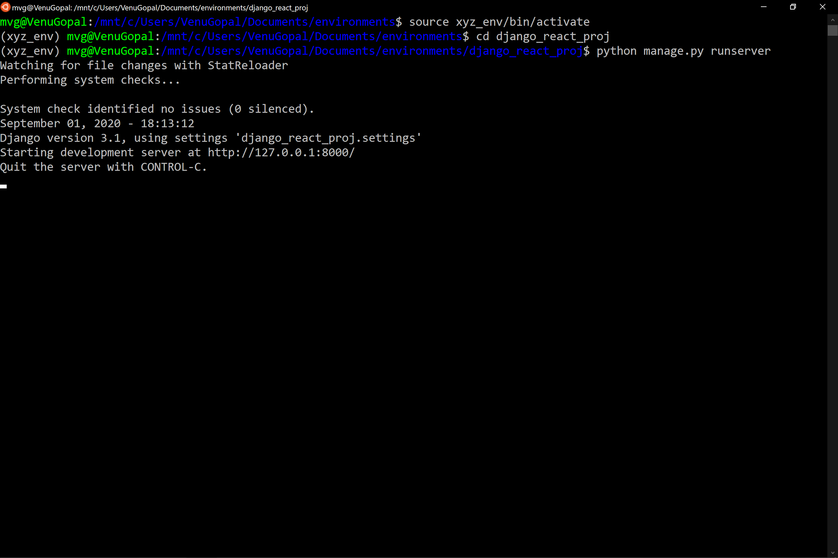

**Fig-3 :**

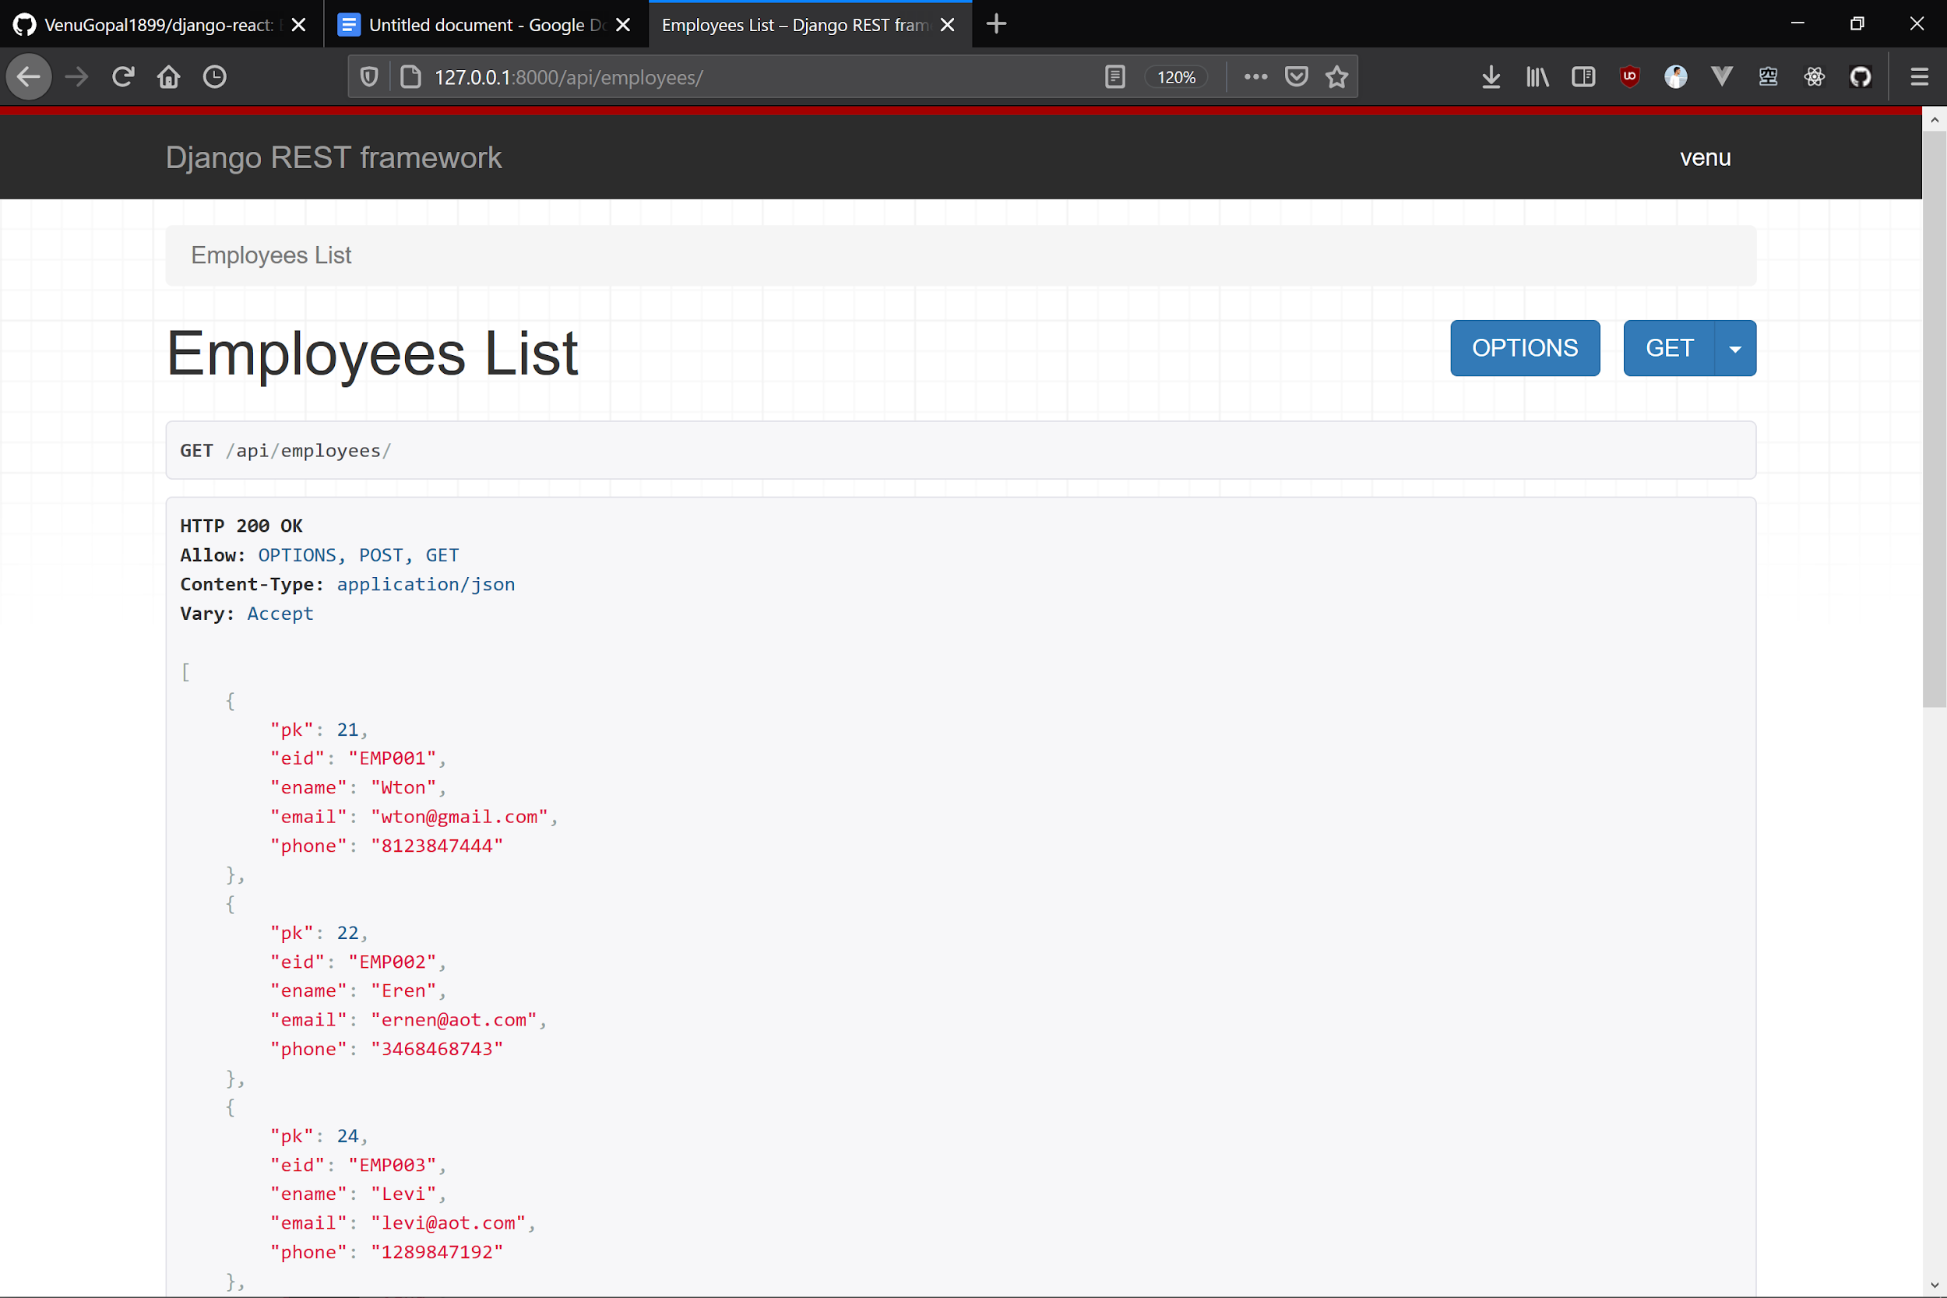

**Fig-4 :**

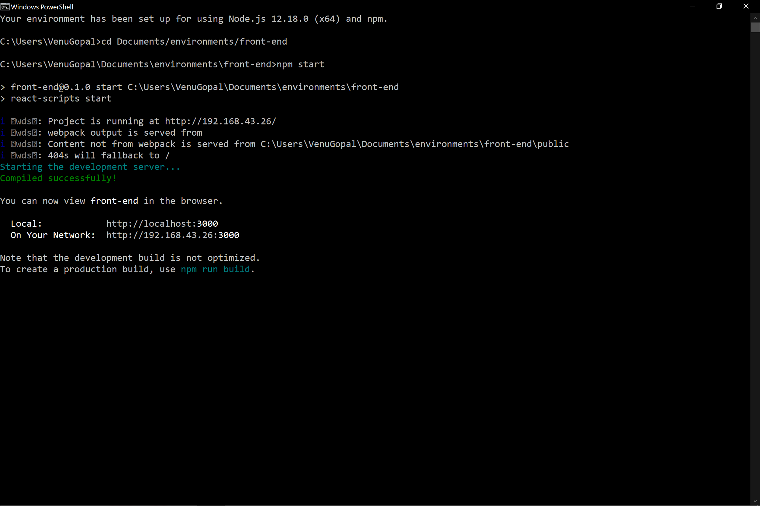

**Fig-5a :**

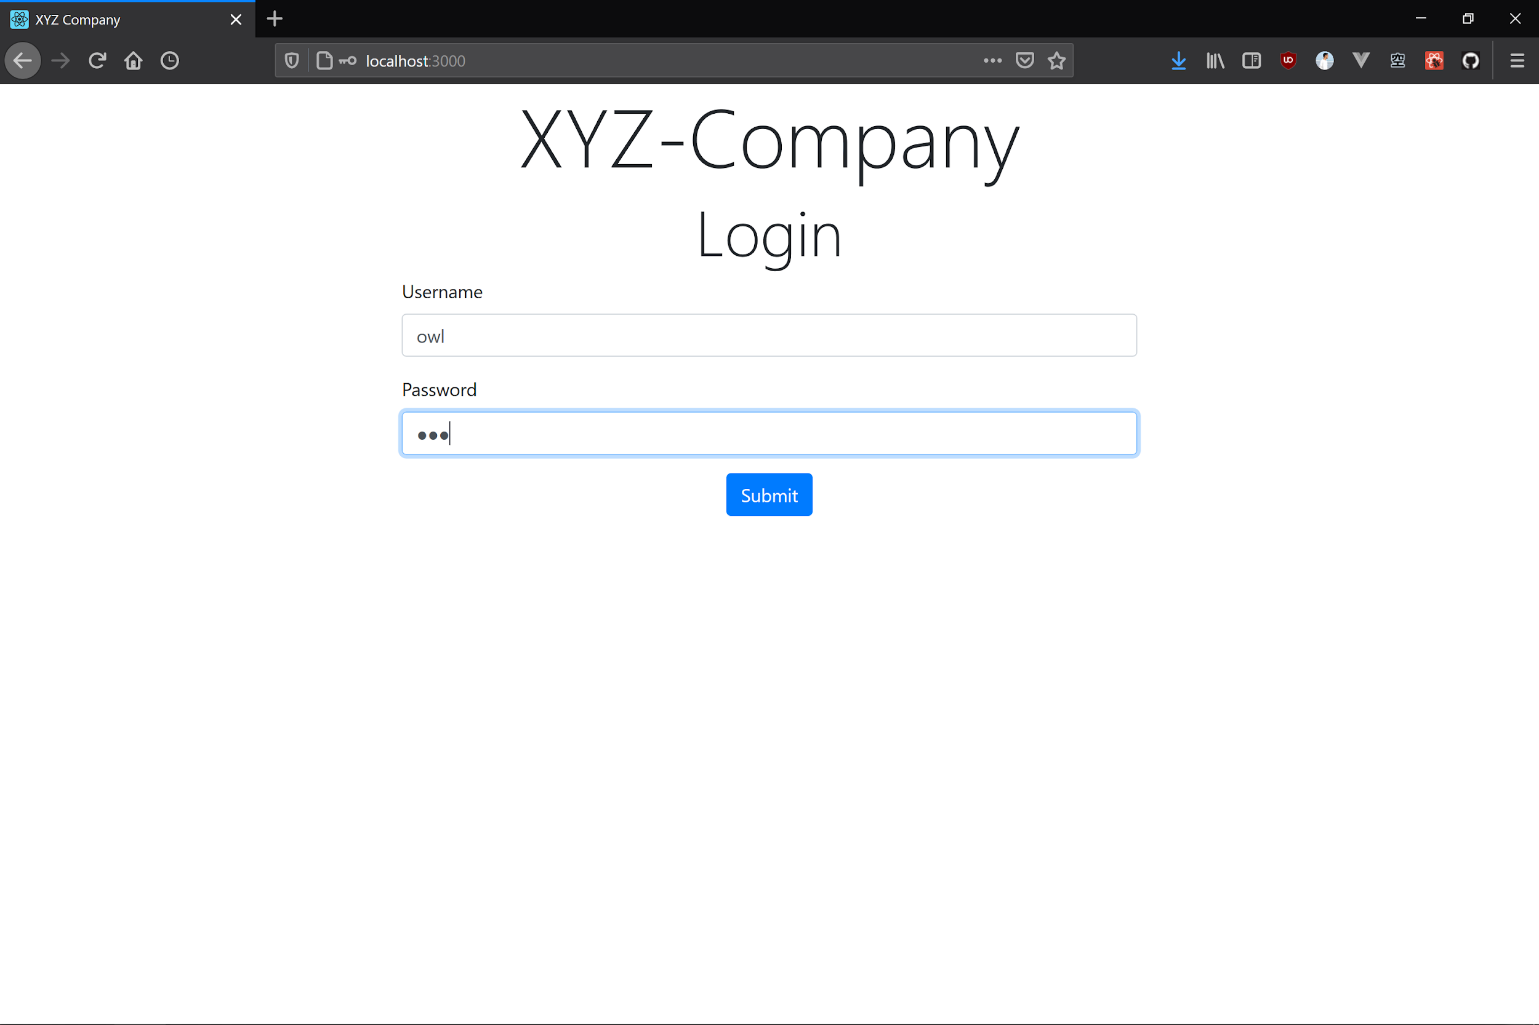

**Fig-5b :**

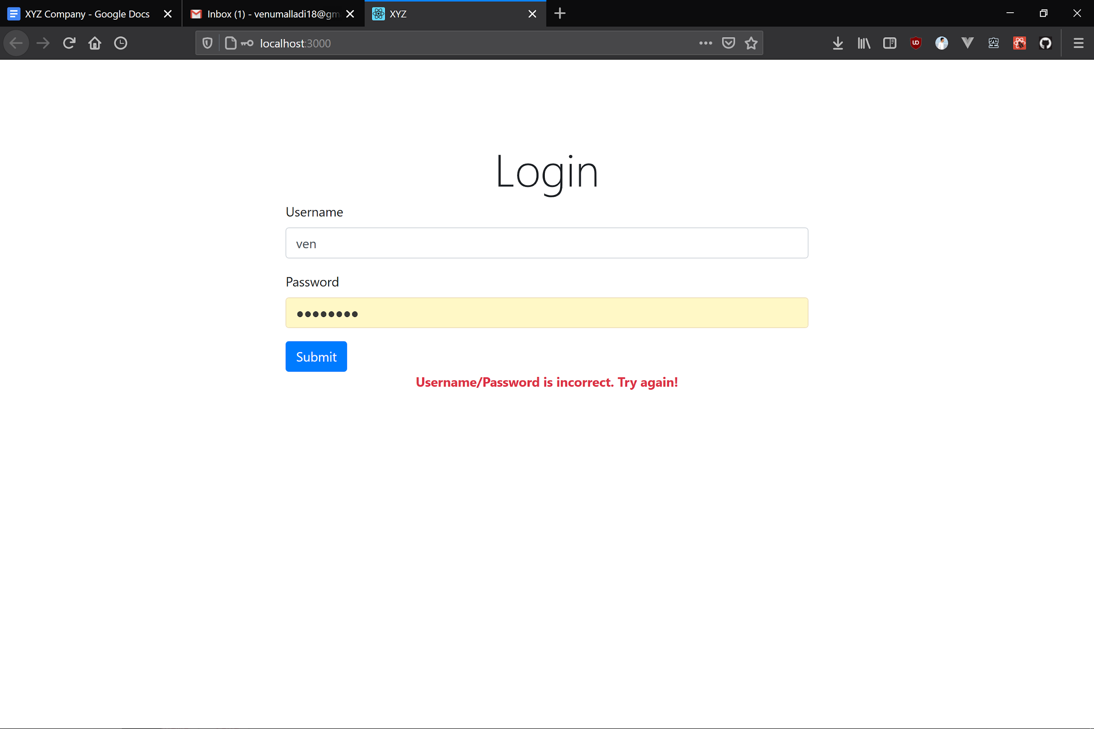

**Fig-6 :**

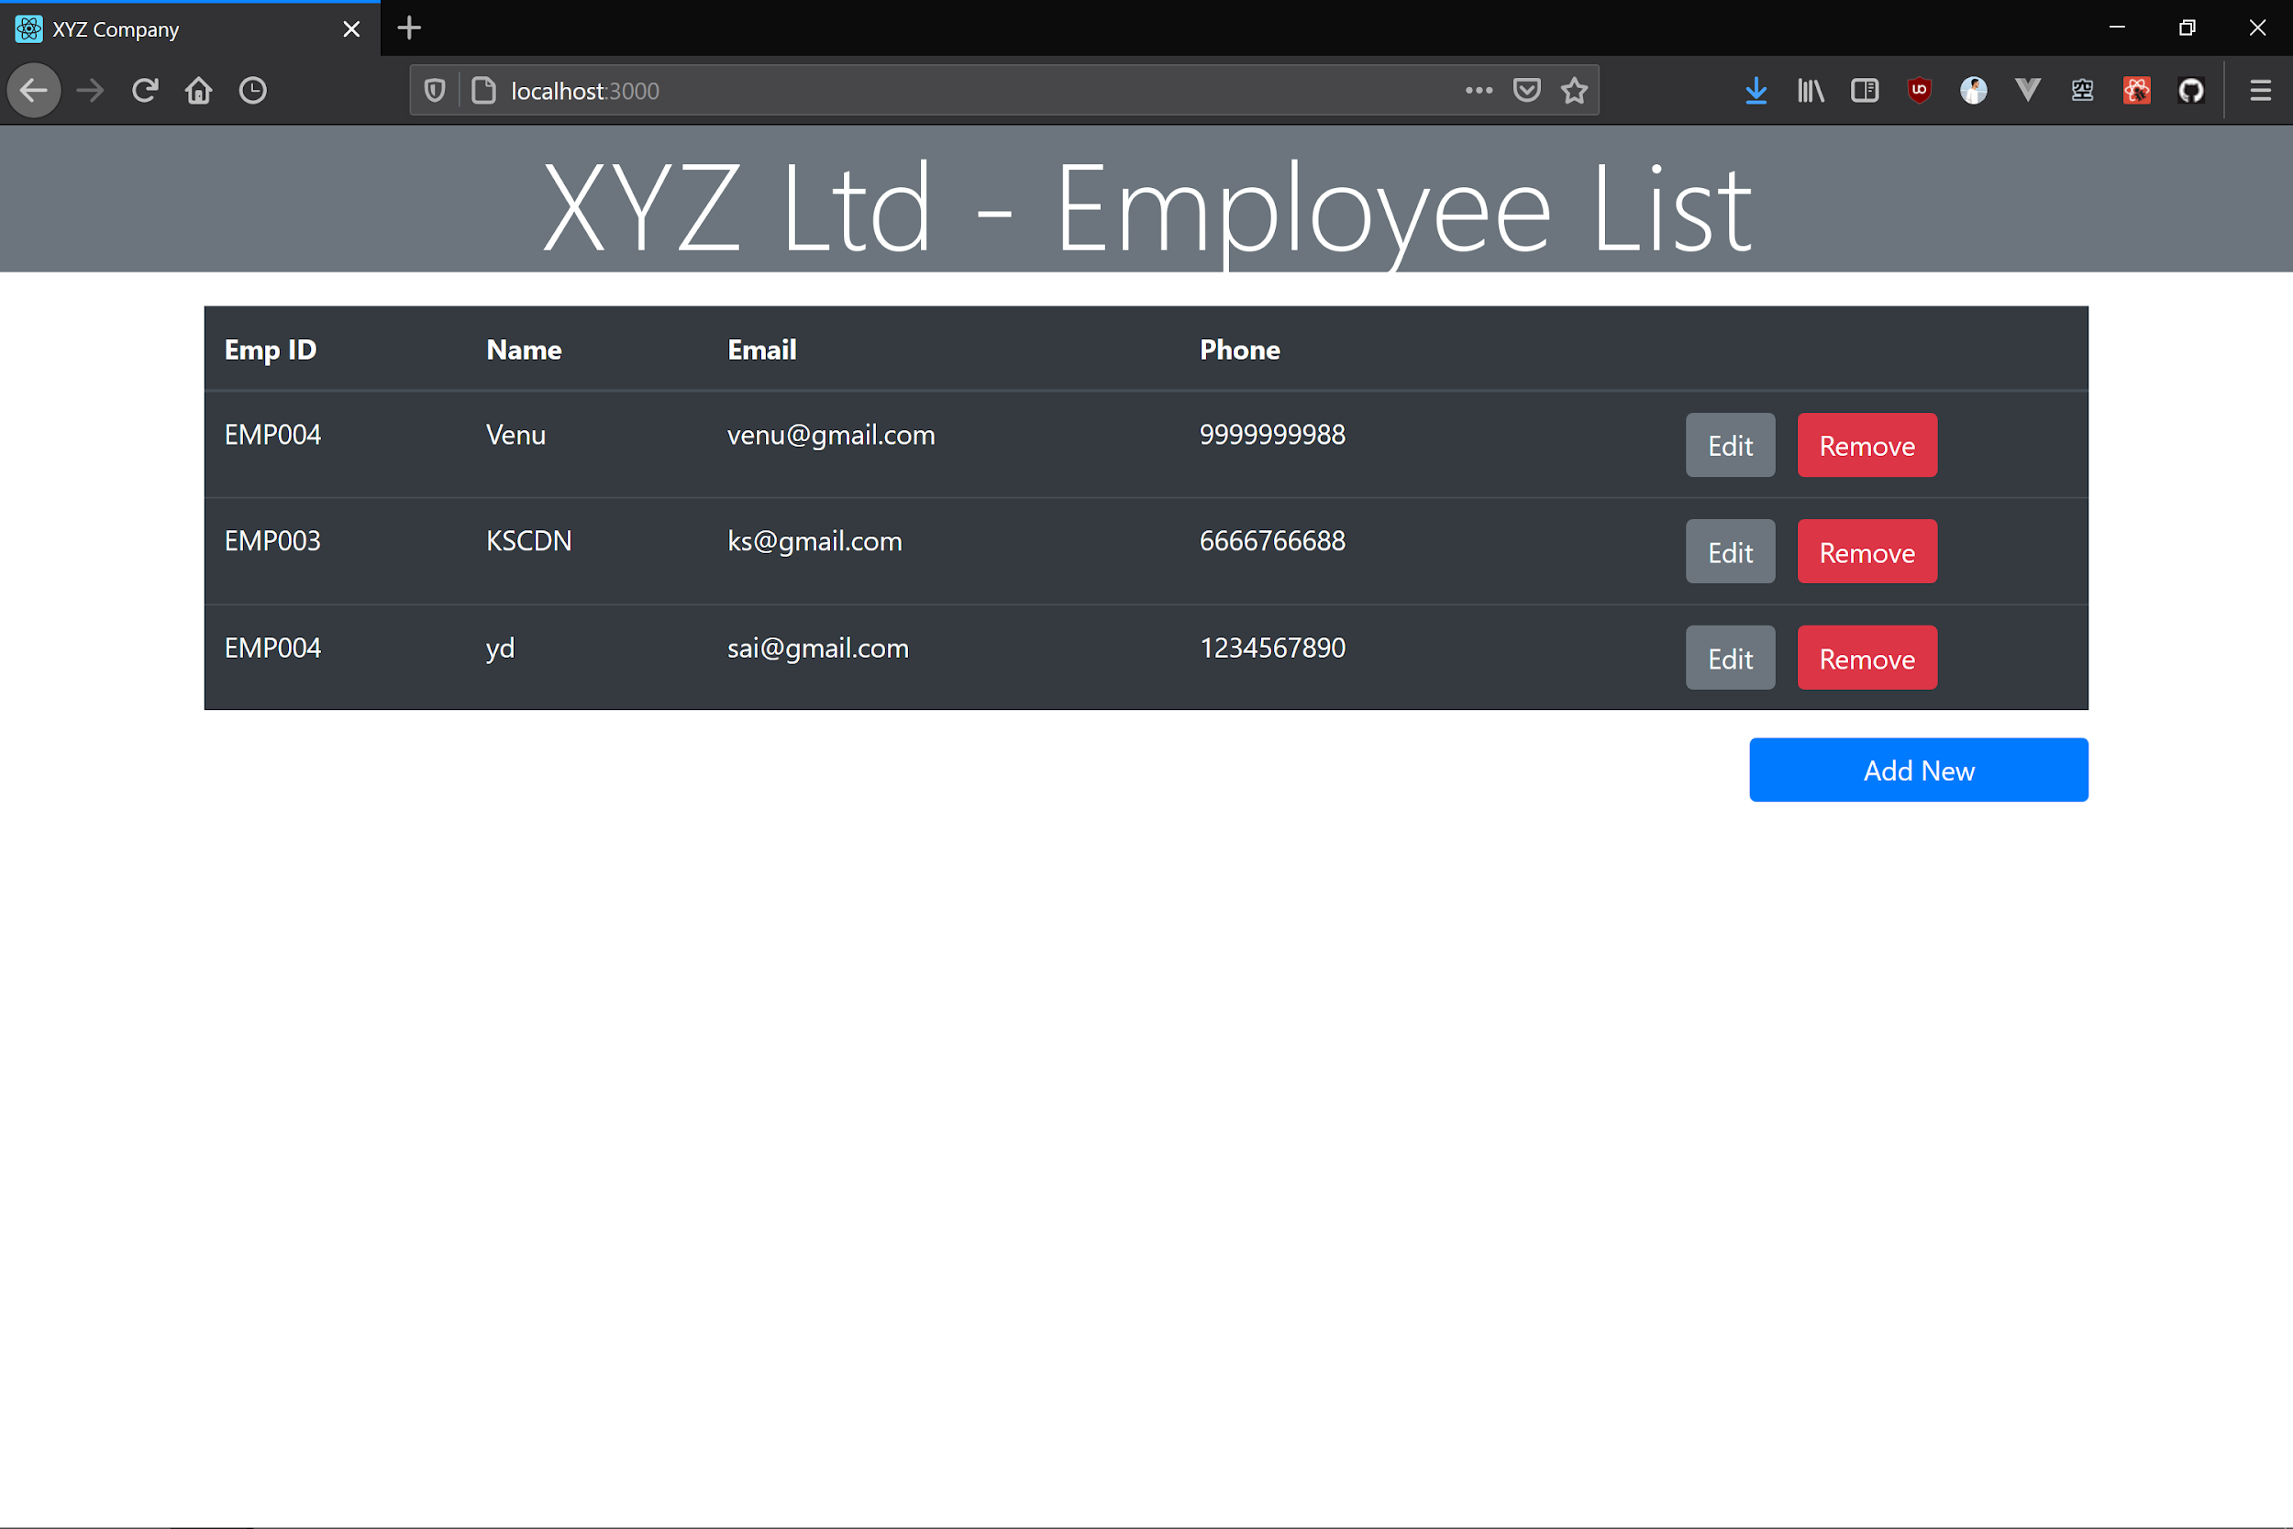

**Fig-7a :**

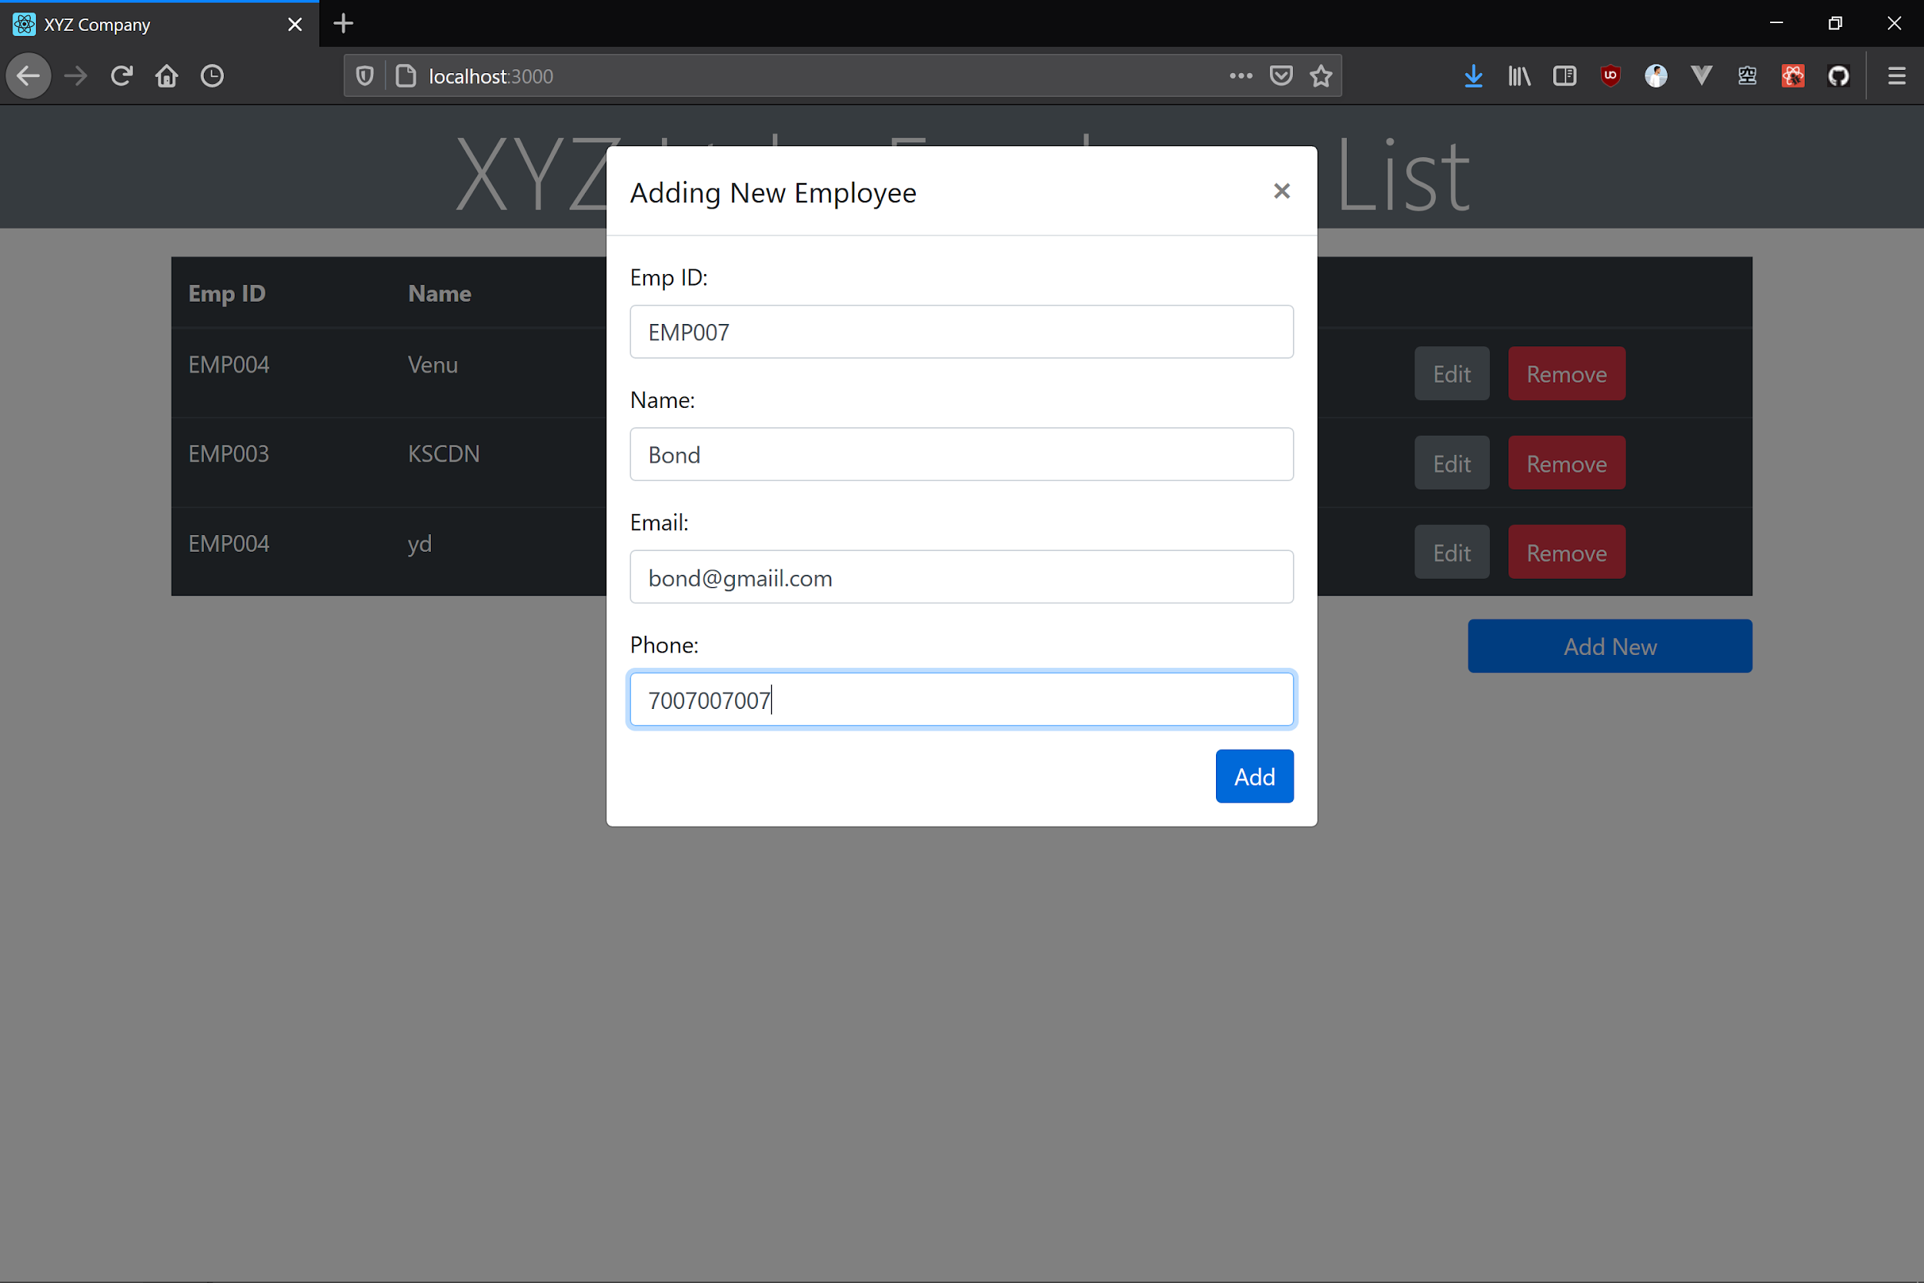

**Fig-7b : (EMPTY FORM SUBMISSION)**

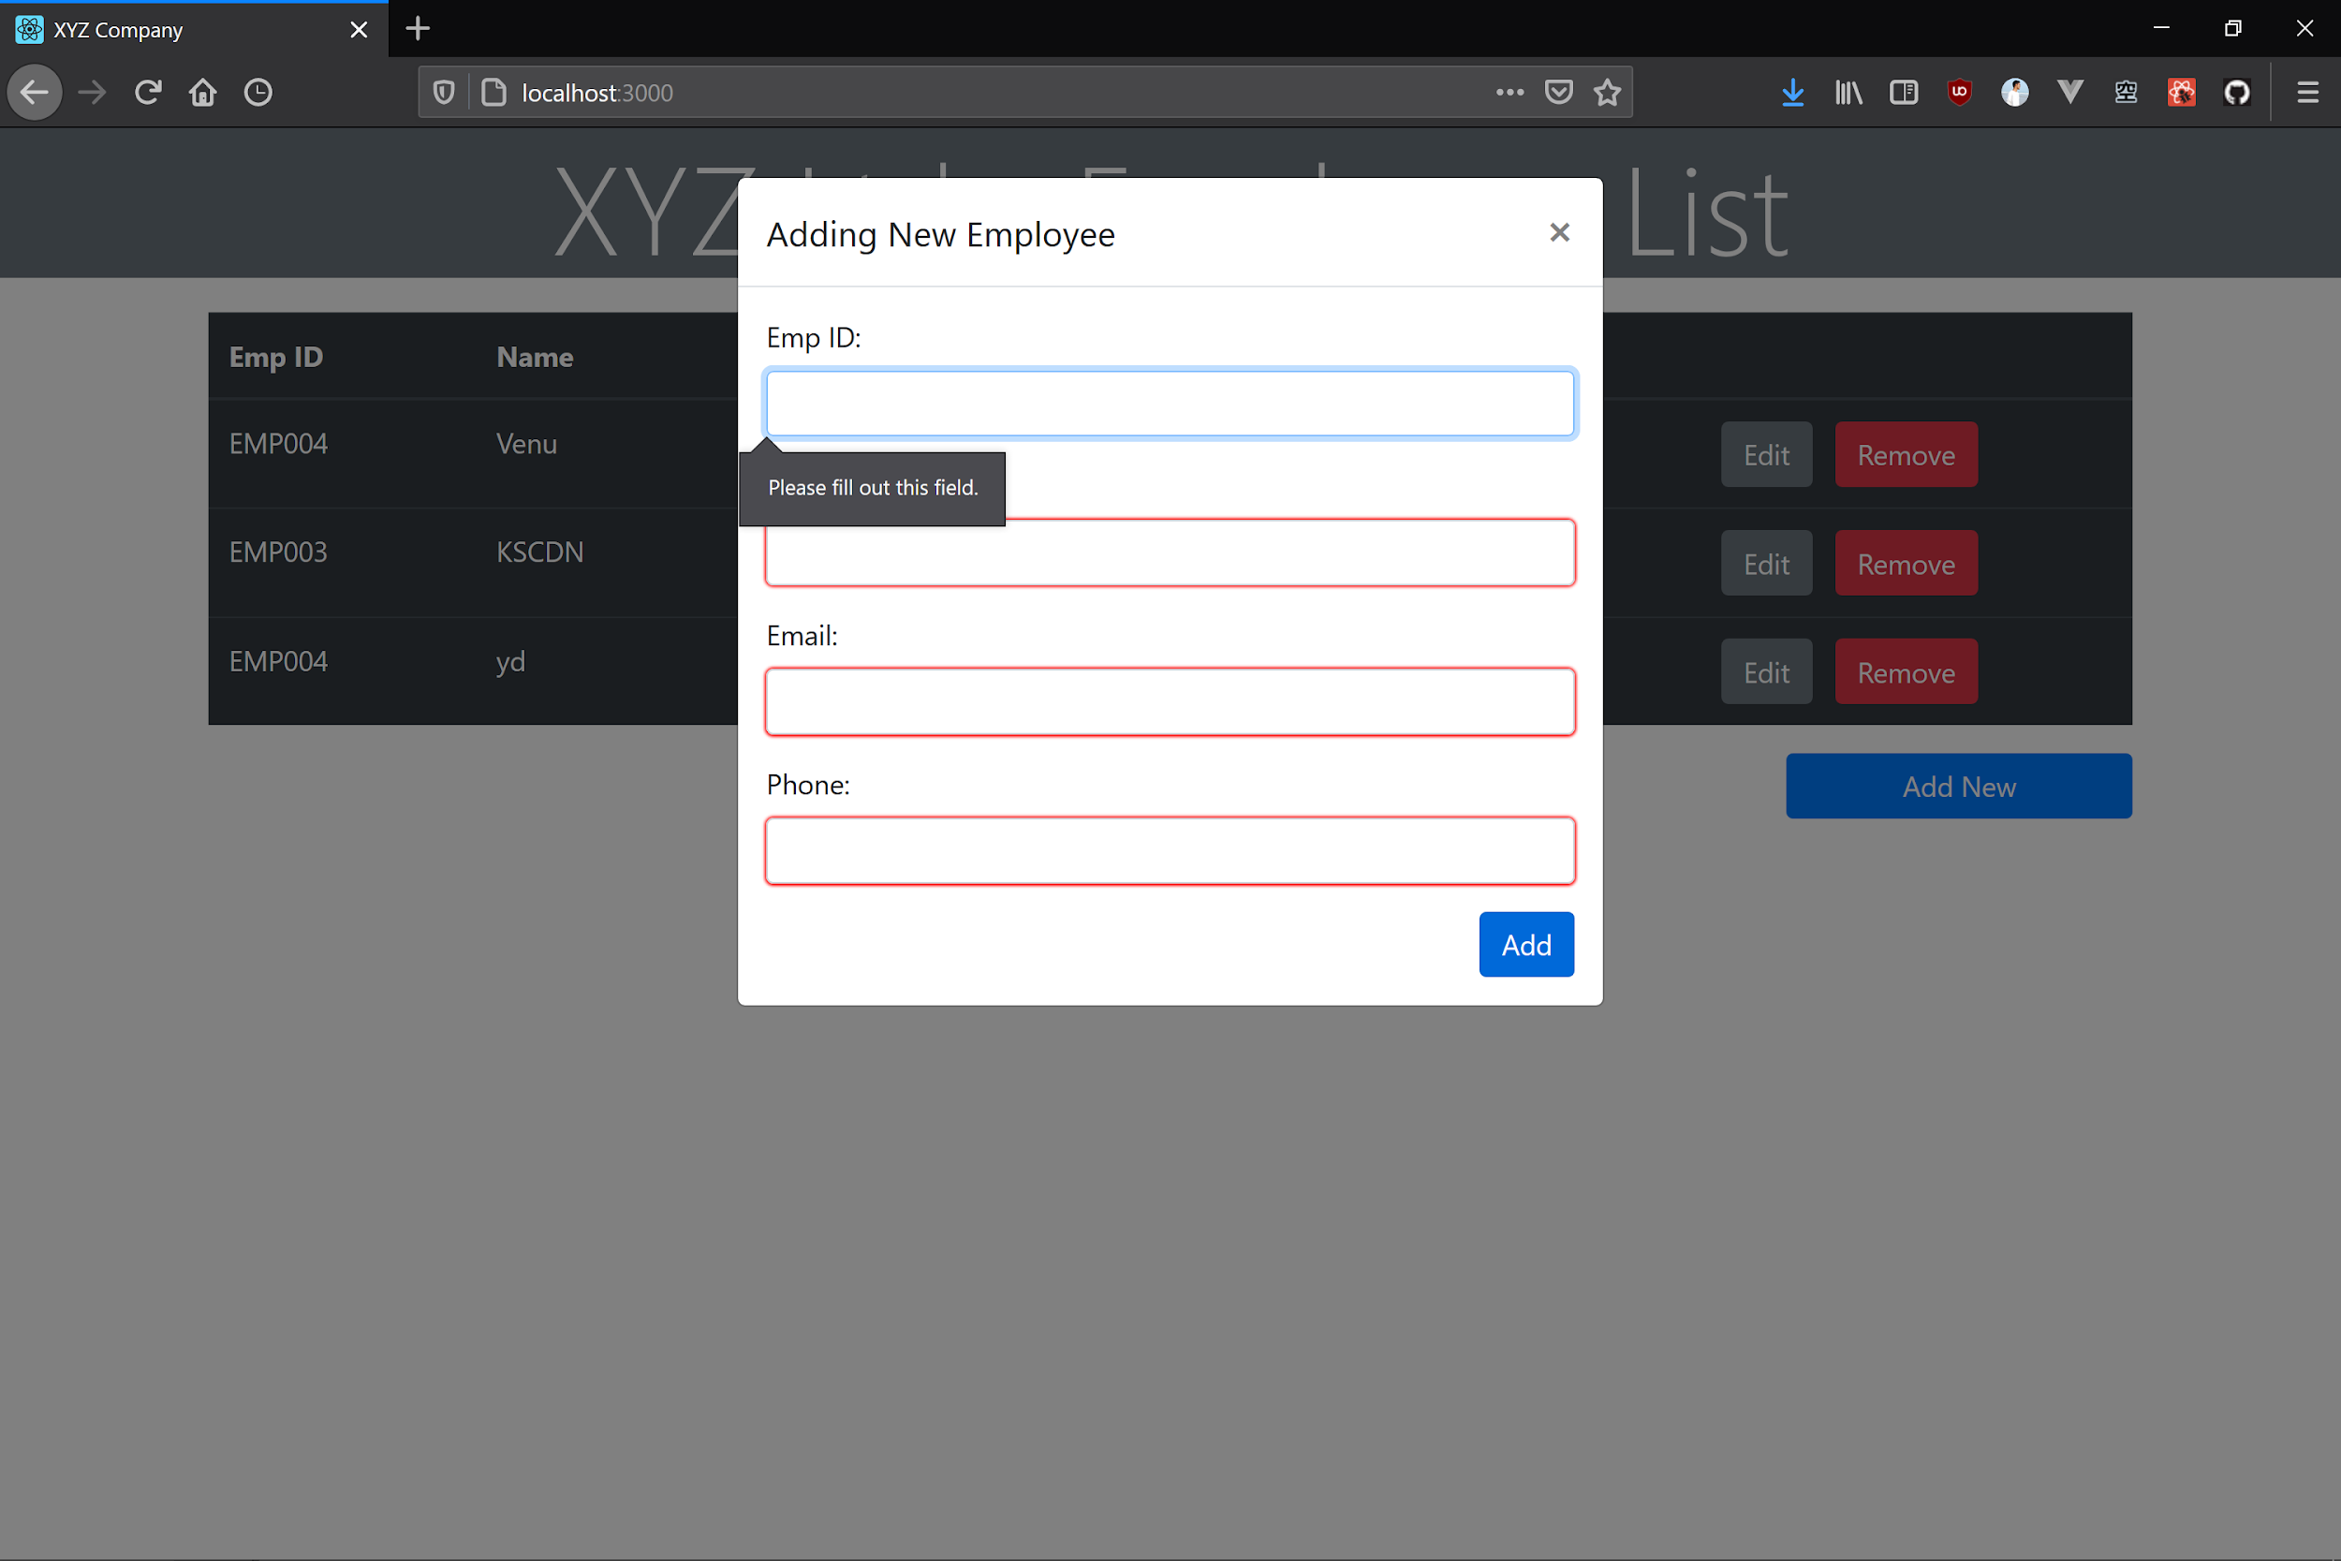

**Fig-7c : (INCORRECT MAIL ID FORMAT)**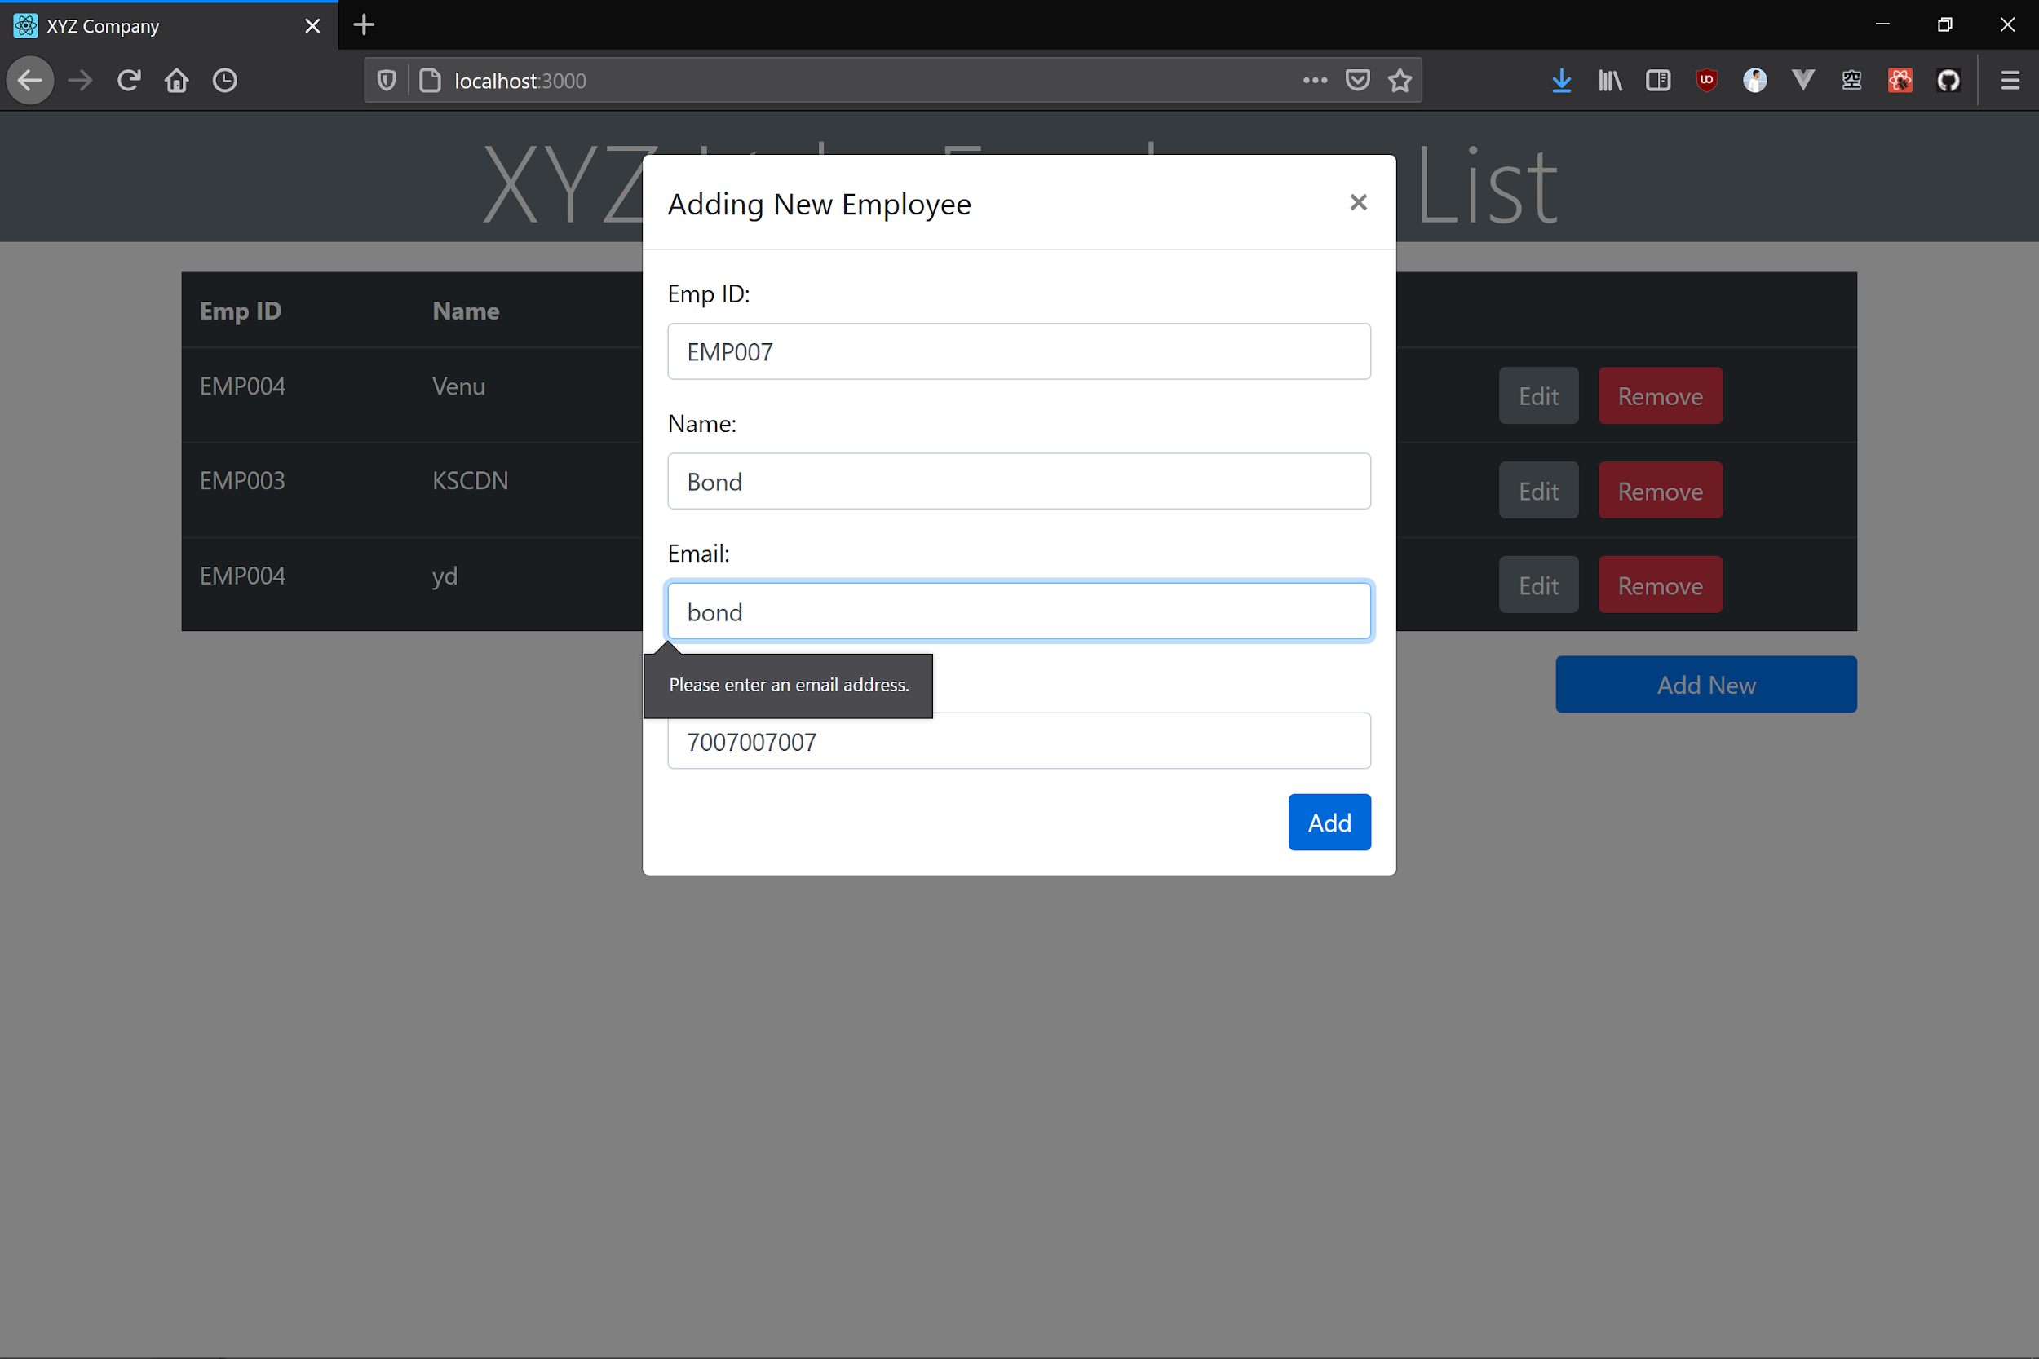

**Fig-7d : (INCORRECT PHONE NUMBER FORMAT)**

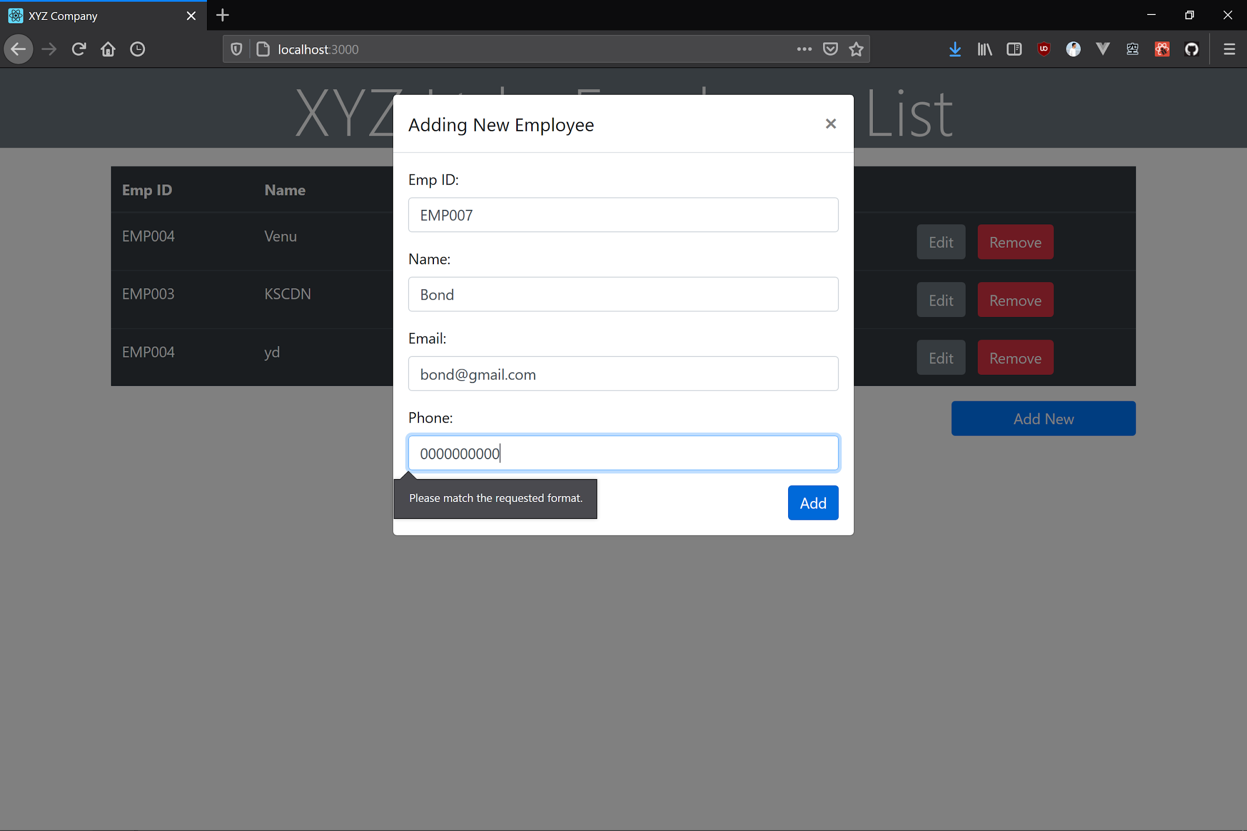**Fig-8 : (ON SUCCESSFUL VALIDATION)**

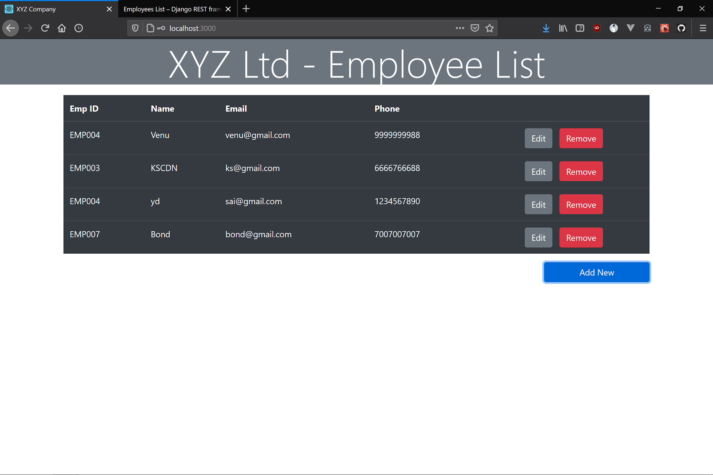

**Fig-9 :**

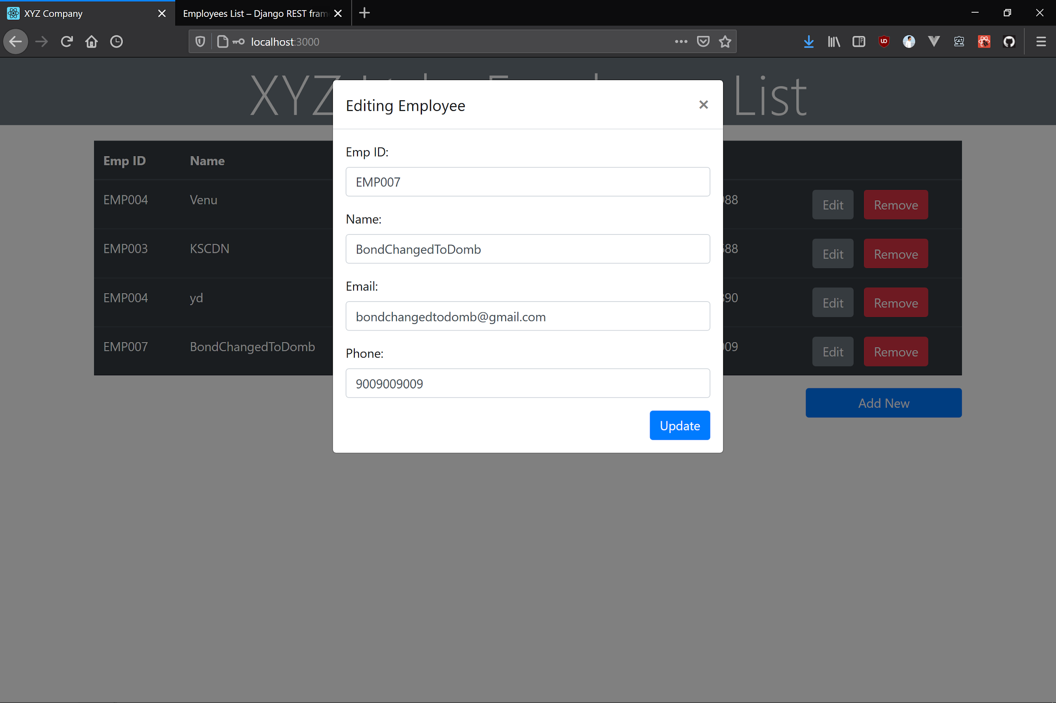

**Fig-10 : (ON SUCCESSFUL VALIDATION)**

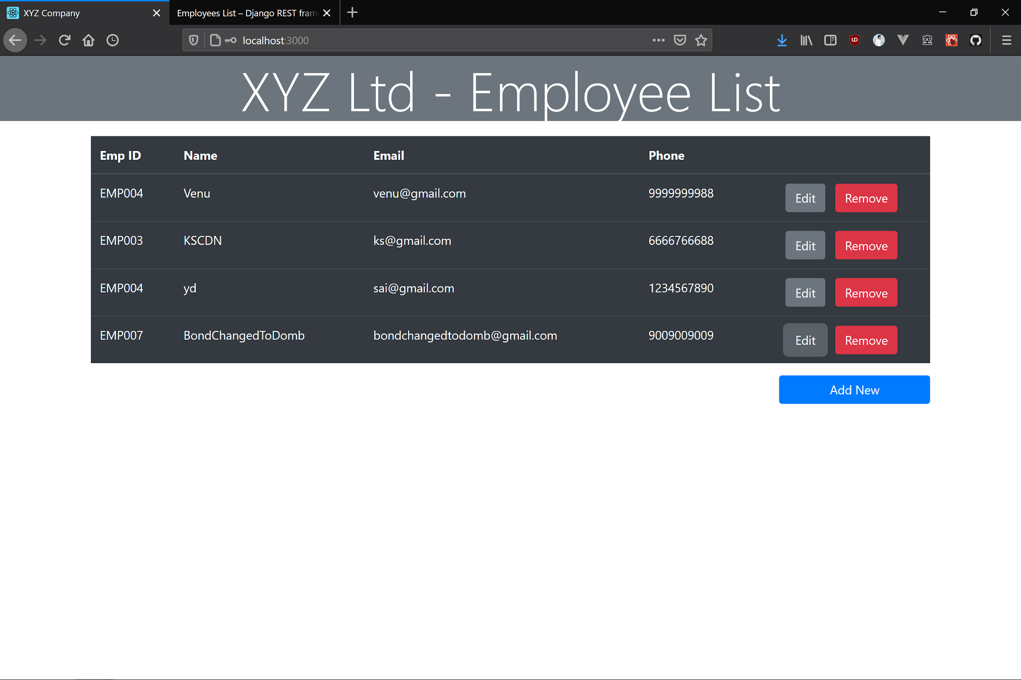

**Fig-11 :**

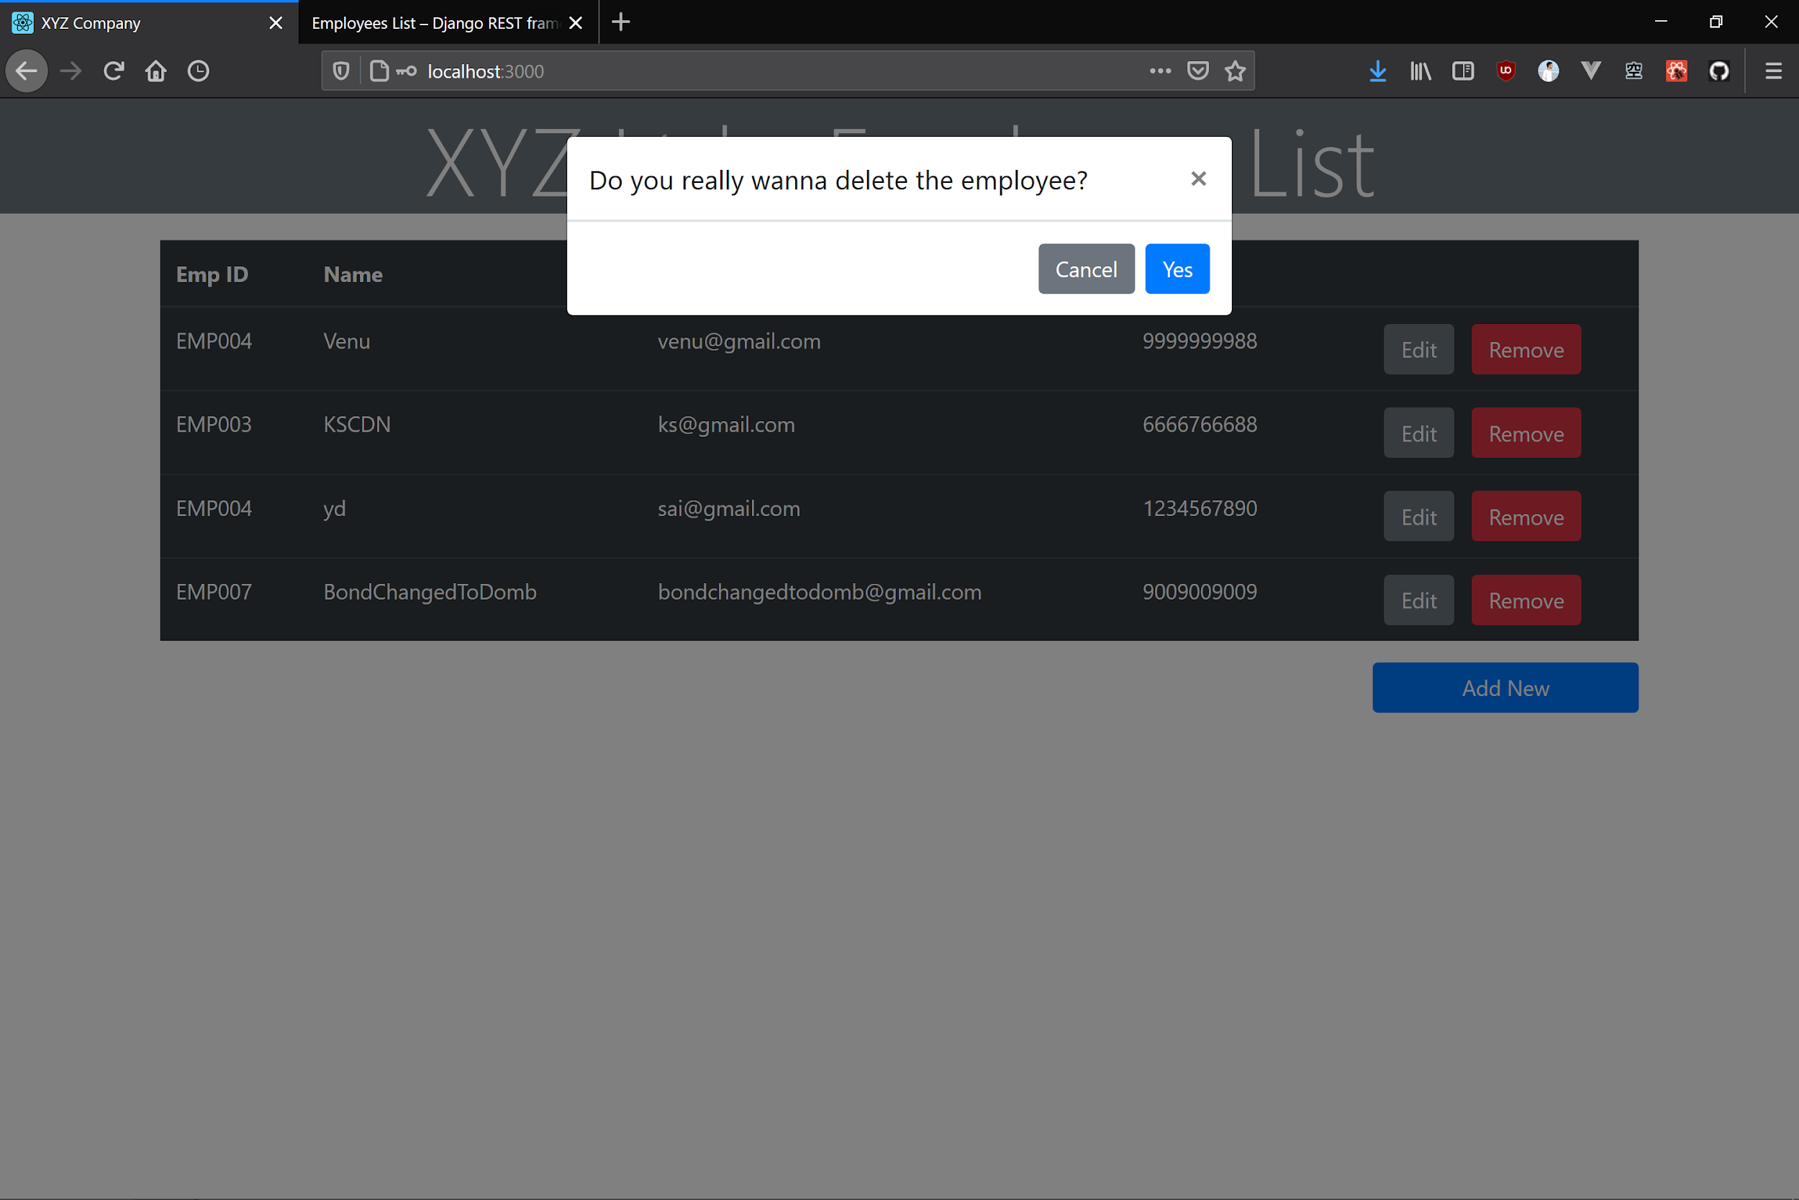

**Fig-12 : (ON SUCCESSFUL DELETION)**

