Account Info

<https://twilio.slack.com/archives/D02EKSD91RN/p1633346785042400>

Recently created rooms

<https://twilio.slack.com/archives/D02EKSD91RN/p1633346785042500>

Participant Analysis

<https://twilio.slack.com/archives/D02EKSD91RN/p1633359430045500>

<https://twilio.slack.com/archives/D02EKSD91RN/p1633359430045600>

<https://twilio.slack.com/archives/D02EKSD91RN/p1633359431045900>

<https://twilio.slack.com/archives/D02EKSD91RN/p1633359431046100>

<https://twilio.slack.com/archives/D02EKSD91RN/p1633359431046200>

<https://twilio.slack.com/archives/D02EKSD91RN/p1633359432046300>

Room Analysis

<https://twilio.slack.com/archives/D02EKSD91RN/p1633359588048200>

<https://twilio.slack.com/archives/D02EKSD91RN/p1633359588048300>

<https://twilio.slack.com/archives/D02EKSD91RN/p1633359589048500>

<https://twilio.slack.com/archives/D02EKSD91RN/p1633359591048900>

<https://twilio.slack.com/archives/D02EKSD91RN/p1633359591049100>

<https://twilio.slack.com/archives/D02EKSD91RN/p1633359592049300>

<https://twilio.slack.com/archives/D02EKSD91RN/p1633359595049500>

<https://twilio.slack.com/archives/D02EKSD91RN/p1633359596049700>

<https://twilio.slack.com/archives/D02EKSD91RN/p1633359596049900>

Track Analysis

<https://twilio.slack.com/archives/D02EKSD91RN/p1633359762052400>

https://twilio.slack.com/archives/D02EKSD91RN/p1633359762052500

<https://twilio.slack.com/archives/D02EKSD91RN/p1633359589048700>

vms --room-sid RMe1b0eaf5072dd12c1726ce587a64cb29

-------------------

| Account: ACa6bc63a1e576acdb93362be716f4d469

| VMS: VM0157a14382371656e1823d0fe3a3fd24

| Host: HO032ca8d0ba73b422b9e4690068f9e6c2

| Region: us-east-1

-------------------

2021-10-01T07:32:40.338840Z - VMS process created

2021-10-01T08:05:13.744679Z - VMS process terminated

vms --recording-sid [RTb9013e052cea062a4bfcd9a0576524ce](https://www.twilio.com/console/video/logs/recordings/RTb9013e052cea062a4bfcd9a0576524ce)

No data available

vms2 rooms impact --sid RMe1b0eaf5072dd12c1726ce587a64cb29 recording

<https://twilio.slack.com/archives/D02EKSD91RN/p1633360327061800>

recordings --room-sid RMe1b0eaf5072dd12c1726ce587a64cb29

<https://twilio.slack.com/archives/D02EKSD91RN/p1633360406063400>

billing --account-sid ACa6bc63a1e576acdb93362be716f4d469 --since_until 2021-10-01 2021-10-04

billing --account-sid ACa6bc63a1e576acdb93362be716f4d469 --business-date 2021-10-01

Kibana Tasks

1. <https://kibana.us1.eak.twilio.com/video/goto/352d83d4611273536125d188995cbfe9>

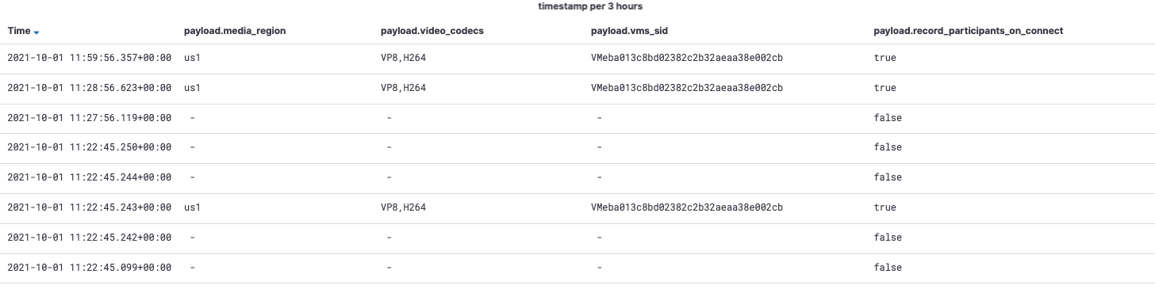

1. https://kibana.us1.eak.twilio.com/video/goto/9ed673233cf931359d10474f3414b496

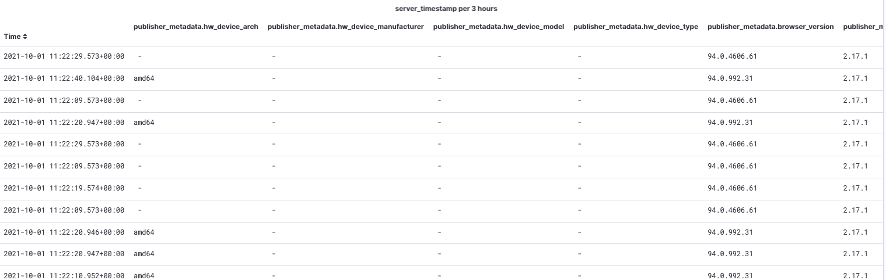

1. https://kibana.us1.eak.twilio.com/video/goto/1db5c9f80b63a8e6602fce4fd800919d

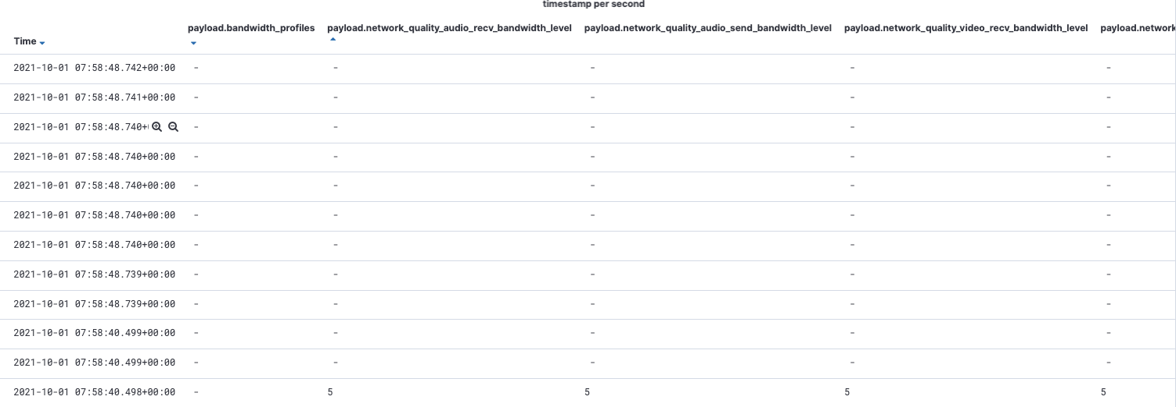

1. https://kibana.us1.eak.twilio.com/video/goto/b9ce8243094f895ec4da3876ac549987

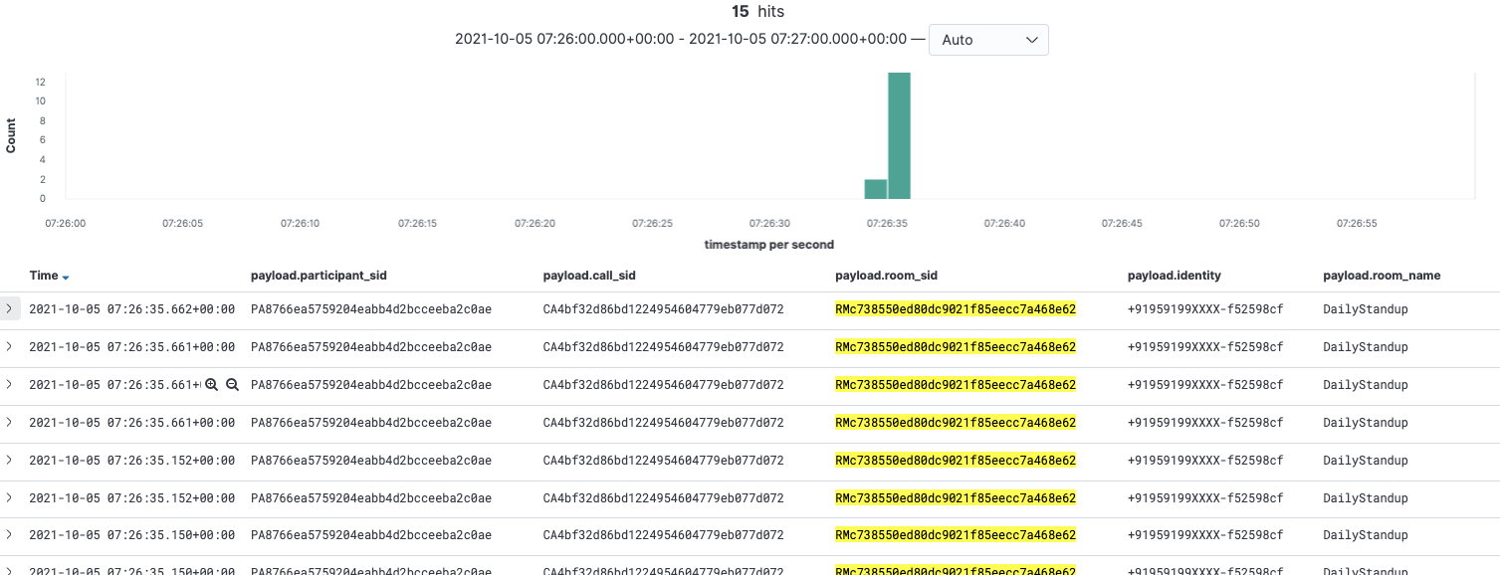

1. https://kibana.us1.eak.twilio.com/video/goto/c91c24740982c8ca09dddc58e422cf4d

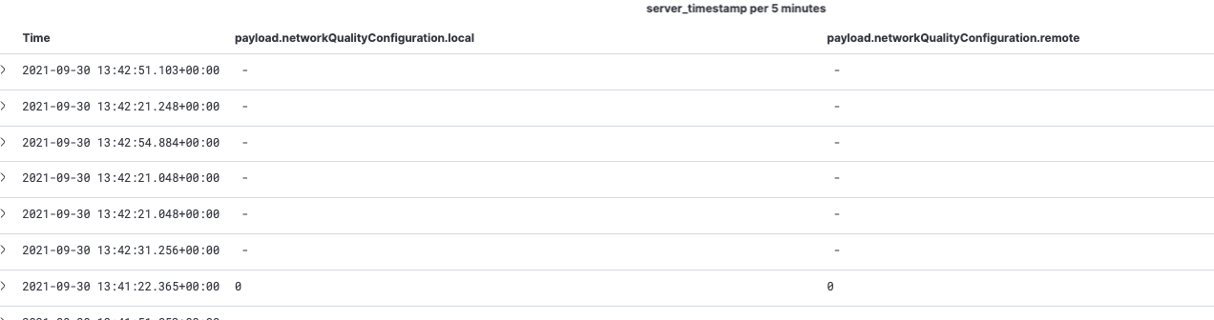

1. https://kibana.us1.eak.twilio.com/video/goto/476019d7ed4b6d396a563dab2f12c8ae

