**Lesson 03 Demo 03**

**Creating and Deleting Tags**

**Objective:** To create and delete tags in a Git repository, helping users efficiently manage version control and maintain historical checkpoints within their software development projects

**Tools required:** Git and GitHub

**Prerequisites:** Refer to Lesson 02 Demo 01 for creating and cloning a repository

Steps to be followed:

1. Create a tag
2. Delete a tag

**Step 1: Create a tag**

1. Clone and navigate to your git repository by using the following command:

**git clone <url-of-repo>**

**cd <repo-name>**

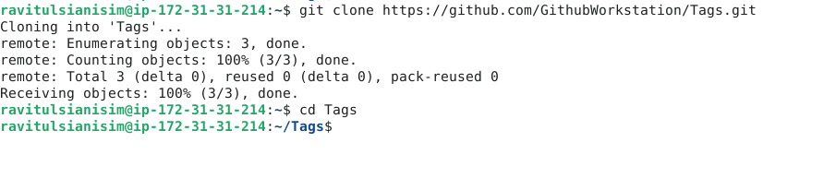

1. Create a tag by using the following command:

**git tag <tag-name>**



1. Verify the creation of the tag by using the following command:

**git tag**

1. Push tag to Git repository by using the following command:

**git push origin <tag-name>**

**Step 2: Delete a tag**

1. Use the following command to delete the tag locally:

**git tag -d <tag-name>**



1. Push the deletion to the remote repository by using the following command:

**git push origin --delete <tag-name>**

1. Verify deletion by using the following command:

**git tag**



No tag name is listed which means the tag has been deleted.

By following these steps, you have successfully created and deleted tags in a Git repository which will enhance your version control practices, ensuring clear and organized management of release points and significant changes in your projects.