


Baseline V6.1
Release Notes
Jul 2024

System Release Notes

EXIMBILLS © Trade Finance System

Baseline Version 5.0

Release Notes

July 2022

Copyright 2022 © China Systems Corporation

All Rights Reserved

This document is protected by United States Copyright Law and may contain Trade Secrets Information which is proprietary to China Systems Corporation. No part of this document may be copied, photocopied, reproduced, translated, distributed, or reduced to any electronic medium or machine-readable form without prior consent in writing from China Systems Corporation. The information in this document may be used only under the terms and conditions of separate China Systems Corporation license agreements.
Information is subject to change without notice. China Systems Corporation makes no warranties, either expressed or implied, with respect to the software herein described as to its quality, performance, including, without limitations to, its fitness for any particular purpose.
This document may not reflect total system capability at any subsequent date as a result of development. It is also possible that it may contain references to facilitate not available on your computer system. Such references should not be construed to mean that these facilities will necessarily be made available on all types of computer hardware or in all user locations.
China Systems Corporation accepts no responsibility or liability for any damages or loss of business or revenue due to the use of this document.
All trademarks, registered trademarks and trade names mentioned in this document are the sole property of their respective holders.

ORDER MORE EXIMBILLS DOCUMENTATION

Additional copies of Documentation are available for purchase from China Systems Corporation or through your local EXIMBILLS Support Office.



CHINA SYSTEMS CORPORATION

Comments may be addressed to:

corporatedocs@chinasystems.com

5th Floor, Building No.3

No. 699-8 Xuan Wu Avenue

Xuan Wu District

Nanjing, P.R.C. 210042

Table of Contents
Table of Contents 3
I. Released Environment Information 4
1. Public URL Access 4
2. Application Software Version 4
3. How to apply for the Access request 4
II. Some Special Setting 4
1. About EE Parameter adjustment 5
2. About CE Parameter adjustment 8
III. How to verify REST API is work 9
1. REST API test link for EE 9
2. REST API test link for CE 9

Released Environment Information

Public URL Access
Product | Version | URL
EE | V6.1 | https://www.neweximbills.com/BL6EximBillWeb/SYS_index.htm
CE | V6.1 | https://www.neweximbills.com/BL6CEWeb/SYS_index.htm

Application Software Version

Product | Version
WAS | WAS 9.0.5.11
DB | Oracle 21C
MQ | MQ 9.1

How to apply for the Access request

Product | Comments
EE | Register the request on GDB at first, after that, system will send an email to inform the accessing account after approval.
CE | For SCF module, the accessing account will be auto-created follow the business flow. For other’s module, can use BUYER/SELLER to access it.

Some Special Setting

About EE Parameter adjustment
1 | After deploy the new EAR to your local server, please make sure some system configuration already be changed in your local environment.  - EE_PARA\EE_SYS\SYST\sys_para.xml.  <HTTPS_AP_HOST_ADDR attr="C">[…]</HTTPS_AP_HOST_ADDR>  <HTTPS_AP_HOST_PORT attr="C">[…]</HTTPS_AP_HOST_PORT>  <RMI_WEBSERVICE_URL attr="C">[…]</RMI_WEBSERVICE_URL>  - EE_PARA\Default\APSERV\apServer.xml  <IPAddr>[…]</IPAddr>  <IIOPPort>[…]</IIOPPort>  - EE_PARA\EE_SYS\BATCH\root.xml  IIOPPort=[…] IPAddr=[…]  - EE_PARA\EEConfig\EE_ESP_RestInfo.xml  <esp_host>[…]</esp_host>  - EE_PARA\SCF_CS\parameter.json  {…"clients":[{"name":"CE", "items":[{"name":"clientUrl", "value":[…]  {…"clients":[{"name":"EE", "items":[{"name":"clientUrl", "value":[…]  If need change context, then have to make sure the configuration below is align with the setting on the WAS.  - EE_PARA\EE_SYS\SYST\sys_para.xml.  <COMMUNICATOR_CONTEXT_ROOT attr="C">[…]</COMMUNICATOR_CONTEXT_ROOT>  This is the basic system configuration file from EEV6.0.0 with microservices involved: [Parameter Folder]\EEConfig\EE\services.yml.  - For J2EE mode, please update the following highlighted configuration using your actual server information.  - clusteringcache: eecache # eecache|redis  - mode: j2ee # eecluster|j2ee|k8s|nacos|eureka  - host: "http://localhost:9080"  - ip: "&" # Local machine's IP address, If & means let system to get the IP  - port: 9080 # All services' server-port  - name: EximBillWeb  - basePath: Baseline # basePath  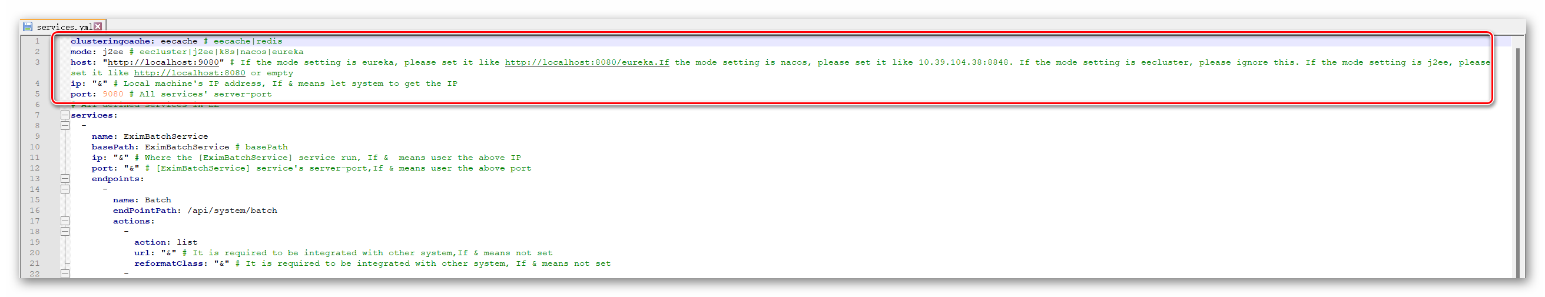  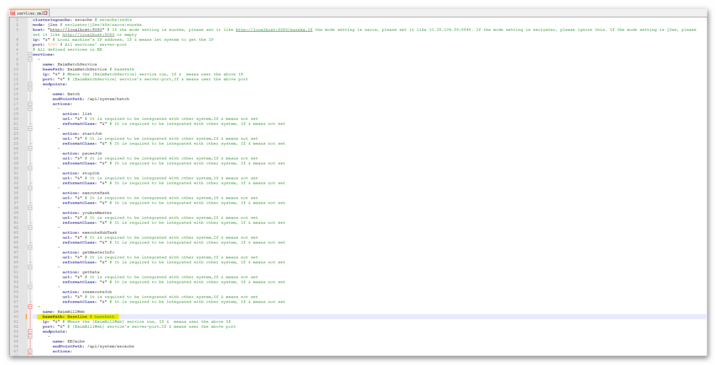
2 | If need communicate between EE&CE except SCF, then have to build MQ before change files below:  - EE_PARA\Default\QMGR\mq_Q_BANK.xml  <queue-host-name>[…]</queue-host-name>  - EE_PARA\Default\QMGR\mq_Q_CE.xml  <queue-host-name>[…]</queue-host-name>
3 | If need communicate with SWIFT device, then have to change IP&Port of below files follow the real situation:  EE_PARA\mfvr\meta\SYSM_GAPI_PTCL\*  EE_PARA\Default\QMGR\mq_QI.MT.QMTS.xml  EE_PARA\Default\QMGR\mq_QO.MT.QMTS.xml  EE_PARA\Default\QMGR\mq_SWIFT_IN.xml  EE_PARA\Default\QMGR\mq_SWIFT_IN_COE_EE.xml  EE_PARA\Default\QMGR\mq_SWIFT_IN_ESP  EE_PARA\Default\QMGR\mq_SWIFT_OUT.xml  EE_PARA\Default\QMGR\mq_SWIFT_OUT_ESP.xml  EE_PARA\Default\QMGR\mq_SWIFT_RESP.xml  EE_PARA\Default\QMGR\mq_SWIFT_RESP_ESP.xml  EE_PARA\Default\QMGR\mq_XML_IN.xml  EE_PARA\Default\QMGR\mq_XML_OUT.xml
4 | After deploy the new EAR on WAS,  - To update the JDBC driver setting for the updated name of the OJDBC8 Jar file located under EE_LIB directory, click on this item:  Resources > JDBC > JDBC providers > Oracle JDBC Driver link  ojdbc8-12.2.0.1.jar should be used after EEV6.0.0.  If you use other OJDBC8 Jar file before instead of EE provided, please keep the original setting directly.  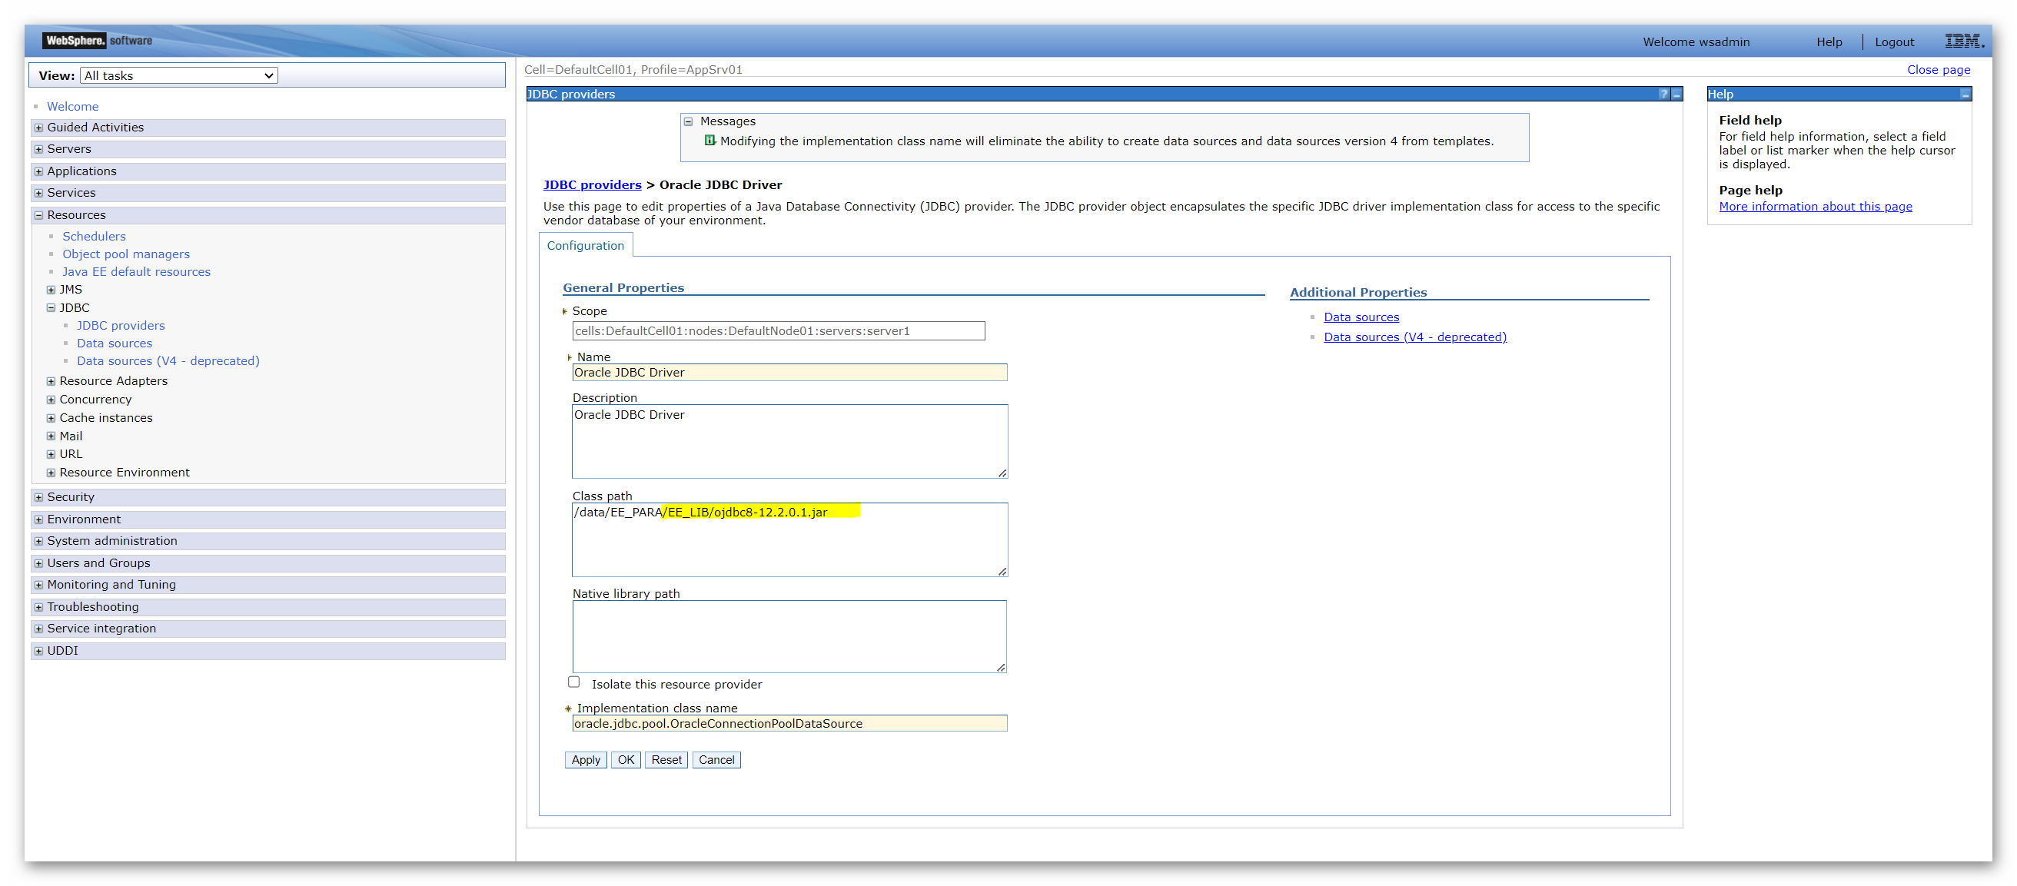  - Please go to Enterprise Applications > EximBill > Manage Modules > EximBillWeb> General Properties and set the Class Loader Order to “Classes loaded with local class loader first (parent last)”.  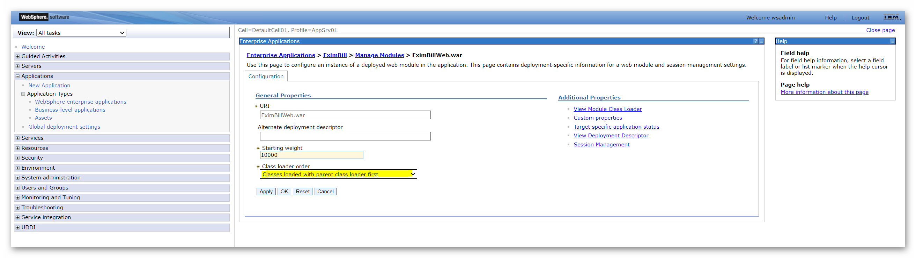  Please go to Shared Libraries > <EE_LIB> and Class Loading: Unmark the option for not using an isolated class loader for this shared library.  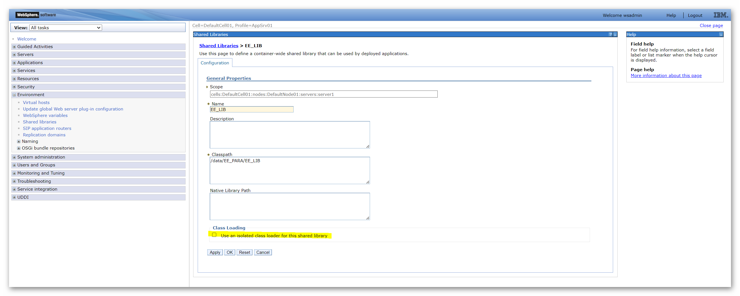  - Please go to Application servers > server1 > Process definition > Java Virtual Machine > Custom properties and add the following for Log4j upgrade.  isLog4jAutoInitializationDisabled ---- TRUE  log4j.configurationFile ---- [Path to EE_Log_Config.xml]  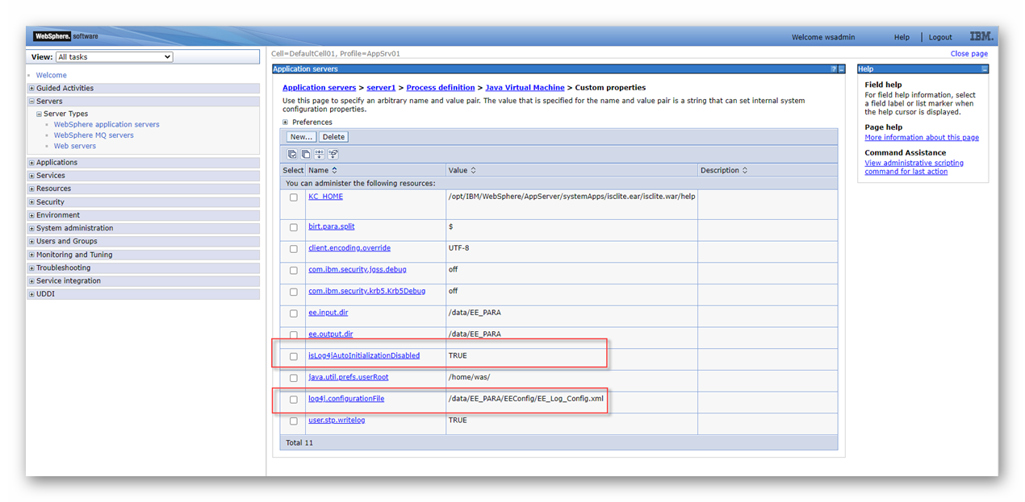

About CE Parameter adjustment
1 | After deploy the new EAR to your local server, please make sure some system configuration already be changed in your local environment.  - PARA\CE_SYS\SYST\sys_para.xml  <BATCH_SERVER_URL attr="C">[…]</BATCH_SERVER_URL>  <BIRT_SERVER_URL attr="C">[…]</BIRT_SERVER_URL>  <HTTPHOST_LIST attr="C">[…]</HTTPHOST_LIST>  <HTTPS_AP_HOST_PORT attr="C">[…]</HTTPS_AP_HOST_PORT>  <EE_OPENAPI_HOST>[…]</EE_OPENAPI_HOST>  - PARA\CE_SYS\password_config.xml  <reset_url_prefix>[…]</reset_url_prefix>  - EE_PARA\Default\APSERV\apServer.xml  <IPAddr>[…]</IPAddr>  <IIOPPort>[…]</IIOPPort>  If need change context, then have to make sure the configuration below is align with the setting on the WAS.  - PARAM\CE_SYS\LegalRequest.properties  - PARA\CE_SYS\ejbserver.properties
2 | If need communicate between CE&EE, then have to build MQ before change files below:  - PARA\Default\QMGR\mq_Q_BANK.xml  <queue-host-name>[…]</queue-host-name>  - PARA\Default\QMGR\mq_Q_CE.xml  <queue-host-name>[…]</queue-host-name>

How to verify REST API is work

REST API test link for EE
http://<IP>:<Port>/<Context>/scfservice/scfapi/ping/hello
If return “ping ok hello”, that means REST API is work.

REST API test link for CE
http://<IP>:<Port>/<Context>/v1/message-api-receiver/ping/hello
If return “ping ok hello”, that means REST API is work.

