China Systems

Payment Redesign
Specification

Version 1.0

Copyright 2012 China Systems Corporation
All Rights Reserved

This document is protected by United States copyright law and may contain Trade Secrets information, which is proprietary to China Systems Corporation. No part of this document may be copied, photocopied, reproduced, translated, distributed, or reduced to any electronic medium or machine-readable form without prior consent in writing from China Systems Corporation. The information in this document may be used only under the terms and conditions of separate China Systems Corporation license agreements.

Information is subject to change without notice. China Systems Corporation makes no warranties, either expressed or implied, with respect to the software herein described as to its quality, performance, including, without limitations to, its merchantability or its fitness for any particular purpose.

This document may not reflect total system capability at any subsequent date as a result of development. It is also possible that it may contain references to facilities not available on your computer system. Such references should not be construed to mean that these facilities will necessarily be made available on all types of computer hardware or in all user locations.

China Systems Corporation accepts no responsibility or liability for any damages or loss of business or revenue due to the use of this document.

All trademarks, registered trademarks and trade names mentioned in this document are the sole property of their respective holders.

CHINA SYSTEMS CORPORATION LTD.
Corner House
20 Parliament Street
Hamilton HM 12
Bermuda
cs@chinasystems.com

Document Revisions Control
Version | Date | Author | Comments
V1.0 | 24/10/2024 | Eddy | Initial Draft

目录
1. INTRODUCTION 4
2. REQUIREMENTS 4
2.1 Business Requirement 4
2.2 Business Case 6
2.3 Business Context 7
3. PROPOSAL SOLUTION 8
3.1 Precondition 8
3.2 Configuration and customization 8
4. FUNCTION DESCRIPTION 8
4.1 General Description 8
4.2 Function List 8
4.3 Function UI 10
5. CALCULATION 15
6. APPENDICES 15
5.1 System Environment 15
5.2 Technology Stack 15
5.3 Table List 15
5.4 Table Diagram 16

INTRODUCTION

本文档用于介绍Payment的重新设计方案，该方案遵循“参数化驱动”的原则，以“字段为中心”的设参理念，通过在输入界面中使用可嵌套的业务数据对象（BDO）来驱动系统参数，从而生成指定的输出。该设计替代了传统Java EE中基于JSP的组件，采用了更灵活的模块化架构，为数据管理、界面构建及输出生成提供了一个动态且可扩展的解决方案。

REQUIREMENTS

Business Requirement
针对之前会议提出的需求，目前有了以下的方案：

- Payment主要的5个CDO能否简化成1个通用的组件，需要后续细化讨论 。
结论： 不合并成一个通用组件，还是用不同的BDO实现
- 针对Payment出SWIFT和Voucher，现有的配置文件难以维护（原本PaymentConfig.props是存在EximBillsPayment JAR中的），需要改造成使用Utility统一维护。后续还需要支持MX报文。
结论：Baseline已将配置文件放到EEPARA中，暂时并未由Utility统一维护。
- 鉴于Report的考虑，是否可以将保存的信息简单结构化，而不是存入大字段中。(是否需要添加一张event表记录交易中的payment event? 还是改造现有的表)
结论：目前Credit表中的字段对于Baseline已足够，项目上可以在Utility和表中动态添加字段。
- SWIFT validation的结果需要更加清晰的错误内容，对应到页面上的字段，而不是只显示某个Tag出错。（目前还有错误太多显示不全的问题） 需要ESP服务增强
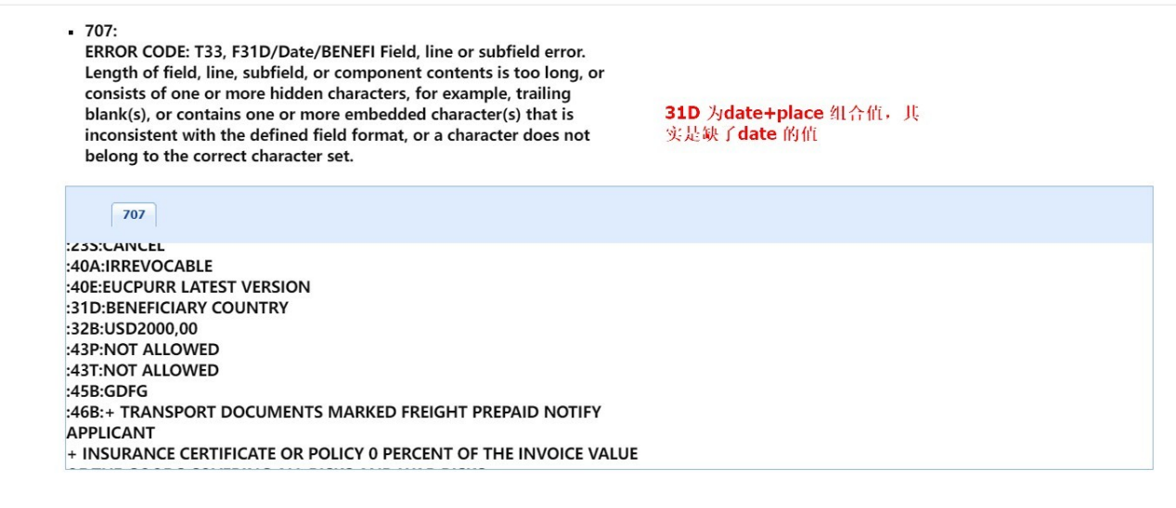
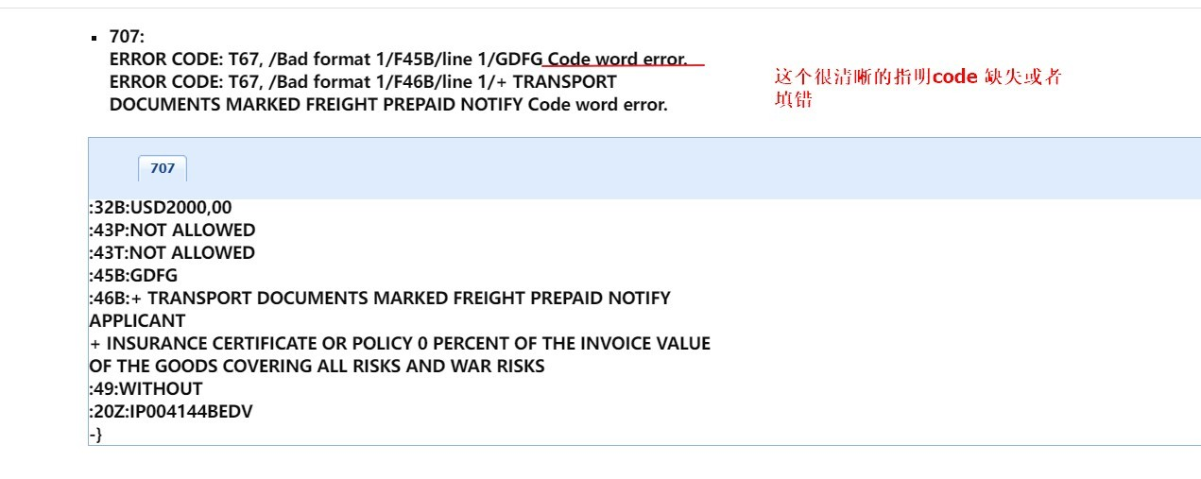
结论：ESP服务需要返回更加友好的错误信息（比如：能直接定位到具体栏位而不是Tag）

- Payment组件中能否添加一个Load Template的功能（报文页面字段太多，客户填写困难），这些Template通过一个Maintenance Function设置。要以MX vdo 处理为最终解决目标。 添加新Function，通过选择不同的swift类型加载现有的swift小页，提供增删改查API
结论：考虑到MX报文的复杂性，Payment组件需要支持加载报文填写模板，这些模板需要额外的功能对其进行维护，业务人员使用该功能可以预填写针对不同报文的模板。

Payment组件清单如下：

组件名称 | 组件描述
付款条款 (PaymentTerms) | 该组件用于登记初始付款条款信息，存储在相应的表中，后续组件可以从表中抓取数据作为基础信息进行处理
付款计划 (PaymentSchedule) | 该组件用于为到单单据设定实际的付款到期日。组件将调用付款条款信息（如果有的话），然后使用实际单据信息来更新付款条款信息，供付款指示经办人、付款经办人组件处理。
付款指示经办人(PaymentInstruction) | 该组件用于录入实际的付款项目，借、贷记金额、日期、账户等账目信息。用于承兑延期付款部分
付款指示经办人 (PaymentInstructionDealer) | 该组件用于录入实际的付款项目，借、贷记金额、日期、账户等账目信息。用于承兑延期付款部分，同时也可用于支付即期付款。
付款经办人 (PaymentDealer) | 该组件用于录入实际的付款项目，借、贷记金额、日期、账户等账目信息。用于在到期日对已承兑的延期付款部分进行付款

Payment
Schedule
Payment Terms (optional)
Payment Dealer
Payment Instruction Dealer
Payment Instruction (optional)

Business Case
对应到Baseline进口信用证模组的功能，示例如下：

Issue LC Function
Check Document
Pay/Accept
Payment at Maturity

对应到Baseline出口信用证模组的功能，示例如下：
Pay/Accept
Check Document
Payment at Maturity
Advice LC Function

Business Context
Payment组件可以被嵌入到每个模组的功能中。交易提交之后，在EE Transaction Main Controller识别到存在Payment DO的数据时调用Payment Component，并按需调用其他服务，如：Swift Service、Voucher Service

Componet A
Transaction Screen
Open API
Payment Component
EE Trx Main Controller
Swift Service
Voucher Service
Trx Tables &&
Payment Table
… …
Payment Data Object

PROPOSAL SOLUTION4

Precondition
- Utility支持设置Payment相关组件（BDO）,同时支持项目上扩展和调整
- Payment相关Business Data Object , PC在Screen Editor中通过拖拽方式放到页面上。
- UI需要实现VDO的页面展示和数据整合以支持MX报文。

Configuration and customization
- PaymentConfig.props

此文件是Baseline现有的Payment的配置文件，主要用于指定各类Payment DO的数据处理适配器、SWIFT模板、Voucher模板以及其他一些Payment相关的全局设置。

FUNCTION DESCRIPTION

General Description
Payment DO页面的样式参考最新的Baseline，使用新的UI框架实现。

Function List
基于现在Baseline的业务，整理出用到Payment DO的Function清单如下：

DO Name | Module | Function ID | Function Description
PaymentTermsHeader | EPLC | F05030704079 | TransferNotiToTheFirstBene
PaymentTermsHeader | EPLC | F05030704084 | ProcessMT738
PaymentTermsHeader | EPLC | F05030704080 | ReceiveMT738
PaymentTermsHeader | EPLC | F05030701961 | Register LC after Pre Advice
PaymentTermsHeader | EPLC | F05030701960 | Process 700 After 705
PaymentTermsHeader | EPLC | F05030701953 | Beneficiary Response
PaymentTermsHeader | EPLC | F05030701959 | Process 700/710/720
PaymentTermsHeader | EPLC | F05030701958 | Receive MT707
PaymentTermsHeader | EPLC | F05030703109 | Advise LC One Step
PaymentTermsHeader | EPLC | F05030701969 | Advise Amendment
PaymentTermsHeader | EPLC | F05030703901 | LC Received&Advised
PaymentTermsHeader | EPLC | F05030701968 | Register Amendment
PaymentTermsHeader | EPLC | F05030703902 | Advise Amendment To CE
PaymentTermsHeader | EPLC | F05030703914 | Beneficiary Response From CE
PaymentTermsHeader | EPLC | F05030701977 | Advise LC
PaymentTermsHeader | EPLC | F05030701976 | Register LC
PaymentTermsHeader | EPLC | F05030701974 | Process MT707
PaymentTermsHeader | EPLC | F05030703387 | Process 700/710/720
PaymentTermsHeader | EPLC | F05030703700 | Receive722
PaymentTermsHeader | EPLC | F05030703149 | Receive MT720
PaymentTermsHeader | EPLC | F05030703147 | Receive MT700
PaymentTermsHeader | EPLC | F05030703150 | Receive MT798
PaymentTermsHeader | EPLC | F05030703703 | ReceiveMT735
PaymentTermsHeader | EPLC | F05030703702 | Advice of Amendment
PaymentTermsHeader | EPLC | F05030703701 | Process722
PaymentTermsHeader | EPLC | F05030703058 | Advise Amendment One Step
PaymentTermsHeader | EPLC | F05030703402 | Process MT707
PaymentTermsHeader | EPLC | F05030703095 | Register Documents Not Advised by us
PaymentTermsHeader | IPLC | F05030703699 | Process LC Application
PaymentTermsHeader | IPLC | F05030703698 | Process LC Amendment Request
PaymentTermsHeader | IPLC | F05030702017 | Issue Transfer LC
PaymentTermsHeader | IPLC | F05030703105 | IPLC Receive MT772 (C2B)
PaymentTermsHeader | IPLC | F05030702016 | Issue Back-to-Back LC
PaymentTermsHeader | IPLC | F05030702015 | Issue Letter of Credit
PaymentTermsHeader | IPLC | F05030703103 | IPLC Receive MT770 (C2B)
PaymentTermsHeader | IPLC | F05030702021 | Issue Amendment
PaymentTermsHeader | IPLC | F05030703117 | Resubmit Issue LC from CE
PaymentTermsHeader | IPLC | F05030703118 | Review Import LC Application
PaymentTermsHeader | IPLC | F05030703130 | IPLC_ReceiveMT707
PaymentTermsHeader | IPLC | F05030703129 | IPLC_ReceiveMT700
PaymentTermsHeader | IPLC | F05030703156 | ReceiveMT798
PaymentTermsHeader | IPLC | F05030703945 | Issue Amendment From CE
PaymentTermsHeader | IPLC | F05030702070 | Issue Letter of Credit One Step
PaymentTermsHeader | IPLC | F05030702749 | ApplforIssueLCfromCE
PaymentTermsHeader | IPLC | F05030703057 | Issue Transfer LC One Step
PaymentTermsHeader | IPLC | F05030703056 | Issue Back-to-Back LC One Step
PaymentTermsHeader | IPLC | F05030702093 | Issue Amendment One Step
PaymentTermsHeader | IPLC | F05030703894 | Receive Amt From CE
PaymentTermsHeader | IPLC | F05030703893 | Issue LC From CE
PaymentTermsHeader | IPLC | F05030703892 | Review Import LC From CE
PaymentTermsHeader | IPLC | F05030703891 | Receive LC From CE
PaymentTermsHeader | IPLC | F05030703896 | Receive Resubmit Amt From CE
PaymentTermsHeader | IPLC | F05030703895 | Review LC Amendment From CE
PaymentScheduleHeader | EPLC | F05030703916 | Check Documents(CE)
PaymentScheduleHeader | EPLC | F05030702078 | Check Documents
PaymentScheduleHeader | EPLC | F05030702094 | Send Documents
PaymentScheduleHeader | IPLC | F05030703900 | Check Document(CE)
PaymentScheduleHeader | IPLC | F05030701982 | Check Document
PaymentScheduleHeader | IPLC | F05030701986 | Register Waiver
PaymentInstructionDealer | EPLC | F05030702144 | Pay/Accept
PaymentInstructionDealer | EPLC | F05030703904 | Pay/Accept(CE)
PaymentInstructionDealer | EPLC | F05030703919 | ReceivePaymentInstruction
PaymentInstructionDealer | IPLC | F05030703911 | ReceivePaymentInstruction From CE
PaymentInstructionDealer | IPLC | F05030703913 | Pay/Accept(CE)
PaymentInstructionDealer | IPLC | F05030701993 | Pay/Accept
PaymentInstructionDealer | IPLC | F05030703386 | Pay/Accept
PaymentInstructionDealer | EPLC | F05030703164 | ReceivePaymentInstruction
PaymentDealer | EPLC | F05030702147 | Settle Partial Payment
PaymentDealer | EPLC | F05030702146 | Discount
PaymentDealer | EPLC | F05030703905 | Payment At Maturity(CE)
PaymentDealer | EPLC | F05030702156 | Payment at Maturity
PaymentDealer | EPLC | F05030702076 | Note Other Bank Charge
PaymentDealer | IPLC | F05030703912 | Payment at Maturity(CE)
PaymentDealer | IPLC | F05030701994 | Payment at Maturity
PaymentDealer | IPLC | F05030702747 | Note Other Bank Charges

Function UI

- Issue LC - PaymentTerms
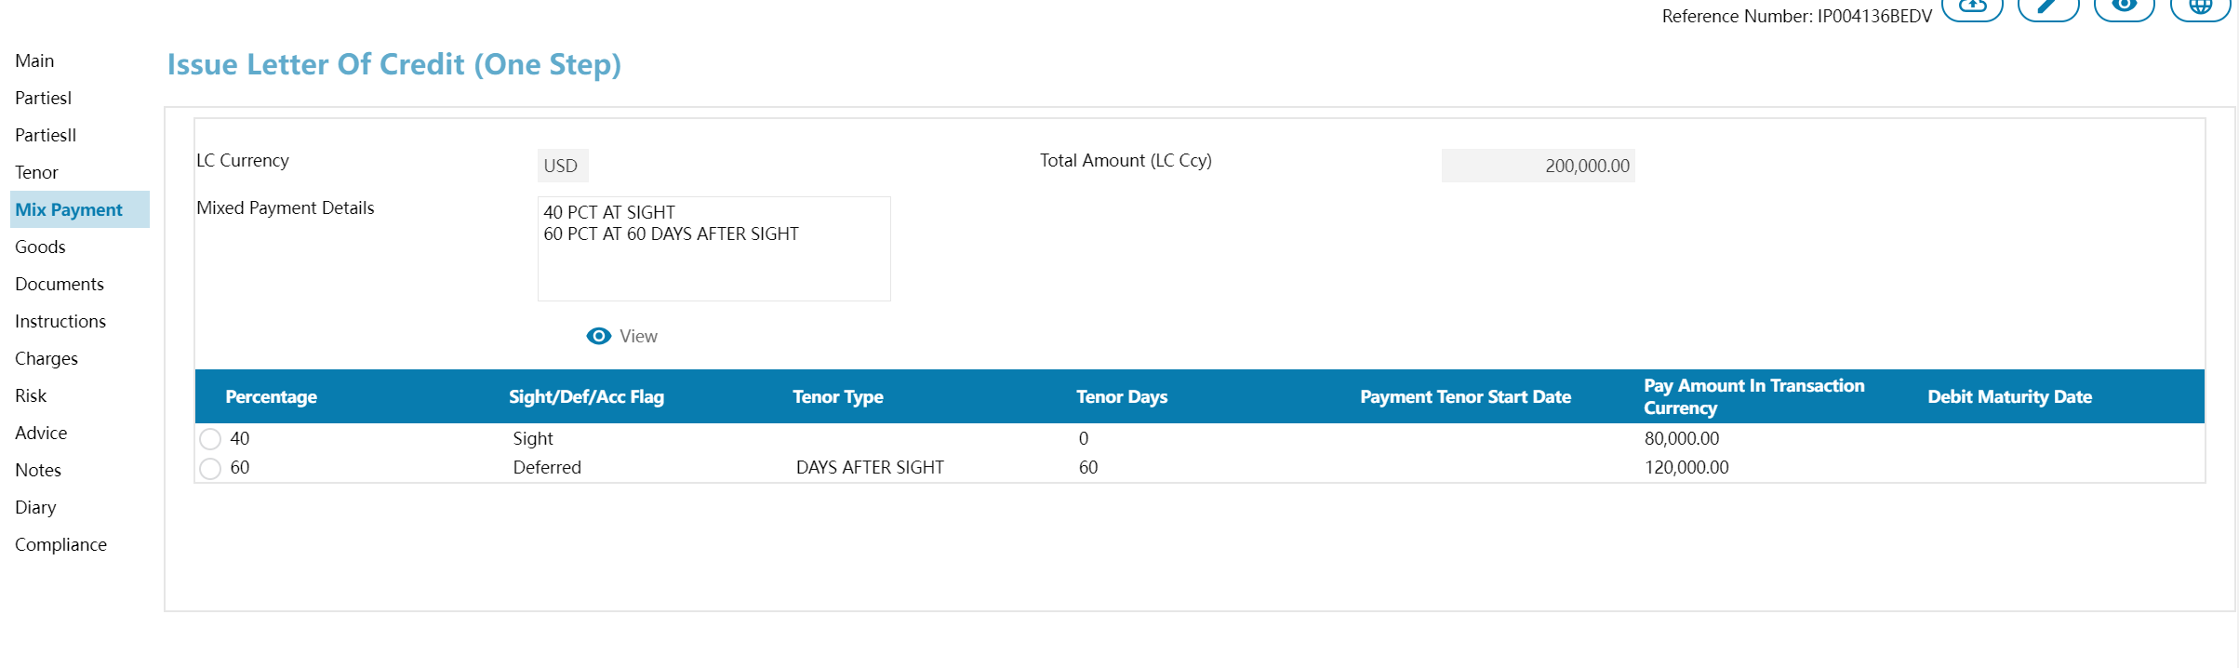
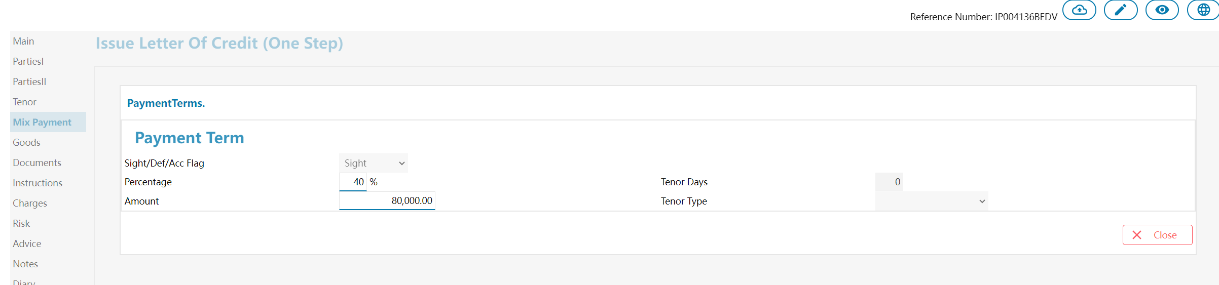
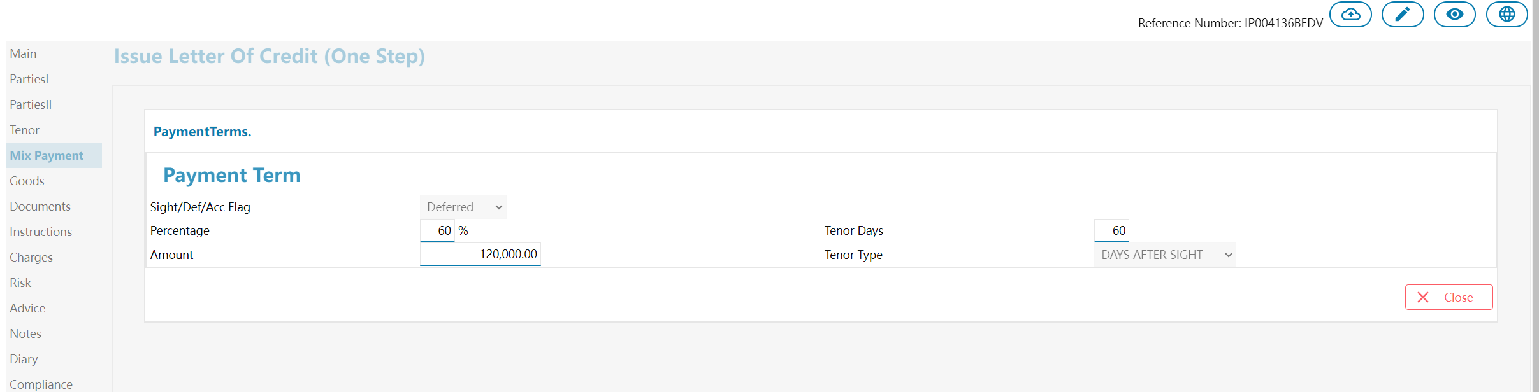
- Check Document - Payment Schedule
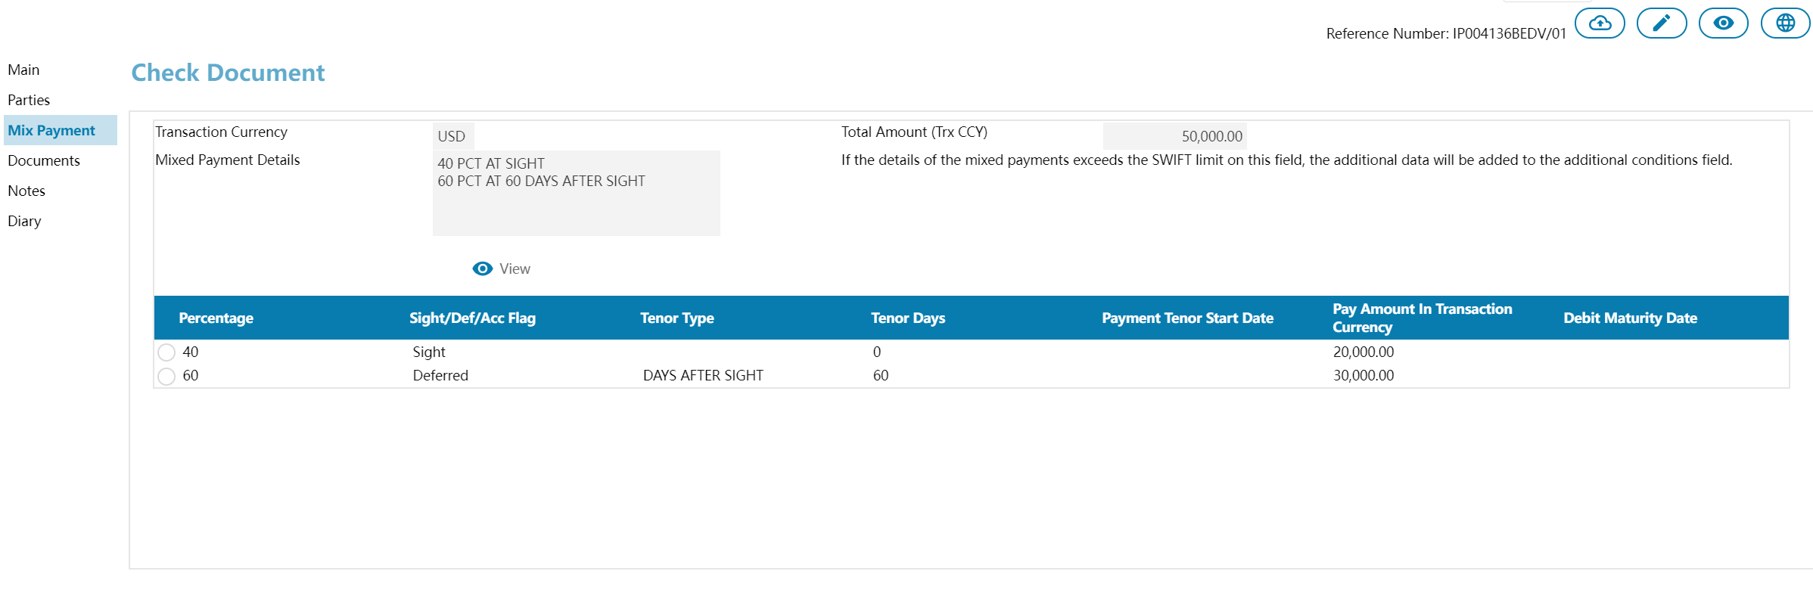
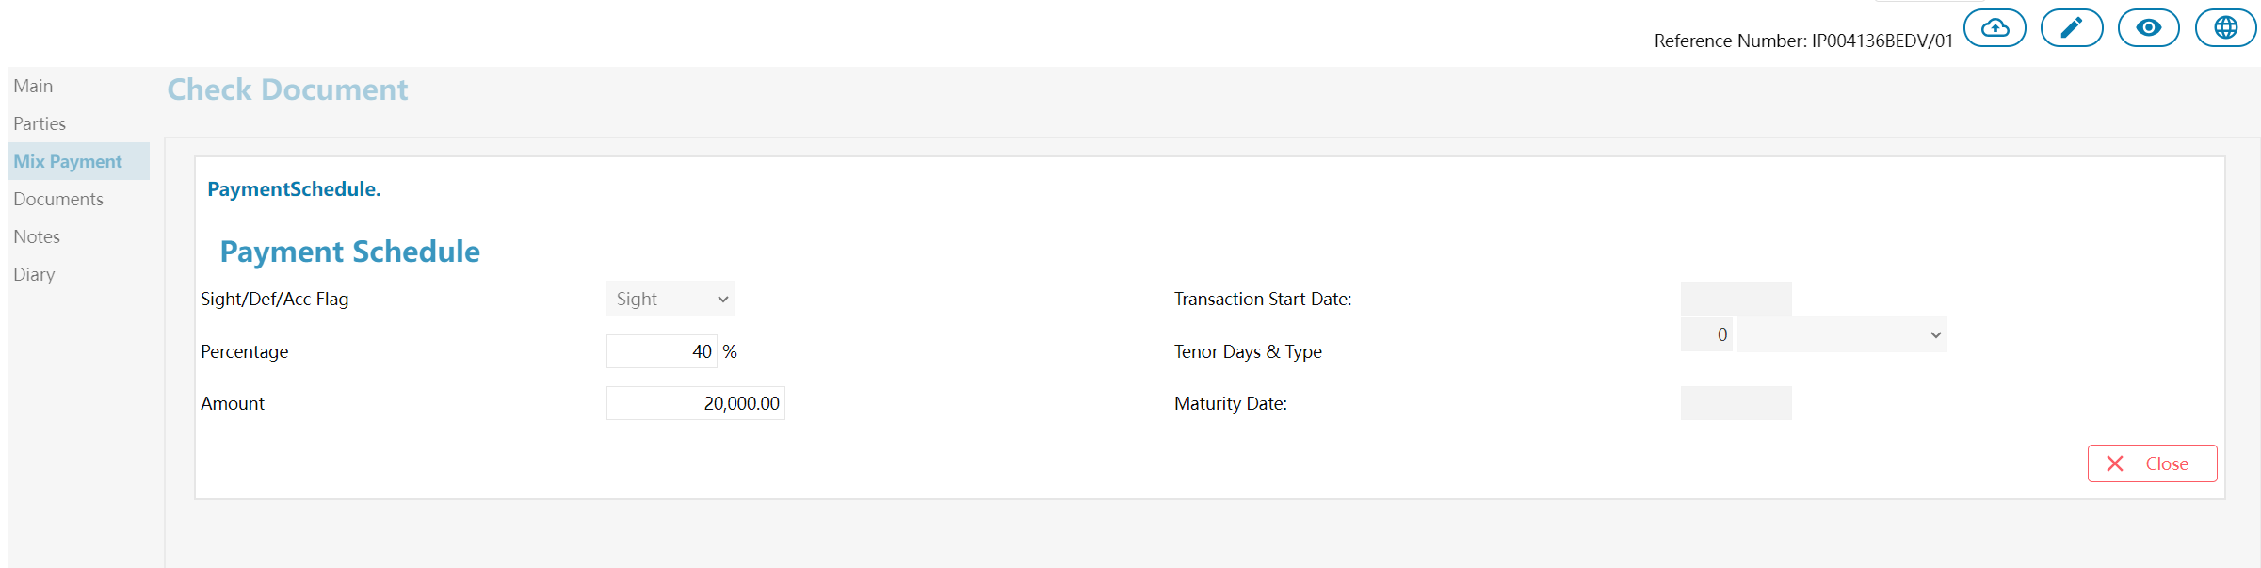

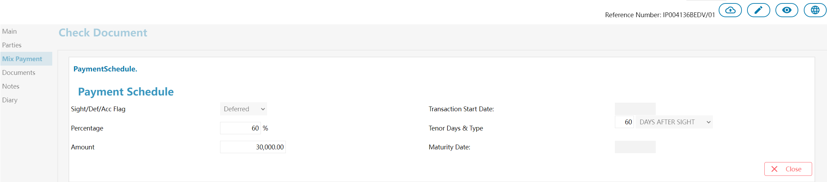

- Pay/Accept - Payment Instruction Dealer

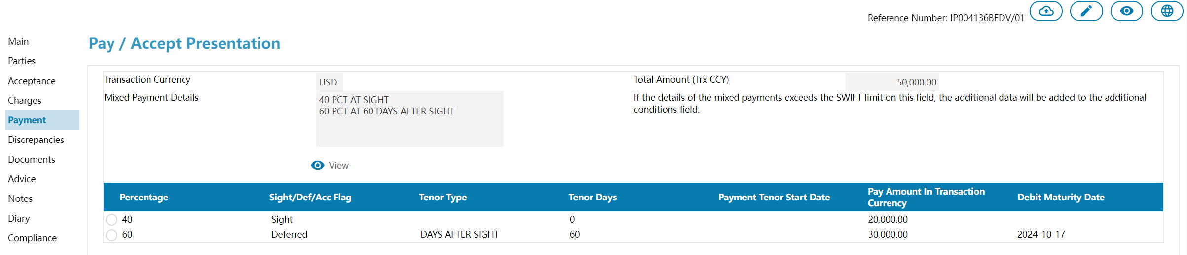
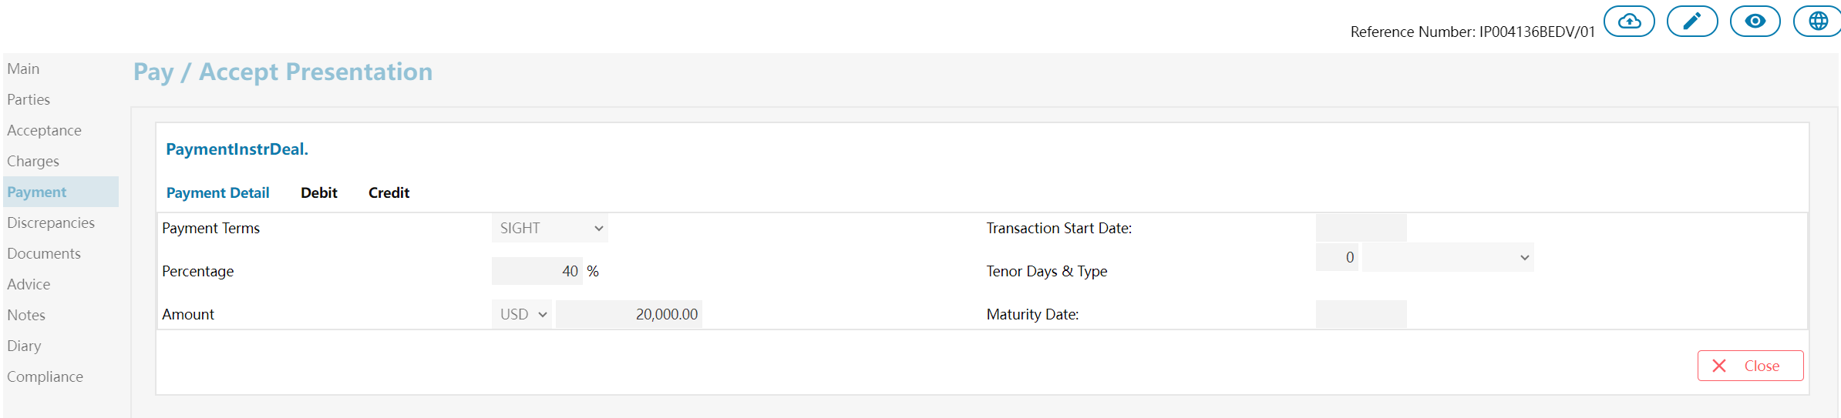
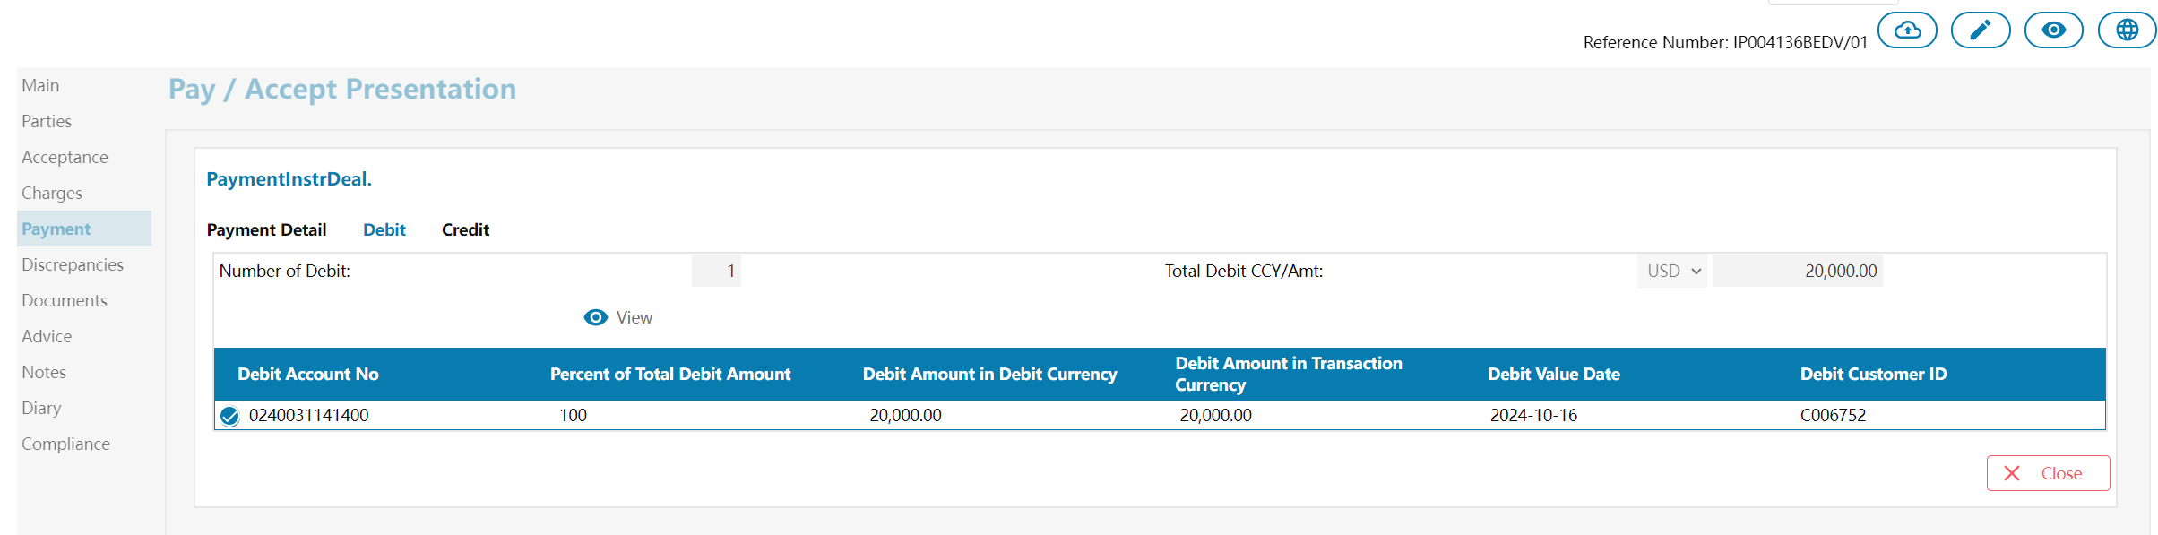
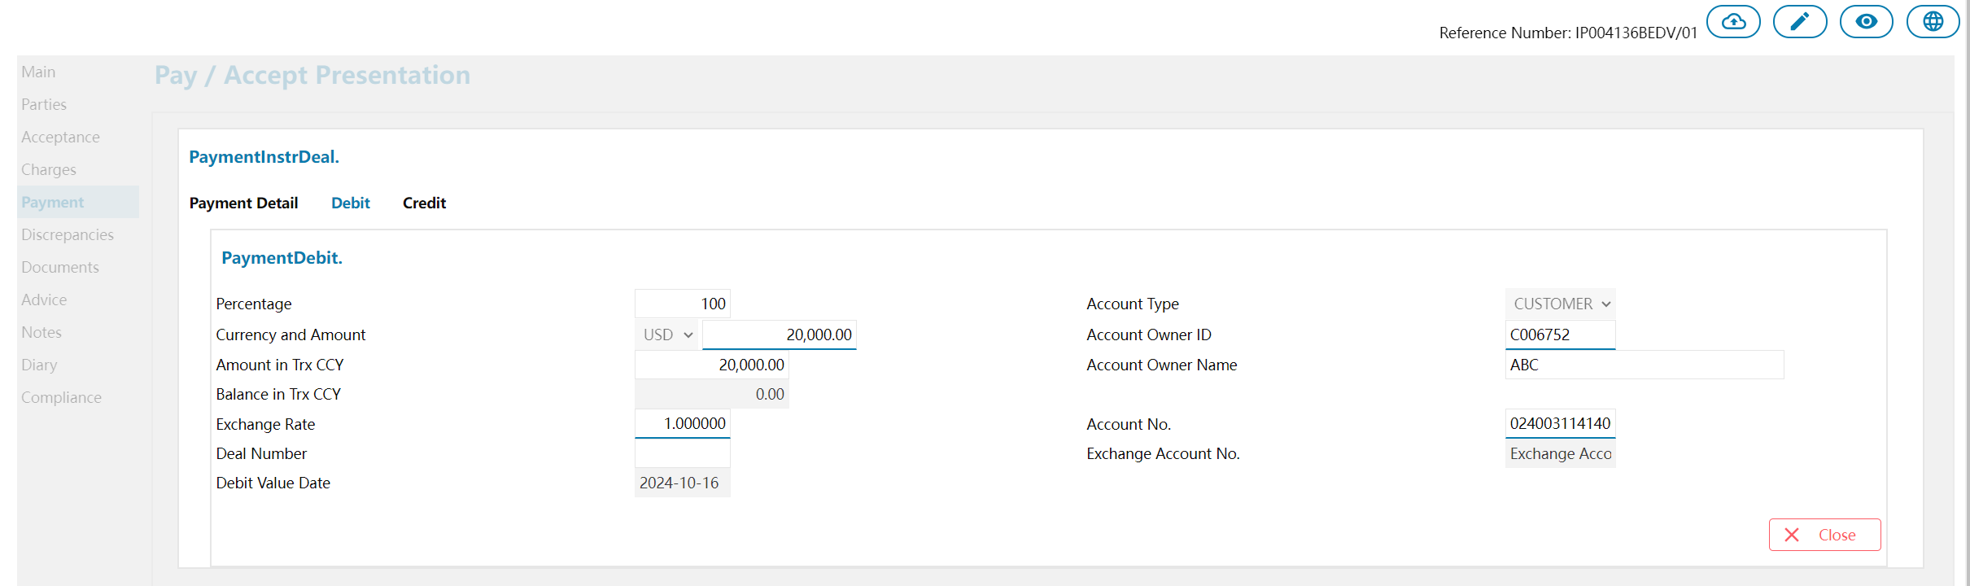

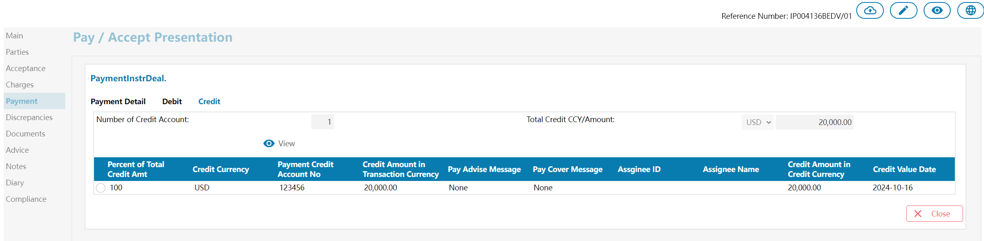

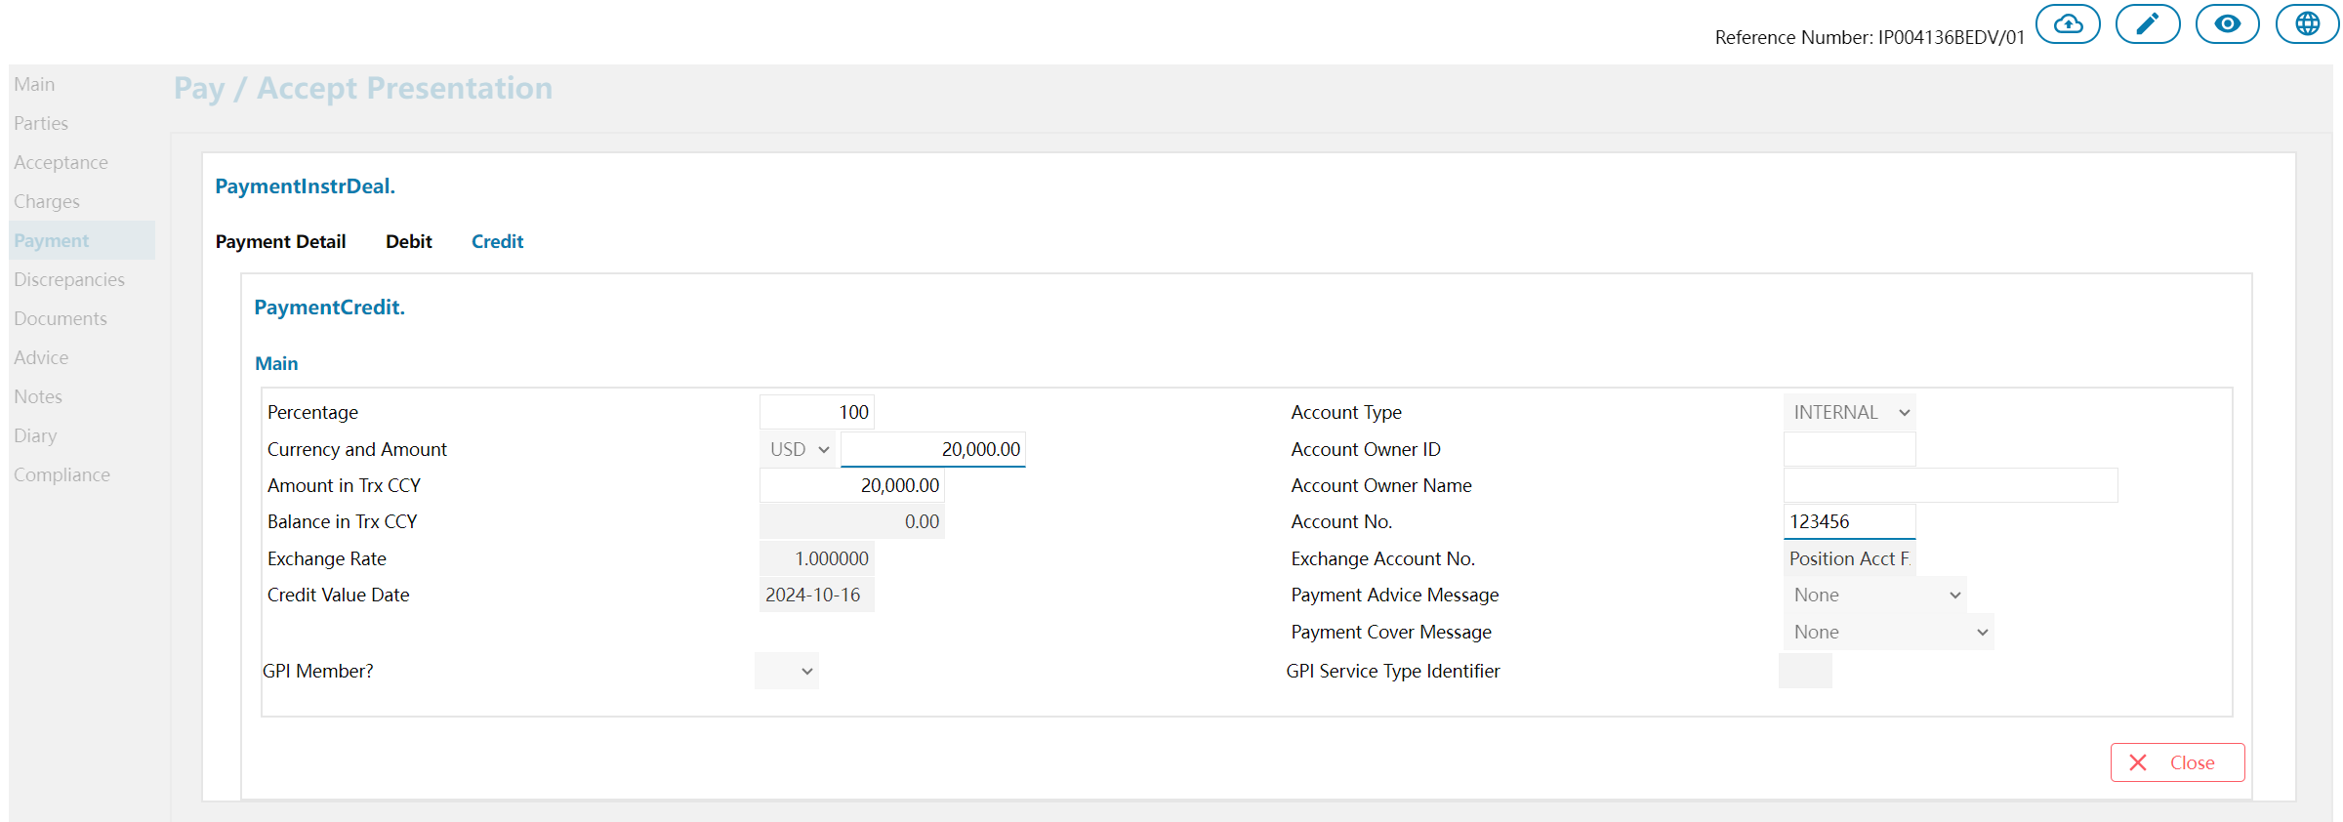

- Pay At Maturity - PaymentInstrcution

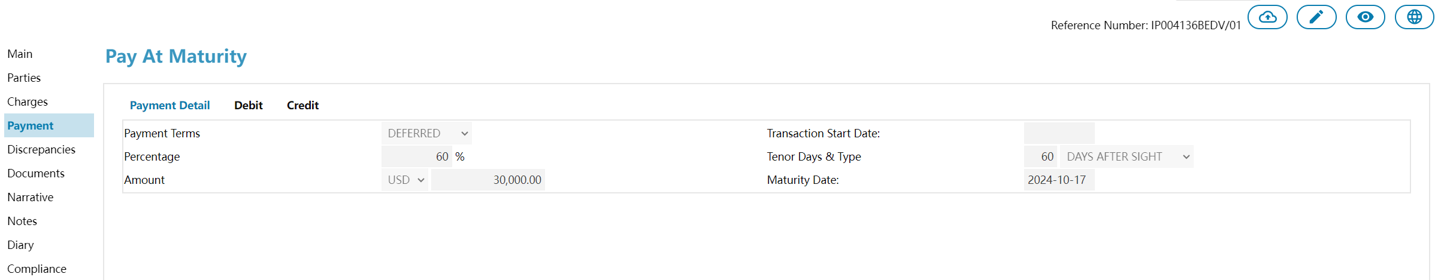
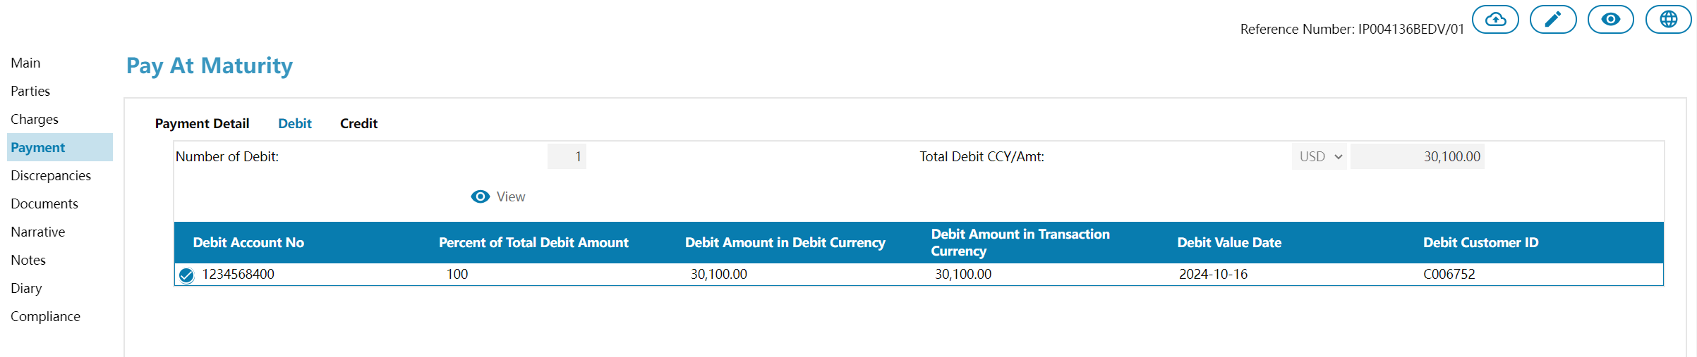
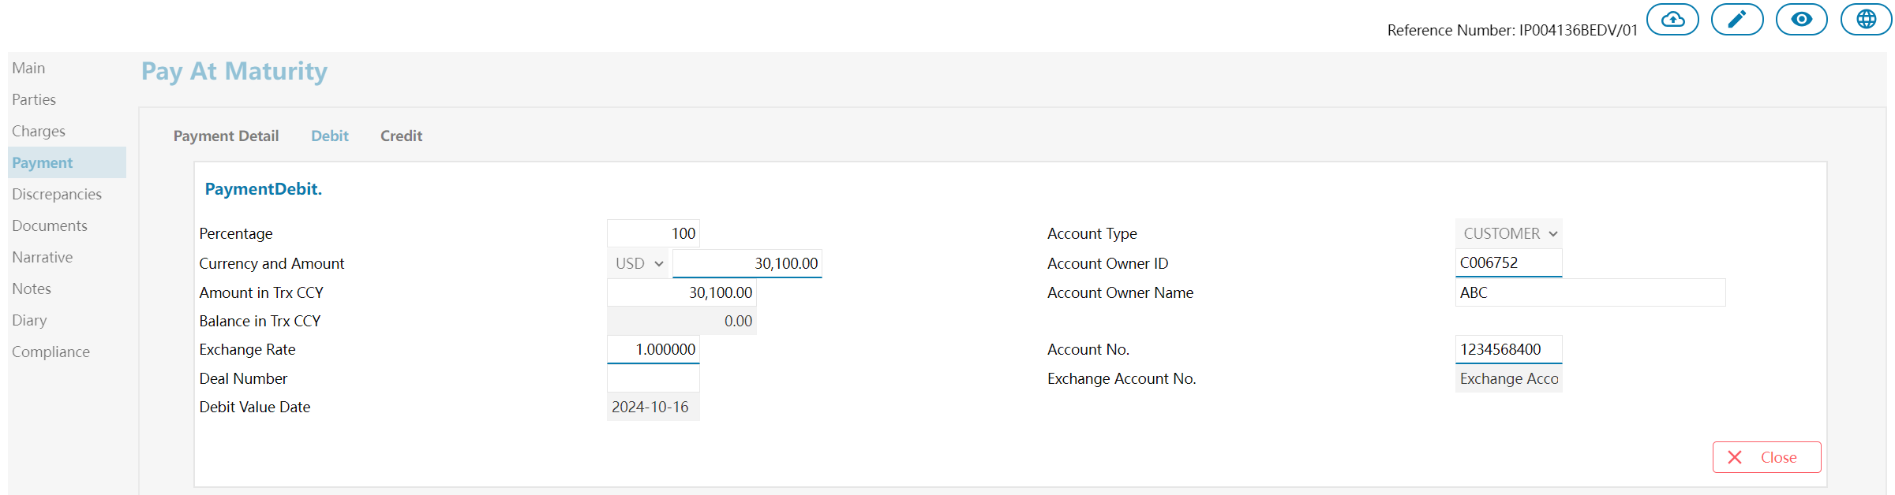

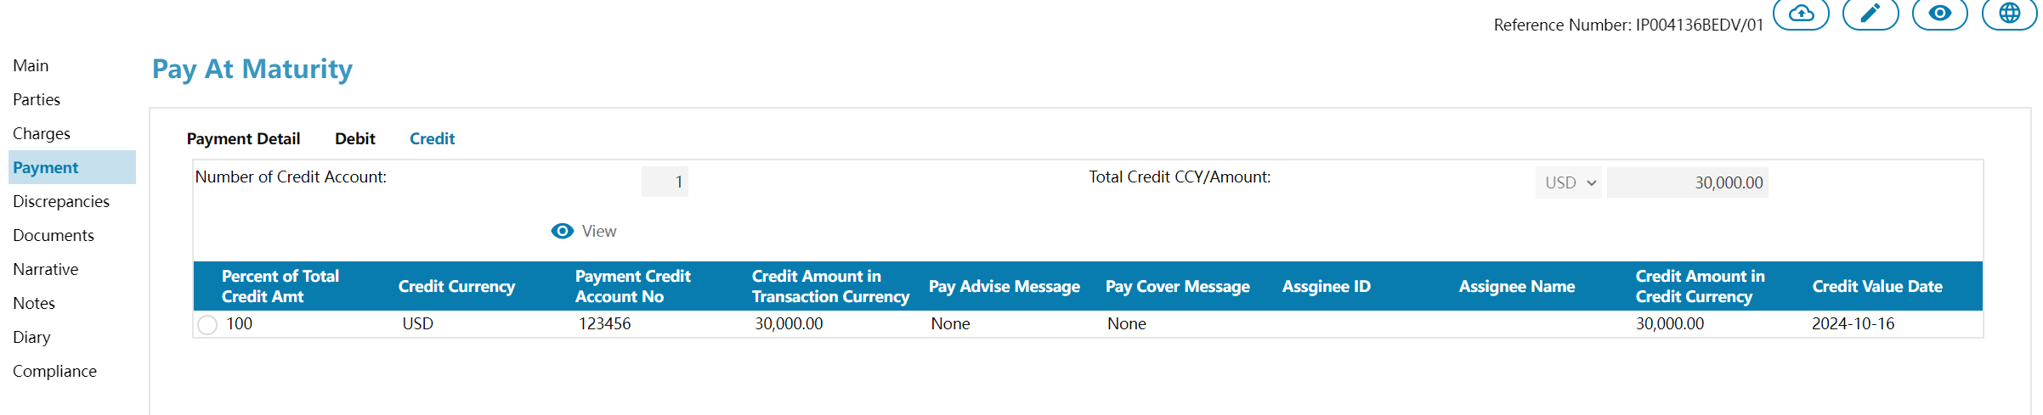
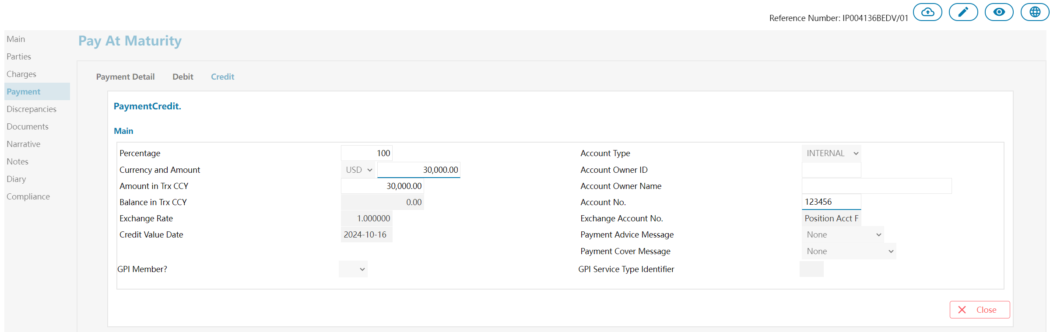

CALCULATION
Payment DO相关的计算需要重新归纳整理，并调整成“以字段为核心”的方式。

APPENDICES

System Environment
新的Payment框架将被集成到EEV7中.

Technology Stack
Front-end development：
- 原生Java Script
- AugularJS
- HTML Web Components
Backend Development：
- JDK 11

Table List
Table Seq | Table Name | Table Description
1 | cpyt_temp | Temp Table
2 | cpyt_terms_header | Transaction Schedule Information
3 | cpyt_terms | Transaction Schedule
4 | cpyt_schedule_header | Payment Schedule Information
5 | cpyt_schedule | Payment Schedule
6 | cpyt_debit_header | Payment Debit Information
7 | cpyt_debit | Payment Debit Detail
8 | cpyt_credit_header | Payment Credit Information
9 | cpyt_credit | Payment Credit Detail

Table Diagram
- cpyt_temp

Field Name | Field Description | Field Type
cpyt_c_module_ref | Module Reference | varchar(40)
cpyt_c_ref | Payment Reference | varchar(40)
cpyt_func_name | Payment Function Name | varchar(35)
cpyt_temp_data | Templete Data | text
cpyt_trx_status | Transaction Status | varchar(1)
c_cust_id | Customer Id | varchar(32)
c_func_short_name | Function Short Name | varchar(16)
c_main_ref | Main Reference | varchar(40)
c_module | Module | varchar(4)
c_rele_by | Release User | varchar(32)
c_trx_code | Function Id | varchar(12)
c_trx_ref | Transaction Reference | varchar(40)
c_unit_code | Entity Id | varchar(12)
c_user_id | Create User | varchar(32)
d_create_bu_date | Transaction Create Date | timestamp
d_rele_bu_date | Transaction Release Date | timestamp
d_create_sys_date | Transaction Create System Date | timestamp
d_rele_sys_date | Transaction Release System Date | timestamp
i_event_times | Event Times | integer

- cpyt_terms_header

Field Name | Field Description | Field Type
cpyt_c_mix_pay_detail | Mixed payment details | text
cpyt_c_pay_for | Payment for | text
cpyt_c_ref | Reference Id | varchar(40)
cpyt_c_trx_ccy | Transaction currency code | varchar(3)
cpyt_n_pay_ttl_amt_lcy | Total amount in local currency | numeric(18,3)
cpyt_n_pay_ttl_amt_txccy | Total amount in transaction currency | numeric(18,3)
c_cust_id | Customer Id | varchar(30)
c_main_ref | Main reference | varchar(40)
c_trx_code | Transaction code | varchar(12)
c_trx_ref | Transaction reference | varchar(40)
c_unit_code | Entity Id | varchar(12)
c_user_id | User Id | varchar(32)
d_trx_date | Transaction date | timestamp
i_event_times | Event times | integer
c_cpyt_has_schedule | Has payment schedule | varchar(1)

- cpyt_terms

Field Name | Field Description | Field Type
cpyt_c_pay_per | Payment period | varchar(10)
cpyt_c_ref | Reference Id | varchar(40)
cpyt_c_sda_flag | SDA flag | varchar(10)
cpyt_c_tenor_desc | Tenor description | varchar(160)
cpyt_c_tenor_type | Tenor type | varchar(40)
cpyt_d_tenor_start_date | Tenor start date | timestamp
cpyt_i_sequence | Sequence number | integer
cpyt_i_tenor_days | Tenor days | integer
cpyt_n_pay_amt | Payment amount | numeric(18,3)
c_cust_id | Customer Id | varchar(30)
c_main_ref | Main reference | varchar(40)
c_trx_ref | Transaction reference | varchar(40)
c_unit_code | Entity Id | varchar(12)
c_user_id | User Id | varchar(32)
d_trx_date | Transaction date | timestamp
i_event_times | Event times | integer

- cpyt_schedule_header

Field Name | Field Description | Field Type
cpyt_c_local_ccy | Local currency code | varchar(3)
cpyt_c_mix_pay_detail | Mixed payment details | text
cpyt_c_pay_for | Payment for | text
cpyt_c_ref | Reference Id | varchar(40)
cpyt_c_rela_ref | Related reference Id | varchar(40)
cpyt_c_trx_ccy | Transaction currency code | varchar(3)
cpyt_n_pay_ttl_amt_lcy | Total amount in local currency | numeric(18,3)
cpyt_n_pay_ttl_amt_txccy | Total amount in transaction currency | numeric(18,3)
cpyt_n_unpd_amt_txccy | Unpaid amount in transaction currency | numeric(18,3)
cpyt_origin_module | Origin module | varchar(4)
c_cust_id | Customer Id | varchar(30)
c_main_ref | Main reference | varchar(40)
c_trx_code | Transaction code | varchar(12)
c_trx_ref | Transaction reference | varchar(40)
c_unit_code | Entity Id | varchar(12)
c_user_id | User Id | varchar(32)
d_trx_date | Transaction date | timestamp
i_event_times | Event times | integer

- cpyt_schedule

Field Name | Field Description | Field Type
cpyt_acpt_dt | Acceptance date | timestamp
cpyt_aval_flg | Availability flag | varchar(4)
cpyt_bill_aval_dt | Billing availability date | timestamp
cpyt_currnt_status | Current status | varchar(35)
cpyt_c_cfnc_ref | Confirmation reference | varchar(40)
cpyt_c_pay_per | Payment period | varchar(10)
cpyt_c_ref | Reference Id | varchar(40)
cpyt_c_sda_flag | SDA flag | varchar(10)
cpyt_c_tenor_desc | Tenor description | varchar(160)
cpyt_c_tenor_type | Tenor type | varchar(40)
cpyt_d_mat_date | Maturity date | timestamp
cpyt_d_tenor_start_date | Tenor start date | timestamp
cpyt_i_instru_times | Instruction times | integer
cpyt_i_sequence | Sequence number | integer
cpyt_i_tenor_days | Tenor days | integer
cpyt_n_pay_amt | Payment amount | numeric(18,3)
cpyt_n_pay_trxccy_bal | Transaction currency balance | numeric(18,3)
cpyt_origin_module | Origin module code | varchar(4)
cpyt_pay_ccy | Payment currency code | varchar(3)
cpyt_protest_dt | Protest date | timestamp
cpyt_ret_swt_flag | Return switch flag | varchar(1)
cpyt_stl_amt | Settlement amount | numeric(18,3)
cpyt_stl_ccy | Settlement currency code | varchar(3)
cpyt_stl_dt | Settlement date | timestamp
cpyt_unpaid_flag | Unpaid flag | varchar(1)
c_cust_id | Customer Id | varchar(30)
c_locked_flag | Locked flag | varchar(1)
c_locked_op | Locked operator | varchar(32)
c_lock_func_id | Lock function Id | varchar(12)
c_main_ref | Main reference | varchar(40)
c_message_type | Message type | varchar(16)
c_stp_code | STP code | varchar(36)
c_trx_ref | Transaction reference | varchar(40)
c_unit_code | Entity Id | varchar(12)
c_user_id | User Id | varchar(32)
d_trx_date | Transaction date | timestamp
i_event_times | Event times | integer

- cpyt_debit_header

Field Name | Field Description | Field Type
cpyt_c_ref | Reference Id | varchar(40)
cpyt_dr_ttl_amt_ttlccy | Total amount in total currency | numeric(18,3)
cpyt_dr_ttl_ccy | Total currency code | varchar(3)
cpyt_mdr_adv | MDR advice | text
cpyt_non_exch_rt | Non-exchange rate | numeric(18,8)
cpyt_no_dr | Number of debits | integer
cpyt_schedule_ref | Schedule reference | varchar(40)
cpyt_sell_rate | Selling rate | numeric(18,8)
cpyt_ttl_favamt | Total favorable amount | numeric(18)
cpyt_ttl_incm | Total income | numeric(18)
c_main_ref | Main reference | varchar(40)
c_trx_code | Transaction code | varchar(12)
c_trx_ref | Transaction reference | varchar(40)
c_unit_code | Entity Id | varchar(12)
c_user_id | User Id | varchar(32)
d_trx_date | Transaction date | timestamp
i_event_times | Event times | integer

- cpyt_debit

Field Name | Field Description | Field Type
cpyt_buy_close_rt | Buying close rate | numeric(18,8)
cpyt_c_ref | Reference Id | varchar(40)
cpyt_dr_ac | Debit account | varchar(35)
cpyt_dr_ac_proc | Debit account processing | varchar(10)
cpyt_dr_ac_type | Debit account type | varchar(35)
cpyt_dr_add1 | Debit account address 1 | varchar(35)
cpyt_dr_add2 | Debit account address 2 | varchar(35)
cpyt_dr_add3 | Debit account address 3 | varchar(35)
cpyt_dr_amt_drccy | Debit amount in debit currency | numeric(18,3)
cpyt_dr_amt_txccy | Debit amount in transaction currency | numeric(18,3)
cpyt_dr_bk_ac | Debit bank account | varchar(35)
cpyt_dr_bk_add1 | Debit bank address 1 | varchar(35)
cpyt_dr_bk_add2 | Debit bank address 2 | varchar(35)
cpyt_dr_bk_add3 | Debit bank address 3 | varchar(35)
cpyt_dr_bk_cor_med | Debit bank correspondence medium | varchar(128)
cpyt_dr_bk_id | Debit bank Id | varchar(16)
cpyt_dr_bk_name | Debit bank name | varchar(35)
cpyt_dr_bk_sw_add | Debit bank SWIFT address | varchar(11)
cpyt_dr_bk_sw_tag | Debit bank SWIFT tag | varchar(1)
cpyt_dr_branch | Debit bank branch | varchar(6)
cpyt_dr_buy_rate | Debit buy rate | numeric(18,8)
cpyt_dr_ccy | Debit currency code | varchar(3)
cpyt_dr_chg_flag | Debit charge flag | varchar(3)
cpyt_dr_chg_lcccy | Debit charge local currency amount | numeric(18,3)
cpyt_dr_cor_med | Debit correspondence medium | varchar(128)
cpyt_dr_deal | Debit deal | varchar(35)
cpyt_dr_email_add | Debit account email address | varchar(40)
cpyt_dr_fax_no | Debit account fax number | varchar(30)
cpyt_dr_id | Debit Id | varchar(12)
cpyt_dr_name | Debit account name | varchar(35)
cpyt_dr_per | Debit percentage | varchar(10)
cpyt_dr_rate | Debit rate | numeric(18,8)
cpyt_dr_si | Debit special instructions | text
cpyt_dr_val_date | Debit value date | timestamp
cpyt_dr_vat_no | Debit VAT number | varchar(12)
cpyt_exch_favamt | Exchange favorable amount | numeric(18,3)
cpyt_favor_buy_rate | Favorable buy rate | numeric(18,8)
cpyt_i_sequence | Sequence number | integer
cpyt_nostro_ac | Nostro account | varchar(35)
cpyt_nostro_ac_ccy | Nostro account currency code | varchar(3)
cpyt_pay_dr_by | Debit payment by | varchar(10)
cpyt_pmt_exch_incm | Payment exchange income | numeric(18)
cpyt_settle_method | Settlement method | varchar(40)
cpyt_unpaid_flag | Unpaid flag | varchar(1)
cpyt_vostro_ac | Vostro account | varchar(35)
cpyt_vostro_ac_ccy | Vostro account currency code | varchar(3)
c_main_ref | Main reference | varchar(40)
c_trx_ccy | Transaction currency code | varchar(3)
c_trx_ref | Transaction reference | varchar(40)
c_unit_code | Entity Id | varchar(12)
i_event_times | Event times | integer

- cpyt_credit_header

Field Name | Field Description | Field Type
cpyt_cr_ttl_ccy | Total credit currency code | varchar(3)
cpyt_c_ref | Reference Id | varchar(40)
cpyt_dr_ttl_amt_ttlccy | Total amount in total currency | numeric(18,3)
cpyt_mcr_adv | MCR advice | text
cpyt_no_cr | Number of credits | integer
cpyt_schedule_ref | Schedule reference | varchar(40)
c_main_ref | Main reference | varchar(40)
c_trx_code | Transaction code | varchar(12)
c_trx_ref | Transaction reference | varchar(40)
c_unit_code | Entity Id | varchar(12)
c_user_id | User Id | varchar(32)
d_trx_date | Transaction date | timestamp
i_event_times | Event times | integer

- cpyt_credit

Field Name | Field Description | Field Type
cpyt_anngn_vat_no | VAT number for anngn | varchar(10)
cpyt_assgn_ac | Assigned account | varchar(35)
cpyt_assgn_add1 | Assigned address 1 | varchar(35)
cpyt_assgn_add2 | Assigned address 2 | varchar(35)
cpyt_assgn_add3 | Assigned address 3 | varchar(35)
cpyt_assgn_cor_med | Assigned correspondence medium | varchar(32)
cpyt_assgn_email_add | Assigned email address | varchar(32)
cpyt_assgn_fax_no | Assigned fax number | varchar(30)
cpyt_assgn_id | Assigned ID | varchar(16)
cpyt_assgn_nm | Assigned name | varchar(35)
cpyt_assgn_si | Assigned special instructions | text
cpyt_cr_ac | Credit account | varchar(35)
cpyt_cr_ac_type | Credit account type | varchar(35)
cpyt_cr_amt_crccy | Credit amount in credit currency | numeric(18,3)
cpyt_cr_amt_txccy | Credit amount in transaction currency | numeric(18,3)
cpyt_cr_bk_ac | Credit bank account | varchar(35)
cpyt_cr_bk_add1 | Credit bank address 1 | varchar(35)
cpyt_cr_bk_add2 | Credit bank address 2 | varchar(35)
cpyt_cr_bk_add3 | Credit bank address 3 | varchar(35)
cpyt_cr_bk_cor_med | Credit bank correspondence medium | varchar(128)
cpyt_cr_bk_id | Credit bank Id | varchar(16)
cpyt_cr_bk_name | Credit bank name | varchar(35)
cpyt_cr_bk_sw_add | Credit bank SWIFT address | varchar(11)
cpyt_cr_bk_sw_tag | Credit bank SWIFT tag | varchar(1)
cpyt_cr_branch | Credit bank branch | varchar(6)
cpyt_cr_buy_rate | Credit buy rate | numeric(18,8)
cpyt_cr_ccy | Credit currency code | varchar(3)
cpyt_cr_deal | Credit deal | varchar(35)
cpyt_cr_per | Credit percentage | varchar(10)
cpyt_cr_rate | Credit rate | numeric(18,8)
cpyt_cr_val_date | Credit value date | timestamp
cpyt_c_ref | Reference Id | varchar(40)
cpyt_i_sequence | Sequence number | integer
cpyt_nostro_ac | Nostro account | varchar(35)
cpyt_nostro_ac_ccy | Nostro account currency code | varchar(3)
cpyt_pay_adv_msg | Payment advice message | varchar(10)
cpyt_pay_cov_msg | Payment cover message | varchar(10)
cpyt_settle_method | Settlement method | varchar(40)
cpyt_unpaid_flag | Unpaid flag | varchar(1)
cpyt_vostro_ac | Vostro account | varchar(35)
cpyt_vostro_ac_ccy | Vostro account currency code | varchar(3)
c_main_ref | Main reference | varchar(40)
c_trx_ccy | Transaction currency code | varchar(3)
c_trx_ref | Transaction reference | varchar(40)
c_unit_code | Entity Id | varchar(12)
i_event_times | Event times | integer

