Temperature detecting and alerting system using 8051 which will communicate through I2C Protocol and send alerting message through the GSM

Abstract:

The main aim of this project is to continuously detect the temperature using LM75 I2C based temperature sensor and monitor the temperature. If the temperature exceeds a threshold it will send a message to the user using the GSM module interfaced to the 8051 using UART protocol.

The main purpose for doing this project is to interface a temperature sensor using I2C protocol. The main advantage of this protocol is, Many slave devices are connected to the master device by only using 2 wires.

Code :

#include <reg51.h>

#include <stdio.h>

#include <stdlib.h>

sbit SDA = P3^5;

sbit SCL = P3^4;

sbit RS = P1^0;

sbit RW = P1^1;

sbit E = P1^2;

void i2c_start();

void i2c_stop();

void i2c_write(unsigned char);

unsigned char i2c_read();

void lcdcmd(unsigned char);

void lcdprintstr(char *str);

void lcddata(unsigned char);

void lcdprintfloat(float);

void lcdprintint(int);

void lcdinit();

void delay(unsigned int);

void gsm_init();

void tx(unsigned char);

void tx_str(unsigned char *s);

void sms(unsigned char *num1,unsigned char *msg);

#define number 00112211445

void main() {

unsigned int temperature;

float k;

lcdinit();

gsm_init();

while(1){

i2c_start();

i2c_write(0x90);

i2c_write(0x00);

i2c_start();

i2c_write(0x90|0x01);

temperature=i2c_read();

if(temperature>45){

lcdcmd(0x01);

lcdcmd(0x80);

lcdprintstr("Alert ");

lcdcmd(0xc0);

sms(number, "ALERT temperature reached 45");

delay(1);

}

else{

lcdcmd(0x80);

lcdprintstr("Temperature");

lcdcmd(0xc0);

k=(float)(temperature);

lcdprintfloat(k);

lcdcmd(0xc0);

}

i2c_stop();

}

}

void i2c_start() {

SCL=1;SDA=1;delay(1);SDA=0;SCL=0;

}

void i2c_stop() {

SCL=0;SDA = 0;delay(1);SCL = 1;SDA = 1;

}

void i2c_write(unsigned char data1) {

unsigned char i;

for (i = 0; i < 8; i++) {

SDA = (data1 & 0x80) ? 1 : 0;

SCL = 1;

SCL = 0;

data1 <<= 1;

}

SDA = 1;

SCL = 1;

while (SDA==1);

SCL = 0;

delay(1);

}

unsigned char i2c_read(void) {

unsigned char i,dat = 0;

for (i=0;i<8;i++){

SCL = 1;

dat <<= 1;

dat |= SDA;

SCL = 0;

}

SDA=1;

SCL=1;

delay(1);

SCL=0;

return dat;

}

void lcdcmd(unsigned char cmd) {

RS=0;RW=0;E=1;P2=cmd;E=0;delay(10);

}

void lcddata(unsigned char data1) {

RS=1;RW=0;E=1;P2=data1;E=0;delay(10);

}

void lcdinit() {

lcdcmd(0x38);

lcdcmd(0x0C);

lcdcmd(0x01);

lcdcmd(0x80);

}

void lcdprintstr(char *str) {

while (*str) {

lcddata(*str++);

}

}

void delay(unsigned int time){

int i,j;

for (i=0;i<time;i++){

for(j=0;j<922;j++);

}

}

void lcdprintfloat(float num) {

int integerpart=(int)num;

int decimalpart=(int)((num - integerpart)*100);

lcdprintint(integerpart);

lcdprintstr(".");

if (decimalpart < 10) {

lcdprintstr("0");

}

lcdprintint(decimalpart);

}

void lcdprintint(int num) {

char buffer[16];

sprintf(buffer, "%d", num);

lcdprintstr(buffer);

}

void gsm_init(){

SCON=0x50;

TMOD=0x21;

TH1=0xFD;

TL1=0xFD;

TR1=1;

}

void tx(unsigned char send)

{

SBUF=send;

while(TI==0);

TI=0;

}

void tx_str(unsigned char *s){

while(*s)

tx(*s++);

}

void sms(unsigned char *num1,unsigned char *msg){

tx_str("AT");

tx(0x0d);

delay(1);

tx_str("AT+CMGF=1");

tx(0x0d);

delay(1);

tx_str("AT+CMGS=");

tx(0x0d);

delay(1);

while(*msg){

tx(*msg++);

}

tx(0x0d);

delay(1);

}

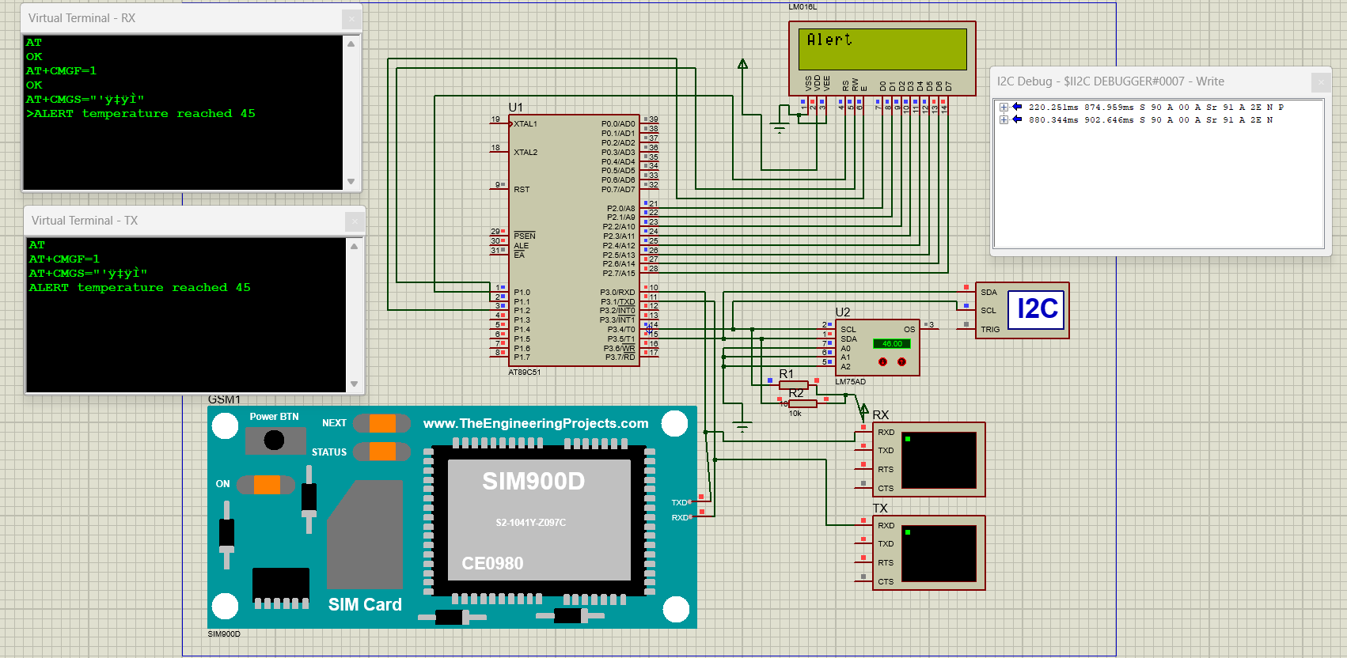Connections: