Web-Based Music Genre Classification for Timeline Song Visualization and Analysis

In this project author has used various traditional machine learning algorithms such as SVM, Decision Tree, LSTM, Feed Forward neural network but not used any advance machine learning algorithms such as Extreme Machine Learning or Bagging Classifier or XGBOOST so as extension we have added XGBOOST algorithm which is giving best accuracy compare to rest of the algorithms.

XGBoost which stands for Extreme Gradient Boosting, is a scalable, distributed gradient-boosted decision tree (GBDT) machine learning library. It provides parallel tree boosting and is the leading machine learning library for regression, classification, and ranking problems.

XGBoost is an optimized distributed gradient boosting library designed to be highly efficient, flexible and portable. It implements Machine Learning algorithms under the Gradient Boosting framework. It provides a parallel tree boosting to solve many data science problems in a fast and accurate way.

Due to above advantages of XGBOOST we have implemented as this project extension and below is the output screens

You run the project similar to old fashion and just I added extra link to train XGBOOST algorithm

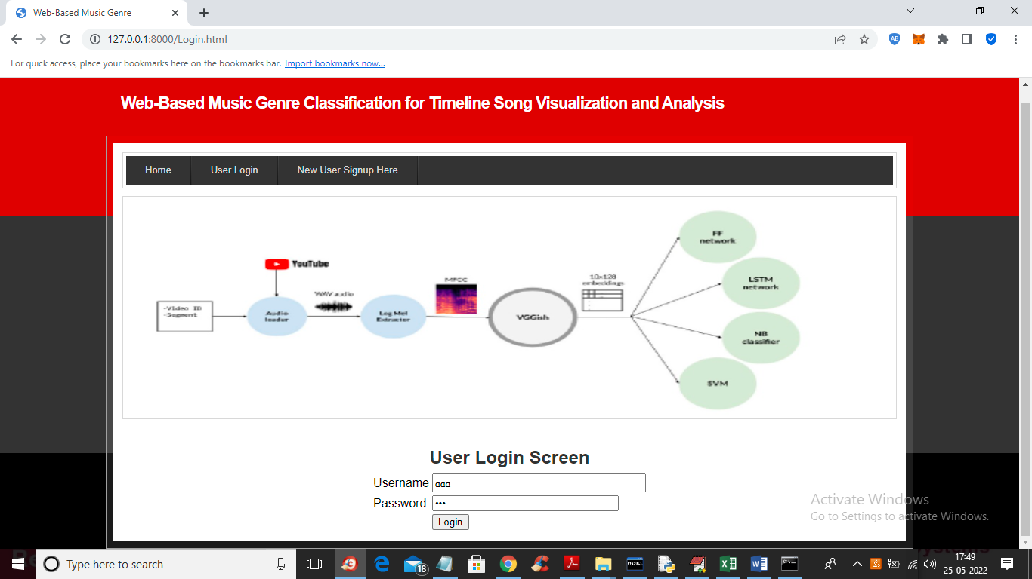

In above screen user is login and after login will get below screen

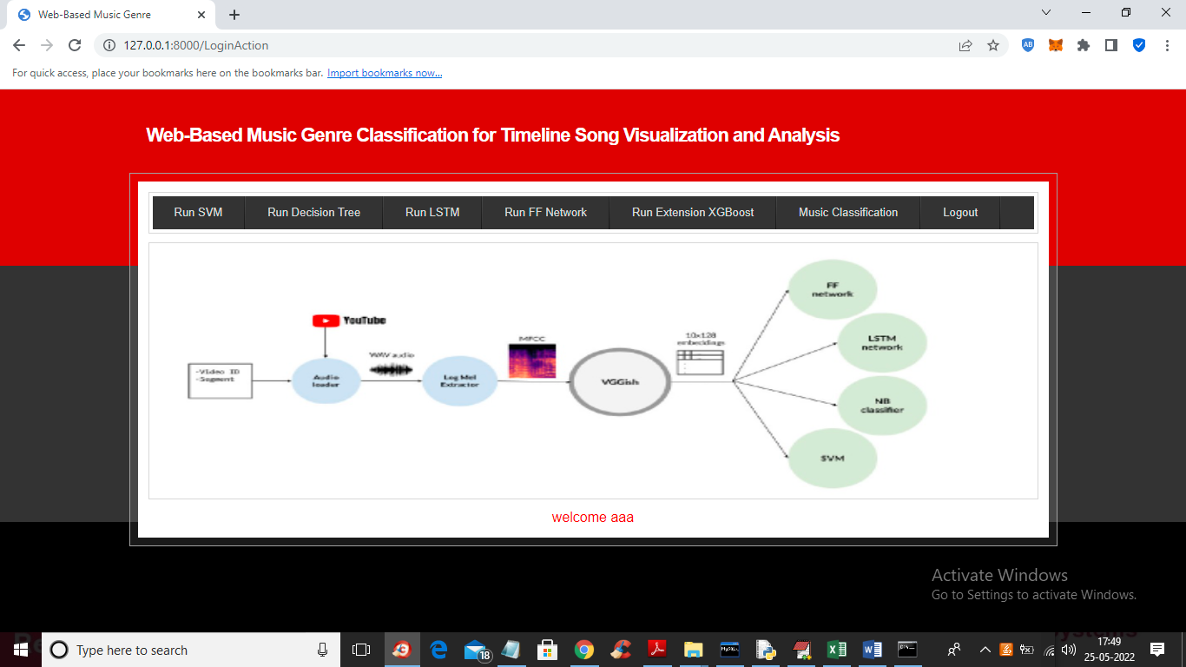

In above screen run each algorithm by clicking on each link and to get below output

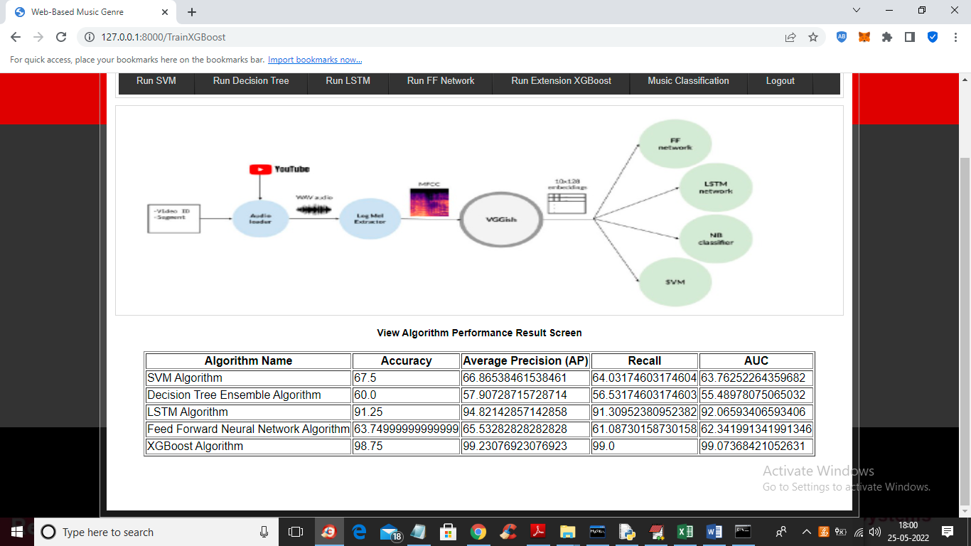

In above screen in all algorithms XGBOOST extension has got high performance compare to other algorithms