

**IT3010**

**Network Design & Management**

**3rd Year, 1st Semester**

Individual Assessment

Submitted to

Sri Lanka Institute of Information Technology

In partial fulfillment of the requirements for the

Bachelor of Science Special Honors Degree in Information Technology

26/04/2024

# Server and Client configuration

* Set Host Name as client.chat.ndm.lk.

Figure 1:Set Host Name

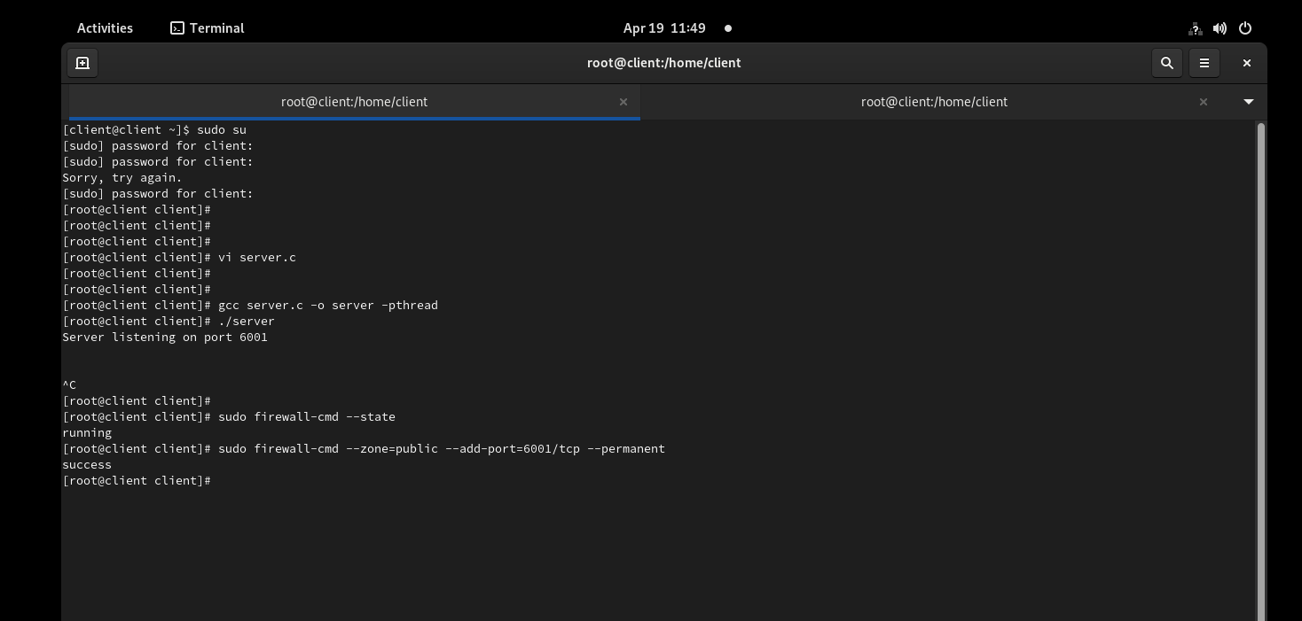

Figure 2: Run Server

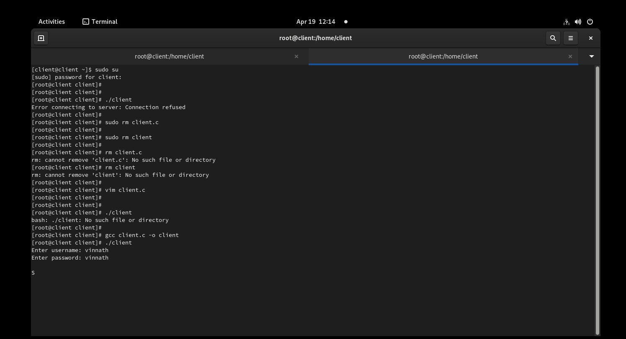

Figure 3: Create User and login.

* 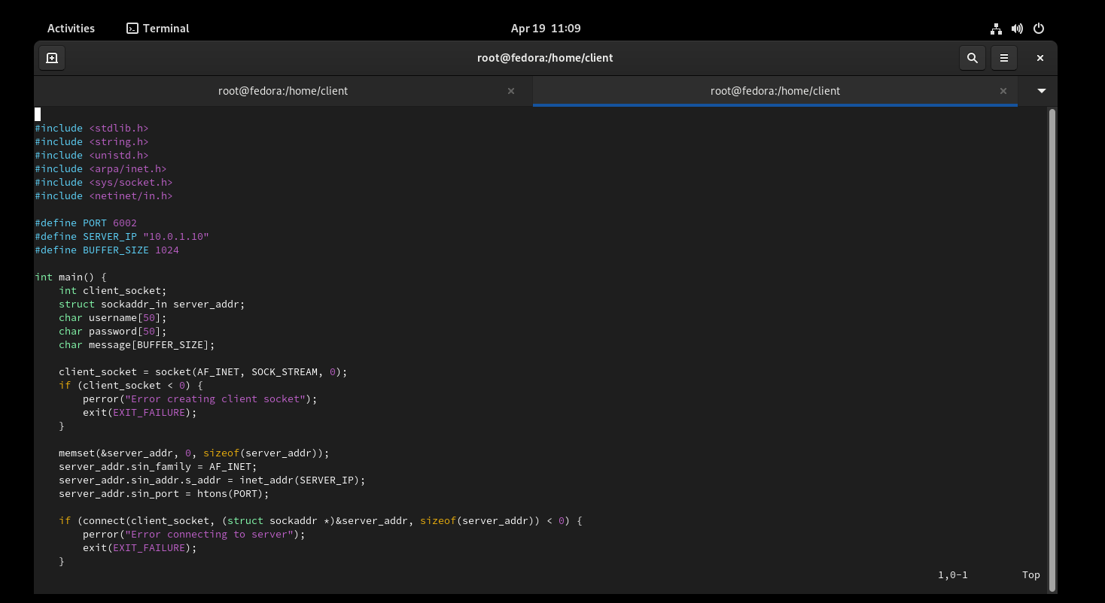Codes

Figure 4:Client Code

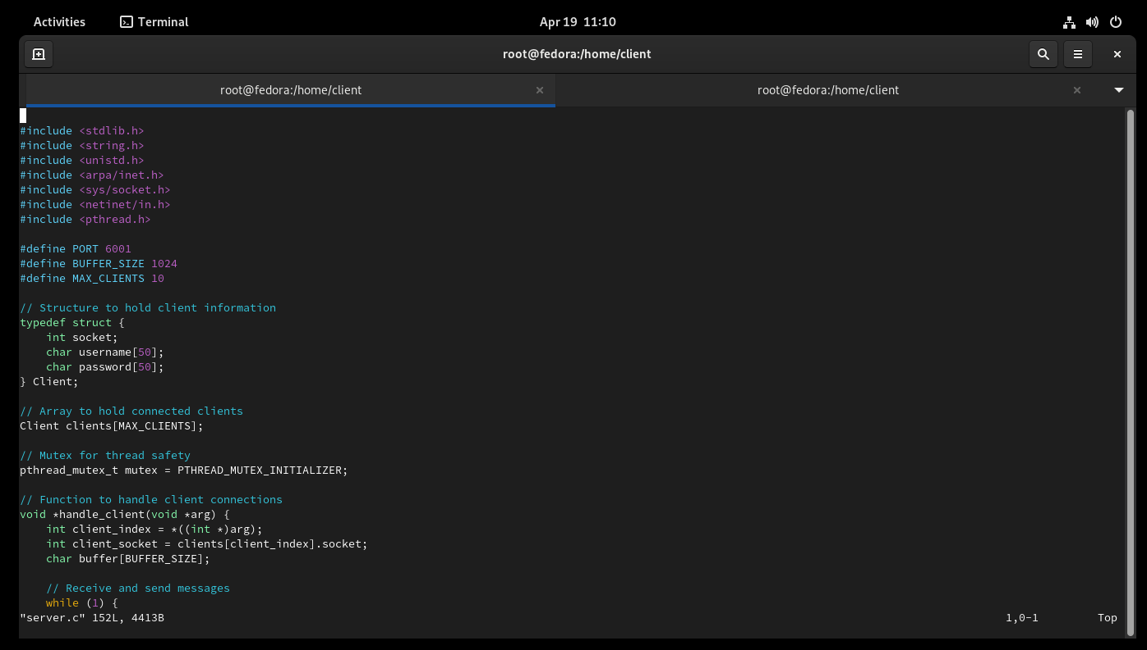

Figure 5:Server Code



Figure 6:Setup FireWall

Figure 7:DHCP Configuration

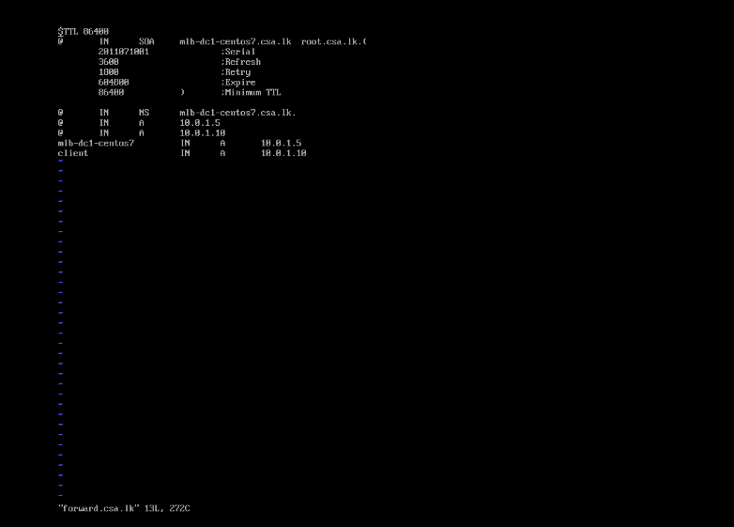

Figure 8: Forward Lookup

Figure 9: Reverse Lookup

* Chatting

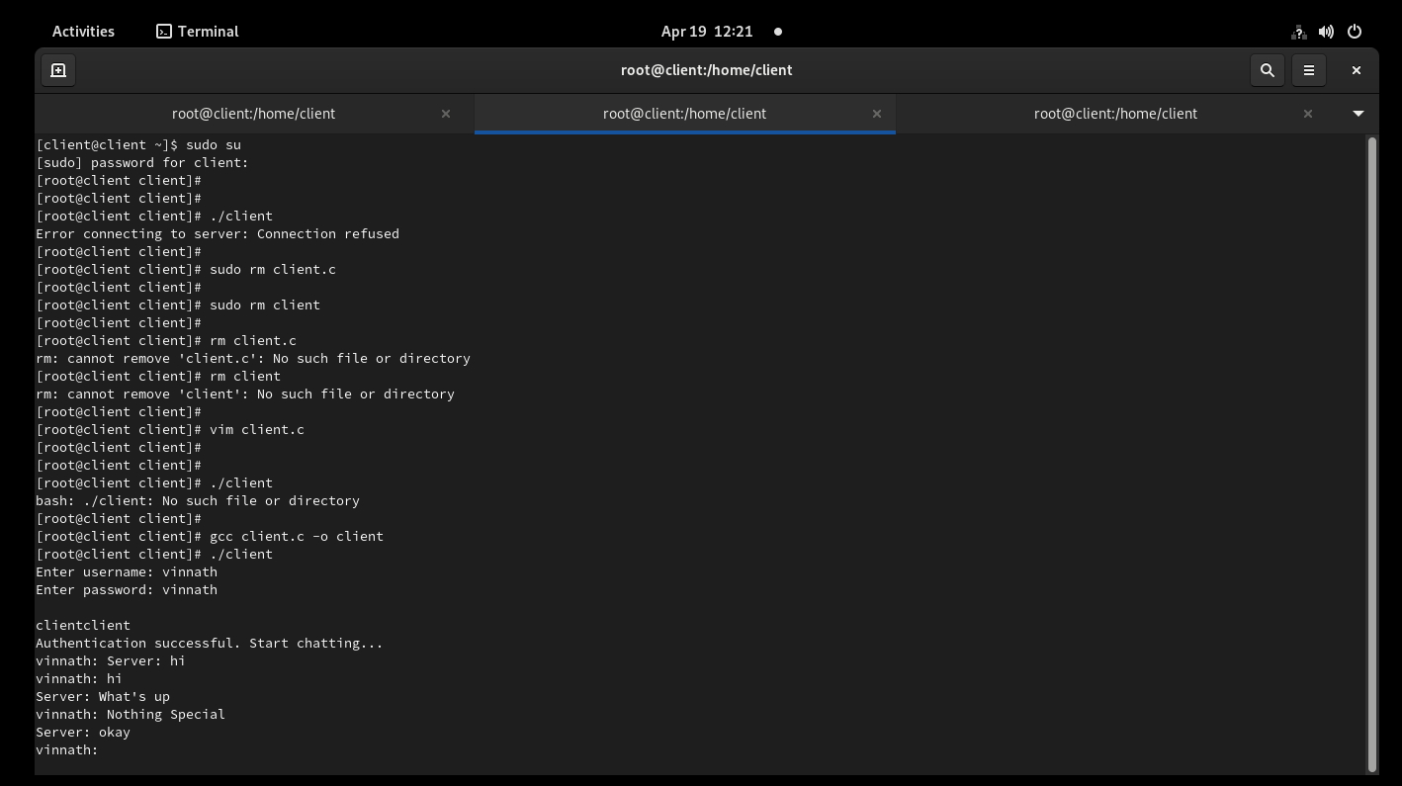

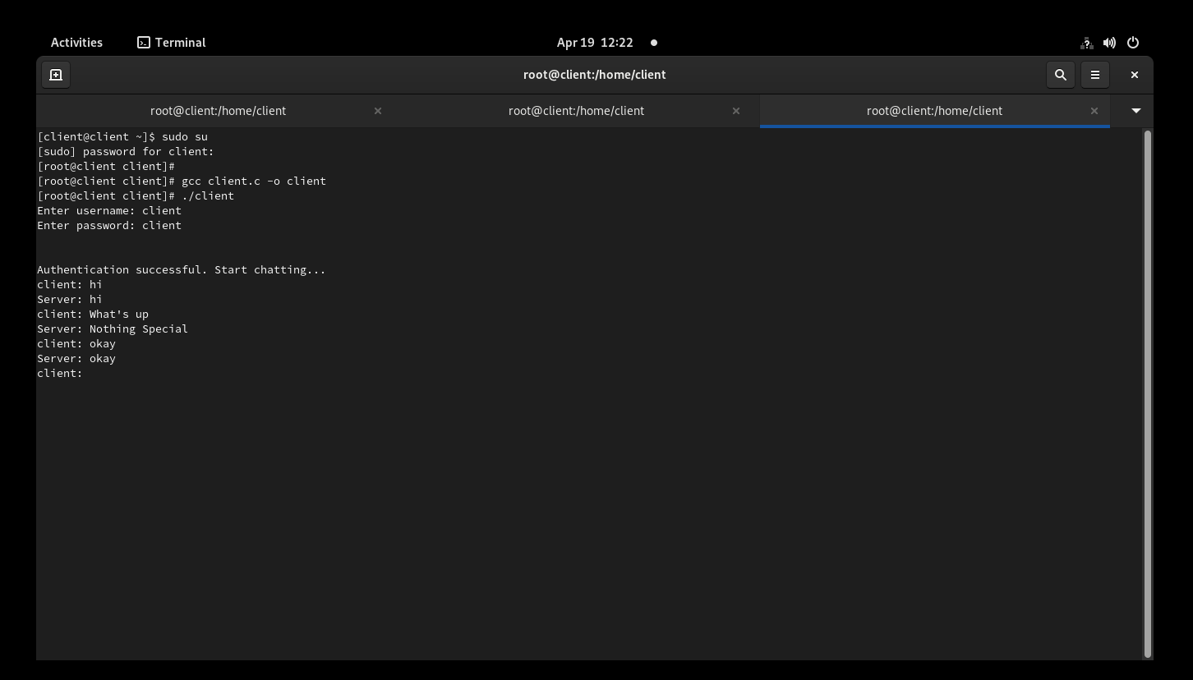

**Declaration**

I certify that this report does not incorporate without acknowledgement, any material previously submitted for a degree or diploma in any university, and to the best of my knowledge and belief it does not contain any material previously published or written by another person, except where due reference is made in text.

Registration Number: IT21244766

Name: Pathirana K P V