**Project abstract:**

Our rest API service determines the skills required for a job opening at the given source of resumes of specified location and match applicant resumes based on skills identified by our Generative AI Model with the help of Cognitive search. Our Generative AI Model extracts information from resumes across different fields and present it in a structured format like a database or spreadsheet. It captures essential details like the candidate's name, contact information, education, work experience, skills, and other pertinent information.

The extracted data is valuable for tasks such as resume screening, candidate tracking, and database management. By employing our AI enabled API, industries such as IT, Healthcare, Banking, and more can streamline their recruitment processes, enhance efficiency, and achieve better results.

**High Level Design Diagram:**

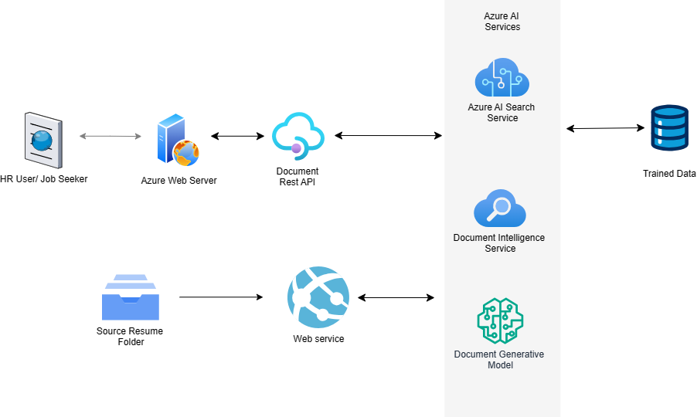

**Sample request:**

{

"context": "Excellent relationship building skills",

"category": "resume",

"threshold": 0.7,

"noOfMatches": 3,

"inputPath": "https://hackathontestdata2024.blob.core.windows.net/data?comp=list"

}

**Sample response:**

{

"count": 1,

"metadata": {

"confidenceScore": 74.428505

},

"results": [

{

"id": "11616482",

"name": "11616482.pdf",

"score": 74.428505

}

],

"status": "Success"

}