**Resume Best Match – Test Document**

**Team 343 - Global Hackathon 2024**

Ping URL:

GET: <https://team343App.azurewebsites.net/hackathon2024/team343/ping>

Respone:

{

    "status": "Success"

}

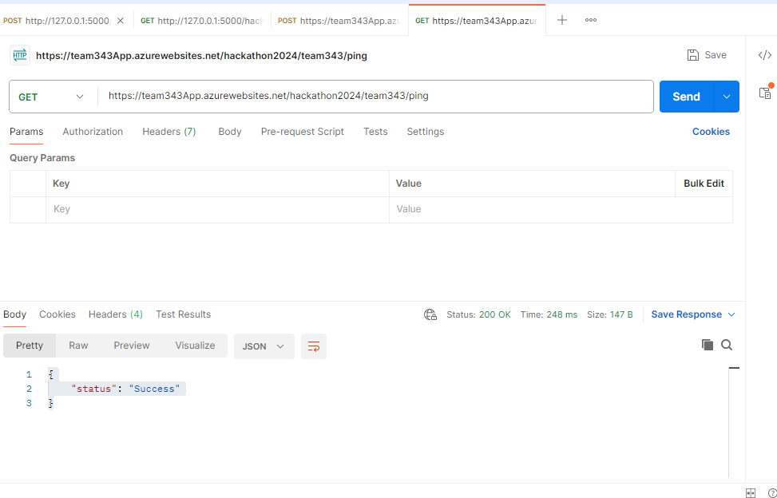

Search API URL:

POST: <https://team343App.azurewebsites.net/hackathon2024/team343/search>

Scenorio1:

Request:

{

        "context": "Account Mangage with 5 years experience",

        "category": "resume",

        "threshold": 0.7,

        "noOfMatches": 3,

        "inputPath": "https://hackathontestdata2024.blob.core.windows.net/data?comp=list"

    }

Response:

{

    "count": 4,

    "metadata": {

        "confidenceScore": 1.209674705

    },

    "results": [

        {

            "id": "11616482",

            "name": "11616482.pdf",

            "score": 2.181108

        },

        {

            "id": "10247517",

            "name": **null**,

            "score": 1.1926777

        },

        {

            "id": "11336022",

            "name": "11336022.pdf",

            "score": 0.73245656

        },

        {

            "id": "10909720",

            "name": "10909720.pdf",

            "score": 0.73245656

        }

    ],

    "status": "Success"

}

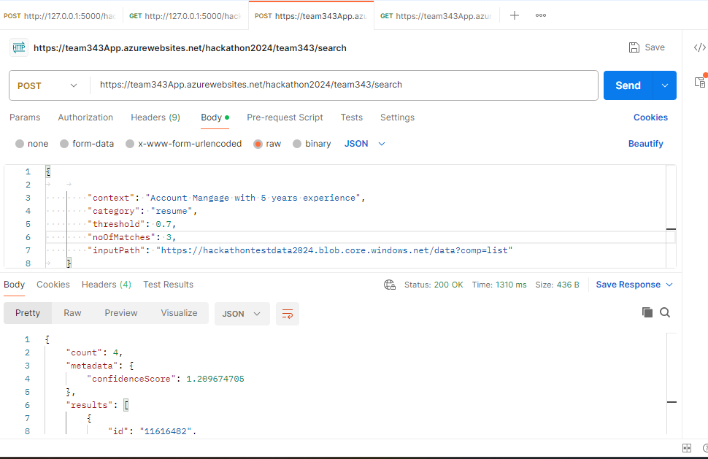

Scenorio2:

Request:

{

        "context": "Teacher has more than 3 years experience",

        "category": "resume",

        "threshold": 0.7,

        "noOfMatches": 3,

        "inputPath": "https://hackathontestdata2024.blob.core.windows.net/data?comp=list"

    }

Response:

{

    "count": 3,

    "metadata": {

        "confidenceScore": 1.4831833666666665

    },

    "results": [

        {

            "id": "11616482",

            "name": "11616482.pdf",

            "score": 1.8292544

        },

        {

            "id": "11336022",

            "name": "11336022.pdf",

            "score": 1.3236783

        },

        {

            "id": "10909720",

            "name": "10909720.pdf",

            "score": 1.2966174

        }

    ],

    "status": "Success"

}

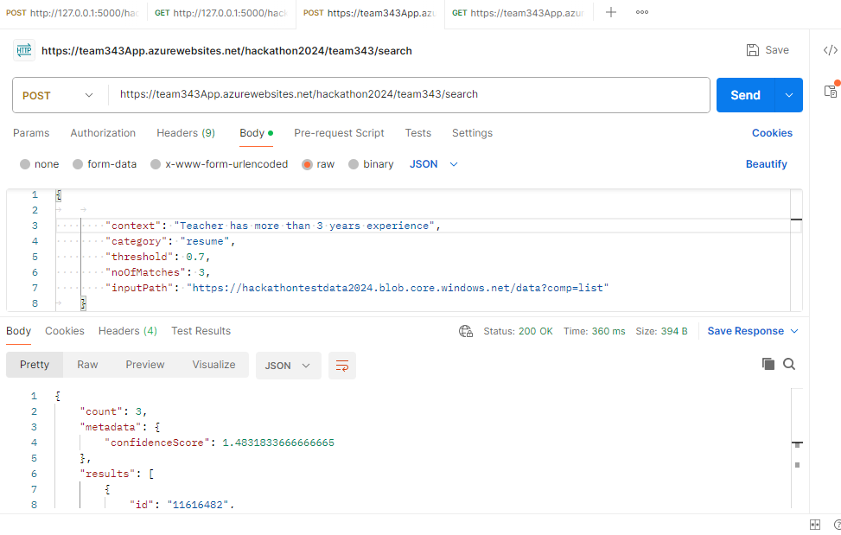

Scenorio3:

Request:

{

        "context": "Account Manager with MBA qualification",

        "category": "resume",

        "threshold": 0.7,

        "noOfMatches": 3,

        "inputPath": "https://hackathontestdata2024.blob.core.windows.net/data?comp=list"

    }

Response:

{

    "count": 2,

    "metadata": {

        "confidenceScore": 0.99915099

    },

    "results": [

        {

            "id": "11616482",

            "name": "11616482.pdf",

            "score": 1.837859

        },

        {

            "id": "10247517",

            "name": **null**,

            "score": 0.16044298

        }

    ],

    "status": "Success"

}

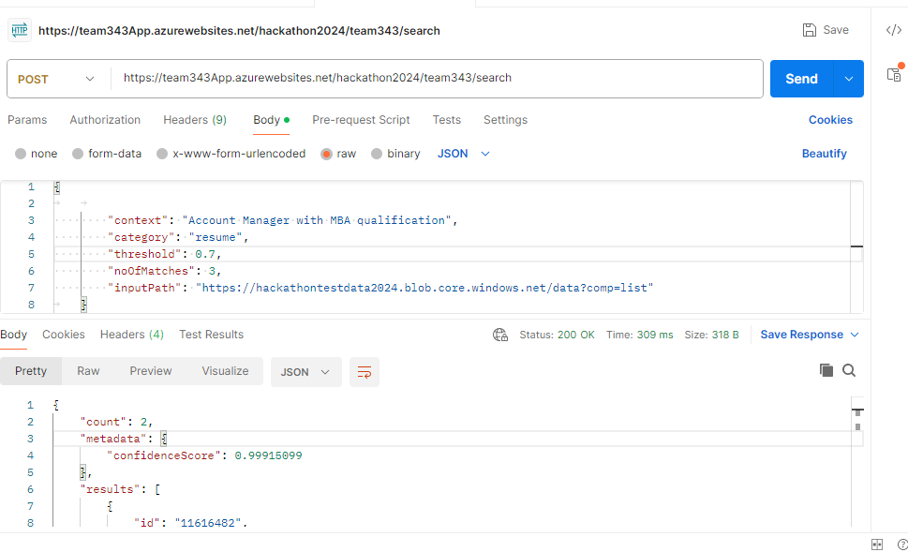

Scenorio 4:

Request:

{

        "context": "Account Manager with MBA qualification",

        "category": "Test",

        "threshold": 0.7,

        "noOfMatches": 3,

        "inputPath": "https://hackathontestdata2024.blob.core.windows.net/data?comp=list"

    }

Response:

{

    "status": "Bad Request Please check category should be resume!"

}

