Acknowledgement

I am deeply grateful to the Principle of St. Mary’s school for her kind support, encouragement and cooperation in my endeavour to complete this successfully.

I am deeply indebted to Ms. Payal Sehgal for her invaluable guidance which gave me insight and helped me carry out my project in a systematic manner.

I am also thankful to my parents for their encouragement and cooperation.

Certificate

**This is to certify that Roll No________, student of class 12th-a, has successfully completed Computer Science Project under the guidance of Ms.PayalSehgal during the year 2018-19 in partial fulfilment of computer science practical examination conducted by AISSCE,New Delhi.**

**Signature of Computer Science Teacher**

**Signature of External Examiner**

9

11

13

15

17

19

212543

1. About C++
2. About the Project
3. Header file used
4. File Generated
5. Work Description
6. Limitations of the Project
7. Flowchart of the Project
8. Output Screens
9. Source Code

Index

ABOUT C++

C++ is a general-purpose object-oriented programming (OOP) language, developed by **Bjarne Stroustrup**, and is an extension of the C language. It is therefore possible to code C++ in a "C style" or "object-oriented style." In certain scenarios, it can be coded in either way and is thus an effective example of a hybrid language.

C++ is considered to be an intermediate-level language, as it encapsulates both high- and low-level language features. Initially, the language was called "C with classes" as it had all the properties of the C language with an additional concept of "classes." However, it was renamed C++ in 1983.

C++ is one of the most popular languages primarily utilized with system/application software, drivers, client-server applications and embedded firmware.

The main highlight of C++ is a collection of predefined classes, which are data types that can be instantiated multiple times. The language also facilitates declaration of user-defined classes. Classes can further accommodate member functions to implement specific functionality. Multiple objects of a particular class can be defined to implement the functions within the class. Objects can be defined as instances created at run time. These classes can also be inherited by other new classes which take in the public and protected functionalities by default.

ABOUT

THE PROJECT

In the existing system, most of the records are maintained on paper. It becomes very inconvenient to modify the data. In the existing system, here is a possibility that the same data in different registers may have different values which means the entries of the same data do not match. This inconsistent state does not supply the concrete information which poses a problem in the case information related to particular search record .Our project is very useful.

User is no longer required to check his register in search of records, as now it can be searched over the software by choosing some options. The user need not to type in most of the information. He/she is just required to enter the desired options. On the whole it liberates the user from keeping lengthy manual records. In a nutshell, it abates the work load of an organization .In today’s world, no one likes to perform calculations on calculator or manually when computer is there. Everyone wants his/her work to be done by computer automatically and displaying the result for further manipulations. This term paper project is just an application of the language C in developing software. This is the program for keeping records of the bank, that is the entire details of the customer, savings, how much money he/she can deposit and withdraw from the bank, to open the new account, create a new account, display all account holders, balance enquiry etc.

HEADER FILES USED

**<iostream.h>** : contains the definition of basic iostream class template, which implements formatted input and output.

**<conio.h>** : This header declares several useful library functions for performing "console input and output" from a program.

**<time.h>** : In C programming language **time**.**h** (used as ctime in C++) is a header file **defined** in the C Standard Library that contains **time** and date function declarations to provide standardized access to **time**/date manipulation and formatting.

**<dos.h>** : **Dos**.**h** header file of C language contains functions for handling interrupts, producing sound, date and time functions.

**<string.h>** : **string**.**h** is the header in the C standard library for the C programming language which contains macro definitions, constants and declarations of functions and types used not only for **string** handling but also various memory handling functions.

**<stdio.h>** : **stdio**.**h** is the header file for standard input and output. This is useful for getting the input from the user(Keyboard) and output result text to the monitor(screen).

**<stdlib.h>** : **stdlib**.**h** is the header of the general purpose standard library of C programming language which includes functions involving memory allocation, process control, conversions and others.

**<fstream.h>** : contains the definitions of basic ifstream, basic ofstream and basic fstream class templates which implement formatted input, output and input/output on file streams.

FILES GENERATED

* Data.dat
* Stores the data of user
* It helps to form a new account
* Modify details of a user
* Search an account
* Delete account.
* Employee.dat
* Stores the data of employee
* It helps to form a new employee entry
* Modify details of a employee
* Search an employee account
* Delete employee account
* Pass.dat
* To view transactions of an individual
* Stores the date, particulars, type of transaction.

WORK DESCRIPTION

The ***“BANK MANAGEMENT SYSTEM”***undertaken as a project is based on relevant technologies. This project is developed to nurture the needs of a user in a banking sector by embedding all the tasks of transactions taking place in a bank. The Domain "Banking System" keeps the day by day tally record as a complete banking. It also holds records of employee of the bank. The following are the domains of the program :

* Open New Account
* Keeps Records of All Account Holders
* View transactions
* Add money
* Withdraw money
* View passbook
* Frequently asked questions related to the bank
* Issue debit/credit cards and print cheque book
* Modify And Delete Account’s Information
* Enter employee information
* Modify and delete employee information
* Security of data
* User friendly and interactive

The main objective of this project is to make a C++ program which maintains a person’s account in a bank, provide ease of service to the user and keep record of its employees.

LIMITATIONS

OF THE PROJECT

* Program cannot link account details to print cheque books, debit cards and credit cards.
* Cannot give loans to its users.
* No Fixed deposit accounts can be made
* No interest is given on money deposited.
* Verification of the user is not done.
* No money is deducted from the account even if no transaction is made for a long time

FLOWCHART OF THE PROGRAM

**WELCOME TO 4CLOVER BANK**

**ENTER YOUR CHOICE**

**CUSTOMER**

**EXIT**

**EMPLOYEE**

**ENTER YOUR CHOICE**

**ENTER YOUR CHOICE**

New customer

Customer details

Deposit/Withdraw money

View Transactions

Corrected details

Delete Account

FAQs

Issue Cards/cheque

About us

View all

Enter data

See data

Modify data

Delete data

Search data

**Deposit Withdraw**

**Debit card Credit Card Cheque**

**Back to customer menu ?**

**Back to Employee menu ?**

STOP

**Back to main menu?**

OUTPUT SCREENS

Welcome screen

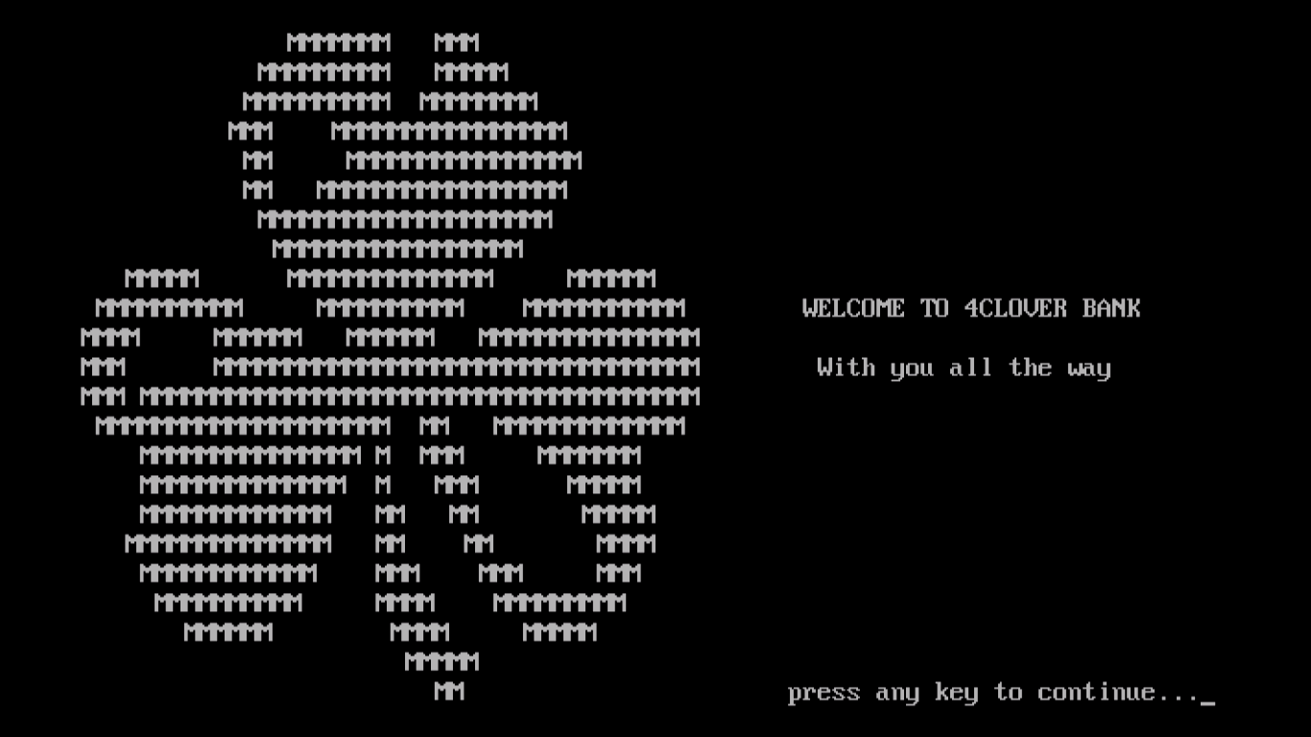

Main menu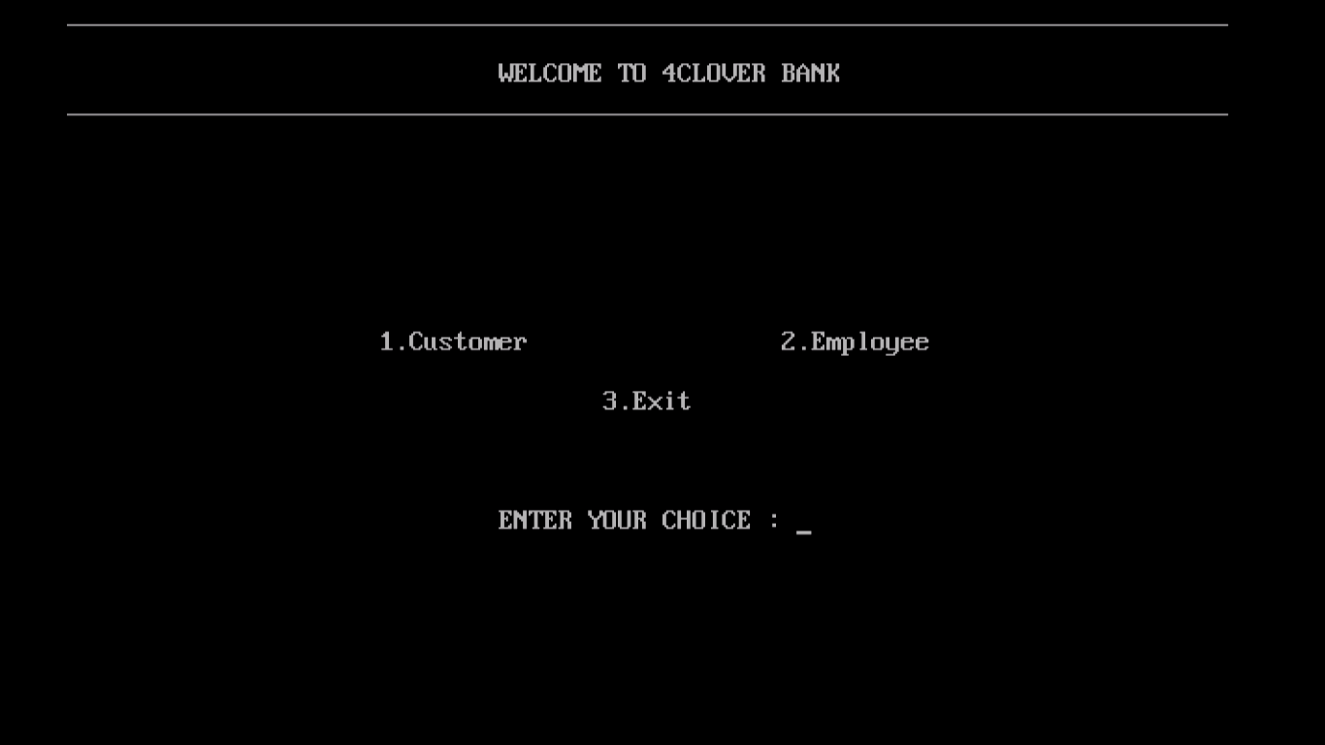

Customer Menu

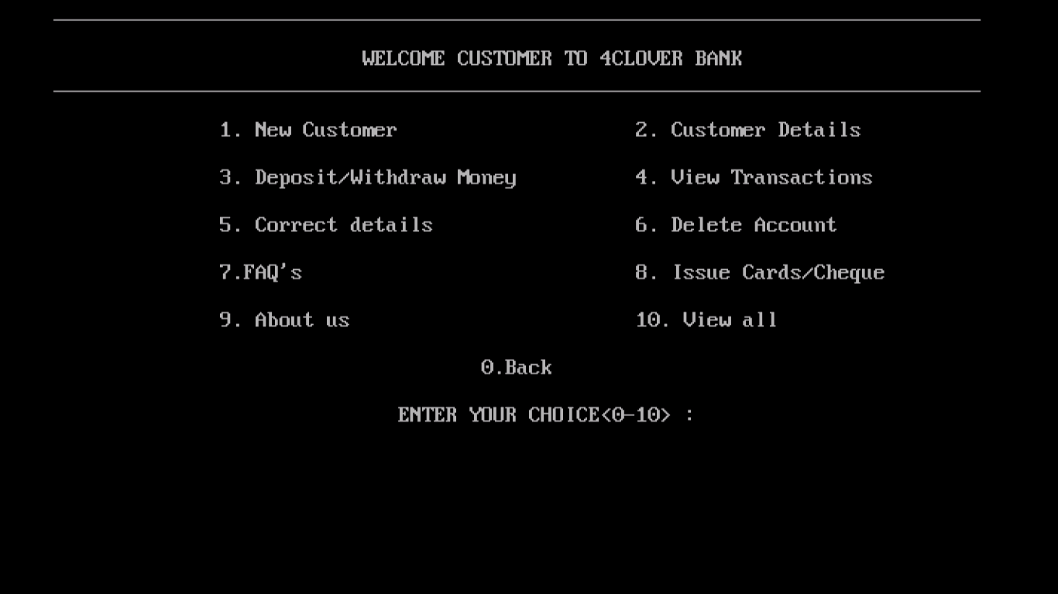

New Customer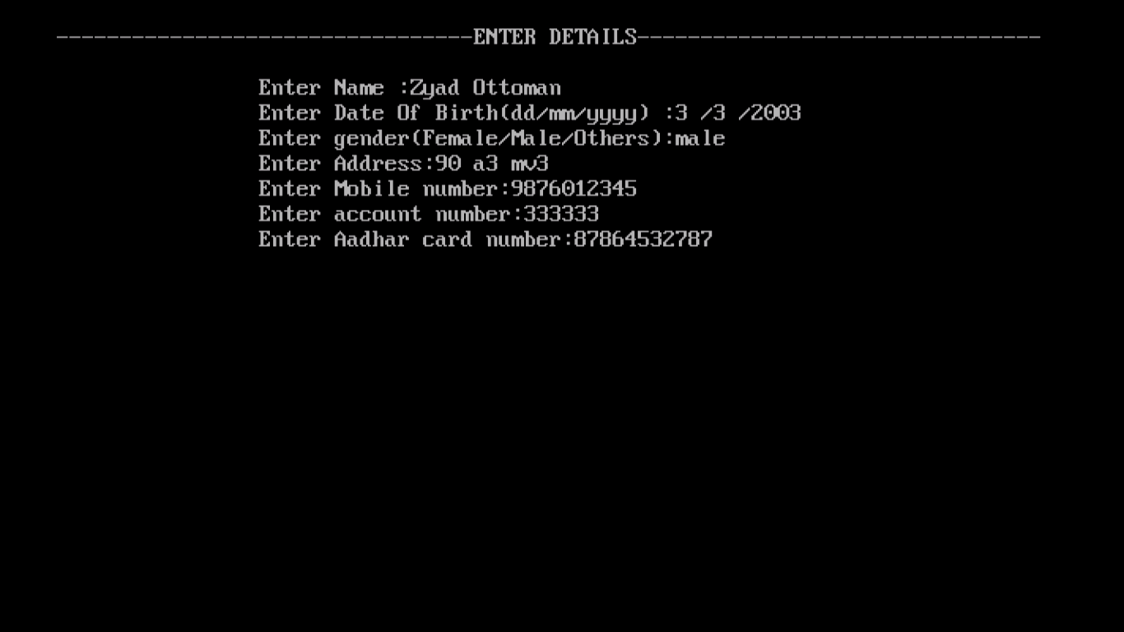

Security Questions (in case of forgetting the pin)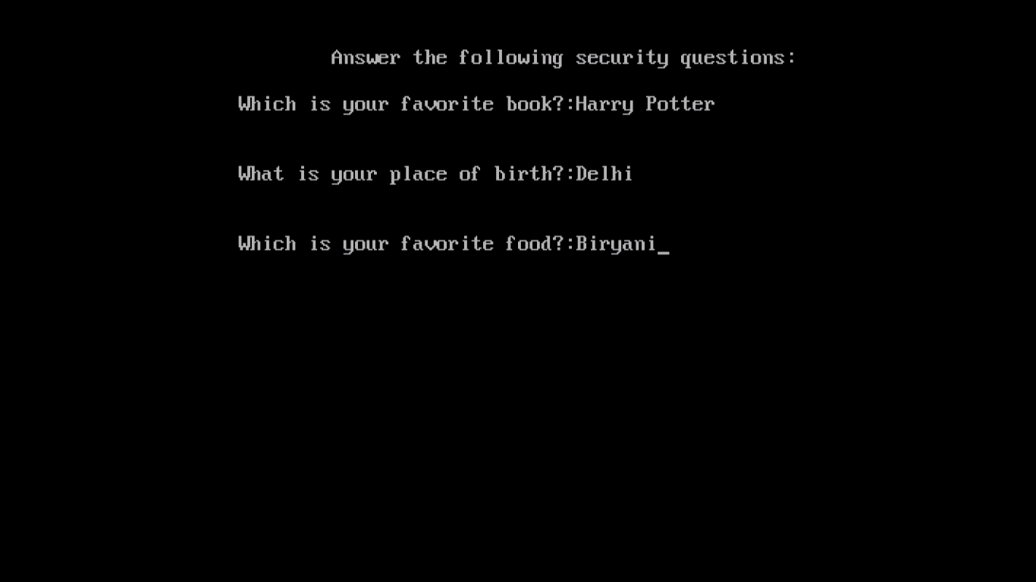

Account Created(pin given)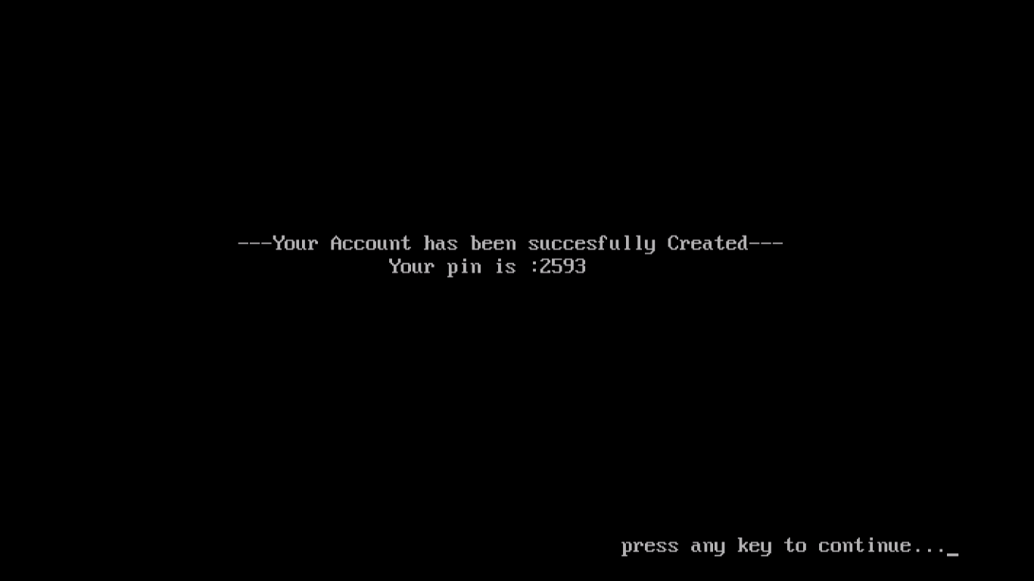

Searching Account 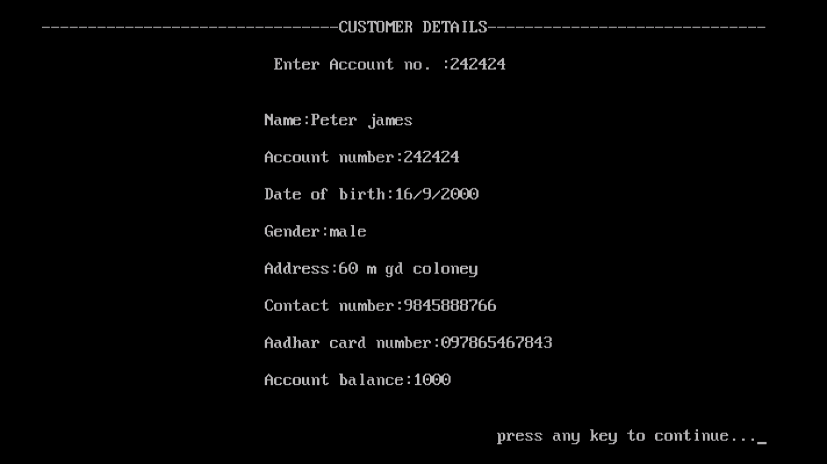

Transaction portal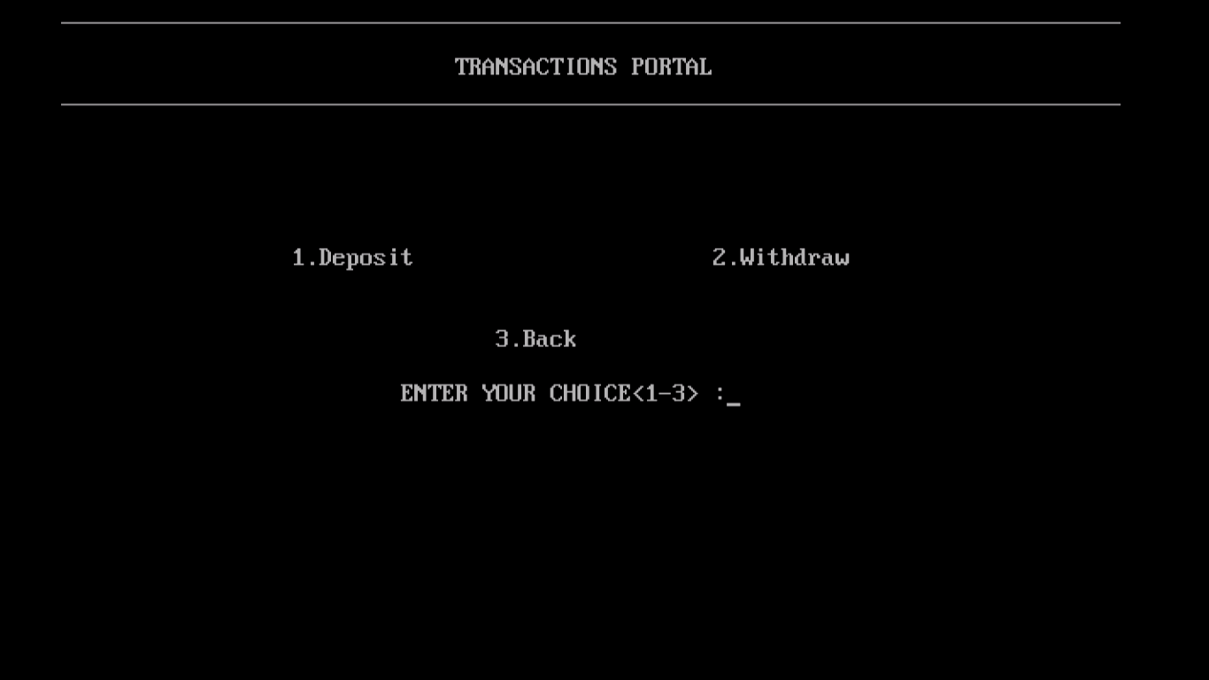

Deposit money

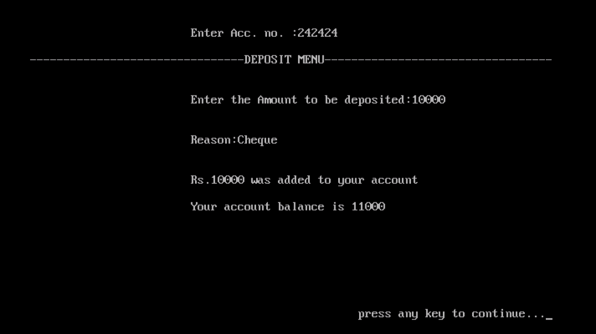

Withdraw money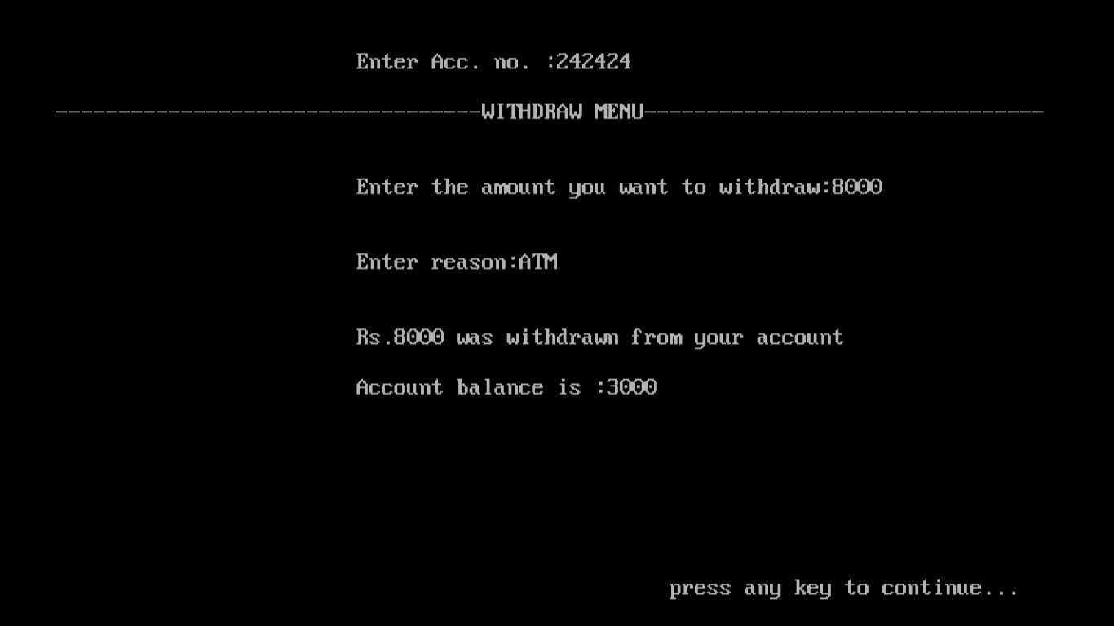

Passbook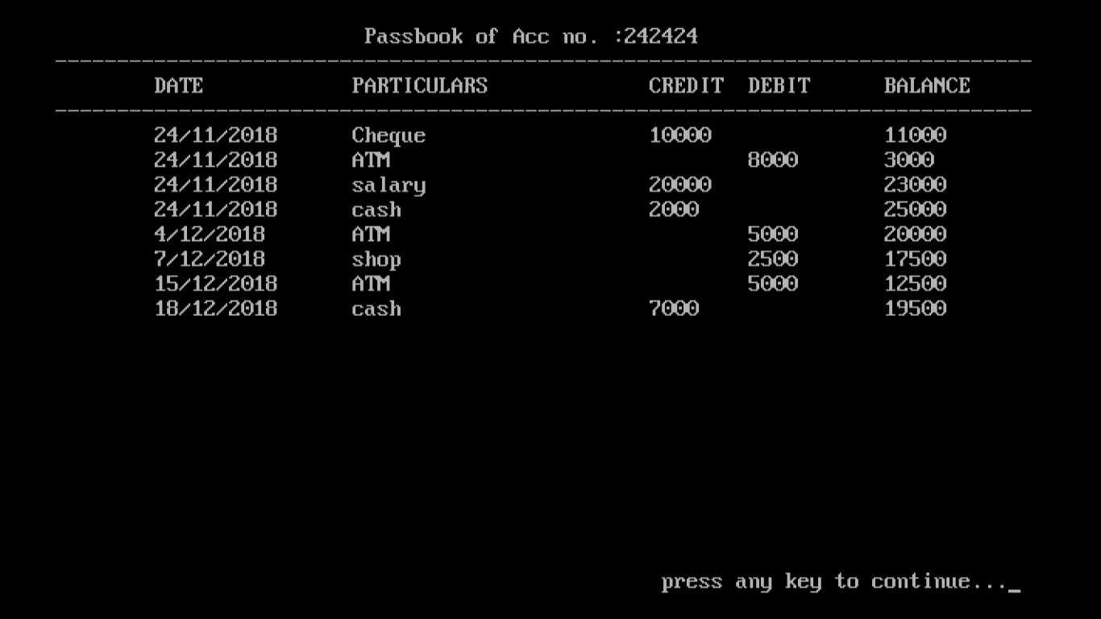

Correction/Modification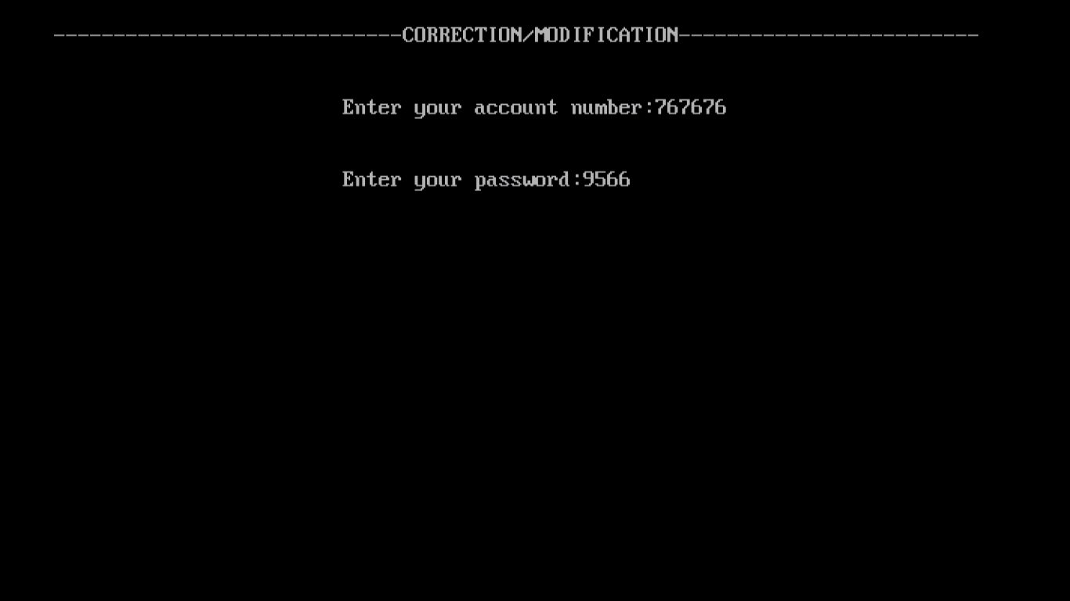

Entering corrected Data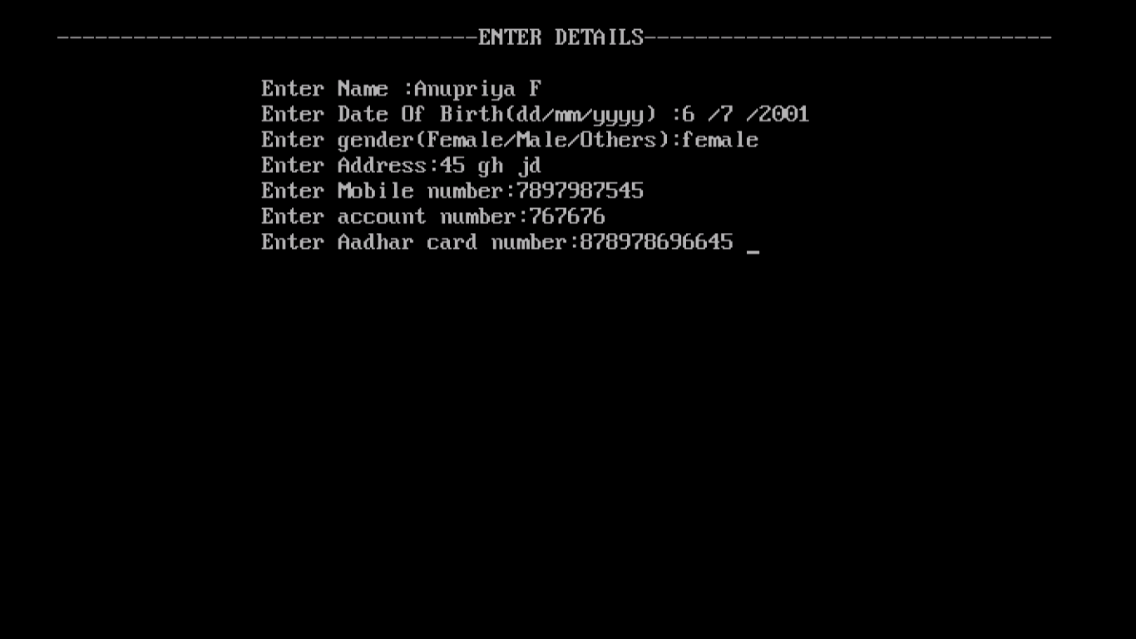

Re-entering Security Questions

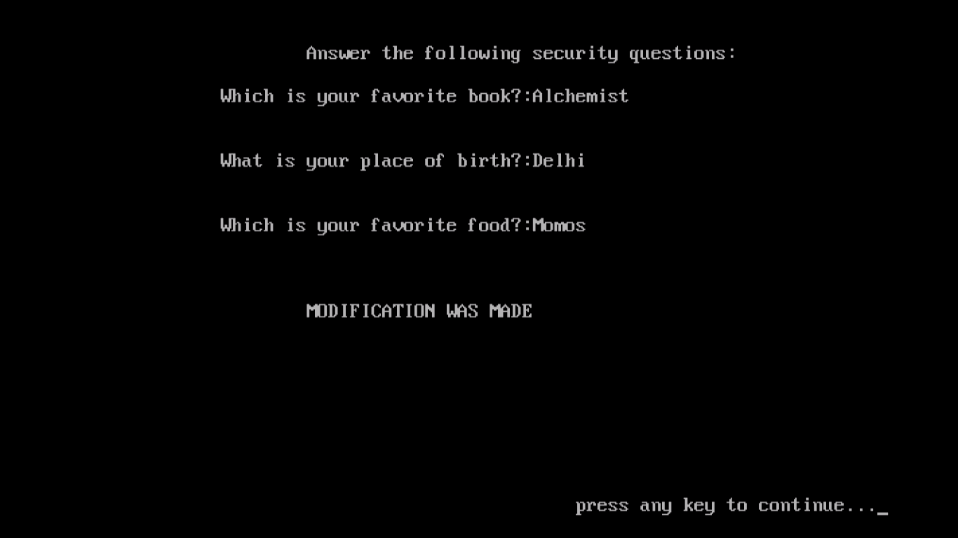

If password goes wrong

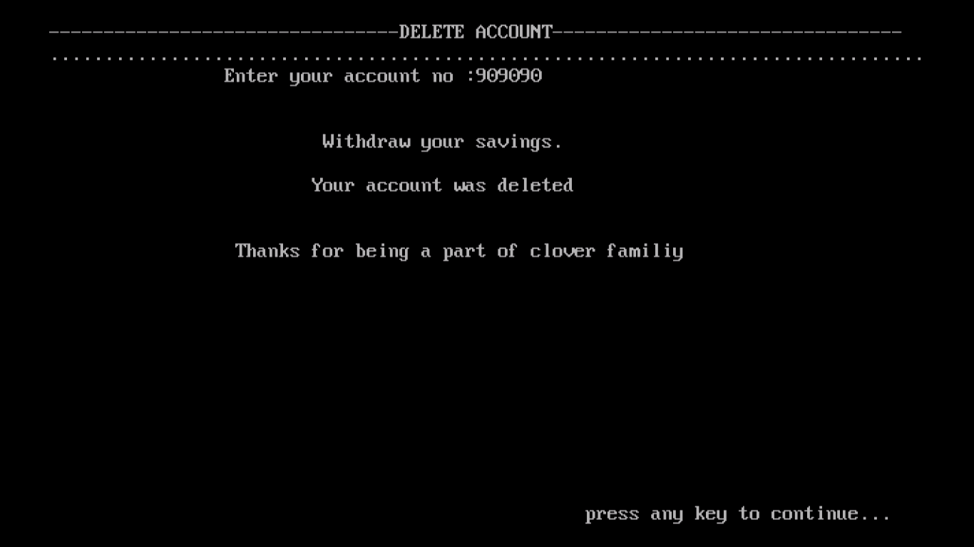

Deleting an account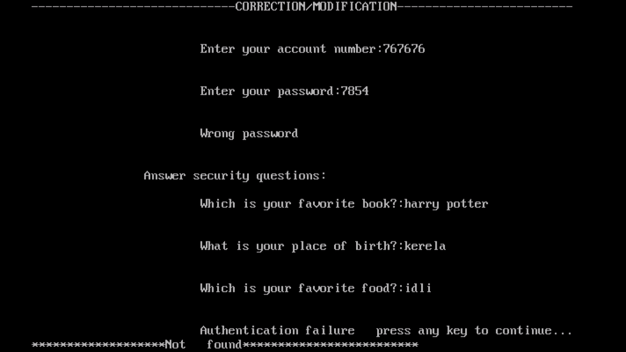

FAQs

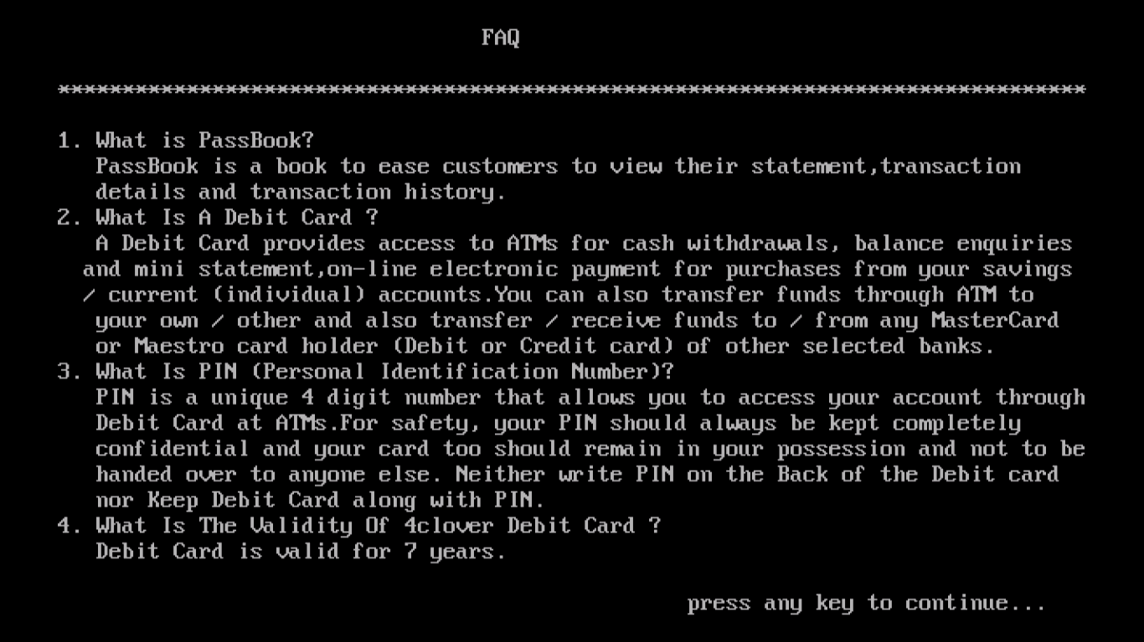

Issue Cards/Cheque Menu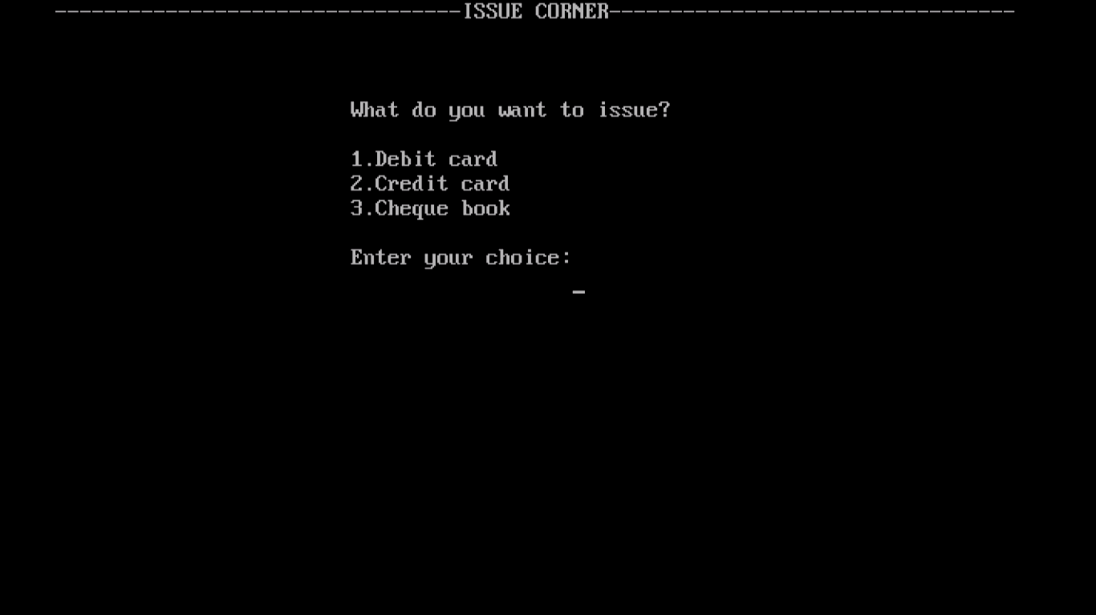

Debit Card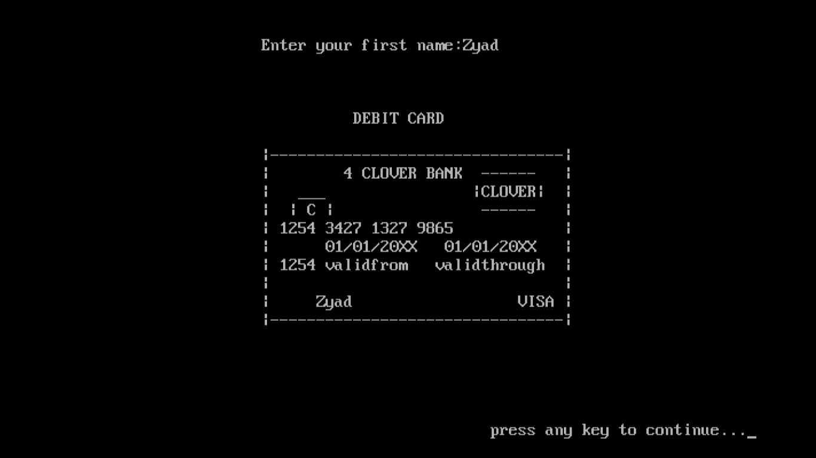

Credit card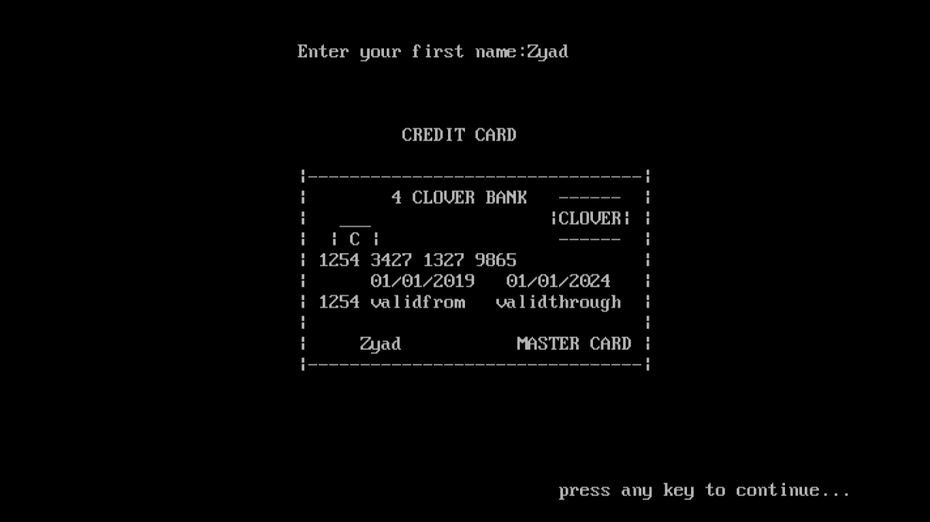

Cheque 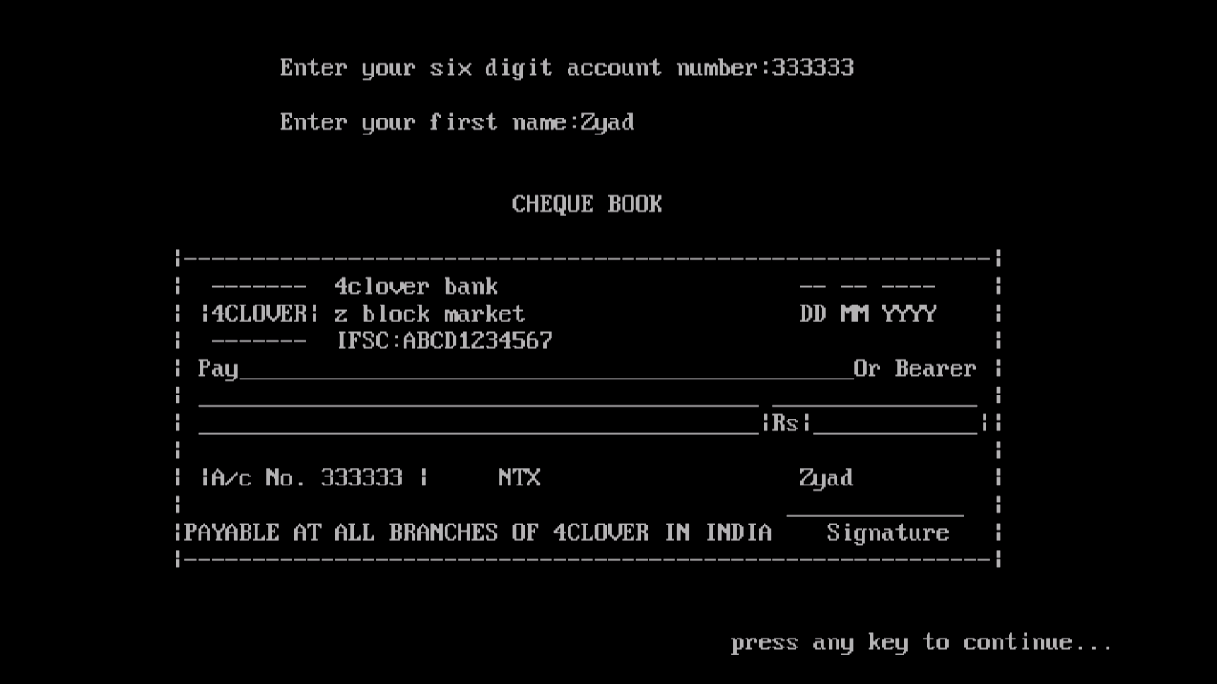

List of all customers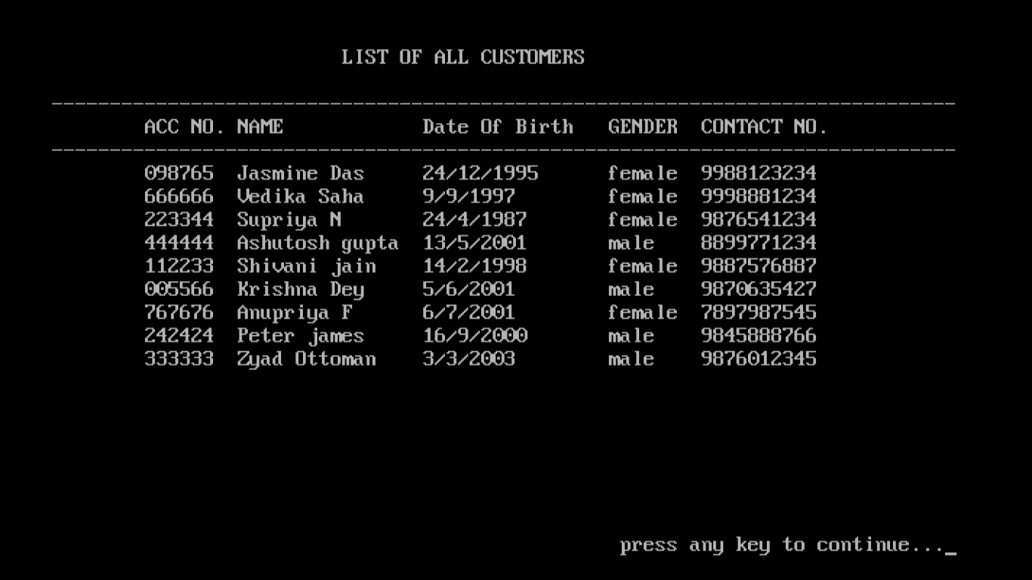

Employee Menu

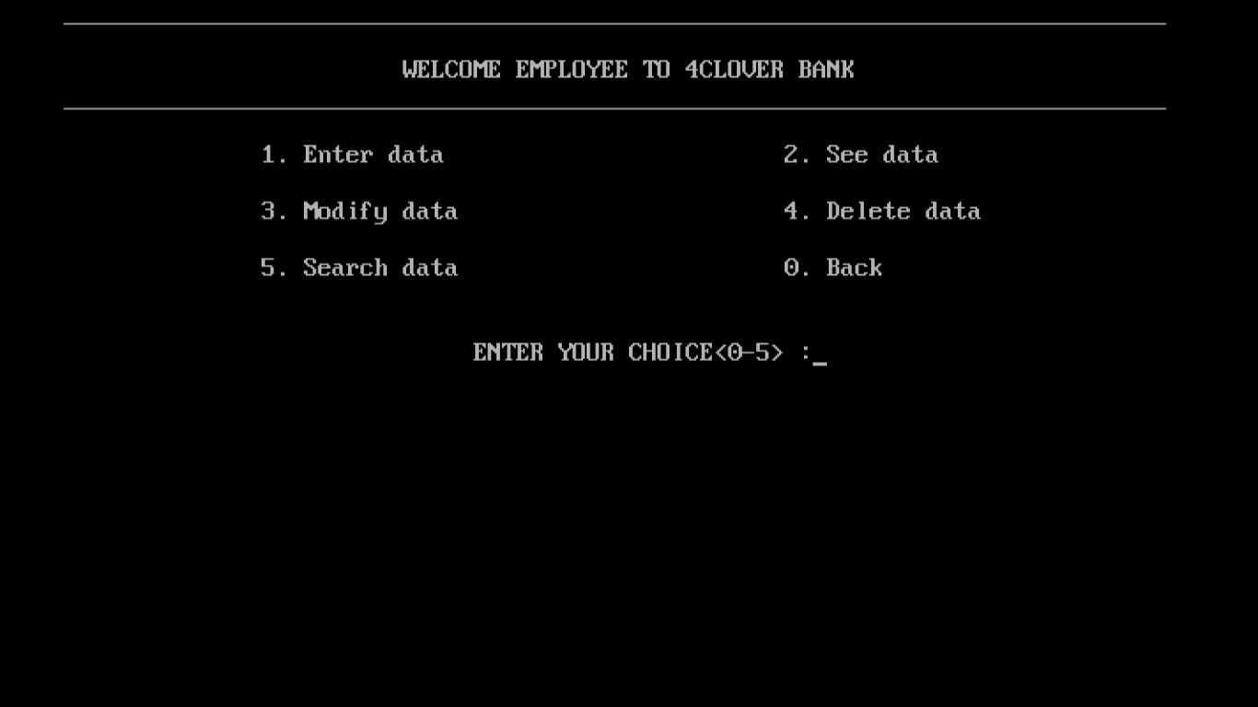

Enter Data

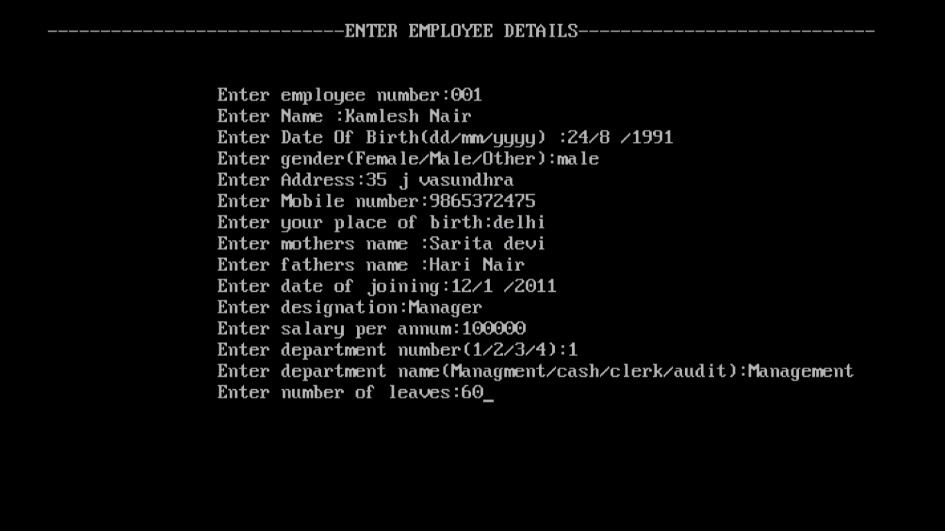

ID Proof

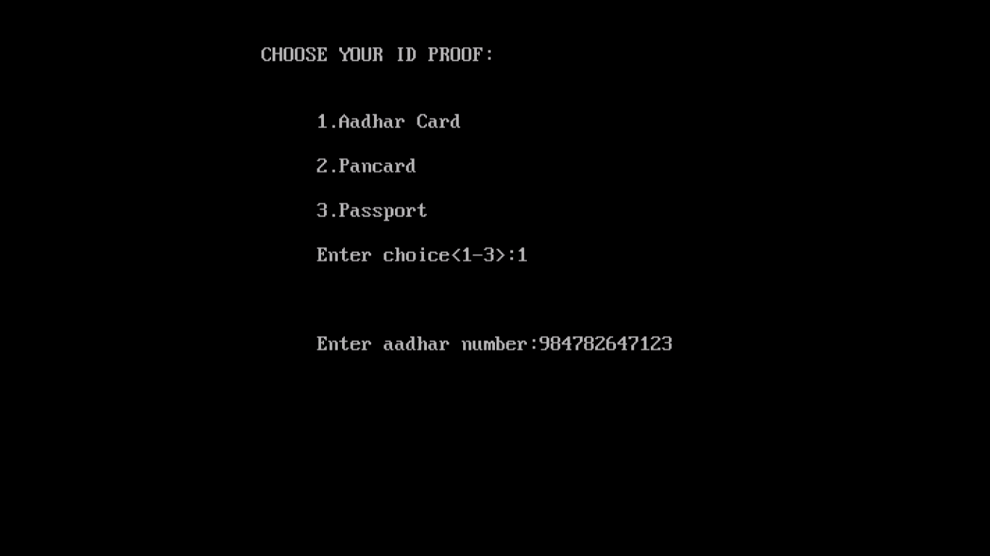

List of all Employee

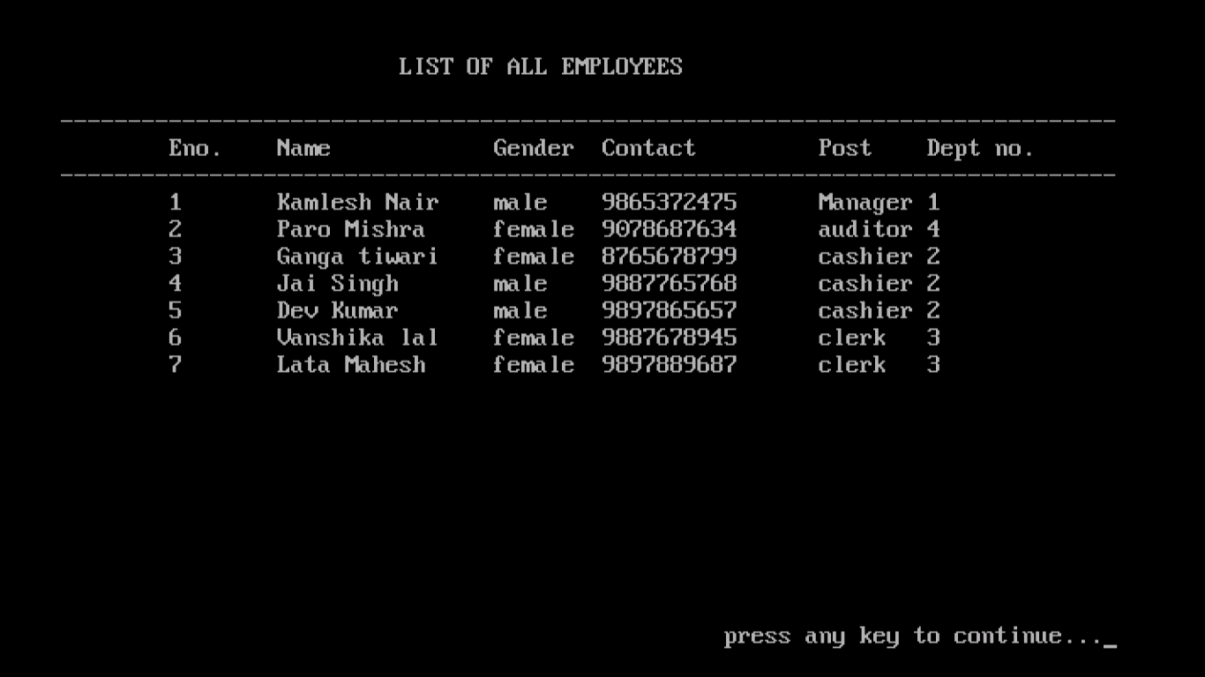

Correction/Modification of data

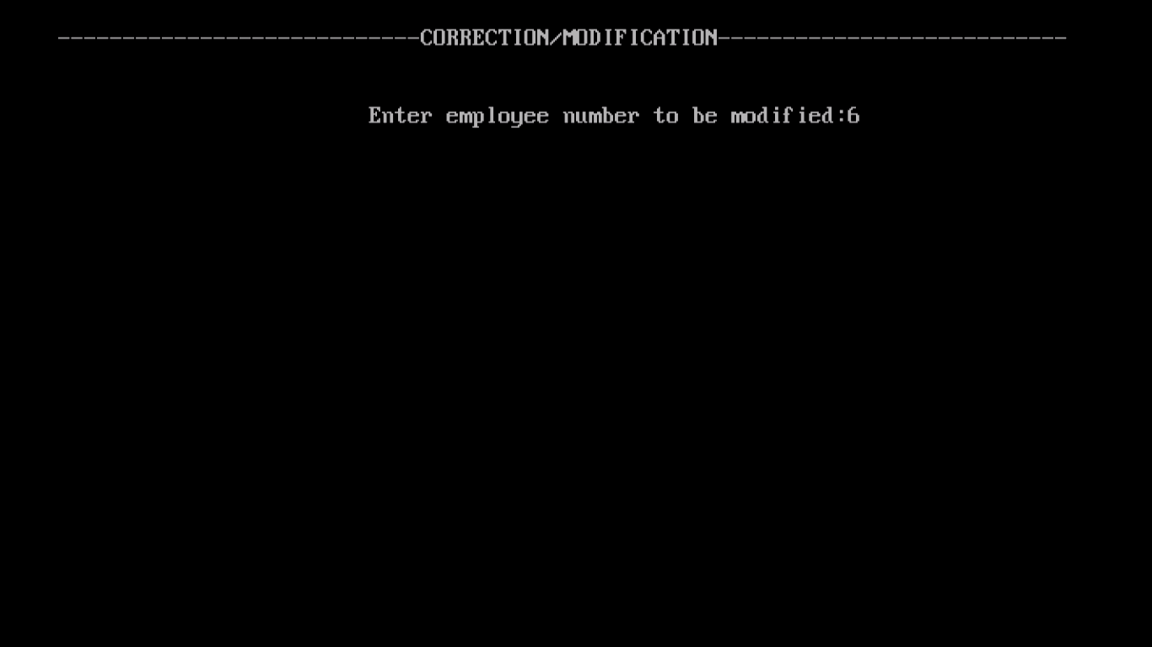

Entering Corrected details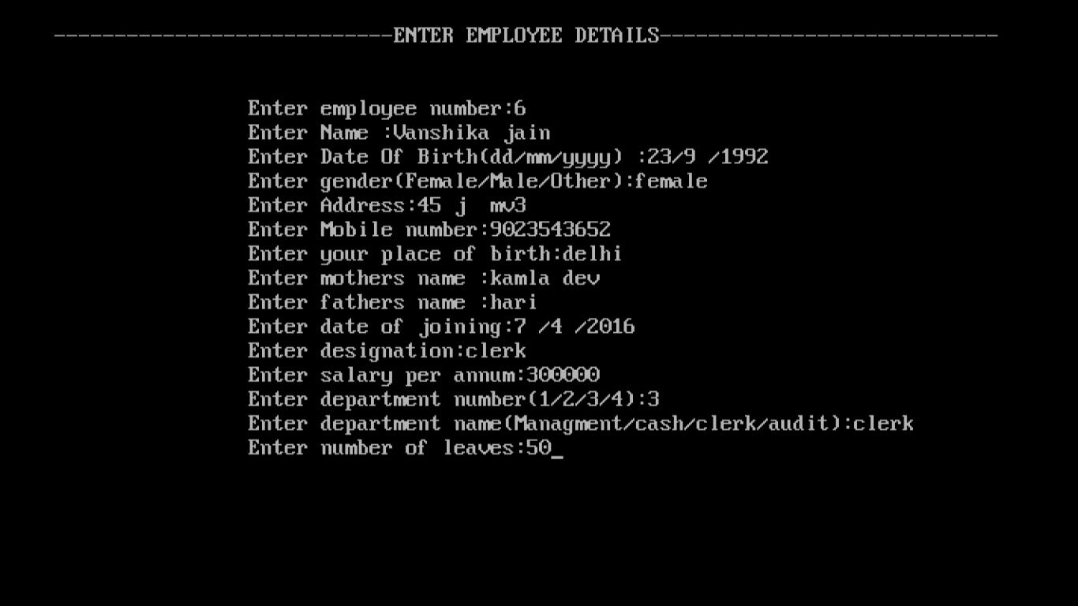

Modification Made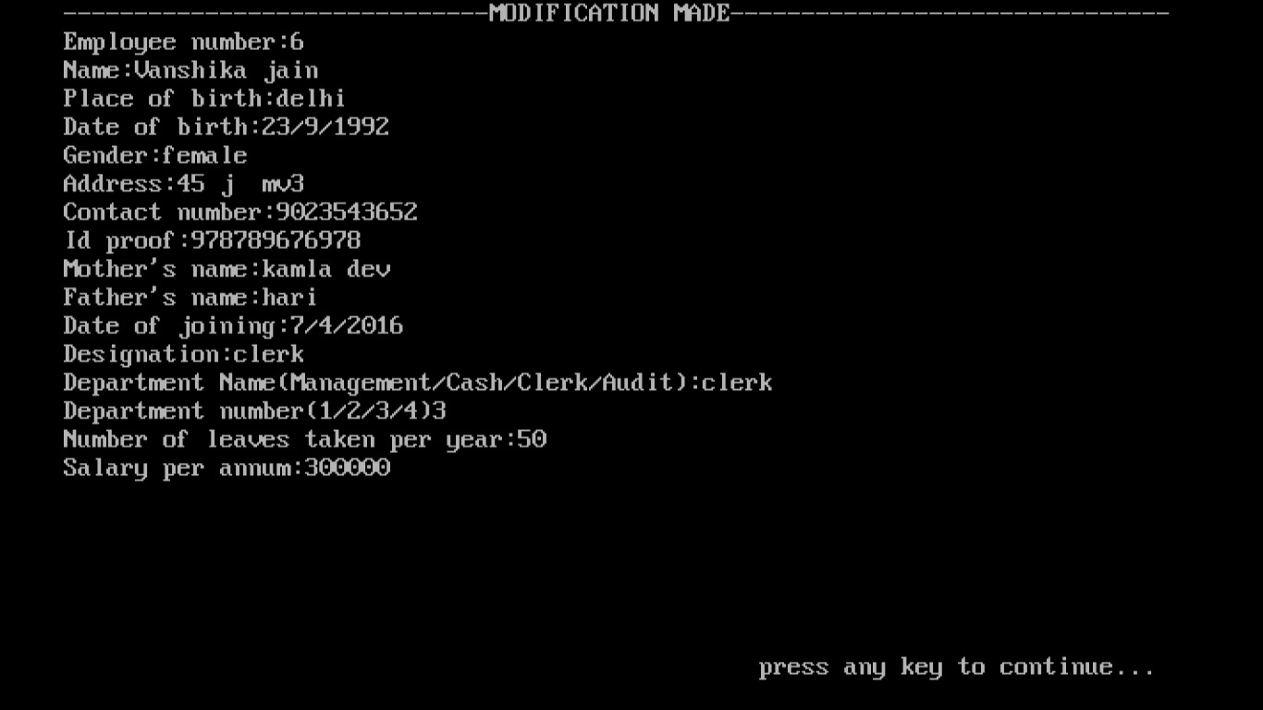

Deleting Employee

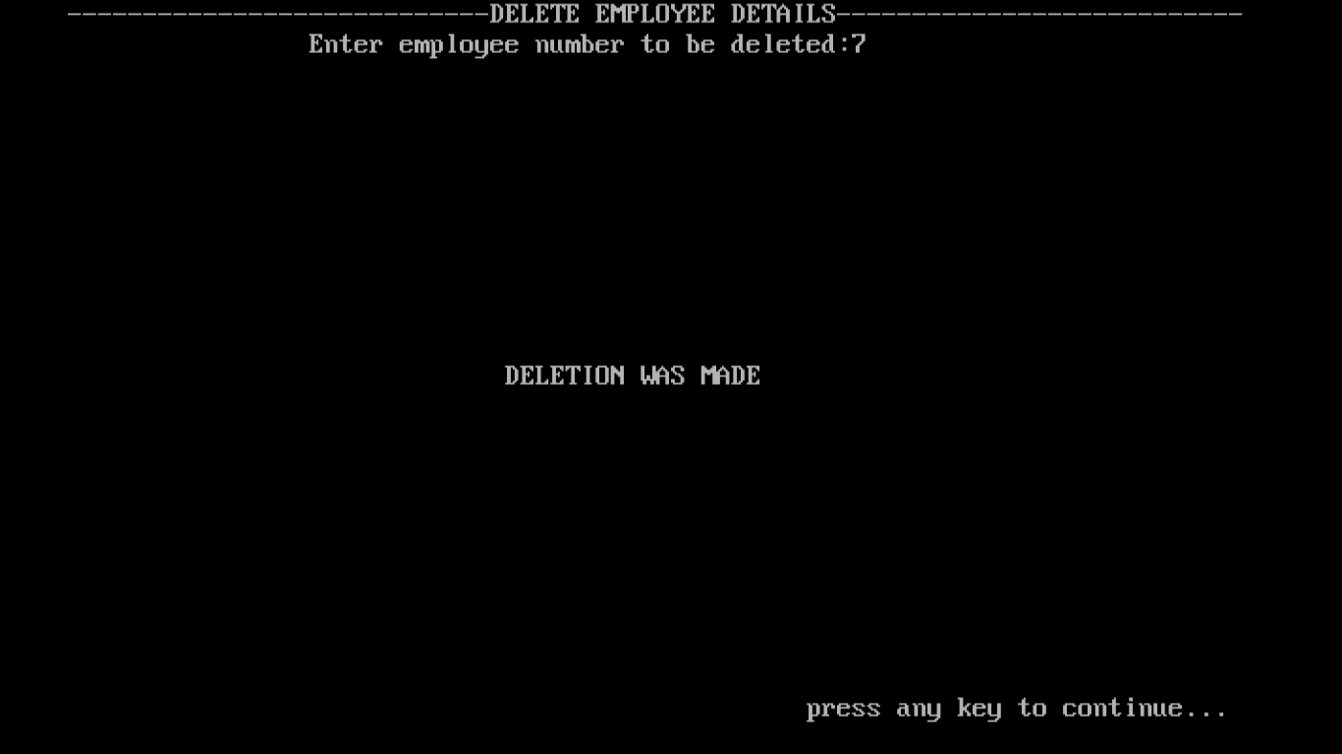

List of all Employee

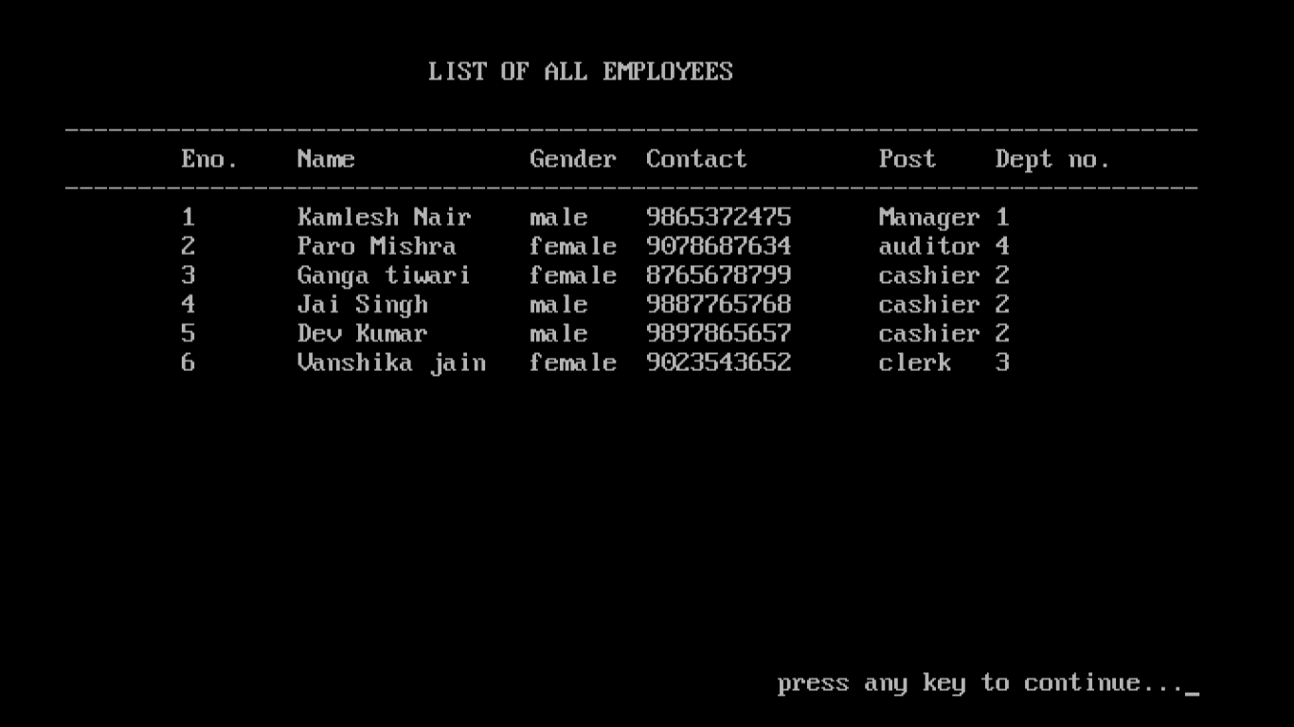

Searching Employee

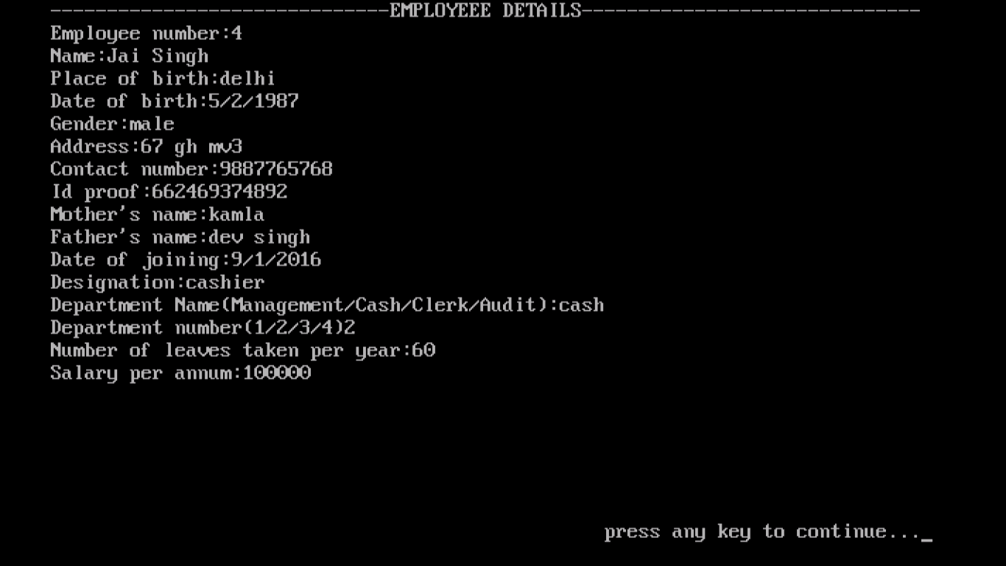

About us

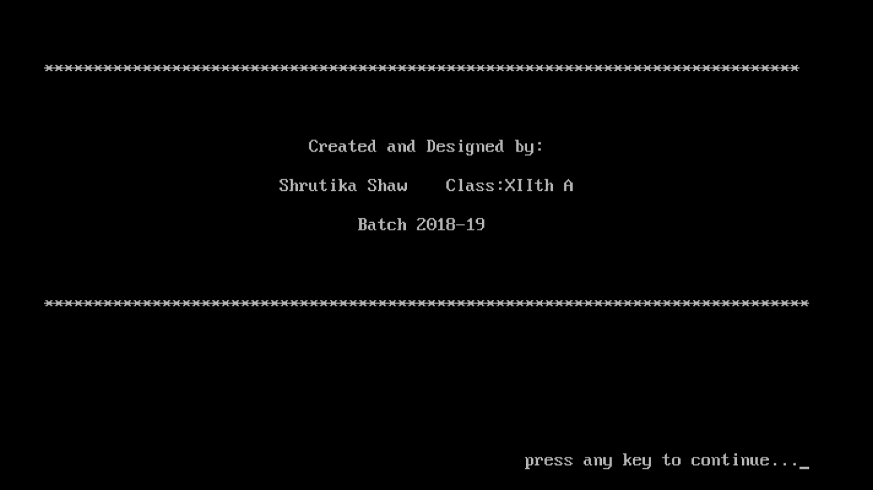

Exit

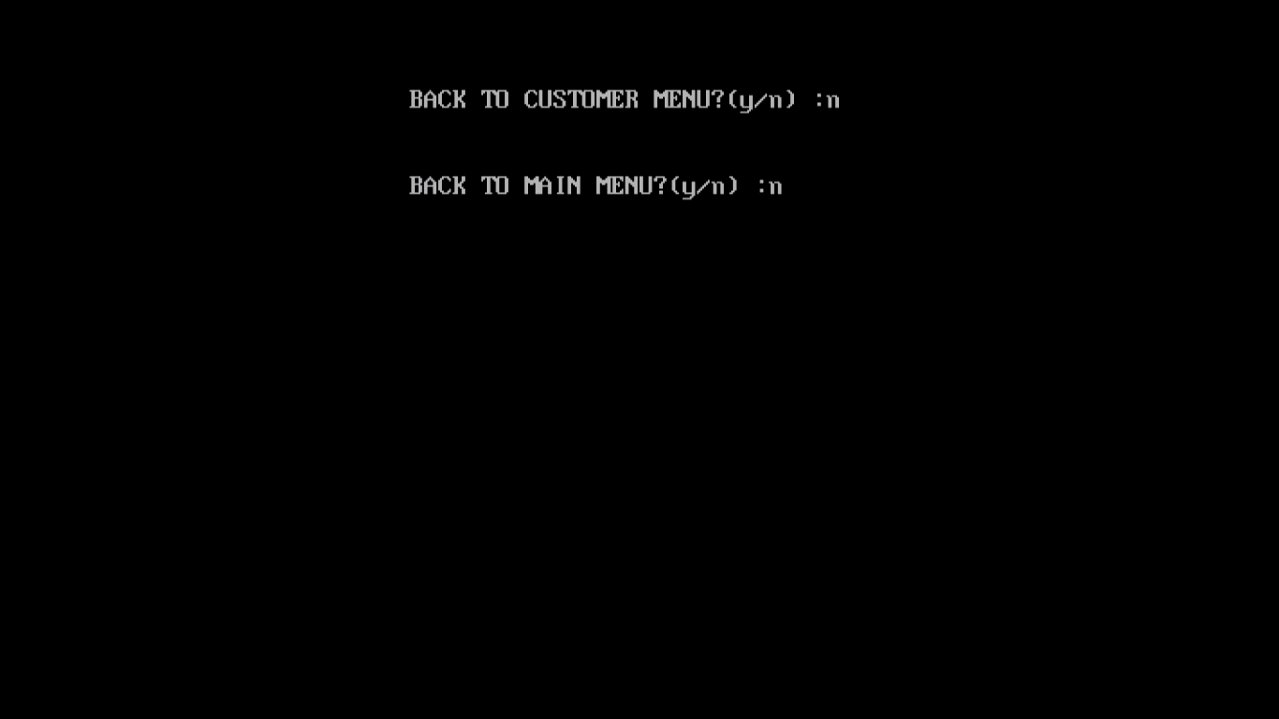

SOURCE CODE

#include<iostream.h>

#include<conio.h>

#include<time.h>

#include<dos.h>

#include<string.h>

#include<stdio.h>

#include<stdlib.h>

#include<fstream.h>

void cdate(int& a,int& b,int& c)

{ int d1,m1,y1;

struct date d;

getdate(&d);

d1=d.da_day;

m1=d.da_mon;

y1=d.da_year;

a=d1;

b=m1;

c=y1;

}

void credit()

{ char n[10];

clrscr();

cout<<"\n\n\t\t\tEnter your first name:";

gets(n);

cout<<"\n\n\n CREDIT CARD";

cout<<"\n\n";

cout<<"\t\t\t|--------------------------------|\n";

cout<<"\t\t\t| 4 CLOVER BANK ------ |\n";

cout<<"\t\t\t| ___ |CLOVER| |\n";

cout<<"\t\t\t| | C | ------ |\n";

cout<<"\t\t\t| 1254 3427 1327 9865 |\n";

cout<<"\t\t\t| 01/01/2019 01/01/2024 |\n";

cout<<"\t\t\t| 1254 validfrom validthrough |\n";

cout<<"\t\t\t| |\n";

cout<<"\t\t\t| MASTER CARD |\n";

cout<<"\t\t\t|--------------------------------|\n";

gotoxy(31,18);

cout<<n;

gotoxy(50,24);

cout<<"press any key to continue...";

getch();

}

void debit()

{ char b[10];

clrscr();

cout<<"\n\n\t\t\tEnter your first name:";

gets(b);

cout<<"\n\n\n DEBIT CARD";

cout<<"\n\n";

cout<<"\t\t\t|--------------------------------|\n";

cout<<"\t\t\t| 4 CLOVER BANK ------ |\n";

cout<<"\t\t\t| ___ |CLOVER| |\n";

cout<<"\t\t\t| | C | ------ |\n";

cout<<"\t\t\t| 1254 3427 1327 9865 |\n";

cout<<"\t\t\t| 01/01/20XX 01/01/20XX |\n";

cout<<"\t\t\t| 1254 validfrom validthrough |\n";

cout<<"\t\t\t| |\n";

cout<<"\t\t\t| VISA |\n";

cout<<"\t\t\t|--------------------------------|\n";

gotoxy(31,19);

cout<<b;

gotoxy(50,24);

cout<<"press any key to continue...";

getch();

}

void cheque()

{clrscr();

char ac[8];

char g[10];

cout<<"\n\n\t\tEnter your eight digit account number:";

gets(ac);

cout<<"\n\t\tEnter your first name:";

gets(g);

cout<<"\n\n\n CHEQUE BOOK";

cout<<"\n\n\n";

cout<<"\n\t|-----------------------------------------------------------|";

cout<<"\n\t| ------- 4clover bank -- -- ---- |";

cout<<"\n\t| |4CLOVER| z block market DD MM YYYY |";

cout<<"\n\t| ------- IFSC:ABCD1234567 |";

cout<<"\n\t| Pay_____________________________________________Or Bearer |";

cout<<"\n\t| _________________________________________ _______________ |";

cout<<"\n\t| _________________________________________|Rs|____________||";

cout<<"\n\t| |";

cout<<"\n\t| |A/c No. | NTX |";

cout<<"\n\t| _____________ |";

cout<<"\n\t|PAYABLE AT ALL BRANCHES OF 4CLOVER IN INDIA Signature |";

cout<<"\n\t|-----------------------------------------------------------|";

gotoxy(20,21);

cout<<ac;

gotoxy(55,21);

cout<<g;

gotoxy(50,24);

cout<<"press any key to continue...";

getch();

}

void about_us()

{clrscr();

cout<<"\n\n\n********************************************************************************\n";

cout<<"The Bank has brand image and trust reposed by its customers have been reflected";

cout<<" in the growing customer base and rising business graph of the Bank.\n";

cout<<"Domestic business of the Bank has crossed the milestone of Rs.10 lakh crore.\n";

cout<<"The bank has been able to reach out to its customers across the nation with \n";

cout<<" nearly 7000 branches,of which nearly 62% branches are in Rural and Semi Urban Areas.";

sleep(6);

gotoxy(50,24);

cout<<"press any key to continue...";

getch();

}

void faq()

{clrscr();

cout<<"\n\n********************************************************************************\n";

cout<<"1. What is PassBook?\n";

cout<<" PassBook is a book to ease customers to view their statement,transaction\n";

cout<<" details and transaction history.\n";

cout<<"2. What Is A Debit Card ?\n";

cout<<" A Debit Card provides access to ATMs for cash withdrawals, balance enquiries";

cout<<" and mini statement,on-line electronic payment for purchases from your savings";

cout<<" / current (individual) accounts.You can also transfer funds through ATM to\n";

cout<<" your own / other and also transfer / receive funds to / from any MasterCard\n";

cout<<" or Maestro card holder (Debit or Credit card) of other selected banks.\n";

cout<<"3. What Is PIN (Personal Identification Number)?\n";

cout<<" PIN is a unique 4 digit number that allows you to access your account through";

cout<<" Debit Card at ATMs.For safety, your PIN should always be kept completely\n";

cout<<" confidential and your card too should remain in your possession and not to be";

cout<<" handed over to anyone else. Neither write PIN on the Back of the Debit card\n";

cout<<" nor Keep Debit Card along with PIN.\n";

cout<<"4. What Is The Validity Of 4clover Debit Card ?\n";

cout<<" Debit Card is valid for 7 years.\n";

cout<<"5. What Is NEFT ? (To Enquire The IFSC Code)\n";

cout<<" NEFT stands for `National Electronic Funds Transfer`.\n";

cout<<" NEFT system is a nation wide funds transfer system to facilitate transfer\n";

cout<<" of funds from any bank branch to any other bank branch.\n";

sleep(10);

gotoxy(50,24);

cout<<"press any key to continue...";

getch();

}

class emp_details

{ int eno;

char pob[40];

char name[40];

int DOB[3];

char g[10];

char address[100];

char mobile_no[11];

char mname[30];

char fname[30];

char idproof[20];

char idtype;

int DOJ[3];

char post[20];

float salary;

char department[20];

int departmentno;

int leaves;

public:

void gdata()

{clrscr();

cout<<"\n----------------------------ENTER EMPLOYEE DETAILS----------------------------\n";

cout<<"\n\n\t\tEnter employee number:";

cin>>eno;

cout<<"\t\tEnter Name :";

gets(name);

cout<<"\t\tEnter Date Of Birth(dd/mm/yyyy) :";

cin>>DOB[0];

gotoxy(52,7);

cout<<"/";

cin>>DOB[1];

gotoxy(55,7);

cout<<"/";

cin>>DOB[2];

cout<<"\t\tEnter gender(Female/Male/Other):";

gets(g);

cout<<"\t\tEnter Address:";

gets(address);

cout<<"\t\tEnter Mobile number:";

gets(mobile_no);

cout<<"\t\tEnter your place of birth:";

gets(pob);

cout<<"\t\tEnter mothers name :";

gets(mname);

cout<<"\t\tEnter fathers name :";

gets(fname);

cout<<"\t\tEnter date of joining:";

cin>>DOJ[0];

gotoxy(41,14);

cout<<"/";

cin>>DOJ[1];

gotoxy(44,14);

cout<<"/";

cin>>DOJ[2];

cout<<"\t\tEnter designation:";

gets(post);

cout<<"\t\tEnter salary per annum:";

cin>>salary;

cout<<"\t\tEnter department number(1/2/3/4):";

cin>>departmentno;

cout<<"\t\tEnter department name(Managment/cash/clerk/audit):";

gets(department);

cout<<"\t\tEnter number of leaves:";

cin>>leaves;

id_proof();

}

void id_proof()

{ clrscr();

int a;

cout<<"\n\n\t\t CHOOSE YOUR ID PROOF:\n";

cout<<"\n\n\t\t\t1.Aadhar Card";

cout<<"\n\n\t\t\t2.Pancard";

cout<<"\n\n\t\t\t3.Passport";

cout<<"\n\n\t\t\tEnter choice<1-3>:";

cin>>a;

if(a==1)

{cout<<"\n\n\n\t\t\tEnter aadhar number:";

idtype='a';

gets(idproof);

}

else if(a==2)

{cout<<"\n\n\n\t\t\tEnter Pancard number:";

idtype='p';

gets(idproof);

}

else if(a==3)

{cout<<"\n\n\n\t\t\tEnter Passport number:";

idtype='P';

gets(idproof);

}

}

void pdata()

{

cout<<"\nEmployee number:"<<eno;

cout<<"\nName:"<<name;

cout<<"\nPlace of birth:"<<pob;

cout<<"\nDate of birth:"<< DOB[0]<<"/"<<DOB[1]<<"/"<<DOB[2];

cout<<"\nGender:"<<g;

cout<<"\nAddress:"<<address;

cout<<"\nContact number:"<<mobile_no;

cout<<"\nId proof:"<<idproof;

cout<<"\nMother's name:"<<mname;

cout<<"\nFather's name:"<<fname;

cout<<"\nDate of joining:"<<DOJ[0]<<"/"<<DOJ[1]<<"/"<<DOJ[2];

cout<<"\nDesignation:"<<post;

cout<<"\nDepartment Name(Management/Cash/Clerk/Audit):"<<department;

cout<<"\nDepartment number(1/2/3/4)"<<departmentno;

cout<<"\nNumber of leaves taken per year:"<<leaves;

cout<<"\nSalary per annum:"<<salary;

sleep(2);

gotoxy(50,24);

cout<<"press any key to continue...";

getch();

}

void disp()

{

cout<<eno<<"\t"<<name<<"\t"<<g<<"\t"<<mobile_no<<"\t"<<post<<"\t\t"<<departmentno;

}

int geteno()

{ return eno; }

void e_modify();

void e_delete();

void e_search();

}e1;

void e_read()

{clrscr();

cout<<"----------------------------------------------------------------------\n";

cout<<" Eno.\tName\t\tGender\tContact\t\tPost\t\tDepartment no.\n";

cout<<"----------------------------------------------------------------------\n";

ifstream f;

f.open("employee.dat",ios::binary);

while(!f.eof())

{ f.read((char*)&e1,sizeof(e1));

if(f.eof())

break;

e1.disp();

}

f.close();

sleep(2);

gotoxy(50,24);

cout<<"press any key to continue...";

getch();

}

void e_write()

{ clrscr();

ofstream f;

cout<<"\n----------------------------ENTER EMPLOYEE DETAILS----------------------------\n";

f.open("employee.dat",ios::app|ios::binary);

char ans='y';

while(ans=='y')

{ e1.gdata();

f.write((char*)&e1,sizeof(e1));

cout<<"\t\t\tDo you want to continue?:";

cin>>ans;

cout<<"\n";

}

f.close();

sleep(2);

gotoxy(50,24);

cout<<"press any key to continue...";

getch();

}

void emp_details::e_modify()

{ clrscr();

fstream f;

long pos;

int no;

char found='n';

cout<<"\n----------------------------CORRECTION/MODIFICATION---------------------------\n ";

f.open("employee.dat",ios::in|ios::out);

cout<<"\n\n\t\t\tEnter employee number to be modified:";

cin>>no;

while(!f.eof())

{ pos=f.tellg();

f.read((char*)&e1,sizeof(e1));

if(f.eof())

break;

if(e1.geteno()==no)

{ found='y';

e1.gdata();

f.seekg(pos);

f.write((char*)&e1,sizeof(e1));

}

}

if(found=='n')

cout<<"\n\t\t*******************Not found*************************";

f.close();

clrscr();

f.open("employee.dat",ios::in||ios::binary);

cout<<"------------------------------MODIFICATION MADE-------------------------------";

while(!f.eof())

{ f.read((char*)&e1,sizeof(e1));

if(f.eof())

break;

if(e1.geteno()==no)

e1.pdata();

}

f.close();

sleep(2);

gotoxy(50,24);

cout<<"press any key to continue...";

getch();

}

void emp_details::e_search()

{ clrscr();

emp_details e1;

int a;

char found='n';

ifstream f;

f.open("employee.dat",ios::binary);

cout<<"------------------------------EMPLOYEEE DETAILS------------------------------";

cout<<"\n\n\t\t\tEnter employee number to be searched:";

cin>>a;

clrscr();

cout<<"------------------------------EMPLOYEEE DETAILS------------------------------";

while(!f.eof())

{

f.read((char*)&e1,sizeof(e1));

if(e1.geteno()==a)

{ e1.pdata();

found='y';

break;

}

}

if(found=='n')

cout<<"\n\n\t\t\tEntered employee number does not exist\n";

f.close();

sleep(2);

gotoxy(50,24);

cout<<"press any key to continue...";

getch();

}

void emp_details::e_delete()

{ clrscr();

ifstream fin;

ofstream fout;

int b;

char found='n';

fin.open("employee.dat",ios::in);

fout.open("temp.dat",ios::out);

cout<<"----------------------------DELETE EMPLOYEE DETAILS---------------------------\n";

cout<<"\t\tEnter employee number to be deleted:";

cin>>b;

while(!fin.eof())

{

fin.read((char*)&e1,sizeof(e1));

if(fin.eof())

break;

if(e1.geteno()==b)

found='y';

else

fout.write((char*)&e1,sizeof(e1));

}

if(found=='n')

cout<<"\n\n\t\tNot found\n";

fin.close();

fout.close();

remove("employee.dat");

rename("temp.dat","employee.dat");

if(found=='y')

{

gotoxy(30,13);

cout<<"DELETION WAS MADE";

}

sleep(2);

gotoxy(50,24);

cout<<"press any key to continue...";

getch();

}

class account

{

char acc_no[7];

char name[30];

int DOB[3];

char gender[10];

char address[30];

char mobile_no[11];

char aadhar_no[13];

char security[3][15];

int pin;

float amount;

public:

account()

{amount=1000;}

char *getacc_no()

{return acc_no;}

int passcheck(int p,char a[]);

void getdata()

{clrscr();

cout<<"\n---------------------------------ENTER DETAILS--------------------------------";

cout<<"\n\n\t\tEnter Name :";

gets(name);

cout<<"\t\tEnter Date Of Birth(dd/mm/yyyy) :";

cin>>DOB[0];

gotoxy(52,5);

cout<<"/";

cin>>DOB[1];

gotoxy(55,5);

cout<<"/";

cin>>DOB[2];

cout<<"\t\tEnter gender(Female/Male/Others):";

gets(gender);

cout<<"\t\tEnter Address:";

gets(address);

cout<<"\t\tEnter Mobile number:";

gets(mobile_no);

cout<<"\t\tEnter account number:";

gets(acc_no);

cout<<"\t\tEnter Aadhar card number:";

gets(aadhar_no);

security_question();

}

void security_question()

{ clrscr();

cout<<"\n\n\t\t\tAnswer the following security questions:";

cout<<"\n\n\t\tWhich is your favorite book?:";

gets(security[0]);

cout<<"\n\n\t\tWhat is your place of birth?:";

gets(security[1]);

cout<<"\n\n\t\tWhich is your favorite food?:";

gets(security[2]);

getch();

}

void file_modify();

float get_amount()

{return amount;}

void file_delete();

void display()

{ clrscr();

cout<<"\n\n\t\t\tName:"<<name;

cout<<"\n\n\t\t\tAccount number:"<<acc_no;

cout<<"\n\n\t\t\tDate of birth:"<< DOB[0]<<"/"<<DOB[1]<<"/"<<DOB[2];

cout<<"\n\n\t\t\tGender:"<<gender;

cout<<"\n\n\t\t\tAddress:"<<address;

cout<<"\n\n\t\t\tContact number:"<<mobile_no;

cout<<"\n\n\t\t\tAadhar card number:"<<aadhar_no;

cout<<"\n\n\t\t\tAccount balance:"<<amount;

}

void amount_change(float m)

{ amount=m;

}

void cus_search();

void file_read();

void file_write();

}s1;

void account::file_read()

{ clrscr();

ifstream f;

cout<<"------------------------------------------------------------------------------\n";

cout<<"\tACC NO.\tNAME\t\tDate Of Birth\tGENDER\tCONTACT NO.\n";

cout<<"------------------------------------------------------------------------------\n";

f.open("data.dat",ios::binary);

while(!f.eof())

{ f.read((char*)&s1,sizeof(s1));

if(f.eof())

break;

cout<<"\t"<<acc_no<<"\t"<<name<<"\t"<<DOB[0]<<"/"<<DOB[1]<<"/"<<DOB[2]<<"\t"<<gender<<"\t"<<mobile_no<<"\n";

}

f.close();

sleep(2);

gotoxy(50,24);

cout<<"press any key to continue...";

getch();

}

void account::file_write()

{ clrscr();

ofstream f;

randomize();

pin=random(10000);

f.open("data.dat",ios::app|ios::binary);

s1.getdata();

f.write((char*)&s1,sizeof(s1));

f.close();

clrscr();

gotoxy(17,11);

cout<<"---Your Account has been succesfully Created---";

gotoxy(30,12);

cout<<"Your pin is :";

cout<<pin;

sleep(2);

gotoxy(50,24);

cout<<"press any key to continue...";

getch();

}

void account::cus_search()

{ clrscr();

char temp_acc[8];

char found='n';

ifstream f;

cout<<"\n--------------------------------CUSTOMER DETAILS------------------------------";

f.open("data.dat", ios::binary) ;

cout<<"\n\n\t\t\t Enter Account no. :";

gets(temp_acc);

while(!f.eof())

{

f.read((char*)&s1,sizeof(s1));

if(strcmpi(s1.acc_no,temp_acc)==0)

{

display();

found='y';

break;

}

}

if(found=='n')

cout<<"\n\n\n\t\t\tInvalid Account Number";

sleep(2);

gotoxy(50,24);

cout<<"press any key to continue...";

getch();

}

void account::file_modify()

{ clrscr();

char acc[7];

int check,pass;

fstream f;

long pos;

cout<<"\n-----------------------------CORRECTION/MODIFICATION-------------------------\n";

char found='n';

f.open("data.dat",ios::in|ios::out|ios::binary);

cout<<"\n\n\t\t\tEnter your account number:";

gets(acc);

cout<<"\n\n\t\t\tEnter your password:";

cin>>pass;

check=passcheck(pass,acc);

if(check==1)

{

while(!f.eof())

{ pos=f.tellg();

f.read((char*)&s1,sizeof(s1));

if(f.eof())

break;

if(strcmpi(s1.getacc_no(),acc)==0)

{ found='y';

s1.getdata();

f.seekg(pos);

f.write((char*)&s1,sizeof(s1));

cout<<"\n\n\n\t\t\tMODIFICATION WAS MADE";

}

}

}

if(found=='n')

cout<<"\n*******************Not found*************************";

f.close();

sleep(2);

gotoxy(50,24);

cout<<"press any key to continue...";

getch();

}

void account::file_delete()

{ clrscr();

cout<<"\n--------------------------------DELETE ACCOUNT--------------------------------\n";

ofstream fstore;

ifstream fin;

ofstream fout;

int pass;

char acc[7];

char found='n';

fstore.open("deldata.dat",ios::out|ios::binary);

fin.open("data.dat",ios::in|ios::binary);

fout.open("temp.dat",ios::out|ios::binary);

cout<<"................................................................................";

cout<<"\t\tEnter your account no :";

cin>>acc;

while(!fin.eof())

{

fin.read((char*)&s1,sizeof(s1));

if(fin.eof())

break;

if(strcmpi(s1.getacc_no(),acc)==0)

{

found='y';

cout<<"\n\n\t\t\t Withdraw your savings.";

cout<<"\n\n\t\t\tYour account was deleted";

cout<<"n\n\n\t\t Thanks for being a part of clover familiy ";

fstore.write((char*)&s1,sizeof(s1));

}

else

fout.write((char*)&s1,sizeof(s1));

}

if(found=='n')

cout<<"\n\n\n\t\tAccount was Not found\n";

fin.close();

fout.close();

fstore.close();

remove("data.dat");

rename("temp.dat","data.dat");

sleep(2);

gotoxy(50,24);

cout<<"press any key to continue...";

getch();

}

int account::passcheck(int p,char a[])

{ int r=0;

char ans[15];

ifstream g;

g.open("data.dat",ios::binary);

while(!g.eof())

{ if(g.eof())

break;

g.read((char*)&s1,sizeof(s1));

if(strcmpi(s1.acc_no,a)==0)

break;

}

if(p!=pin)

{ cout<<"\n\n\t\t\tWrong password";

cout<<"\n\n\n\t\tAnswer security questions:";

cout<<"\n\n\t\t\tWhich is your favorite book?:";

gets(ans);

if(strcmpi(security[0],ans)!=0)

{

cout<<"\n\n\t\t\tWhat is your place of birth?:";

gets(ans);

if(strcmpi(security[1],ans)!=0)

{

cout<<"\n\n\t\t\tWhich is your favorite food?:";

gets(ans);

if(strcmpi(security[2],ans)!=0)

cout<<"\n\n\t\t\tAuthentication failure";

else

r=1;

}

else

r=1;

}

else

r=1;

}

else

r=1;

return r;

}

class passbook

{ char acc_no[7];

int date[3];

char particulars[30];

char type;

float amount;

float t_balance;

public:

void get_pass()

{ cout<<"\t"<<date[0]<<"/"<<date[1]<<"/"<<date[2]<<"\t"<<particulars;

if(type=='d')

cout<<"\t";

else

cout<<"\t\t";

cout<<amount;

cout<<"\t"<<t_balance;

}

void add_withdraw(char t);

char *get_acc()

{return acc_no;}

void enter_pass();

void view_passbook();

}p1;

void passbook::view_passbook()

{ ifstream f;

char temp_acc[7];

cout<<"\n\n\n\t\t\tEnter Account No.:";

gets(temp_acc);

clrscr();

f.open("pass.dat",ios::in|ios::binary);

cout<<"__________________________________________________________________\n";

cout<<"\tDATE \tPARTICULARS \tAMOUNT CREDIT \tAMOUNT DEBIT \tBALANCE";

cout<<"_________________________________________________________________\n";

while(!f.eof())

{f.read((char*)&p1,sizeof(p1));

if(f.eof())

break;

if(strcmpi(temp_acc,acc_no)==0)

get_pass();

}

f.close();

sleep(2);

gotoxy(50,24);

cout<<"press any key to continue...";

getch();

}

void passbook::add_withdraw(char t)

{

fstream f1,f2;

float money,tmoney;

char temp_acc[7];

cout<<"\n\n\t\t\tEnter Acc. no. :";

gets(temp_acc);

f1.open("data.dat",ios::binary|ios::in);

while(!f1.eof())

{ f1.read((char*)&s1,sizeof(s1));

if(f1.eof())

break;

if(strcmpi(temp_acc,s1.getacc_no())==0)

{ tmoney=s1.get_amount();

break;

}

else

cout<<"\n\n\t\t\tAccount not found";

}

if(t=='d')

{

cout<<"\n\n\t\t\tEnter the Amount to be deposited:";

cin>>money;

tmoney=tmoney+money;

cout<<"\n\n\t\t\tReason:";

gets(particulars);

cout<<"\n\n\t\t\tRs."<<money<<" was added to your account";

cout<<"\n\n\t\t\tYour account balance is "<<tmoney;

sleep(2);

gotoxy(50,24);

cout<<"press any key to continue...";

getch();

}

else if(t=='w')

{

cout<<"\n\n\t\t\tEnter the amount you want to withdraw:";

cin>>money;

if(money>tmoney)

{ cout<<"\n\n\t\t\tInsufficient Balance";

sleep(2);

gotoxy(50,24);

cout<<"press any key to continue...";

getch();

}

else

{tmoney=tmoney-money;

cout<<"\n\n\t\t\tEnter reason:";

gets(particulars);

cout<<"\n\n\t\t\tRs."<<money<<" was withdrawn from your account";

cout<<"\n\n\t\t\tAccount balance is :"<<tmoney;

gotoxy(50,24);

sleep(2);

cout<<"press any key to continue...";

getch();

}

}

strcpy(acc_no,s1.getacc_no());

cdate(date[0],date[1],date[2]);

type=t;

amount=money;

t_balance=tmoney;

f2.open("pass.dat",ios::binary|ios::app|ios::out);

f2.write((char*)&p1,sizeof(p1));

long pos;

char found='n';

f1.seekg(ios::beg);

while(!f1.eof())

{ pos=f1.tellg();

f1.read((char*)&s1,sizeof(s1));

if(f1.eof())

break;

if(strcmpi(s1.getacc_no(),temp_acc)==0)

{ found='y';

s1.amount_change(tmoney);

f1.seekg(pos);

f1.write((char*)&s1,sizeof(s1));

break;

}

}

if (found=='n')

{ cout<<" \n\n\t\t\tnot found "; }

}

void main()

{ clrscr();

cout<<"\n";

cout<<" MMMMMMM MMM\n";

cout<<" MMMMMMMMM MMMMM\n";

cout<<" MMMMMMMMMM MMMMMMMM\n";

cout<<" MMM MMMMMMMMMMMMMMMM\n ";

cout<<" MM MMMMMMMMMMMMMMMM\n";

cout<<" MM MMMMMMMMMMMMMMMMM\n";

cout<<" MMMMMMMMMMMMMMMMMMMM\n";

cout<<" MMMMMMMMMMMMMMMMM\n";

cout<<" MMMMM MMMMMMMMMMMMMM MMMMMM\n";

cout<<" MMMMMMMMMM MMMMMMMMMM MMMMMMMMMMM\n";

cout<<" MMMM MMMMMM MMMMMM MMMMMMMMMMMMMMM\n";

cout<<" MMM MMMMMMMMMMMMMMMMMMMMMMMMMMMMMMMMM\n";

cout<<" MMM MMMMMMMMMMMMMMMMMMMMMMMMMMMMMMMMMMMMMM\n";

cout<<" MMMMMMMMMMMMMMMMMMMM MM MMMMMMMMMMMMM\n";

cout<<" MMMMMMMMMMMMMMM M MMM MMMMMMM\n";

cout<<" MMMMMMMMMMMMMM M MMM MMMMM\n";

cout<<" MMMMMMMMMMMMM MM MM MMMMM\n";

cout<<" MMMMMMMMMMMMMM MM MM MMMM\n";

cout<<" MMMMMMMMMMMM MMM MMM MMM\n";

cout<<" MMMMMMMMMM MMMM MMMMMMMMM\n";

cout<<" MMMMMM MMMM MMMMM\n";

cout<<" MMMMM\n";

cout<<" MM\n";

gotoxy(51,11);

sleep(2);

cout<<"WELCOME TO 4CLOVER BANK";

gotoxy(45,13);

sleep(1);

cout<<"\t With you all the way";

gotoxy(50,24);

sleep(1);

cout<<"press any key to continue...";

getch();

clrscr();

char logidentity='y',ans='y',an='y';

int e=0,z=0,ch=0;

while(logidentity=='y')

{ clrscr();

cout<<"______________________________________________________________________________";

gotoxy(30,3);

cout<<"WELCOME TO 4CLOVER BANK\n";

cout<<"______________________________________________________________________________";

sleep(1);

gotoxy(22,12);

cout<<"1.Customer";

cout<<"\t\t\t2.Employee";

gotoxy(37,14);

cout<<"3.Exit";

gotoxy(30,18);

cout<<"ENTER YOUR CHOICE : ";

cin>>ch;

clrscr();

if(ch==1)

{ while(ans=='y')

{

clrscr();

cout<<"______________________________________________________________________________";

gotoxy(27,3);

cout<<"WELCOME CUSTOMER TO 4CLOVER BANK\n";

cout<<"______________________________________________________________________________";

sleep(2);

gotoxy(15,6);

cout<<"1. New Customer";

gotoxy(50,6);

cout<<"2. Customer Details";

gotoxy(15,8);

cout<<"3. Deposit/Withdraw Money";

gotoxy(50,8);

cout<<"4. View Transactions";

gotoxy(15,10);

cout<<"5. Correct details";

gotoxy(50,10);

cout<<"6. Delete Account";

gotoxy(15,12);

cout<<"7.FAQ's";

gotoxy(50,12);

cout<<"8. Issue Cards/Cheque";

gotoxy(15,14);

cout<<"9. About us";

gotoxy(50,14);

cout<<"10. View all ";

gotoxy(33,16);

cout<<"0.Back";

gotoxy(30,18);

cout<<"ENTER YOUR CHOICE<0-10> : ";

cin>>z;

if(z==1)

s1.file_write();

else if(z==2)

s1.cus_search();

else if(z==4)

p1.view_passbook();

else if(z==5)

s1.file_modify();

else if(z==6)

s1.file_delete();

else if(z==9)

about_us();

else if(z==7)

faq();

else if(z==10)

s1.file_read();

else if(z==0)

break;

else if(z==3)

{int u;

clrscr();

cout<<"______________________________________________________________________________";

gotoxy(30,3);

cout<<"TRANSACTIONS PORTAL\n";

cout<<"______________________________________________________________________________";

gotoxy(15,12);

cout<<" 1.Deposit";

cout<<"\t\t\t2.Withdraw";

gotoxy(33,13);

cout<<"3.Back";

gotoxy(30,15);

cout<<"ENTER YOUR CHOICE :";

cin>>u;

clrscr();

if(u==1)

p1.add_withdraw('d');

else if(u==2)

p1.add_withdraw('w');

}

else if(z==8)

{ clrscr();

cout<<"---------------------------------ISSUE CORNER---------------------------------\n";

cout<<"\n\n\n\t\t\tWhat do you want to issue?";

cout<<"\n\n\t\t\t1.Debit card";

cout<<"\n\t\t\t2.Credit card";

cout<<"\n\t\t\t3.Cheque book";

int r;

cout<<"\n\n\t\t\tEnter your choice: ";

cin>>r;

if(r==1)

debit();

else if(r==2)

credit();

else if(r==3)

cheque();

else

{ clrscr();

gotoxy(35,20);

cout<<"\n\n\n\t\t\tINVALID CHOICE";

}

}clrscr();

cout<<"\n\n\n\t\t\tBACK TO CUSTOMER MENU?(y/n) :";

cin>>ans;

getch();

}

}

else if(ch==2)

{

while(an=='y')

{ clrscr();

cout<<"______________________________________________________________________________";

gotoxy(30,3);

cout<<"WELCOME EMPLOYEE TO 4CLOVER BANK\n";

cout<<"______________________________________________________________________________";

sleep(2);

gotoxy(15,6);

cout<<"1. Enter data";

cout<<"\t\t\t2. See data";

gotoxy(15,8);

cout<<"3. Modify data";

cout<<"\t\t\t4. Delete data";

gotoxy(15,10);

cout<<"5. Search data";

cout<<"\t\t\t0. Back";

gotoxy(30,13);

cout<<"ENTER YOUR CHOICE<0-5> :";

cin>>e;

if(e==1)

e_write();

else if(e==2)

e_read();

else if(e==3)

e1.e_modify();

else if(e==0)

break;

else if(e==4)

e1.e_delete();

else if(e==5)

e1.e_search();

clrscr();

cout<<"\n\n\\n\t\t\tBACK TO EMPLOYEE MENU?(y/n) :";

cin>>an;

}

}

else

break;

cout<<"BACK TO MAIN MENU?(y/n) :";

cin>>logidentity;

}

getch();

}