**Computer Graphics Practical Back-up**

***Vaishnavi Jha***

***2018355  
B.Sc. (Hons.) Computer Science***

***2018-2021***

**Q1. Write a program implementing Mid-point line drawing algorithm.**

Program:

#include<iostream.h>

#include<graphics.h>

#include<conio.h>

#include<dos.h>

void bresenhams(int x1,int y1,int x2, int y2 )

{

int dx=0,dy=0,a=0,b=0;

int s=0,p=0,x=0,y=0;

dy=y2-y1;

dx=x2-x1;

a=2*dx;

b=2*dy;

s=b-a;

p=b-dx;

x=x1;y=y1;

while(x<x2)

{

if(p<0)

{

putpixel(x,y1,RED);

x=x+1;

p=p+b;

}

else

{

putpixel(x,y,RED);

x=x+1;

y=y+1;

p=p+s;

}

delay(100);

}

}

void main()

{

int gd= DETECT,gm;

initgraph(&gd,&gm,"C:\\TurboC3\\BGI");

int x1,x2,y1,y2;

x1=x2=y1=y2=0;

cout<<"Enter the starting coordinate of the line : \nx : ";

cin>>x1;

cout<<"y : ";

cin>>y1;

cout<<"Enter the ending coordinates of the line : \nx : ";

cin>>x2;

cout<<"y : ";

cin>>y2;

setbkcolor(WHITE);

bresenhams(x1,y1,x2,y2);

getch();

}

Output:

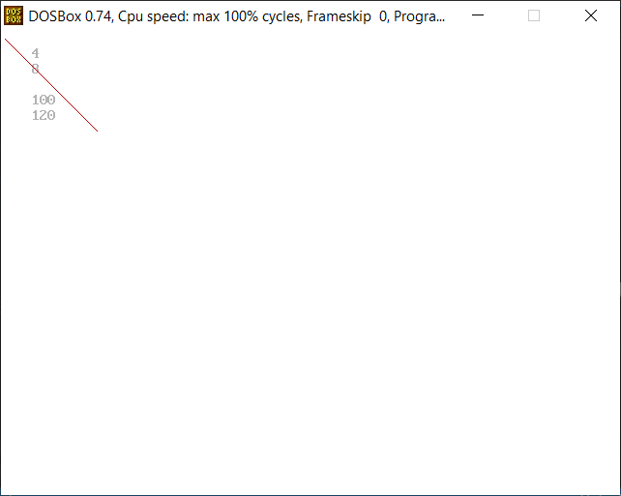

**Q2. Write a program implementing Mid-point circle drawing algorithm.**

Program:

#include<iostream.h>

#include<graphics.h>

#include<dos.h>

#include<conio.h>

void circlePoints(int x,int y,int x_centre,int y_centre)

{

putpixel(x+x_centre,y+y_centre,RED);

delay(100);

putpixel(-x+x_centre,y+y_centre,RED);

delay(100);

putpixel(x+x_centre,-y+y_centre,RED);

delay(100);

putpixel(-x+x_centre,-y+y_centre,RED);

delay(100);

putpixel(y+y_centre,x+x_centre,RED);

delay(100);

putpixel(-y+y_centre,x+x_centre,RED);

delay(100);

putpixel(y+y_centre,-x+x_centre,RED);

delay(100);

putpixel(-y+y_centre,-x+x_centre,RED);

delay(100);

}

void midPointCircle(int r,int x_centre,int y_centre)

{

int x=0;

int y=r;

double d=3-2*r;

while(y>x)

{

if(d<0)

d=d+4*x+6.0;

else

{

d=d+4*(x-y)+10.0;

y=y-1;

}

x++;

circlePoints(x,y,x_centre,y_centre);

}

return;

}

void main()

{

int i,gd=DETECT,gm;

int x,y,r;

initgraph(&gd,&gm,"C:\\TURBOC3\\BGI");

cout<<"Enter the centre coordinates:\n";

cout<<"x: ";

cin>>x;

cout<<"y: ";

cin>>y;

cout<<"Enter radius: ";

cin>>r;

setbkcolor(WHITE);

midPointCircle(r,x,y);

getch();

}

Output:

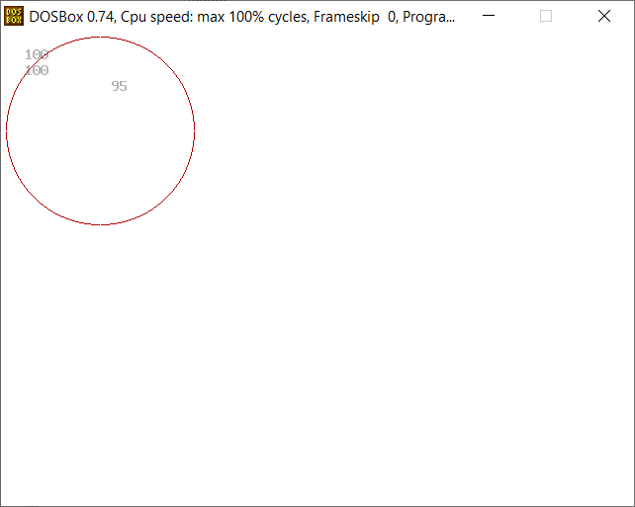

**Q3. Write a program implementing Cohen-Sutherland Line Clipping Algorithm.**

Program:

#include<iostream.h>

#include<graphics.h>

#include<conio.h>

/*TOP=0001, LEFT=1000, RIGHT=0100, BOTTOM=0010*/

int compOutCode(

double x,double y,

double xmin,double xmax,

double ymin,double ymax)

{

int code=0000;

if(y>ymax)

code+=0001;

else if(y<ymin)

code+=0010;

if(x>xmax)

code+=0100;

else if(x<xmin)

code+=1000;

return code;

}

void cohen(

double x0,double y0,

double x1, double y1,

double xmin,double xmax,

double ymin,double ymax)

{

cout<<"Applying Cohen-Sutherlan Algorithm";

int outcode0,outcode1,outcodeout;

int acc=0,done=0;

outcode0=compOutCode(x0,y0,xmin,xmax,ymin,ymax);

outcode1=compOutCode(x1,y1,xmin,xmax,ymin,ymax);

do

{

if(!(outcode0|outcode1))

{

acc=1;done=1;

}

else if(outcode0&outcode1)

{ done=1;

}

else{

double x,y;

outcodeout=outcode0?outcode0:outcode1;

if(outcodeout&0001)

{

x=x0+(x1-x0)*(ymax-y0)/(y1-y0);

y=ymax;

cout<<"\nClipping Top!!!";

}

else if(outcodeout&0010)

{

x=x0+(x1-x0)*(ymin-y0)/(y1-y0);

y=ymin;

cout<<"\nClipping Bottom!!!";

}

else if(outcodeout&0100)

{y=y0+(y1-y0)*(xmax-x0)/(x1-x0);

x=xmax;

cout<<"\nClipping Right";

}

else

{y=y0+(y1-y0)*(xmin-x0)/(x1-x0);

x=xmin;

cout<<"\nClipping Left";

}

if(outcodeout==outcode0)

{

x0=x;y0=y;outcode0=compOutCode(x0,y0,xmin,xmax,ymin,ymax);

}

else

{

x1=x;y1=y;outcode1=compOutCode(x1,y1,xmin,xmax,ymin,ymax);

}

}

}

while(done==0);

clrscr();

cout<<"After clipping window and line:";

rectangle(xmin,ymax,xmax,ymin);

line(x0,y0,x1,y1);

getch();

return;

}

void main()

{

int i,gd=DETECT,gm;

int l,r,b,t;

initgraph(&gd,&gm,"C:\\TURBOC3\\BGI");

cout<<"Enter the coordinates of clipping window:\n";

cout<<"left: ";

cin>>l;

cout<<"bottom: ";

cin>>b;

cout<<"right: ";

cin>>r;

cout<<"top: ";

cin>>t;

int x0,x1,y0,y1;

cout<<"Enter the coordinates of original line:\n";

cout<<"x0: ";

cin>>x0;

cout<<"y0: ";

cin>>y0;

cout<<"x1: ";

cin>>x1;

cout<<"y1: ";

cin>>y1;

clrscr();

cout<<"Before clipping window and line:";

rectangle(l,t,r,b);

line(x0,y0,x1,y1);

getch();

cohen(x0,y0,x1,y1,l,r,b,t);

return;

}

Output:

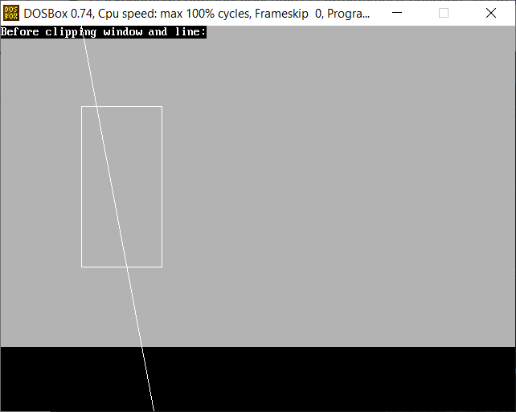

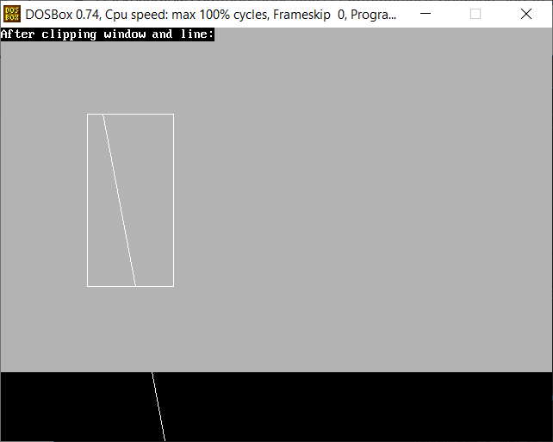

**Q4. Write a program implementing Sutherland-Hodgeman Algorithm for polygon clipping.**

Program:

#include<iostream.h>

#include<conio.h>

#include<graphics.h>

int k,xmin,ymin,xmax,ymax,arr[20],m;

void clipl (int x1, int y1, int x2, int y2)

{

if(x2-x1)

m=(y2-y1)/(x2-x1);

else

m=100000;

if(x1 >= xmin && x2 >= xmin)

{

arr[k]=x2;

arr[k+1]=y2;

k+=2;

}

if(x1 < xmin && x2 >= xmin)

{

arr[k]=xmin;

arr[k+1]=y1+m*(xmin-x1);

arr[k+2]=x2;

arr[k+3]=y2;

k+=4;

}

if(x1 >= xmin && x2 < xmin)

{

arr[k]=xmin;

arr[k+1]=y1+m*(xmin-x1);

k+=2;

}

}

void clipt(int x1, int y1, int x2, int y2)

{

if(y2-y1)

m=(x2-x1)/(y2-y1);

else

m=100000;

if(y1 <= ymax && y2 <= ymax)

{

arr[k]=x2;

arr[k+1]=y2;

k+=2;

}

if(y1 > ymax && y2 <= ymax)

{

arr[k]=x1+m*(ymax-y1);

arr[k+1]=ymax;

arr[k+2]=x2;

arr[k+3]=y2;

k+=4;

}

if(y1 <= ymax && y2 > ymax)

{

arr[k]=x1+m*(ymax-y1);

arr[k+1]=ymax;

k+=2;

}

}

void clipr(int x1, int y1, int x2, int y2)

{

if(x2-x1)

m=(y2-y1)/(x2-x1);

else

m=100000;

if(x1 <= xmax && x2 <= xmax)

{

arr[k]=x2;

arr[k+1]=y2;

k+=2;

}

if(x1 > xmax && x2 <= xmax)

{

arr[k]=xmax;

arr[k+1]=y1+m*(xmax-x1);

arr[k+2]=x2;

arr[k+3]=y2;

k+=4;

}

if(x1 <= xmax && x2 > xmax)

{

arr[k]=xmax;

arr[k+1]=y1+m*(xmax-x1);

k+=2;

}

}

void clipb(int x1, int y1, int x2, int y2)

{

if(y2-y1)

m=(x2-x1)/(y2-y1);

else

m=100000;

if(y1 >= ymin && y2 >= ymin)

{

arr[k]=x2;

arr[k+1]=y2;

k+=2;

}

if(y1 < ymin && y2 >= ymin)

{

arr[k]=x1+m*(ymin-y1);

arr[k+1]=ymin;

arr[k+2]=x2;

arr[k+3]=y2;

k+=4;

}

if(y1 >= ymin && y2 < ymin)

{

arr[k]=x1+m*(ymin-y1);

arr[k+1]=ymin;

k+=2;

}

}

void main()

{

int gd=DETECT,gm,n,poly[20];

int xi,yi,xf,yf,polyy[20];

initgraph(&gd,&gm,"C:\\TurboC3\\BGI");

setcolor(WHITE);

cout<<"Enter the Minimum Coordinates of visible window : x : ";

cin>>xmin;

cout<<"y : ";

cin>>ymin;

cout<<"Enter the Maximum Coordinates of visible window : x : ";

cin>>xmax;

cout<<"y : ";

cin>>ymax;

cout<<"Enter the number of side of Polygon to be clipped : ";

cin>>n;

cout<<"Enter the coordinates :";

for(int i=0 ; i < 2*n ; i++)

cin>>polyy[i];

polyy[i]=polyy[0];

polyy[i+1]=polyy[1];

for(i=0 ; i < 2*n+2 ; i++)

poly[i]=polyy[i];

clrscr();

rectangle(xmin,ymax,xmax,ymin);

cout<<"\tUNCLIPPED POLYGON";

setcolor(WHITE);

fillpoly(n,poly);

getch();

clrscr();

k=0;

for(i=0;i < 2*n;i+=2)

clipl(polyy[i],polyy[i+1],polyy[i+2],polyy[i+3]);

n=k/2;

for(i=0;i < k;i++)

polyy[i]=arr[i];

polyy[i]=polyy[0];

polyy[i+1]=polyy[1];

k=0;

for(i=0;i < 2*n;i+=2)

clipt(polyy[i],polyy[i+1],polyy[i+2],polyy[i+3]);

n=k/2;

for(i=0;i < k;i++)

polyy[i]=arr[i];

polyy[i]=polyy[0];

polyy[i+1]=polyy[1];

k=0;

for(i=0;i < 2*n;i+=2)

clipr(polyy[i],polyy[i+1],polyy[i+2],polyy[i+3]);

n=k/2;

for(i=0;i < k;i++)

polyy[i]=arr[i];

polyy[i]=polyy[0];

polyy[i+1]=polyy[1];

k=0;

for(i=0;i < 2*n;i+=2)

clipb(polyy[i],polyy[i+1],polyy[i+2],polyy[i+3]);

for(i=0;i < k;i++)

poly[i]=arr[i];

if(k)

fillpoly(k/2,poly);

setcolor(RED);

rectangle(xmin,ymax,xmax,ymin);

cout<<"CLIPPED POLYGON";

getch();

closegraph();

}

Output:

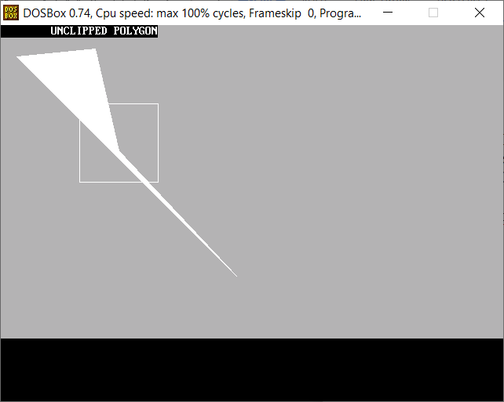

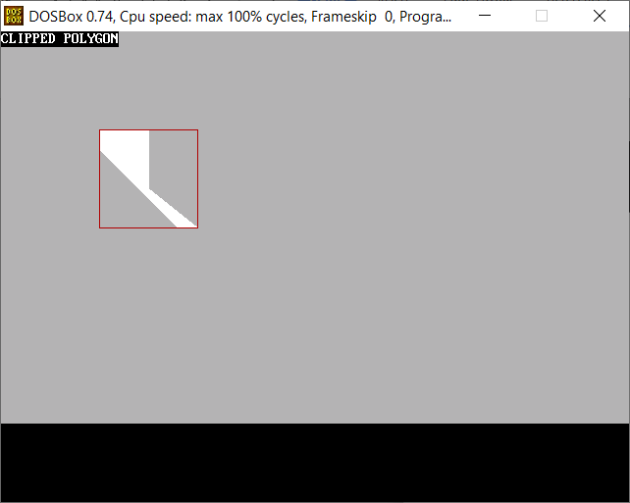

**Q5. Write a program implementing Polygon-Filling Algorithm**

Program:

#include <conio.h>

#include <iostream.h>

#include <graphics.h>

#include <stdlib.h>

#include <dos.h>

class point

{

public:

int x,y;

};

point p[20];

int inter[20],x,y;

int v,xmin,ymin,xmax,ymax;

int c;

void read()

{

cout<<"SCAN_FILL ALGORITHM";

cout<<"\nEnter the no of vertices of polygon : ";

cin>>v;

cout<<"Enter the coordinates : \n " ;

for(int i=0; i<v; i++) //ACCEPT THE VERTICES

{

cout<<"x"<<(i+1)<<"=";

cin>>p[i].x;

cout<<"y"<<(i+1)<<"=";

cin>>p[i].y;

}

p[i].x=p[0].x;

p[i].y=p[0].y;

xmin=xmax=p[0].x;

ymin=ymax=p[0].y;

}

void calcs()

{

for(int i=0;i<v;i++)

{

if(xmin>p[i].x)

xmin=p[i].x;

if(xmax<p[i].x)

xmax=p[i].x;

if(ymin>p[i].y)

ymin=p[i].y;

if(ymax<p[i].y)

ymax=p[i].y;

}

}

void ints(float z) //DEFINE FUNCTION INTS

{

int x1,x2,y1,y2,temp;

c=0;

for(int i=0;i<v;i++)

{

x1=p[i].x;

y1=p[i].y;

x2=p[i+1].x;

y2=p[i+1].y;

if(y2<y1)

{

temp=x1;

x1=x2;

x2=temp;

temp=y1;

y1=y2;

y2=temp;

}

if(z<=y2&&z>=y1)

{

if((y1-y2)==0)

x=x1;

else // used to make changes in x. so that we can fill our polygon after cerain distance

{

x=((x2-x1)*(z-y1))/(y2-y1);

x=x+x1;

}

if(x<=xmax && x>=xmin)

inter[c++]=x;

}

}

}

void sort(int z) //SORT FUNCTION

{

int temp,j,i;

for(i=0;i<v;i++)

{

line(p[i].x,p[i].y,p[i+1].x,p[i+1].y); // used to make hollow outlines of a polygon

}

delay(100);

for(i=0; i<c;i+=2)

{

delay(100);

line(inter[i],z,inter[i+1],z); // Used to fill the polygon ....

}

}

void display()

{

float s,s2;

s=ymin+0.01;

cleardevice();

while(s<=ymax)

{

ints(s);

sort(s);

s++;

}

}

int main() //START OF MAIN

{

int gd=DETECT,gm;

initgraph(&gd,&gm,"C:\\TurboC3\\BGI");

int cl;

cout<<"\nEnter the colour u want:(0-15)->"; //Selecting colour

cin>>cl;

setcolor(cl);

read();

calcs();

cleardevice();

display();

closegraph();

getch();

return 0;

}

Output:

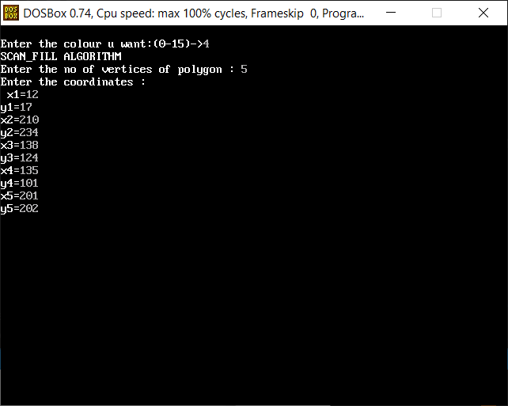

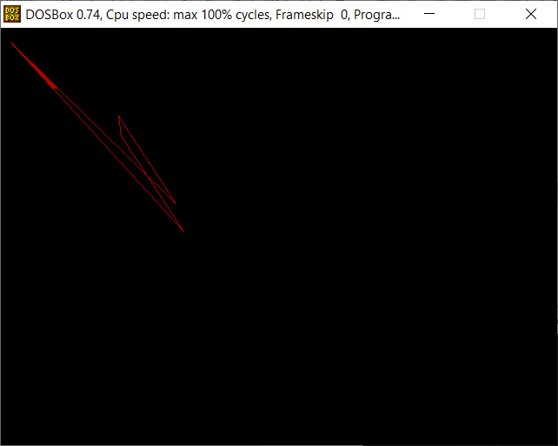

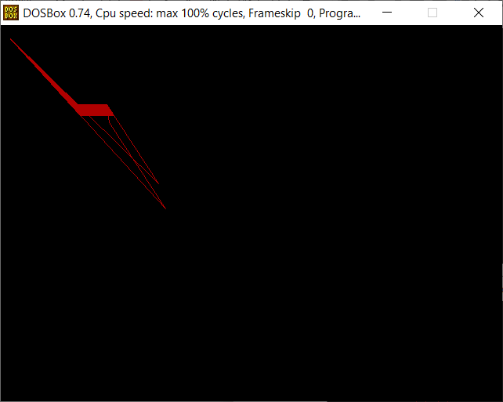

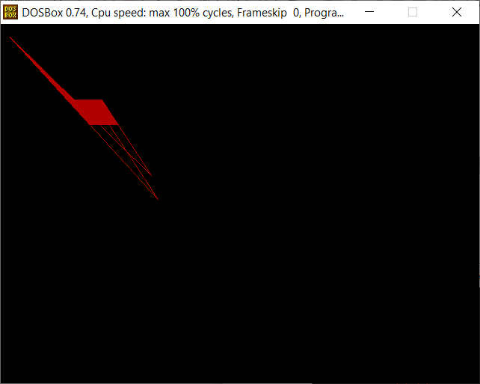

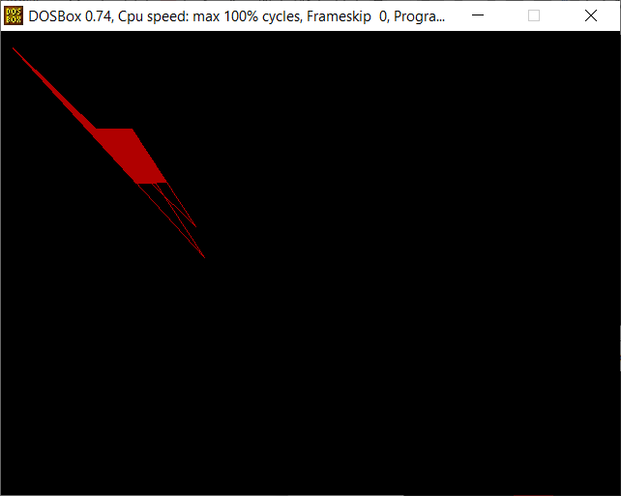

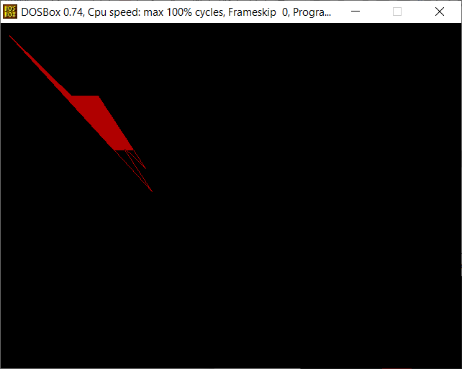

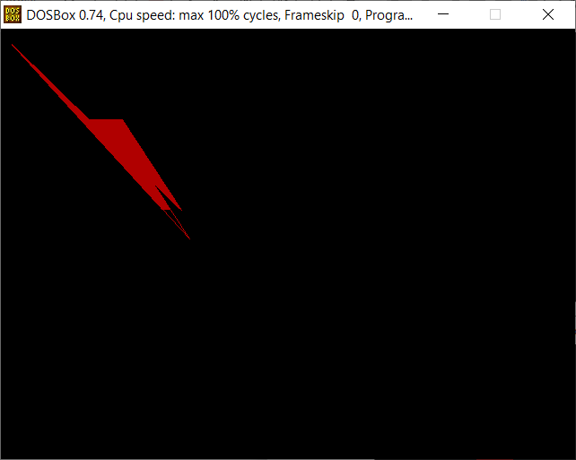

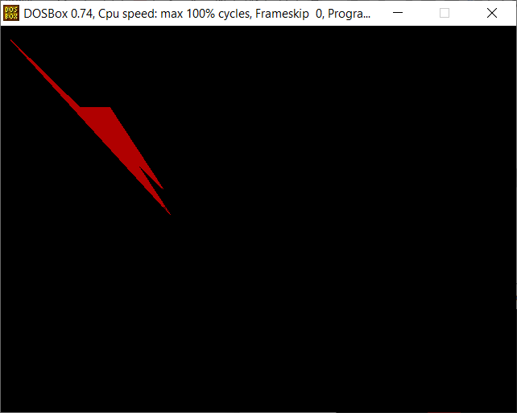

**Q6. Write a program implementing 2D transformations.**

Program:

#include<iostream.h>

#include<graphics.h>

#include<conio.h>

#include<dos.h>

#include<math.h>

#define pi 3.14285714

class transformations

{

double vertices[3][3]; //matrix contains vertices of the triangle

double t_matrix[3][3]; //transformation matrix

double result[3][3];

public:

transformations(){};

void get_vertices();

void display_triangle();

void display_triangle_result();

void multiplication();

void copyback();

void rotation(double angle,double m,double n);

void reflection(double m,double c);

void scaling(double a,double d);

void shearing(double b,double c);

};

void transformations::get_vertices()

{

int i=0;

for(i=0;i<3;i++)

{

cout<<"\nEnter vertex "<<i+1<<"...";

cout<<"\nx1 : ";

cin>>vertices[i][0];

result[i][0]=vertices[i][0];

cout<<"y1 : ";

cin>>vertices[i][1];

result[i][1]=vertices[i][1];

vertices[i][2]=result[i][2]=1;

}

}

void transformations::display_triangle()

{

int i=0;

for(i=0;i<2;i++)

line(vertices[i][0],vertices[i][1],vertices[i+1][0],vertices[i+1][1]);

line(vertices[i][0],vertices[i][1],vertices[0][0],vertices[0][1]);

}

void transformations::display_triangle_result()

{

int i=0;

for(i=0;i<2;i++)

line(result[i][0],result[i][1],result[i+1][0],result[i+1][1]);

line(result[i][0],result[i][1],result[0][0],result[0][1]);

}

void transformations::copyback()

{

int i=0,j=0;

for(i=0;i<3;i++)

for(j=0;j<3;j++)

result[i][j]=vertices[i][j];

}

void transformations::multiplication()

{

double r[3][3];

int i=0,j=0,k=0;

for(i=0;i<3;i++)

{

for(j=0;j<3;j++)

{

r[i][j]=0;

for(k=0;k<3;k++)

r[i][j]+=result[i][k]*t_matrix[k][j];

}

}

for(i=0;i<3;i++) //Copying back the result

for(j=0;j<3;j++)

result[i][j]=r[i][j];

}

//ROTATION:-

void transformations::rotation(double angle,double m,double n)

{

angle=((pi/180)*angle);

copyback();

cleardevice();

setcolor(RED);

display_triangle();

delay(20);

getch();

t_matrix[0][0]=1; //Matrix for translating the triangle to origin

t_matrix[0][1]=0;

t_matrix[0][2]=0;

t_matrix[1][0]=0;

t_matrix[1][1]=1;

t_matrix[1][2]=0;

t_matrix[2][0]=(m*(-1));

t_matrix[2][1]=(n*(-1));

t_matrix[2][2]=1;

multiplication();

t_matrix[0][0]=cos(angle); //Matrix to perform rotation about origin

t_matrix[0][1]=sin(angle);

t_matrix[1][0]=(sin(angle)*(-1));;

t_matrix[1][1]=cos(angle);

t_matrix[2][0]=0;

t_matrix[2][1]=0;

multiplication();

t_matrix[0][0]=1; //Matrix to translate back to original centre of rotation

t_matrix[0][1]=0;

t_matrix[1][0]=0;

t_matrix[1][1]=1;

t_matrix[2][0]=m;

t_matrix[2][1]=n;

multiplication();

setcolor(GREEN);

display_triangle_result();

delay(20);

getch();

}

//REFLECTION:-

void transformations::reflection(double m,double c)

{

double angle=atan(m); //tan inverse(slope)=angle

copyback();

cleardevice();

double x1=0,y1=c,x2=400,y2=(m*x2)+c;

setcolor(YELLOW);

line(x1,y1,x2,y2);

delay(20);

getch();

setcolor(RED);

display_triangle();

delay(20);

getch();

t_matrix[0][0]=1; //translate (0,-c)

t_matrix[0][1]=0;

t_matrix[0][2]=0;

t_matrix[1][0]=0;

t_matrix[1][1]=1;

t_matrix[1][2]=0;

t_matrix[2][0]=0;

t_matrix[2][1]=(c*(-1));

t_matrix[2][2]=1;

multiplication();

t_matrix[0][0]=cos(-1*angle); //rotate the object about the x-axis by -angle

t_matrix[0][1]=sin(-1*angle);

t_matrix[1][0]=(sin(-1*angle)*(-1));;

t_matrix[1][1]=cos(-1*angle);

t_matrix[2][0]=0;

t_matrix[2][1]=0;

multiplication();

t_matrix[0][0]=1; //reflection about x-axis

t_matrix[0][1]=0;

t_matrix[1][0]=0;

t_matrix[1][1]=-1;

t_matrix[2][0]=0;

t_matrix[2][1]=0;

multiplication();

t_matrix[0][0]=cos(angle); //rotate the object about the x-axis by -angle

t_matrix[0][1]=sin(angle);

t_matrix[1][0]=(sin(angle)*(-1));;

t_matrix[1][1]=cos(angle);

t_matrix[2][0]=0;

t_matrix[2][1]=0;

multiplication();

t_matrix[0][0]=1; //translating back to original line of reflection

t_matrix[0][1]=0;

t_matrix[1][0]=0;

t_matrix[1][1]=1;

t_matrix[2][0]=0;

t_matrix[2][1]=c;

multiplication();

setcolor(GREEN);

display_triangle_result();

delay(20);

getch();

}

//SCALING:-

void transformations::scaling(double a,double d)

{

copyback();

cleardevice();

setcolor(RED);

display_triangle();

delay(20);

getch();

t_matrix[0][0]=a; //Matrix for scaling the triangle

t_matrix[0][1]=0;

t_matrix[0][2]=0;

t_matrix[1][0]=0;

t_matrix[1][1]=d;

t_matrix[1][2]=0;

t_matrix[2][0]=0;

t_matrix[2][1]=0;

t_matrix[2][2]=1;

multiplication();

setcolor(GREEN);

display_triangle_result();

delay(20);

getch();

}

//SHEARING:-

void transformations::shearing(double b,double c)

{

copyback();

cleardevice();

setcolor(RED);

display_triangle();

delay(20);

getch();

t_matrix[0][0]=1; //Matrix for shearing the triangle

t_matrix[0][1]=b;

t_matrix[0][2]=0;

t_matrix[1][0]=c;

t_matrix[1][1]=1;

t_matrix[1][2]=0;

t_matrix[2][0]=0;

t_matrix[2][1]=0;

t_matrix[2][2]=1;

multiplication();

setcolor(GREEN);

display_triangle_result();

delay(20);

getch();

}

void main()

{

clrscr();

int gd=DETECT,gm,choice;

transformations t1;

char ch1,ch2;

double angle,m,n,slope,intercept,a,b,c,d;

do

{

cout<<"\n\n\t ........TWO DIMENSIONAL TRANSFORMATIONS........\n";

cout<<"\nEnter the details of a triangle(i.e. 2-D object).....";

t1.get_vertices();

do

{

initgraph(&gd,&gm,"C:\\Turboc3\\BGI");

cout<<"\n.......MENU.......";

cout<<"\n1.Rotation.";

cout<<"\n2.Reflection.";

cout<<"\n3.Scaling.";

cout<<"\n4.Shearing.";

cout<<"\n..................";

cout<<"\n\nEnter your choice :: ";

cin>>choice;

switch(choice)

{

case 1:cout<<"\n\nFOR ROTATION..........";

cout<<"\nEnter the angle of rotation :: ";

cin>>angle;

cout<<"\nNow,enter the point about which you wanna perform rotation :: ";

cout<<"\nx coordinate : ";

cin>>m;

cout<<"y coordinate : ";

cin>>n;

t1.rotation(angle,m,n);

break;

case 2:cout<<"\n\nFOR REFLECTION..........";

cout<<"\nTo enter the line in slope-intercept form(i.e. y=mx+c)....";

cout<<"\nEnter slope(m) : ";

cin>>slope;

cout<<"Then,enter y-intercept(c) : ";

cin>>intercept;

t1.reflection(slope,intercept);

break;

case 3:cout<<"\n\nFOR SCALING..........";

cout<<"\nEnter the factor of scaling...";

cout<<"\nAlong the x-axis : ";

cin>>a;

cout<<"And, along the y-axis : ";

cin>>d;

t1.scaling(a,d);

break;

case 4:cout<<"\n\nFOR SHEARING..........";

cout<<"\nEnter the factor of shearing...";

cout<<"\nAlong the x-axis : ";

cin>>c;

cout<<"And, along the y-axis : ";

cin>>b;

t1.shearing(b,c);

break;

default:cout<<"\n\n\t!!!INVALID CHOICE!!!";

getch();

}

closegraph();

cout<<"\nWanna try another tarnsformation(y/n)...";

cin>>ch2;

}while(ch2=='y');

cout<<"\n\nWant to try with a triangle of different dimensions(y/n)? ";

cin>>ch1;

}while(ch1=='y');

}

Output:

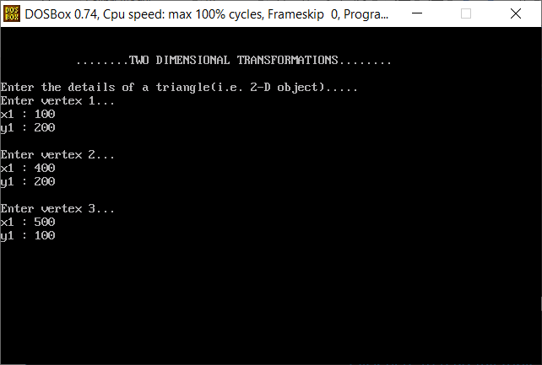

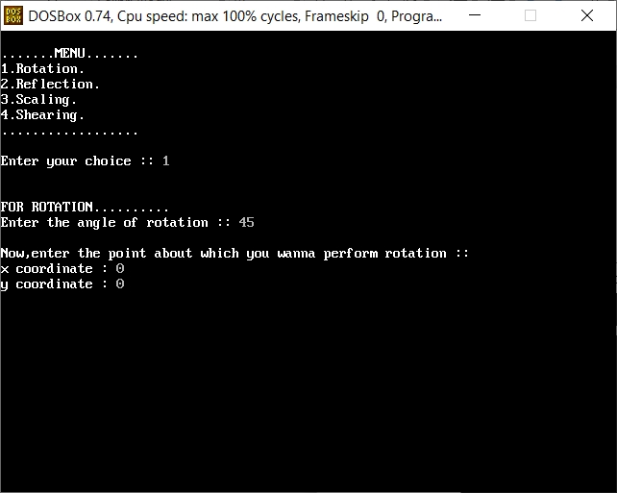

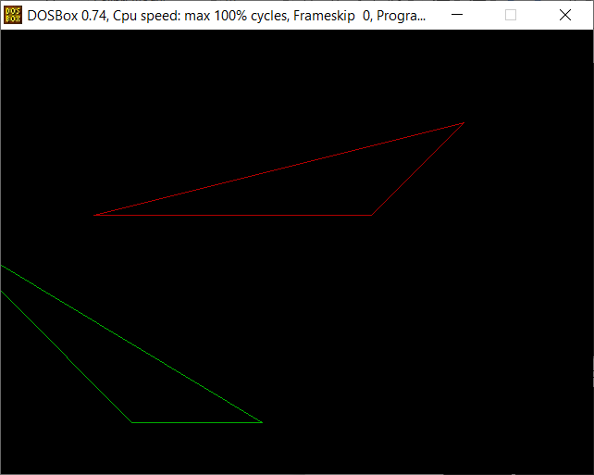

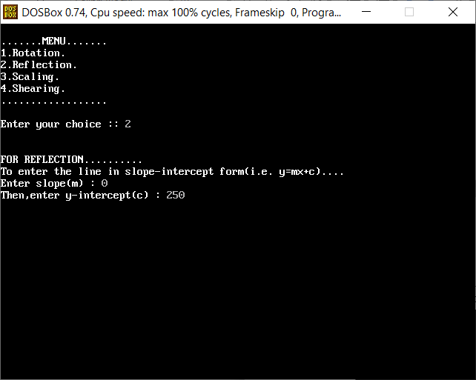

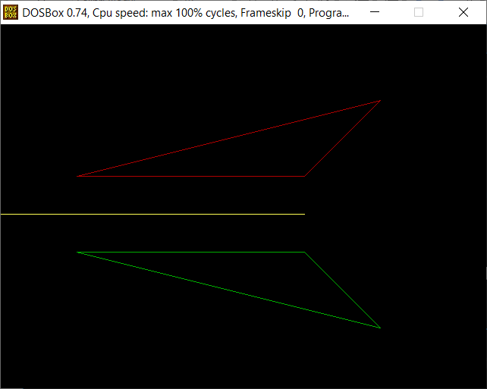

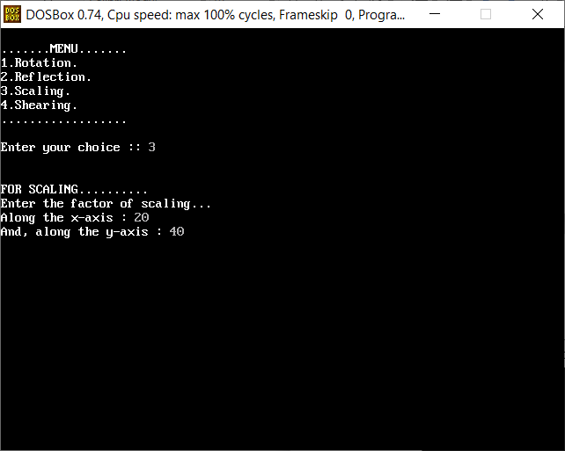

**Q7. Write a program implementing 3D transformations.**

Program:

#include<iostream.h>

#include<graphics.h>

#include<conio.h>

#include<dos.h>

#include<math.h>

#define pi 3.14285714

class projections

{

double vertices[8][4]; //matrix contains vertices of the triangle

double t_matrix[4][4]; //transformation matrix

double result[8][4];

public:

projections(){};

void get_vertices();

void display_cube();

void multiplication();

void copyback();

void orthographic();

void axonometric(double angle_x,double angle_y);

void cavalier(double angle);

void cabinet(double angle);

void single_point(double r);

void two_point(double r);

void three_point(double r);

};

void projections::get_vertices()

{

for(int i=0;i<8;i++)

{

cout<<"\nEnter vertex "<<i+1<<"...";

cout<<"\nx : ";

cin>>vertices[i][0];

result[i][0]=vertices[i][0];

cout<<"y : ";

cin>>vertices[i][1];

result[i][1]=vertices[i][1];

cout<<"z : ";

cin>>vertices[i][2];

result[i][2]=vertices[i][2];

vertices[i][3]=result[i][3]=1;

}

}

void projections::display_cube()

{

int i=0;

for(i=0;i<3;i++)

line(result[i][0],result[i][1],result[i+1][0],result[i+1][1]);

line(result[i][0],result[i][1],result[0][0],result[0][1]);

for(i=4;i<7;i++)

line(result[i][0],result[i][1],result[i+1][0],result[i+1][1]);

line(result[i][0],result[i][1],result[4][0],result[4][1]);

for(i=0;i<4;i++)

line(result[i][0],result[i][1],result[i+4][0],result[i+4][1]);

}

void projections::copyback()

{

int i=0,j=0;

for(i=0;i<8;i++)

for(j=0;j<4;j++)

result[i][j]=vertices[i][j];

}

void projections::multiplication()

{

double r[8][4];

int i=0,j=0,k=0;

for(i=0;i<8;i++)

{

for(j=0;j<4;j++)

{

r[i][j]=0;

for(k=0;k<4;k++)

r[i][j]+=result[i][k]*t_matrix[k][j];

}

}

for(i=0;i<8;i++) //Copying back the result

for(j=0;j<4;j++)

result[i][j]=r[i][j];

}

//ORTHOGRAPHIC PROJECTION....................................................................

void projections::orthographic()

{

cleardevice();

clearviewport();

cout<<"\tORTHOGRAPHIC PROJECTION...........";

copyback();

t_matrix[0][0]=1; //[T] for parallel projection on plane z=0

t_matrix[0][1]=0;

t_matrix[0][2]=0;

t_matrix[0][3]=0;

t_matrix[1][0]=0;

t_matrix[1][1]=1;

t_matrix[1][2]=0;

t_matrix[1][3]=0;

t_matrix[2][0]=0;

t_matrix[2][1]=0;

t_matrix[2][2]=0;

t_matrix[2][3]=0;

t_matrix[3][0]=0;

t_matrix[3][1]=0;

t_matrix[3][2]=0;

t_matrix[3][3]=1;

multiplication();

setcolor(GREEN);

display_cube();

delay(20);

getch();

}

//AXONOMETRIC PROJECTION..................................................................

void projections::axonometric(double angle_x,double angle_y)

{

angle_x=((pi/180)*angle_x); //tan inverse(slope)=angle

angle_y=((pi/180)*angle_y);

cleardevice();

clearviewport();

cout<<"\tAXONOMETRIC PROJECTION...........";

copyback();

t_matrix[0][0]=cos(angle_y); //[T] for parallel projection on plane z=0

t_matrix[0][1]=(sin(angle_y))*(sin(angle_x));

t_matrix[0][2]=0;

t_matrix[0][3]=0;

t_matrix[1][0]=0;

t_matrix[1][1]=cos(angle_x);

t_matrix[1][2]=0;

t_matrix[1][3]=0;

t_matrix[2][0]=sin(angle_y);

t_matrix[2][1]=(-1)*(cos(angle_y)*sin(angle_x));

t_matrix[2][2]=0;

t_matrix[2][3]=0;

t_matrix[3][0]=0;

t_matrix[3][1]=0;

t_matrix[3][2]=0;

t_matrix[3][3]=1;

multiplication();

setcolor(GREEN);

display_cube();

delay(20);

getch();

}

//CAVALIER OBLIQUE PROJECTION..................................................................

void projections::cavalier(double angle)

{

angle=((pi/180)*angle); //converting degrees into radian

cleardevice();

clearviewport();

cout<<"\tCAVALIER PROJECTION...........";

copyback();

t_matrix[0][0]=1; //[T] for cavalier projection on plane z=0

t_matrix[0][1]=0;

t_matrix[0][2]=0;

t_matrix[0][3]=0;

t_matrix[1][0]=0;

t_matrix[1][1]=1;

t_matrix[1][2]=0;

t_matrix[1][3]=0;

t_matrix[2][0]=(-1)*1*cos(angle);

t_matrix[2][1]=(-1)*1*sin(angle);

t_matrix[2][2]=0;

t_matrix[2][3]=0;

t_matrix[3][0]=0;

t_matrix[3][1]=0;

t_matrix[3][2]=0;

t_matrix[3][3]=1;

multiplication();

setcolor(GREEN);

display_cube();

delay(20);

getch();

}

//CABINET OBLIQUE PROJECTION..................................................................

void projections::cabinet(double angle)

{

angle=((pi/180)*angle); //converting degrees into radian

cleardevice();

clearviewport();

cout<<"\tCABINET PROJECTION...........";

copyback();

t_matrix[0][0]=1; //[T] for cabinet projection on plane z=0

t_matrix[0][1]=0;

t_matrix[0][2]=0;

t_matrix[0][3]=0;

t_matrix[1][0]=0;

t_matrix[1][1]=1;

t_matrix[1][2]=0;

t_matrix[1][3]=0;

t_matrix[2][0]=(-1)*0.5*cos(angle);

t_matrix[2][1]=(-1)*0.5*sin(angle);

t_matrix[2][2]=0;

t_matrix[2][3]=0;

t_matrix[3][0]=0;

t_matrix[3][1]=0;

t_matrix[3][2]=0;

t_matrix[3][3]=1;

multiplication();

setcolor(GREEN);

display_cube();

delay(20);

getch();

}

//SINGLE POINT PRESPECTIVE PROJECTION..................................................................

void projections::single_point(double r)

{

double l=10,m=10,n=10; //Translation factors along x, y and z axis

cleardevice();

clearviewport();

cout<<"\tSINGLE POINT PRESPECTIVE PROJECTION...........";

r=(-1/r);

copyback();

t_matrix[0][0]=1; //[T] for single point prespective projection on plane z=0

t_matrix[0][1]=0;

t_matrix[0][2]=0;

t_matrix[0][3]=0;

t_matrix[1][0]=0;

t_matrix[1][1]=1;

t_matrix[1][2]=0;

t_matrix[1][3]=0;

t_matrix[2][0]=0;

t_matrix[2][1]=0;

t_matrix[2][2]=0;

t_matrix[2][3]=r;

t_matrix[3][0]=l;

t_matrix[3][1]=m;

t_matrix[3][2]=0;

t_matrix[3][3]=r*n+1;

multiplication();

setcolor(GREEN);

display_cube();

delay(20);

getch();

}

//TWO-POINT PRESPECTIVE PROJECTION..................................................................

void projections::two_point(double r)

{

double angle=45;

angle=(pi/180)*angle;

cleardevice();

clearviewport();

cout<<"\tTWO POINT PRESPECTIVE PROJECTION...........";

copyback();

r=(-1/r);

t_matrix[0][0]=cos(angle); //[T] for two point prespective projection on plane z=0

t_matrix[0][1]=0;

t_matrix[0][2]=(-1*sin(angle));

t_matrix[0][3]=sin(angle)/r;

t_matrix[1][0]=0;

t_matrix[1][1]=1;

t_matrix[1][2]=0;

t_matrix[1][3]=0;

t_matrix[2][0]=sin(angle);

t_matrix[2][1]=0;

t_matrix[2][2]=cos(angle);

t_matrix[2][3]=(-1*cos(angle))/r;

t_matrix[3][0]=0;

t_matrix[3][1]=0;

t_matrix[3][2]=0;

t_matrix[3][3]=1;

multiplication();

setcolor(GREEN);

display_cube();

delay(20);

getch();

}

//THREE POINT PRESPECTIVE PROJECTION..........................................

void projections::three_point(double r)

{

double angle_y=45,angle_x=45;

angle_y=(pi/180)*angle_y;

angle_x=(pi/180)*angle_x;

cleardevice();

clearviewport();

cout<<"\tTHREE POINT PRESPECTIVE PROJECTION...........";

copyback();

r=(-1/r);

t_matrix[0][0]=cos(angle_y); //[T] for three point prespective projection on plane z=0

t_matrix[0][1]=sin(angle_y)*sin(angle_x);

t_matrix[0][2]=0;

t_matrix[0][3]=(sin(angle_y)*cos(angle_x))/r;

t_matrix[1][0]=0;

t_matrix[1][1]=cos(angle_x);

t_matrix[1][2]=0;

t_matrix[1][3]=(-1*sin(angle_x))/r;

t_matrix[2][0]=(sin(angle_y));

t_matrix[2][1]=(-1*cos(angle_y)*sin(angle_x));

t_matrix[2][2]=0;

t_matrix[2][3]=(-1*cos(angle_y)*cos(angle_x))/r;

t_matrix[3][0]=0;

t_matrix[3][1]=0;

t_matrix[3][2]=0;

t_matrix[3][3]=1;

multiplication();

setcolor(GREEN);

display_cube();

delay(20);

getch();

}

void main()

{

clrscr();

int gd=DETECT,gm,choice;

projections t1;

char ch1,ch2,axis,axis1,axis2;

double angle_x,angle_y,angle,ratio,ratio1,ratio2,ratio3;

do

{

cout<<"\n\n\t ........PROJECTIONS OF 3D OBJECTS........\n";

cout<<"\nEnter the details of a cube(i.e. 3D object).....";

t1.get_vertices();

do

{

initgraph(&gd,&gm,"C:\\Turboc3\\BGI");

cout<<"\n\n...........MENU...........";

cout<<"\n1.Orthographic.";

cout<<"\n2.Axonometric.";

cout<<"\n3.Cavalier (Oblique type 1).";

cout<<"\n4.Cabinet (Oblique type 2)";

cout<<"\n5.Single-Point presepective.";

cout<<"\n6.Two-Point presepective.";

cout<<"\n7.Three-Point presepective.";

cout<<"\n............................";

cout<<"\n\nEnter your choice :: ";

cin>>choice;

switch(choice)

{

case 1:t1.orthographic();

break;

case 2:cout<<"\n\nFOR AXONOMETRIC PROJECTION..........";

cout<<"\nEnter the angle of rotation about :-";

cout<<"\nx-axis : ";

cin>>angle_x;

cout<<"And, y-axis : ";

cin>>angle_y;

t1.axonometric(angle_x,angle_y);

break;

case 3:cout<<"\n\nFOR CAVALIER PROJECTION..........";

cout<<"\nEnter the angle of inclination : ";

cin>>angle;

t1.cavalier(angle);

break;

case 4:cout<<"\n\nFOR CABINET PROJECTION..........";

cout<<"\nEnter the angle of inclination : ";

cin>>angle;

t1.cabinet(angle);

break;

case 5:cout<<"\n\nFOR SINGLE POINT PRESPECTIVE PROJECTION..........";

cout<<"\nAssuming that the VP lies on the z-axis....";

cout<<"Enter the prespective ratio for z-axis :: ";

cin>>ratio;

t1.single_point(ratio);

break;

case 6:cout<<"\n\nFOR TWO POINT PRESPECTIVE PROJECTION..........";

cout<<"\nAssuming that the VP lies on the z-axis....";

cout<<"Enter the prespective ratio for z-axis :: ";

cin>>ratio;

t1.two_point(ratio);

break;

case 7:cout<<"\n\nFOR THREE POINT PRESPECTIVE PROJECTION..........";

cout<<"\nAssuming that the VP lies on the z-axis....";

cout<<"Enter the prespective ratio for z-axis :: ";

cin>>ratio;

t1.three_point(ratio);

break;

default:cout<<"\n\n\t!!!INVALID CHOICE!!!";

getch();

}

closegraph();

cout<<"\nWanna try another projection(y/n)...";

cin>>ch2;

}while(ch2=='y');

cout<<"\nWanna try with a cube of different dimensions(y/n)... ";

cin>>ch1;

}while(ch1=='y');

}

Output:

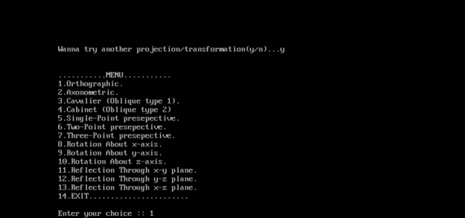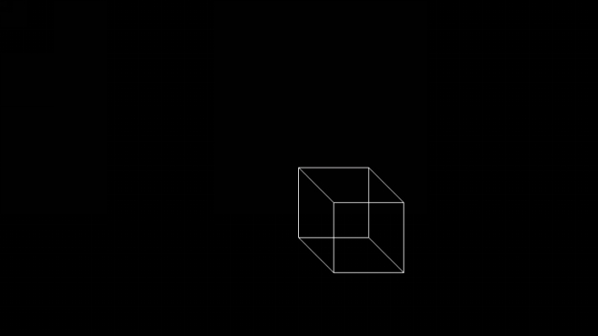

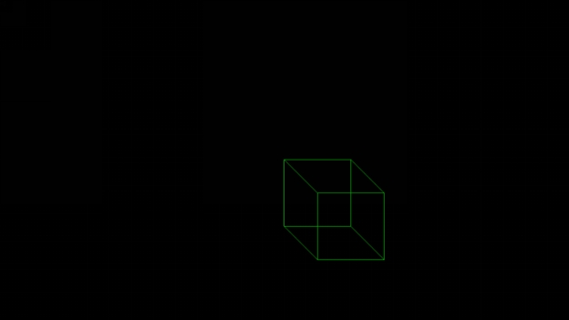

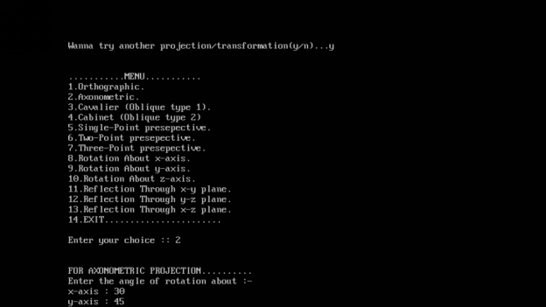

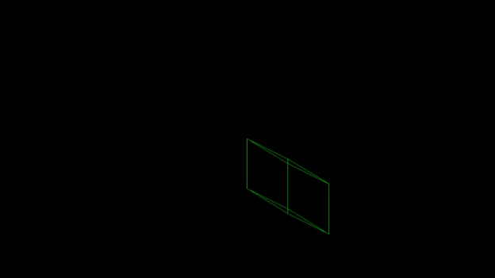

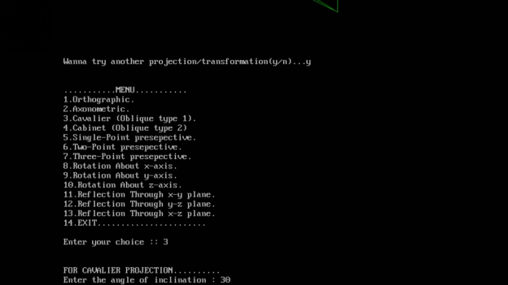

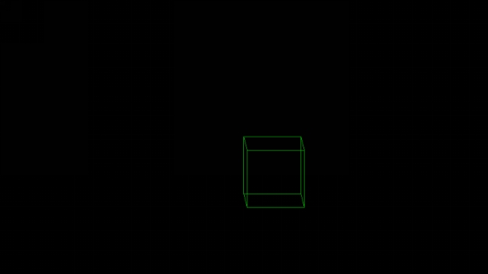

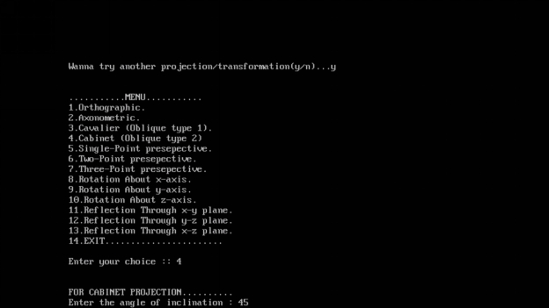

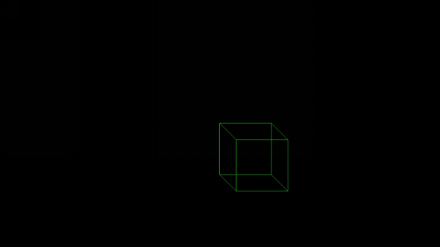

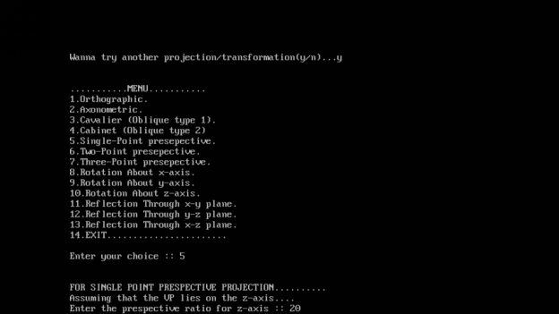

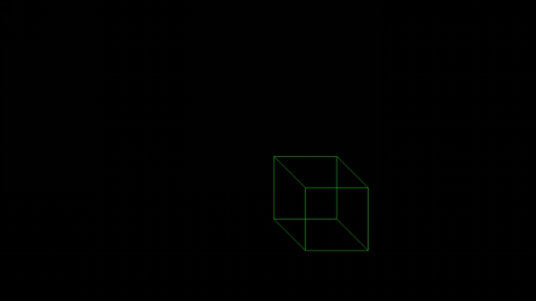

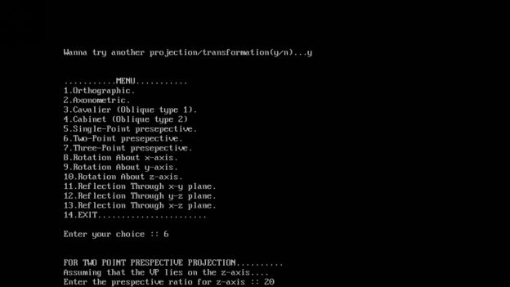

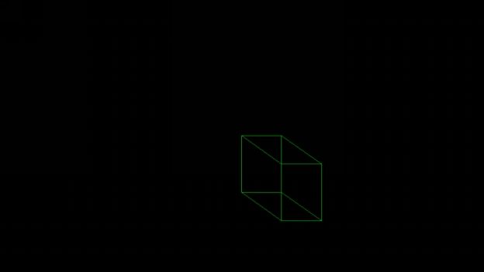

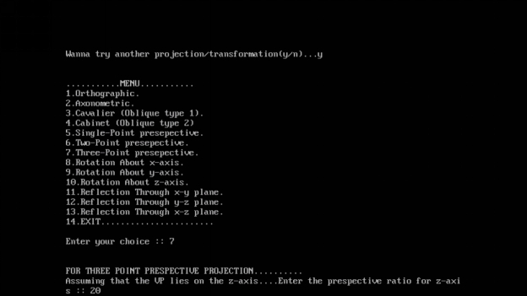

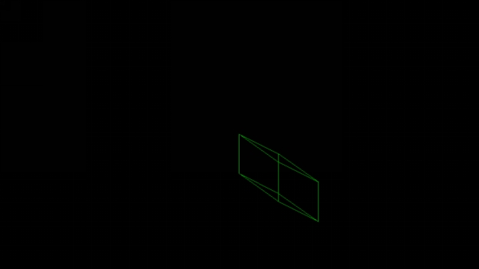

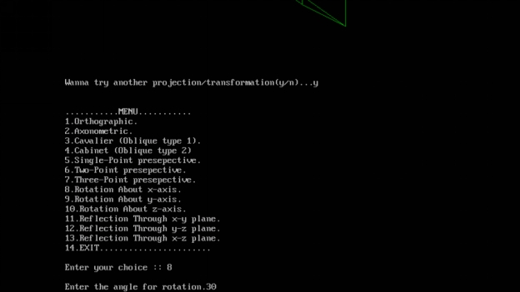



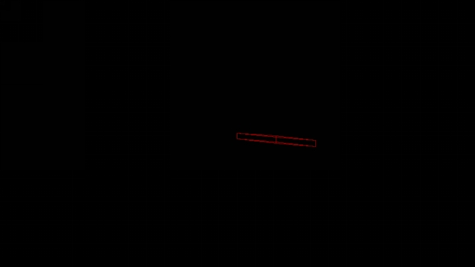

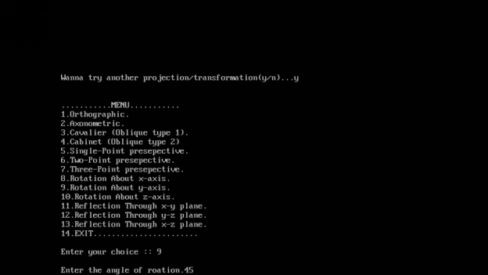



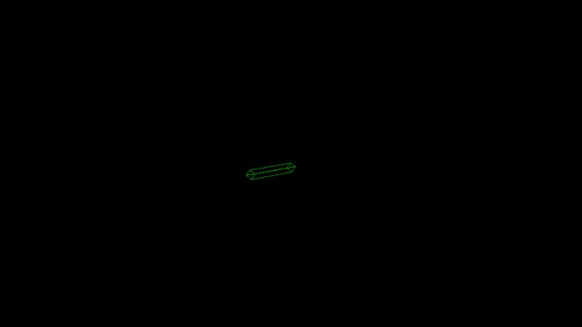

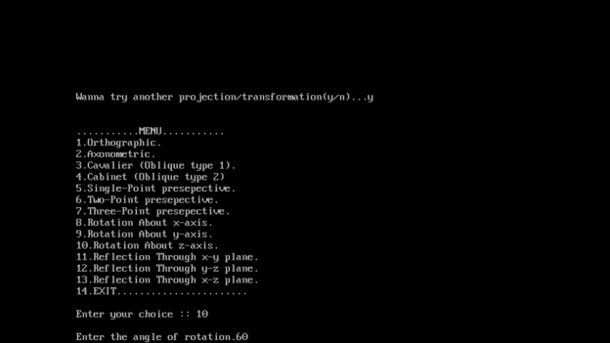



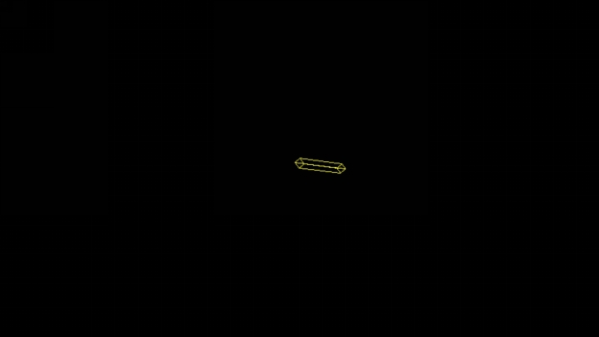

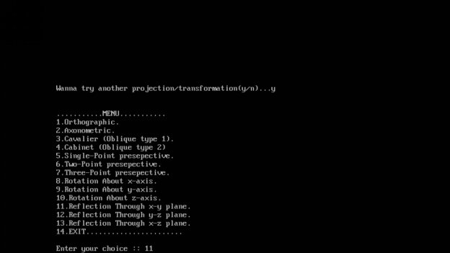

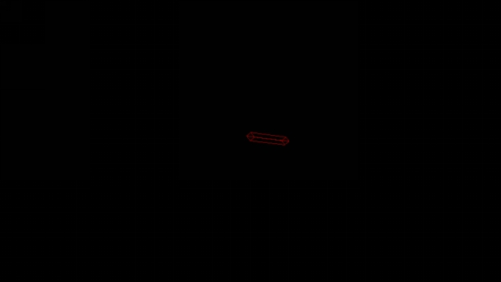



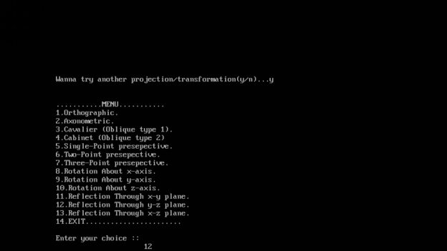

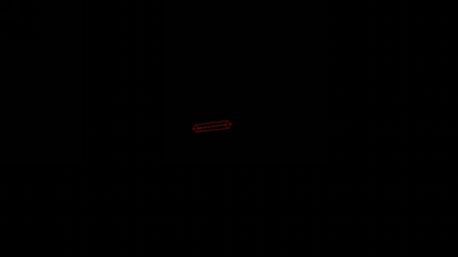

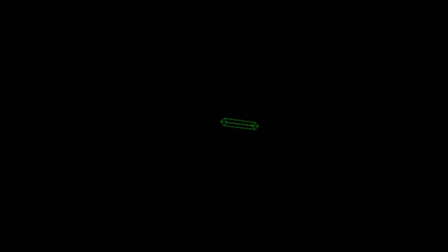

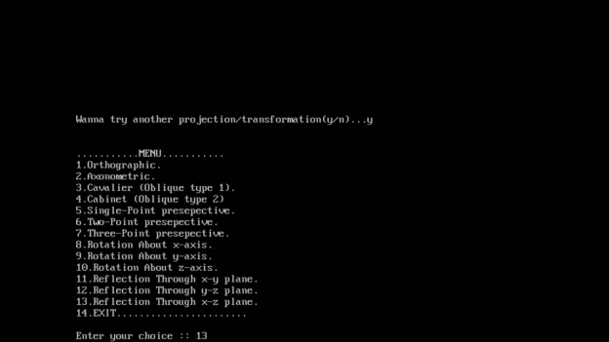



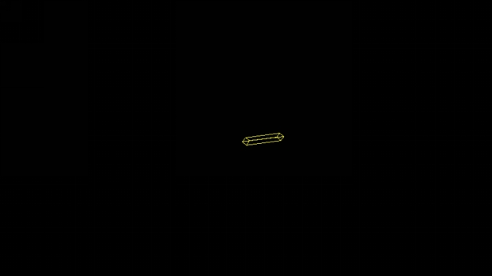

**Q8. Write a program implementing Hermite- Bezier Curve**

Program:

#include<stdio.h>

#include<graphics.h>

#include<iostream.h>

#include<conio.h>

#include<stdlib.h>

#include<math.h>

void bezier(int x[4], int y[4])

{

double t;

for(t=0.0;t < 1.0;t+=0.0005)

{

double xt=pow(1-t,3)*x[0]+3*t*pow(1-t,2)*x[1]+3*pow(t,2)*(1-t)*x[2]+pow(t,3)*x[3];

double yt=pow(1-t,3)*y[0]+3*t*pow(1-t,2)*y[1]+3*pow(t,2)*(1-t)*y[2]+pow(t,3)*y[3];

putpixel(xt,yt,RED);

}

for(int i=0;i < 4;i++)

putpixel(x[i],y[i],YELLOW);

getch();

closegraph();

return;

}

void main()

{

/* request auto detection */

int gdriver = DETECT, gmode, errorcode;

/* initialize graphics and local variables */

initgraph(&gdriver, &gmode, "..\\bgi");

/* read result of initialization */

errorcode = graphresult();

/* an error occurred */

if (errorcode != grOk)

{

printf("Graphics error: %s\n", grapherrormsg(errorcode));

printf("Press any key to halt:");

getch();

exit(1);

}

int x[4],y[4];

int i;

cout<<"Enter x and y coordinates"<<endl;

for(i=0;i < 4;i++)

{

cin>>x[i];

cout<<endl;

cin>>y[i];

}

clrscr();

bezier(x,y);

}

Output:

