**ARTIFICIAL INTELLIGENCE PRACTICAL**

**Name: Jyoti Rawat**

**Roll.no: 2019320**

**Date: 22 February, 2022**

**Q10: Write a prolog program to implement reverse (L,R) where List L is original and list R is reversed list.**

**CODE:**

ar([H|T],A,R):-ar(T,[H|A],R).

ar([],A,A).

reverse(L,R):-ar(L,[],R).

OUTPUT:

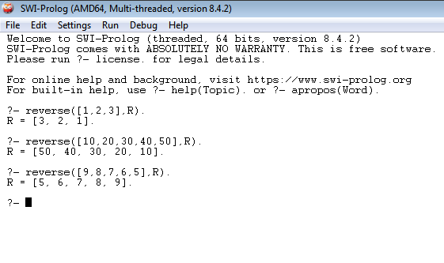

**Q11: Write a prolog programImplement palindrome(L) to check whether list L is a palindrome or not.**

**CODE:**

ar([H|T],A,R):-ar(T,[H|A],R).

ar([],A,A).

rev(L,R):-ar(L,[],R).

palindrome(L):-rev(L,L).

OUTPUT:

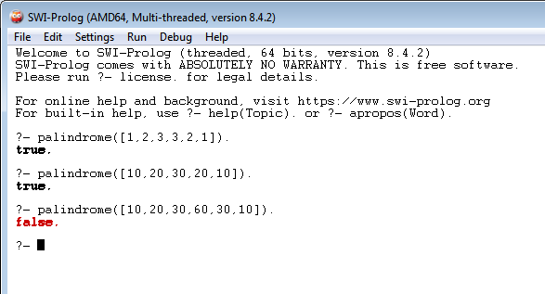

**Q: SUBLIST:**

CODE:

conc([],L,L).

conc([X|T],L2,[X|P]):-

conc(T,L2,P).

sublist(S,L):-

conc(L1,L2,L),

conc(S,L3,L2).

OUTPUT:

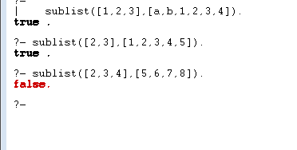

**Q: PERMUTATION:**

CODE:

perm([],[]).

perm(P,[X|T]):-

append(Q,[X|T1],P),

append(Q,T1,P1),

perm(P1,T).

OUTPUT:

