Publié à l'aide de Google Docs

[Signaler un abus](https://drive.google.com/abuse?id=AKkXjozsfTVq2zlMGwhhaR8D9tKhanyRJEEH9QIheaAJd3TSmpI6fYdWlFBXiKzZrYhzcq7yjund2L5RyjqX4Es:0&docurl=https://docs.google.com/document/d/e/2PACX-1vRnTmwDeynRlYUu9ib-jtkH7Ukas7TWyd0ww-aS6itEKjhXWCaGeI72fJ_0MIwrHG4oCK140Iv7iwBy/pub)[En savoir plus](https://support.google.com/docs/answer/183965)

Appium Step by Step | Part 1

Mise à jour automatique effectuée toutes les 5 minutes

APPIUM 2 Getting Started

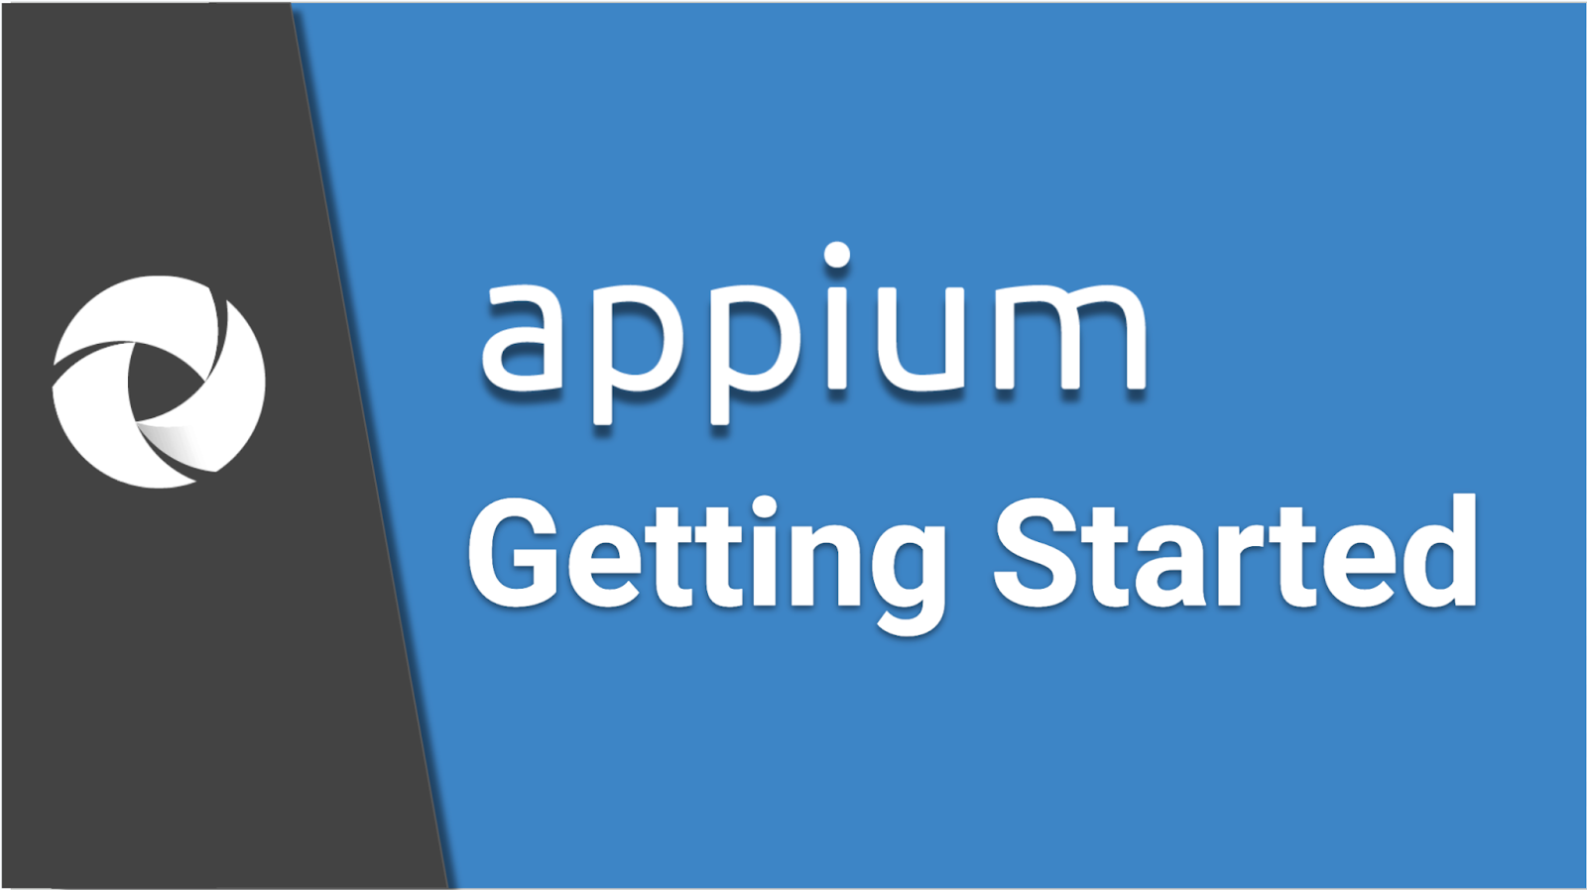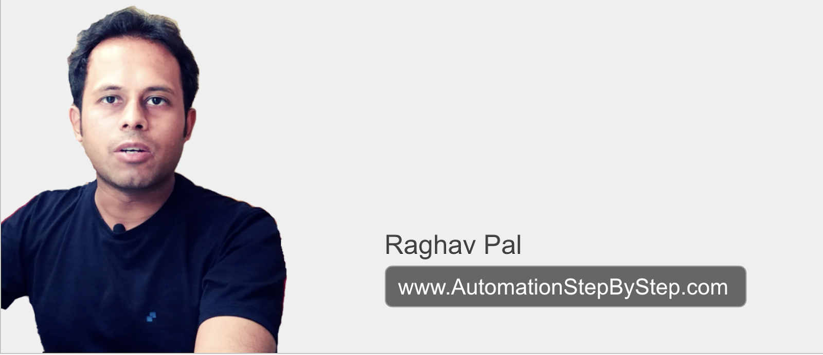

This is for complete Beginners

Will start from scratch and go up Step by Step

Windows and Mac OS

You can do hands-on along with me

Can watch at 1.5x speed

Let me know if you face any problem

Let’s Get Started…

**Videos:**

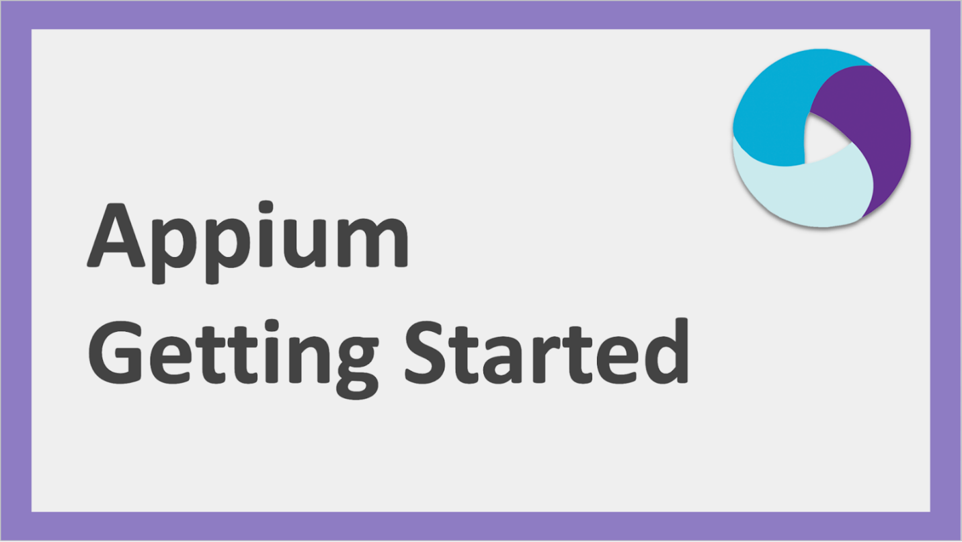

Part 1 - Basic Setup on Windows and Mac OS

[https://youtu.be/pTe2cspINoU](https://www.google.com/url?q=https://youtu.be/pTe2cspINoU&sa=D&source=editors&ust=1722860748777854&usg=AOvVaw2C2gX38AmtHizb2QDY6HPR)

Part 2 - Complete setup for Android Mobile Testing without using Android Studio

[https://youtu.be/dVTZpsNINM8](https://www.google.com/url?q=https://youtu.be/dVTZpsNINM8&sa=D&source=editors&ust=1722860748778226&usg=AOvVaw0MDjVs0cAuvbut3c17ukBZ)

Part 3 - Complete setup for Android Mobile Testing using Android Studio

[https://youtu.be/oqaJvdIQ7JQ](https://www.google.com/url?q=https://youtu.be/oqaJvdIQ7JQ&sa=D&source=editors&ust=1722860748778492&usg=AOvVaw0Hi7ty8UXV0xnmMTmPStYb)

Part 4 - How to create AVD Android Virtual Device or Emulator

[https://youtu.be/KZsslCtU4No](https://www.google.com/url?q=https://youtu.be/KZsslCtU4No&sa=D&source=editors&ust=1722860748778718&usg=AOvVaw1au0GimXIHUcAyTv46fhxO)

Part 5 - Android Real Device setup for Automation

[https://youtu.be/QfuKGkdgw8o](https://www.google.com/url?q=https://youtu.be/QfuKGkdgw8o&sa=D&source=editors&ust=1722860748778956&usg=AOvVaw02tdVcTUcCUoxNLDIUmffC)

Part 6 - How to setup and use Appium Inspector

[https://youtu.be/S3wDYhnxDh0](https://www.google.com/url?q=https://youtu.be/S3wDYhnxDh0&sa=D&source=editors&ust=1722860748779209&usg=AOvVaw1hktsuw8liS2EnuwB9HgMN)

Part 7 - Complete Hands-On Demo and recording with Appium Inspector

[https://youtu.be/cY93qWjNkow](https://www.google.com/url?q=https://youtu.be/cY93qWjNkow&sa=D&source=editors&ust=1722860748779443&usg=AOvVaw0qMSzzx0vOFyu2EN0JRoQ3)

Part 8 - Complete iOS Testing Setup

[https://youtu.be/tvjfBbIuXRA](https://www.google.com/url?q=https://youtu.be/tvjfBbIuXRA&sa=D&source=editors&ust=1722860748779668&usg=AOvVaw3gA6Lwl9T_UF0tMkPif7uP)

**TOPICS**

Part 1

* [APPIUM 2 Changes](https://docs.google.com/document/d/e/2PACX-1vRnTmwDeynRlYUu9ib-jtkH7Ukas7TWyd0ww-aS6itEKjhXWCaGeI72fJ_0MIwrHG4oCK140Iv7iwBy/pub#h.3wmqlynyfz71)
* [Appium Basic Setup on Windows and Mac OS](https://docs.google.com/document/d/e/2PACX-1vRnTmwDeynRlYUu9ib-jtkH7Ukas7TWyd0ww-aS6itEKjhXWCaGeI72fJ_0MIwrHG4oCK140Iv7iwBy/pub#h.1iehu6m5szga)

Next Parts

* [Setup for Android Mobile Testing](https://docs.google.com/document/d/e/2PACX-1vRnTmwDeynRlYUu9ib-jtkH7Ukas7TWyd0ww-aS6itEKjhXWCaGeI72fJ_0MIwrHG4oCK140Iv7iwBy/pub#h.d7ulmvbldno6)
* [Check missing dependencies on our system](https://docs.google.com/document/d/e/2PACX-1vRnTmwDeynRlYUu9ib-jtkH7Ukas7TWyd0ww-aS6itEKjhXWCaGeI72fJ_0MIwrHG4oCK140Iv7iwBy/pub#h.4zyh84j7w1lh)
* [Setup Java JDK](https://docs.google.com/document/d/e/2PACX-1vRnTmwDeynRlYUu9ib-jtkH7Ukas7TWyd0ww-aS6itEKjhXWCaGeI72fJ_0MIwrHG4oCK140Iv7iwBy/pub#h.ur39cvpiii5u)
* [Install appium android drivers](https://docs.google.com/document/d/e/2PACX-1vRnTmwDeynRlYUu9ib-jtkH7Ukas7TWyd0ww-aS6itEKjhXWCaGeI72fJ_0MIwrHG4oCK140Iv7iwBy/pub#h.54sx9npedb39)
* [Setup Android SDK and SDK Tools](https://docs.google.com/document/d/e/2PACX-1vRnTmwDeynRlYUu9ib-jtkH7Ukas7TWyd0ww-aS6itEKjhXWCaGeI72fJ_0MIwrHG4oCK140Iv7iwBy/pub#h.uepj7cu2ytzu)
* [OPTION 1: Download only the required tools](https://docs.google.com/document/d/e/2PACX-1vRnTmwDeynRlYUu9ib-jtkH7Ukas7TWyd0ww-aS6itEKjhXWCaGeI72fJ_0MIwrHG4oCK140Iv7iwBy/pub#h.aa9qrat3xk1h)
* [OPTION 2: Download and install Android Studio](https://docs.google.com/document/d/e/2PACX-1vRnTmwDeynRlYUu9ib-jtkH7Ukas7TWyd0ww-aS6itEKjhXWCaGeI72fJ_0MIwrHG4oCK140Iv7iwBy/pub#h.1iivtt6ouc14)
* [Android Virtual Device Setup for Automation](https://docs.google.com/document/d/e/2PACX-1vRnTmwDeynRlYUu9ib-jtkH7Ukas7TWyd0ww-aS6itEKjhXWCaGeI72fJ_0MIwrHG4oCK140Iv7iwBy/pub#h.dudmxb7ivgrb)
* [How to create and start AVD (Emulator) with Android Studio](https://docs.google.com/document/d/e/2PACX-1vRnTmwDeynRlYUu9ib-jtkH7Ukas7TWyd0ww-aS6itEKjhXWCaGeI72fJ_0MIwrHG4oCK140Iv7iwBy/pub#h.a1exd8jm2gvk)
* [How to create and start AVD (Emulator) without Android Studio](https://docs.google.com/document/d/e/2PACX-1vRnTmwDeynRlYUu9ib-jtkH7Ukas7TWyd0ww-aS6itEKjhXWCaGeI72fJ_0MIwrHG4oCK140Iv7iwBy/pub#h.xsleqpy5hcbd)
* [Other Options for Android Virtual Devices (Emulators)](https://docs.google.com/document/d/e/2PACX-1vRnTmwDeynRlYUu9ib-jtkH7Ukas7TWyd0ww-aS6itEKjhXWCaGeI72fJ_0MIwrHG4oCK140Iv7iwBy/pub#h.g1vvx8z1rb9k)
* [Remote Cloud Devices](https://docs.google.com/document/d/e/2PACX-1vRnTmwDeynRlYUu9ib-jtkH7Ukas7TWyd0ww-aS6itEKjhXWCaGeI72fJ_0MIwrHG4oCK140Iv7iwBy/pub#h.ky1mj931iee8)
* [Android Real Device Setup for Automation](https://docs.google.com/document/d/e/2PACX-1vRnTmwDeynRlYUu9ib-jtkH7Ukas7TWyd0ww-aS6itEKjhXWCaGeI72fJ_0MIwrHG4oCK140Iv7iwBy/pub#h.m3emczv76vkr)
* [Get APK file for testing](https://docs.google.com/document/d/e/2PACX-1vRnTmwDeynRlYUu9ib-jtkH7Ukas7TWyd0ww-aS6itEKjhXWCaGeI72fJ_0MIwrHG4oCK140Iv7iwBy/pub#h.f1eh23lg92jk)
* [Setup and Start Appium Inspector](https://docs.google.com/document/d/e/2PACX-1vRnTmwDeynRlYUu9ib-jtkH7Ukas7TWyd0ww-aS6itEKjhXWCaGeI72fJ_0MIwrHG4oCK140Iv7iwBy/pub#h.txvv396d4yfa)
* [1st Recording session with Appium and Appium Inspector](https://docs.google.com/document/d/e/2PACX-1vRnTmwDeynRlYUu9ib-jtkH7Ukas7TWyd0ww-aS6itEKjhXWCaGeI72fJ_0MIwrHG4oCK140Iv7iwBy/pub#h.fct8og9etx8h)
* [Common User Questions](https://docs.google.com/document/d/e/2PACX-1vRnTmwDeynRlYUu9ib-jtkH7Ukas7TWyd0ww-aS6itEKjhXWCaGeI72fJ_0MIwrHG4oCK140Iv7iwBy/pub#h.alfsoscb4wos)
* [REFERENCES](https://docs.google.com/document/d/e/2PACX-1vRnTmwDeynRlYUu9ib-jtkH7Ukas7TWyd0ww-aS6itEKjhXWCaGeI72fJ_0MIwrHG4oCK140Iv7iwBy/pub#h.983mem8gs5uj)

- - - - - - - - - - - - - - - - - - - - - - - - - - - - - - - - - - - - - - - - - - - - - - - - - - - - - - - - - - - - - - - - -

Next part

* Setup for iOS Mobile Testing
* iOS Real Device and Simulator Setup for Automation

**APPIUM 2 Changes**

* From appium 2.x onwards, the communication will happen over w3c protocol (refer images)
* Appium drivers are maintained separately, so need to install on a need basis
* Introduced appium plugins, so different communities or individuals can create code blocks to add/alter certain appium commands which can talk with the appium drivers

Migrating from Appium 1.x to Appium 2.x

[https://appium.io/docs/en/2.0/guides/migrating-1-to-2/](https://www.google.com/url?q=https://appium.io/docs/en/2.0/guides/migrating-1-to-2/&sa=D&source=editors&ust=1722860748783422&usg=AOvVaw2VDBnZwROxTNBYwVSpwIwT)

[**TOPICS**](https://docs.google.com/document/d/e/2PACX-1vRnTmwDeynRlYUu9ib-jtkH7Ukas7TWyd0ww-aS6itEKjhXWCaGeI72fJ_0MIwrHG4oCK140Iv7iwBy/pub#h.eoqr2a4ylhfk)

**Appium Basic Setup on Windows and Mac OS**

Step 1 - Check if Node.js is installed and setup           
node -v         npm -v

Step 2 - If not, download & install Node.js                  
[https://nodejs.org/en/download/](https://www.google.com/url?q=https://nodejs.org/en/download/&sa=D&source=editors&ust=1722860748784546&usg=AOvVaw3n7u82rOxfsTQItKTBhmak)

On **Mac OS**, another way to get node is using homebrew

1. Check homebrew is installed brew --version           which brew
2. If not install homebrew goto terminal and run /bin/bash -c "$(curl -fsSL https://raw.githubusercontent.com/Homebrew/install/HEAD/install.sh)"
3. Can update brew - brew update
4. Run commands to get node and npm

brew install node

brew install npm

Step 3 - Check if appium is available on the system           
appium --version or appium -v

Step 4 - Install Appium via NPM                                    
npm install -g appium@latest  
Installing Appium 2.0 only installs the Appium server, but not the drivers since all drivers have been isolated from the Appium server app  
We will Install the Appium UiAutomator2 Driver for Android and Appium XCUITest Driver for iOS separately

Step 5 - Verify appium is available on the system                  
appium -v         which appium        where appium

Step 6 - Run command appium to get information on our installed appium  (CTRL + C to quit)

Step 7 - Install appium-doctor (optional)                          
npm install -g appium-doctor  
**Appium Doctor** is a handy tool from Appium team that serves as a pre-flight check for Appium test environment  
Attempts to diagnose and fix common Node, iOS and Android configuration issues         appium-doctor -h

Step 8 - Check and install required appium drivers as per the our testing needs

Run command to see available drivers

appium driver list        (works on appium 2.0 or later)

appium plugin list

Install Appium driver

Android:        appium driver install uiautomator2  
iOS:                appium driver install xcuitest

Check:        appium driver list

Update:        appium driver list --updates

Step 9 : Run appium server                        appium server  OR  appium

                                                        appium --allow-cors

      Press Ctrl+C to stop appium server  
  
--allow-cors: This is a flag that tells the Appium server to enable CORS - Cross-Origin Resource Sharing (CORS) enabled

You might need to use this command if you're using a testing framework that runs on a different domain than the Appium server.

For example, if you're using the Appium Inspector to record and edit test scripts, you'll need to start the Appium server with CORS enabled if the Inspector is running on a different domain

This works on Appium 2.x versions

Other options that can be used with **appium** command:

|  |  |  |  |
| --- | --- | --- | --- |
| **Flag** | **Description** | **Use Case** | **Example** |
| **General Configuration** | | | |
| --address | IP address for the server to listen on | Bind to specific network interface or make accessible on other devices | appium --address 192.168.1.100 |
| --port | Port number for the server to listen on | Change default port (4723) or for network configuration | appium --port 4724 |
| --session-override | Allow multiple sessions with same capabilities | Run multiple tests on same device/emulator simultaneously | appium --session-override |
| **Logging and Timezone**By default appium.log file is created in default appium folder else can specify  appium --log C:\MyLogs\appium.log | | | |
| --log-level | Set log level for the server | Control amount of information logged (debug, info, etc.) | appium --log-level debug |
| --log-timestamp | Prefix log lines with timestamps | Easier tracking of events in the log | appium --log-timestamp |
| --local-timezone | Set server's time zone | Ensure accurate timestamps, especially for different time zones | appium --local-timezone America/Los_Angeles |
| **Driver Specific** | | | |
| --chromedriver-executable | Path to ChromeDriver executable | For Chrome or Chromium-based web automation | appium --chromedriver-executable /path/to/chromedriver |
| **Security (Use with Caution)** | | | |
| --allow-insecure | Enable specific insecure features | Use carefully as it introduces security risks | appium --allow-insecure get_server_logs |
| --relaxed-security | Enable all insecure features | Only use in development or with trusted apps | appium --relaxed-security |

**APPIUM 2.0 SETUP CHECKLIST**

* Node.JS
* Appium Server
* Appium Doctor (optional)
* Check Appium Drivers (android/ios)
* Run appium server and check

[**TOPICS**](https://docs.google.com/document/d/e/2PACX-1vRnTmwDeynRlYUu9ib-jtkH7Ukas7TWyd0ww-aS6itEKjhXWCaGeI72fJ_0MIwrHG4oCK140Iv7iwBy/pub#h.eoqr2a4ylhfk)

**Never Stop Learning**

Raghav Pal

AutomationStepByStep.com

…