SOFTWARE PROCESS MODELS AND REQUIREMENTS ENGINEERING
Comparing Different Ways to Build a Digital Wallet Application

Course Name: Introduction to Software Engineering
Course Code: IS1103-1
Assignment Number & Title: Assignment 1 - Software Process Models and Requirements Engineering
Student Name: Abhinav Acharya
USN: NNM24IS006
Semester & Section: 4th semester & ‘A’ section
Department: ISE
Institution Name: NMAM Institute of Technology
Academic Year: 2025-26
Instructor Name: Dr.Jason Elroy Martis

ABSTRACT
This paper looks at three ways of building software — Waterfall, Incremental, and Spiral — by thinking through how each one would work when building a Digital Wallet Application. I studied how each method deals with what the app needs to do, how safely and quickly it must work, how it handles unexpected problems, and how much time and money each one needs. I also put together a requirements document listing everything the app must do and how well it must perform, along with a plan to check if those requirements are correct and practical. After looking at everything, the Spiral method suits this project best because a digital wallet handles real money and sensitive personal data, meaning risks must be dealt with carefully at every single step.
GITHUB REPOSITORY LINK
GitHub URL: {Insert your GitHub repository link here}
1. INTRODUCTION
Software engineering means using organized methods to plan, build, run, and look after software applications. The Software Development Lifecycle gives a step-by-step plan for making software from start to finish. Choosing the right development method matters a lot it shapes whether we finish on time, stay within budget, and deliver what users actually need. [1] [2]
In this study, I am comparing three methods — Waterfall, Incremental, and Spiral — by imagining how each one would work when building a Digital Wallet Application. A digital wallet lets people store money digitally, send and receive payments, pay bills, and manage finances all from their phone. This kind of app has serious challenges like protecting users' money from fraud, keeping personal data private, ensuring payments go through instantly, and following strict financial laws. These challenges make it a great example for comparing development approaches.
Studies show that poor requirements management causes around 71% of all software project failures. This report covers the first unit of our software engineering course, focusing on process models and requirements engineering. My three goals are: (1) find which method fits a high-risk financial app, (2) list everything the app needs to do and how well it must perform, and (3) build a solid plan for checking those requirements. [3] [4]
2. PROBLEM STATEMENT
This study involves analyzing the development lifecycle for a Digital Wallet Application by comparing Waterfall, Incremental, and Spiral methods, checking how each handles requirements and risks, and examining time and cost tradeoffs. I will also write a full requirements document and create a checking plan with identified challenges.
Assumptions: B2C app for individual users, team of 15-20 people, 12-18 month timeline, typical fintech startup budget, built using modern mobile and cloud technologies.
3. CASE STUDY: DIGITAL WALLET APPLICATION
3.1 What the App Is About
The Digital Wallet Application is a mobile-first platform where users store money, make payments, transfer funds, and handle daily financial tasks from their phone. Apps like Google Pay, Paytm, and PhonePe are well-known examples. Our app must handle sensitive tasks like moving real money, storing bank details, and processing instant transactions while keeping everything fully secure. [5]
3.2 Main Features
- Sign up, KYC identity verification, and biometric login
- Send and receive money via phone number or QR code
- Pay bills, recharges, and subscriptions
- Full transaction history with notifications
- Spending limits, budgets, and financial summaries
- Freeze wallet and device management for security
- Admin tools for fraud monitoring and compliance reporting
3.3 Who Uses It
Regular users, business owners accepting payments, system administrators, bank and payment gateway partners, compliance officers, and customer support staff.
3.4 Technical Requirements
Process each transaction in under 3 seconds, maintain 99.99% uptime, follow RBI guidelines and PCI-DSS standards, handle millions of daily transactions, work on both Android and iOS, and connect securely with banks and payment networks.
4. LOOKING AT THE THREE BUILDING METHODS
4.1 Waterfall Method
The Waterfall approach works like a straight staircase — you finish one step completely before moving to the next. The steps go like this: gather requirements, design the system, build it, test it, launch it, and then maintain it. [6]
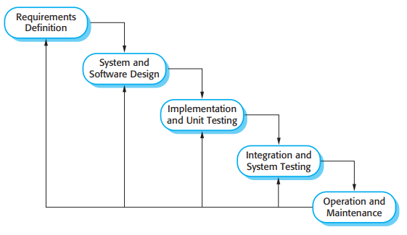 [1]
Good things about using it for our wallet app: Everything gets written down clearly, helping with legal and compliance paperwork. Fixed checkpoints track progress and spending. Works for stable parts like basic account setup. Easier for teams new to fintech.
Bad things about using it for our wallet app: Misunderstanding requirements at the start is extremely expensive to fix later. Customers see nothing until the whole app is done. Financial regulations and user expectations change regularly — Waterfall cannot adapt. All testing happens at the end, finding security holes very late.
Why it does not fit: The reason I do not think Waterfall suits a digital wallet is that financial technology moves too fast. New payment methods, changing regulations, and growing security threats require continuous adaptation that Waterfall simply cannot support. [7]
4.2 Incremental Building Method
The Incremental method cuts the whole app into smaller working pieces. Each piece delivers some actual features that users can start using, while the rest of the app keeps being built in the background. [8]
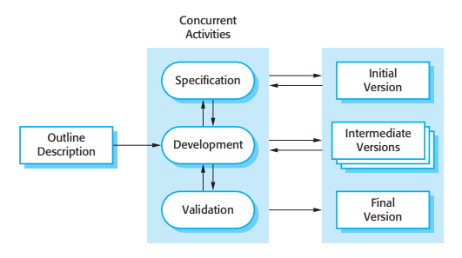[1]
Good things about using it for our wallet app: Core features like sending and receiving money can be released early. Real user feedback shapes later versions. Financial risk is lower through staged spending. Smaller pieces are easier to test for security. The team can shift focus between stages based on market feedback and can earn revenue from early releases.
Stage breakdown: Stage 1 (Months 1-4): KYC, wallet top-up, basic transfers, transaction history. Stage 2 (Months 5-8): Bill payments, QR codes, spending limits, notifications. Stage 3 (Months 9-12): Split bills, request money, digital card, budgeting tools. Stage 4 (Months 13-16): Business payments, loyalty rewards, advanced analytics.
Bad things about using it for our wallet app: Security must be perfect from Stage 1 — no room to fix it later with real money involved. Overall architecture needs very strong upfront planning. Consistent user experience across stages takes extra effort. Regulatory changes can force rework of earlier stages.
Why it somewhat fits: Incremental works reasonably well because it gets core payment features to users early and allows improvement based on real feedback. But the security demands of a financial app still require strong upfront planning. [9]
4.3 Spiral Method
The Spiral approach combines building the app multiple times in loops, where every loop includes carefully looking for and dealing with risks before moving forward. Each loop goes through four steps: Planning what to build, Analyzing what could go wrong, Actually building it, and Checking if it turned out right. [10]
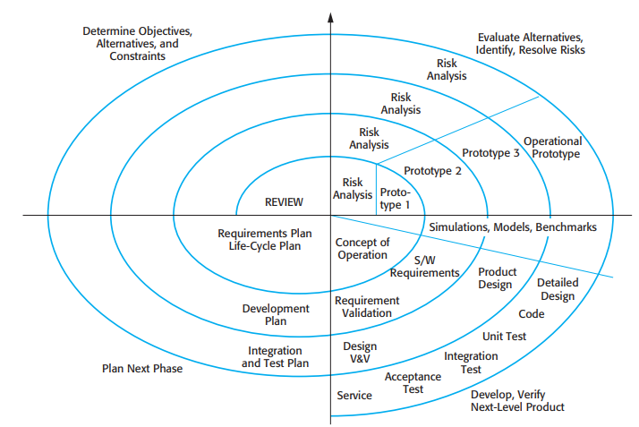[1]

Good things about using it for our wallet app:
- Every loop starts by asking "what could go wrong?" which is exactly the right question for an app handling real money
- Fraud risks, data breach risks, and regulatory risks get spotted and dealt with early instead of after launch
- Stakeholders get to review and give feedback after every loop, keeping the app aligned with business goals
- Building test versions first lets us prove that features like instant payments and biometric login will actually work before spending everything on them
- Very well suited for complex, high-risk projects where the cost of failure is high
Risks relevant to our digital wallet: Fraud (fake transactions, account takeovers), Regulatory (non-compliance with RBI, PCI-DSS, GDPR), Technical (payment gateway failures), Security (data breaches exposing bank details), Scalability (app crashing during peak traffic), and Trust (users losing confidence after any security incident). Each Spiral loop checks these risks and puts solutions in place before moving forward.
Bad things about using it for our wallet app:
- Needs team members who genuinely understand how to spot and evaluate financial risks
- Takes more time and costs more money than simpler straight-line methods
- Managing multiple loops requires a skilled and experienced project leader
- Can feel unnecessarily complex for simpler, low-risk features
Why it fits best:
The reason I believe the Spiral method is the right choice for our digital wallet is that the cost of getting something wrong is not just a bug — it is people losing their money or their personal data. The Spiral method's whole point is to make sure we find and fix risks before they become disasters. [11]
4.4 Summary Comparison
{Insert Comparison Table with headers: Criteria, Waterfall, Incremental, Spiral}
Comparison points:
- Flexibility: Not flexible (Waterfall), Somewhat flexible (Incremental), Very flexible (Spiral)
- Risk Handling: Poor (Waterfall), Moderate (Incremental), Excellent (Spiral)
- Security Focus: Weak (Waterfall), Moderate (Incremental), Strong (Spiral)
- Customer Feedback: Barely any (Waterfall), After each stage (Incremental), After every loop (Spiral)
- Speed to Launch: Slowest (Waterfall), Medium (Incremental), Medium-slow but safer (Spiral)
- Overall Cost: Cheapest (Waterfall), Medium (Incremental), Most expensive but lowest failure risk (Spiral)
- Documentation: Very thorough (Waterfall), Good per stage (Incremental), Very thorough (Spiral)
- Best Suited For: Stable low-risk projects (Waterfall), Staged delivery projects (Incremental), High-risk complex projects (Spiral)

5. FIGURING OUT WHAT THE APP NEEDS
5.1 How I Gathered Requirements
I collected requirements through: talking with potential users about how they currently handle payments, studying apps like Google Pay, Paytm, and Apple Pay, reviewing RBI and PCI-DSS guidelines, running workshops with business and compliance teams, writing user scenarios for key tasks, and analyzing common complaints about existing payment apps. [12]
5.2 WHAT THE APP MUST DO
FR1: User Accounts and Identity — Sign up with phone and email, KYC identity verification using government ID, biometric login (fingerprint or face ID), secure PIN reset, and profile management including linked bank accounts.
FR2: Wallet and Payments — Add money from bank or card, send money instantly via phone number or UPI ID, receive money, scan QR codes to pay at shops, and generate personal QR codes for receiving payments.
FR3: Bill Payments — Pay utility bills (electricity, water, gas), mobile recharges, broadband, streaming subscriptions, and insurance premiums directly from the wallet.
FR4: Transaction Management — Full history of all transactions with date, time, amount, and recipient, filter and search through records, download statements, and get instant notification for every transaction.
FR5: Security Features — Auto-lock after 3 failed logins, PIN or biometric confirmation before every payment, option to freeze wallet if fraud is suspected, and list of all devices that have logged in.
FR6: Budget Tools — Set monthly spending limits per category, view spending graphs, get alerts when approaching budget limit, and receive a monthly financial summary.
FR7: Admin Tools — Monitor transactions for fraud, block suspicious accounts, pull compliance reports, manage user complaints, and update rules when regulations change.
5.3 HOW WELL THE APP MUST WORK
Performance: Each transaction completes in under 3 seconds, the app handles 500,000 transactions per hour at peak times, pages load within 1.5 seconds, and payment success rate stays above 99.5%.
Security: All data encrypted using AES-256, communication uses TLS 1.3, passwords and PINs are hashed and never stored in plain text, protection against SQL injection and man-in-the-middle attacks, and every transaction is logged for auditing.
Availability: Online 99.99% of the time, automatic failover if a server fails, hourly backups, and full disaster recovery within 2 hours with no more than 15 minutes of data loss.
Scalability: Handles 10 million active users, automatically scales up during traffic spikes, and supports new payment methods without rebuilding the system.
Usability: No training needed for basic tasks, works in at least 5 Indian languages, meets accessibility standards for visually impaired users, and gives clear understandable error messages.
Compliance: Follows RBI guidelines, meets PCI-DSS standards for card data, complies with IT Act 2000 and PDPB for privacy, and keeps detailed audit logs for regulators.
6. HOW WE CHECK IF REQUIREMENTS ARE RIGHT
Making sure requirements are correct means confirming they actually match what everyone needs and can be realistically built. I will check using these methods: Formal reviews with users, developers, security experts, and compliance officers to find unclear or missing requirements. Prototypes of critical features like the payment flow and biometric login so real users can try them before full development begins. Test cases for every functional requirement covering normal use, edge cases like zero-balance payments, and error situations like network failure mid-transaction — if we cannot write a test for something, that requirement needs rewriting. Diagrams including Use Case, State, and Data Flow diagrams to confirm information moves correctly through the system. Clear acceptance conditions written for each requirement, for example: "When a user with enough balance sends money and confirms with PIN, the recipient receives it within 3 seconds and both users get a notification." Finally, four structured sign-off sessions across four weeks with customers, developers, security teams, and management. [13]
7. PROBLEMS WE MIGHT FACE WHILE CHECKING
Regulations Keep Changing: RBI and other financial rules update regularly, making previously valid requirements outdated. Solution: Assign a compliance officer to track changes and flag affected requirements immediately.
Security Cannot Be Fully Predicted: New hacking methods appear constantly. Solution: Run regular penetration tests and treat security as an ongoing process rather than a one-time check.
Users Cannot Imagine Unseen Features: Users struggle to describe features they have never seen before. Solution: Show prototypes and competitor apps to get more specific, useful feedback.
Speed Versus Safety Conflicts: The business side wants fast launches; the security team needs more time. Solution: Set a firm rule that no payment feature launches without complete security sign-off.
Testing at Scale Is Difficult: Simulating 500,000 simultaneous users is genuinely hard. Solution: Use cloud-based load testing tools to validate performance requirements before launch.
8. DISCUSSION AND MY RECOMMENDATION
After thinking everything through, I am confident the Spiral Method is the right choice for building the Digital Wallet Application, and here is why I feel this way.
A digital wallet is not a regular app. If a social media app crashes, users get annoyed. If a digital wallet fails, people lose real money or have their bank details stolen. The stakes are much higher, and that is exactly why the Spiral method's core focus on finding and fixing risks at every single step makes it the only truly safe choice .
Financial regulations also keep changing. UPI rules, data protection laws, and RBI compliance requirements keep evolving. The evaluation phase at the end of each Spiral loop means we review and adjust to new rules before they become a problem. Features like AI fraud detection and biometric authentication are also technically complex — building early test versions in the first loops proves they will actually work before spending the full budget on them.
My Spiral plan: Loop 1 (Months 1-3) proves core payment architecture and passes security audits. Loop 2 (Months 4-7) builds the full payment and transfer system with load testing. Loop 3 (Months 8-12) adds bill payments, budgeting, and fraud detection. Loop 4 (Months 13-18) adds business payments, advanced analytics, and regulatory certification.
9. CONCLUSION
After studying all three approaches for a Digital Wallet Application, the most important thing I learned is that the right development method can genuinely be the difference between success and an expensive failure.
Waterfall is too rigid for something as fast-changing and high-risk as a fintech app. Incremental building improves things with staged delivery and earlier user feedback, but it does not have a strong enough built-in process for managing serious security and regulatory risks that come with handling real money.
The Spiral method is clearly the best choice because it treats risk management not as an afterthought but as the main force behind every decision. For an app where one security breach could permanently destroy user trust and bring heavy legal penalties, this risk-first mindset is not optional — it is essential.
Key learnings: When failure costs are high, the method must have strong risk management built in. Financial app requirements need legal and security experts, not just developers. Checking requirements must happen continuously, not just once. Getting real users involved through prototypes from the very beginning leads to a much better final product.
Final recommendation: Build the Digital Wallet Application using the Spiral method, with each loop driven by identifying and eliminating the biggest risks first.
10. REFERENCES
[1] I. Sommerville, "Software Engineering," 10th ed., Pearson Education, 2015.
[2] R. S. Pressman and B. R. Maxim, "Software Engineering: A Practitioner's Approach," 8th ed., McGraw-Hill Education, 2014.
[3] D. W. Arner, J. Barberis, and R. P. Buckley, "The Evolution of Fintech: A New Post-Crisis Paradigm?" Georgetown Journal of International Law, vol. 47, no. 4, pp. 1271-1319, 2016.
[4] The Standish Group, "CHAOS Report 2020: Beyond Infinity," The Standish Group International, 2020.
[5] S. Srinivas, V. S. Rajput, and P. Agarwal, "Digital Payment Systems: Opportunities and Challenges," International Journal of Advanced Research in Computer Science, vol. 8, no. 5, pp. 315-319, 2017.
[6] W. W. Royce, "Managing the Development of Large Software Systems," Proceedings of IEEE WESCON, vol. 26, no. 8, pp. 1-9, 1970.
[7] B. W. Boehm, "A Spiral Model of Software Development and Enhancement," IEEE Computer, vol. 21, no. 5, pp. 61-72, May 1988.
[8] C. Larman and V. R. Basili, "Iterative and Incremental Development: A Brief History," IEEE Computer, vol. 36, no. 6, pp. 47-56, June 2003.
[9] K. Beck et al., "Manifesto for Agile Software Development," Agile Alliance, 2001.
[10] B. W. Boehm, "Software Risk Management: Principles and Practices," IEEE Software, vol. 8, no. 1, pp. 32-41, Jan. 1991.
[11] P. Kruchten, "The Rational Unified Process: An Introduction," 3rd ed., Addison-Wesley Professional, 2003.
[12] K. Pohl, "Requirements Engineering: Fundamentals, Principles, and Techniques," Springer Publishing Company, 2010.
[13] IEEE Computer Society, "IEEE Recommended Practice for Software Requirements Specifications," IEEE Std 830-1998, 1998.
[14] A. van Lamsweerde, "Requirements Engineering: From System Goals to UML Models to Software Specifications," John Wiley & Sons, 2009.
DECLARATION OF ACADEMIC INTEGRITY
I hereby declare that this assignment is my original work and has not been copied or plagiarized from any source. All references and resources used have been properly cited. I understand that any form of academic dishonesty will result in severe consequences including but not limited to forfeiting my marks for this assignment.
Student Name: Abhinav Acharya
USN: NNM24IS006
Date: 16-02-2026
Signature:


