1. pwd: The pwd (print working directory) command displays the name of the current working directory. This is a basic Linux command.

Eg.

> pwd

/home

> cd /home/Dev/www

Screenshot:

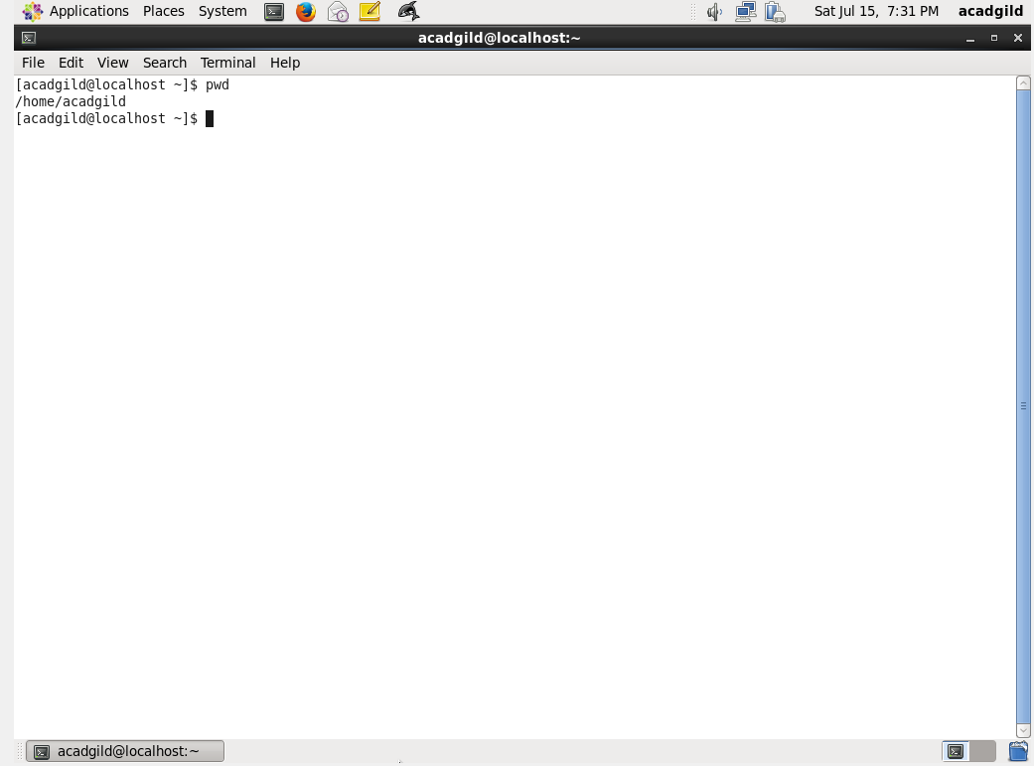

2. vi

vi, pronounced by using each letter (vee-aye), is a widely-used and popular UNIX-based text editor.

Like most UNIX system interfaces and other text editors, it lets you control the system by using the keyboard rather than a combination of mouse selections and keystrokes.

The succinctness of the interface makes it highly useful for people who work at a computer all day, especially programmers entering or manipulating language statements.

3. touch

The touch command lets you change file timestamps (the access and modification times). When name of a non-existent file is passed as an argument, that file gets created.

***touch****[file-name]*

eg. touch testfiles123.txt

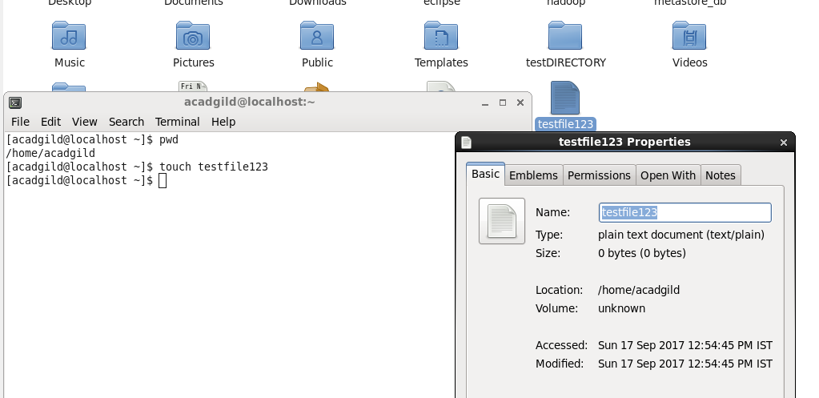

4. mkdir

Short for "make directory". mkdir is used to create directories on a file system.

If the specified DIRECTORY does not already exist, mkdir creates it.

More than one DIRECTORY may be specified when calling mkdir.

Syntax: mkdir testDIRECTORY

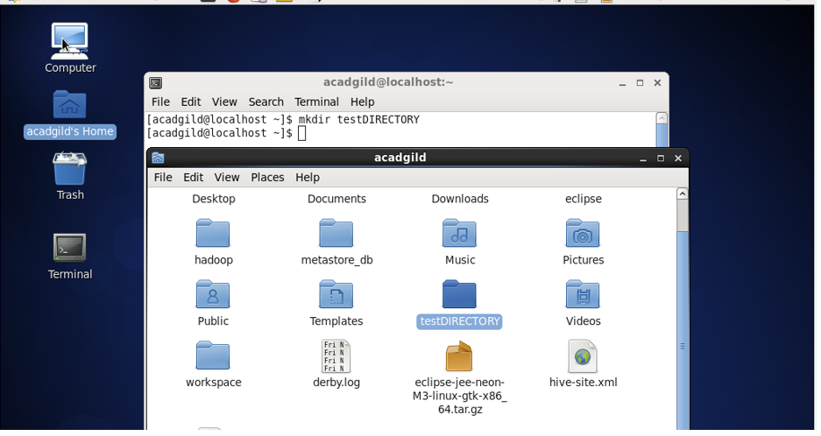

5. rm

The rm command removes (deletes) files or directories.

rm removes each specified FILE. By default, it does not remove directories;

The removal process unlinks a file name in a filesystem from data on the storage device, and marks that space as usable by future writes. In other words, removing files increases the amount of available space on your disk.

The data itself is not destroyed, but after being unlinked, it becomes inaccessible. The effects of an rm operation cannot be undone.

Syntax: rm FILEname

Eg. rm testfile123

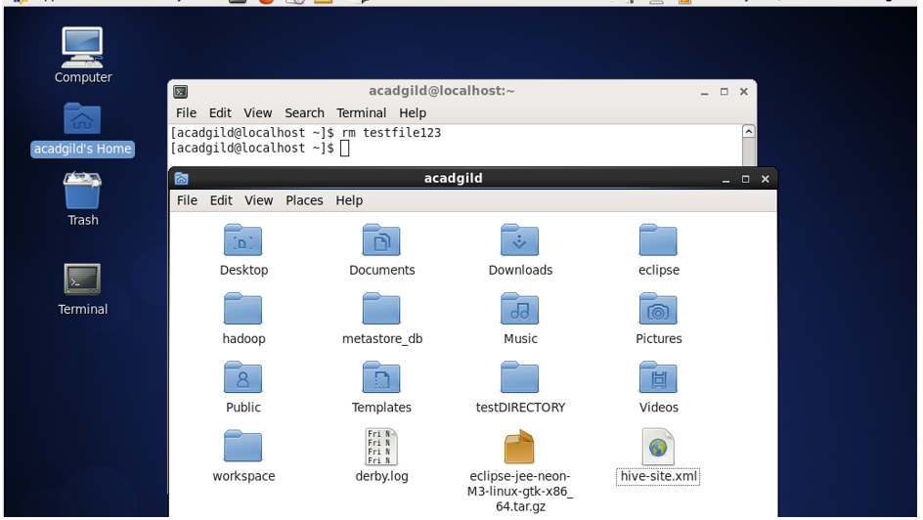

6. ls

Lists the contents of a directory.

syntax: ls [FILE]

eg. ls testDIRECTORY

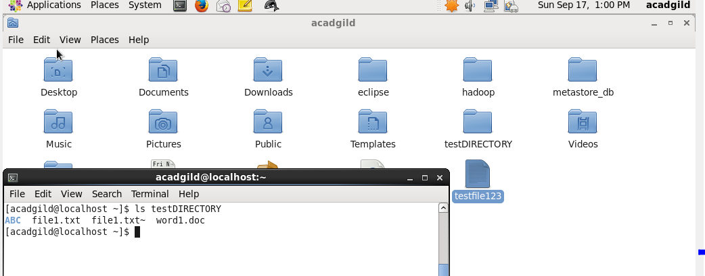

7. echo

echo displays a line of text.

echo is a fundamental command found in most operating systems that offer a command line. It is frequently used in scripts, batch files, and as part of individual commands; anywhere you may need to insert text.

echo syntax

echo [SHORT-OPTION] [STRING]

echo LONG-OPTION

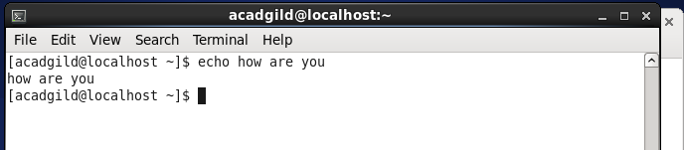

8. cat

cat stands for "catenate." It reads data from files, and outputs their contents. It is the simplest way to display the contents of a file at the command line.

cat is one of the most commonly-used commands in Linux. It can be used to:

a. Display text files

b. Copy text files into a new document

c. Append the contents of a text file to the end of another text file, combining them

cat mytext.txt

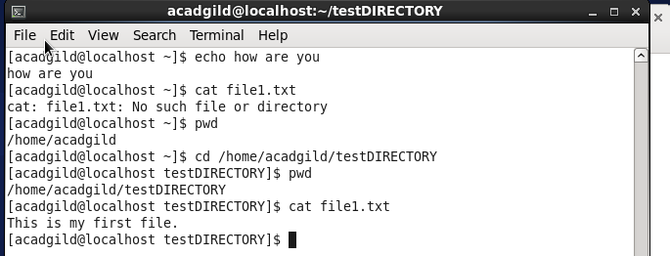

9. who

The who command prints information about all users who are currently logged in.

Syntax: who

Eg. who

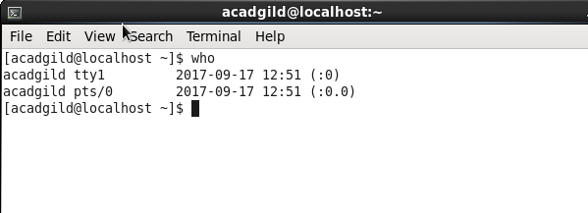

10.cd

The cd command, which stands for "change directory", changes the shell's current working directory.

It can be used to move around within the hierarchy of your file system.

cd directory

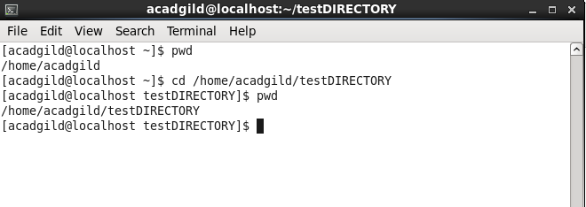

11.date

The date command is used to print out, or change the value of, the system's time and date information.

date

date [OPTION]... [+FORMAT]

date [-u|--utc|--universal] [MMDDhhmm[[CC]YY][.ss]]

eg.

date

date -s "09/17/2017 16:48:00"

Sep 17, 2017, 16:48 PM.

date "+DATE: %m/%d/%y%nTIME: %H:%M:%S"

DATE: 07/16/01

TIME: 16:44:55

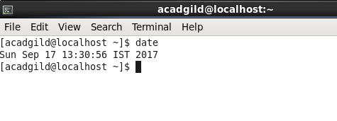

12.cal

The cal command is used to print the calendar of the system's date.

Syntax: cal

Eg.

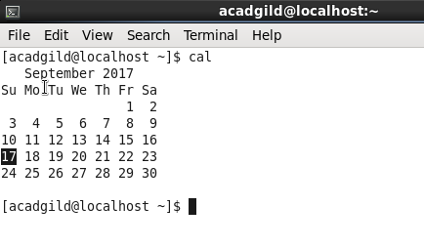

13.mv

Usage: hadoop fs -mv URI [URI …] <dest>

Moves files from source to destination. This command allows multiple sources as well in

which case the destination needs to be a directory. Moving files across filesystems is not

permitted.

Example:

• hadoop fs -mv /user/hadoop/file1 /user/hadoop/file2

• hadoop fs -mv hdfs://nn.example.com/file1 hdfs://nn.example.com/file2

hdfs://nn.example.com/file3 hdfs://nn.example.com/dir1

14.cp

Usage: hadoop fs -cp URI [URI …] <dest>

Copy files from source to destination. This command allows multiple sources as well in

which case the destination must be a directory.

Example:

• hadoop fs -cp /user/hadoop/file1 /user/hadoop/file2

• hadoop fs -cp /user/hadoop/file1 /user/hadoop/file2 /user/hadoop/dir

Exit Code:

Returns 0 on success and -1 on error.

15.which

Command used to locate the executable file associated with a given command.

It returns the pathnames of the files (or links) which would be executed in the current environment, had the filename (or filenames) been given as a command (or commands) in a strictly POSIX-conformant shell. It does this by searching the paths in the PATH environment variable for executable files matching the names of the arguments.

which does not follow symbolic links.

Syntax:

which -a [filename]

examples:

which sh

Locates the pathname of the file which would be run if the sh command were executed. On most systems, this will output:

/bin/sh