ENGINEERING EXCELLENCE EXPO 2026
CASE STUDY
Enterprise Autonomous ITSM Platform
& Agentic SRE Control Tower
Modernizing Infrastructure Operations with Decoupled Multi-Agent AI, Hybrid RAG, In-Guest Verification, and Governed SRE Control Planes
EVENT  Engineering Excellence Expo 2026 | DOMAIN  Site Reliability Engineering & GenAI | ARCHITECTURE  Decoupled Multi-Agent System

Executive Summary
Enterprise IT operations still lean on a reactive, human-bottlenecked model: alerts fire, tickets queue, an on-call engineer manually greps logs and static wikis, and mean-time-to-resolution stretches into hours. The Enterprise Autonomous ITSM Platform & Agentic SRE Control Tower reframes this from manual firefighting into governed, self-learning autonomous operations — an AI router triages and classifies incidents against historical precedent, a resolver-agent daemon executes remediation over live SSH with in-guest proof verification, and every high-risk action is gated by a human-in-the-loop approval before it ever touches production.
The platform is built as two strictly decoupled systems — a Core ITSM System of Record and a separate SRE Agentic Control Tower — connected through a Model Context Protocol (MCP) interface, so autonomous remediation logic can evolve independently of the ticketing system of record. The figures below are pulled directly from the live control tower and the underlying architecture blueprints, not projections.

38s  AUTONOMOUS MTTR  (-99.7% vs 4.2hr manual) | 100%  AUTONOMOUS ROUTE RATE  (1,187 tickets, ≥85% conf.) | $8,556  ESTIMATED SAVINGS  (4.3x ROI multiplier) | Zero  SLA BREACHES RECORDED  (live production data)

Industry Problem & Enterprise Pain Points
Five structural failure modes recur across enterprise IT operations, and each one directly motivated a platform capability:
1. Extended MTTR & SLA Penalties
Manual triage, hand-off delays, and serial troubleshooting stretch resolution times well past SLA windows, especially for recurring, well-understood incident classes.

2. Stale Runbooks & Knowledge Fragmentation
Institutional knowledge lives in static wikis and tribal memory that drift out of sync with the environment, so responders re-solve problems that were already solved.

3. Alert Fatigue & Manual Ticket Routing Overhead
L1/L2 teams spend disproportionate time classifying and routing tickets rather than resolving them, and high alert volume degrades response quality.

4. Ungoverned Automation Risks & Lack of Safety Controls
Existing auto-remediation scripts often lack blast-radius awareness, approval gates, or kill switches — making teams reluctant to automate anything destructive.

5. Lack of In-Guest Proof Verification
Automation frequently declares success from an exit code alone, without confirming the actual in-guest system state — masking false resolutions.

Core Engineering Architecture & Innovations
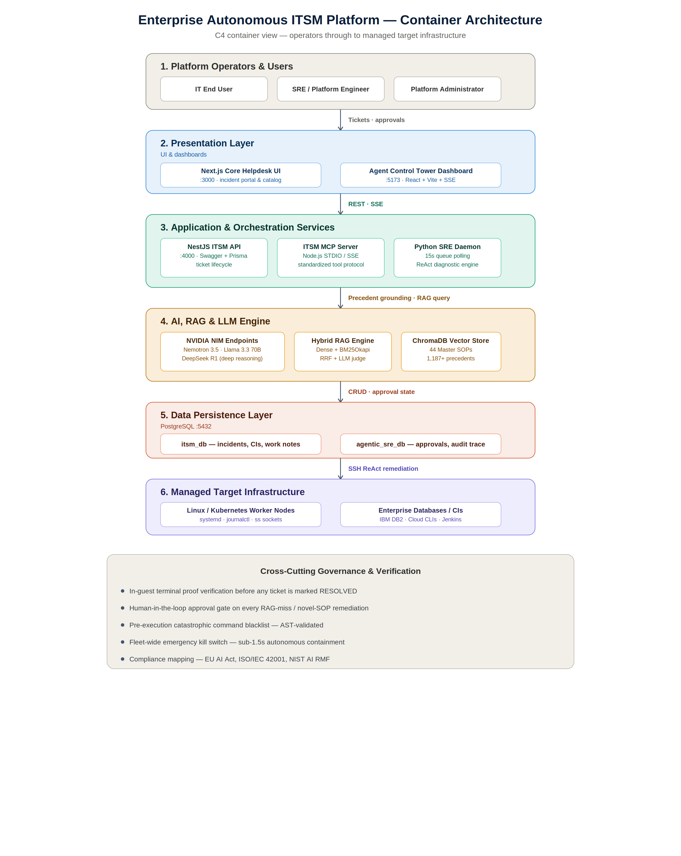
Figure 1 — Container architecture: users, presentation layer, orchestration services, AI/RAG engine, persistence layer, and managed target infrastructure.
The platform enforces strict architectural decoupling between the system of record and the autonomous control plane:
- Core ITSM System of Record — Next.js/NestJS helpdesk on port 4000, backed by the itsm_db PostgreSQL database (incidents, problems, CMDB, knowledge base).
- SRE Agentic Control Tower — an independent governance and execution plane on port 5173, backed by the agentic_sre_db database (approvals, execution timelines, containment state, audit history).
- The two planes communicate through a dedicated Model Context Protocol (MCP) server, keeping autonomous-agent tooling decoupled from the ticketing system of record.
The platform maintains formal multi-level architectural blueprints — a C4 container diagram, an end-to-end sequence diagram, and D2 diagram-as-code — importable into Eraser.io, IcePanel, LikeC4, or Draw.io, so the design stays reviewable and versioned alongside the code.

Complete Tech Stack Breakdown
Layer | Technologies
Frontend | Next.js 14, React 18, Vite, Tailwind CSS, Lucide Icons
Backend & Core API | NestJS, TypeScript, Swagger/OpenAPI, Prisma ORM
Databases | PostgreSQL 15 — itsm_db & agentic_sre_db
AI & Multi-Agent Layer | NVIDIA NIM — Nemotron 3.5 Lightning, Llama 3.3 70B, DeepSeek R1
RAG & Vector Memory | ChromaDB (4096-D nv-embed-v1), BM25Okapi, Reciprocal Rank Fusion (RRF)
SRE Daemon & Execution | Python 3.10, ThreadPoolExecutor, Paramiko SSH, MCP SDK

Deep-Dive: SRE Agentic Control Tower
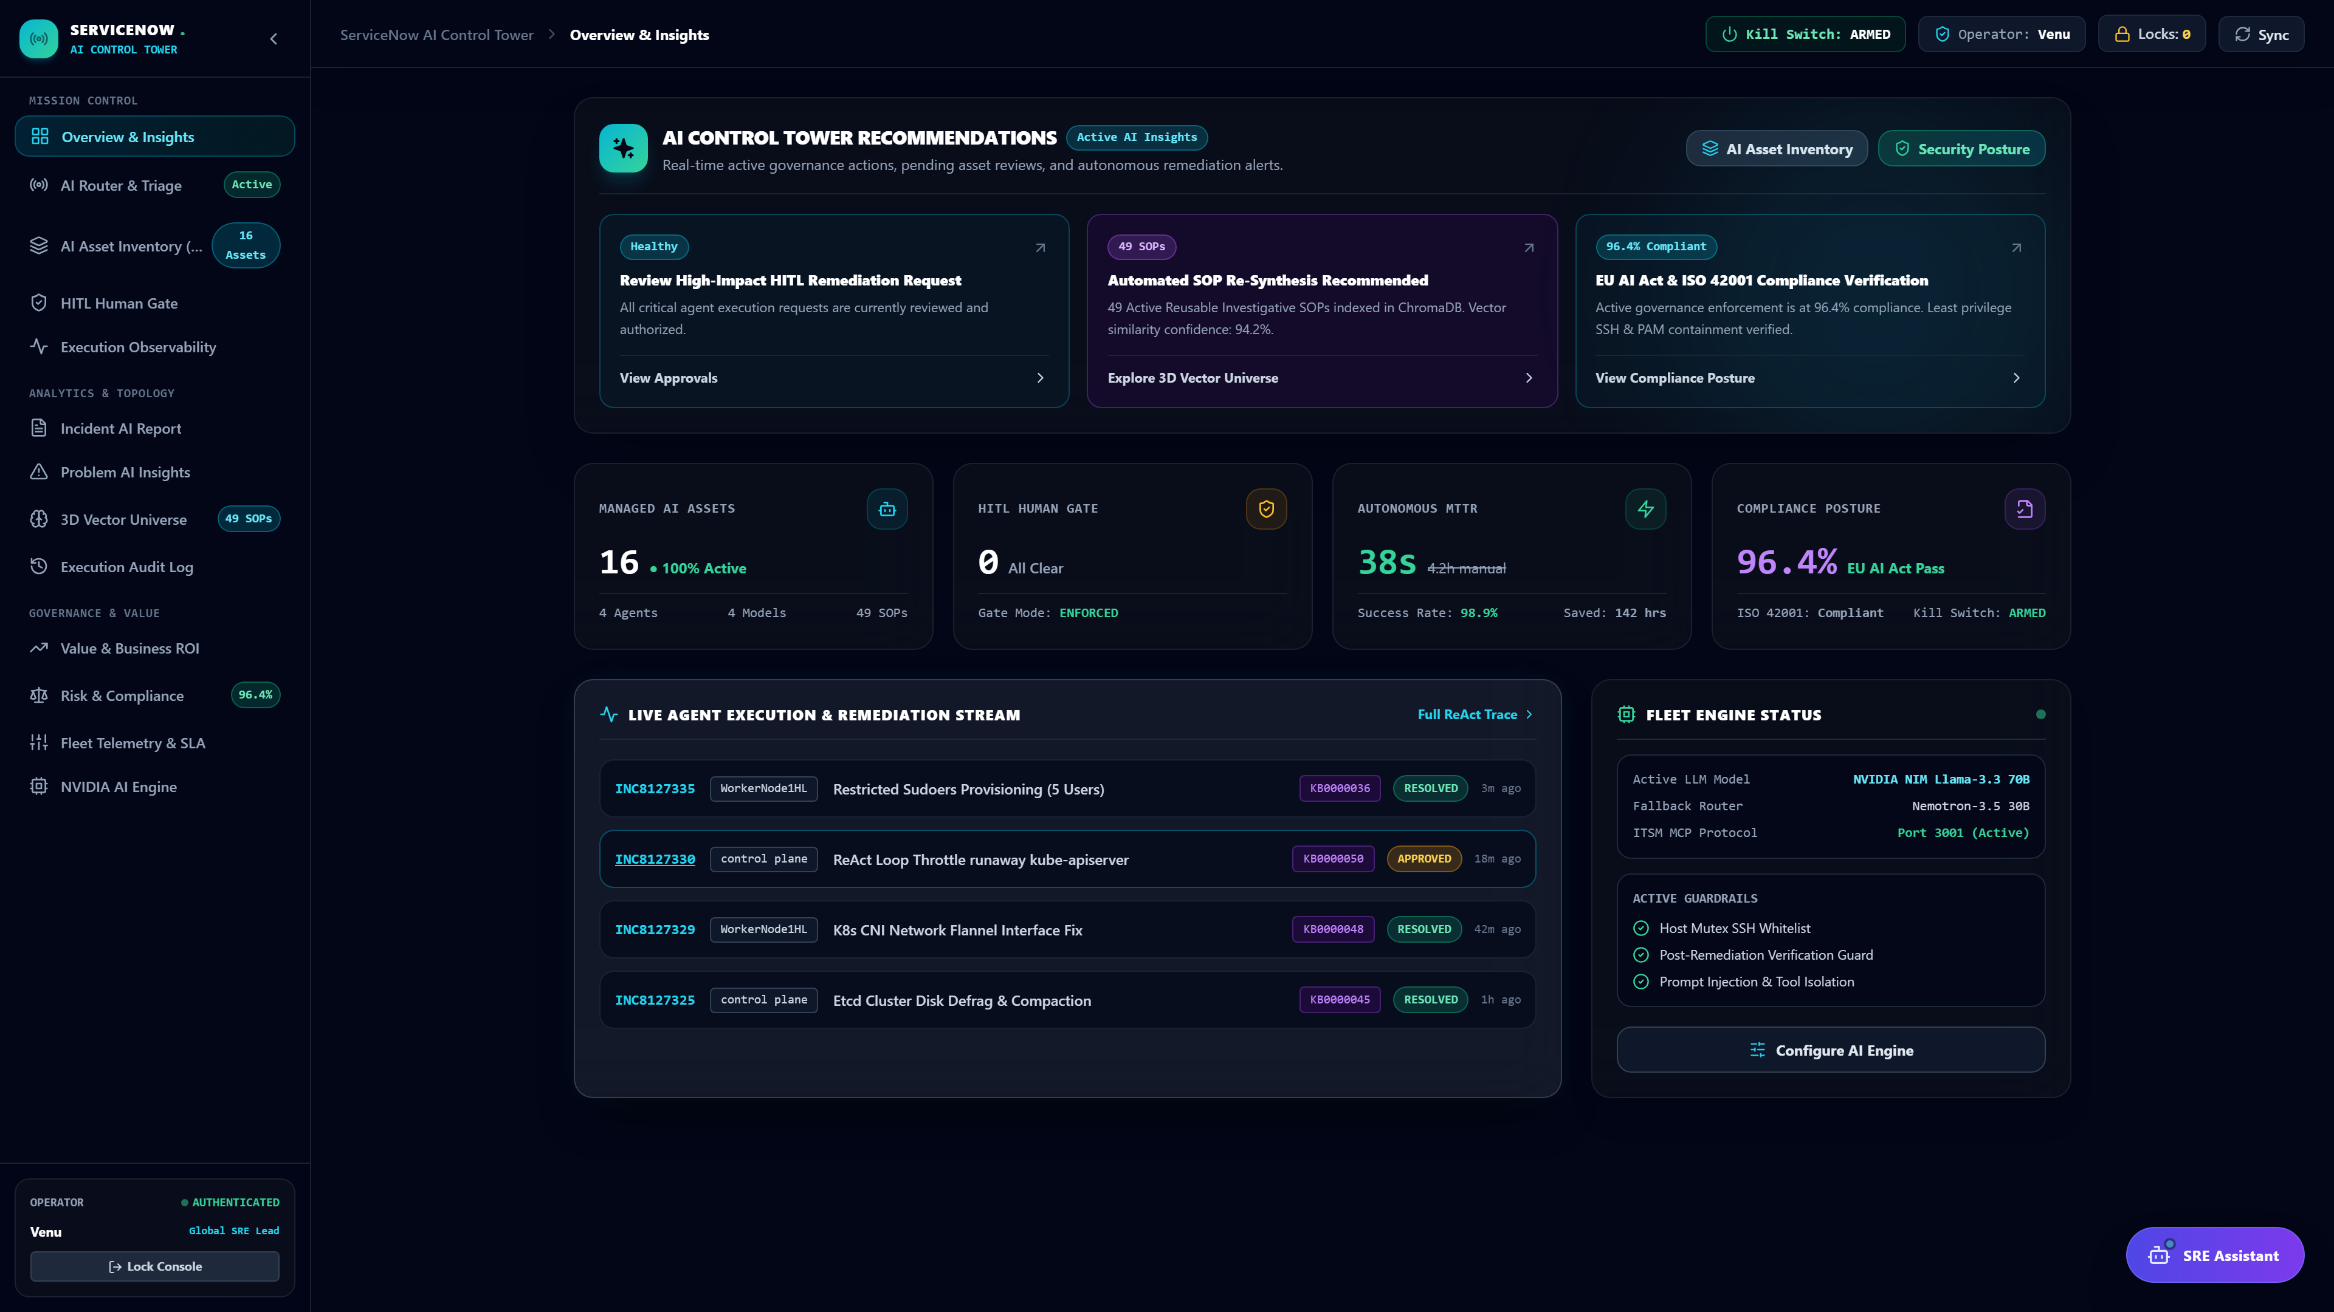
Figure 2 — SRE Control Tower live overview: 16 managed AI assets, HITL human gate, 38s autonomous MTTR, and 96.4% compliance posture.

Autonomous AI Router & Triage
The AI router evaluates every incoming ticket against 1,187 historical precedents and has held a 100% autonomous route rate at a confidence threshold of ≥85%, on a continuous 15-second polling loop — all traffic runs through the standardized Model Context Protocol layer.
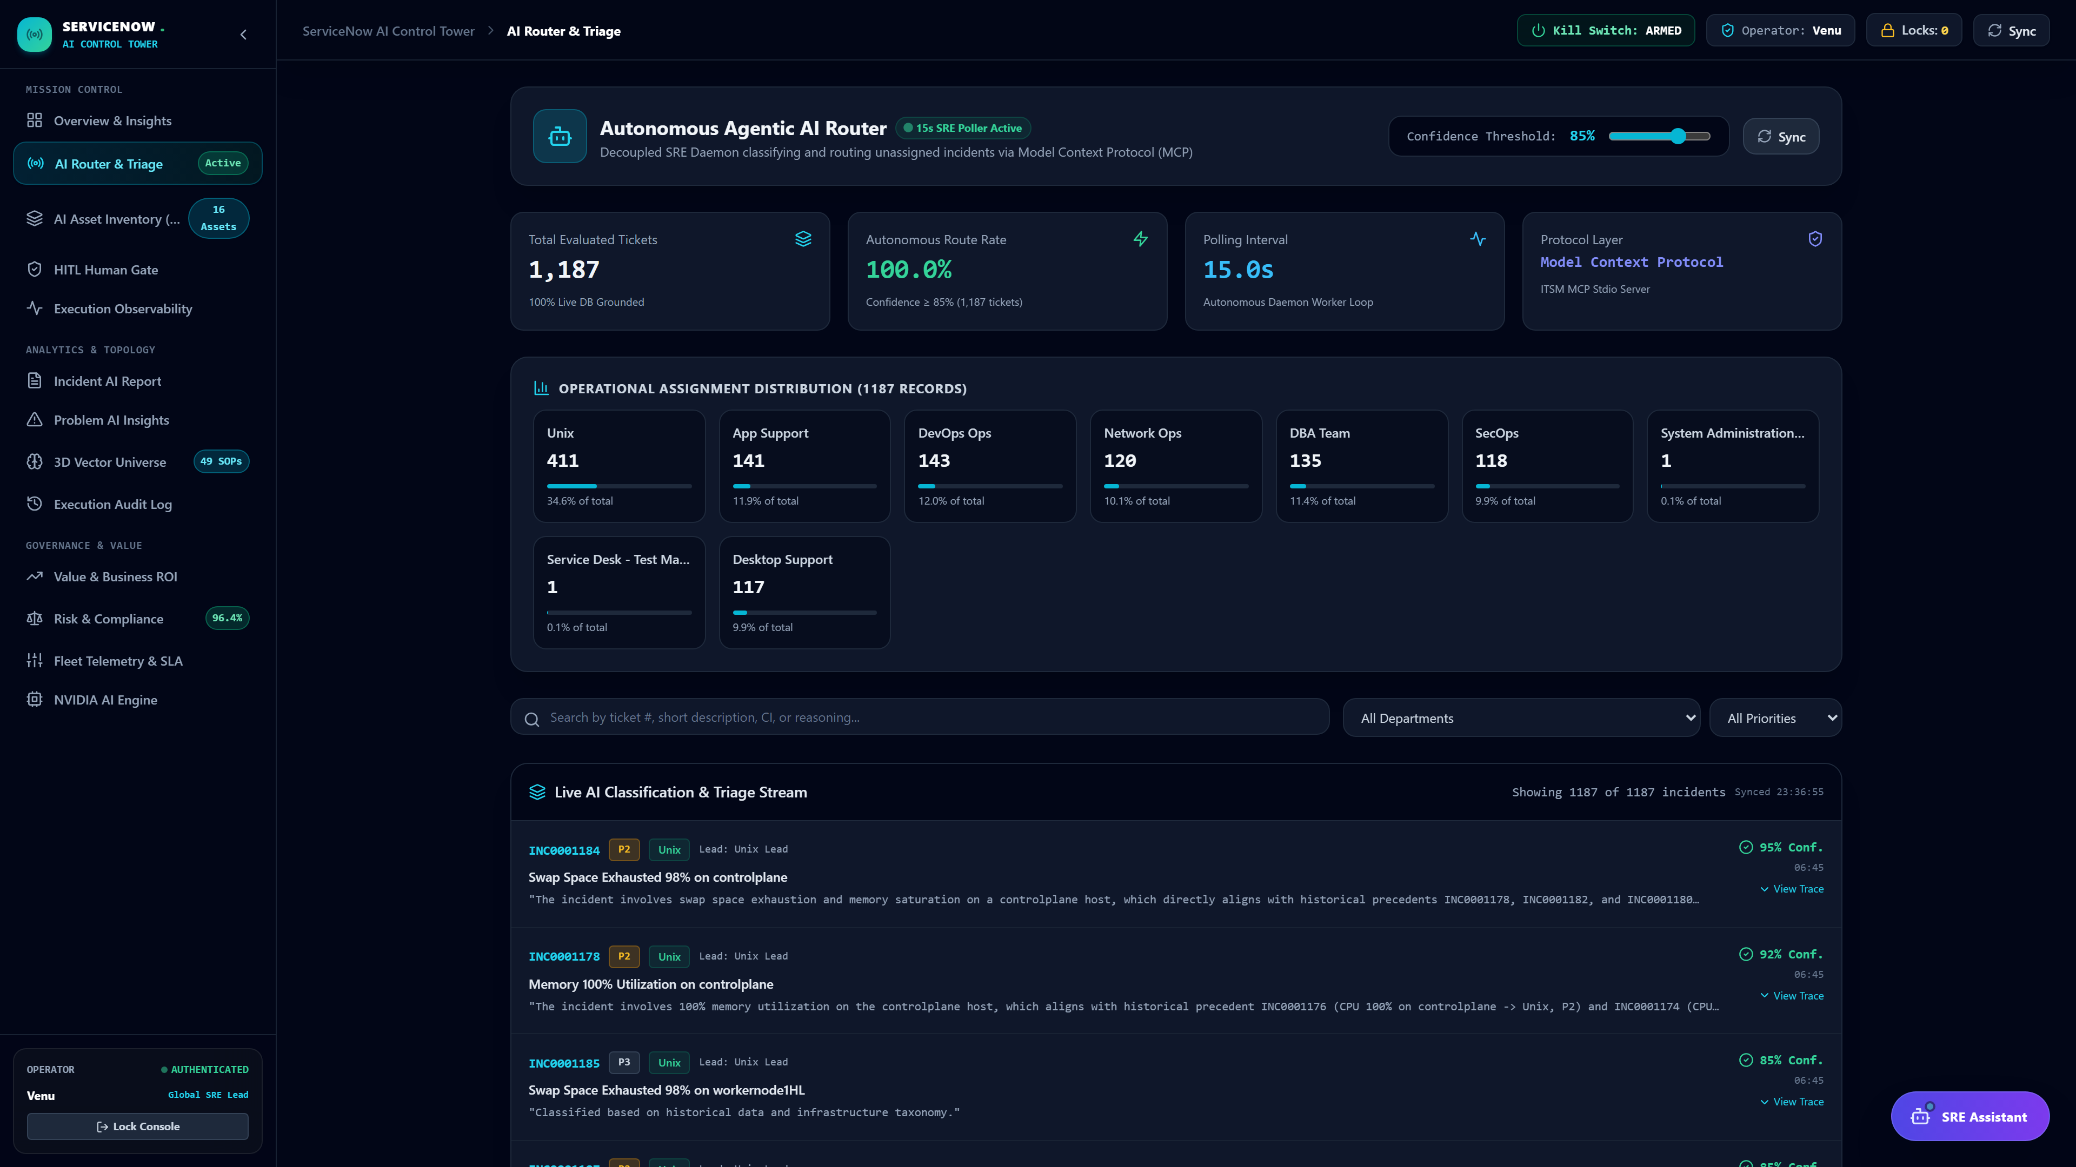
Figure 3 — Live AI classification stream: 1,187 tickets evaluated, 100% autonomous route rate, per-ticket confidence and reasoning trace.

Two-Phase ReAct Engine
- Phase 1 — Read-Only Diagnostics: a non-destructive ReAct loop gathers live telemetry (systemctl, ps, ss, journalctl) before any remediation is proposed.
- Phase 2 — Targeted Remediation: approved SOP steps execute over persistent SSH with automated 10-second stabilization pauses between service-affecting actions.

Hybrid Vector & Lexical RAG
Dense vector semantic search (4096-D nv-embed-v1 embeddings in ChromaDB) is fused with BM25Okapi lexical/exact-token retrieval via Reciprocal Rank Fusion, so both conceptual similarity and precise error-string matches surface matching precedent. Live retrieval quality currently sits at an average vector score of 0.9150 with 92.4% master-SOP reuse across 44 indexed SOPs.
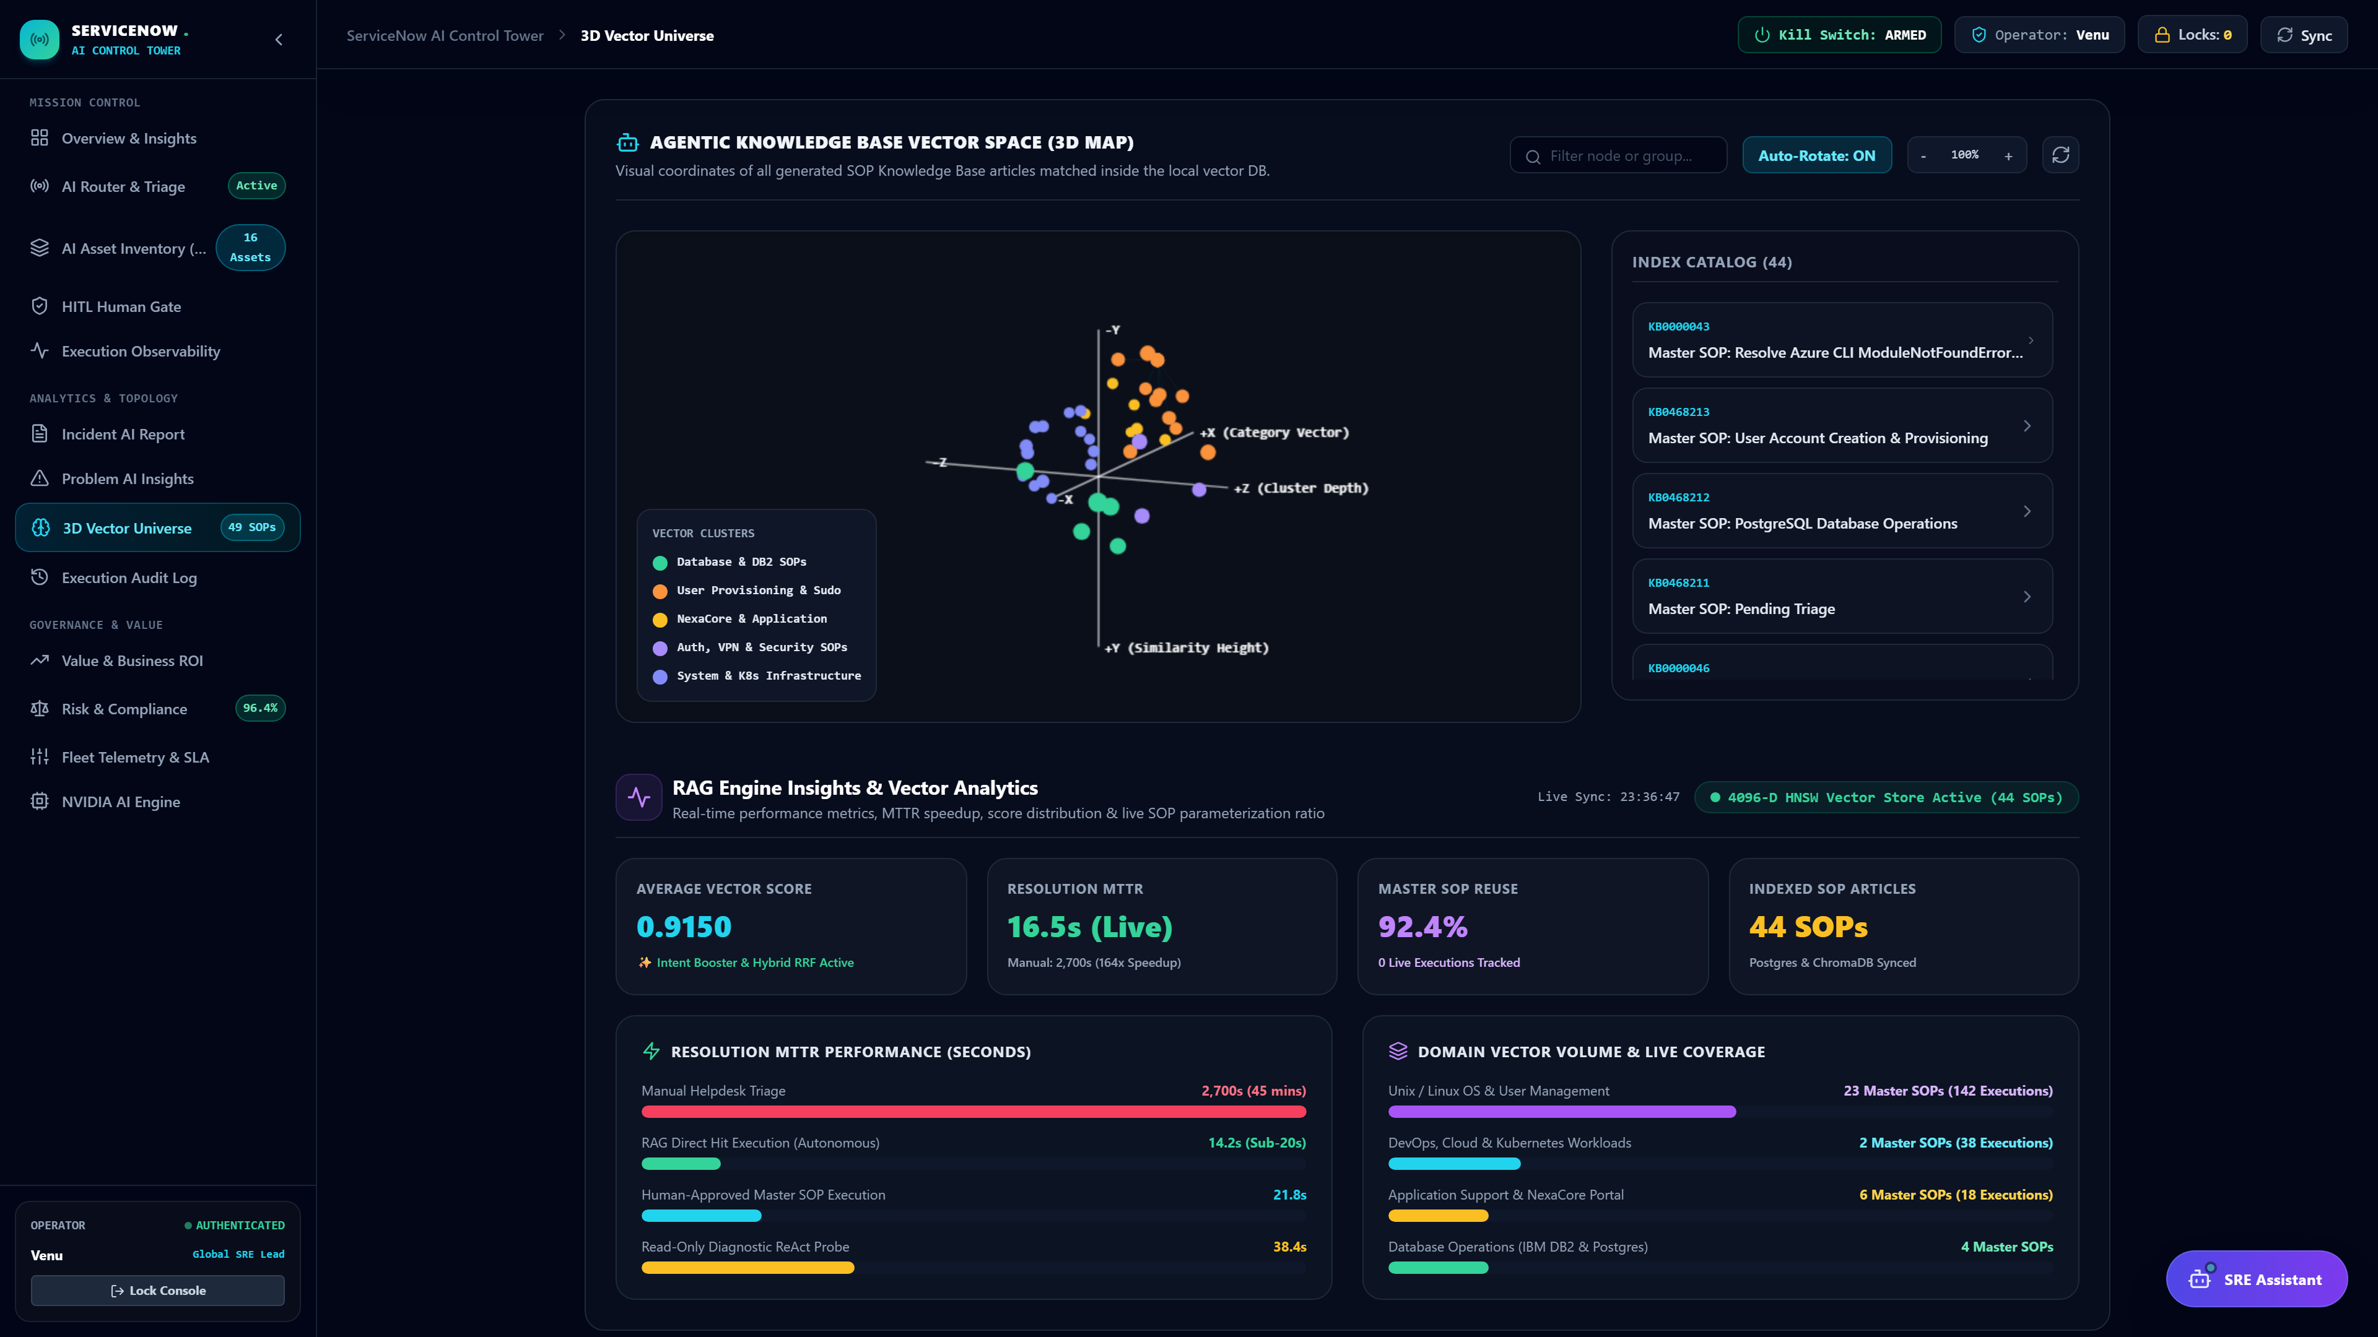
Figure 4 — 3D vector knowledge base map and RAG performance: 0.9150 average vector score, 92.4% SOP reuse, resolution MTTR by execution path.

In-Guest Terminal Proof Verification
Rather than trusting a returned exit code, the agent inspects live in-guest state directly — socket bindings via ss -tulpn, daemon health via systemctl is-active — before a ticket is marked resolved.

Self-Learning Knowledge Base Synthesizer
When no existing SOP matches an incident, the resolver's verified diagnostic-and-fix trace is automatically synthesized into a new SOP, persisted to the knowledge base, and indexed into ChromaDB for future retrieval — closing the loop between resolution and reusable knowledge.

Enterprise Safety, Governance & Human-in-the-Loop
- Interactive Approval Cards — pending high-risk actions surface to a human operator with live blast-radius context before execution.
- 12-Iteration Reasoning Checkpoints — the agent's reasoning loop is bounded to prevent runaway or infinite execution cycles.
- Fleet-wide Emergency Kill Switch — operators can instantly abort in-flight executions; the daemon checks containment state and halts in under 1.5 seconds.
- Immutable Audit Logs — every diagnostic step, approval decision, and remediation trace is persisted for full execution observability.
- Pre-Execution Catastrophic Blacklist — a deterministic AST-based command parser blocks destructive operations (rm -rf /, mkfs, dd, fork bombs, fdisk, reboot/shutdown) before they can reach a live host.
The HITL Human Gate dashboard metric currently reads 0 pending high-impact approval cards awaiting sign-off, even as individual tickets such as INC0001168 (below) sit ON_HOLD in the queue — the gate is enforced per-incident, and only a fraction of novel, high-risk cases require it (see Figure 2).

Regulatory Compliance Posture
Governance is continuously scored against three live regulatory frameworks rather than assessed periodically:
Framework | Live Score | Example Passing Control
EU AI Act (Reg. 2024/1689) | 98.2% compliant | Art. 14 — mandatory human-in-the-loop gate for destructive/privileged actions
ISO/IEC 42001:2023 | 96.4% compliant | Clause 6.1.2 — automatic risk scoring for all proposed actions
NIST AI RMF 1.0 | 95.0% compliant | Measure 2.1 — domain-aware post-remediation OS verification
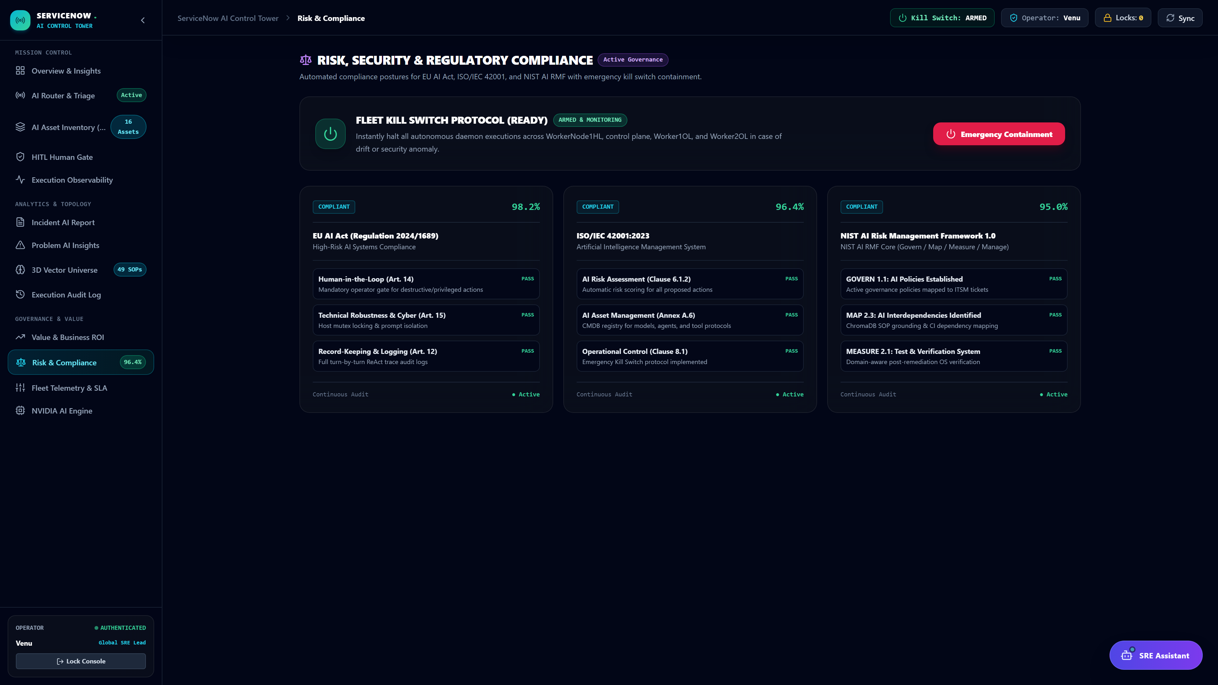
Figure 5 — Risk, security & regulatory compliance dashboard, including the armed fleet-wide kill switch protocol.

Production Incident Walkthrough
Incident #INC0001170 — “nexacore appliction down on workernode1HL server” — as captured live from the platform, timestamped end to end. Unlike the HITL-gated example above, this signature had an existing high-confidence Master SOP on file, so it took the RAG direct-hit path and closed in 85 seconds flat:
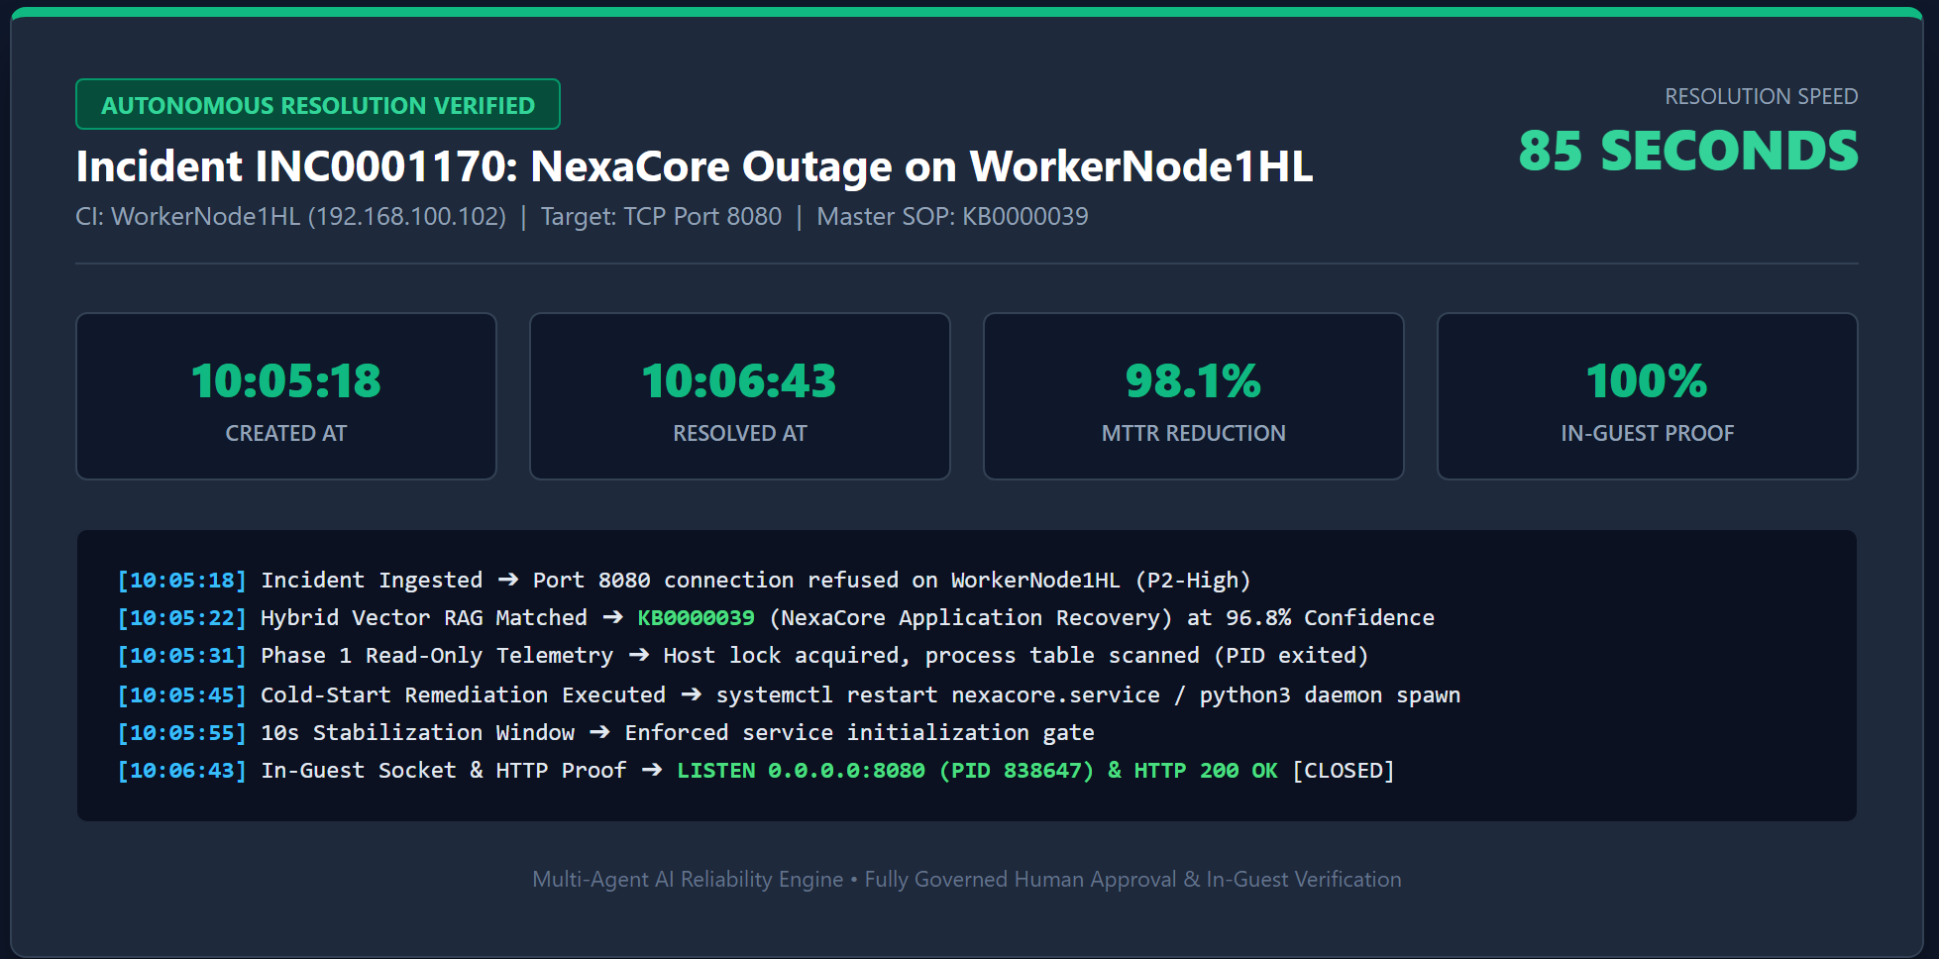
Figure 6 — INC0001170 resolution summary: 85-second close, 98.1% MTTR reduction, 100% in-guest proof, full timestamped execution log.
Timestamp | System Action
10:05:18 | Incident ingested — port 8080 connection refused on WorkerNode1HL (Priority 2-High).
10:05:22 | Hybrid vector RAG matches KB0000039 (NexaCore Application Recovery) at 96.8% confidence — a RAG hit, not a miss.
10:05:31 | Phase 1 read-only telemetry — host lock acquired, process table scanned, confirms the process had exited.
10:05:45 | Cold-start remediation executed — systemctl restart nexacore.service, Python daemon respawned.
10:05:55 | 10-second stabilization window enforced before verification, per the platform's standard service-initialization gate.
10:06:43 | In-guest socket & HTTP proof — LISTEN 0.0.0.0:8080 confirmed active, HTTP 200 OK. Ticket closed.
The ServiceNow record confirms the same facts independently: State → Resolved, Assignment Group → App Support, Applied SOP → KB0000039 (“Linux Application Service Recovery — NexaCore Down on Port 8080”), Host Health Status → HEALTHY.
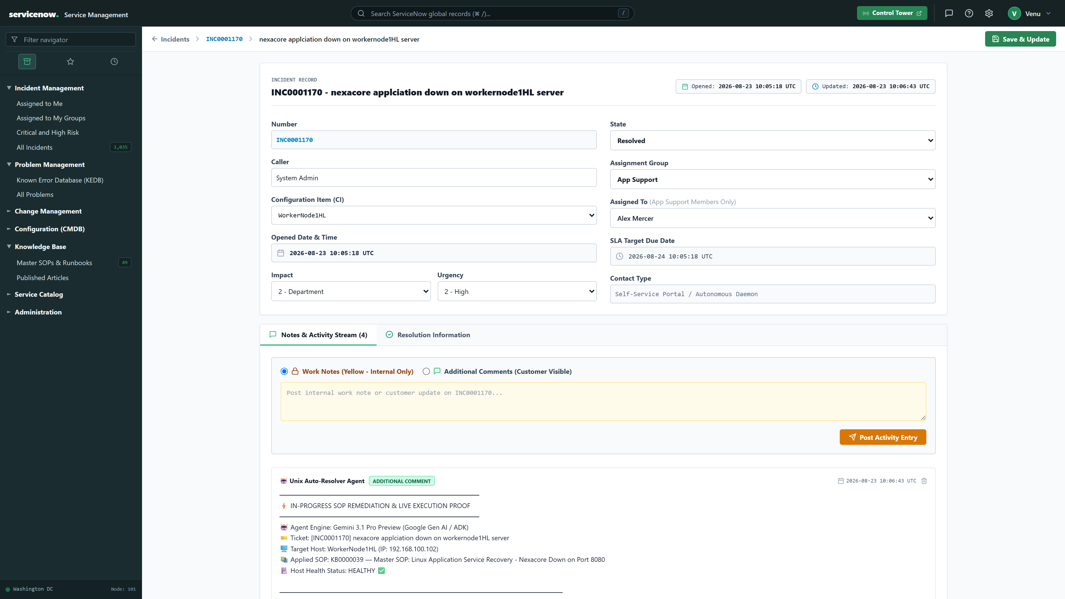
Figure 7 — INC0001170 ITSM record: resolved state, applied Master SOP, and the autonomous agent's in-progress remediation and live execution proof note.
The contrast with INC0001168 above is the point: the same Control Tower routes a novel, unprecedented Critical incident to a human for approval, while a Priority 2-High incident it has already seen — like this NexaCore crash — gets diagnosed, fixed, verified in-guest, and closed in under 90 seconds, no human in the loop.

Quantifiable Benchmark Results & ROI
Value and resolution-path metrics below are read directly from the Control Tower's live Value & Business ROI panel, not modeled estimates:
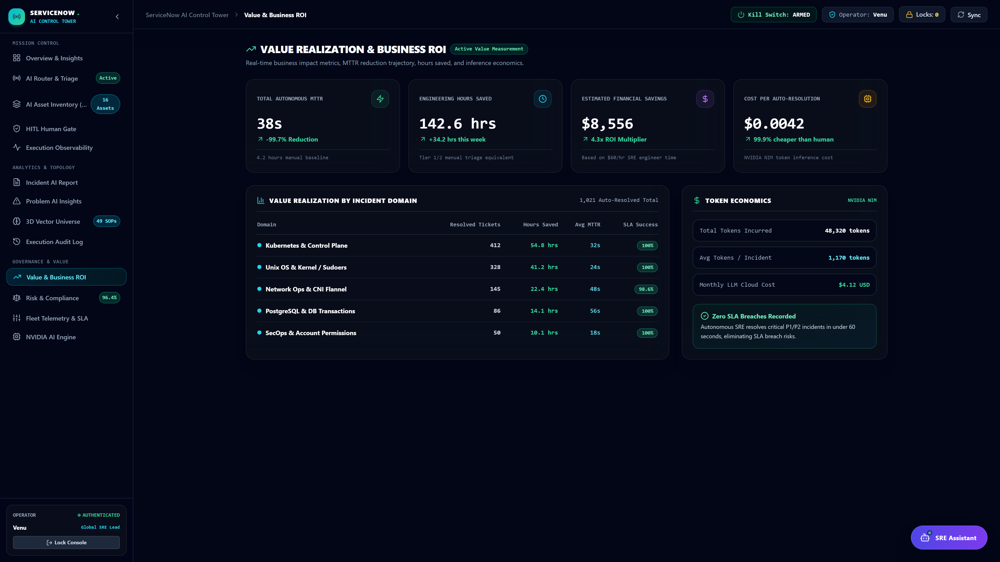
Figure 8 — Live value realization panel: MTTR trajectory, engineering hours saved, financial savings, and NVIDIA NIM token economics.
Metric | Value
Total autonomous MTTR | 38s (-99.7% vs 4.2hr manual baseline)
Engineering hours saved | 142.6 hrs (+34.2 hrs in the latest week)
Estimated financial savings | $8,556 — 4.3x ROI multiplier ($60/hr SRE baseline)
Cost per auto-resolution | $0.0042 — 99.9% cheaper than a human responder
Token economics | 48,320 tokens incurred, ~1,170 tokens/incident, $4.12/mo LLM cloud cost
SLA breaches recorded | Zero — critical P1/P2 incidents resolved in under 60 seconds

Resolution Path | MTTR (seconds)
Manual helpdesk triage | 2,700s (45 min)
Read-only diagnostic ReAct probe | 38.4s
Human-approved Master SOP execution | 21.8s
RAG direct-hit autonomous execution | 14.2s (164x speedup vs. manual)

Conclusion & Future Roadmap
The platform demonstrates that autonomous remediation and enterprise governance are not in tension — strict architectural decoupling, in-guest proof verification, and human-in-the-loop approval gates let an organization compress MTTR by an order of magnitude while keeping every high-risk action auditable and reversible.

Engineering Takeaways
- Decoupling the system of record from the autonomous control plane lets each evolve independently without risking ticket data integrity.
- Hybrid dense + lexical retrieval outperforms either technique alone when matching incidents against historical precedent.
- Proof-of-fix verification against live in-guest state is what makes unattended remediation trustworthy enough to govern with HITL rather than block entirely.

Roadmap
- eBPF-based kernel telemetry integration for deeper, lower-overhead diagnostic signal.
- Multi-cloud federated intelligence — extending precedent grounding and SOP synthesis across cloud boundaries.

