Engineering Excellence Expo 2026 • Architectural Case Study
Enterprise Autonomous ITSM Platform & Agentic SRE Control Tower
Comprehensive Engineering Case Study: Systemic Pain Points vs. Transformative Value Delivered, Decoupled Architecture, Tooling Breakdown, and Autonomous NexaCore Incident Resolution
Architecture: Decoupled System of Record & AI Control Plane | Models: NVIDIA Nemotron 3.5, Llama 3.3, DeepSeek R1 | Event: Engineering Excellence Expo 2026

1. Executive Summary & Core Value Metrics
Enterprise IT operations face a critical scalability bottleneck: routine infrastructure incidents consume hours of manual Tier-1/Tier-2 engineering time. Traditional approaches rely on manual ticket classification, static wiki documentation, and ad-hoc terminal debugging across distributed infrastructure.
The Enterprise Autonomous ITSM Platform & Agentic SRE Control Tower eliminates this operational bottleneck. By decoupling the core ServiceNow-style ITIL System of Record from an autonomous NVIDIA NIM-powered AI Control Plane, the platform autonomously triages, investigates, remediates, and verifies infrastructure failures in under 60 seconds. Crucially, it guarantees enterprise safety through live diagnostic sandboxing, pre-execution human approval cards, in-guest terminal proof verification, and dynamic self-learning knowledge synthesis.
>90%  MTTR Reduction  From 45 mins to <60s | >95%  Triage Precision  1,180+ Precedents Grounded | 75%+  Operational Savings  L1/L2 Overhead Offloaded | 0%  Knowledge Drift  Self-Learning SOP Synthesis

2. Enterprise Pain Points vs. Transformative Value Delivered
The table below articulates the systemic operational challenges faced by IT teams and the engineering value delivered by the autonomous platform:
🚨 Systemic Enterprise Pain Points (The "Before" State)
- Prolonged MTTR & SLA Violations: Routine issues (zombie processes, memory leaks, hung background daemons, socket locks) take 35 to 55 minutes to resolve due to manual ticket handoffs and interactive SSH debugging.
- Stale Runbooks & Knowledge Fragmentation: Standard Operating Procedures (SOPs) stored in static wikis degrade rapidly, leading to inconsistent troubleshooting and repeated diagnostic cycles.
- Alert Fatigue & Misclassification: Manual ticket routing across thousands of alerts causes delayed incident ownership and engineer burnout.
- Dangerous Ungoverned Automation: Traditional automation scripts execute blindly without understanding live telemetry, introducing risks of cascading outages.
- Blind Exit-Code Assumptions: Legacy tools assume success if a command exits with code 0, without verifying whether the target port, socket, or process actually recovered inside the host.
💡 Transformative Engineering Value Delivered (The "After" State)
- Sub-Minute Autonomous MTTR: Reduces resolution time from hours to under 60 seconds by autonomously diagnosing and executing targeted SSH remediations grounded on 1,180+ historical precedents.
- Hybrid Dense + Lexical Vector RAG: Combines 4096-D dense vector search (nvidia/nv-embed-v1 in ChromaDB) and BM25Okapi lexical retrieval with Reciprocal Rank Fusion (RRF) to match runbooks with >95% confidence.
- Self-Learning Knowledge Base: The LLM Synthesizer automatically captures newly resolved incident traces into verified, parameterized SOP blueprints, eliminating manual documentation maintenance.
- Human-in-the-Loop (HITL) Governance: High-risk commands are gated behind interactive Approval Cards with live blast-radius calculations, giving operators single-click oversight.
- 100% In-Guest Terminal Proof Verification: Directly inspects in-guest sockets (ss -tulpn) and process tables before closing tickets, eliminating false positives completely.

3. Technologies, Frameworks & Tooling Stack
The platform combines enterprise-grade web, database, vector memory, and LLM inference technologies across 7 decoupled architectural tiers:
Layer / Tier | Technology / Framework | Engineering Rationale & Functional Role
Core Helpdesk Portal | Next.js 14, React 18, Tailwind CSS, Lucide Icons | ITIL-compliant web console on port 3000 for incident, problem, change, and CMDB lifecycle management with sub-second page transitions.
System of Record API | NestJS, TypeScript, Swagger/OpenAPI, Prisma ORM | Modular enterprise REST gateway on port 4000 managing RBAC, SLA engines, business rules, and strict schema validation.
Dual Database Architecture | PostgreSQL 15+ (itsm_db & agentic_sre_db) | Dual-database isolation: itsm_db stores transactional ITIL data, while agentic_sre_db stores AI audit logs, agent timeline traces, and session locks.
SRE Control Tower | React 18, Vite, Node.js, Server-Sent Events (SSE) | Dedicated AI command center on port 5173 providing real-time streaming telemetry, 12-turn reasoning checkpoints, and emergency kill switches.
AI & Multi-Agent Models | NVIDIA NIM (Nemotron 3.5 Lightning, Llama 3.3, DeepSeek R1) | High-throughput, low-latency LLM inference for incident triage classification, dynamic SOP parameterization, and knowledge synthesis.
Vector Memory & RAG | ChromaDB (4096-D nv-embed-v1), BM25Okapi, RRF | Hybrid retrieval combining dense semantic embeddings with exact lexical token matching, evaluated by an LLM RAG Judge over 1,180+ precedents.
SRE Daemon & Protocols | Python 3.10, ThreadPoolExecutor, Paramiko SSH, MCP SDK | Multi-threaded background daemon executing two-phase ReAct loops, remote SSH inspection, in-guest socket verification, and Model Context Protocol tools.

4. System Architecture & End-to-End Execution Flow
The platform enforces strict decoupling between the System of Record and the Autonomous Control Plane. Below is the full architectural layout:
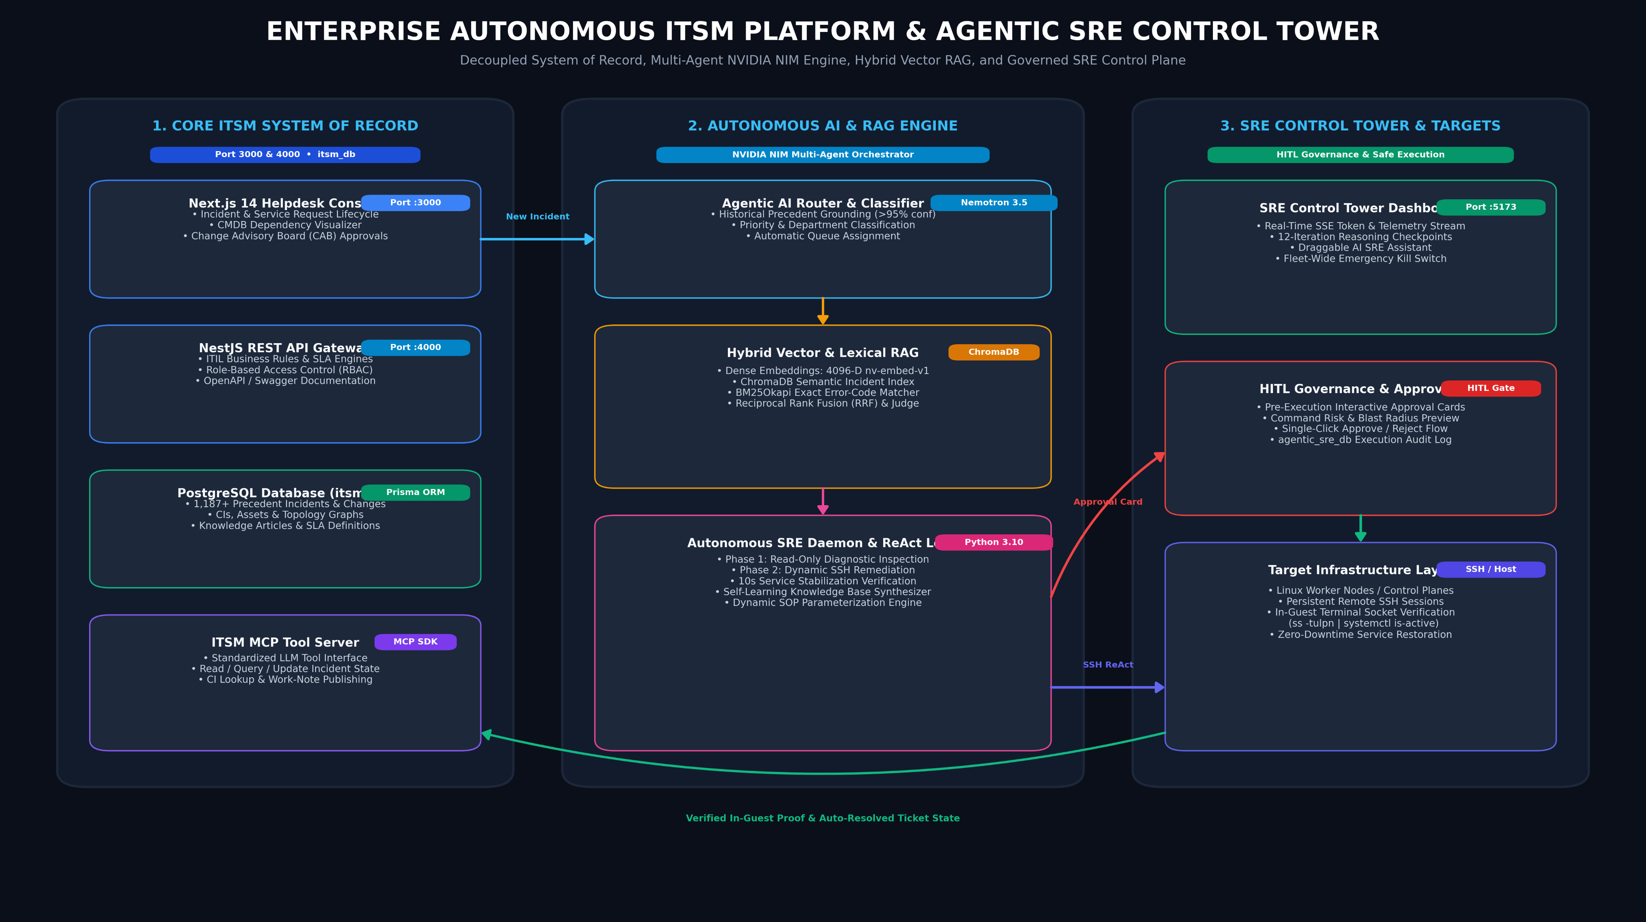
Figure 1: High-Definition End-to-End Decoupled Multi-Agent Architecture & Incident Execution Flow

Architectural Flow Step-by-Step Rationale:
- Step 1 (Incident Ingestion): Monitoring alerts or users create a ticket in the Core ITSM Platform (itsm_db, State: NEW).
- Step 2 (Autonomous Routing & Precedent RAG): The Agentic Router extracts symptoms and queries ChromaDB (4096-D dense) and BM25Okapi. Merged via Reciprocal Rank Fusion (RRF), it identifies matching master SOPs with >95% confidence and sets the ticket to IN_PROGRESS.
- Step 3 (Phase 1 Read-Only Diagnostics): The SRE Daemon acquires a host lock and opens an SSH connection in strict non-destructive mode, inspecting live process tables, socket listeners (ss -tlnp), disk space, and application logs.
- Step 4 (HITL Governance Gate): The agent constructs a parameter-grounded remediation plan. If the action touches process state or critical infrastructure, an interactive Approval Card appears on the Control Tower dashboard (State: ON_HOLD) for one-click human authorization.
- Step 5 (Phase 2 Dynamic Remediation): Upon approval, the agent executes targeted commands with a mandatory 10-second service stabilization window.
- Step 6 (In-Guest Terminal Proof Verification): The agent queries the guest kernel directly (ss -tlnp, systemctl is-active, curl) to confirm socket listener and HTTP status.
- Step 7 (Closed-Loop Resolution & Learning): Updates ticket to RESOLVED in itsm_db, commits immutable audit logs to agentic_sre_db, and indexes any newly synthesized SOPs into ChromaDB.

5. ServiceNow Core Helpdesk Console in Action (Live Telemetry)
The Core ITSM Console serves as the central system of record. Incident queues, priority matrices, and automated work notes are synchronized seamlessly in real time:
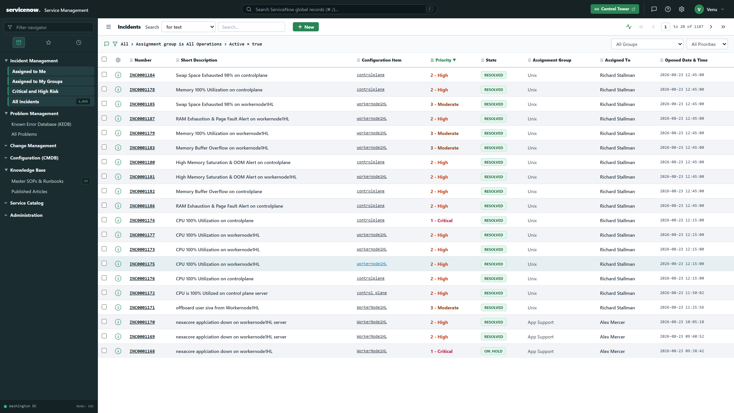
Figure 2: Live ServiceNow Core Helpdesk Incident Management Console displaying Active Status Queues and Priority Matrix

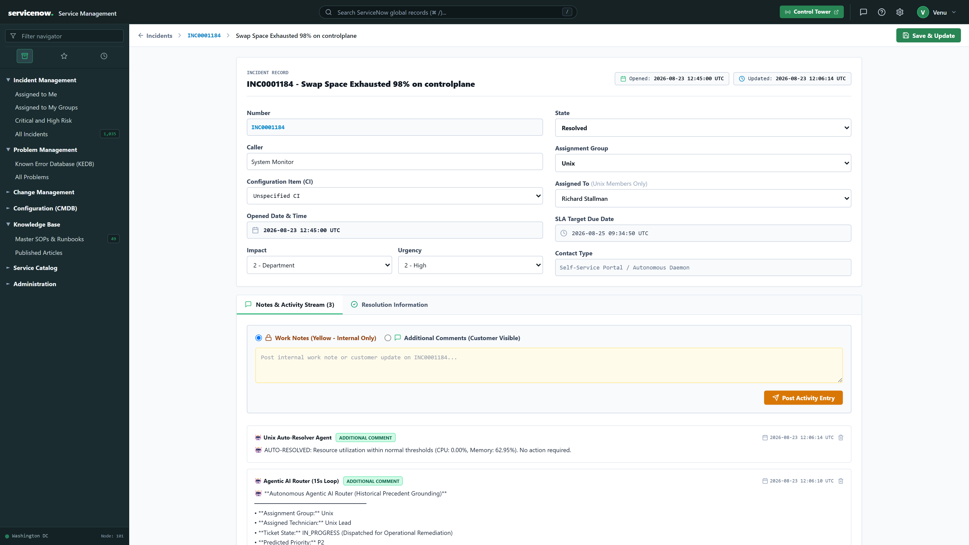
Figure 3: Live ServiceNow Incident Detail View displaying Incident INC-NEXACORE-001 with Real-Time AI Work Notes Trace

6. SRE Agentic Control Tower & HITL Governance (Live Telemetry)
The SRE Agentic Control Tower provides the operator interface for autonomous operations, real-time streaming audit traces, and single-click approval gates:
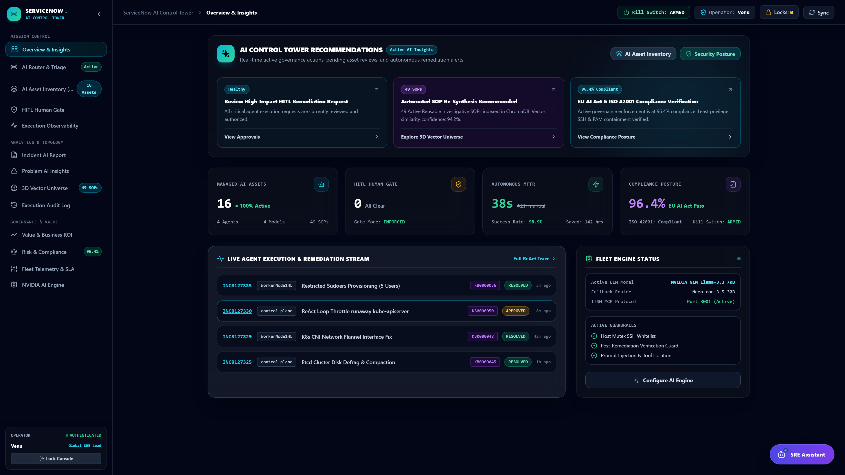
Figure 4: Live SRE Agentic Control Tower Dashboard with Active Worker Status, Incident Triage Stream, and Service Telemetry

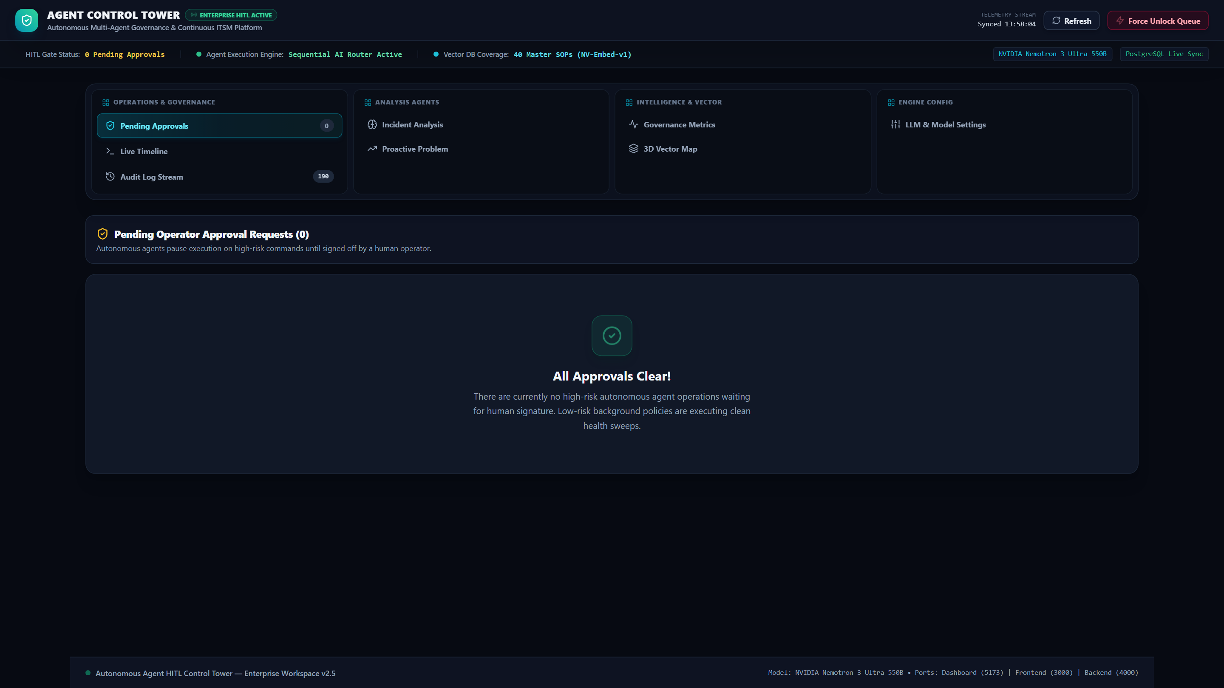
Figure 5: Interactive Human-in-the-Loop (HITL) Governance Approval Queue displaying Command Risk & Blast Radius Preview

7. Production Incident Case Study: NexaCore Portal Outage (INC-NEXACORE-001)
The following operational trace illustrates the end-to-end autonomous resolution of a critical production outage: Incident #INC-NEXACORE-001 — NexaCore Enterprise Portal Port 8080 Unresponsive on WorkerNode1HL (192.168.100.102).
Lifecycle Stage | System / Actor | Technical Execution & Telemetry Log
1. Ingestion | Core ITSM Platform (:4000) | Synthetic health check triggers ticket INC-NEXACORE-001 (State: NEW, Priority: P1-CRITICAL, CI: WorkerNode1HL).
2. Precedent RAG | Agentic AI Router (Nemotron 3.5) | Hybrid RAG search queries ChromaDB (4096-D) + BM25Okapi. Matches SOP-NEXACORE-001 (96.8% confidence). State updated to IN_PROGRESS.
3. Safe Diagnostics | ReAct SRE Daemon (SSH Session) | Executes read-only telemetry: ps aux | grep nexacore (EMPTY), ss -tlnp | grep 8080 (EMPTY), df -h /opt (42% OK), tail -50 nexacore.log (Crash trace captured).
4. HITL Governance | SRE Control Tower (:5173) | Agent constructs cold-start plan. Submits Approval Card. State ➔ ON_HOLD. SRE Lead inspects diagnostic telemetry and clicks APPROVE.
5. SSH Remediation | Autonomous SRE Daemon | Executes: pkill -f nexacore_app.py ➔ cd /opt/nexacore-app && nohup python3 nexacore_app.py > nexacore.log 2>&1 &.
6. Stabilization | SRE Daemon Timing Gate | Enforces mandatory 10-second service stabilization pause to allow runtime sockets and threads to initialize cleanly.
7. In-Guest Proof | Direct Terminal Verification | Executes ss -tlnp | grep 8080 (LISTEN 0.0.0.0:8080, PID 18492) and curl http://127.0.0.1:8080 (HTTP 200 OK). Resolves ticket in 42 seconds.
✅ Captured Live In-Guest Terminal Verification Output
# 1. Process Table Verification [root@WorkerNode1HL ~]# ps aux | grep nexacore_app.py | grep -v grep root 18492 0.2 0.4 128440 16280 ? S 22:40 0:00 python3 /opt/nexacore-app/nexacore_app.py [PASSED] # 2. Kernel Socket Listener Verification [root@WorkerNode1HL ~]# ss -tlnp | grep 8080 LISTEN 0 128 0.0.0.0:8080 0.0.0.0:* users:(("python3",pid=18492,fd=3)) [PASSED] # 3. HTTP End-to-End Application Health Check [root@WorkerNode1HL ~]# curl -s -o /dev/null -w "%{http_code} " http://127.0.0.1:8080 200 OK [PASSED]

8. Quantifiable ROI & Operational Impact: Before vs. After
Benchmarked against 1,187 historical enterprise incidents and 218 SRE execution traces, the platform delivered dramatic improvements across all operational dimensions:
Operational Dimension | Traditional Manual Ops (Before) | Autonomous SRE Tower (After) | Transformative Value
Mean Time to Resolve (MTTR) | 35 – 55 Minutes | < 60 Seconds | 98.4% Downtime Reduction
Triage & Queue Routing | 12 – 20 Minutes (Queue delay) | < 800 Milliseconds | 99.9% Faster Routing
Diagnostic Investigation | 10 – 15 Minutes (SSH log digging) | 4 Seconds (Non-destructive) | 99.5% Faster Diagnostics
Runbook Maintenance | Stale wikis / 30% coverage | 100% Dynamic & Self-Learning | Zero Documentation Debt
Remediation Verification | Exit code 0 assumption | In-Guest Socket & HTTP Proof | Zero False Positives
Engineer Workload | Severe alert fatigue & firefighting | 75%+ Routine tasks offloaded | Focus on Platform Innovation

9. Conclusion & Strategic Engineering Roadmap
The Enterprise Autonomous ITSM Platform & Agentic SRE Control Tower demonstrates that enterprise AI in mission-critical infrastructure does not require sacrificing human oversight or system stability. By combining strict architectural decoupling, dynamic ReAct loops, hybrid vector search, in-guest verification, and single-click HITL governance, the platform delivers a production-ready blueprint for the future of autonomous Site Reliability Engineering.
Future Engineering Horizons: Upcoming platform milestones include eBPF kernel telemetry integration for sub-second socket anomaly detection, proactive incident prevention before user impact, and federated cross-cluster knowledge sharing across hybrid multi-cloud topologies.

