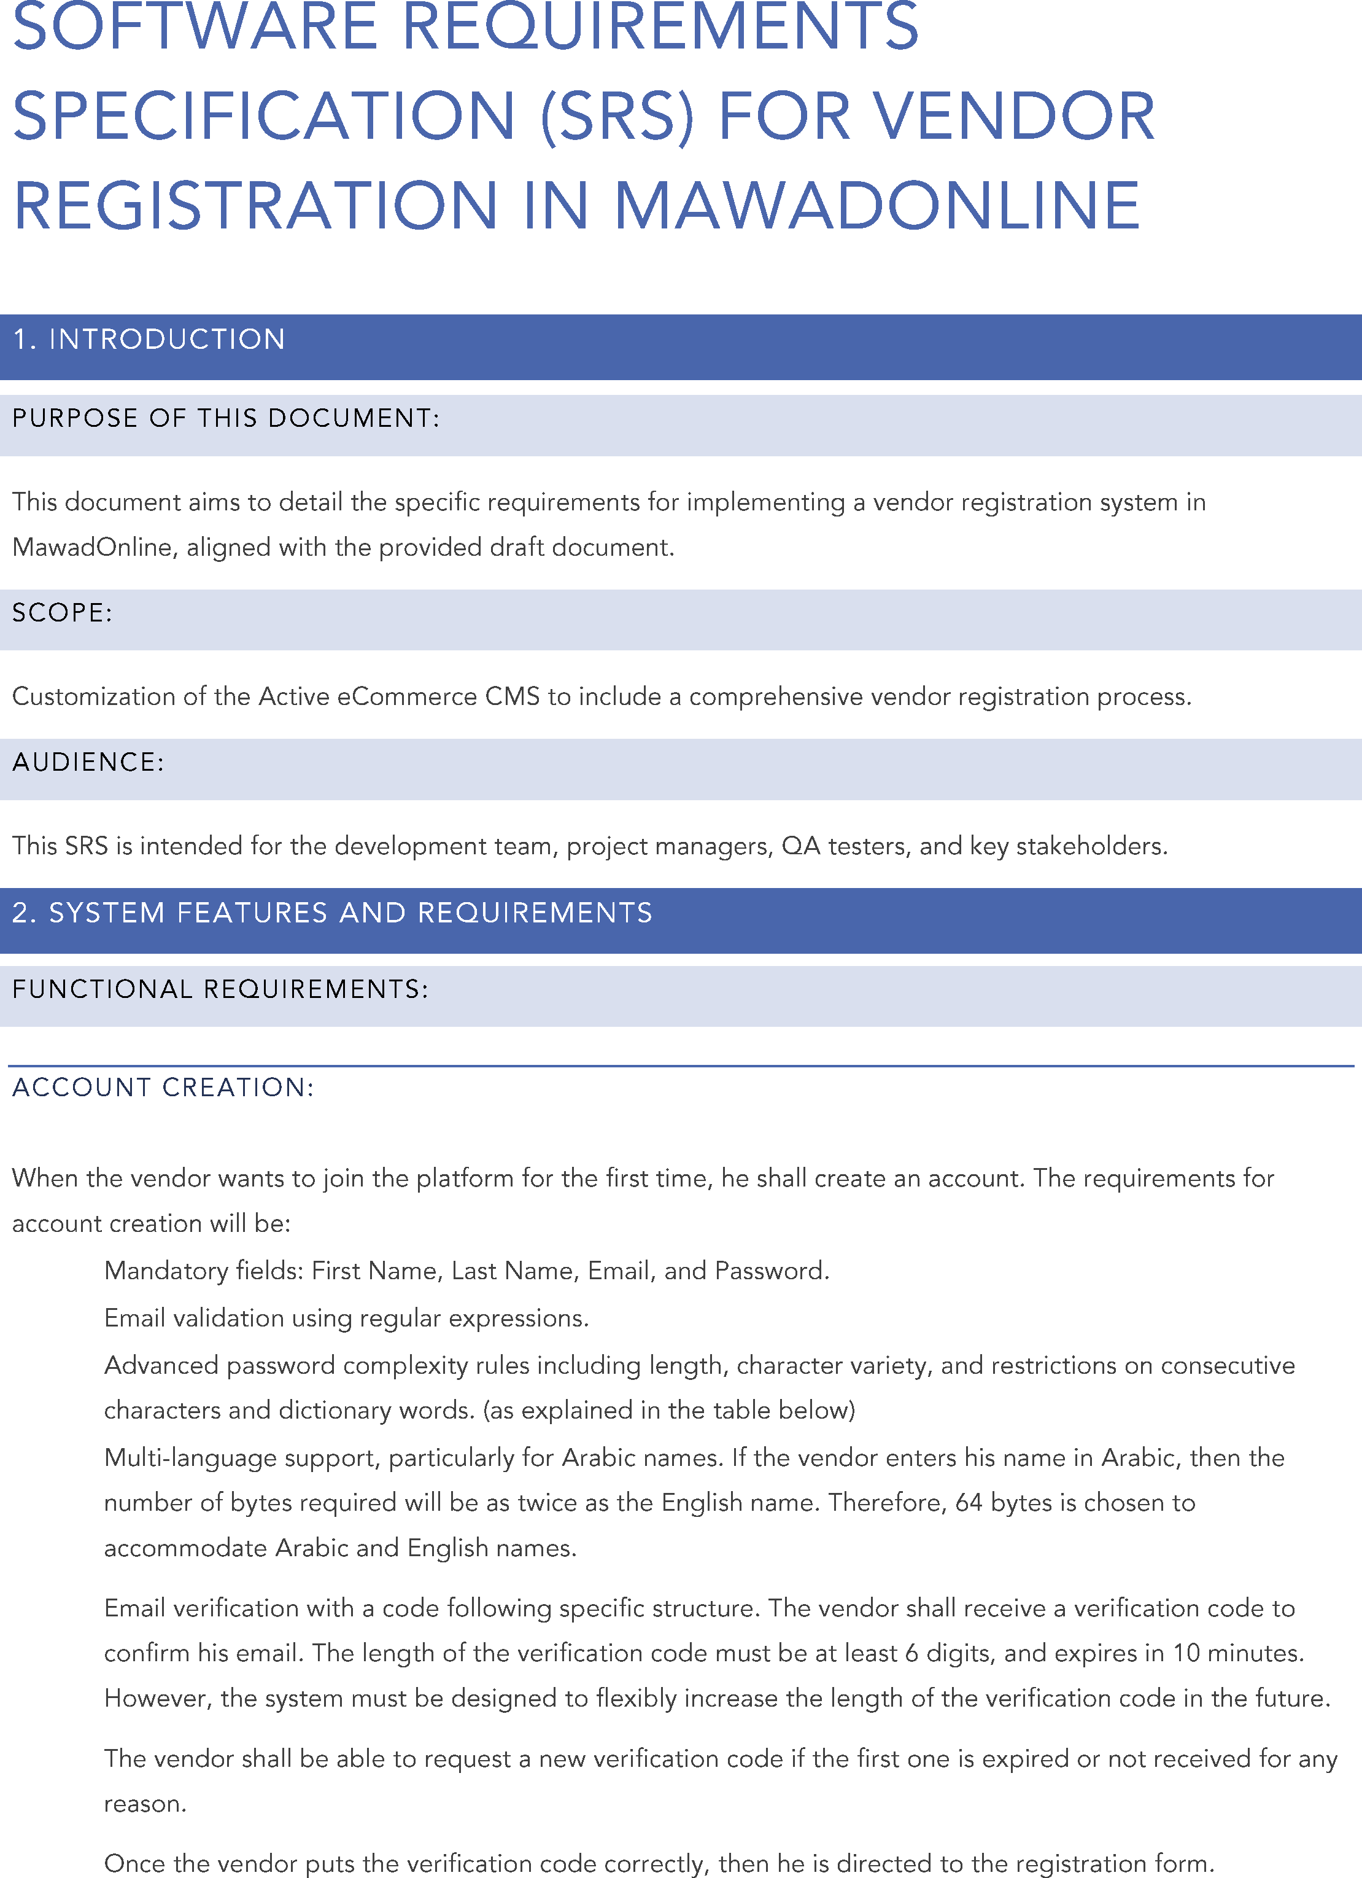

S
  
S

S

S

S

S

S

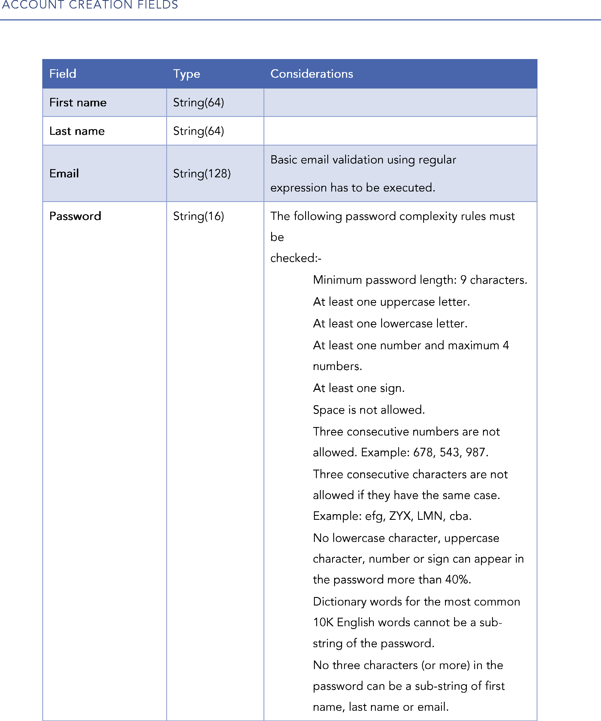

|  |  |  |
| --- | --- | --- |
|  |  |  |
|  |  |  |
|  |  |  |
|  |  | S S S S  S  S  S  S S S S |

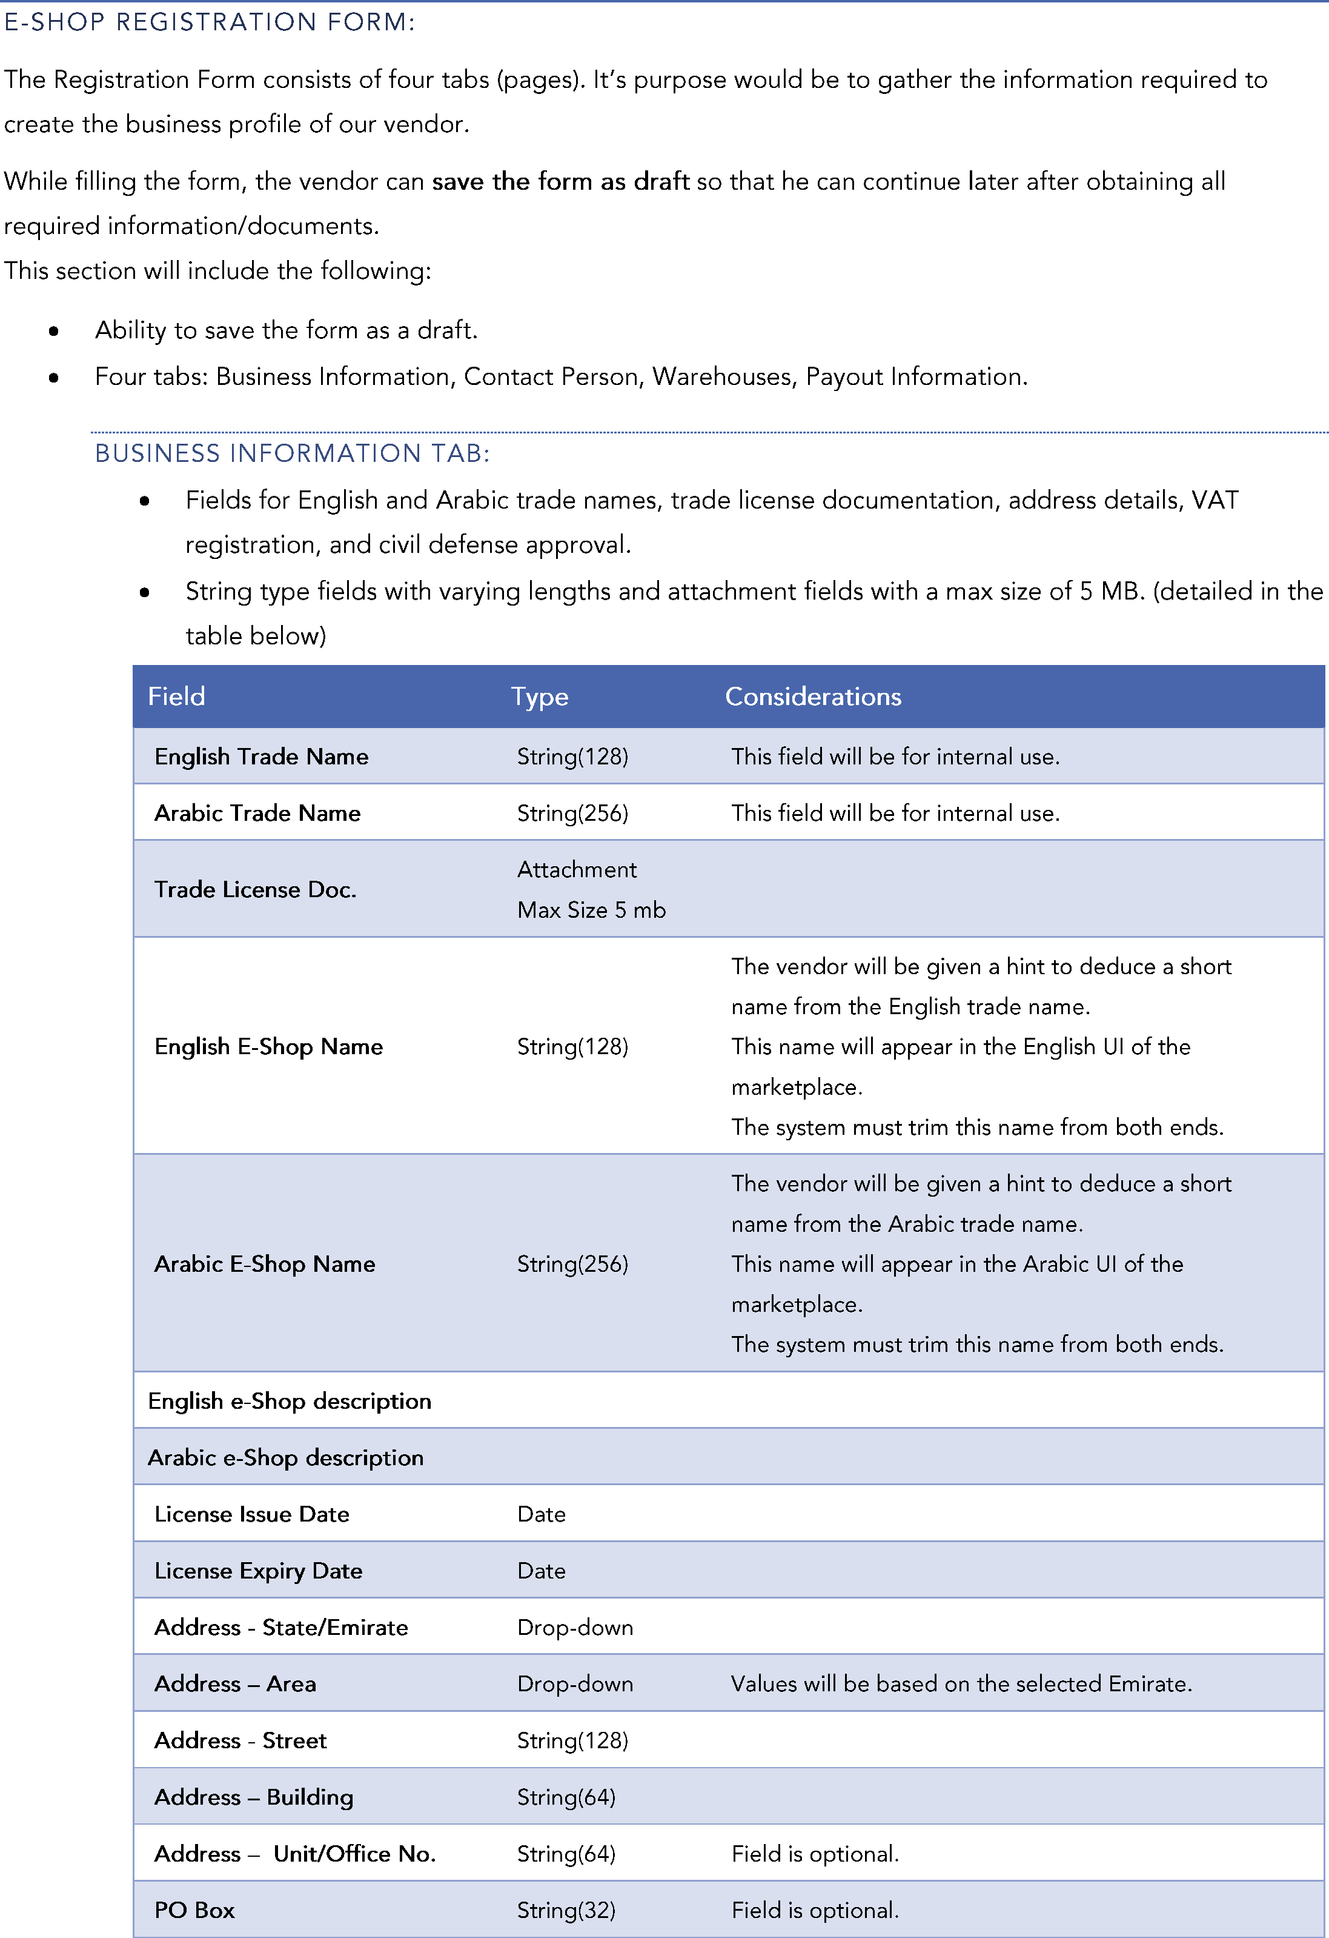

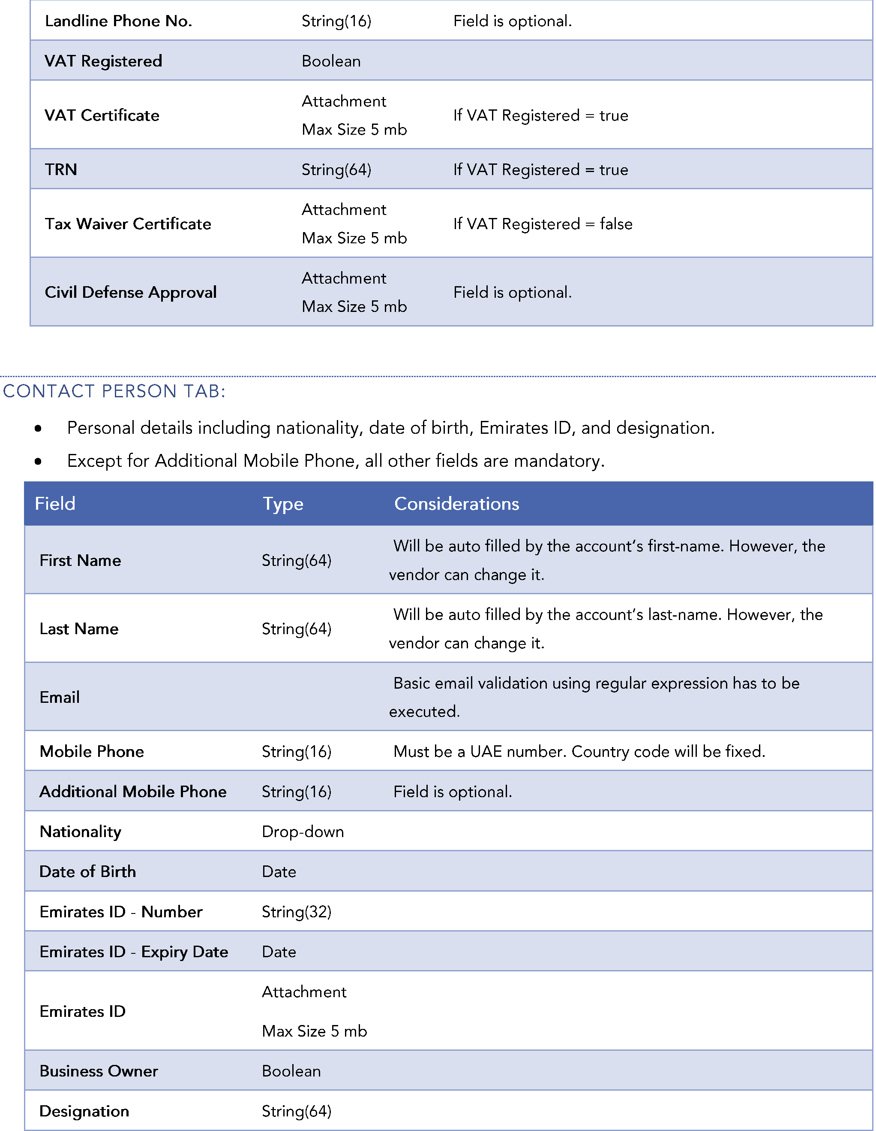

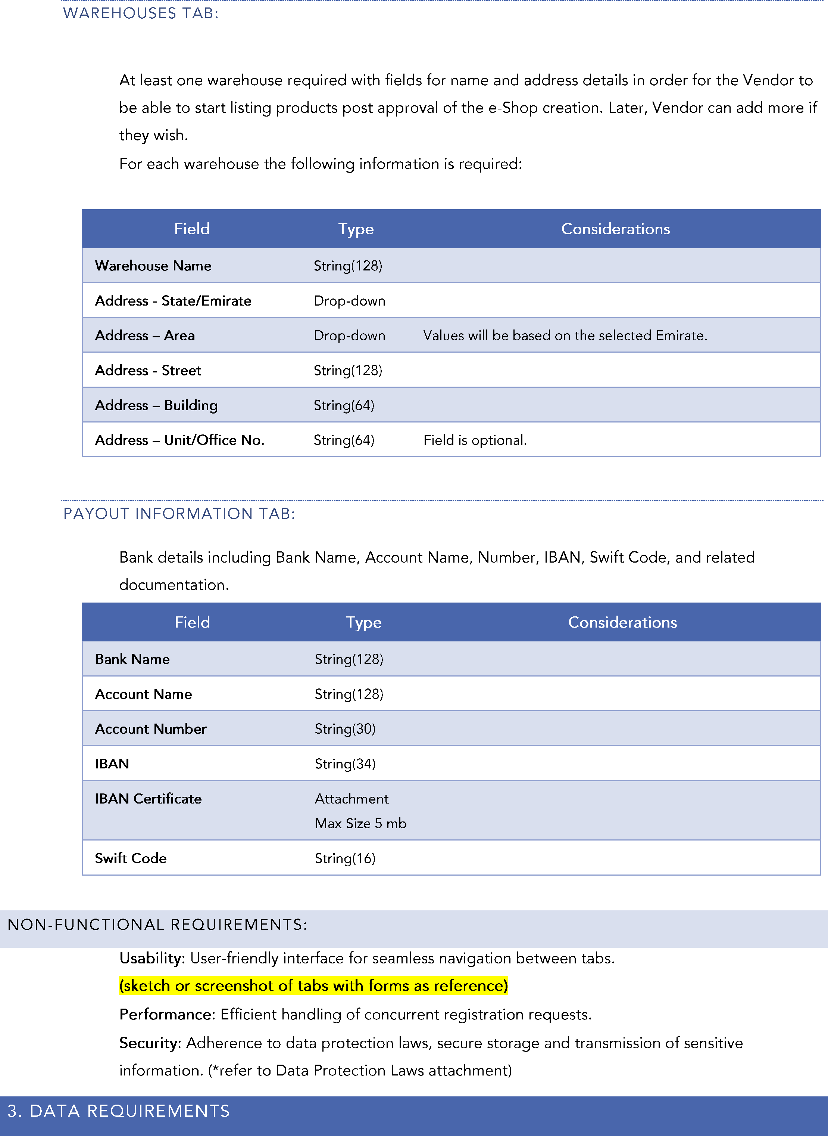

S

S

S
  
S

S

S