LAPORAN PENGERJAAN UJI KOMPETENSI KEJURUAN SMK MAHARDHIKA BATUJAJAR

TAHUN PELAJARAN 2022-2023

KOMPETENSI KEAHLIAN : Rekayasa Perangkat Lunak KELAS : XII RPL 1

NAMA LENGKAP : Yosia Anggoro

NIS : 0053944954

PAKET SOAL :

JENIS APLIKASI : Web

ALOKASI WAKTU : 24 jam

# PENJADWALAN KEGIATAN

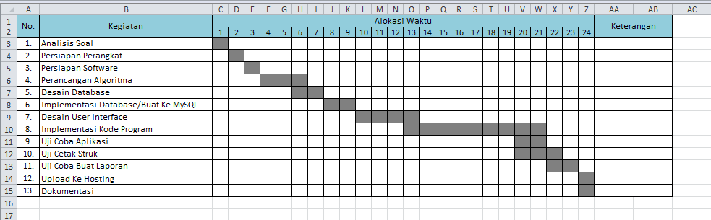

# PERSIAPAN PERANGKAT KERAS

|  |  |
| --- | --- |
| Processor | Intel(R) Core(TM) 2 Duo CPU E7500 @ 2.93GHz (2CPUs), ~2.9GHz |
| RAM | 4096MB |

# PERSIAPAN PERANGKAT LUNAK

* Astah
* Balsamiq
* XAMPP Control Panel
* Visual Code Studio
* Chrome

# PERANCANGAN ALGORITMA APLIKASI

# Use Case

# 

# ERD

# 

# Activity diagram

# Login

# C:\Users\USER\AppData\Local\Microsoft\Windows\INetCache\Content.Word\Login pengaduan.jpg

# Register

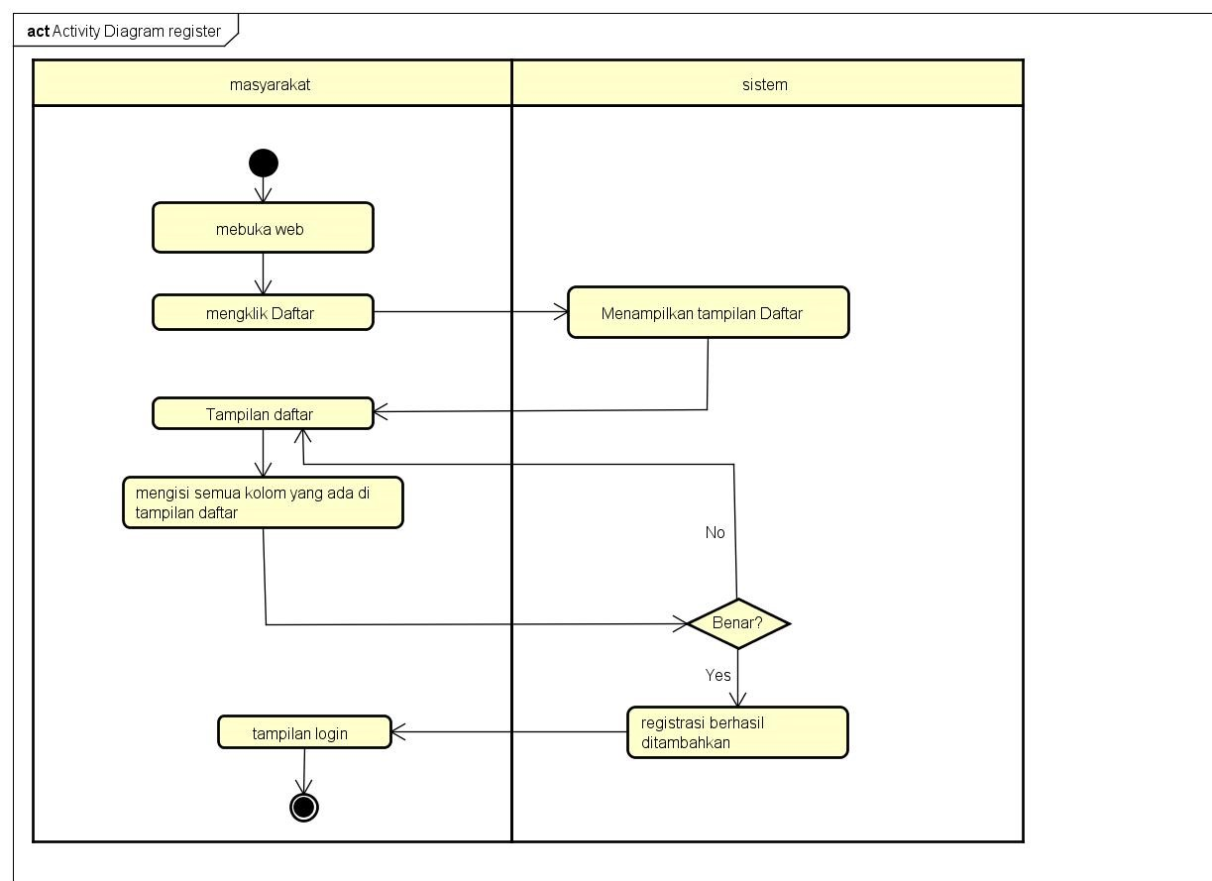

# Tulis Laporan

# 

# Admin/Petugas Menanggapi Pengaduan

# 

# Admin/Petugas Menghapus Pengaduan

# 

* **Admin Menambah User**

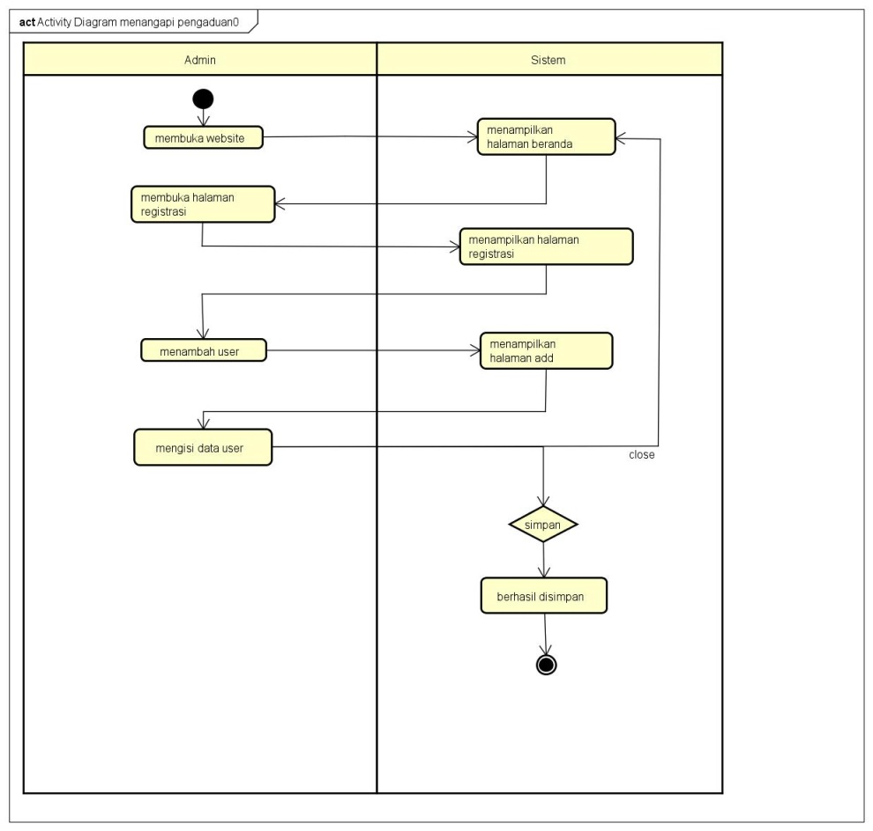

* **Edit Data User**

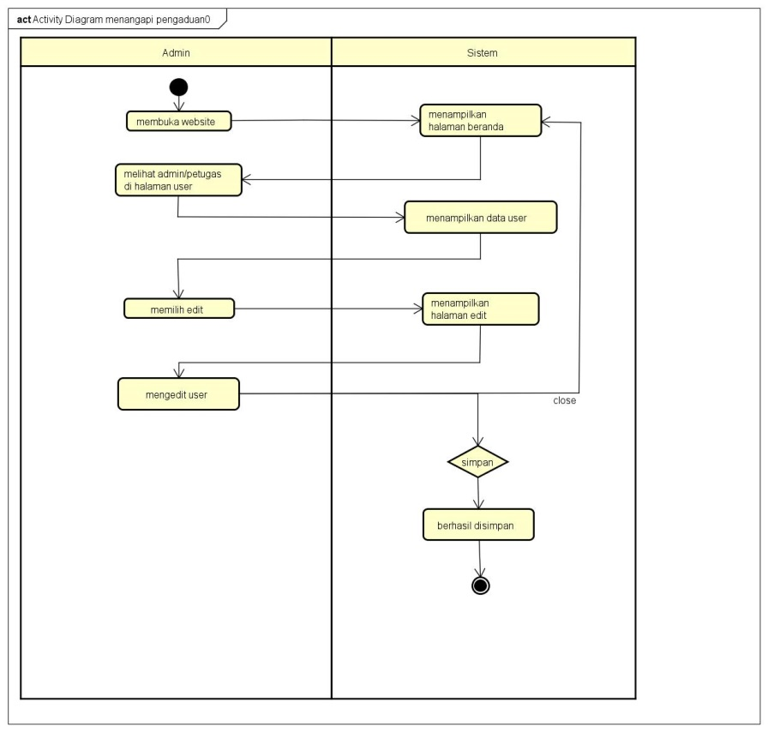

* **Hapus Data User**

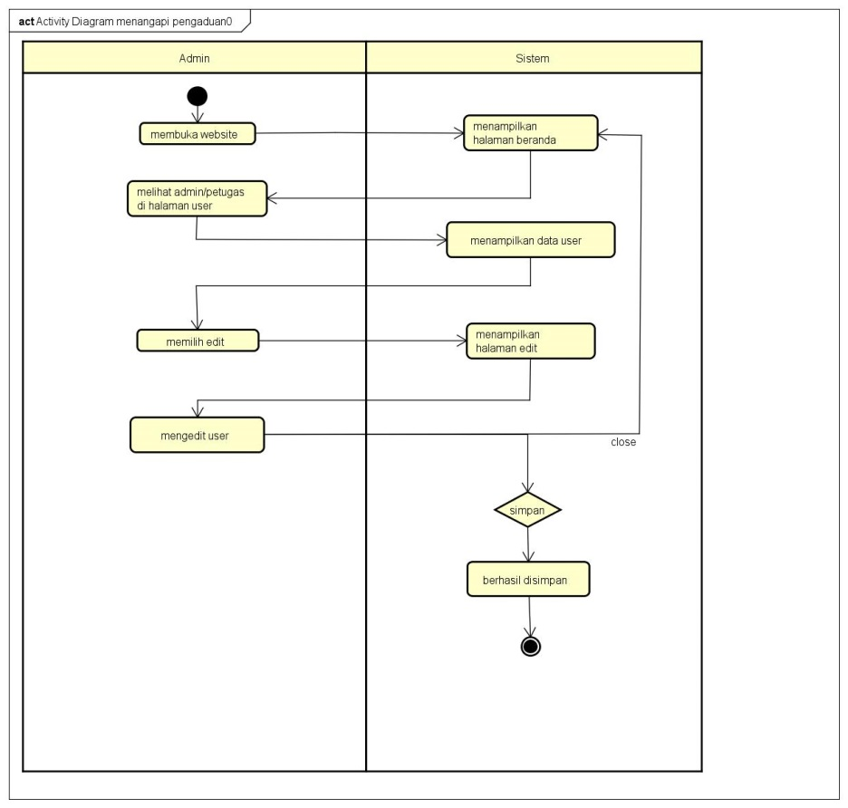

# PERANCANGAN DESAIN BASIS DATA

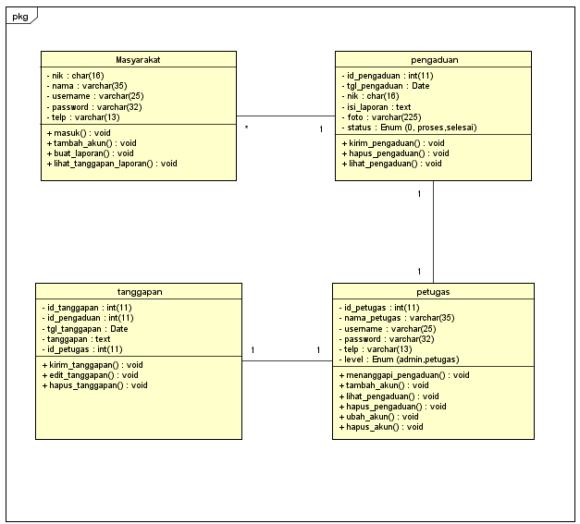

# DUMMY DATA

# Masyarakat

|  |  |  |  |  |
| --- | --- | --- | --- | --- |
| **NIK** | **Nama** | **Username** | **Password** | **Telepon** |
| 00598745632 | Justin | Justin | 321456 | 088232159784 |
| 00578965431 | Leo | Leo | 654123 | 088315479654 |
| 00589764512 | Sky | Sky | 357951 | 081215458943 |
| 00547896352 | Cassie | Cassie | 159357 | 089756512131 |
| 00569874125 | Sally | sally | 654852 | 089756612254 |

* **Petugas**

|  |  |  |  |  |  |
| --- | --- | --- | --- | --- | --- |
| **ID Petugas** | **Nama Petugas** | **Username** | **Password** | **Telepon** | **Level** |
| 011124 | Jack | mejack | 321456 | 022123658 | Admin |
| 000358797 | Jasson | mejasson | 654123 | 081235897425 | Petugas |
| 000358798 | Lily | melily | 357951 | 082398795435 | Petugas |

* **Pengaduan**

|  |  |  |  |  |  |
| --- | --- | --- | --- | --- | --- |
| **ID Pengaduan** | **Tanggal Pengaduan** | **NIK** | **Isi Laporan** | **Foto** | **Status** |
| 011124 | Jack | mejack | 321456 | 022123658 |  |
| 000358797 | Jasson | mejasson | 654123 | 081235897425 |  |
| 000358798 | Lily | melily | 357951 | 082398795435 |  |

# PEMBUATAN BASIS DATA (MySQL Code)

* **Database Masyarakat**

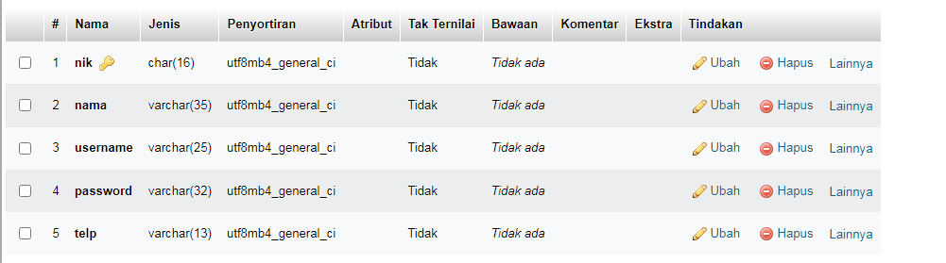

* **Database Petugas**

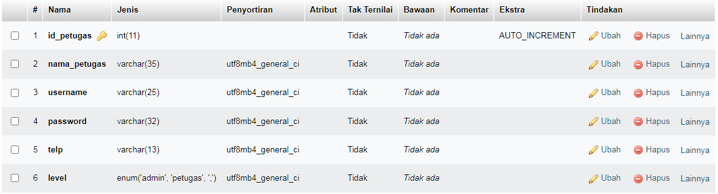

* **Database Pengaduan**

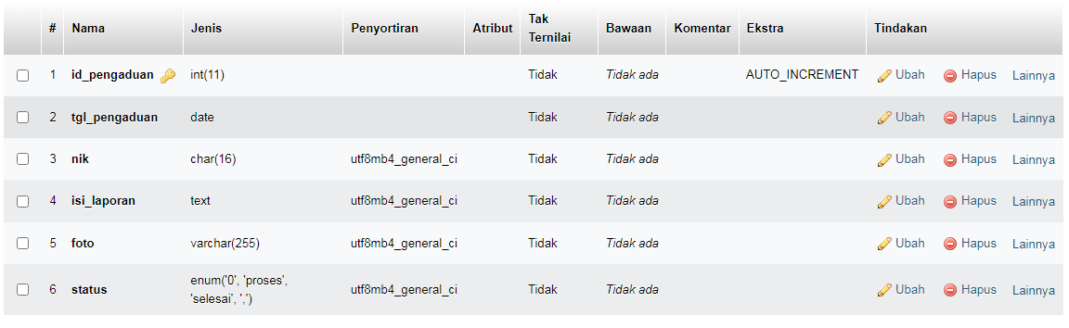

* **Database Tanggapan**

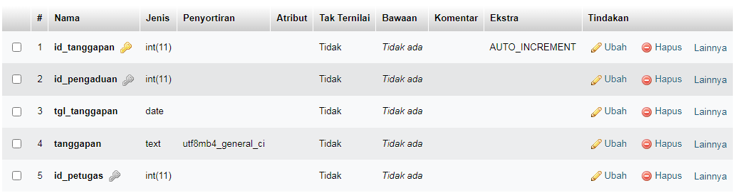

# PERANCANGAN TAMPILAN ANTARMUKA (UI) WEB

1. Admin dashboard

Dashboard Admin Ubah data masyarakat

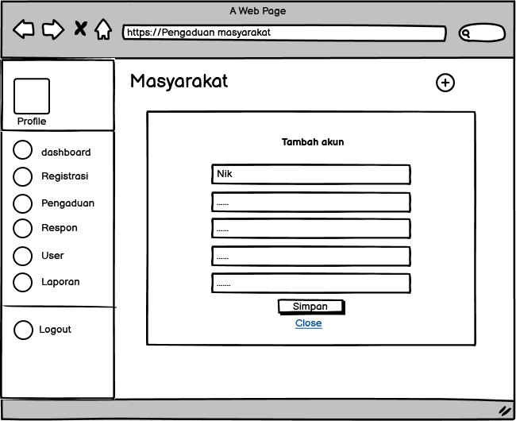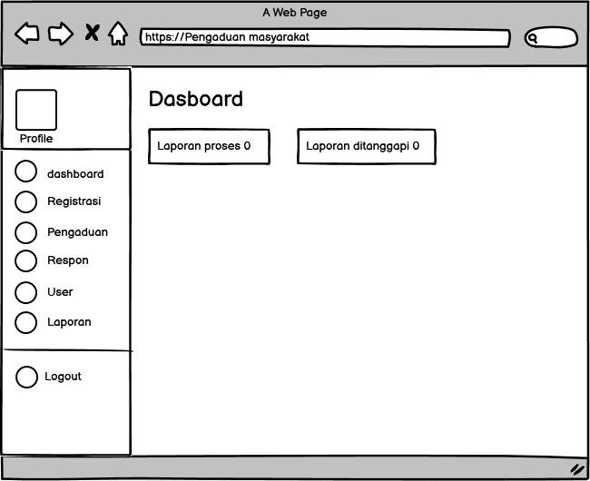

Tambah admin dan petugas Tabel akun masyarakat yang sudah di terdaftar

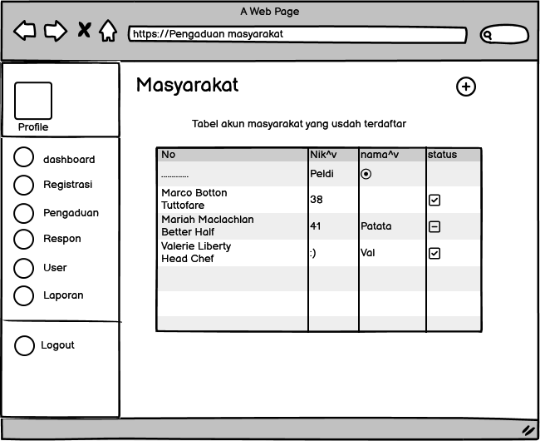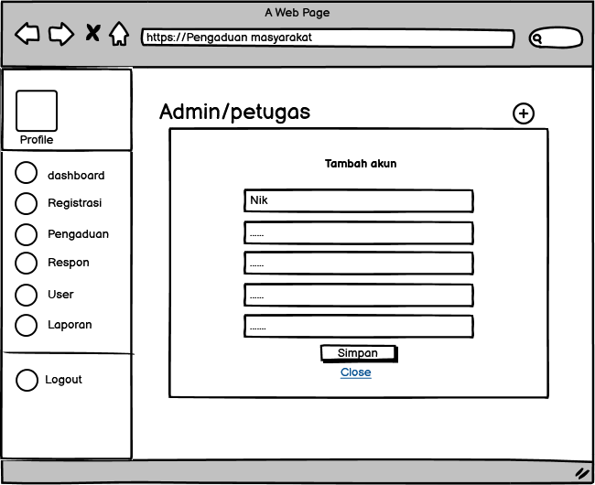

Tabel user admin/petugas



1. Tampilan Petugas

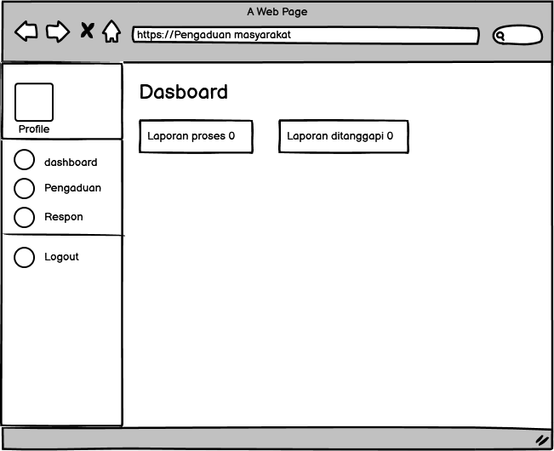

1. Tampilan masyarakat

Dashboard Tambah Laporan

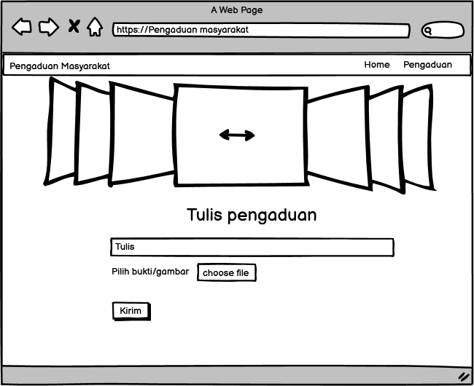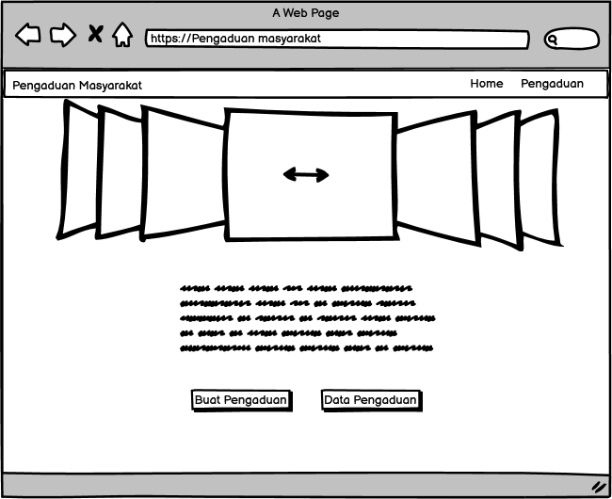

Tanggapan Login

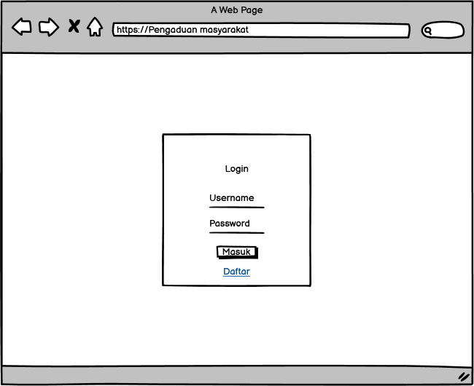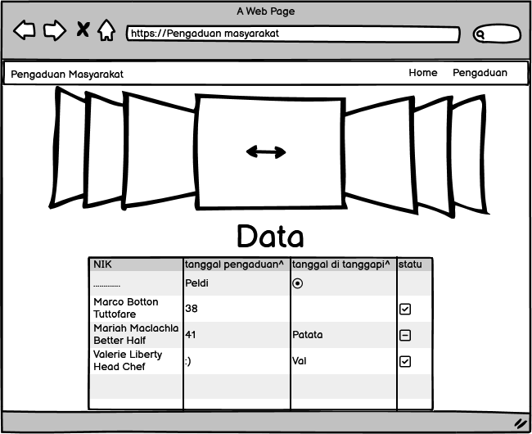

Register Masyarakat

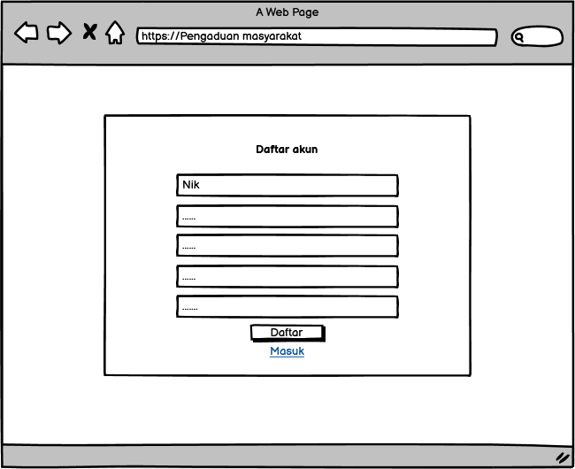

1. PEMBUATAN STYLE WEB (CSS) container.css

|  |
| --- |
| @import url('https://fonts.googleapis.com/css2?family=Sofia+Sans+Semi+Condensed:wght@600&display=swap');  *, html{  font-size: 20px;  margin: 0;  font-family: 'Sofia Sans Semi Condensed', sans-serif;  box-sizing: border-box;  }  body{  margin: 0;  padding: 0;  }  h1 {  font-family: 'Lato', sans-serif;  font-weight: 300;  letter-spacing: 2px;  font-size: 40px;  }  h3{  font-size: 20px;  }  header, main, footer{  display: flex;  text-align: center;  justify-content: center;  }  /* header{  width: 100%;  height: 100px;  background: aqua;  } */  /* nav{  width: 100%;  height: 90px;  background: grey;  } */  .fConteiner {  display: flex;  width: 100%;  height: 10vh;  background-color: lightgrey;  }  .wrapper{  display: flex;  font-size: 20px;  padding: 15px;  justify-content: space-between;  align-items: center;  width: 100%;  height: 80px;  background-color: black;  color: white;  box-shadow: 0 7px 15px 0 rgba(0, 0, 0, 0.5);  }  .brand {  display: flex;  flex-direction: row;  font-size: 1.5em;  padding: 15px;  text-transform: capitalize;  }  .fristname{  color: white;  font-weight: 700;  }  .lastname{  color: grey;  padding-left: 4px;  }  .navigation {  display: flex;  justify-content: center;  align-items: center;  }  .navigation >li {  list-style-type: none;  padding: 15px;  }  .navigation >li >a {  color: white;  font-size: 17px;  text-decoration: none;  text-transform: capitalize;  }  .navigation>li>a:hover {  color: grey;  transition: all .3s ease-in-out;  }  .active {  background-color: gray;  color: white;  padding: 15px;  }  .active:hover {  color: white !important;  }  main{  width: 100%;  height: 600px;  background-image: url("/img/login.jpg");  background: linear-gradient(to bottom, #696969 25%, #DCDCDC 50%, #D3D3D3 75%, #E6E6FA 100%);  }  .image{  display: flex;  width: 100%;  transition: 2s;  }  .image img{  width: 100%;  }  .slide{  width: 900px;  margin: auto;  border-radius: 5px;  overflow: hidden;  position: relative;  }  #slide-1:target ~ .image {  margin-left: 0px;  }  #slide-2:target ~ .image {  margin-left: -100%;  }  #slide-3:target ~ .image {  margin-left: -200%;  }  .geser a{  display: inline-block;  height: 25px;  width: 25px;  background-color: #ff9400;  font-size: 0px;  border-radius: 50%;  margin: 3px;  transition: 1s;  }  .geser a:hover {  background-color: rgb(255, 255, 255);  }  .geser {  position: absolute;  margin-left: auto;  margin-right: auto;  left: 0;  right: 0;  text-align: center;  margin-top: -50px;  }  @media screen and (max-width: 800px){  .wrapper {  width: 90%;  }  }  aside{  width: 100%;  height: 450px;  background: linear-gradient(to bottom, #E6E6FA 25%, #D3D3D3 50%, #DCDCDC 75%, #696969 100%); ;  text-align: center;  justify-content: center;  }  .fcc-btn {  background-color: rgb(71, 189, 71);  color: rgb(255, 255, 255);  padding: 15px 25px;  text-decoration: none;  border-radius: 5%;  }  .fcc-btn:hover {  background-color: #223094;  }  footer{  width: 100%;  height: 110px;  background: aqua;  }  .area{  width: 100%;  background: transparent;  border-radius: 5px;  padding: 25px 25px 30px;  }  .area h2{  color: black;  font-size: 50px;  text-align: center;  }  .area textarea{  width: 50%;  height: 59px;  padding: 15px;  border-radius: 5px;  outline: none;  resize: none;  font-size: 20px;  margin-top: 5px;  border-radius: 5px;  border-color: black;  }  textarea :is(:focus, :valid){  border-color: white;  padding: 14px;  border-color: aqua;  }  textarea::-webkit-scrollbar{  width: 0px;  }  input[type="file"]::file-selector-button {  border: 2px solid #6c5ce7;  padding: 0.2em 0.4em;  border-radius: 0.2em;  background-color: white;  transition: 1s;  }  input[type="file"]::-ms-browse:hover {  background-color: #81ecec;  border: 2px solid grey;  }  input[type="file"]::-webkit-file-upload-button:hover {  background-color: #81ecec;  border: 2px solid grey;  }  input[type="file"]::file-selector-button:hover {  background-color: gray;  border: 2px solid #00cec9;  }  label{  font-size: 30px;  }  .z-depth-5, .modal {  -webkit-box-shadow: 0 24px 38px 3px rgba(0, 0, 0, 0.14), 0 9px 46px 8px rgba(0, 0, 0, 0.12), 0 11px 15px -7px rgba(0, 0, 0, 0.2);  box-shadow: 0 24px 38px 3px rgba(0, 0, 0, 0.14), 0 9px 46px 8px rgba(0, 0, 0, 0.12), 0 11px 15px -7px rgba(0, 0, 0, 0.2);  }  .modal {  display: none;  position: fixed;  left: 0;  right: 0;  background-color: #fafafa;  padding: 0;  max-height: 70%;  width: 55%;  margin: auto;  overflow-y: auto;  border-radius: 2px;  will-change: top, opacity;  }  .modal:focus {  outline: none;  }  @media only screen and (max-width: 992px) {  .modal {  width: 80%;  }  }  .modal h1, .modal h2, .modal h3, .modal h4 {  margin-top: 0;  }  .modal .modal-content {  padding: 24px;  }  .modal .modal-close {  cursor: pointer;  }  .modal .modal-footer {  border-radius: 0 0 2px 2px;  background-color: #fafafa;  padding: 4px 6px;  height: 56px;  width: 100%;  text-align: right;  }  .modal .modal-footer .btn, .modal .modal-footer .btn-large, .modal .modal-footer .btn-small, .modal .modal-footer .btn-flat {  margin: 6px 0;  }  .modal-overlay {  position: fixed;  z-index: 999;  top: -25%;  left: 0;  bottom: 0;  right: 0;  height: 125%;  width: 100%;  background: #000;  display: none;  will-change: opacity;  }  .modal.modal-fixed-footer {  padding: 0;  height: 70%;  }  .modal.modal-fixed-footer .modal-content {  position: absolute;  height: calc(100% - 56px);  max-height: 100%;  width: 100%;  overflow-y: auto;  }  .modal.modal-fixed-footer .modal-footer {  border-top: 1px solid rgba(0, 0, 0, 0.1);  position: absolute;  bottom: 0;  }  .modal.bottom-sheet {  top: auto;  bottom: -100%;  margin: 0;  width: 100%;  max-height: 45%;  border-radius: 0;  will-change: bottom, opacity;  }  .datepicker-modal {  max-width: 325px;  min-width: 300px;  max-height: none;  }  .datepicker-container.modal-content {  display: -webkit-box;  display: -webkit-flex;  display: -ms-flexbox;  display: flex;  -webkit-box-orient: vertical;  -webkit-box-direction: normal;  -webkit-flex-direction: column;  -ms-flex-direction: column;  flex-direction: column;  padding: 0;  }  @media only screen and (min-width: 601px) {  .datepicker-modal {  max-width: 625px;  }}  .datepicker-container.modal-content {  -webkit-box-orient: horizontal;  -webkit-box-direction: normal;  -webkit-flex-direction: row;  -ms-flex-direction: row;  flex-direction: row;  }  .timepicker-modal {  max-width: 325px;  max-height: none;  }  .timepicker-container.modal-content {  display: -webkit-box;  display: -webkit-flex;  display: -ms-flexbox;  display: flex;  -webkit-box-orient: vertical;  -webkit-box-direction: normal;  -webkit-flex-direction: column;  -ms-flex-direction: column;  flex-direction: column;  padding: 0;  }  @media only screen and (min-width: 601px) {  .timepicker-modal {  max-width: 600px;  }  .timepicker-container.modal-content {  -webkit-box-orient: horizontal;  -webkit-box-direction: normal;  -webkit-flex-direction: row;  -ms-flex-direction: row;  flex-direction: row;  }}  .col .row {  margin-left: -0.75rem;  margin-right: -0.75rem;  }  .row .col {  float: left;  -webkit-box-sizing: border-box;  box-sizing: border-box;  padding: 0 0.75rem;  min-height: 1px;  }  .input-field.col .dropdown-content [type="checkbox"] + label {  top: 1px;  left: 0;  height: 18px;  -webkit-transform: none;  transform: none;  }  .input-field.col .prefix ~ label,  .input-field.col .prefix ~ .validate ~ label {  width: calc(100% - 3rem - 1.5rem);  } |

1. PEMBUATAN KODE WEB (PHP/JS) File index.php

|  |
| --- |
| <html>  <head><meta charset="utf-8">  <title>Layanan Pengaduan Masyarakat</title>  <link rel="stylesheet" href="css/container.css">  <link rel="shortcut icon" href="img/short.jpg"></head>  <body><div class="fConteiner">  <nav class="wrapper">  <div class="brand">  <div class="fristname">Layanan</div>  <div class="lastname"> Pengaduan Masyarakat</div>  </div>  <ul class="navigation">  <li><a href="from-login.php">Login</a></li>  <li><a href="register.php">Daftar</a></li>  </ul>  </nav>  </div>  <div >  <main>  <div class="slide">  <div class="kanan">  <span id="slide-1"></span>  <span id="slide-2"></span>  <span id="slide-3"></span>  <div class="image">  <img src="https://kelurahan-manisrejo.madiunkota.go.id/wp-content/uploads/2023/01/LOGO-PENGADUAN-MASYARAKAT.jpg">  <img src="https://www.undp.org/sites/g/files/zskgke326/files/styles/banner_image_desktop/public/migration/ba/GoGreen_twitter.jpg?h=d28b8abe&itok=VG-pHl3v">  <img src="https://1.bp.blogspot.com/-QEb_FzAox4o/XTLbzcL7RhI/AAAAAAAAcfw/XWebDMFf4WgvAdolW8sNYwp0dxpbpXPVQCK4BGAYYCw/s1600/iklan%2Bhemat%2Blistrik.png">  </div>  </div>  <!-- navigasi -->  <div class="geser">  <a href="#slide-1">1</a>  <a href="#slide-2">2</a>  <a href="#slide-3">3</a>  </div>  </div>  </main>  <aside>  <div><h1>Layanan Pengaduan Masyarakat Online</h1><br></div>  <h3>Sampaikan Laporan Anda Kepada Kami <br>Secara Online</h3>  <br>  <h2> Untuk Menulis Pengaduan Harap Masuk, Jika Belum Memiliki Akun Silahkan Daftar Terlebih Dahulu</h2>  </aside>  </div>  <!-- <footer>  </footer> -->  </div>  </body>  </html> |

File koneksi.php

|  |
| --- |
| <?php $koneksi=mysqli_connect("localhost","root","","pdm"); ?> |

CRUD File

Register.php

|  |
| --- |
| <title>Layanan Pengaduan Masyarakat</title>  <link rel="shortcut icon" href="img/short.jpg">  <meta charset="utf-8">  <meta http-equiv="X-UA-Compatible" content="IE=edge,chrome=1">  <meta name="viewport" content="width=device-width, initial-scale=1.0, maximum-scale=1.0, user-scalable=0">  <link href="//cdnjs.cloudflare.com/ajax/libs/materialize/0.98.2/css/materialize.min.css" rel="stylesheet" id="bootstrap-css">  <script src="//cdnjs.cloudflare.com/ajax/libs/materialize/0.98.2/js/materialize.min.js"></script>  <script src="//code.jquery.com/jquery-1.11.1.min.js"></script>  <link rel="stylesheet" type="text/css" href="css/style.css">  <body style="background: linear-gradient(to bottom, #696969 50%, #696969 100%);">  <div class="card" style="padding: 18px; width: 50%; margin: 0 auto; margin-top: 2%;">  <h3 style="text-align: center;" class="grey-text">Daftar</h3>  <form method="POST">  <div class="input_field">  <label for="nik">NIK</label>  <input id="nik" type="number" name="nik" required></div>  <div class="input_field">  <label for="nama">Nama</label>  <input id="nama" type="text" name="nama" required></div>  <div class="input_field">  <label for="username">Username</label>  <input id="username" type="text" name="username" required></div>  <div class="input_field">  <label for="password">Password</label>  <input id="password" type="password" name="password" required></div>  <div class="input_field">  <label for="telp">Nomor Telepon</label>  <input id="telp" type="number" name="telp" required></div>  <div class="input-field">  <input type="submit" name="simpan" value="Simpan" class="btn right"></div></form>  <?php  include 'conn/koneksi.php';  if(isset($_POST['simpan'])){  $password = md5($_POST['password']);  $query= mysqli_query($koneksi,"INSERT INTO masyarakat VALUES ('".$_POST['nik']."','".$_POST['nama']."','".$_POST['username']."','".$password."','".$_POST['telp']."')");  if($query){  echo "<script>alert('tes')</script>";  header ('location:index.php');  } } ?>  <a href="index.php" class="modal-close waves-effect waves-green btn-flat">Close</a> </div></body> |

Dashboard.php

|  |
| --- |
| <h3 class="grey-text">Dahsboard</h3>  <div class="row">  <div class="col s4">  <div class="card white">  <div class="card-content black-text">  <?php  $query = mysqli_query($koneksi,"SELECT * FROM pengaduan");  $jlmmember = mysqli_num_rows($query);  if($jlmmember<1){  $jlmmember=0;  } ?>  <span class="card-title">Laporan Masuk<b class="right"><?php echo $jlmmember; ?></b></span>  <p></p>  </div>  </div>  </div>  <div class="col s4">  <div class="card grey">  <div class="card-content white-text">  <?php  $query = mysqli_query($koneksi,"SELECT * FROM pengaduan WHERE status='selesai'");  $jlmmember = mysqli_num_rows($query);  if($jlmmember<1){  $jlmmember=0;  } ?>  <span class="card-title">Laporan Selesai <b class="right"><?php echo $jlmmember; ?></b></span>  <p></p>  </div>  </div>  </div>  </div> |

Registrasi.php

|  |
| --- |
| <div class="row">  <div class="col s12 m9">  <h3 class="grey-text">Masyarakat</h3>  </div>  <div class="col s12 m3">  <div class="section"></div>  <a class="waves-effect waves-light btn modal-trigger blue" href="#modal1"><i class="material-icons">add</i></a>  </div>  </div>  <table id="example" class="display responsive-table" style="width:100%">  <thead>  <tr>  <th>No</th>  <th>NIK</th>  <th>Nama</th>  <th>Username</th>  <th>Telp</th>  <th>Opsi</th>  </tr>  </thead>  <tbody>  <?php  $no=1;  $query = mysqli_query($koneksi,"SELECT * FROM masyarakat ORDER BY nik ASC");  while ($r=mysqli_fetch_assoc($query)) { ?>  <tr>  <td><?php echo $no++; ?></td>  <td><?php echo $r['nik']; ?></td>  <td><?php echo $r['nama']; ?></td>  <td><?php echo $r['username']; ?></td>  <td><?php echo $r['telp']; ?></td>  <td><a class="btn teal modal-trigger" href="#regis_edit?nik=<?php echo $r['nik'] ?>">Edit</a> <a onclick="return confirm('Anda Yakin Ingin Menghapus Y/N')" class="btn red" href="index.php?p=regis_hapus&nik=<?php echo $r['nik'] ?>">Hapus</a></td>  <!-- ------------------------------------------------------------------------------------------------------------------------------------ -->  <!-- Modal Structure -->  <div id="regis_edit?nik=<?php echo $r['nik'] ?>" class="modal">  <div class="modal-content">  <h4>Edit</h4>  <form method="POST">  <div class="col s12 input-field">  <label for="nik">NIK</label>  <input id="nik" type="number" name="nik" value="<?php echo $r['nik']; ?>">  </div>  <div class="col s12 input-field">  <label for="nama">Nama</label>  <input id="nama" type="text" name="nama" value="<?php echo $r['nama']; ?>">  </div>  <div class="col s12 input-field">  <label for="username">Username</label>  <input id="username" type="text" name="username" value="<?php echo $r['username']; ?>"><br><br>  </div>  <div class="col s12 input-field">  <label for="telp">Telp</label>  <input id="telp" type="number" name="telp" value="<?php echo $r['telp']; ?>"><br><br>  </div>  <div class="col s12 input-field">  <input type="submit" name="Update" value="Simpan" class="btn right">  </div>  </form>  <?php  if(isset($_POST['Update'])){  $update=mysqli_query($koneksi,"UPDATE masyarakat SET nik='".$_POST['nik']."',nama='".$_POST['nama']."',username='".$_POST['username']."',telp='".$_POST['telp']."' WHERE nik='".$r['nik']."' ");  if($update){  echo "<script>alert('Data Tersimpan')</script>";  echo "<script>location='location:index.php?p=registrasi';</script>";  } } ?>  </div>  <div class="modal-footer">  <a href="#!" class="modal-close waves-effect waves-green btn-flat">Close</a>  </div>  </div>  <!-- ------------------------------------------------------------------------------------------------------------------------------------ -->  </tr>  <?php }  ?>  </tbody>  </table>  <!-- Modal Structure -->  <div id="modal1" class="modal">  <div class="modal-content">  <h4>Add</h4>  <form method="POST">  <div class="col s12 input-field">  <label for="nik">NIK</label>  <input id="nik" type="number" name="nik">  </div>  <div class="col s12 input-field">  <label for="nama">Nama</label>  <input id="nama" type="text" name="nama">  </div>  <div class="col s12 input-field">  <label for="username">Username</label>  <input id="username" type="text" name="username"><br><br>  </div>  <div class="col s12 input-field">  <label for="password">Password</label>  <input id="password" type="password" name="password"><br><br>  </div>  <div class="col s12 input-field">  <label for="telp">Telp</label>  <input id="telp" type="number" name="telp"><br><br>  </div>  <div class="col s12 input-field">  <input type="submit" name="simpan" value="Simpan" class="btn right">  </div>  </form>  <?php  if(isset($_POST['simpan'])){  $password = md5($_POST['password']);  $query=mysqli_query($koneksi,"INSERT INTO masyarakat VALUES ('".$_POST['nik']."','".$_POST['nama']."','".$_POST['username']."','".$password."','".$_POST['telp']."')");  if($query){  echo "<script>alert('Data Tesimpan')</script>";  echo "<script>location='location:index.php?p=registrasi';</script>";  } } ?>  </div>  <div class="modal-footer">  <a href="#!" class="modal-close waves-effect waves-green btn-flat">Close</a>  </div>  </div> |

User.php

|  |
| --- |
| <div class="row">  <div class="col s12 m9">  <h3 class="grey-text">User</h3>  </div>  <div class="col s12 m3">  <div class="section"></div>  <a class="waves-effect waves-light btn modal-trigger blue" href="#modal1"><i class="material-icons">add</i></a>  </div>  </div>  <table id="example" class="display responsive-table" style="width:100%">  <thead>  <tr>  <th>No</th>  <th>Nama</th>  <th>Username</th>  <th>Telepon</th>  <th>Level</th>  <th>Opsi</th>  </tr>  </thead>  <tbody>    <?php  $no=1;  $tampil = mysqli_query($koneksi,"SELECT * FROM petugas ORDER BY nama_petugas ASC");  while ($r=mysqli_fetch_assoc($tampil)) { ?>  <tr>  <td><?php echo $no++; ?></td>  <td><?php echo $r['nama_petugas']; ?></td>  <td><?php echo $r['username']; ?></td>  <td><?php echo $r['telp']; ?></td>  <td><?php echo $r['level']; ?></td>  <td><a class="btn teal modal-trigger" href="#user_edit<?php echo $r['id_petugas'] ?>">Edit</a> <a class="red btn" onclick="return confirm('Anda Yakin Ingin Menghapus Y/N')" href="index.php?p=user_hapus&id_petugas=<?php echo $r['id_petugas'] ?>">Hapus</a></td>  <!-- ------------------------------------------------------------------------------------------------------------------------------------ -->  <!-- Modal Structure -->  <div id="user_edit<?php echo $r['id_petugas'] ?>" class="modal">  <div class="modal-content">  <h4>Edit</h4>  <form method="POST">  <div class="col s12 input-field">  <label for="nama">Nama</label>  <input hidden type="text" name="id_petugas" value="<?php echo $r['id_petugas']; ?>">  <input id="nama" type="text" name="nama" value="<?php echo $r['nama_petugas']; ?>">  </div>  <div class="col s12 input-field">  <label for="username">Username</label>  <input id="username" type="text" name="username" value="<?php echo $r['username']; ?>"><br><br>  </div>  <div class="col s12 input-field">  <label for="telp">Telp</label>  <input id="telp" type="number" name="telp" value="<?php echo $r['telp_petugas']; ?>"><br><br>  </div>  <div class="col s12 input-field">  <p>  <label>  <input value="admin" class="with-gap" name="level" type="radio" <?php if($r['level']=="admin"){echo "checked";} ?> />  <span>Admin</span>  </label>  <label>  <input value="petugas" class="with-gap" name="level" type="radio" <?php if($r['level']=="petugas"){echo "checked";} ?> />  <span>Petugas</span>  </label>  </p>  </div>  <div class="col s12 input-field">  <input type="submit" name="Update" value="Simpan" class="btn right">  </div>  </form>  <?php  if(isset($_POST['Update'])){  // echo $_POST['nama'].$_POST['username'].$_POST['telp'].$_POST['level'];  $update=mysqli_query($koneksi,"UPDATE petugas SET nama_petugas='".$_POST['nama']."',username='".$_POST['username']."',telp_petugas='".$_POST['telp']."',level='".$_POST['level']."' WHERE id_petugas='".$_POST['id_petugas']."' ");  if($update){  echo "<script>alert('Data di Update')</script>";  echo "<script>location='index.php?p=user'</script>";  } } ?>  </div>  <div class="modal-footer">  <a href="#!" class="modal-close waves-effect waves-green btn-flat">Close</a>  </div>  </div>  <!-- ------------------------------------------------------------------------------------------------------------------------------------ -->  </tr>  <?php }  ?>  </tbody>  </table>  <!-- Modal Structure -->  <div id="modal1" class="modal">  <div class="modal-content">  <h4>Add</h4>  <form method="POST">  <div class="col s12 input-field">  <label for="nama">Nama</label>  <input id="nama" type="text" name="nama">  </div>  <div class="col s12 input-field">  <label for="username">Username</label>  <input id="username" type="text" name="username"><br><br>  </div>  <div class="col s12 input-field">  <label for="password">Password</label>  <input id="password" type="password" name="password"><br><br>  </div>  <div class="col s12 input-field">  <label for="telp">Telp</label>  <input id="telp" type="number" name="telp"><br><br>  </div>  <div class="col s12 input-field">  <select class="default" name="level">  <option selected disabled="">Pilih Level</option>  <option value="admin">Admin</option>  <option value="petugas">Petugas</option>  </select></div>  <div class="col s12 input-field">  <input type="submit" name="input" value="Simpan" class="btn right"></div>  </form>  <?php  if(isset($_POST['input'])){  $password = md5($_POST['password']);  $query=mysqli_query($koneksi,"INSERT INTO petugas VALUES (NULL,'".$_POST['nama']."','".$_POST['username']."','".$password."','".$_POST['telp']."','".$_POST['level']."')");  if($query){  echo "<script>alert('Data Ditambahkan')</script>";  echo "<script>location='index.php?p=user'</script>";  } } ?>  </div>  <div class="modal-footer">  <a href="#!" class="modal-close waves-effect waves-green btn-flat">Close</a>  </div>  </div> |

1. UJI COBA

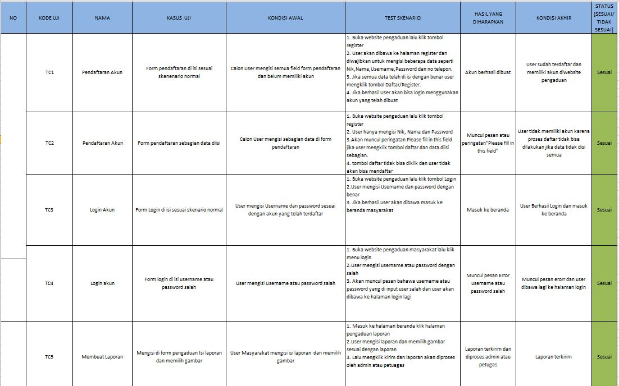

1. REVISI

|  |
| --- |
|  |

1. PENENTUAN DOMAIN DAN HOSTING
2. UPLOAD WEB KE HOSTING
3. UPLOAD WEB KE GITHUB