**Title:** Conception and implementation of a single window harmonization system for acquisition and provision of waste-water treatment plant data.

**Course:** Distributed Computing Systems Engineering

**Name of student**: Wojciech Lesnianski

**StudentNo**.: 1644612

**Name of supervisor**: Alireza Mousavi

**Background:**

Access to clean water is the most basic and fundamental type of the human infrastructure. The quality of life highly depends on the accessibility to clean water. 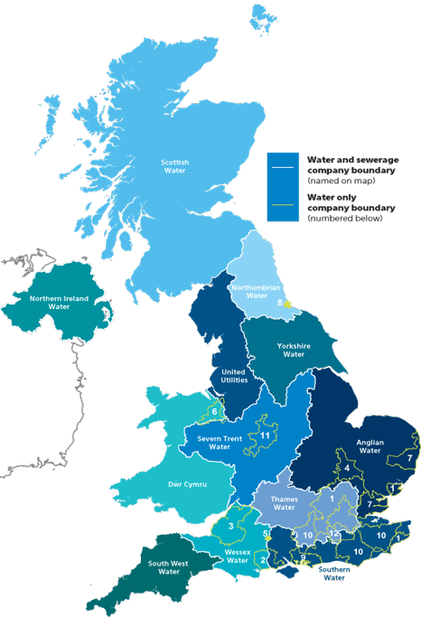

12 big water and sewage companies plus several water-only companies cover most of UKs water supply.

Tu jest obrazek ktore czesci UK ma ktora firma wody, zeby pokazac ze jest ich duzo I kazda operuje w swoim stylu.

(https://www.water.org.uk/consumers/find-your-supplier)

**Aims and Objectives:**

Creation of a single window system to make cooperative work between companies easier, as well as provide harmonized data to 3rd party systems and the public.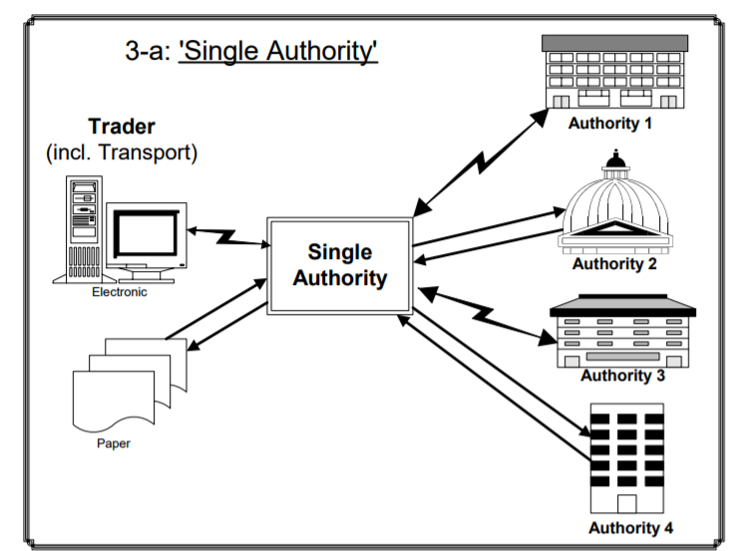

**Ten obrazek jest strasznie brzydki, ten computer po lewej ma byc oczyszczalnia te texty po lewej na dole maja byc “historical data” a to po prawej moze byc “Authority (np taki firmowy domek)” “Public (np czlowiek)” I “3rd party system” (np computer)**

**Na obrazku ogolnie w srodku ma byc moj system, po lewej rzeczy z ktorych biore dane (oczyszczalnie I historyczne dane z jakis exceli I bazy danych) a po prawej ludzie I systemy ktore beda braly potem te dane z mojego system (inne systemy, normalni publiczni ludzie I jakies firmy rzadu (np))**

**Experimental work:**

Even though a data format is recommended, we expect the worst case and thus need a way to deal with different data formats. How do we get the data into our harmonized system anyway?

1. Removing all data which is recognized as unnecessary data
2. Harmonize the remaining data into the predefined data-schema
3. Remove the data still unrecognized after the harmonization
4. Standardize the harmonized data

Ogolny opis jak dziala system, ktore kroki trzeba zrobic zeby dzialalo jak ma

**Project Plan:**

**System Architecture:**

The architecture is split into components to make iterative development easier. The components are integrated into the system one by one.

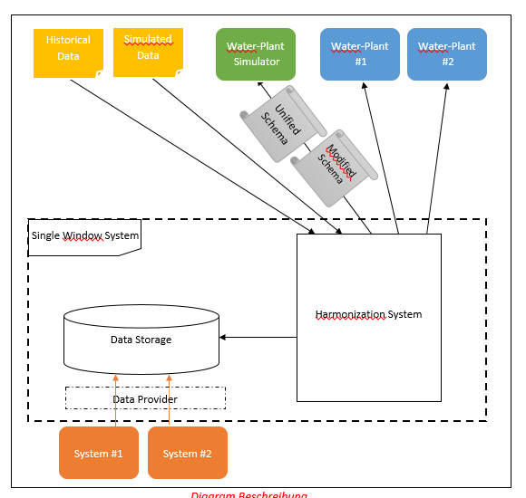

**Gantt chart**

**(praktycznie pokazuje co ile czasu mi ma zajac po lewej widac nazwe zadania a balki pokazuja ile na to zadanie mam czasu (dokladne daty po lewej)**

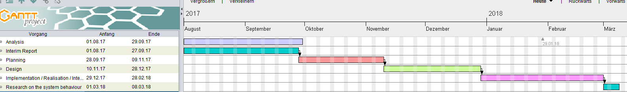

**Future Work:**

* Investigate on the behavior of the system with a simulator
* Define what is needed to make the system work with real-world
* Describe the major problems which need to be solved to provide a better solution