SMART INDIA HACKATHON 2026
Gram-Disha — PROBLEM-TO-SOLUTION WORKBOOK
AI-DRIVEN HYPER-LOCAL BUSINESS ADVISORY AND FINANCIAL STRUCTURING ASSISTANT FOR RURAL MICRO-ENTREPRENEURS
Team Name | Gram-Disha Team
Problem Statement ID | SIH26091
Problem Statement Title | AI-Driven Hyper-Local Business Advisory and Financial Structuring Assistant for Rural Micro-Entrepreneurs
Target context | Rural and semi-urban microenterprise decision support; concessional scheme navigation; financial structuring
Submission principle
Transparent decision support, not a success predictor. Public evidence is labelled by source, geographic level and vintage; calculations and scheme matching are deterministic; missing or weak evidence increases uncertainty and can trigger abstention.
[VERIFIED / DERIVED / PROXY / USER-REPORTED / ASSUMPTION / PROPOSED / UNKNOWN / BLOCKED] labels are retained throughout the workbook.
TEAM RULE: Understand the problem → identify users → find the root cause → study existing solutions → find the gap → define the USP → then choose technology.

INDEX
SECTION | WORKBOOK PURPOSE
01 | Problem Understanding
02 | Problem Decomposition
03 | Root Cause Analysis — 5 WHY
04 | Stakeholder & User Identification
05 | User Persona
06 | Data & Information Mapping
07 | Solution Ideation — Think Beyond Technology
08 | Idea Combination & Concept Building
09 | Existing Solution Research
10 | Gap Identification
11 | Unique Value Proposition (USP)
12 | Solution Blueprint & Flow
13 | Demo / Prototype Plan

01. PROBLEM UNDERSTANDING
Rural micro-entrepreneurs often make enterprise decisions without a structured way to connect local context, financial feasibility and concessional scheme rules. The core gap is not a lack of information in isolation; it is the absence of an accessible bridge that organizes fragmented evidence into an understandable decision workflow.

COLOR | PERSPECTIVE | GUIDING QUESTION | TEAM ANALYSIS / GROUND REALITY
RED | Problem | What is going wrong? | Anecdotal or copycat enterprise selection; limited localized market context; financial-literacy barriers around margin, debt, cash flow and repayment timing.
BLUE | Users | Who is affected? | Rural micro-entrepreneurs, women/SHG participants, scheme-category beneficiaries, SCA field teams, district officers and VLE/CSC intermediaries.
GREEN | Data | What evidence exists? | LGD village identity; Census 2011; PMGSY/GeoSadak habitation proxy; OSM context; AGMARKNET market data for applicable categories; district socioeconomic proxies; scheme rules.
YELLOW | Expected outcome | What should improve? | Better-informed enterprise selection, clearer financial structuring, safer scheme navigation and more transparent institutional review.
PURPLE | Constraints | What must be handled? | Stale/coarse data, coordinate uncertainty, intermittent connectivity, language/digital barriers and zero tolerance for arithmetic hallucination.
Evidence boundary: impact such as reduced failure/default is a future validation question, not an achieved result. [PROPOSED / UNKNOWN]

01. PROBLEM UNDERSTANDING — CONTINUED
The practical challenge is a chain of disconnected decisions: “What should I start?”, “Can I afford it?”, “Which scheme fits?”, “When will cash begin?”, and “Why does the system recommend this?” Gram-Disha treats these as one decision journey while keeping evidence and uncertainty visible.

02. PROBLEM DECOMPOSITION
NO. | SUB-CHALLENGE | SYSTEMIC EFFECT / RESPONSE
1 | Anecdotal enterprise selection & local saturation | Copycat choices can ignore local supply-demand conditions. The system uses evidence-led candidate generation and flags missing competitor evidence rather than claiming complete competition data.
2 | Geographic blindness | Viability depends on local access, market reach and spatial context. LGD identity, Census context, PMGSY habitation proxy and OSM are combined with explicit geographic labels.
3 | Financial structuring & margin confusion | Users may confuse available cash with total project scale. The financial engine models user contribution, project cost and debt only under the applicable scheme rule.
4 | Scheme routing & rule confusion | Different scheme categories can have different rates, tenure, margin and moratorium provisions. The rule engine is versioned and returns potentially eligible / not eligible / unknown.
5 | Cash-flow vs repayment timing | Repayment needs to be evaluated against setup and operating assumptions. The financial engine exposes scenarios and repayment timing rather than promising outcomes.
6 | Language & digital literacy | Formal forms and jargon create access barriers. MVP is text-first; regional-language and voice interfaces are later implementation layers.
7 | Pre-sanction feasibility visibility | Institutional reviewers need a reproducible view of assumptions, evidence and calculations. The system produces an explanation and audit trace.
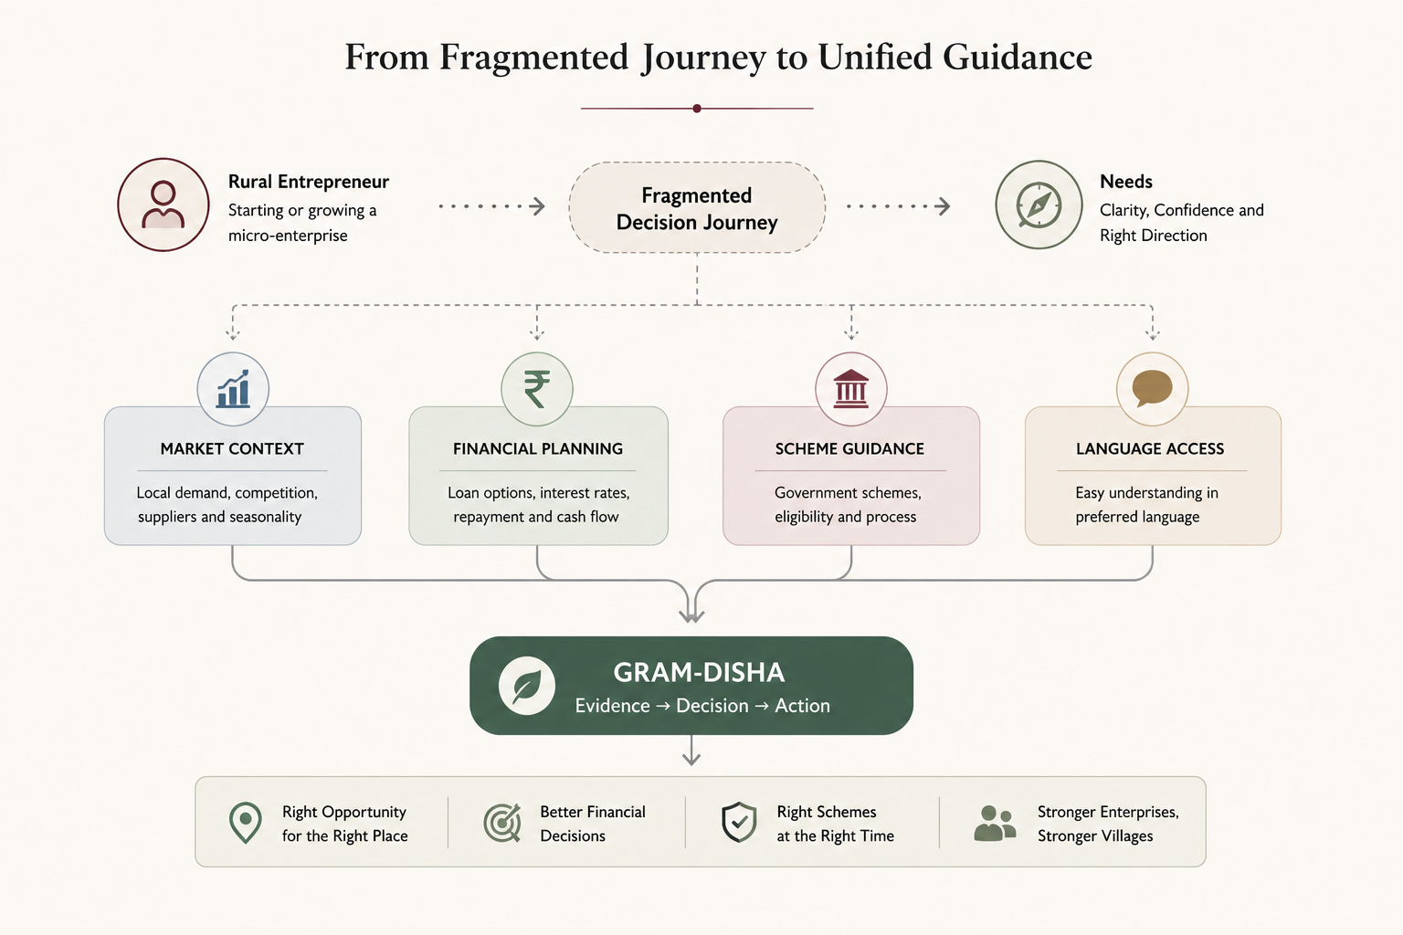
Visual is a workflow model of the problem system, not a measured failure-rate chart. [DERIVED / PROPOSED]

03. ROOT CAUSE ANALYSIS — 5 WHY

LEVEL | CAUSAL CHAIN
WHY 1 | Some entrepreneurs choose ventures without sufficient local or financial assessment.
WHY 2 | Localized demand, competition and unit economics are difficult to access through existing public tools.
WHY 3 | Formal feasibility consulting is costly or unavailable at village level.
WHY 4 | Existing digital systems commonly prioritize registration, application or transaction workflows rather than integrated pre-decision guidance.
WHY 5 | Spatial, economic, financial and scheme-rule evidence is fragmented across different sources and is not routinely assembled into one multilingual, deterministic decision-support workflow.

ROOT CAUSE IDENTIFIED
Absence of an accessible, evidence-backed advisory bridge connecting grassroots entrepreneurial intent with localized business context, deterministic financial structuring and concessional scheme rules. [DERIVED — Five-Why chain; not claimed as the sole root cause]

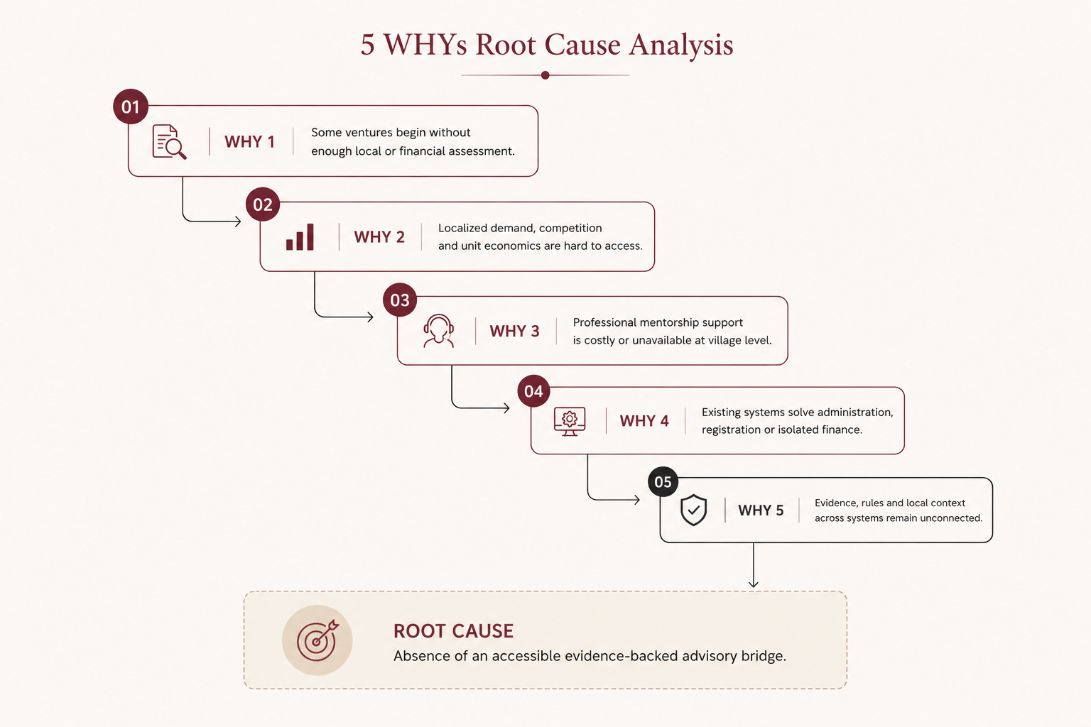

04. STAKEHOLDER & USER IDENTIFICATION
STAKEHOLDER / USER | ROLE | PAIN POINT | CORE NEED
Rural beneficiary | Primary enterprise operator | Limited business context and finance/scheme understanding | Simple evidence-backed feasibility + financial + scheme guidance
Women SHG / community entrepreneur | Primary user; scheme structure may differ | Individual vs group pathways can be confusing | Clear eligibility gating and documentation guidance
SCA / channelizing agency | Concessional capital appraisal/disbursal | Manual scrutiny and inconsistent project narratives | Reproducible feasibility, assumptions and financial report
District welfare / field officer | Verification and recommendation | Poorly structured proposals | Traceable report with evidence and calculations
CSC / VLE | Assisted digital intermediary | Complex forms and calculations | Guided workflow for assisted applications

04. STAKEHOLDER & USER IDENTIFICATION — ECOSYSTEM
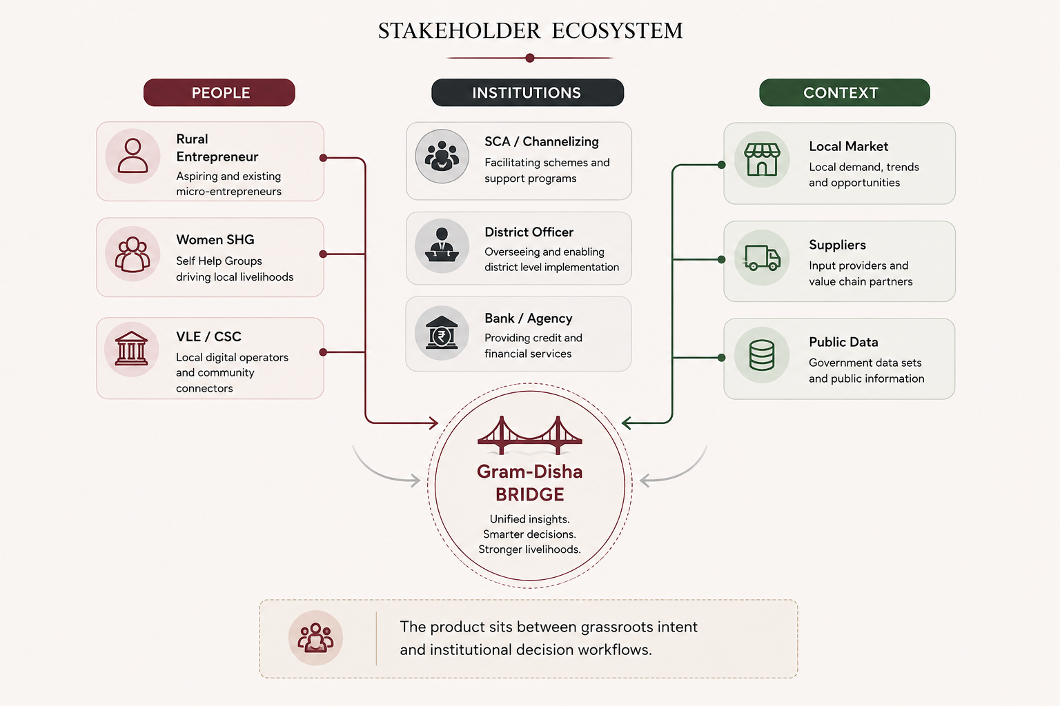
The ecosystem is intentionally broader than the final applicant. Gram-Disha is designed as decision support that can be used directly by a beneficiary or in assisted mode by an institutional/intermediary user. It does not become the sanctioning authority.
05. USER PERSONA
Illustrative persona — used to test whether the workflow answers a real decision sequence. This is not a real individual and does not establish a measured population segment.
DIMENSION | ILLUSTRATIVE PROFILE
Persona | Ramesh Kumar — aspiring rural dairy entrepreneur [SIMULATION / ILLUSTRATIVE]
Age / education | 28 years; 10th-standard educated [ILLUSTRATIVE]
Context | Rural/semi-rural cluster; first-time enterprise applicant [ILLUSTRATIVE]
Capital | Available capital entered by the user; no silent default in production [USER-REPORTED]
Goal | Choose a feasible enterprise, understand financing structure and prepare a clear project plan.
Pain points | Uncertainty about local demand, competition, project cost, repayment timing and scheme pathway.
Needs from Gram-Disha | Location evidence, business options, deterministic financial calculation, scheme rule matching, explanation and confidence/uncertainty.

PERSONA DECISION LADDER

QUESTION | SYSTEM RESPONSE
“Is this business locally plausible?” | Evidence layer + category-specific demand/accessibility context
“Can I finance it?” | Financial engine + scenario analysis
“Which scheme may fit?” | Versioned scheme engine → POTENTIALLY_ELIGIBLE / NOT_ELIGIBLE / UNKNOWN
“Why this recommendation?” | Contribution trace + sources + assumptions + uncertainty

06. DATA & INFORMATION MAPPING
Gram-Disha uses a source-bound evidence architecture. The source is not treated as a universal truth: every layer retains its geographic level, temporal vintage, access method and confidence.
DATA LAYER | PRIMARY SOURCE | ACCESS / VINTAGE | ROLE / LIMITATION
Village identity / code | LGD | Bulk directory; ongoing registry | Authoritative identity/join key; not a measure of current population or purchasing power.
Village demographics | Census 2011 | Village-level; 2011 | Population/household/demographic context; latest available village census, therefore stale.
Habitation location | PMGSY / GeoSadak | Government survey records; coverage requires reconfirmation | Approximate habitation proxy; never relabel as exact village coordinate.
Roads / POIs | OpenStreetMap | As-mapped; community sourced | Spatial context; completeness varies; not a complete competitor registry.
Market prices | AGMARKNET | Market-level; frequent/daily where available | Category-gated market reference; not village price or village demand.
Socioeconomic proxy | NITI MPI / NFHS-5 | District; 2019–21 | District-level context; not village income/purchasing power.
Climate | IMD gridded data | Grid / historical | Regional climate exposure proxy; not village measurement.
Scheme rules | Official scheme documents / Track A.1 register | Versioned; verified for research baseline | Deterministic rule inputs; final agency verification remains required.
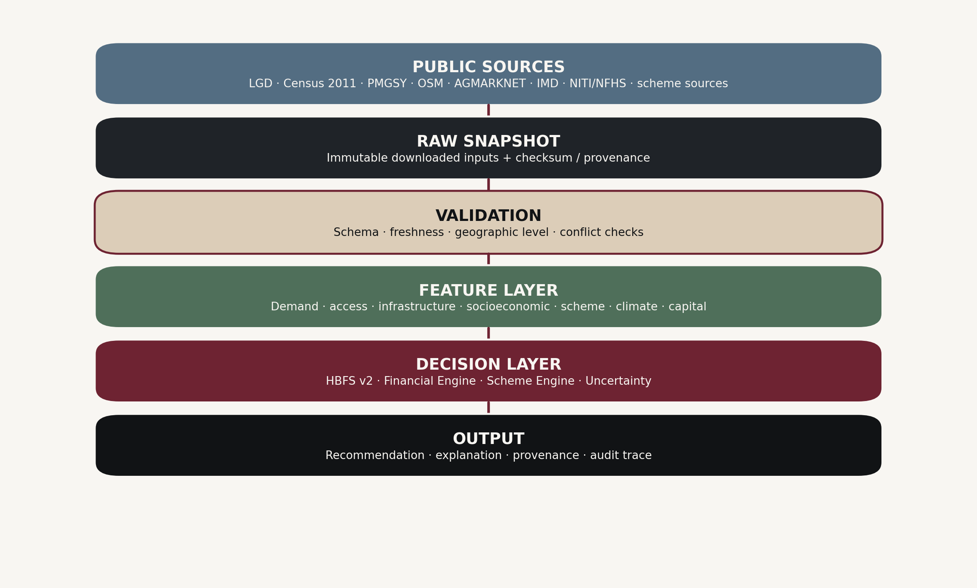
Source registry principle: Raw source → snapshot → validation → canonical data → feature → normalized feature → recommendation. [DERIVED]

06. DATA & INFORMATION MAPPING — EVIDENCE BOUNDARY
SOURCE | WHAT IT ESTABLISHES | GEOGRAPHIC LEVEL | TEMPORAL LANGUAGE | MVP USE
LGD | Standardized local-government/village identity | Village | Ongoing / registry | YES
Census 2011 | Village demographic context | Village | 2011; latest available village census | YES
PMGSY/GeoSadak | Habitation/road survey context where available | Habitation / infrastructure record | Coverage vintage must be shown | YES, caveated
OSM | Community-mapped roads/POIs | As-mapped spatial context | As mapped | YES, cached
AGMARKNET | Market-level commodity prices | Market | Daily/frequent where available | YES, category-gated
NITI MPI / NFHS-5 | Socioeconomic/deprivation indicators | District | 2019–21 | YES, proxy
IMD | Gridded climate context | Grid | Historical | CONDITIONAL
BharatNet | Connectivity programme context | Gram Panchayat | Current reports where available | CONDITIONAL / proxy
RBI / TRAI | Macro/state financial or telecom context | State / national / circle | Varies | OPTIONAL; not village evidence

GEOGRAPHIC SCALE RULE
The architecture never converts one geographic level into another. LGD village identity is a join key; PMGSY habitation is a coordinate proxy; BharatNet is GP-level; NITI/NFHS is district-level; IMD is gridded; AGMARKNET is market-level. A feature requiring a finer location than the evidence supports becomes UNKNOWN or is explicitly downgraded.

FEATURE | ALLOWED WORDING | FORBIDDEN WORDING
Coordinate | Approximate habitation location from government survey | Exact village coordinate
Connectivity | GP-level connectivity proxy | Village internet connectivity
Socioeconomic | District socioeconomic proxy | Village purchasing power / village income
Climate | Gridded regional climate exposure proxy | Village climate measurement
Market price | Market-level price reference | Village price / village demand
This scale discipline is a core product requirement, not a footnote.

07. SOLUTION IDEATION — THINK BEYOND TECHNOLOGY
IDEA | WHAT CHANGES | WHY IT MATTERS
Margin-first onboarding | Start with available capital and location before building an enterprise budget. | Anchors recommendations in financial reality and prevents silent assumptions.
Evidence-first local context | Resolve location and gather source-labelled market, spatial and socioeconomic context. | Moves advice from generic suggestions to traceable local decision support.
Deterministic finance | Keep EMI, DSCR, break-even and scheme calculations outside the LLM. | Protects arithmetic integrity and makes outputs reproducible.
Versioned scheme routing | Match user/business facts against versioned rule conditions. | Avoids presenting an informational match as government eligibility.
Uncertainty + abstention | Expose missingness, proxy confidence and source disagreement. | Prevents the interface from manufacturing certainty when evidence is weak.
Assisted access | Design for VLE/CSC-assisted use; voice can be added later. | Addresses digital-literacy constraints without making unverified voice capability an MVP dependency.
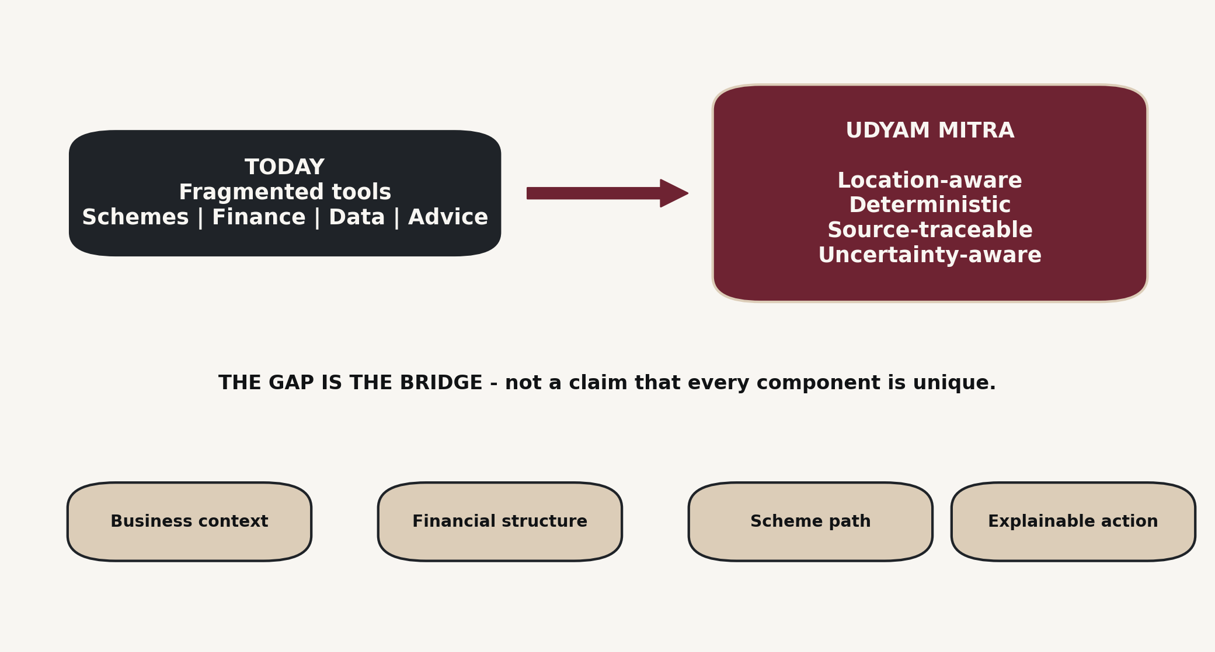
08. IDEA COMBINATION & CONCEPT BUILDING

EVIDENCE | FINANCIAL | SCHEME | ACCESS / GOVERNANCE
Location + market context | Deterministic calculations | Versioned rules | Multilingual interface + uncertainty
Census / OSM / PMGSY / AGMARKNET where applicable | EMI / DSCR / break-even / ROI | Potentially eligible / not eligible / unknown | Provenance / audit / abstention

CORE SOLUTION CONCEPT
Gram-Disha is an evidence-backed rural microenterprise decision-support system that combines localized public-data context, deterministic financial structuring, versioned scheme-rule matching and transparent uncertainty reporting in a multilingual interface. [PROPOSED]

09. EXISTING SOLUTION RESEARCH
The ecosystem already contains strong components. The research gap is structural integration rather than the absence of all existing services.
EXISTING SOLUTION / CATEGORY | PRIMARY FUNCTION | STRENGTH | STRUCTURAL LIMITATION / SAFE CLAIM
JanSamarth / government scheme portals | Scheme discovery / application workflows | Government-linked scheme/application pathways | Does not, in this workbook, establish a complete hyperlocal feasibility workflow. Current 2026 competitor feature verification remains [BLOCKED].
Udyam / Udyam Assist | Business formalization / registration | Official registration pathway | Registration is not the same as pre-decision feasibility or financial structuring.
Generic AI assistants | Conversational advice / explanation | Flexible language and broad knowledge | May overlap conceptually; source-bound village evidence and deterministic scheme/finance controls must be supplied by the application.
Accounting / project-report software | Financial records / DPR preparation | Structured accounting outputs | Often assumes the user already has the business inputs and financial knowledge; pricing/market context is outside scope.
Agri / marketplace platforms | Market or commerce functions | Domain-specific data/services | Do not necessarily integrate rural enterprise feasibility, scheme rules and uncertainty into one workflow.
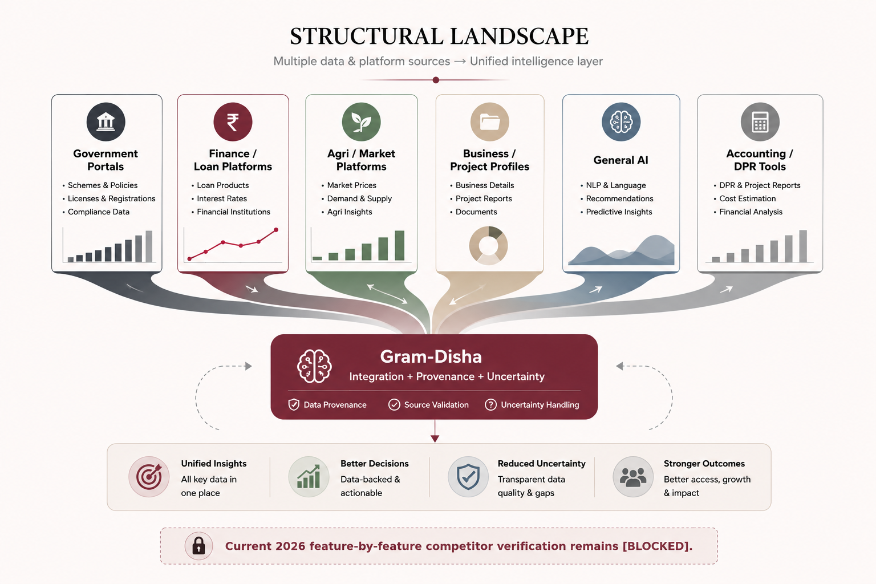
Competitor visual is a category map, not a current-2026 superiority claim. [BLOCKED for live competitor forensics]

SAFE POSITIONING
“Preliminary analysis identifies overlapping components across government portals, agri platforms, fintech/financial tools and general AI. Current 2026 feature verification remains pending.” [BLOCKED / SAFE WORDING]

10. GAP IDENTIFICATION
OBSERVED STRUCTURAL GAP | WHAT THE RESEARCH SUPPORTS | Gram-Disha RESPONSE
Fragmented information | Location, market, finance and schemes are distributed across different systems. | Evidence layer with source, vintage and geographic level preserved.
Lack of integrated location-aware context | Public sources provide different pieces at different spatial scales. | Location resolution + spatial context with explicit proxy/UNKNOWN behavior.
Financial and scheme confusion | Scheme rules can be difficult to translate into a user-specific financial structure. | Deterministic financial engine + versioned rule engine.
Uncertainty hidden by generic advice | A recommendation can appear more certain than its evidence. | U score, confidence labels, assumptions and abstention policy.
Language/access barrier | Formal digital workflows can be difficult for users with lower digital literacy. | Simple MVP interface; multilingual/voice layers are future implementation.
No outcome validation | There is no outcome dataset supporting predictive accuracy. | Position as decision support; collect pilot outcomes before calibration.
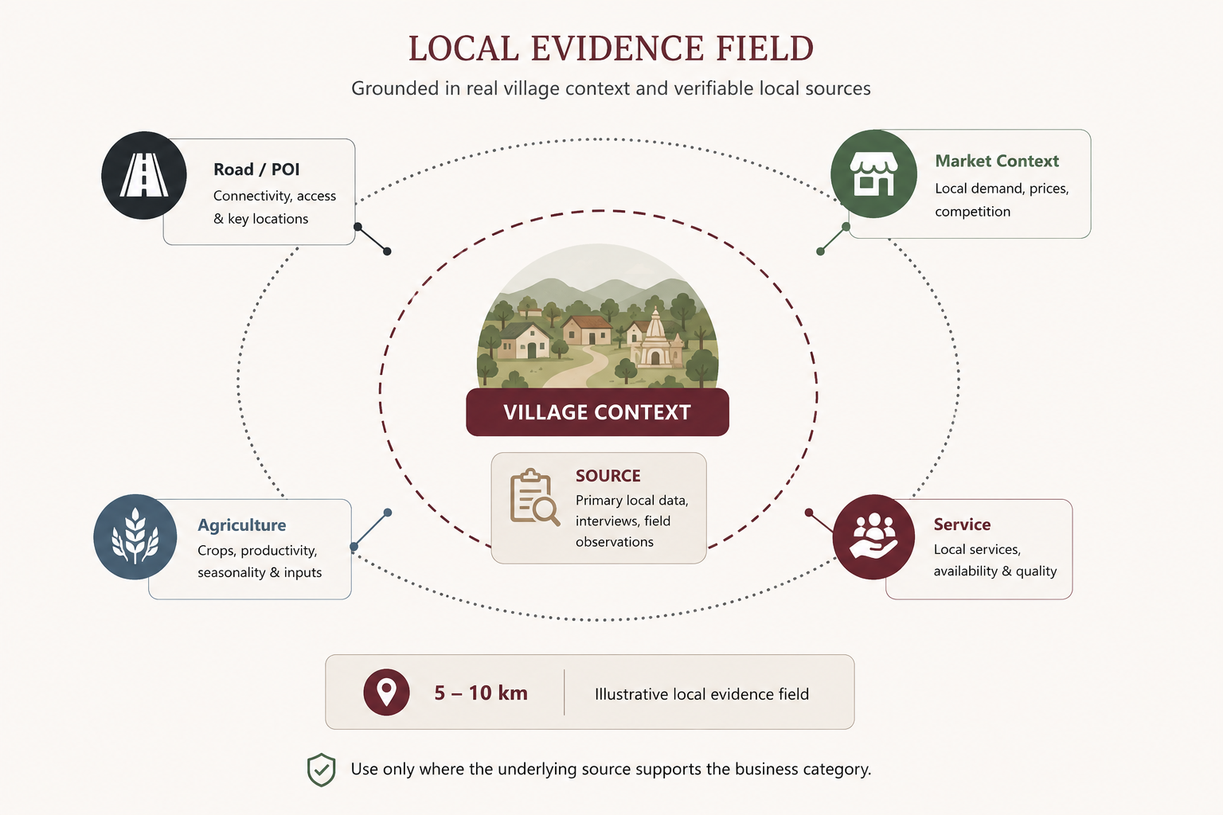

HYPERLOCAL RADIUS PRINCIPLE
A spatial radius is a method for organizing available evidence around a location; it is not proof that every competitor, buyer or supplier inside the radius is observed. The MVP therefore displays evidence coverage and limitations instead of claiming complete 5–10 km market intelligence.

TAM / SAM / SOM — MARKET-SIZING FRAME
TAM | SAM | SOM
All rural micro and small businesses that could potentially use digital business/financial decision support. | Targetable businesses within chosen geography, supported languages, connectivity and business categories. | Initial pilot population that the team can realistically reach; use a validated acquisition target rather than claiming market share.

11. UNIQUE VALUE PROPOSITION (USP)
KEY QUESTION | ANSWER
Problem we solve | Fragmented rural business decision support — location, finance and scheme guidance are difficult to use together in one evidence-grounded workflow.
Who benefits | Rural microentrepreneurs and supporting institutional actors such as SCA officers, VLEs and field teams.
What we do differently | Integrate evidence, location context, deterministic financial rules, verified scheme rules and explicit uncertainty into one workflow.
Why it is better | Not because it is “more intelligent” than general AI; because the workflow is source-bound, reproducible and transparent.
Expected impact | Potential areas: better-informed enterprise selection, clearer financial understanding, more structured applications and transparent institutional review. Quantitative outcomes require pilot validation.
One-line USP | Gram-Disha turns fragmented public evidence and financial rules into transparent, multilingual decision support for rural microenterprise planning.
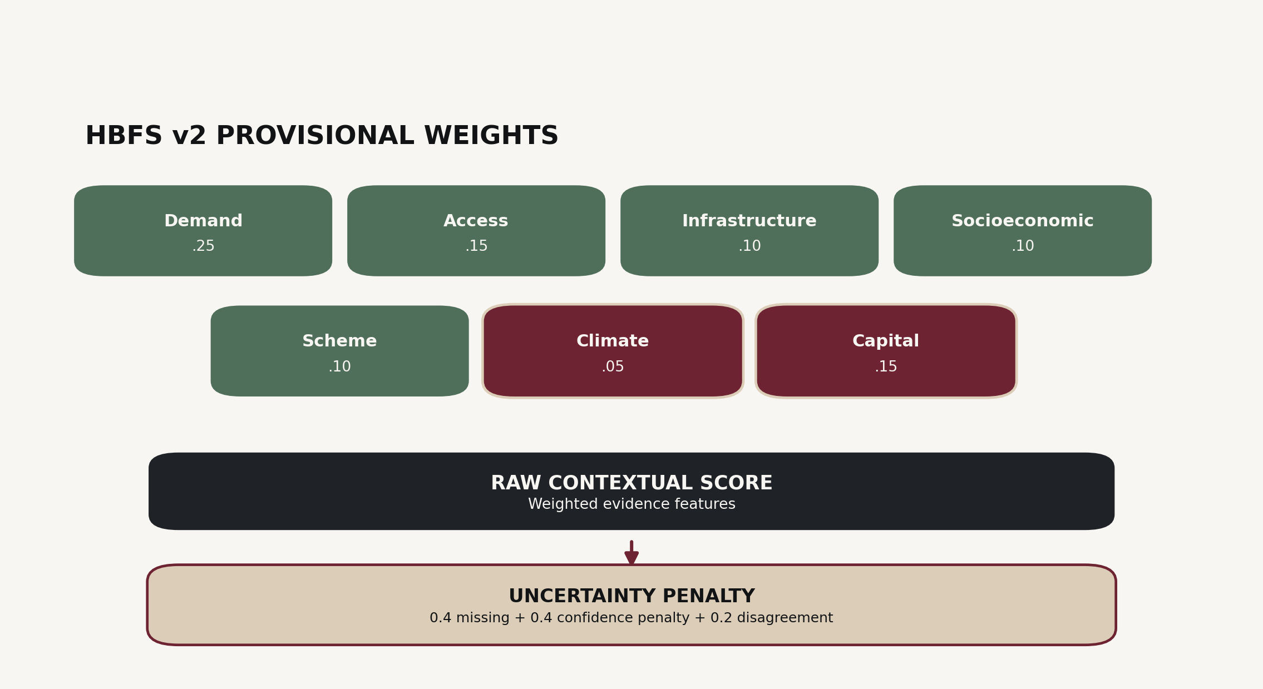

HBFS v2 — DECISION-SUPPORT INDEX
HBFS_v2 = 0.25·Demand + 0.15·Accessibility + 0.10·Infrastructure + 0.10·Socioeconomic + 0.10·Scheme − 0.05·Climate − 0.15·Capital − 0.20·U
All seven feature values are normalized to [0,1]; positive features increase the raw score, penalty features are subtracted, and U ∈ [0,1] penalizes missingness, proxy weakness and source disagreement. Weights are provisional literature-based priors, not empirically calibrated. [PROPOSED]

IMPACT & BENEFITS
AREA | EXPECTED CONTRIBUTION | EVIDENCE BOUNDARY
Economic | Better-informed enterprise selection, financial planning and access to understandable scheme guidance. | Outcome improvement is a future pilot question.
Social | Supports underserved rural entrepreneurs and assisted users through simpler decision support. | Accessibility benefit is a design objective, not a measured outcome.
Financial | Clarifies project cost, debt, repayment, break-even and scenario trade-offs. | Projections depend on input assumptions; no profit guarantee.
Institutional | Creates a structured evidence and calculation trail for review. | Institutional time/NPA impact is not yet measured.

SDG ALIGNMENT
SDG 1 — No Poverty • SDG 8 — Decent Work & Economic Growth • SDG 9 — Industry, Innovation & Infrastructure • SDG 10 — Reduced Inequalities • SDG 12 — Responsible Consumption & Production

12. SOLUTION BLUEPRINT & FLOW
The end-to-end workflow keeps the LLM at the interface layer while deterministic code owns calculations, scoring, eligibility matching, provenance and audit.
STAGE | INPUT / PROCESS / OUTPUT
1 • USER | Location + available capital + skills + business intent [USER-REPORTED]
2 • LOCATION | LGD identity → Census cross-reference → PMGSY habitation proxy → OSM spatial context
3 • EVIDENCE | Census / OSM / PMGSY / AGMARKNET (where category-gated) / NITI-NFHS / IMD / scheme sources
4 • BUSINESS | Evidence-tiered catalog → candidate generation → capital/geographic/data checks
5 • DECISION ENGINES | HBFS v2 contextual score + deterministic financial engine + versioned scheme engine
6 • UNCERTAINTY | Missingness + proxy confidence + source disagreement → U; GREEN/YELLOW/ORANGE/RED
7 • EXPLANATION | Contributions + sources + assumptions + limitations + recommendation trace
8 • ACTION | Structured feasibility/financial report for user and, where applicable, institutional review
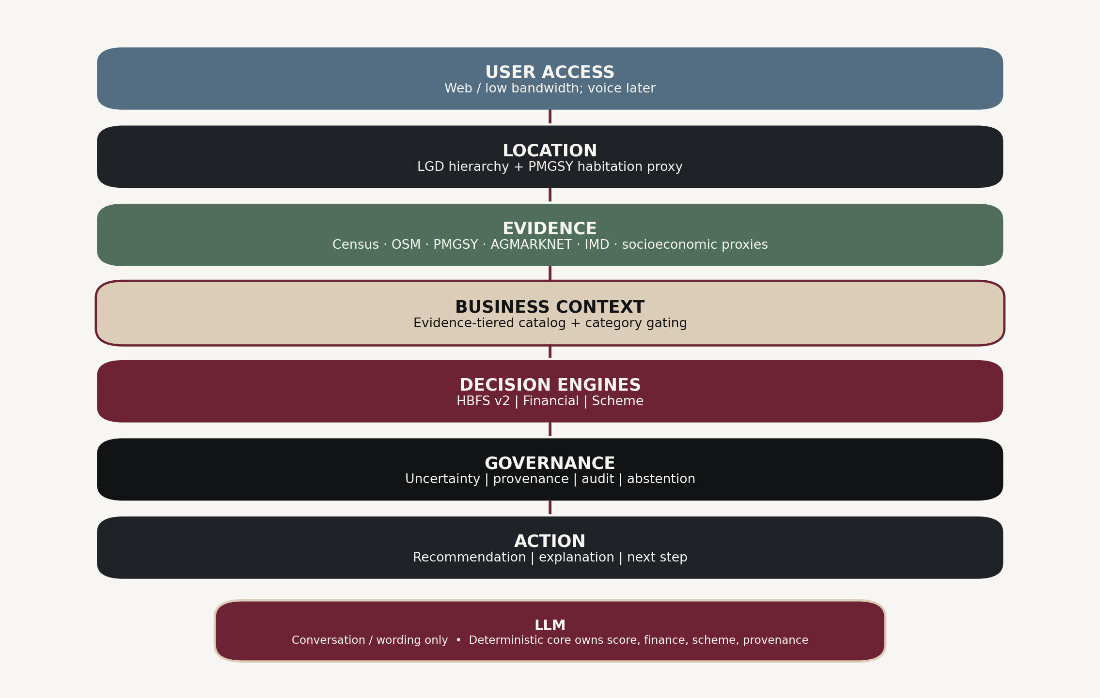
LLM boundary: conversation / translation / wording only. Deterministic core owns score, finance, scheme, provenance and audit. [PROPOSED ARCHITECTURE]

12. SOLUTION BLUEPRINT & FLOW — FINANCIAL + SCHEME LOGIC
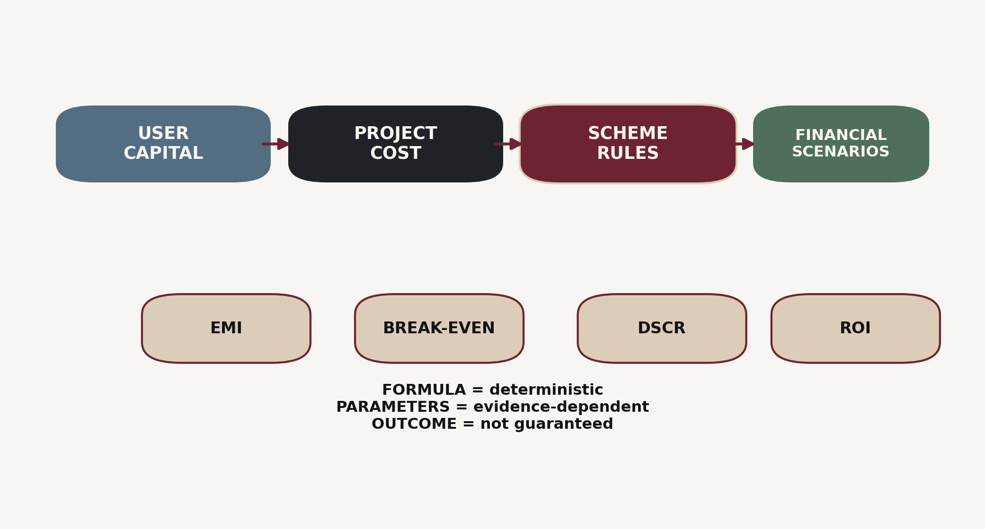

FINANCIAL ENGINE
Deterministic formulas include EMI, DSCR, break-even and ROI. Parameters such as revenue, costs, margin and working-capital assumptions are evidence-dependent. Scenarios are evidence-backed where lower/base/upper assumptions exist; otherwise illustrative sensitivity is explicitly labelled. No universal loan formula is used when scheme-specific rules differ.
OUTPUT | RULE / INTERPRETATION
EMI | P × r × (1+r)^n / ((1+r)^n − 1), with scheme-appropriate periodic rate and repayment periods.
DSCR | Net Operating Income / Debt Service. Thresholds are decision-support conventions unless a governing lender rule specifies otherwise.
Break-even | Fixed Cost / (Price − Variable Cost), with edge-case checks for zero/negative contribution margin.
ROI | Annual Net Profit / Total Investment; a projection metric, not a guarantee.
Scenario modes | Evidence-backed range when sourced; otherwise explicitly illustrative sensitivity (e.g., ±20%). Never label illustrative values as percentiles.
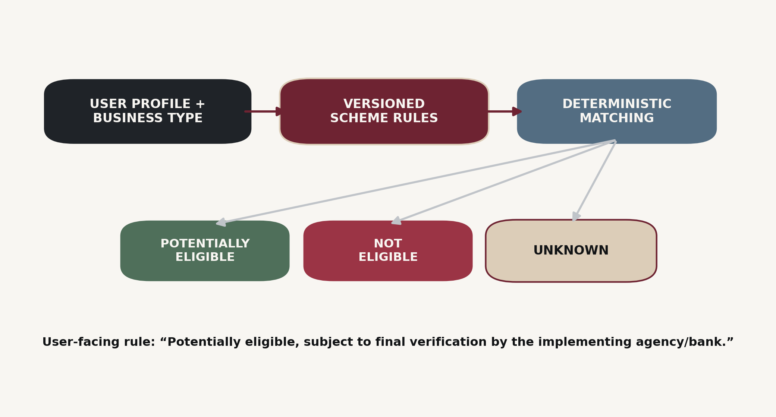

SCHEME ENGINE
The engine evaluates tracked conditions such as beneficiary category, business type, project-cost range and other available user facts. Missing critical information yields UNKNOWN. The output is never “government eligible”; it is POTENTIALLY_ELIGIBLE, NOT_ELIGIBLE or UNKNOWN, subject to final verification by the implementing agency/bank.

FEASIBILITY • VIABILITY • SCALABILITY • SUSTAINABILITY • LONGEVITY
DIMENSION | MVP VIEW
Feasibility | Core components—web UI, public-data ingestion, deterministic calculations, Postgres/PostGIS and Python services—are implementable with available open-source tooling. Voice is not an MVP dependency.
Viability | Potential B2G pilot/contract, B2B/API partnerships and free basic B2C access with later premium services; neutrality should be preserved by avoiding conflicted referral incentives.
Scalability | Begin with one district/pilot geography; expand by adding source adapters, languages, business categories and scheme rules without changing the core evidence/provenance model.
Sustainability | Digital reports, evidence reuse and better planning can reduce avoidable paperwork and waste; sustainability outcomes require measurement.
Longevity | Versioned source and scheme updates plus pilot outcome collection create a path from provisional v2 decision support to later validated model versions.

MVP COST ESTIMATION
COMPONENT | PROTOTYPE ESTIMATE
UI/UX + mobile/web development | ₹20,000
Backend + database | ₹15,000
AI/ML integration | ₹25,000
Cloud/API services | ₹10,000
Market-data integration | ₹10,000
Testing + security | ₹10,000
ESTIMATED MVP TOTAL | ₹90,000
Prototype-level planning estimate supplied for presentation; not a commercial deployment quote. Scale costs rise with infrastructure, model usage, data, security, maintenance and compliance.

12. SOLUTION BLUEPRINT & FLOW — PROVENANCE & GOVERNANCE

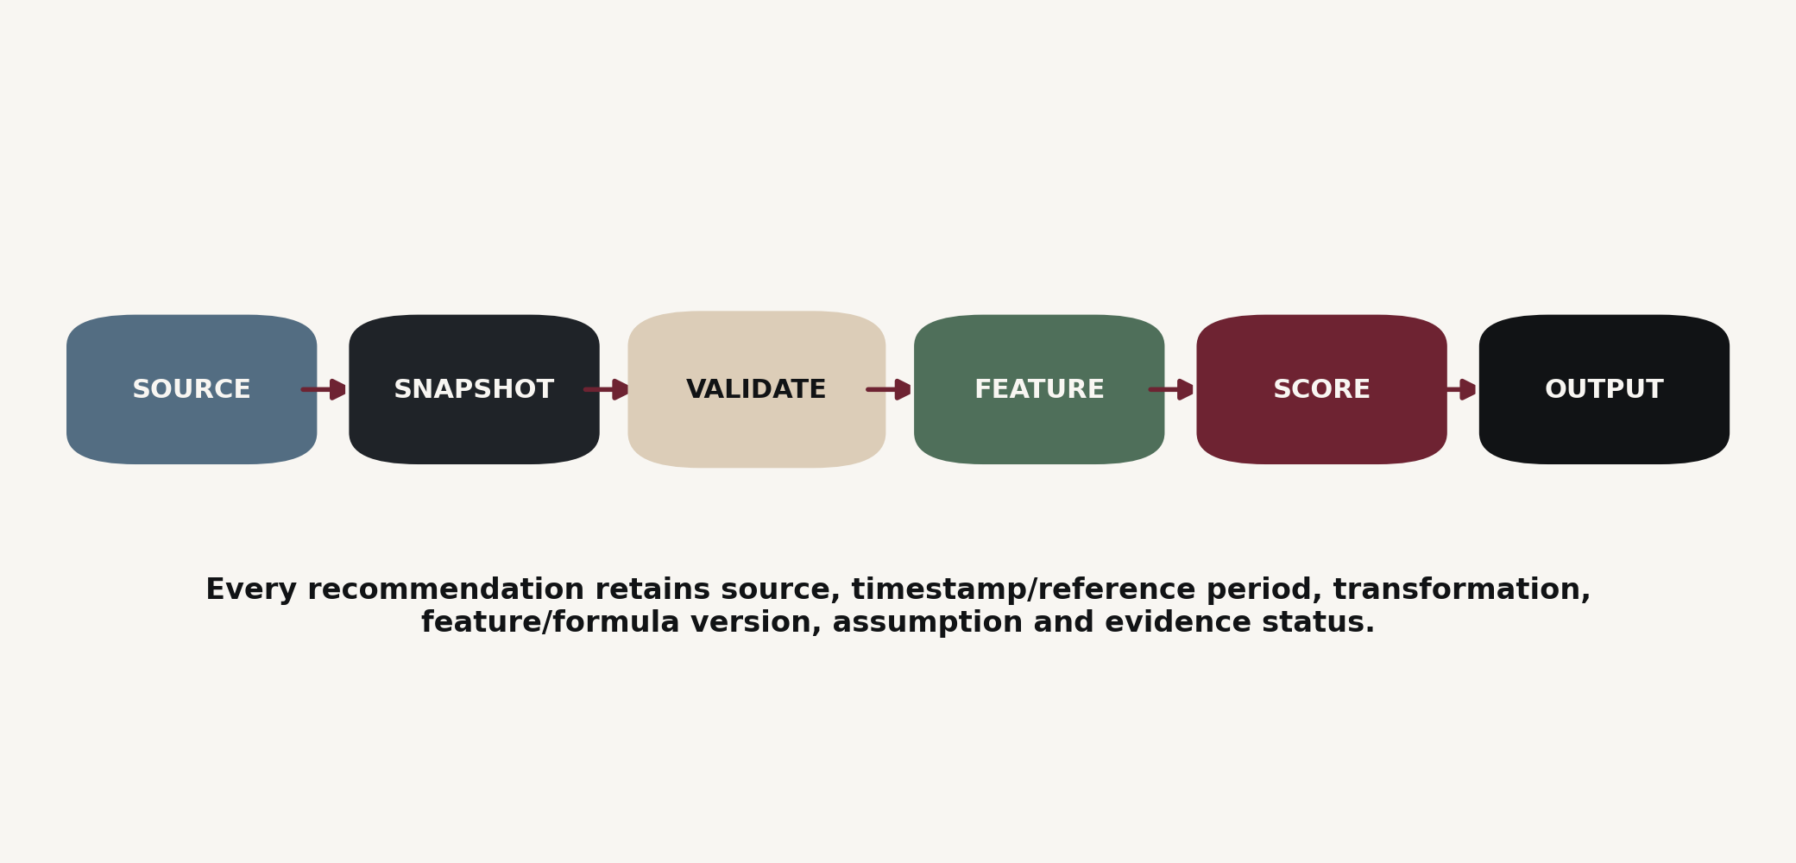

PROVENANCE CHAIN
Every recommendation is reproducible from the source snapshot and transformation path: raw source → snapshot → validation → canonical data → feature → normalization → HBFS/financial/scheme output → explanation. Formula version and feature version are retained with the run.
GOVERNANCE CONTROL | IMPLEMENTATION RULE
Evidence status | Never upgrade PROXY / ASSUMPTION / USER-REPORTED into VERIFIED.
Unknown handling | UNKNOWN is not zero; missing evidence increases uncertainty or causes abstention.
Coordinate integrity | coordinate_level ∈ HABITATION / BLOCK_CENTROID / DISTRICT_CENTROID / UNKNOWN; never fabricate village precision.
Uncertainty | U = 0.4·missingness + 0.4·proxy confidence penalty + 0.2·source disagreement.
Abstention | GREEN <0.2; YELLOW 0.2–<0.4; ORANGE 0.4–<0.6; RED ≥0.6 or coverage <30%. Thresholds are proposed policy.
LLM guardrail | LLM cannot write deterministic values or directly modify scheme rules, scores, financial calculations or provenance.
The uncertainty model is a governance mechanism, not a probability of business success.

APPROVED CLAIM LANGUAGE
APPROVED CLAIMS | BOUNDARY
“Uses the official LGD village registry.” | “Census 2011 is the latest available village census used in the MVP.”
“Approximate habitation location from government survey.” | “Market-level price reference; not a village price.”
“Potentially eligible, subject to implementing-agency/bank verification.” | “Deterministic scenarios based on published or explicitly labelled assumptions.”
“HBFS v2 uses provisional literature-based weights and is not empirically validated.” | Current-2026 competitor functionality remains [BLOCKED]. Outcome validation remains [UNKNOWN].
13. DEMO / PROTOTYPE PLAN
The SIH demonstration should prove the core USP through a traceable journey rather than a collection of disconnected screens.
STEP | WHAT IS SHOWN | WHAT IT PROVES / EVIDENCE
1 | User searches/selects a village using LGD-backed lookup. | Location identity and join-key foundation. [VERIFIED]
2 | Resolved village / block / district identity plus Census 2011 stamp. | Correct geographic and temporal framing. [VERIFIED]
3 | PMGSY habitation point shown with “approximate habitation location” caveat. | Coordinate discipline; no false exact-village claim. [DERIVED/PROXY]
4 | OSM roads/POIs around the resolved location. | Community-mapped spatial context; coverage caveat. [PROXY]
5 | AGMARKNET evidence only for an applicable agri-linked business. | Market-level evidence, not village demand. [VERIFIED]
6 | Scheme engine shows POTENTIALLY_ELIGIBLE / NOT_ELIGIBLE / UNKNOWN with rule version. | Deterministic scheme matching; no guarantee. [VERIFIED RULE / OUTPUT DERIVED]
7 | Financial projection: project cost, user contribution, debt, EMI, DSCR, break-even, scenarios. | Arithmetic is deterministic; parameters are labelled.
8 | HBFS v2 score + U + evidence coverage. | Transparent contextual ranking, not success prediction. [PROPOSED MODEL]
9 | Explanation with feature contributions, assumptions and sources. | Reproducibility and human-readable reasoning.
10 | Audit trace / run identifier. | Lineage and change accountability.
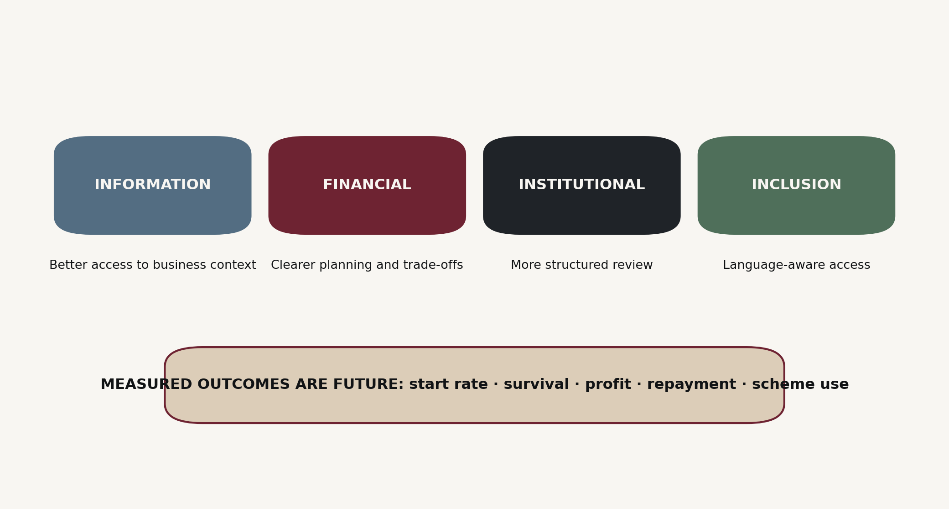

DEMO SAFETY LINE
“This demonstration shows how public evidence, deterministic financial rules and versioned scheme rules can be combined into transparent decision support. It does not predict business success or guarantee scheme eligibility or profit.”

FINAL IDEA SUMMARY — READY TO CONVERT INTO PPT
PRESENTATION BLOCK | FINAL CONTENT
1. Problem | Rural micro-entrepreneurs need accessible, localized decision support connecting enterprise choice, financial planning and scheme navigation.
2. Research gap | Existing services are fragmented across scheme discovery, registration, market services, accounting and general AI; the integration and evidence-governance layer remains the focus.
3. Solution | Gram-Disha: evidence-backed rural microenterprise decision support with location context, deterministic finance, versioned scheme rules and uncertainty.
4. Core workflow | Location → Evidence → Business context → HBFS + Financial + Scheme → Uncertainty → Explanation → Action.
5. Trust model | Source, date/vintage, geographic level, evidence class, assumptions and formula versions travel with the output.
6. Differentiation | Structural integration and governance: source-bound, deterministic, uncertainty-aware and abstention-capable.
7. MVP boundary | Text-first; one pilot geography; public data; no voice/IVR/WhatsApp dependency; no predictive claim; no live competitor claims.
FINAL PRODUCT POSITIONING
EVIDENCE-BACKED RURAL MICROENTERPRISE DECISION-SUPPORT SYSTEM
Not a loan approval system. Not a credit score. Not a government eligibility authority. Not a business-success predictor.

