Introduction
This report presents the project plan for the COMP1004 module coursework. The project has a focus on self-management and the use of time.

The project is a single-page pixel-art tower defence game called The Great Goblin War (Working Title). The aim is for players to place ‘towers’ in order to defend against enemies walking along a set path to prevent them from reaching the player’s ‘base’. Enemies will arrive in a set number of increasingly difficult ‘waves’, once all waves are defeated, the player will be able to progress to the next level and possibly gain a new tower or tower upgrade.

Within this Game Design Document the Software Development Lifecycle (SDLC) is discussed with an explanation of how this is applied to the current project. Following on from the project plan a design document is provided.

Software Development Lifecycle

This section discusses the Software Development Lifecycle (SDLC) and describes how this is being used in this particular project.

The planning phase for this project took place over a week. Only 2 ideas were considered for this project; the tower defence game, and a backup project should the game project seem unfeasible. The primary source of inspiration was the popular tower defence series ‘Kingdom Rush’, mostly for it’s use of pre-set locations to build towers, ability to trigger the next wave early for additional rewards, and system of having set archetypes of towers that are later customised and specialised.

Sprints:
Week 1: planning and research
Week 2: writing GDD
Week 2: Drawing and animating pixel-art sprites of Goblin characters
Week 3: Drawing pixel-art sprites of Towers and projectiles
Week 4: Drawing level background
Week 5: Coding welcome screen, main menu and level select
Week 6: Coding tower placement
Week 7: Coding Waves and enemy pathfinding (level 1, singular enemy type)
Week 8: -- Christmas break –
Week 9: Coding Tower detection of enemies and combat (1 tower)
Week 10: Final prototype testing and video presentation
Week 11: Mid-project submission
Week 12: Coding additional tower options
Week 13: Coding additional enemy types
Week 14: Coding Waves and enemy pathfinding (level 2)
Week 15: Coding Tower upgrade system
Week 16: Coding Waves and enemy pathfinding (Level 3)
Week 17: Drawing Tower specialisations
Week 18: Coding Tower specialisations
Week 19: -- Easter Break –
Week 20: Additional optional features (e.g. difficulty modes, additional tower options etc.)
Week 21: Final Testing
Week 23: Reflective account and poster
Week 24: Final Report

Design Document
This project will be coded using JavaScript, HTML and CSS. The game is intended to function on a single page. The game will primarily consist of classic tower-defence gameplay; placing and upgrading ‘towers’ to defend a base from increasingly difficult waves of enemies. This gameplay will use bright colours, upbeat music and cartoonish pixel-art characters, however at certain intervals, usually towards the end of a level, an enemy will drop a letter that the player can pick up by clicking it. When clicking this letter the music will suddenly change to something more sombre and dramatic, showing the letter with a more realistically drawn background using more muted colours as the player reads the contents of the letters. The letters will be used to portray the underlying story of the game. When closed, the game will immediately revert to it’s original style, utilising a sudden, unaddressed, dramatic shift in tone for comedic affect, inspired by similar joke scenes commonly used in 2000’s cartoons such as Spongebob Squarepants, The Marvellous Misadventures of Flapjack, and Chowder.

This project will utilise classes to standardise behaviours for similar objects, for example utilising an “enemy” class, with child objects for each enemy variation.

Background
Great Goblin War is a 2D pixel art tower defence game focusing on problem solving with the player needing to solve the problem presented within a set time frame. Problem solving is a crucial skill and research has found that those who play strategy and precision based games have improved problem solving and motor skills (Granic, 2014). These types of games have also been shown to enhance creativity in young people, improve people’s moods, promote relaxation and ward off anxiety (ibid).

Consideration must be given to legal, social and ethical issues relating to this project. Game assets, characters, sound effects and music for example must be conscious of ensuring the copyright of materials is recognised. Copyright free assets will be sought after for background music, all other assets will be made personally, based on artwork made and provided by commissioned concept artists. More complex visual assets (such as the detailed background used when reading letters) will be made by commissioned illustrators. The Copyright, Designs and Patents Act 1988 is the UK copyright law which protects creators works from unlawful usage of their material. It allows the creator to decide how their work may be distributed, meaning their work cannot be copied and distributed by another entity without explicit consent (Copyright, Designs and Patents Act 1988).

Based on descriptions outlined by PEGI (Pan European Game Information), the organisation in charge of video game age ratings in Europe and the UK, this game will be unsuitable to children under 7 due to images or scenes that may be potentially frightening to young children (the letter reading scenes) and mild cartoon violence.

Finally, web accessibility is a key aspect to be considered when designing the interface. Good accessibility not only makes sense to allow a wider audience to be able to use the application, but it is also a legal requirement under the UK Equality Act of 2010 (Equality, 2010).

Sitemap
This section provides an outline of how the application is designed. Whilst this is a single page application, the sitemap indicates how the user will navigate through the topics.

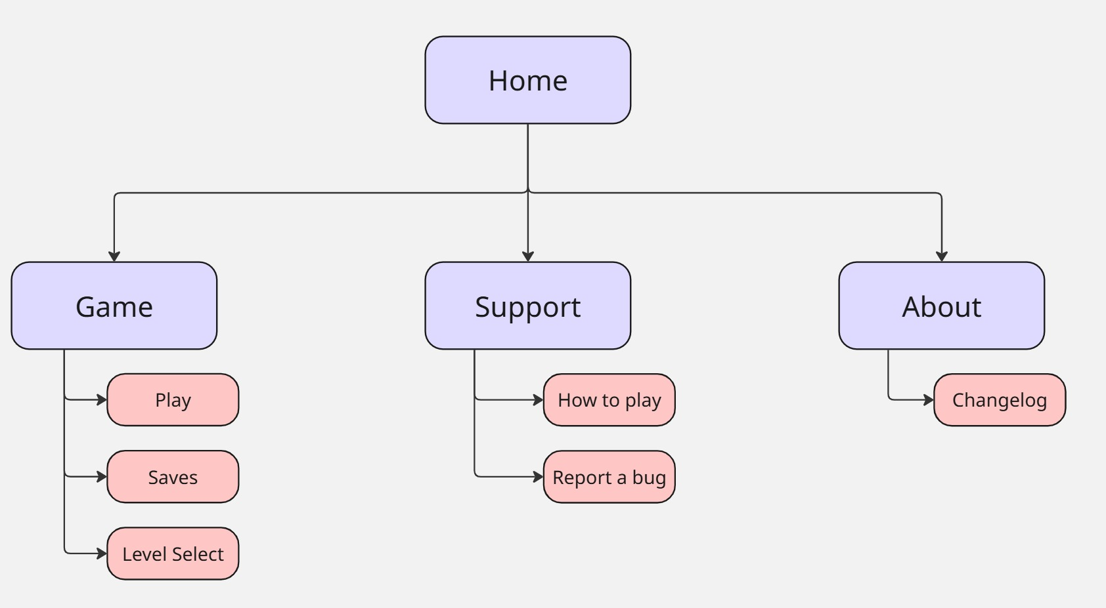

Wireframes
This section provides an illustration of the wireframe.
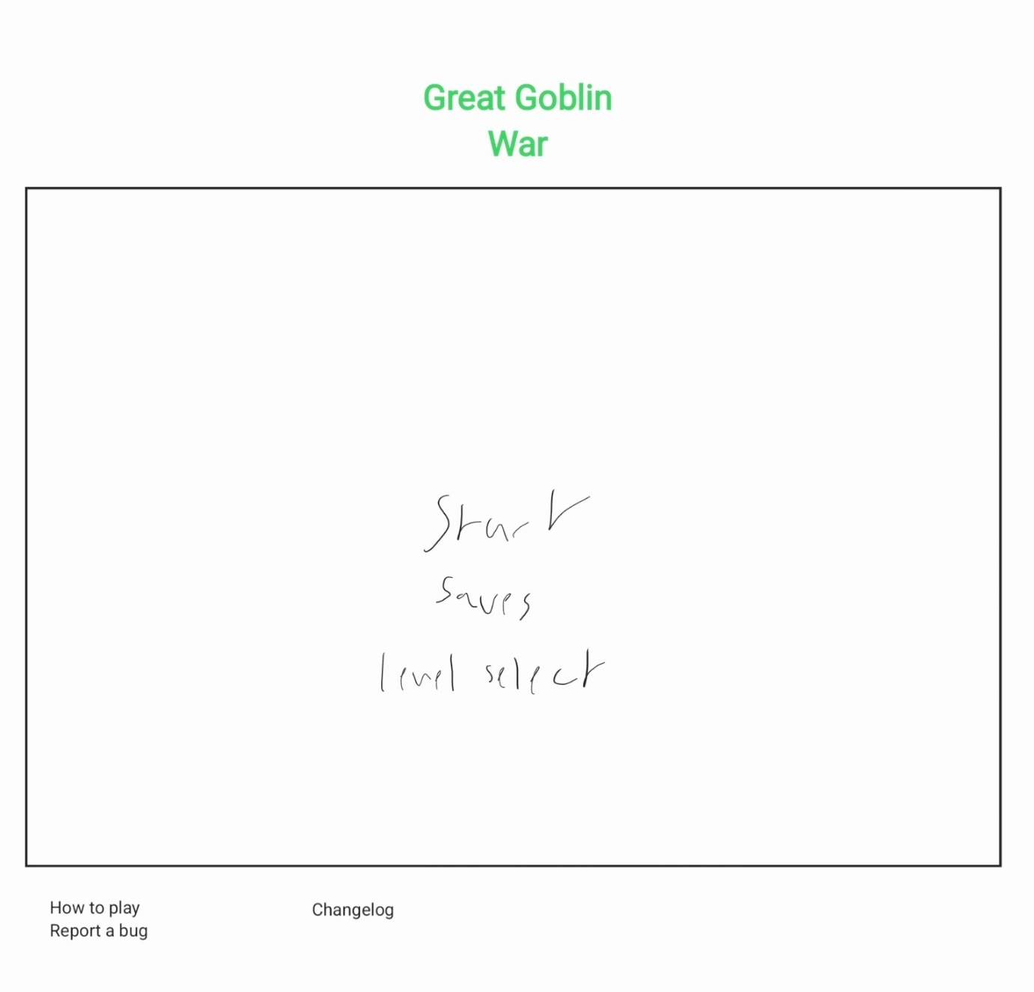

Noted issues and constraints

A potential issue I anticipate is coding enemy pathfinding. It is not something I have studied before and after briefly researching the subject, it may be outside of my current skill range. If this proves to be the case, I will manually code the enemy movement

Github repo link

https://github.com/Vepello/1004_Goblin_War

References

Copyright, Designs and Patents Act 1988, c. 1. Available at: https://www.legislation.gov.uk/ukpga/1988/48/contents (Accessed: 13 January 2026).
Granic, I. (2014) ‘The Benefits of Playing Video Games ‘, Radboud University Nijmegen. Available at: https://www.apa.org/pubs/journals/releases/amp-a0034857.pdf (Accessed:13 January 2026)

PEGI Age rating information. Available at https://pegi.info/what-do-the-labels-mean (Accessed 13 January 2026)

