1.#include <stdio.h>
int sum(int n){
int sum = 0 ;
for(int i =0 ; i <n ; i++){
sum=sum+i;
}
return sum;
}
int main(){
int n;
printf("Enter the value for n");
scanf("%d",&n);
int a = sum(n);
printf("The value is %d",a);
}

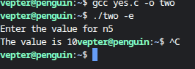

2.#include <stdio.h>
int sum(int n){
int sum = 0 ;
for(int i =1 ; i <n+1 ; i++){
sum=sum+i*i;
}
return sum;
}
int main(){
int n;
printf("Enter the value for n");
scanf("%d",&n);
int a = sum(n);
printf("The value is %d",a);
}

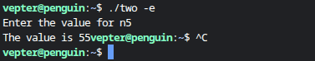
3.#include <stdio.h>
int sum(int n){
int sum = 0 ;
for(int i =1 ; i <n+1 ; i++){
sum=sum+i*i*i;
}
return sum;
}
int main(){
int n;
printf("Enter the value for n");
scanf("%d",&n);
int a = sum(n);
printf("The value is %d",a);
}

.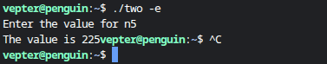

4.#include <stdio.h>
int factorial(int n){
if(n==0) return 1;
return n *factorial(n-1);
}
int main(){
int n;
printf("Enter the value for n");
scanf("%d",&n);
int a = factorial(n);
printf("The value is %d",a);
}

.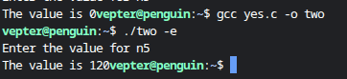

5.#include <stdio.h>

int main() {
int arr[3][3];
printf("Enter the elements:\n");

for(int i = 0; i < 3; i++){
for(int j = 0; j < 3; j++){
scanf("%d", &arr[i][j]);
}
}

printf("Before transpose:\n");
for(int i = 0; i < 3; i++){
for(int j = 0; j < 3; j++){
printf("%d ", arr[i][j]);
}
printf("\n");
}

for(int i = 0; i < 3; i++){
for(int j = i + 1; j < 3; j++){
int temp = arr[i][j];
arr[i][j] = arr[j][i];
arr[j][i] = temp;
}
}

printf("After transpose:\n");
for(int i = 0; i < 3; i++){
for(int j = 0; j < 3; j++){
printf("%d ", arr[i][j]);
}
printf("\n");
}

return 0;
}
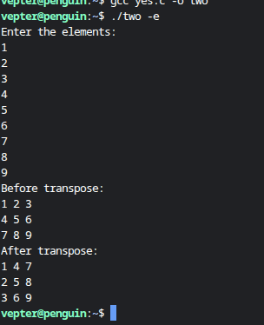

6.#include <stdio.h>
int sum(int n){
int sum = 0;
for(int i =0 ; i <n ; i++){
sum=sum+i;
printf("%d\t",sum);
}
return sum;
}
int main(){
int n;
printf("Enter the value for n");
scanf("%d",&n);
int a = sum(n);

}

