**Sources for the verbal text**

**NA1816**: printed edition of Andrea Leone Tottola’s libretto, set to music by Valentino Fioravanti (Naples, Teatro de’ Fiorentini, 1816)

**A1**: Bellini’s autograph score (first version: Naples, Teatrino del Collegio di San Sebastiano, 1825)

**A2**: Bellini’s autograph score (second version: planned for a performance with a professional cast at the Teatro del Fondo in Naples, presumably in 1826 🡪 failed project; we only have 5 numbers of this version)

**Libretto-related elements to be included in the model**

* Reproduction of **NA1816**
* Encoding of the verbal text (discussed later)

These will have to be linked with corresponding sections of the digital score and of the reproduction of the musical sources (autograph score in particular)

**Encoding**

As for the musical text, I do not want diplomatic encodings of the verbal text as it appears in the sources; rather, I would present an encoding of the ‘edited text’ (see below).

**Versions**

There are a few passages where the verbal text Bellini actually set to music does not coincide with the verbal text of the printed libretto. Some sections have been added (like N. 2 Aria di Struley); others have been omitted and not set to music (entire numbers or brief sections within larger numbers).

In the printed edition, we are planning to present a single transcription based on **NA1816**, which however should mirror the text set to music by Bellini, with the following graphic differentiations:

* [[… ]]: text printed in **NA1816**, which Bellini did not set to music (only brief sections within larger numbers that Bellini actually set to music)
* <…>: text not printed in **NA1816**, which Bellini set to music
* […]: editorial integrations

Please note that, in the printed edition, we are NOT planning to present the verbal text of those numbers that Bellini did not set to music at all. These are just signalled in footnotes (see Atto I, Scena V).

In the digital edition, I want to include the original version of **NA1816** in its entirety. We need to figure out how to present version. Possible options might include:

* One single encoding from which it is clear (maybe also using colours) what is/is not in **NA1816** and what is/is not in Bellini’s autograph scores.
* Two/three encodings, with cross-links: one for **NA1816**, the other one mirroring what is in Bellini’s scores (both versions)
* Three/four encodings: which would include all previously mentioned encodings.

I hope it is clear, but we will certainly have to discuss this together.

**Edited text**

Verbal text printed in **NA1816** as the basis (except those passages that appear only in Bellini’s score – I’ll tell you more about this), with editorial normalization (upper/lower case; modernization of ancient spelling; punctuation integrated; ecc.). In the printed edition, there is no graphic differentiation for this kind of interventions. I would do the same in the digital edition; however, I want these interventions to be signalled within the encoding. See example below, taken from a presentation I did for a class (integrated punctuation within a passage that appears only in Bellini’s score. P.S.: I’m aware we will not be able to keep <…>! We can change them to {…})

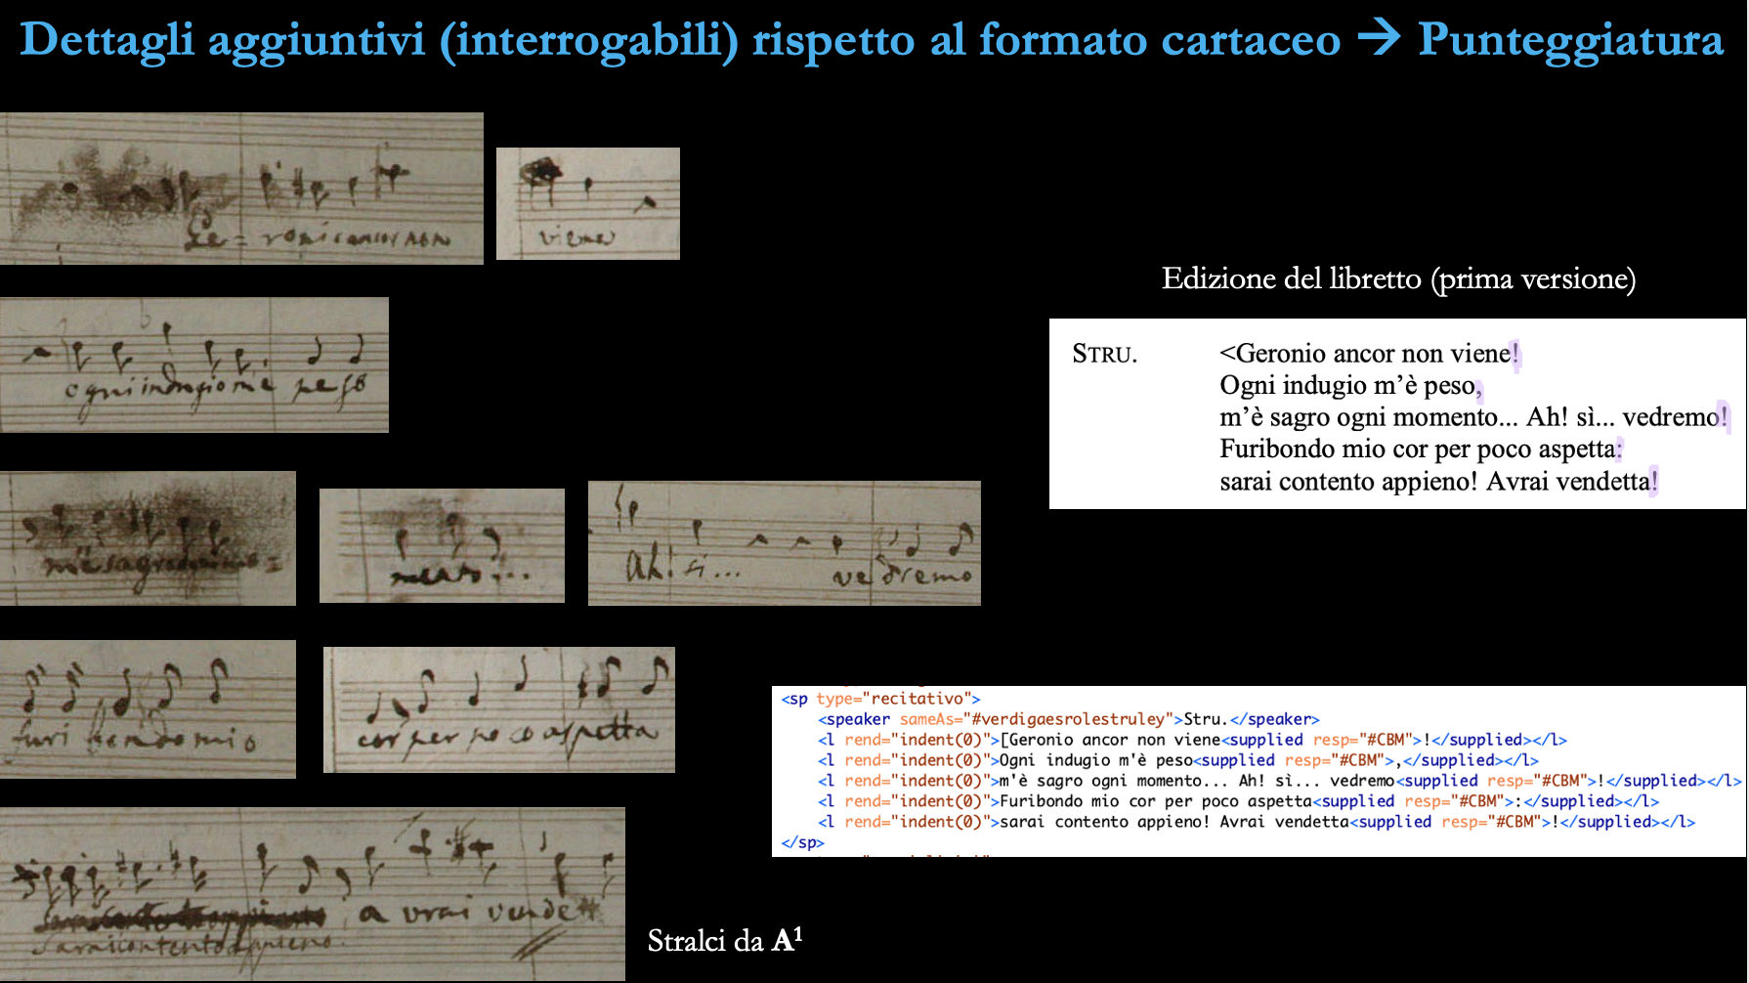

**Text categories**

In this particular genre for Naples there is an alternation among different kinds of text, that normally follow different layouts:

Spoken dialogue (no indentation; no numbering)

Recitative (indentation, level 1; numbering)

‘Versi lirici’ (indentation, level 2 + additional indentation for the first line of each stanza; numbering)

In the printed edition, the differentiation is of course only graphic; in the digital edition, it could also be part of the encoding.

See example below:

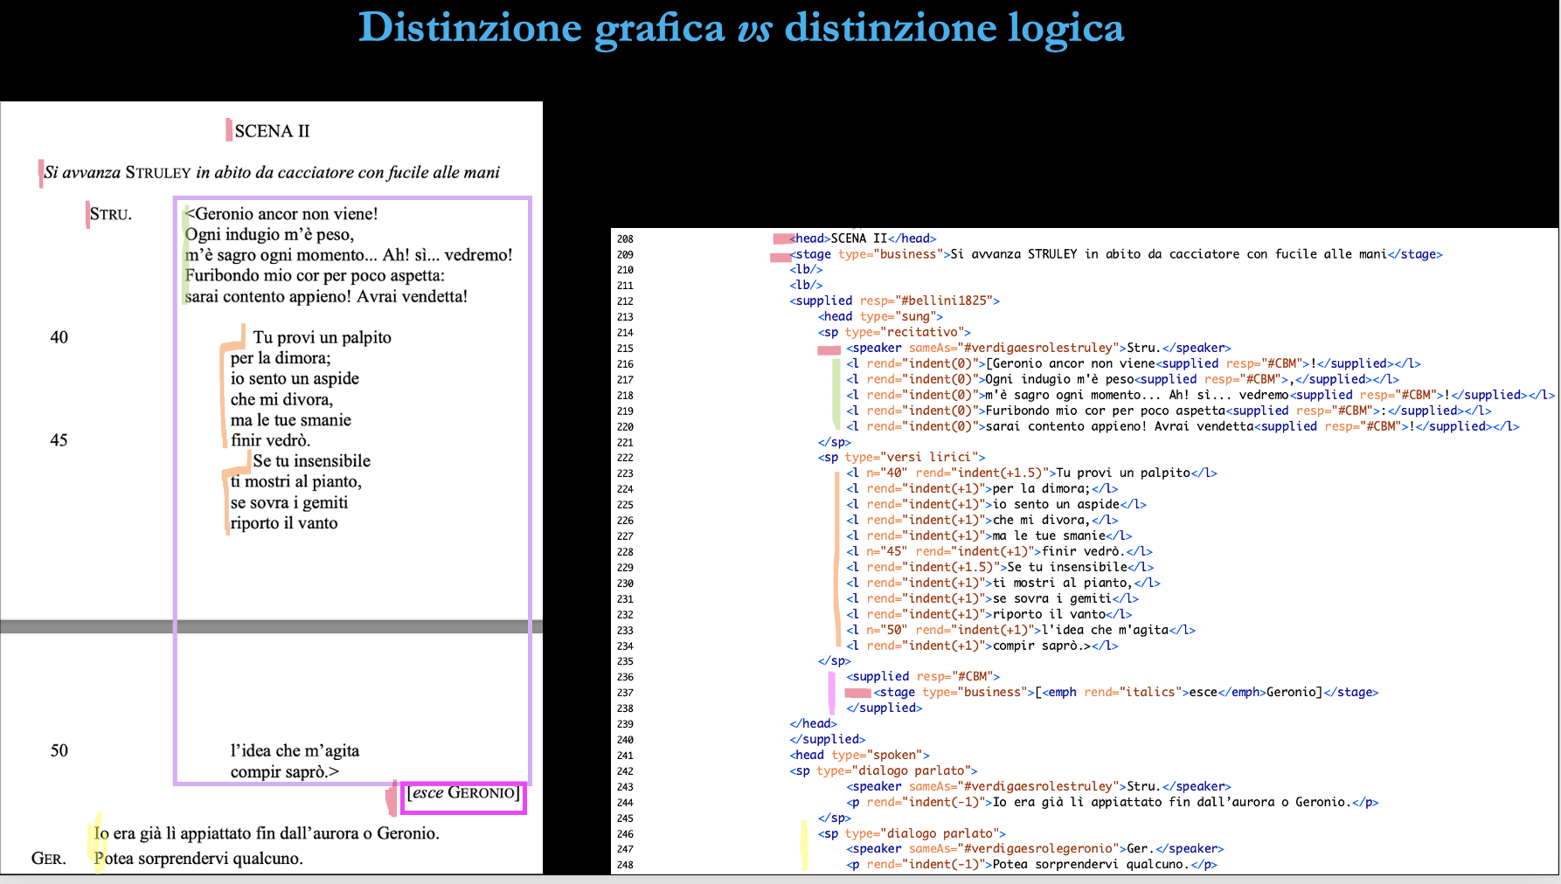

**Further possible distinctions**

I haven’t tried this yet, but I know there are also other things that might be included in the encoding (rhyme schemes, kind of lines, stanzas, etc.). We have time to discuss what we want to include.