Digesting the 6 mer approach with HRAS, KRAS and TP53 genomic sequence

If I take a gene HRAS and plot the n mers frequency what do we see?

1. To do this I downloaded the seqinr package
2. Run the code in the readme

1MER TO 6 MER PLOTS X GENE

|  |
| --- |
|  |
| |  | | --- | |  | |

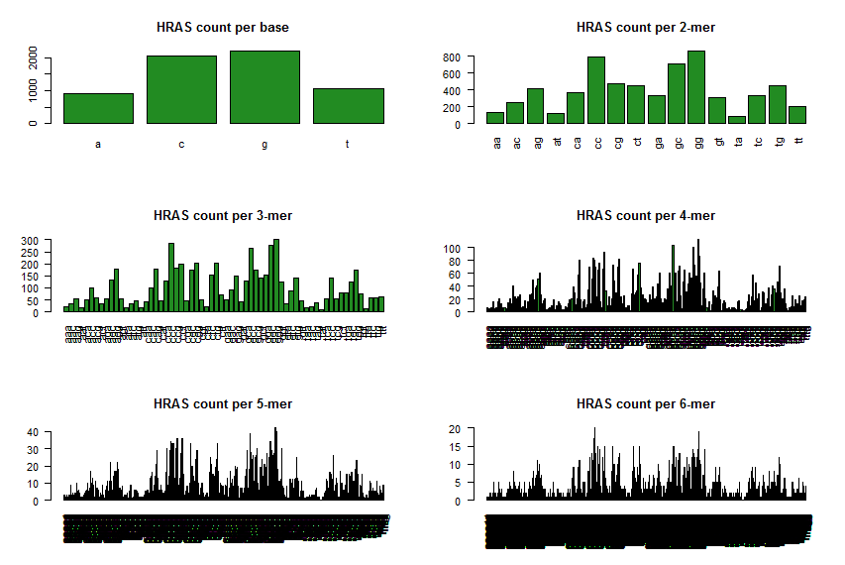

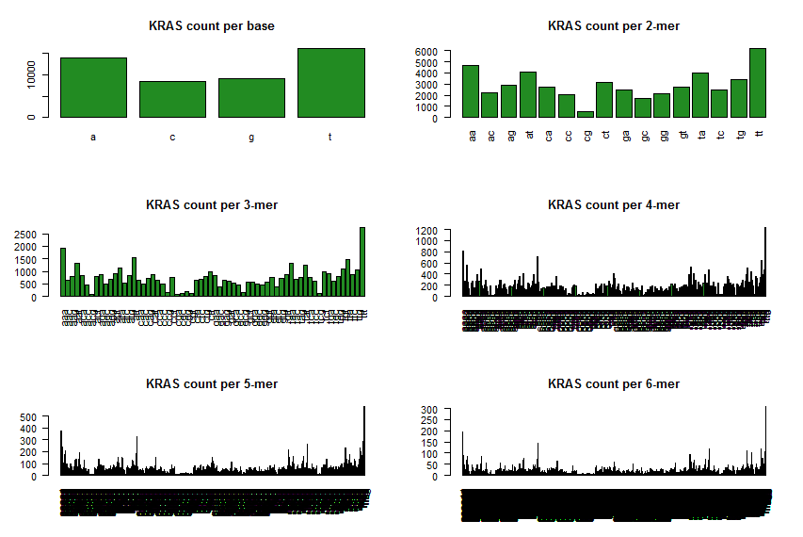

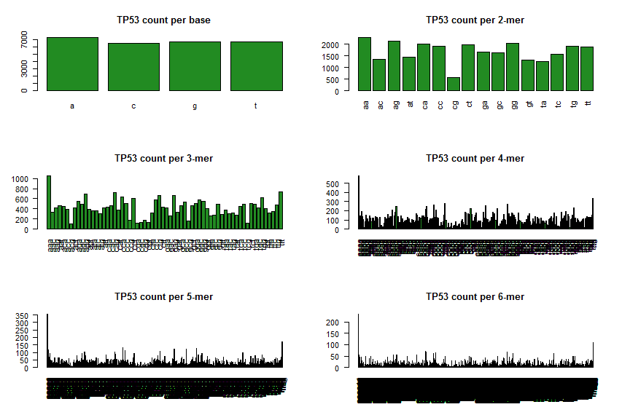

4 MER PLOTS X GENE

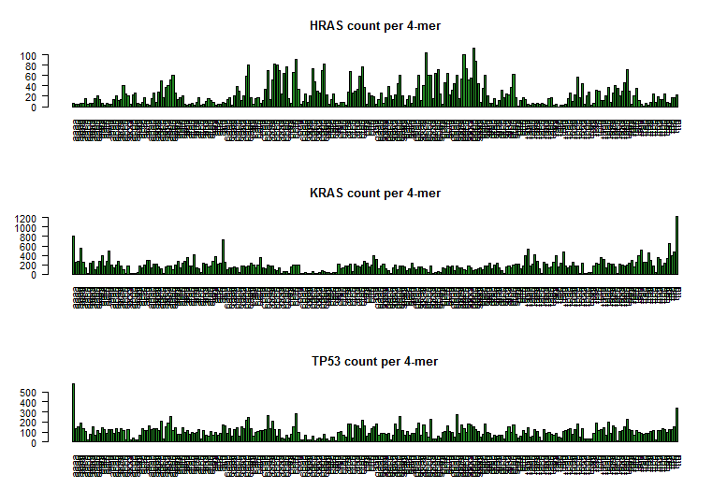

6 MER PLOTS X GENE

