This is a document that intend to explain how two-step discretization evaluation (TEDIE) works with an example data file.

In our example data file, the original data file the network from an in silico network that has 13 nodes and 8 time series. Each time series dataset contains 9 time points. In total there are 23 different discretization methods (bikmeans2-5, i2-5, kmeans2-5, max25, max50, max75, mean, q2-5, TDT, top25, top75). If you are using your own data, please make sure that every time series for a variable (node) is in a column.

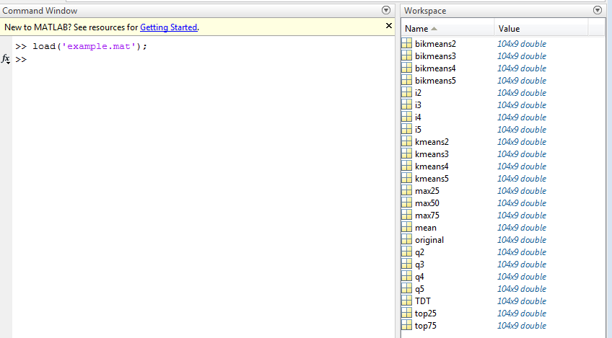

Line 7 is designed for identify the discretization method of interest. For example, here we use i2 discretization as an example.

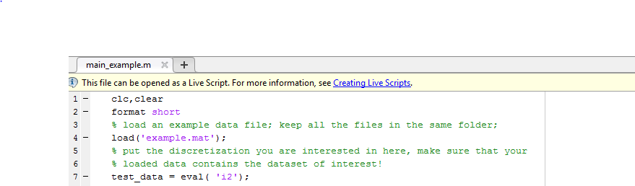

By running the whole script, we are able to see in commend line:

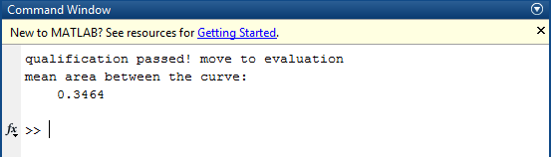

The first line tells us i2 discretization passes qualification step. The third line shows evaluation value (mean area between the curves). The smaller the evaluation number is, the better the discretization is.

We also show what would happen when choose different discretization of interest.

For example, we can try kmeans2:

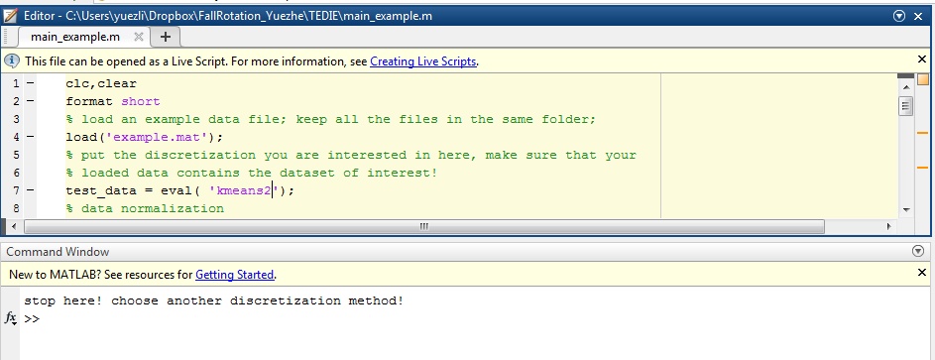

We can also try mean discretization:

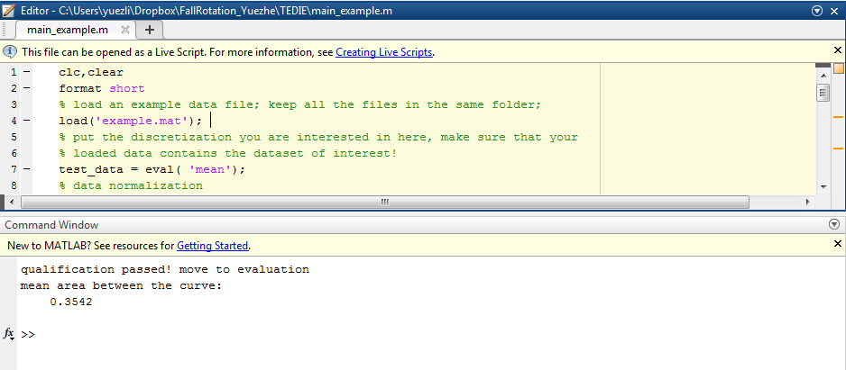

And always check whether the discretization of interest exists in your loaded data file (here is “example.mat”), otherwise:

