**METHODS**

**I. Reconstruction of the Tumorigenic Intracellular Signaling Network With Multi-Omics Data**

The intracellular signaling network of the CL TNBC cell line MDA-MB-231 is comprised of three layers: Functionally related differentially expressed genes, Transcription Factors, and Master Regulators. Gene expression, proteomics, methylation, and mutational profiles were used in the construction of the network.

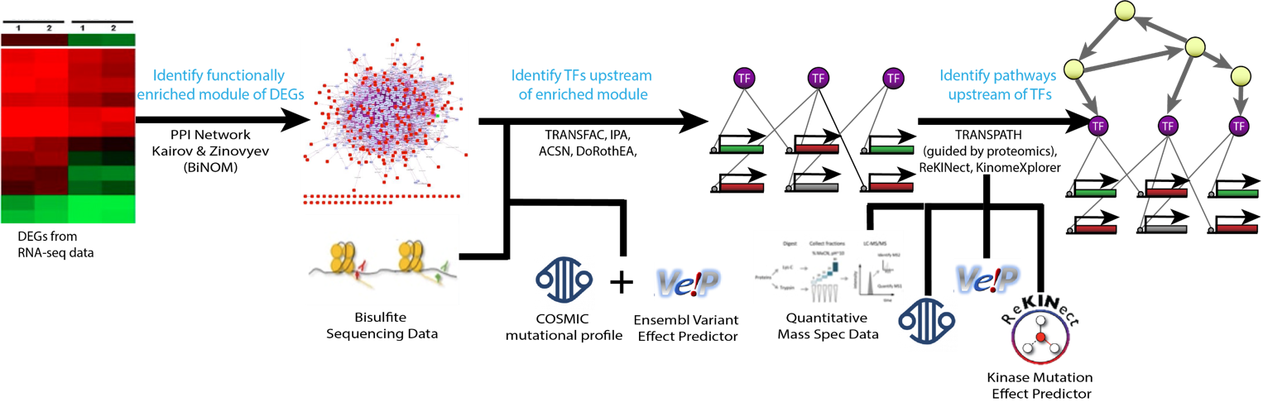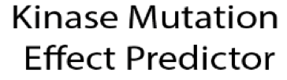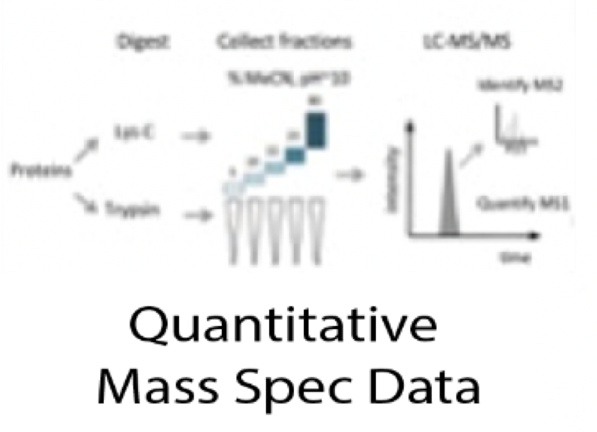

**Figure 1.** Pipeline for the reconstruction of the CL TNBC intracellular signaling network using multi-omics data.

*Data Collection*

Pair-wise RNA-seq data for the CL TNBC cell line MDA-MB-231 and the normal breast cell line MCF10A was taken from [29458327], deposited at Gene Expression Omnibus (GEO) under GSE96860. Each cell line has two biological and two technical replicates. Bisulfite data for MDA-MB-231 was obtained from [24176112] (GEO accession number GSE42944). SNV and CNV profiles have been obtained for MDA-MB-231 from Catalogue of Somatic Mutations in Cancer (COSMIC) Cell Lines Project under sample ID COSS905960 [30371878]. Label free quantitative mass spectrometry for MDA-MB-231 was obtained from [25892236], deposited in proteomicsDB under the accession number PRDB004167.

*RNA-seq Data Processing and Differential Expression*

The raw RNA-seq files were sent to Psomagen for a differential expression analysis. The Trimmomatic program was used to drop adapter sequences and bases with base quality lower than three from the ends, and the sliding window method was used to remove bases that do not qualify for window size 4 and mean quality 15. Reads with length shorter than 36bp were also dropped to produce trimmed data. The trimmed reads were mapped to hg19 using HISAT2, a program that handles spliced reads through Bowtie2 aligner, and known transcripts were assembled with StringTie. If more than one read count for the eight samples was zero, the gene was excluded from the analysis. This includes the removal of all genes with copy number loss as denoted by COSMIC CNV data. Reads were normalized with Relative Log Expression normalization and differential expression was calculated using the Wald test with a negative binomial distribution in the DESeq2 R package.

*Ranking Differentially Expressed Genes*

Differentially expressed genes (DEGs) were filtered for a False Discovery Rate (FDR) less than 0.05, and a P-value less than 0.001. DEGs were ranked using two methods. First, they were ranked DEGs by ascending p-value. The second method, adapted from Ruthi et al., involved computing a pseudo-z-score for each gene and ranking by its descending absolute value [25195578]. The pseudo-z-score of the expression of node is:

Where is the average expression of gene in the cancerous cell line, is the average expression of gene in the normal cell line, and is the standard deviation of the 4 replicates of the expression of gene from the normal cell line. This score reflects the cancerous expression level of a gene compared to the distribution of expression in the normal samples, and is related to the probability that the expression level in the tumor is from the same distribution as is in the normal tissue.

*Identification of Functionally Related Differentially Expressed Genes*

The first step in the pipeline is to identify a module of functionally related DEGs (FunDEGs). This method, developed by Kairov et al., considers functional relationships between molecules based on protein-protein interactions (PPI) as opposed to a statistical cutoff to identify a functionally related core of genes [23055628]. Thus, more biologically relevant interactions may be captured, even if the molecules involved are not highly differentially expressed.

The method stems from percolation in graph theory, where one can estimate the expected size of the largest connected component given a graph and randomly selected nodes. For some number of ranked nodes, most of them are included in the largest connected component (LCC). Thus, if the first ranked nodes () form a largest connected component larger than expected by random, their connections are non-random, and they form a functionally related core.

The method is implemented in the BiNOM Cytoscape 2.8.3 plugin [23453054]. Using the Human Protein Reference Database (HPRD) as the underlying PPI, the percolation score for multiple sets of *k* top-ranked DEGs (k=50-1000 by increments of 50) were computed. The percolation score is defined as:

Where k’ is the number of ranked DEGs found in the HPRD PPI (). is the largest connected component (LCC) formed by these genes. Mean(R(k’)) is the mean LCC size of 10,000 networks of k’ genes, each randomly sampled from the HPRD while preserving the connectivity distribution of the k’ ranked DEGs.

This process is repeated for values of from 50 to 1000 in increments of 50. The optimal () is chosen as the smallest such that decreases as increases for [23055628]. This analysis was run separately on the DEGs ranked by p-value and the DEGs ranked by pseudo z-score. Housekeeping genes, except for VIM because it is a marker of EMT, were filtered from the functionally related core and the resultant LCC was selected as the set of First Order FunDEGs [19534766].

After identifying First Order FunDEGs, BiNOM was used to identify Second Order FunDEGs. This step identifies nodes that share an edge between two First Order FunDEGs in the HPRD. Thus, the genes in the Second Order FunDEGs need not be differentially expressed, but could play important roles in tumorigenesis. Housekeeping genes and genes that are not expressed in MDA-MB-231 were removed from this set of genes and the LCC was selected as the set of Second Order FunDEGs.

To determine which set of genes to use for network construction (The first *k* ranked DEGs, First Order FunDEGs, or Second Order FunDEGs), a weighted sums metric was employed. This compares the contents of each gene set to Claudin-Low related genes, Breast Diseases Ontology genes from DOLite in the GeneAnswers R package, and hallmarks of cancer associated with EMT and innate immune response from the atlas of cancer signaling network as these hallmarks are claudin-low specific [28249905, 19478018, 26192618]. The list with the highest weighted sum was selected as the first layer of the network.

*Identification of Transcription Factors*

The next component of the intracellular signaling network is transcription factors (TFs) that regulate the FunDEGs. These were identified with the Analyze Promotors workflow using TRANSFAC and MATCHTM in GeneXplain [SOURCE]. TRANSFAC is a manually curated database of eukaryotic transcription factors, their genomic binding sites and DNA-binding profiles [10592259]. It stores DNA binding patterns as positional weight matrices (PWMs) that can be used to identify putative transcription factor binding sites (TFBS) with the MATCHTM algorithm [12824369]. The algorithm takes a DNA sequence as input and uses two scores- the matrix similarity score (MSS) and the core similarity score (CSS) - to measure the quality of the match between the sequence and the PWM. Matches that have a MSS and CSS higher than pre-defined cutoff values are reported as putative TFBSs [12824369]. The Analyze Promotors workflow compares putative TFBSs within a specified promotor window size between a “Yes” set and a “No” set of genes. The yes/no ratio is calculated for each TF to indicate the proportion of targets the TF regulates that are in the “Yes” set compared to the “No” set.

For this analysis, PWMs for human TFBS with a p-value<0.001 were used. The “Yes” set was the list of FunDEGs and the “No” set was the list of expressed housekeeping genes. The workflow was run with five different promotor window start sights: 500bp, 1000bp, 1500bp, 2000bp, and 2500bp upstream of the transcription start sight. The results were filtered for TFs with a yes/no ratio > 1.5 and a p-value <0.05. Additionally, Ingenuity Pathway Analysis (IPA) upstream regulator analysis was used to identify TF – FunDEG interactions that have been experimentally validated in any tissue or breast cancer sample [SOURCE]. IPA contains a manually curated database of experimentally validated cause-effect relationships between genes, proteins, chemical compounds, and microRNA. The upstream regulator analysis algorithm takes a statistical approach to identify regulators whose network connections to FunDEGs are unlikely to occur in a random model [24336805]. These results were filtered for interactions with a p-value <0.001. The intersection of the TRANSFAC and IPA results at each promotor window size were filtered against gene and protein expression data for MDA-MB-231 and unmethylated CpG regions from bisulfite data. A weighted sums metric for the lists of TFs from each window size was calculated using the previously described criteria, and coverage of FunDEGs was checked. The TF list with the highest weighted sum covering all FunDEGs was selected.

Although TRANSFAC provides putative TFBS, it does not provide information regarding the sign (activation or inhibition) of the interaction between a TF and FunDEG. Those interactions that were not included in the IPA output were mapped into OmniPath, a network of high quality, manually curated signaling pathways, using Cytoscape [31886476]. Only interactions with confidence level A and B were considered. Interactions with confidence level A are found in more than one review or two curated resources, in a curated signed database, or in a curated datatbase, ChIP-seq, TFBS, and inferedGTEx. Interactions with confidence level B are found in curated resources and Chipseq, in curated resources and TFBS and inferredGTEx, or in Chip sew and TFBS and inferred GTEx. The sign of the relationship for any remaining TF – FunDEG interactions that were not in OmniPath was inferred by Pearson Correlation using the ExpressionCorrelation application in cytoscape [<http://baderlab.org/Software/ExpressionCorrelation>].

Mutations in regulatory regions can influence TF binding affinity. To identify mutations in regulatory regions of the FunDEGs, the COSMIC SNV data for MDA-MB-231 was filtered for SNVs in regulatory regions as determined by the Ensembl Variant Effect Predictor (VEP) [27268795]. If there are mutations in regulatory regions, their impact on TF-binding affinity is predicted as described in [28333948]. In short, each SNV in a regulatory region is analyzed for its ability to modulate the sequence to PWM match score. SNVs that increase the score compared to the wildtype sequence are potential gain-of-binding site events, while SNVs that decrease the score compared to the wildtype sequence are potential loss-of-binding site events. This can be done in GeneXplain using the Mutation effect on sites analysis workflow. Necessary modifications to TF-FunDEG interactions are modified manually according to an increase or decrease in binding affinity.

*Identification of Master Regulators*

The final layer of the network consists of master regulators (MRs) – genes, proteins, or complexes that regulate the TFs in the network. Pathways in which the TFs participate were identified using the Master Regulators with Context Genes with Weights pipeline in GeneXplain and the manually curated TRANSPATH database [12519957]. This workflow uses a specified radius and Dijkstra’s shortest path algorithm on the TRANSPATH database to identify upstream molecules regulating the TFs. Proteomics data for MDA-MB-231 was used as context to guide the shortest path algorithm towards nodes with protein expression. The workflow weighs the context genes based off of the average protein intensity for each gene by decreasing the cost of the edges around genes with higher levels of protein expression, thereby attracting the algorithm to those molecules [29900117]. The analysis was run with radii ranging from 5 to 10, indicating how far upstream from the TFs to search for MRs. The smallest radius such that all the TFs have an upstream MR was chosen. Resultant master regulators were filtered for a z-score > 1.5, an FDR < 0.05, and to include only those that have protein expression. Nodes in MR pathways without gene expression data were removed from the network so long as their removal did not create a source node.

SNVs have the capability to inactivate, activate, or modify the specificity of a protein’s kinase domain which may cause profound signaling changes within a cell. To determine the impact of kinase mutations in our network, the Ensembl VEP ProteinSeqs plugin was used to obtain reference (wild-type) and mutated protein transcripts. Then, the ReKINect software was used to predict and classify kinase modifying mutations in the SNV data for MDA-MB-231 [26388441]. ReKINect employs a database of all known human kinase domains, 111 SH2 domains, and 149,838 phosphorylation sites and will predict the functional impact of the SNV. For mutations affecting protein kinase function, the downstream targets of the mutated kinases were determined with KINSpect, using the ReKINect database [26388442]. KinomeXplorer was used to investigate upstream kinase specificity changes for mutated proteins [24874572]. The identified mutated pathways are added to or removed from the network manually, as they are not included in signaling databases.

*Addition/Removal of Mutated Pathways*

After considering the effect of mutations in TF binding regions and kinase signaling pathways, the effect of any other mutated network node must be considered manually. Ensembl Variant Effect Predictor (VEP) was used to provide information regarding the location and consequence of each SNV [27268795]. Mutations that lie in protein coding regions were filtered to include only those that modify the protein amino acid sequence (missense, splice-site variation, frameshift, deletion, stop gained). A literature curation of the gene variants that cause protein transcript alterations was done to explore their impact on TNBC tumorigenesis.If a gene variant causes gain of function activities that affect a specific TNBC pathway, the interaction and pathway were added to the network manually as appropriate, since they are not included in signaling databases.