Source: <https://www.biorxiv.org/content/biorxiv/early/2018/08/24/313296.full.pdf>

Github: <https://github.com/KarchinLab/CHASMplus>

CHASMplus uses machine learning to predict both well-known and rare driver mutations in a cancer type specific manner. It is trained on mutational profiles from 32 cancer types from The Cancer Genome Atlas, including breast cancer. After inputting SNV data and selecting a cancer type, CHASMplus will compare it to known cancer genome landscape genes in the cancer type and use the number of mutations in the sample to give it a cancer-type specific CHASM score as opposed to a pan-cancer approach. The closer the score is to 1, the more likely it is to be a driver mutation. We will use this tool to narrow down the number of mutations whose effect must be determined through literature curation. We will only consider mutations with a CHASM score above ____, as the others are likely passenger mutations with little effect on the system.

. 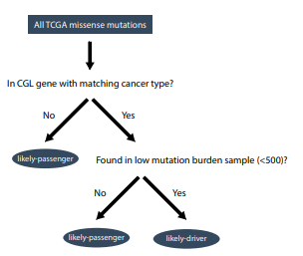

We ran all 4 mutational profiles through CHASM, comparing to breast cancer data specifically. After doing so, TP53 scored ______, and BRCA1 scored _____ …..