**II. Identification and Prioritization of Putative Reversion Targets**

*Identification of the Minimal Feedback Vertex Set*

Identifying the minimal FVS (mFVS) is a well-known NP-hard problem. The OCASANA+ Cytoscape app was used to find the near-mFVSes of the intracellular signaling network. In order to find these near-minimum FVSes, OCASANA+ implements a simulated annealing local search approach, SA-FVSP, originally described by Galinier et al.

*Virtual Screenings*

Virtual screenings were run using SFA to predict the effect of concerted perturbations of the FVS nodes on the long-term behavior of the system. FVS nodes were either knocked-out, knocked-in, or left unchanged. Knock-out perturbations were simulated by setting the basal value of the FVS node to 0, and fixing it there until the system reached an attractor state. Similarly, knock-ins were simulated by setting the basal value of FVS nodes 2-fold higher than the mean expression of that FVS node across all four experimental replicates for MDA-MB-231.

The networks was initialized with normalized RNA-seq expression data for the tumorigenic cell. 100,000 random perturbations of the FVS nodes were applied to this initial state, and the resultant attractors were simulated with SFA. Steady states were reached by running SFA iteratively as opposed to solving the steady state equation so that the value of the FVS nodes could be overridden at each time step so that they remain fixed at their basal level. This process was repeated four times – each time the network was initialized with the RNA-seq expression data of a different experimental replicate of MDA-MB-231 – to provide “experimental” replicates.

*Classification of In Silico Perturbation Attractors*

Attractors produced from *in silico* perturbations of the FVS nodes need to be classified as a phenotype for identification of putative reversion targets. To do so, k-nearest neighbors (knn) classifier was applied to the attractors simulated from each perturbation, using the eight attractors resulting from experimental RNA-seq expression values as a training set. A perturbation must shift the long term behavior of the network towards the normal attractor from all four initial conditions to be considered successful.

*****************

To do so, the clustered attractor landscape is used as a training set for k-nearest neighbors classifier on the perturbation attractors. Perturbations whose attractors are classified in the “normal” cluster have triggered a shift away from the cancerous attractor and towards the normal basin of attraction, indicating they are putative reversion targets.

*** (What distance metric, how do we determine k)

A perturbation must shift the long term behavior of the network towards the normal attractor from all four initial conditions to be considered successful.

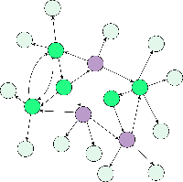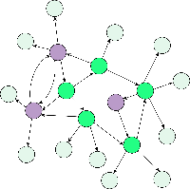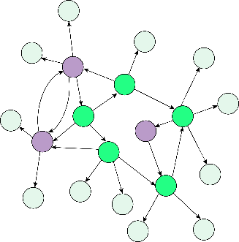

T0Normal

T0Cancer

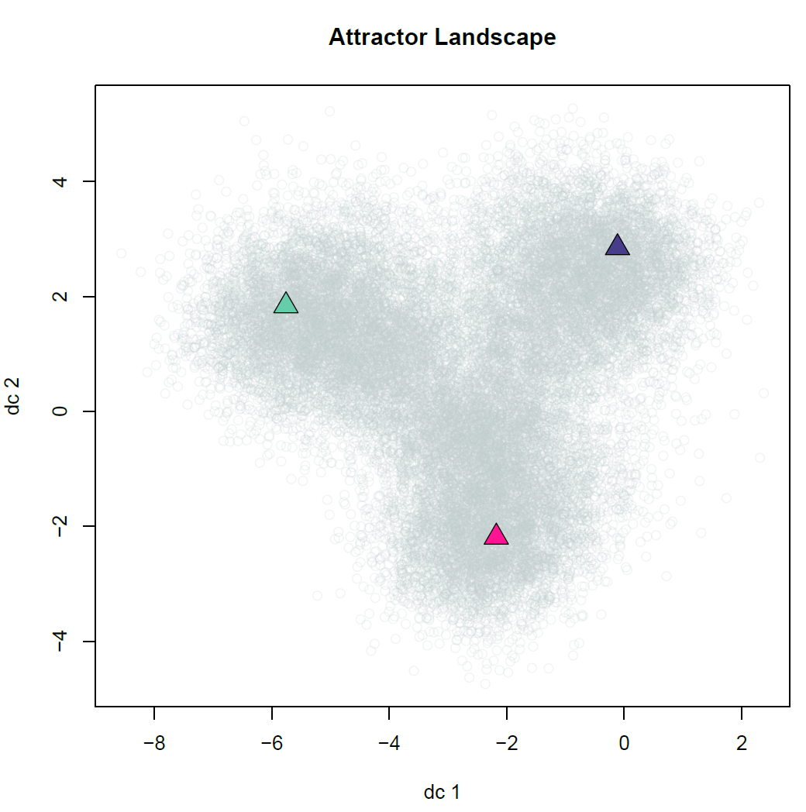

**Simulating network to**

**identify associated attractor**

**from each initial condition**

…

**Simulating network to**

**identify associated attractor**

**from initial condition**

**with FC nodes perturbed**

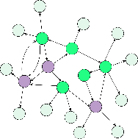

…

T0

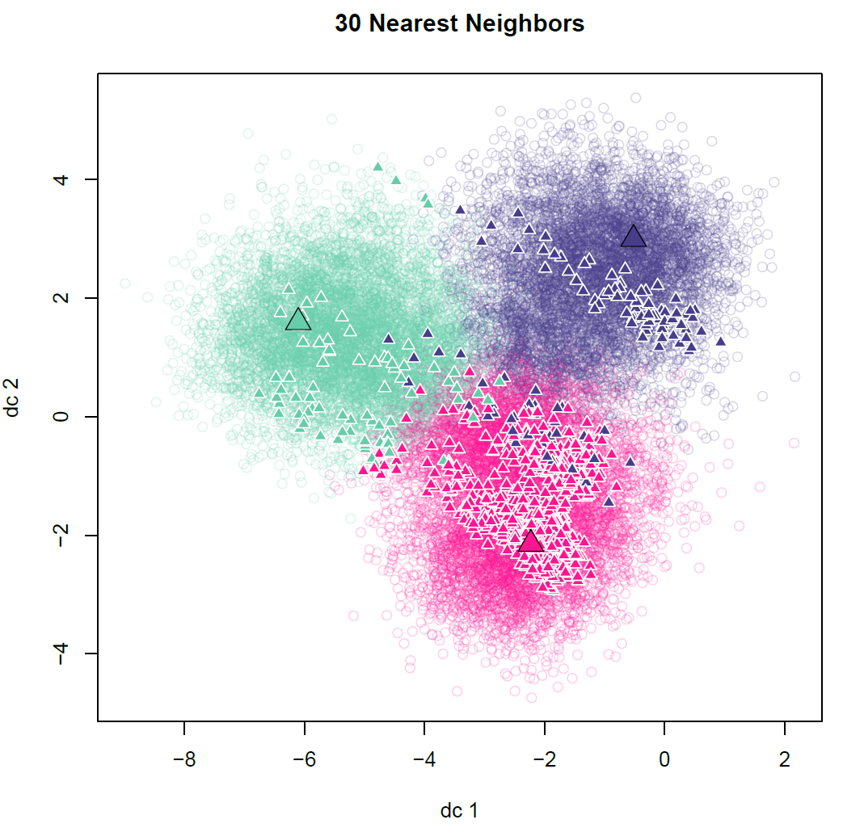

**Classified Attractors**

**(by K-Means)**

**Classify Newly Generated Attractor from**

**Perturbed FC (by K-Nearest-Neighbors)**

?

?

?

Norm0

Ca0



*Prioritization of Putative Reversion Targets*

The perturbations that result in attractors in the normal cluster need to be prioritized for experimental validation. This is done by quantifying how similar the MCF10A and the perturbation attractors are. The direction of activity change (DAC) between MCF10A and MDA-MB-231 attractors and the perturbation attractor and MDA-MB-231 attractor were calculated and grouped into three values: 1 for positive DACs, -1 for negative DACs, and 0 for zero DACs. The hamming distance between the DAC of MCF10A against MDA-MB-231 and the DAC of the perturbation attractor against MDA-MB-231 was calculated and perturbation attractors with smaller distances will be prioritized over larger ones. Additionally, the number of perturbations required to trigger a shift in phenotype will be considered because the MDA-MB-231 basal value of some FVS nodes may already be in the correct orientation and not need perturbation.

*** Mention Druggability