**Zanudo 2015 SFA exploration**

<https://doi.org/10.1371/journal.pcbi.1004193>

**Last time:**

We simulated the trajectory of one initial state with SFA and tried to compare the results to the Boolean trageectory of the same initial state from BoolNet. We weren’tsure how to compare the two so we discretized the logss outoput from SFA multiple ways:

1. Anything > 0 goes to 1, anything <=0 goes to -1
2. Anything >= 0 goes to 1, anything < 0 goes to -1
3. Several other ways and applied discreetest to determine the best method

This resulted in about a 60% accuracy in predicting the attractor with SFA.

We wanted to get a better idea of whether or not we can tell when SFA gives reliable results/ get an intuition for what we can use it for.

**Now:**

In order to accurately interpret SFA results, we need to compute the DAC to some reference value. This will tell us if a node is upregulated or downregulated with respect to the reference. This signaling network is for T-LGL Lukemia, so we used the Lukemia attractor as the reference.

Below is S1 Table from the paper. They identified three interventions that result in the lukemia phenotype.

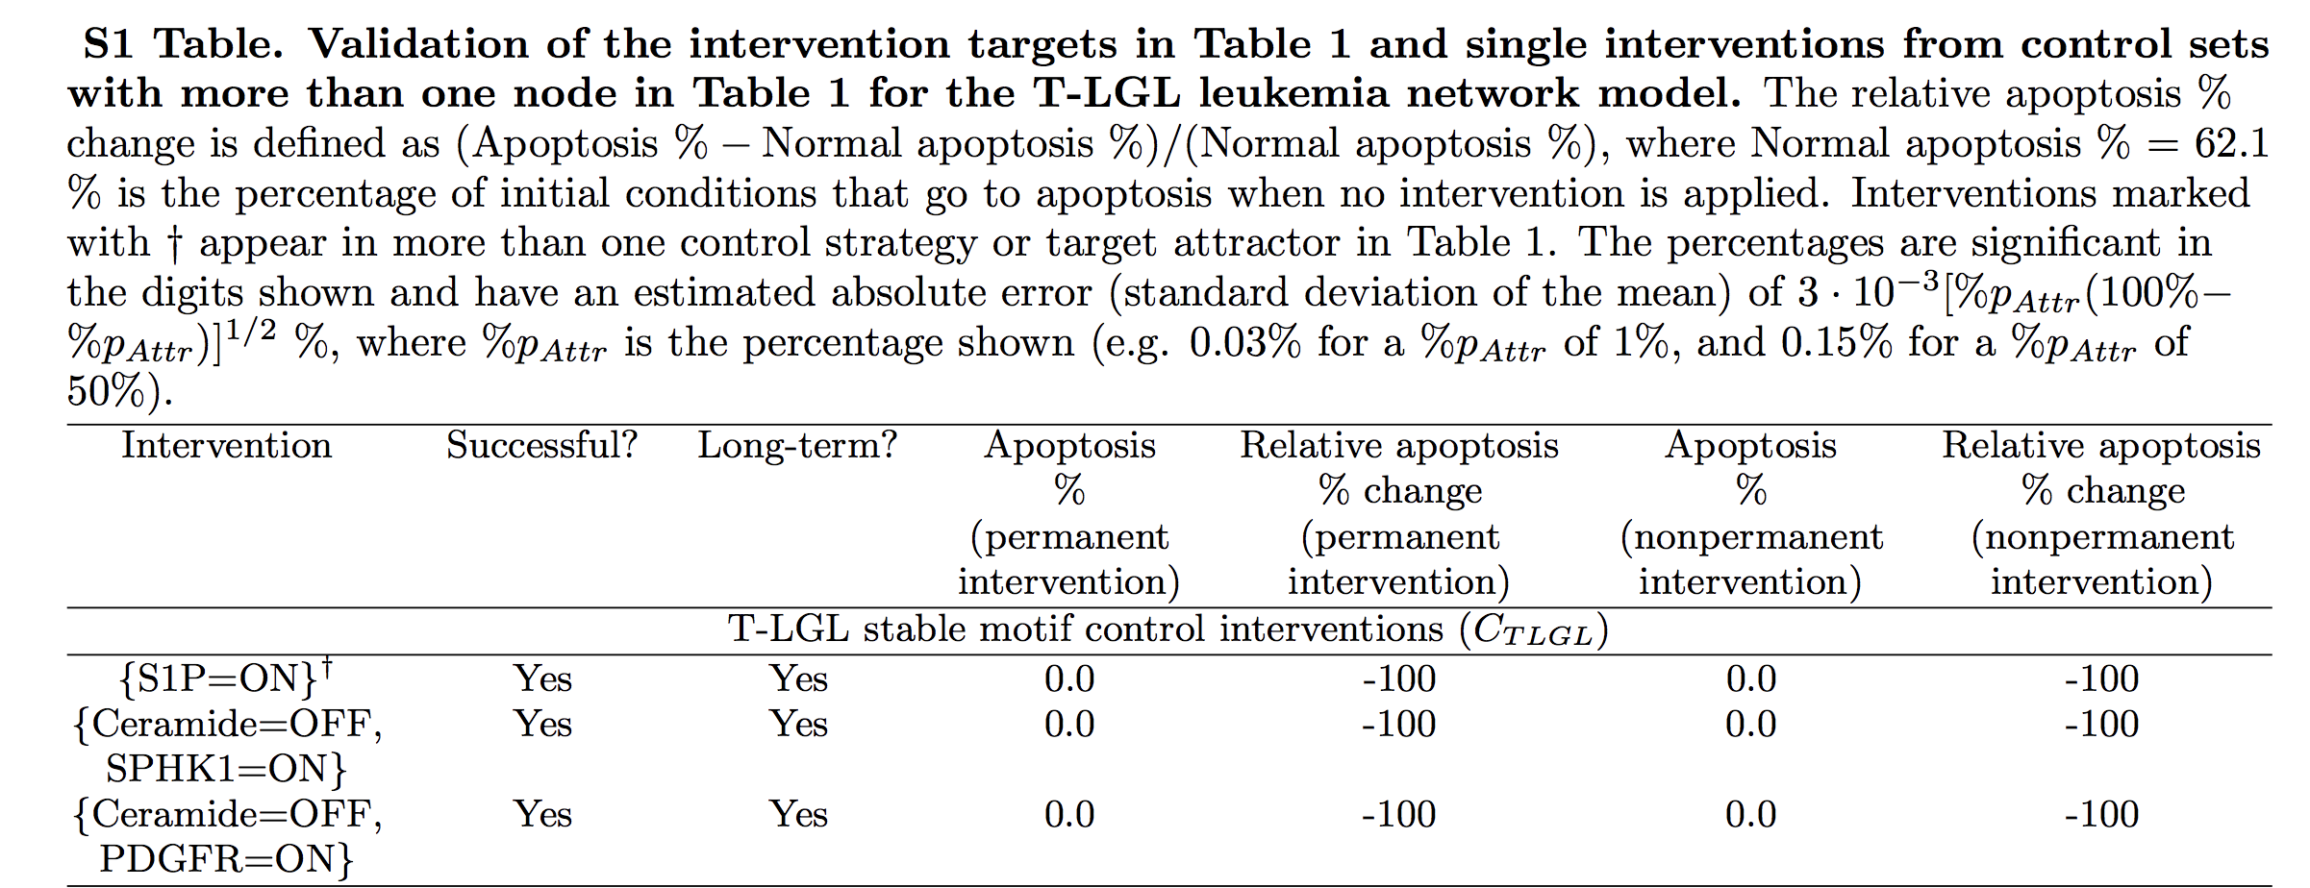

I simulated the attractors of all three of these conditions with SFA (all nodes were given a basal level of 0 except for the node that should be turned on in the intervention). The SFA results were obviously different (see **cancer_attractors.xlsx**), but for the most part nodes had logss values with the same sign (+ or -) so I felt as though SFA was giving similar attractors. I just chose one of them to look at for now (activation of SPHK1). This is the cancerous attractor I used as reference going forward.

We used BoolNet to simulate the attractor landscape of the network and chose one attractor (attractor 15) to work with. We found all the network states in the basin of attractor 15 and chose 4 of them to test with SFA. Ideally, the SFA attractors for all 4 of these initial states would match.

We ran SFA iteratively to see the trajectory of each of these states. Using machine epsilon as our tolerance level, we got around 30 iterations before reaching steady state regardless of the initial condition. We also ran SFA iteratively to get the cancer attractor. Then, we computed the direction of activity change at each time step when compared to the cancerous trajectory (trajectory of interest – cancerous trajectory) and discretized this to >0 🡪 1, and <=0 🡪 0. (see **compare_SFA_BN_traj.xlsx)** The 4 initial states we chose were 33 , 4, 13, and 7 steps away from the attractor in BoolNet, but when we discretized the SFA results, they got to the attractor in 3, 2, 3, and 3 steps, respectively.

Because the length of the trajectories are so different, we have not yet compared the states in the trajectories.

We also compared the SFA attractors of the 4 initial conditions (see **compare_SFA_BN_attractors.xlsx** ). Since these 4 conditions collapse to the same attractor in the Boolean model, we hoped that would be the same with SFA. While this was not the case, 43/60 (70%) of the nodes were the same in all 4 attractors. When comparing to the Boolean attractor, we found that in one of the attractors, 65% of the nodes were the same orientation as the Boolean attractor. However, in the other three attractors 83-85% of the nodes were in the correct orientation.

Zanudo points out that there are multiple attractors corresponding to the cancerous phenotype but they all have similar characteristics:

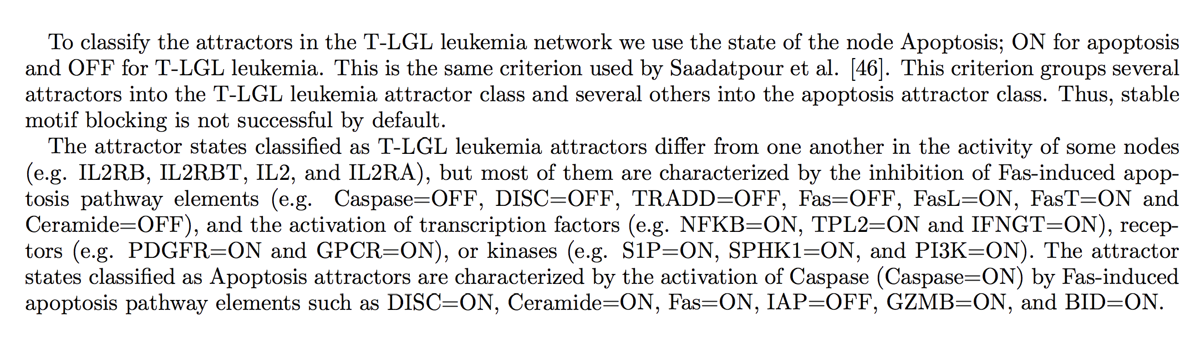

In all 4 of the attractors, the apoptosis node was on, which means they all correspond to the same phenotype. In addition, I looked to see if the “read out nodes” described above were in the same orientation for the SFA attractors and the Boolean attractor. Nodes highlighted in green on the spread sheet are read out nodes. Red cells indicate that the SFA attractor value of that node does not match the Boolean attractor, while yellow indicates that it does.

All 4 SFA attractors have the same direction for at least 14 out of the 16 RONs (one has the correct direction for all 16). This may indicate that while SFA does not produce the same results for the entire attractor that the Boolean model does, it’s outputs can still lead to the same result (The apoptosis node is turned on and the RONs have similar values so these attractors are the same phenotype).